PROJECT TITLE:
Machine Learning-Based Compiler Error Classification

1. INTRODUCTION:
This project aims to classify compiler error messages into three categories:
Lexical, Syntactic, and Semantic errors using Machine Learning techniques.
The system helps developers understand errors quickly and improves debugging efficiency.

2. OBJECTIVE:
- Automate classification of compiler errors
- Reduce debugging time
- Assist in identifying potential security-related issues

3. DATASET:
The dataset consists of compiler error messages labeled into three categories:
- Lexical
- Syntactic
- Semantic

4. METHODOLOGY:

Step 1: Data Preprocessing
- Cleaned and structured dataset
- Split into training and testing sets

Step 2: Feature Extraction
- Used TF-IDF Vectorizer
- Converted text into numerical features

Step 3: Model Training
- Logistic Regression
- Random Forest
- Support Vector Machine (SVM)
- Gradient Boosting
- Multi-Layer Perceptron (MLP)

Step 4: Model Evaluation
- Compared accuracy of all models
- Selected best performing model

Step 5: Deployment
- Built a Flask-based web application
- User inputs error → system predicts category

5. RESULTS:
All models performed well, with Logistic Regression achieving the best performance.

6. SYSTEM ARCHITECTURE:

Input → Preprocessing → Vectorization → Model → Prediction → Output

7. SECURITY ANALYSIS:
Semantic errors are associated with potential vulnerabilities like memory misuse and null pointer dereferencing.

8. TECHNOLOGIES USED:
- Python
- Scikit-learn
- Flask
- HTML & CSS

9. CONCLUSION:
The system successfully classifies compiler errors and provides a user-friendly interface for prediction.
It enhances debugging efficiency and supports secure software development.

10. FUTURE WORK:
- Improve dataset size
- Use deep learning models like BERT
- Deploy on cloud

Graph..

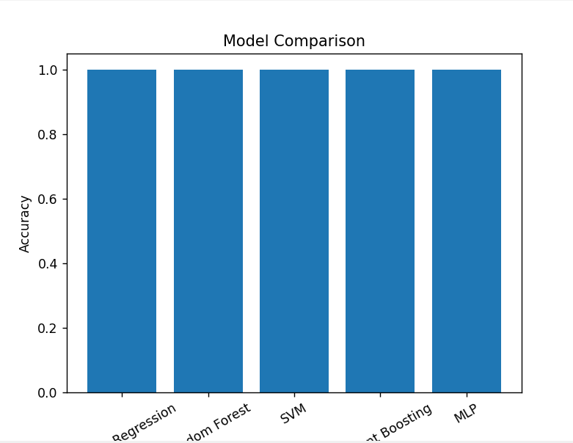

Website..
