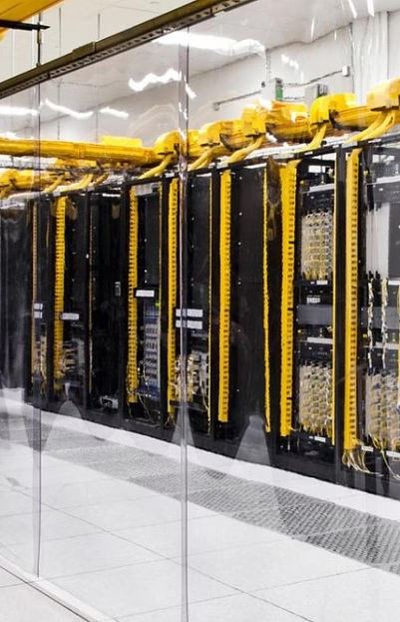

**Introduction to Google Cloud**

Google Cloud is a comprehensive suite of cloud computing services that allows businesses to store and analyze large amounts of data, harness machine learning, and run applications. It provides infrastructure as a service, platform as a service, and serverless computing environments, offering organizations the flexibility to scale and innovate. With its advanced tools and global infrastructure, Google Cloud enables businesses to optimize their operations, drive innovation, and gain a competitive edge in today's digital landscape.

From data storage to machine learning capabilities, Google Cloud stands out for its robustness and versatility. It offers a wide range of services, including data storage, databases, analytics, machine learning, and more. By leveraging Google Cloud, organizations can achieve scalability, reliability, and security, making it a preferred choice for enterprises across various industries.

**Benefits of using Google Cloud for storing big data**

**Scalability:** Google Cloud provides scalable storage options, allowing businesses to expand their data storage as needed without major infrastructure changes.

**Data security:** With advanced encryption and access control features, Google Cloud ensures the security and integrity of big data, meeting industry compliance standards.

**Cost-effective:** Businesses can benefit from the pay-as-you-go pricing model, only paying for the storage and resources they use, which can result in significant cost savings.

**Global accessibility:** Google Cloud's distributed infrastructure enables global accessibility to stored big data, ensuring low latency and high availability for users worldwide.

**Benefits of using Google Cloud for machine learning**

**Scalability:** Google Cloud provides scalable infrastructure and resources for machine learning projects, allowing companies to efficiently handle large datasets and complex models.

**Integrated Services:** The platform offers a wide range of integrated services such as TensorFlow, BigQuery, and AI Platform, streamlining the development and deployment of machine learning applications.

**Advanced Tools:** Google Cloud provides advanced tools and APIs for data preparation, model training, and prediction, enabling businesses to build sophisticated machine learning models with ease.

**Cost-effective:** With pay-as-you-go pricing and various pricing models, Google Cloud provides cost-effective solutions for machine learning, making it accessible for businesses of all sizes.

**Security and Compliance:** The platform prioritizes data security and compliance, offering robust encryption, identity management, and access control features for machine learning projects.

## Comparison of Google Cloud with other cloud providers

## Scalability

Google Cloud offers high scalability, allowing users to scale computing resources to meet fluctuating demands. Its highly elastic nature enables seamless expansion without downtime, making it ideal for growing businesses with evolving needs. On the other hand, many traditional cloud providers have limitations in terms of scalability, often requiring additional setup and configuration for expansion.Machine Learning Capabilities

Google Cloud's integration with cutting-edge machine learning tools, such as TensorFlow, provides a distinct advantage for businesses seeking advanced AI solutions. The platform's robust machine learning capabilities empower users to build, train, and deploy sophisticated models at scale. In contrast, some other cloud providers may have less comprehensive machine learning offerings, limiting the potential for AI- driven innovations.

## Global Network Infrastructure

Google Cloud boasts a vast global network infrastructure with a multitude of data centers across various regions, ensuring low-latency access and high availability. This extensive network results in enhanced performance, reduced data transfer costs, and heightened resilience. In comparison, certain other cloud providers may have a more limited network footprint, potentially impacting the speed and reliability of services.Cost- Effectiveness

When it comes to cost-effectiveness, Google Cloud's transparent pricing model and innovative cost management tools provide users with greater control over their expenditure.

With features like sustained use discounts and preemptible VMs, organizations can optimize their spending while leveraging advanced cloud services.

Conversely, some alternative cloud providers might have less flexible pricing structures, leading to potentially higher overall costs for users.

**Pricing comparison of Google Cloud with other cloud providers**

Features Google Cloud Amazon Web Services (AWS)

Microsoft Azure

|  |  |  |  |
| --- | --- | --- | --- |
| Storage | Google Cloud offers competitive pricing for storage with | AWS provides various storage classes, including S3, | Azure offers different storage types and pricing |
|  | options for standard, nearline, and coldline storage. | Glacier, and EBS, with tiered pricing options. | tiers, including Blob Storage and Cool Access. |

Compute Google Cloud's pricing for compute services is competitive, with options for virtual machines and flexible pricing models.

AWS provides a wide range of compute instances and pricing options, including on- demand and reserved instances.

Azure offers various VM sizes with pay- as-you-go pricing and cost management tools.

|  |  |  |  |
| --- | --- | --- | --- |
| Networking | Google Cloud's | AWS provides | Azure offers |
|  | networking pricing is transparent and  offers options for | flexible networking options with pricing  based on data | competitive pricing  for networking, including |
|  | data transfer and network services. | transfer and network usage. | bandwidth and data transfer costs. |

When comparing the pricing of Google Cloud with other major cloud providers, it's important to consider the specific requirements of your project or organization. Google Cloud offers competitive pricing for storage, compute, and networking services, with transparent pricing models and flexible options. Amazon Web Services (AWS) and Microsoft Azure also provide a wide range of services with tiered pricing. Each provider has its own strengths and cost structures, so it's crucial to conduct a detailed analysis based on your unique needs and usage patterns.

**Security features of Google Cloud**

Google Cloud provides a comprehensive set of security features to ensure data protection, compliance, and confidentiality. The network infrastructure is designed with security in mind, utilizing custom- designed hardware and a global network that provides secure, high- bandwidth links between data centers. Access to resources is protected by IAM (Identity and Access Management) controls, allowing organizations to manage access and permissions effectively.

Encryption at rest and in transit is enforced, securing data stored in various Google Cloud services and while data is being transferred between networked systems. The security features extend to logging and monitoring, providing visibility into system behavior and detecting potential threats. Additionally, Google Cloud offers security certifications and compliance as per industry standards, ensuring adherence to specific regulations and best practices.

Furthermore, Google Cloud's security features are continuously updated and improved to address evolving threats and vulnerabilities, reflecting the commitment to maintaining a secure and reliable cloud platform for businesses and organizations.

**Case studies of companies using Google Cloud for big data and machine learning**

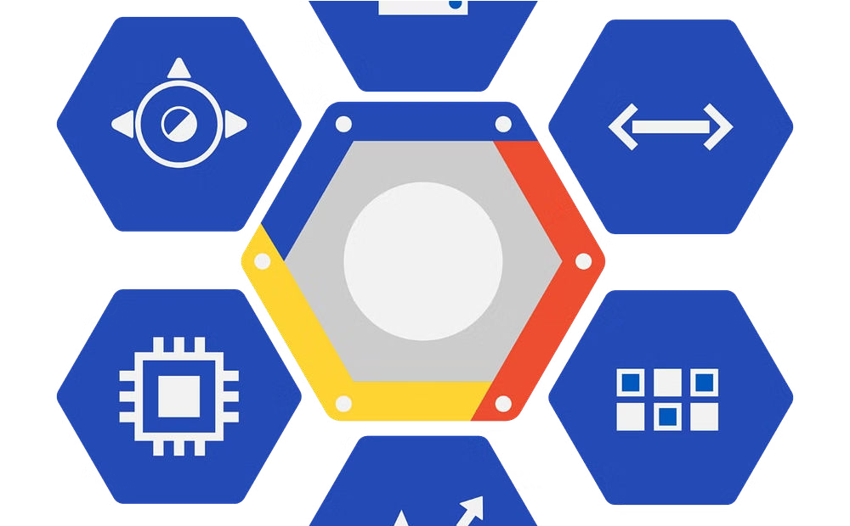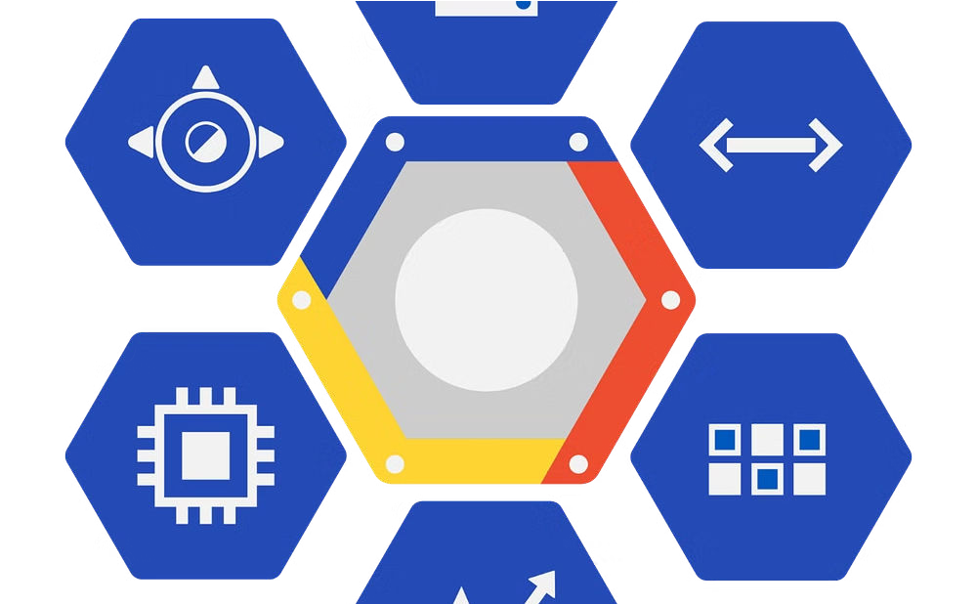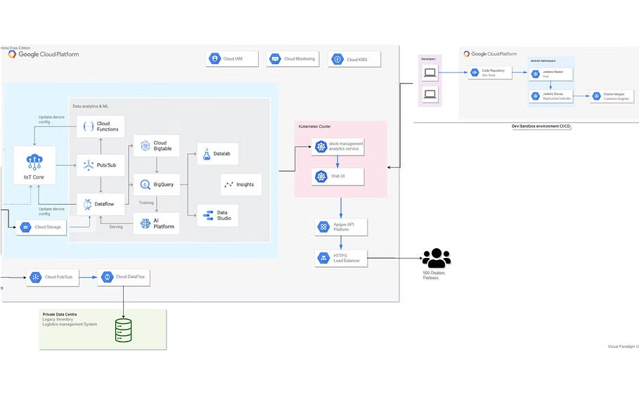

**Data Analytics Transformation**

Company X, a global retail giant, leveraged Google Cloud for its big data and machine learning needs. By utilizing Google Cloud's advanced analytics tools, Company X was able to gain valuable insights into customer behavior, preferences, and market trends. This led to targeted marketing strategies, personalized recommendations, and improved operational efficiency.

**AI-Powered Predictive Maintenance**

Company Y, a leading manufacturing firm, implemented Google Cloud to harness the power of machine learning for predictive maintenance. By analyzing massive volumes of sensor data, they utilized Google Cloud's machine learning capabilities to predict equipment failures, optimize maintenance schedules, and minimize downtime, resulting in substantial cost savings and increased productivity.

**Healthcare Data Insights** Company Z, a healthcare organization, utilized Google

Cloud to unlock critical

insights from big data and machine learning models. By securely processing and analyzing sensitive patient data, they were able to enhance clinical decision- making, detect patterns in disease outbreaks, and improve patient outcomes, demonstrating the transformative potential of Google Cloud in the healthcare sector.

**Limitations of Google Cloud for Big Data and Machine Learning**

While Google Cloud offers a robust infrastructure for big data and machine learning, it does have certain limitations that organizations should consider. One of the primary drawbacks is the complexity of its pricing model, which can be challenging to navigate without careful planning and budgeting. Additionally, the integration of Google Cloud with on-premises systems may require significant effort, especially for legacy applications.

Another limitation is the dependency on network connectivity, as real-time access to large datasets and machine learning models relies heavily on the quality and speed of the network. Furthermore, while Google Cloud provides extensive tools for machine learning, some organizations may find that the platform lacks certain specialized features or niche capabilities that are available on other cloud platforms.

Moreover, data residency and compliance requirements can pose challenges, especially for organizations operating in highly regulated industries or regions with strict data sovereignty laws. Finally, while Google Cloud has made significant strides in enhancing its security measures, some enterprises may have specific security needs that require additional customization beyond the standard offerings.

It's important for businesses to carefully evaluate these limitations in the context of their specific use cases and organizational requirements to make informed decisions regarding the adoption of Google Cloud for big data and machine learning initiatives.

Query: "limitations of cloud technology"

**Future Developments in Google Cloud for Big Data and Machine Learning**

**Enhanced Data Processing**



**1**

**2**

**3**

In the future, Google Cloud aims to enhance its capabilities for processing massive volumes of data at higher speeds. This will involve the development of more efficient algorithms and technologies to optimize the processing of unstructured data, such as images, videos, and audio files. The goal is to provide users with faster insights and analytics from their big data sets.

**AI-Driven Automation**

Google Cloud is committed to leveraging artificial intelligence (AI) to drive automation in the management and analysis of big data. The future development involves creating AI-powered tools that can automate data preparation, model training, and result interpretation, ultimately streamlining the entire machine learning process.

**Integration of Quantum Computing**

Looking ahead, Google Cloud is exploring the integration of quantum computing capabilities to address the complex computational demands of big data and machine learning. By harnessing the power of quantum algorithms, Google aims to unlock new frontiers in data processing, analysis, and predictive modeling, pushing the boundaries of innovation in the cloud computing industry.

**Conclusion and Recommendations for Using Google Cloud for Big Data and Machine Learning**

**Data Integration and Processing**

**1**

Google Cloud provides seamless integration and efficient processing capabilities for big data, enabling organizations to handle massive datasets with ease. Its Dataflow and Dataproc services offer scalable and cost-effective solutions for data processing needs.

**Advanced Machine Learning Tools**

With Google Cloud's AI and ML services, businesses can leverage advanced machine learning tools such as AutoML, TensorFlow, and AI Platform to develop and deploy sophisticated models for predictive analytics and pattern recognition.

**2**

**Case studies of successful implementations of AI-based software in Google Cloud**

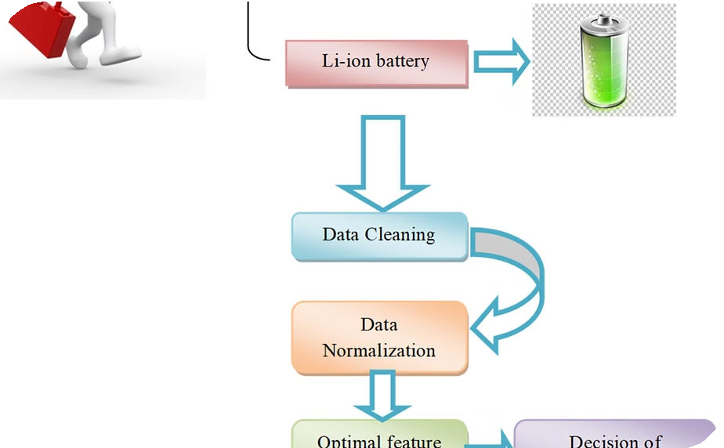

**AI in Medical Diagnosis**

AI-based software in Google Cloud has revolutionized medical diagnosis by providing accurate and efficient analysis of medical images such as X- rays, MRIs, and CT scans. This technology has significantly reduced the margin of error in identifying diseases and abnormalities, leading to better patient outcomes and faster treatment decisions.

**AI in Predictive Maintenance**

Google Cloud's AI-based software has been effectively utilized for predictive maintenance in industrial equipment. By analyzing sensor data and machine learning algorithms, companies have been able to predict equipment failures, optimize maintenance schedules, and minimize downtime, resulting in substantial cost savings and improved operational efficiency.

**AI in Customer Service**

Businesses have successfully integrated AI-based software in Google Cloud to enhance customer service. Through AI- driven chatbots and virtual assistants, organizations have achieved round-the-clock customer support, personalized interactions, and efficient issue resolution, leading to elevated customer satisfaction and loyalty.

**Challenges and Considerations when using AI-based Software in Google Cloud**

Implementing AI-based software in Google Cloud presents several challenges and considerations that organizations need to navigate effectively. One of the key challenges is ensuring the ethical and responsible use of AI, especially in sensitive areas such as healthcare and finance. This involves creating robust governance frameworks and compliance measures to address issues related to data privacy, transparency, and fairness.

Furthermore, the complexity of AI model development and deployment requires skilled talent and resources, which can be a significant hurdle for many organizations. Additionally, managing the scalability and computational requirements of AI workloads in the cloud environment demands careful planning and resource optimization to control costs and maintain performance.

Another crucial consideration is the need for continuous monitoring and evaluation of AI models to ensure accuracy, reliability, and security. This involves implementing robust testing and validation processes to identify and mitigate biases, errors, and security vulnerabilities that could impact the effectiveness of AI solutions.

Moreover, organizations must address the potential impact of AI on the workforce and employment landscape. This entails reskilling and upskilling employees to work alongside AI systems and evaluating the broader societal implications of AI adoption.

**Conclusion and Next Steps for Leveraging AI-based Software in Google Cloud**

**Continuous Learning and Adaptation** As technology evolves, it's essential to stay updated with the latest advancements in

AI-based software within Google Cloud.

This involves participating in seminars, webinars, and industry events to learn about new tools, techniques, and best practices.

**Collaboration with Data Scientists and Engineers**

Building a collaborative environment between data scientists, machine learning engineers, and cloud architects is crucial for successful AI adoption in Google Cloud. This collaboration fosters innovation and enables the integration of cutting-edge AI technologies into business operations

**Introduction to Google Cloud**

Google Cloud is a suite of cloud computing services offered by Google, providing a range of infrastructure and platform services for developers, businesses, and enterprises. It offers solutions for data storage, analytics, machine learning, networking, and more. With Google Cloud, users can leverage the power of Google's infrastructure to build, deploy, and scale applications and services, enhancing efficiency, flexibility, and innovation.

As a leading player in the cloud computing industry, Google Cloud empowers businesses to drive digital transformation, optimize processes, and gain competitive advantages. From startups to established corporations, Google Cloud provides the tools and resources needed to accelerate growth and achieve strategic goals through scalable and reliable cloud solutions.

**Benefits of using Google Cloud for businesses**

**Scalability**

Google Cloud offers businesses the ability to effortlessly scale resources up or down based on demand. This means companies can quickly adapt to changing needs without the hassle of physical hardware upgrades or downgrades. As a result, businesses can save on infrastructure costs and ensure optimal performance at all times.

**Cost-Efficiency**

By leveraging Google Cloud, businesses can reduce capital expenses on hardware and infrastructure. With pay-as-you-go pricing models, companies only pay for the resources they use, resulting in significant cost savings. Moreover, the cloud eliminates the need for on-premises data centers, saving on maintenance and operational expenses.

**Data Security**

Google Cloud provides robust security measures to safeguard sensitive business data. From encryption at rest and in transit to identity and access management, businesses can trust that their critical information is protected from unauthorized access and cyber threats. This enhances customer trust and helps companies comply with industry regulations.

**Overview of AI-based software in Google Cloud**

**Definition:** AI-based software in Google Cloud refers to the suite of artificial intelligence and machine learning tools and services offered by Google Cloud Platform (GCP).

**Capabilities:** These tools enable developers and data scientists to build, train, and deploy machine learning models at scale, leveraging Google's advanced infrastructure and algorithms.

**Applications:** AI-based software in Google Cloud finds applications in diverse domains such as healthcare, finance, retail, and manufacturing, empowering businesses to extract insights and drive innovation.

**Integration:** The seamless integration of AI-based software with other GCP services allows for end-to-end development and deployment of AI solutions.

**Use cases of AI-based software in Google Cloud**

**Enhanced Customer Support**



**1**

**2**

**3**

AI-based software in Google Cloud can be utilized to provide enhanced customer support through intelligent chatbots and virtual assistants. These tools can efficiently handle customer inquiries, provide personalized support, and even automate certain processes, leading to improved customer satisfaction and operational efficiency.

**Intelligent Data Analysis**

Another prominent use case involves leveraging AI-based software for intelligent data analysis. Businesses can harness the power of machine learning algorithms and data visualization tools to gain valuable insights from large datasets. This can lead to informed decision-making, predictive analytics, and the identification of trends and correlations that might be otherwise overlooked.

**Smart Recommendation Systems**

AI-based recommendation systems in Google Cloud can enable businesses to offer personalized product or content recommendations to their customers. These systems analyze user behavior and preferences to provide tailored suggestions, enhancing the overall user experience and potentially increasing engagement and conversions.

**Ke****y features and capabilities of AI-based software in Google Cloud**

Google Cloud's AI-based software offers a wide range of key features and capabilities that empower businesses to unlock the full potential of artificial intelligence. One of the standout features is the integration of pre-trained machine learning models, allowing developers to effortlessly leverage state-of-the-art algorithms for various tasks such as image and speech recognition, natural language processing, and more.

Furthermore, the AI platform provides advanced tools for data analysis and visualization, enabling organizations to derive meaningful insights from their datasets and make data-driven decisions. The seamless scalability and flexibility of Google Cloud's AI-based software make it a compelling choice for businesses of all sizes. Additionally, the platform's robust security measures ensure the protection and privacy of sensitive data, instilling trust and confidence in users.

Moreover, Google Cloud's AI solutions boast powerful automation capabilities, streamlining complex processes and reducing manual effort. The platform's support for deep learning frameworks like TensorFlow and Keras empowers developers to build and train custom models tailored to their unique requirements, fostering innovation and creativity in AI development.

It's important to highlight the continuous advancements in AI research and development by Google, ensuring that the AI-based software in Google Cloud remains at the forefront of technological innovation. These ongoing improvements further solidify Google Cloud's position as a leading provider of AI solutions, delivering cutting-edge features and capabilities to drive transformative outcomes for businesses.

**How to Integrate AI-Based Software in Google Cloud**

Integrating AI-based software in Google Cloud requires a strategic approach to leverage the full potential of artificial intelligence for your business. One of the fundamental steps is to assess your current infrastructure and identify the areas where AI can bring transformative value. Understanding the specific business use cases and the data requirements is crucial for successful integration.

In addition, Google Cloud offers a range of AI-based tools and services, such as machine learning APIs, AI Platform, and AutoML, that can be seamlessly integrated into your existing workflows. It's essential to evaluate these offerings and choose the ones that align with your business objectives and technical capabilities.

Furthermore, a well-defined integration strategy should include considerations for data governance, security, and compliance. Building robust data pipelines, implementing model governance frameworks, and ensuring ethical AI practices are integral parts of the integration process.

**Best Practices for Using AI-based Software in Google Cloud**

**Security First:** When using AI-based software in Google Cloud, prioritize security measures to protect sensitive data and ensure compliance with privacy regulations. Implement encryption, access controls, and regular security audits to maintain a secure environment.

**Optimize Workflows:** Streamline business processes by integrating AI-based software with existing systems. Identify repetitive tasks that can be automated to improve efficiency and free up employees for more strategic initiatives.

**Continuous Monitoring:** Establish monitoring and alerting systems to track the performance of AI models and detect anomalies. Regularly review and update the models to ensure accuracy and effectiveness in decision-making.

**Collaborative Approach:** Foster collaboration between data scientists, engineers, and business stakeholders to develop AI solutions that align with organizational goals and requirements.

Encourage cross-functional teams to work together towards successful AI implementations.

**Ethical Considerations:** Address ethical considerations related to AI by promoting transparency, fairness, and accountability. Develop clear guidelines for the responsible use of AI-based software to mitigate potential biases and ensure ethical decision-making.

**Case studies of successful implementations of AI-based software in Google Cloud**



**AI in Medical Diagnosis**

AI-based software in Google Cloud has revolutionized medical diagnosis by providing accurate and efficient analysis of medical images such as X- rays, MRIs, and CT scans. This technology has significantly reduced the margin of error in identifying diseases and abnormalities, leading to better patient outcomes and faster treatment decisions.

**AI in Predictive Maintenance**

Google Cloud's AI-based software has been effectively utilized for predictive maintenance in industrial equipment. By analyzing sensor data and machine learning algorithms, companies have been able to predict equipment failures, optimize maintenance schedules, and minimize downtime, resulting in substantial cost savings and improved operational efficiency.

**AI in Customer Service**

Businesses have successfully integrated AI-based software in Google Cloud to enhance customer service. Through AI- driven chatbots and virtual assistants, organizations have achieved round-the-clock customer support, personalized interactions, and efficient issue resolution, leading to elevated customer satisfaction and loyalty.

**Challenges and Considerations when using AI-based Software in Google Cloud**

Implementing AI-based software in Google Cloud presents several challenges and considerations that organizations need to navigate effectively. One of the key challenges is ensuring the ethical and responsible use of AI, especially in sensitive areas such as healthcare and finance. This involves creating robust governance frameworks and compliance measures to address issues related to data privacy, transparency, and fairness.

Furthermore, the complexity of AI model development and deployment requires skilled talent and resources, which can be a significant hurdle for many organizations. Additionally, managing the scalability and computational requirements of AI workloads in the cloud environment demands careful planning and resource optimization to control costs and maintain performance.

Another crucial consideration is the need for continuous monitoring and evaluation of AI models to ensure accuracy, reliability, and security. This involves implementing robust testing and validation processes to identify and mitigate biases, errors, and security vulnerabilities that could impact the effectiveness of AI solutions.

Moreover, organizations must address the potential impact of AI on the workforce and employment landscape. This entails reskilling and upskilling employees to work alongside AI systems and evaluating the broader societal implications of AI adoption.

**Conclusion and Next Steps for Leveraging AI-based Software in Google Cloud**

**Continuous Learning and Adaptation** As technology evolves, it's essential to stay updated with the latest advancements in

AI-based software within Google Cloud.

This involves participating in seminars, webinars, and industry events to learn about new tools, techniques, and best practices.

**Collaboration with Data Scientists and Engineers**

Building a collaborative environment between data scientists, machine learning engineers, and cloud architects is crucial for successful AI adoption in Google Cloud. This collaboration fosters innovation and enables the integration of cutting-edge AI technologies into business operations.

**Data Privacy and Ethical Use of AI**

Responsible and ethical use of AI-based software is paramount. Organizations need to implement robust privacy measures and ethical guidelines to ensure that the use of AI in Google Cloud complies with regulations and prioritizes user privacy and data security.

**Measuring and Demonstrating ROI**

It's crucial to establish key performance indicators (KPIs) to measure the impact of AI-based software on business outcomes. This involves robust data analytics to demonstrate the return on investment and the value brought by AI applications in Google Cloud.