CMOS 2-Input NOR Gate
New Final Technical Characterization
LTspice 26.0.2 • 5 V • 50 fF • 0–100 ns
Verified run: 28 September 2026, 16:12:46

CMOS 2-Input NOR Gate — New Final Technical Characterization

1. Circuit Configuration
Parameter | New Final Value
Supply voltage, VDD | 5 V
Output load, CL | 50 fF
PMOS M1/M2 | W = 8 µm, L = 1 µm
NMOS M3/M4 | W = 2 µm, L = 1 µm
Input A | PULSE(0 5 10 ns 1 ns 1 ns 40 ns 1 µs)
Input B | 0 V DC
Transient window | 0–100 ns
Maximum timestep | 10 ps
Simulator | LTspice 26.0.2

2. CMOS Architecture
The 2-input NOR gate uses two PMOS transistors in series in the pull-up network and two NMOS transistors in parallel in the pull-down network.
The circuit implements:
Y = ¬(A + B)
The series PMOS network conducts only when both A and B are low. The parallel NMOS network conducts whenever either A or B is high.
A | B | Y
0 | 0 | 1
0 | 1 | 0
1 | 0 | 0
1 | 1 | 0

3. Latest Input Stimulus
The new NOR uses:
Vin_A = PULSE(0 5 10ns 1ns 1ns 40ns 1us)
Input B is fixed at 0 V.
This means the first rising transition of A occurs at 10 ns and the first falling transition occurs at approximately 51 ns, which matches the propagation-delay measurement intervals in the supplied LTspice log.

4. Transient Simulation
The final simulation uses:
- Start time: 0 ns
- Stop time: 100 ns
- Maximum timestep: 10 ps
- Supply: 5 V
- Load: 50 fF
LTspice successfully converged to the operating point and completed the transient simulation.

5. Device Models
The simulation uses Level-1 MOS models:
- NMOS: VTO = 0.7 V, KP = 20 µA/V², LAMBDA = 0.04
- PMOS: VTO = −0.7 V, KP = 10 µA/V², LAMBDA = 0.05
LTspice reported that the W/L dimensions of M1–M4 are shorter/narrower than recommended for the selected Level-1 model. These warnings did not prevent successful simulation.

6. Propagation Delay
The propagation-delay measurements use the 50% VDD threshold:
VTH = VDD/2 = 2.5 V

6.1 High-to-Low Delay
tpHL = 0.535308 ns = 535.308 ps
Measured from:
10.500000 ns → 11.035308 ns

6.2 Low-to-High Delay
tpLH = 0.424656 ns = 424.656 ps
Measured from:
51.500000 ns → 51.924656 ns

6.3 Average Propagation Delay
tp(avg) = (tpHL + tpLH)/2
tp(avg) = 0.479982 ns = 479.982 ps
The ratio:
tpHL/tpLH ≈ 1.261
Therefore, the falling transition takes approximately 26.1% longer than the rising transition under this exact simulation configuration.

7. Power Characterization
The latest LTspice log reports:
avg_power = -1.32487182873e-05 W FROM 0 TO 1e-07
The negative sign results from the current reference direction of the voltage source. Using the magnitude as consumed supply power:
Pavg = 13.248718 µW
The power measurement uses exactly the same 0–100 ns interval as the transient simulation.

8. Energy Characterization
For the actual 100 ns measurement window:
E = Pavg × T
E = 13.248718 µW × 100 ns
E = 1.324872 pJ
This is the integrated supply energy over the complete 0–100 ns simulation window. It should not be described as the energy of one isolated switching transition.

9. Peak Current
The latest LTspice run reports:
MAX(I(Vdd)) = -2.63874620939e-12 A
Therefore:
|Ipeak| = 2.638746 pA
The peak-current measurement is also evaluated over 0–100 ns.

10. Technical Interpretation
The NOR2 topology has a series PMOS pull-up path. Two PMOS devices must conduct simultaneously to charge the output, increasing effective pull-up resistance. The PMOS width of 8 µm is therefore larger than the 2 µm NMOS width and compensates for the series structure and lower PMOS mobility.
The NMOS devices are parallel. When input A becomes high, M3 can discharge the output directly while M4 remains off because B is fixed at 0 V.
This produces the measured asymmetric delays:
- tpHL = 535.308 ps
- tpLH = 424.656 ps

11. Final Verified Results
Metric | New NOR2 Result
VDD | 5 V
CL | 50 fF
PMOS W/L | 8 µm / 1 µm
NMOS W/L | 2 µm / 1 µm
Transient window | 100 ns
Maximum timestep | 10 ps
tpHL | 0.535308 ns
tpLH | 0.424656 ns
Average delay | 0.479982 ns
Average power | 13.248718 µW
Integrated energy, 0–100 ns | 1.324872 pJ
Peak-current magnitude | 2.638746 pA

12. Figure Placement
Figure 1 — New NOR2 CMOS Schematic: place immediately after the architecture subsection.
Figure 2 — New NOR2 Transient Waveform: place immediately after the transient-simulation subsection and before the propagation-delay calculations.
The waveform should be connected directly to the 2.5 V crossing measurements used to obtain tpHL and tpLH.

13. Important Comparison Note
The new NOR2 timing simulation is now internally consistent: the transient simulation, average-power measurement, and peak-current measurement all use the 0–100 ns interval.
For comparison with the inverter and NAND2, the common timing framework is:
- VDD = 5 V
- CL = 50 fF
- transient window = 100 ns
- maximum timestep = 10 ps
- propagation-delay threshold = 2.5 V
However, the input pulse configuration and inactive-input conditions should still be reported explicitly because switching activity is not necessarily identical across the three logic gates.

14. Conclusion
The new LTspice characterization successfully demonstrates the 2-input CMOS NOR gate using the final 5 V, 50 fF configuration. The measured high-to-low delay is 0.535308 ns, the low-to-high delay is 0.424656 ns, and the average propagation delay is 0.479982 ns.
The latest run reports an average supply-power magnitude of 13.248718 µW over the 0–100 ns simulation interval. The corresponding integrated supply energy is 1.324872 pJ. The peak-current magnitude is 2.638746 pA.
These results are specific to the selected Level-1 MOS models, transistor dimensions, load capacitance, input stimulus, and simulation settings. LTspice also reports geometry-related warnings for the selected Level-1 devices, which should be retained in the formal project documentation.

Figure 1 — New NOR2 CMOS Schematic
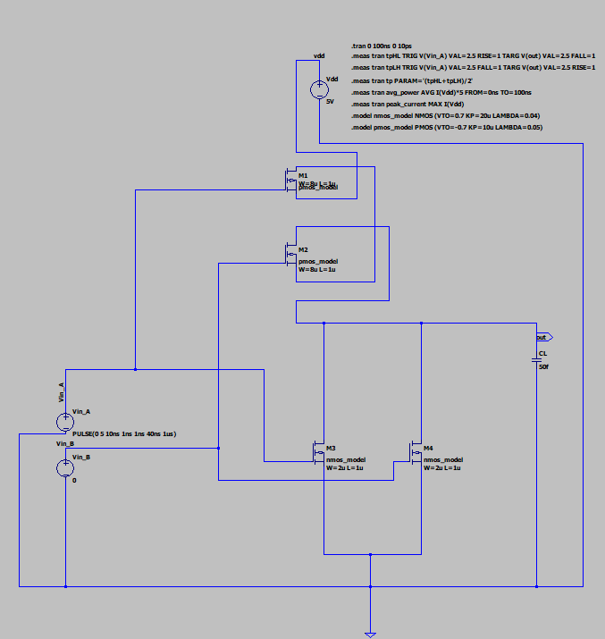
Transistor-level CMOS 2-input NOR gate using series PMOS and parallel NMOS networks.

