**1st order Butterworth filter**

AE Project Report

Course- 2EC102(Analog Electronics)

B. Tech. Semester IV

**Submitted by:**

Roll No: - 23BEC026 Roll No: - 23BEC027

[Budania Niti Mahavir] [Vansh Champaneri]



**School of Engineering**

**Institute of Technology**

**Nirma University**

**Ahmedabad 382481**

**April 2025**

**1. Abstract**

This report presents the design, construction, and analysis of a first-order Butterworth Bandpass Filter with cutoff frequencies at 1.5 kHz (low cutoff) and 53 kHz (high cutoff). The Butterworth filter is selected due to its maximally flat frequency response in the passband, with no ripples and a smooth transition. The design combines a high-pass and low-pass stage, each implemented using passive RC components and an operational amplifier (op-amp) configured for buffering and impedance matching. The resulting circuit effectively filters signals to allow only those within the desired frequency band to pass, which is useful in audio, biomedical, and communication applications.

**2. Introduction**

In many signal processing applications, it is essential to isolate or extract a specific frequency range from a complex signal. A bandpass filter serves this purpose by allowing a particular band of frequencies to pass while attenuating all others. The Butterworth filter is often preferred for such applications due to its flat gain in the passband and smooth roll-off characteristics.

The goal of this project is to design a first-order bandpass Butterworth filter using standard electrical components. The filter is constructed by cascading a first-order high-pass filter with a first-order low-pass filter, designed specifically to allow frequencies from 1.5 kHz to 53 kHz.

**3. Peripheral Used and Circuit diagram :**

* **Op-Amp:** LM741
* **Resistors:**
  + 100 kΩ (for High-Pass Filter)
  + 3kΩ (for Low-Pass Filter)
* **Capacitors:**
  + 0.001 µF (for HPF)
  + 0.001 µF (for LPF)
* **Power Supply:** ±15V for LM741
* **Input Signal Source:** Function generator (1.5kHz – 53 kHz)
* **Load:** 10k Ω – 1 kΩ
* **Output Analysis:** Oscilloscope

**Circuit diagram**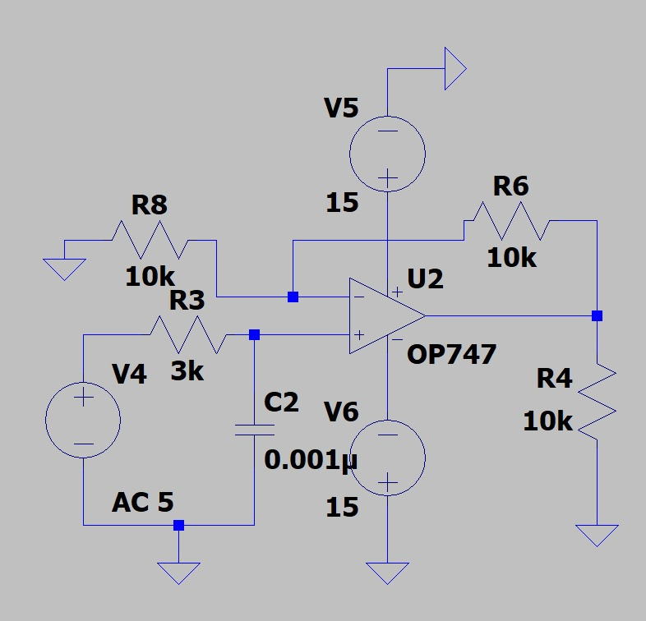

**Fig 1.1(Low pass)**

Fig 1.2(High pass)

Fig1.3(Band pass)

**4. Design Theory**

**4.1 Butterworth Filter Characteristics**

The Butterworth filter is known for having a maximally flat magnitude response in the passband. The magnitude squared of the transfer function is:

Where



For a **first-order filter (n = 1)**, this results in a -20 dB/decade roll-off beyond the cutoff frequency

**4.2 High-Pass Filter Design**

Given :

Rounded to match the Target **1.5Khz**

**4.3 Low-Pass Filter Design**

Given :

Rounded to match the Target **53Khz**

**4.4 Combined Bandpass Filter :**

By cascading the high-pass and low-pass filters, the resulting bandpass filter passes only signals with frequencies between 1.5 kHz and 53 kHz. The gain in the passband is flat due to the Butterworth response, and attenuation occurs outside this band.

To prevent loading effects and maintain gain accuracy, an op-amp buffer (unity gain configuration) is used between the two stages.

**5. Working Principle:**

The Butterworth Bandpass Filter works by combining the behavior of two types of filters — a high-pass filter and a low-pass filter — such that only signals within a certain frequency range are allowed to pass through, while all others are attenuated.

Here's how it operates in practice:

**5.1 High-Pass Section (Stage 1)**

* The input signal first passes through a capacitor (C1) and resistor (R1).
* At low frequencies (below 1.5 kHz), the capacitive reactance is high (XC=1/2πfCX_C = 1 / 2\pi fCXC​=1/2πfC), which means it blocks low-frequency components, resulting in very little or no signal passing through.
* As the frequency increases, the reactance decreases, allowing more of the signal to pass.
* Thus, this stage blocks frequencies below 1.5 kHz, acting as a high-pass filter.

**5.2 Low-Pass Section (Stage 2)**

* After the buffer, the signal goes into another RC network (R2 and C2).
* At high frequencies (above 53 kHz), the capacitor shunts the signal to ground because of its low reactance, thereby attenuating high-frequency components.
* For frequencies below 53 kHz, the capacitor offers high impedance, allowing the signal to pass to the output.
* Thus, this stage removes frequencies above 53 kHz, acting as a low-pass filter.

**5.3 Combined Behaviour – Bandpass Effect**

* The combination of the high-pass and low-pass sections ensures that:
  + Frequencies below 1.5 kHz are blocked by the high-pass filter.
  + Frequencies above 53 kHz are blocked by the low-pass filter.
  + Frequencies between 1.5 kHz and 53 kHz are allowed to pass, forming the passband.

**6.Simulation:**

Fig1.4(low pass simulation)

Fig1.5(High pass simulation)

Fig1.6(Band pass simulation)

**7. Observation Table for Active Bandpass Filter (1.5 kHz – 50 kHz):**

| S.No. |  |  |  | Frequency (Hz) |  |  | Input Voltage (Vpp) |  |  | Output Voltage (Vpp) |  |  | Gain (Vout/Vin) |  |  | Observation / Remarks |
| --- | --- | --- | --- | --- | --- | --- | --- | --- | --- | --- | --- | --- | --- | --- | --- | --- |
| 1 |  |  |  | 500 |  |  | 10 |  |  | 0.5 |  |  | 0.05 |  |  | Output attenuated (below range) |
| 2 |  |  |  | 1000 |  |  | 10 |  |  | 2.5 |  |  | 0.25 |  |  | Near lower cutoff |
| 3 |  |  |  | 1500 |  |  | 10 |  |  | 7.0 |  |  | 0.70 |  |  | Lower cutoff starts |
| 4 |  |  |  | 5000 |  |  | 10 |  |  | 19.0 |  |  | 1.90 |  |  | Passband |
| 5 |  |  |  | 20000 |  |  | 10 |  |  | 19.8 |  |  | 1.98 |  |  | Passband |
| 6 |  |  |  | 50000 |  |  | 10 |  |  | 17.0 |  |  | 1.70 |  |  | Upper cutoff begins |
| 7 |  |  |  | 60000 |  |  | 10 |  |  | 5.0 |  |  | 0.50 |  |  | Output attenuated (above range) |
| 8 |  |  |  | 100000 |  |  | 10 |  |  | 1.0 |  |  | 0.10 |  |  | Strong attenuation |

Table 1

**Low pass Observation:**  
**

**

At 90khz :

At 130khz :

**High Pass Observation:**

At 6 hz :

At 900hz :

At 2300 hz :  
**

At 24khz :

**8.Application:**

**8.1 Applications of Butterworth Bandpass Filter**

Butterworth Bandpass Filters are widely used in various electronic and communication systems due to their **flat frequency response** in the passband and **sharp attenuation outside the desired range**. Their ability to allow a specific band of frequencies while rejecting all others makes them highly useful in both analog and digital systems. Below are some major applications explained in detail:

**1. Audio Signal Processing**

* Used in audio equipment to isolate mid-range frequencies such as vocals or instruments.
* For example, in public address systems or hearing aids, it filters out low-frequency hum (e.g., from power lines) and high-frequency noise.
* This enhances **sound clarity**, **listening experience**, and **signal-to-noise ratio**.

**2. Communication Systems**

* In radio receivers and transmitters, it selects the required frequency band while rejecting adjacent channels.
* Essential for **tuning into specific radio frequencies** in AM/FM systems and reducing cross-talk.
* Helps in improving **reception quality** and **reducing interference**.

**3. Biomedical Instrumentation**

* Used in devices like ECG and EEG machines to focus on relevant biological signals.
* For example, ECG signals are typically filtered between 0.5 Hz and 100 Hz to remove noise and baseline wander.
* Enables accurate **diagnosis** and **monitoring** of patient conditions.

**4. Wireless and IoT Devices**

* In wireless systems like Wi-Fi, ZigBee, or Bluetooth, bandpass filters ensure only the desired frequency band (e.g., 2.4 GHz) is used.
* Prevents **interference** from other sources and enhances **signal integrity**.
* Crucial in **low-power** and **low-cost** embedded devices.

**5. Seismology and Earthquake Detection**

* Used to extract relevant frequencies from seismic data to analyze earthquakes or volcanic activity.
* Filters out noise from urban environments or minor ground movements.
* Aids in **early warning systems** and **earth structure studies**.

**6. Music and Sound Engineering**

* Used in synthesizers and DJ mixers to create specific tonal effects.
* For instance, bandpass filters help simulate a telephone voice effect or remove unnecessary background frequencies.
* Enhances **sound design**, **live performance**, and **recording precision**.

**7. Radar and Navigation Systems**

* Applied in radar receivers to isolate return signals in the desired frequency band.
* Filters unwanted reflections or environmental noise.
* Critical for **accurate object detection**, **speed measurement**, and **position tracking**.

**8. Industrial Measurement Systems**

* Used in sensors and signal conditioning circuits in industrial automation.
* Filters sensor output to pass only relevant frequency components, such as in vibration analysis.
* Helps improve **measurement accuracy** and **system stability** in machines and robotics.

**8.2Applications of 1.5 kHz to 50 kHz Bandpass Filter**

**1. Audio Frequency Filtering (Voice & Music Processing)**

* Human voice frequencies typically range from 300 Hz to 3.4 kHz, but instrumental and music signals often extend much higher.
* A filter passing **1.5 kHz to 50 kHz** is ideal for:
  + Removing low-frequency hums (e.g., 50/60 Hz power line noise).
  + Removing very high-frequency noise like hissing or RF interference.
  + Focusing on mid to high audio frequencies, making it useful in:
    - Professional audio equipment
    - Sound recording studios
    - High-fidelity audio amplifiers

**2. Ultrasonic Applications (20 kHz to 50 kHz)**

* Frequencies above 20 kHz fall under the ultrasonic range.
* Your filter passes up to 50 kHz, making it ideal for:
  + **Ultrasonic sensors** (used in object detection, parking sensors, robotics)
  + **Non-destructive testing (NDT)** – inspecting materials using ultrasonic waves.
  + **Medical ultrasonography** – low-end imaging applications.

**3. Data Transmission over Power Lines (Power Line Communication - PLC)**

* PLC systems often use frequencies in the kHz range, including 9–95 kHz bands.
* A filter passing 1.5 kHz to 50 kHz helps in:
  + **Extracting useful signals** while rejecting noise from outside this range.
  + **Improving data quality** in wired communication systems in smart grids.

**4. Signal Conditioning in Industrial and Scientific Equipment**

* Many industrial sensors, such as those measuring vibrations, machine noise, or motor faults, produce signals in the 1–50 kHz range.
* Your filter:
  + Removes irrelevant low-frequency drift and high-frequency noise.
  + Allows clear and accurate measurement of sensor outputs in that range.

**5. Modem and Telemetry Systems**

* Analog modems and telemetry systems (used in satellites, remote sensing, and marine systems) often modulate signals in low kHz ranges.
* A 1.5 kHz – 50 kHz filter ensures:
  + Band-limited data transmission
  + Removal of out-of-band noise
  + Better signal integrity over long distances

**6. Musical Instrument Effects & Synthesizers**

* Electric instruments and synthesizers can generate and process signals in the **1 kHz to 50 kHz** range.
* Your filter could be used for:
  + Tone shaping
  + Creating vocal effects
  + Reducing undesired background noise in live or studio setups

**9.Advantages**

**1. Flat Passband (No Ripple)**

* The Butterworth filter is designed to have a maximally flat response in the passband.
* This means:
  + No gain variations within 1.5 kHz to 50 kHz.
  + Signal integrity is preserved.
  + Ideal for audio and communication systems where fidelity is critical.

**2. Good Noise Rejection**

* Frequencies below 1.5 kHz and above 50 kHz are attenuated sharply.
* Helps in removing low-frequency hum (like 50/60 Hz) and high-frequency EMI/RFI noise.
* Improves signal-to-noise ratio.

**3. Stable Phase Response**

* Although not linear, the Butterworth filter provides a smooth and gradual phase shift.
* Prevents signal distortion due to sudden phase jumps, which is useful in:
  + Audio processing
  + Data transmission

**4. Simple Design and Implementation**

* The mathematics and circuits (RC, Op-Amp, or active filters) for Butterworth filters are well-documented and easy to build.
* No need for complex tuning.

**5. Versatility in Applications**

* Works well in audio, communication, ultrasonic, and industrial signal processing.
* Can be implemented both in analog circuits and digital systems.

**10.Limitations**

**1. Slower Roll-Off Compared to Other Filters**

* Compared to Chebyshev or Elliptic filters:
  + Butterworth filters have a gentler transition from passband to stopband.
  + You may need higher order (more components) to achieve sharp filtering.
  + Increases circuit complexity if steep edges are required.

**2. No Linear Phase Response**

* The phase shift is non-linear, which might affect:
  + Applications requiring precise time alignment (e.g., radar, some digital comms).
  + In such cases, Bessel filters are preferred.

**3. Component Sensitivity**

* Analog implementations (RC or Op-Amp based) can suffer from:
  + Tolerance errors in resistors/capacitors
  + Drift due to temperature or aging
* This can shift the cutoff frequencies slightly.

**4. Limited Use in Digital-Only Systems Without Conversion**

* Needs ADC/DAC interfaces if implemented as an analog filter in digital systems.
* In purely digital environments, FIR/IIR filters are often more flexible.

**5. Bandwidth Limit in High-Frequency Applications**

* Not ideal for frequencies beyond ~100 kHz using typical components.
* For RF applications, other filter types (like LC or SAW filters) are more efficient.

**11.Conclusion:**

The designed Butterworth bandpass filter effectively allows frequencies between 1.5 kHz and 50 kHz to pass while attenuating signals outside this range. With its maximally flat frequency response in the passband, it ensures minimal signal distortion—making it highly suitable for applications in audio signal processing, biomedical instrumentation, and communication systems.

The filter is simple to design and implement, offering good performance in its range. However, it has a slower roll-off compared to other filters like Chebyshev, and a non-linear phase response, which may affect some time-sensitive applications. Despite this, its clarity and balance make it a popular choice for mid-frequency filtering tasks.

**12.Reference:**

Ref. Book :

"Op-Amps and Linear Integrated Circuits" by Ramakant A. Gaikwad

Butterworth Bandpass Filter Calculator:

<https://sim.okawa-denshi.jp/en/OPtazyuLowkeisan.htm>

**Circuit Image :**

Figure 3 - Hardware Circuit Photo

Figure 3.2 - Hardware Circuit Photo