**1st & 2nd Order Butterworth Filter:**

**Function and Application**

Institute of Technology, Nirma University, Ahmedabad

Vansh Champaneri (23BEC027) , Niti Budania (23BEC026)

**Abstract**

Filters are crucial in signal processing by either admitting or excluding certain frequency components to improve signal quality and performance. This article presents a summary of various filters, such as Butterworth, Chebyshev, Bessel, and Elliptical filters, detailing their respective characteristics and uses. Among the listed filters, the Butterworth filter is well-known for its maximally flat magnitude response to provide the least signal distortion. The focus of this study is the theory behind, construction, and execution of a 2nd-order Butterworth filter, including an examination of its frequency response and relevance in practical applications in engineering. The comparative analysis with other filters is also done to highlight its benefits and shortcomings.

**Introduction**

In signal processing, filters are an important tool used to shape and control the frequency content of signals. From audio processing to communications systems and biomedical applications, filters are used to eliminate unwanted noise, extract meaningful signal components, and improve system performance. Filters can be distinguished based on response characteristics into analog and digital filters, and active and passive filters. Of all the various filter types, frequency-selective filters are most commonly used to accept or reject given ranges of frequency.

There are four general classes of frequency-selective filters:

Low-Pass Filters (LPF): Permit low-frequency components to pass with attenuation of the higher frequencies.

High-Pass Filters (HPF): Permit high-frequency components to pass with attenuation of lower frequencies.

Band-Pass Filters (BPF): Pass a given range of frequencies and reject frequencies other than this range.

Band-Stop Filters (BSF): Block a certain frequency band and pass others.

Within these categories, filters are further grouped depending on their design method and response. Some of the most popular filter designs are Butterworth, Chebyshev, Bessel, and Elliptical filters. All these filters have unique frequency response characteristics and are therefore appropriate for different uses.

The Butterworth filter, the main topic of this paper, is especially recognized for its maximally flat passband

magnitude response that does not significantly distort signals. In contrast to the ripple in the passband or stopband found in Chebyshev and Elliptical filters, the Butterworth filter rolls off in a smooth, gradual manner. This characteristic of the Butterworth filter makes it especially ideal in applications where signal integrity must be preserved.

This paper seeks to present an in-depth analysis of the Butterworth filter, its theoretical background, mathematical derivation, and practical application. Particularly, the implementation and design of a 2nd-order Butterworth filter will be discussed, including its frequency response, circuit implementation, and applications. Through comparison with other filters, this paper will discuss its strengths and weaknesses, citing its relevance in various engineering fields.

**Types of Filters & Their Characteristics**

**1. Butterworth Filter**

* Maximally flat response (No ripples in passband or stopband).
* Moderate roll-off rate compared to other filters.
* Used in audio processing and general-purpose filtering applications.

**2. Chebyshev Filter**

**Type-I:**

* Exhibits ripples in the passband.
* Steeper roll-off than Butterworth filters.
* Suitable for applications where sharp frequency cutoffs are needed.

**Type-II:**

* Exhibits ripples in the stopband but no ripples in the passband.
* Offers a sharper roll-off than Butterworth filters.
* Used in applications where stopband characteristics are more critical.

**3. Bessel Filter**

* Focuses on maintaining a linear phase response.
* Provides the best time-domain response (minimal signal distortion).
* Slower roll-off compared to Butterworth and Chebyshev filters.
* Used in applications requiring minimal phase distortion, such as audio and biomedical signal processing.

**4. Elliptical Filter**

* Sharpest roll-off among all filter types.
* Exhibits ripples in both the passband and stopband.
* Provides the best selectivity but at the cost of increased signal distortion.
* Used in high-speed communication systems where steep cutoffs are necessary.

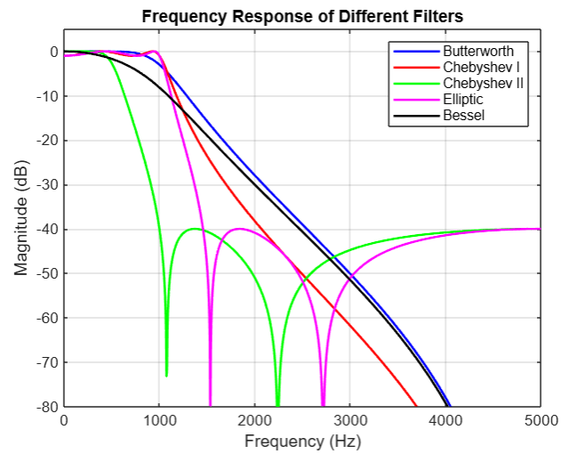

Figure 1 - Freq. Response

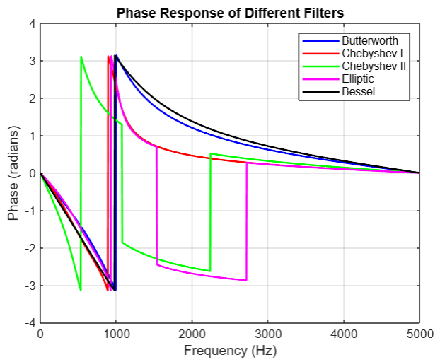

Figure 2 - Mag. Response

**Comparative Table of Filters**

Table 1 - Comparison of Filters

|  |  |  |  |  |  |
| --- | --- | --- | --- | --- | --- |
| Filter Type | Passband Flatness | Stopband Attenuation | Phase Response | Roll-Off Rate | Best Application |
| Butterworth | Flat  (No Ripples) | Moderate (-20n dB/decade) | Non-linear | Gradual | Audio Processing |
| Chebyshev-I | Ripples in Passband | Steep | Non-linear | Sharper than Butterworth | Communications |
| Chebyshev-II | Flat Passband, Stopband Ripples | Steep | Non-linear | Sharper than Butterworth | Signal Processing |
| Bessel | Flat | Poor | **Linear (Best for Time-Domain Signals)** | Slowest | Audio, Biomedical |
| Elliptical | Ripples in Both Bands | **Sharpest Roll-Off** | Worst | Steepest | RF, High-Speed Communications |

This comparison highlights the key differences in filter characteristics, helping in selecting the appropriate filter type for specific applications.

**Butterworth Filter**

The Butterworth filter is one of the most widely used filters due to its maximally flat frequency response in the passband. It was first described by Stephen Butterworth in 1930 as a design that provides a smooth and distortion-free frequency response. The key advantage of the Butterworth filter is that it has no ripples in the passband or stopband, making it ideal for applications where signal integrity is critical.

**Characteristics of the Butterworth Filter:**

1. **Maximally Flat Response:** Unlike Chebyshev or Elliptical filters, the Butterworth filter does not introduce ripples in the passband or stopband, ensuring minimal signal distortion.
2. **Gradual Roll-Off:** The transition from passband to stopband is smooth, making it less aggressive compared to other filters.
3. **Non-Linear Phase Response:** While it provides excellent magnitude characteristics, its phase response is not as linear as a Bessel filter.
4. **Defined by Order (n):** The steepness of the roll-off depends on the filter’s order. Higher-order filters provide a sharper cutoff but require more complex circuit implementation.
5. **Common in Audio & Signal Processing:** Due to its smooth response, it is widely used in audio processing, instrumentation, and analog communication systems.

**Mathematical Expression of Butterworth Filter:**

The transfer function of a Butterworth filter of order **n** is given by:

$$H\left(s\right)=\frac{1}{\sqrt{1+{(\frac{s}{wc})}^{2n}}}$$

Where:

* s is the complex frequency variable.
* wc is the cutoff frequency.
* n is the order of the filter.

For a **2nd-order Butterworth filter**, the magnitude response follows:

$${∣H(jω)∣}^{2}=\frac{1}{1+{(\frac{w}{wc})}^{4}}​$$

This equation ensures a smooth transition from passband to stopband while maintaining a maximally flat response.

**Frequency Response of Butterworth Filter:**

* The magnitude response of the Butterworth filter is flat in the passband and gradually decreases in the stopband.
* The roll-off rate is -20 dB/decade per order, meaning that a 2nd-order Butterworth filter has a roll-off rate of -40 dB/decade.
* The **-3 dB point** defines the cutoff frequency wc, where the filter starts attenuating frequencies.

**Why Choose the Butterworth Filter?**

* When signal accuracy is more important than having a sharp cutoff.
* When a smooth and stable frequency response is required.
* When minimum signal distortion is a priority, such as in audio applications and analog filtering.

**2nd-Order Butterworth Filter using Sallen-Key Topology**

The standard **low-pass** Sallen-Key Butterworth filter circuit consists of:

* Resistors: R1​ and R2​
* Capacitors: C1​ and C2​
* Operational Amplifier (Op-Amp)

**Transfer Function:**

The transfer function for the Sallen-Key low-pass filter is given by:

$$H(s)=\frac{1}{1+\frac{s}{wc}+\frac{s^{2}}{{(wc)}^{2}}}​$$

* wc​=2πfc​ is the cutoff frequency,
* Q is the quality factor, which determines damping,
* s is the Laplace transform variable.

For a **Butterworth response**, we set Q=0.707 (for a critically damped system with no overshoot).

**Cutoff Frequency Formula:**

$$fc​=\frac{1}{2π\sqrt{R1​R2​C1​C2​​}}​$$

where fc​ is the -3dB cutoff frequency.

**Zero-Plot Plot for 2nd Butterworth Filter:**

The Zero-Pole Plot provides a graphical representation of the poles and zeros of the transfer function of a filter in the complex plane. It helps in understanding the stability, frequency response, and filter characteristics.

1. **Zero-Pole Plot of 2nd-Order Butterworth Low-Pass Filter**

* The first figure represents the zero-pole plot of a low-pass Butterworth filter.
* The poles are located inside the unit circle, ensuring stability.
* A zero is placed at z=−1z = -1z=−1, which corresponds to the characteristic of a low-pass filter.
* The pole locations determine the cutoff frequency and filter response, with a smooth roll-off and a maximally flat magnitude response.

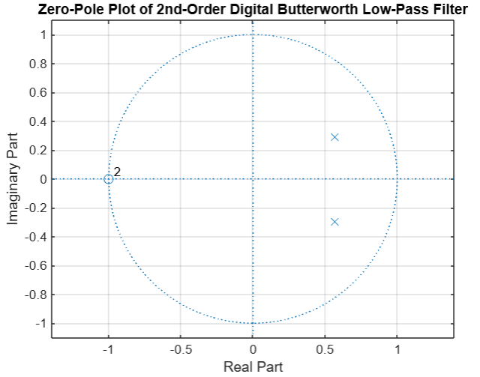

Figure 3 - Pole - Zero Analysis Low Pass filter

1. **Zero-Pole Plot of 2nd-Order Butterworth High-Pass Filter**

* The second figure represents the zero-pole plot of a high-pass Butterworth filter.
* The poles remain inside the unit circle, ensuring the system is stable.
* A zero is placed at z=1z = 1z=1, which is characteristic of a high-pass filter.
* The filter has a smooth response while attenuating low frequencies and passing high frequencies efficiently.

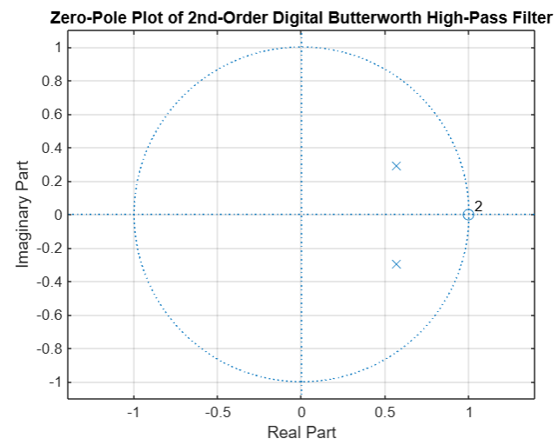

Figure 4 -Zero Pole analysis of High pass filter

**Key Observations:**

* In both plots, the poles are symmetrically placed to maintain a Butterworth response, which is characterized by a maximally flat magnitude in the passband.
* The low-pass filter zeros at z=−1z = -1z=−1 attenuate high frequencies, while the high-pass filter zeros at z=1z = 1z=1 attenuate low frequencies.
* The filter is designed to have a smooth roll-off without any ripples, unlike Chebyshev or Elliptical filters.

**Circuit Design Considerations:**

* To ensure a Butterworth response, we choose equal component values, i.e., R1=R2 & C1​=C2​.
* The gain of the circuit is unity (1x) by default but can be modified for a different response.
* Op-Amps like the LM358, TL072, or OP07 are commonly used in such circuits. We use LM741 Op-Amp.

**Simulation & Analysis:**

**Low Pass Butterworth Filter :**

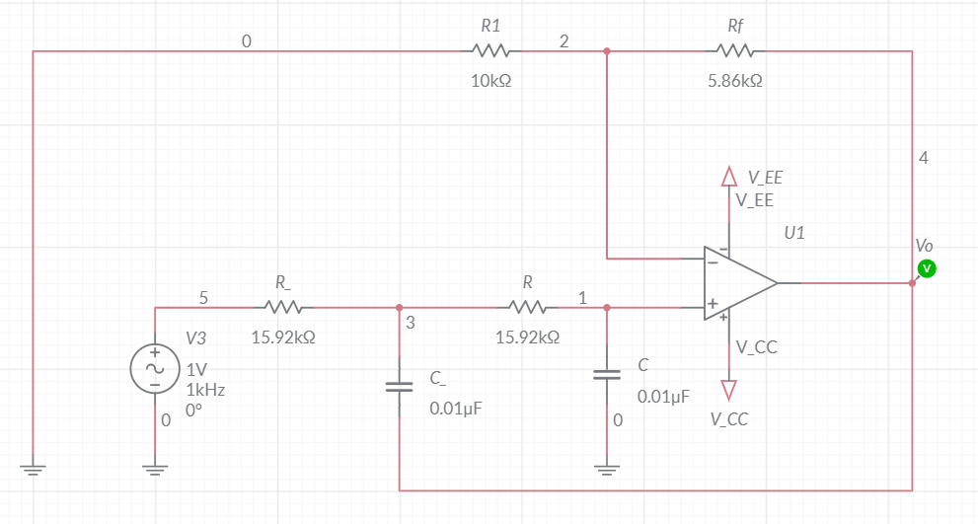

Figure 5- Multisim Simulation Low Pass Circuit

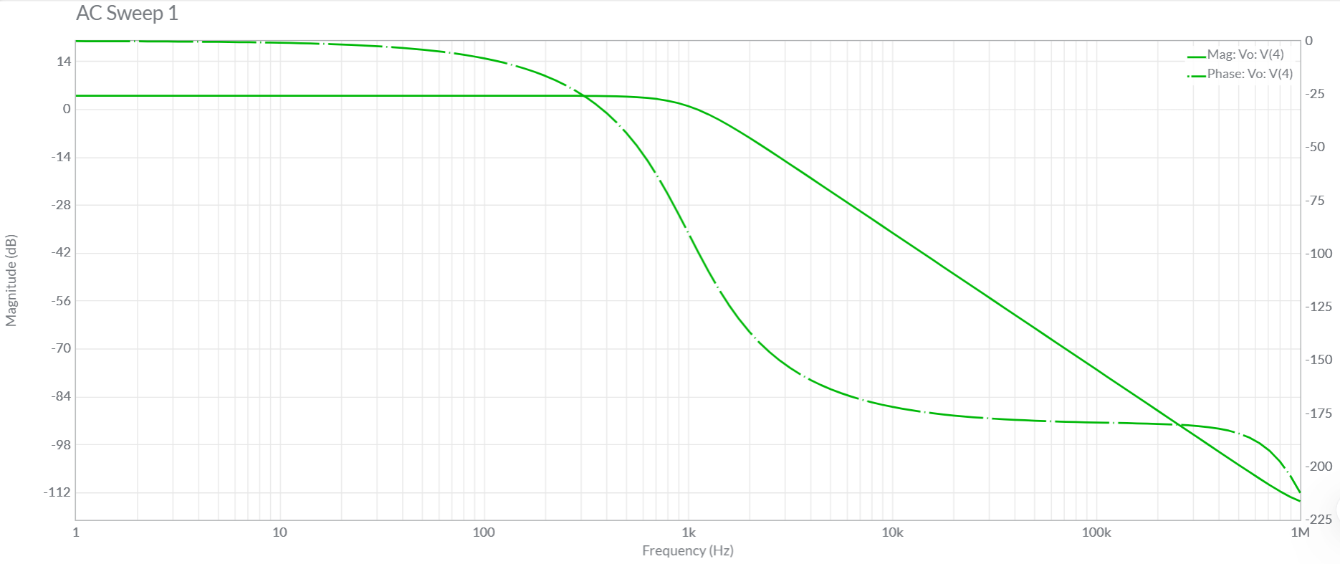

Figure 6 - Mag. & Freq. Response of Circuit

**High Pass Butterworth Filter :**

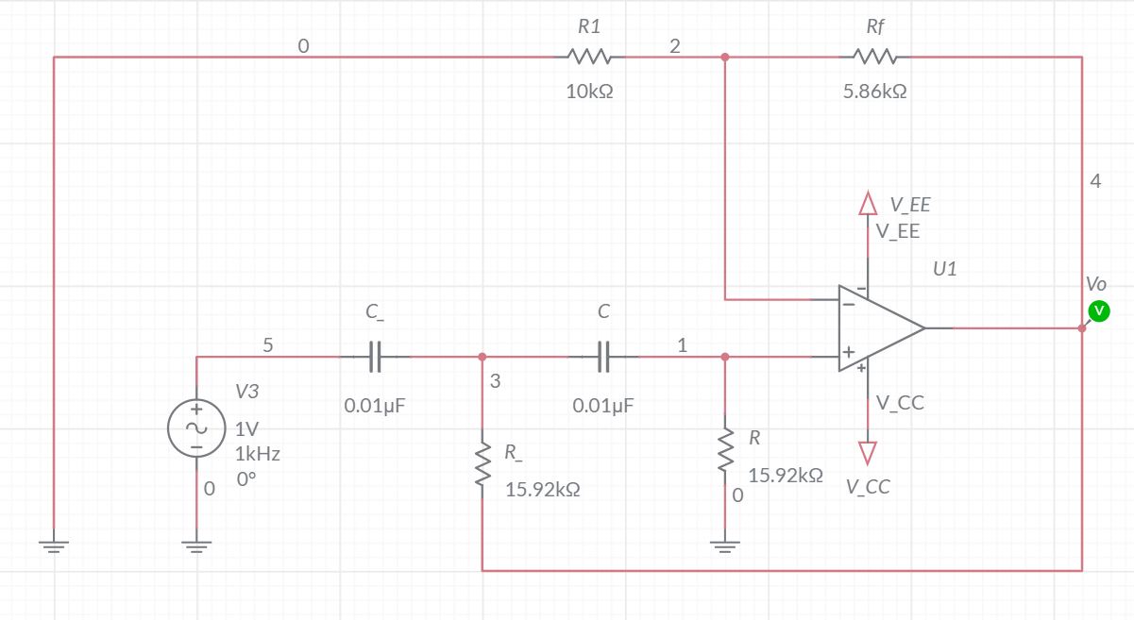

Figure 7- Multisim Simulation High Pass Circuit

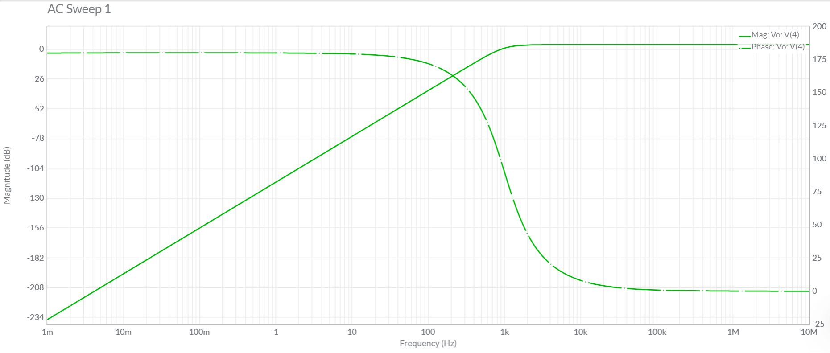

Figure 8 - Mag. & Freq. Response of Circuit

**Applications of Butterworth Filters**

Butterworth filters are widely used in various fields of engineering and signal processing due to their smooth frequency response and minimal signal distortion. Below are some key applications:

1. Audio Signal Processing :

* Used in equalizers, crossover networks, and anti-aliasing filters for high-fidelity sound systems.
* Helps in removing high-frequency noise from audio signals while maintaining a natural sound output.

1. Communication Systems

* Essential in modulation and demodulation circuits to eliminate unwanted noise and interference.
* Used as band-pass filters in RF communication systems to isolate specific frequency bands.
* Helps in image rejection in superheterodyne receivers.

1. Biomedical Signal Processing

* Used in ECG (Electrocardiogram) and EEG (Electroencephalogram) systems to filter out noise while preserving critical biological signals.
* Helps in removing muscle artifacts from biomedical recordings.

1. Instrumentation & Measurement Systems

* Used in oscilloscopes and spectrum analyzers to ensure accurate signal measurement.
* Helps in filtering out power line noise (50/60 Hz hum) in sensitive electronic circuits.

1. Image Processing & Computer Vision

* Applied in low-pass filtering to remove unwanted high-frequency components, such as noise and sharp edges.
* Helps in smoothing images for better feature extraction in machine learning and AI-based vision systems.

1. Power Electronics & Motor Control

* Used in pulse-width modulation (PWM) circuits to smoothen the output voltage waveform.
* Helps in reducing electromagnetic interference (EMI) in power converters.

1. IoT & Embedded Systems

* Used in sensor signal conditioning to improve the accuracy of temperature, pressure, and other analog sensors.
* Helps in removing unwanted noise from environmental sensor readings in IoT devices.

**References**

[1] Ramakant A. Gayakwad, *Op-Amps and Linear Integrated Circuits*, 4th Edition, Prentice Hall, 2000.

[2] S. K. Mitra, *Digital Signal Processing: A Computer-Based Approach*, IEEE, 2010.

[3] Multisim Simulation :  
 <https://www.multisim.com/content/5mq9zzjHqMTxpNj629UXa9/second-order-high-pass-butterworth-filter/open/>  
 <http://multisim.com/content/7poxkhf2JnYP5KSHefK2K9/second-order-low-pass-butterworth-filter/open/>

[4] MATLAB for Plots of Frequency & Magnitude Response