Enterprise-Scale Intelligent PDF Parsing and Structured Data Extraction System for Pharmaceutical Research Documents using AWS
A Project Work / Practice School Report submitted
to
MANIPAL ACADEMY OF HIGHER EDUCATION
for partial fulfilment of the requirement for
the award of the degree
of
BACHELOR OF TECHNOLOGY
in
COMPUTER AND COMMUNICATION ENGINEERING
Submitted by
Vansh Amit Jogani
220953126
Under the guidance of
Ms. Chithra K  Assistant Professor  School of Computer Engineering  MIT, Manipal | Neha Agrawal  Manager – Data Delivery  Enterprise Data  Eli Lilly and Company, Hyderabad

MANIPAL INSTITUTE OF TECHNOLOGY
MANIPAL
(A constituent unit of MAHE, Manipal)
SCHOOL OF COMPUTER ENGINEERING
July 2026

DECLARATION
I hereby declare that this project work titled “Enterprise-Scale Intelligent PDF Parsing and Structured Data Extraction System for Pharmaceutical Research Documents using AWS” is original and has been carried out by me in the School of Computer Engineering of Manipal Institute of Technology, Manipal, under the guidance of Ms. Chithra K, Assistant Professor, School of Computer Engineering, M.I.T., Manipal, and Ms. Neha Agrawal, Manager – Data Delivery, Enterprise Data, Eli Lilly and Company, Hyderabad. No part of this work has been submitted for the award of a degree or diploma either to this University or to any other University.

Place: Manipal
Date:
Vansh Amit Jogani
(Reg. No. 220953126)

MANIPAL INSTITUTE OF TECHNOLOGY
(A constituent unit of MAHE, Manipal)
SCHOOL OF COMPUTER ENGINEERING
Place: Manipal
Date: DD/MM/YYYY
CERTIFICATE
This is to certify that the project titled “Enterprise-Scale Intelligent PDF Parsing and Structured Data Extraction System for Pharmaceutical Research Documents using AWS” is a record of the bonafide work done by Vansh Amit Jogani (Reg. No. 220953126) submitted in partial fulfilment of the requirements for the award of the Degree of Bachelor of Technology (B.Tech.) in COMPUTER AND COMMUNICATION ENGINEERING of Manipal Institute of Technology, Manipal, Karnataka, during the academic year 2025–2026.

Ms. Chithra K  Assistant Professor  School of Computer Engineering,  Manipal Institute of Technology, Manipal | Dr. Smitha N. Pai  Professor & Associate Dean,  School of Computer Engineering,  Manipal Institute of Technology, Manipal
PROJECT COMPLETION LETTER
The project completion certificate issued by Eli Lilly and Company on the organization letterhead, signed by the mentor / authorised person, is to be inserted here. It states the internship duration (16 January 2026 – 15 July 2026) and the project title.
[ Placeholder — company completion letter to be appended. ]
ACKNOWLEDGMENTS
I would like to express my sincere gratitude to everyone who supported and guided me through the course of this Practice School internship at Eli Lilly and Company, Hyderabad.
I am deeply grateful to the Director and the Dean of Manipal Institute of Technology, and to Dr. Smitha N. Pai, Professor and Associate Dean, School of Computer Engineering, for enabling this internship opportunity. I extend my heartfelt thanks to my internal guide, Ms. Chithra K, Assistant Professor, School of Computer Engineering, for her continued academic guidance, timely feedback, and encouragement throughout the project.
I am especially thankful to my external guide and supervisor, Ms. Neha Agrawal, Manager – Data Delivery, Enterprise Data, for her mentorship, for trusting me with meaningful and challenging problems, and for her constructive feedback at every stage. I would also like to thank my mentors and buddies, Mr. Pradeep HC and Ms. Deeksha CA, for their day-to-day technical guidance, code reviews, and patient support as I ramped up on the enterprise environment.
Finally, I thank the entire Enterprise Data and Data Delivery team at Eli Lilly for the collaborative and welcoming environment, and my family and friends for their constant support and motivation throughout this journey.

Vansh Amit Jogani
ABSTRACT
Pharmaceutical research and manufacturing generate large volumes of documentation — stability studies, certificates of analysis, and batch records — that arrive as PDFs from many different laboratories and vendors. These documents are semi-structured, vary widely in layout, and frequently include scanned pages and tables that span multiple pages, making manual extraction slow, error-prone, and impossible to scale. This work addresses the problem of automatically converting such heterogeneous research PDFs into standardised, machine-readable JSON for downstream analytics, reporting, and regulatory archival within an enterprise data platform.
The proposed system is a cloud-native, event-driven pipeline that combines optical character recognition with a Visual Language Model (VLM). Amazon Textract provides a reliable text-and-table baseline that is treated as ground truth, while a VLM examines each page as both an image and text to first generate a JSON schema and then populate it with extracted values. A validation layer scores every page for completeness against the OCR baseline and automatically re-extracts pages that fall below a quality threshold, and a post-processing stage performs data-quality flagging, multi-page merging, and refinement into typed values and standardised dates.
Evaluated on a set of nineteen representative documents using precision, recall, and the Jaccard index against the Textract reference, the pipeline consistently achieved high recall — averaging roughly eighty-five percent — indicating that most information present on the page is captured. A domain-expert review by the research laboratories team reported accuracy of approximately ninety-five percent on their documents and recognised the built-in per-page quality scoring as a key strength. Under a stress test the pipeline processed on the order of five hundred documents in thirty to forty-five minutes at a concurrency of about twenty-five workers, and it was successfully deployed and validated through development and quality-assurance environments.
The results demonstrate that a template-free OCR-plus-VLM approach with self-healing validation can reliably transform diverse pharmaceutical PDFs into structured data, shifting the human reviewer’s role from reading every line to reviewing only flagged items. The report also documents three supporting contributions delivered during the internship: a latency-reduction initiative for a web-analytics pipeline, an autonomous agent that generates data-load pipeline configurations from any REST API, and a lineage-and-usage dashboard for the platform’s reusable components. Tools and technologies used include Python, AWS (S3, Lambda, Glue, Textract, Secrets Manager, CloudFormation/SAM), Claude Sonnet via an internal GenAI gateway, PyMuPDF, dlt (Data Load Tool), SQLite, and GitHub Actions.
CONTENTS

(Right-click the table and choose “Update Field”, or press Ctrl+A then F9 in Word, to populate page numbers.)
LIST OF TABLES
Table 1.1 Project work schedule across the six-month internship
Table 2.1 Comparison of document-processing approaches
Table 3.1 Technology stack of the document-parsing pipeline
Table 3.2 Per-page quality grades (recall and Jaccard thresholds)
Table 3.3 Tiered self-healing re-extraction strategy
Table 4.1 Validation framework — metrics and findings
Table 5.1 GA4 pipeline — measured baseline metrics
Table 5.2 EDB reusable-components — discovery coverage
LIST OF FIGURES
Figure 3.1 EDB Document Parser — four-phase extraction pipeline
Figure 5.1 GA4 Enhancement Pipeline — latency-reduction data flow
Figure 5.2 Agentic DLT Config Generator — autonomous four-phase workflow
Figure 5.3 EDB Lineage Discovery Engine — reusable-components dashboard
ABBREVIATIONS
API : Application Programming Interface
AWS : Amazon Web Services
CoA : Certificate of Analysis
CI/CD : Continuous Integration / Continuous Deployment
CR : Change Request
DAG : Directed Acyclic Graph
DLT : Data Load Tool
ETL : Extract, Transform, Load
GBQ : Google BigQuery
GA4 : Google Analytics 4
GMP : Good Manufacturing Practice
ICH : International Council for Harmonisation
JSON : JavaScript Object Notation
OCR : Optical Character Recognition
PDF : Portable Document Format
QA : Quality Assurance
REST : Representational State Transfer
VLM : Visual Language Model
NOTATIONS
TP : True positives — values correctly extracted
FP : False positives — extracted values not found in the reference
FN : False negatives — reference values missed by extraction
A, B : Value sets being compared (pipeline output and OCR reference)
∩ , ∪ : Set intersection and union, used in the Jaccard index

CHAPTER 1

INTRODUCTION

1.1 Introduction
Modern pharmaceutical organisations run on documentation. Every batch that is manufactured, every stability study that is placed on charts, and every certificate of analysis issued by a contract testing laboratory produces a formal report, and the overwhelming majority of these reports circulate as PDFs. Within an enterprise data function, these documents must eventually become structured data so that they can feed analytics, quality dashboards, and regulatory systems. The gap between an unstructured PDF and a clean, queryable record is therefore a recurring and expensive problem in enterprise data engineering.
The difficulty is that these documents are heterogeneous. They originate from different laboratories and vendors, each with its own template, and they mix natively generated digital PDFs with scanned paper documents. Tables routinely run across page boundaries, numeric results carry units and qualifiers, and identifiers such as batch and reference numbers must be captured character-for-character. Traditional rule-based or template-based parsers break the moment a new layout appears, and pure OCR returns text without the structure that downstream systems need.
This project designs and implements a scalable, cloud-native system that automatically parses diverse research PDFs and converts them into standardised JSON. The system is novel in that it is template-free: rather than maintaining a bespoke parser per document type, it uses a Visual Language Model to infer the structure of each page directly, guided and validated by a reliable OCR baseline. The significance of the end result is a pipeline that turns hours of manual review per document into minutes of automated processing, while flagging exactly where a human still needs to look.

1.2 Motivation
The motivation for the work is grounded in the day-to-day reality of the research laboratories (LRL) team, whose reviewers previously read through each document by hand to extract and verify data. This manual process is slow, does not scale to the hundreds of documents received, and is prone to transcription error. An automated pipeline that produces structured, quality-scored output directly addresses this bottleneck and frees expert reviewers to focus their attention where it matters.
A second motivation is reusability. The Enterprise Data team benefits from a general document-processing capability that is not tied to one vendor or one document type, and that can be extended to new formats without engineering a new parser each time. A template-free approach built on managed cloud services meets both goals at once.

1.3 Objectives
The primary objective of the project is to design and implement an intelligent, cloud-native PDF parsing system that converts heterogeneous pharmaceutical research documents into standardised, validated JSON. This primary objective is supported by the following specific objectives:
- Design and implement an event-driven ingestion pipeline on AWS, triggered automatically by uploads to Amazon S3.
- Develop an intelligent parsing system capable of handling heterogeneous document formats, including both native-text and scanned PDFs.
- Integrate optical character recognition for scanned research documents as a reliable text baseline.
- Detect and reconstruct multi-page tables, addressing the “table bleed” problem.
- Convert extracted content into standardised JSON schemas suitable for downstream analytics.
- Integrate the solution with enterprise CI/CD and monitoring frameworks.
As a secondary, forward-looking objective, the project explores lightweight model-optimisation techniques such as knowledge distillation, in which a smaller domain-adapted model is trained from the outputs of a larger model for more efficient inference on pharmaceutical documents.

1.4 Target Specifications
The system was designed against a set of concrete targets that define acceptable behaviour:
- Template-free operation: no per-document-type template authoring should be required; the schema must be inferred automatically for each document.
- Multi-format coverage: native-text PDFs, scanned documents, and multi-vendor layouts must all be supported.
- Measurable quality: every page must receive a completeness score (recall and Jaccard) against the OCR reference, with defined quality grades.
- Self-healing: pages that score below a configurable recall threshold must be re-extracted automatically, without reprocessing the entire document.
- Throughput at enterprise scale: the pipeline must sustain batch processing of hundreds of documents through parallel execution.
- Auditability: per-page metrics, full diagnostics, and inference-cost tracking must be produced for every document.

1.5 Project Work Schedule
The internship ran for six months, from 16 January 2026 to 15 July 2026, within the Enterprise Data – Data Delivery team, following an Agile delivery model with fortnightly sprints. The schedule below summarises the work across the period.
Period | Focus | Key deliverables
Jan (wk 1–4) | Onboarding & setup | Compliance training; access provisioning; CI/CD with GitHub Actions; first S3 → Lambda → Glue workflow; local Apache Spark experiments
Late Feb | Project familiarisation | Studied the parsing pipeline; proposed the precision / recall / Jaccard validation metrics; refactored the codebase into modules; added image inputs to the VLM (multimodal extraction)
Early Mar | Core parsing & features | Parallel processing; prompt engineering; multi-page merging; validation framework; evaluated and dropped Docling; migrated to the internal GenAI gateway; added suggested-schema generation and the self-healing rerun
Late Mar | Validation & review | Ran the end-to-end pipeline on 19 documents with high recall; shared structured outputs with the LRL team for domain-expert review
Apr | Data quality & deploy | Added the five-check data-quality flagging layer; created the repository and deployment stack; deployed to the development environment with S3-triggered automation; received ~95% accuracy feedback from LRL; midterm evaluation
May | QA & new workstreams | Deployed to QA; stress-tested ~500 PDFs at ~25 workers; built the Agentic DLT config generator end-to-end; obtained BigQuery access and produced the GA4 baseline discrepancy metrics and impact analysis
Jun | Delivery & dashboard | PDF parser fully functional in QA with knowledge transfer to a teammate; GA4 discrepancy report in QA; built the EDB reusable-components lineage-and-usage dashboard
Table 1.1 Project work schedule across the six-month internship.

1.6 Organization of the Report
The remainder of this report is organised as follows. Chapter 2 reviews the background and related work in document processing, OCR, and Visual Language Models. Chapter 3 describes the detailed methodology and architecture of the PDF parsing system together with the tools used. Chapter 4 presents the result analysis, including the validation framework and the domain-expert evaluation. Chapter 5 documents three additional contributions delivered during the internship. Chapter 6 concludes the report and outlines the future scope. References and appendices follow.

1.7 Contribution Summary
The primary contribution of this work is the design, implementation, evaluation, and deployment of a template-free, self-healing PDF-to-JSON extraction pipeline for pharmaceutical documents, carried out individually under the guidance of senior team members. In addition, the author contributed to a latency-reduction initiative for a web-analytics pipeline, built an autonomous agent that generates data-load pipeline configurations from any REST API, and developed a lineage-and-usage dashboard for the platform’s reusable components. These additional contributions are detailed in Chapter 5.
CHAPTER 2

BACKGROUND THEORY / LITERATURE REVIEW
This chapter introduces the technical background that underpins the project and reviews the main approaches to automated document processing. It surveys traditional OCR, deep-learning document analysis, Visual Language Models, and the cloud-native architectural patterns used to operate such systems at scale, and it summarises the reasoning behind the design choices adopted in this work.

2.1 Background Theory
Automated document processing has advanced considerably with progress in optical character recognition and cloud computing. Optical character recognition converts the pixels of a document image into machine-readable text. Classical engines such as Tesseract perform well on clean, single-column text but struggle with the complex, multi-column, table-heavy layouts common in scientific and pharmaceutical documents, where reading order and cell structure carry meaning.
Deep-learning services extend this baseline. Amazon Textract detects not only text but also tables and key-value pairs using trained models, which makes it suitable for enterprise-scale document processing. However, its output is essentially a faithful transcription of what appears on the page; it does not, on its own, impose the domain-specific structure that downstream systems require. In this project, Textract is used precisely for what it does best — a high-fidelity, interpretation-free reading of the page — and is treated as the reference baseline against which structured extraction is validated.
Visual Language Models represent a more recent approach to document understanding. By combining visual perception with language modelling, a VLM can interpret layout and content simultaneously, reasoning about a page as both an image and a stream of text. This allows the model to use spatial cues — column boundaries, header rows, the alignment of a value under a timepoint — that text-only pipelines discard. Recent work indicates that such multimodal models can outperform text-only pipelines on heterogeneous documents, particularly for table extraction and section identification.
Finally, knowledge distillation offers a route to efficiency: a smaller “student” model can be trained to reproduce the behaviour of a larger “teacher” model on domain-specific data, reducing inference cost. This is considered in the project only as a forward-looking direction rather than an implemented component.

2.2 Literature Survey
The table below compares the principal approaches evaluated for this work, along with the role each plays in the final design.
Approach | Strengths | Limitations / role in this work
Tesseract OCR | Open-source; simple text extraction | Weak on complex scientific layouts and tables; not adopted
Amazon Textract | Deep-learning table and form extraction; enterprise-grade | Outputs unstructured text; used as the OCR ground-truth baseline
Docling | Open-source document parser; layout-aware | Underperformed Textract on pharmaceutical formats and added overhead; evaluated and dropped
Visual Language Model | Layout-aware, multimodal understanding; template-free | Higher inference cost; adopted as the core extraction engine
Knowledge distillation | Smaller, cheaper domain-specific models | Requires training data and effort; retained as future scope
Table 2.1 Comparison of document-processing approaches.
On the infrastructure side, event-driven architectures on AWS — using S3 upload events to trigger Lambda functions that orchestrate Glue ETL jobs — provide a well-established pattern for processing documents automatically on arrival, without manual intervention and with elastic, serverless compute. This pattern forms the operational backbone of the system described in Chapter 3.

2.3 Summary of Literature Review
The survey points to a hybrid design. No single technique is sufficient on its own: OCR reads text reliably but without structure, and a VLM infers structure but benefits from a reliable text anchor to remain grounded and verifiable. Combining the two — OCR as ground truth, a VLM for structure, and an explicit validation step that compares the two — captures the strengths of each while mitigating their individual weaknesses. Docling was evaluated as an OCR alternative and dropped after it failed to improve on Textract while adding overhead.

2.4 Conclusions
The literature and the practical evaluation together justify the central architectural decision of this project: a template-free, OCR-anchored, VLM-driven extraction pipeline with a validation layer that scores and, where necessary, repairs its own output. The next chapter describes how this design is realised.
CHAPTER 3

METHODOLOGY
This chapter presents the detailed methodology of the PDF parsing system. It describes the end-to-end architecture, the responsibilities of each pipeline phase, the validation and self-healing mechanism, and the post-processing that produces the final structured output. It then lists the tools and technologies used.

3.1 Detailed Methodology
The system is an event-driven pipeline built on managed AWS services. A PDF placed in an S3 bucket raises an event that invokes a Lambda function; the function matches the file against a set of keyword rules to identify the document type and starts the appropriate AWS Glue job. The Glue job imports the core Python library and runs the extraction pipeline for the document. The overall architecture is shown in Figure 3.1.
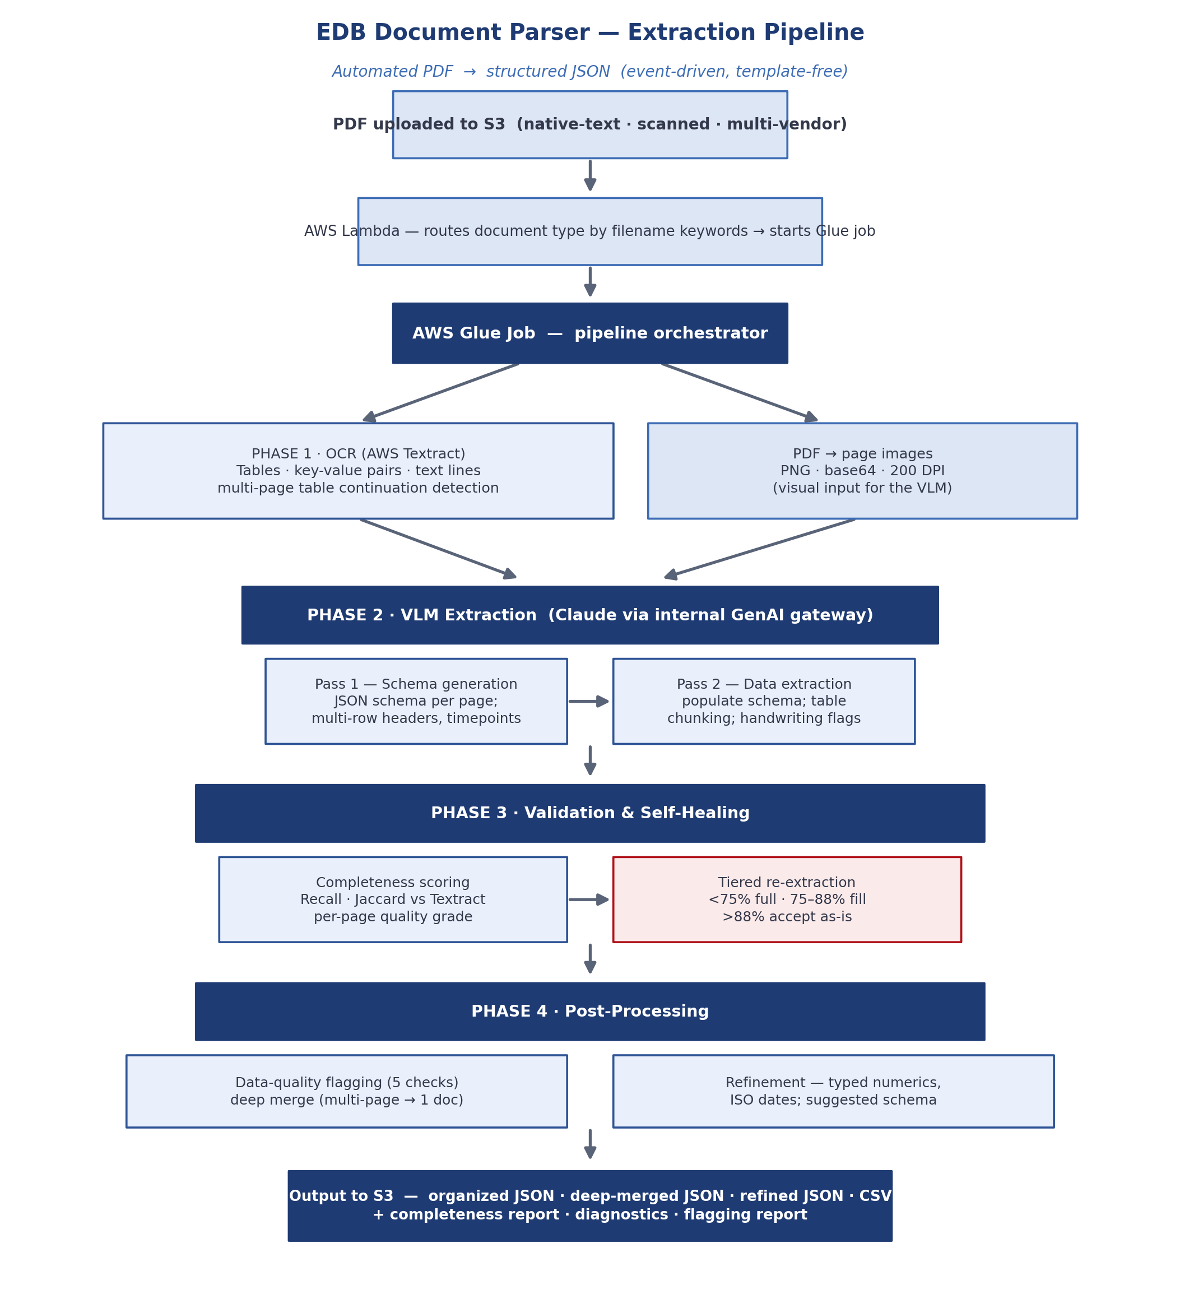
Figure 3.1 EDB Document Parser — the four-phase extraction pipeline, from S3 ingestion through OCR and VLM extraction to validation, self-healing, and post-processing.

3.1.1 Phase 1 — OCR and page rendering
In the first phase, two representations of the document are produced in parallel. Amazon Textract analyses the PDF to extract table cells, key-value pairs, and text lines, and detects tables that continue across pages by comparing header similarity between adjacent pages. Simultaneously, each PDF page is rendered to a PNG image at 200 DPI and encoded so that it can be passed to the model as a visual input. The Textract output serves as the interpretation-free ground truth for the page, while the images give the model the visual context it needs to reason about layout.

3.1.2 Phase 2 — VLM extraction in two passes
The second phase uses a Visual Language Model — Claude Sonnet, accessed through an internal GenAI gateway — in two passes. In the first pass the model examines the page image together with the OCR data and produces a JSON schema for that page, correctly handling multi-row headers, timepoint columns, and continuation tables. In the second pass the model populates that schema with the actual values, chunking large tables into manageable pieces, preserving multi-line cell content, and flagging handwritten entries. Separating structure from content in this way keeps each pass focused and improves reliability. A key engineering insight during development was that the model must receive the page image and not text alone: adding image inputs allowed the model to exploit visual layout and materially improved extraction quality.

3.1.3 Phase 3 — validation and self-healing
The third phase makes the pipeline verifiable. Every value produced by the model is compared, using fuzzy matching, against the Textract output for the same page, and each page receives a recall score (the proportion of reference values that were captured) and a Jaccard score (the overlap between the two value sets). Pages are then graded, and low-scoring pages are repaired automatically according to a tiered strategy, so that only the affected pages — not entire documents — are reprocessed. The grading and re-extraction policies are given in Tables 3.2 and 3.3.
Grade | Recall | Jaccard
Excellent | ≥ 95% | ≥ 85%
Good | ≥ 85% | ≥ 70%
Fair | ≥ 70% | ≥ 50%
Poor | ≥ 50% | —
Critical | < 50% | —
Table 3.2 Per-page quality grades based on recall and Jaccard thresholds.
Recall range | Strategy | Description
< 75% | Full re-extraction | A targeted VLM call that re-extracts the specific missing rows and key-value pairs, then merges the result while avoiding duplicates.
75% – 88% | Lightweight fill | Missing values are filled by direct lookup in the Textract output, with no additional VLM call.
> 88% | Accept as-is | The page is accepted without further processing.
Table 3.3 Tiered self-healing re-extraction strategy.

3.1.4 Phase 4 — post-processing
The final phase turns validated per-page results into a clean, unified document. A data-quality flagging step applies five checks — European decimal-comma normalisation, plausibility against a specification upper bound, consistency between adjacent timepoints, handwriting and signature detection, and out-of-specification values against parsed acceptance criteria — and records the outcomes in a dedicated field so that reviewers can see immediately which values need attention. A deep-merge step combines per-page results into a single document, concatenating continuation tables in order and de-duplicating at page boundaries. A refinement step converts numeric strings to typed numbers, normalises dates to ISO format, and parses pharmaceutical result strings into value, unit, and qualifier components. Finally, a suggested-schema step produces a reusable schema for similar future documents — a feature added specifically so that the LRL team could run the pipeline in a manual-schema mode and select the fields they needed.

3.2 Tools Used
The pipeline is implemented in Python and deployed on AWS using infrastructure-as-code, with continuous integration through GitHub Actions. Table 3.1 lists the main components of the technology stack.
Layer | Technology
Language | Python 3.11
Visual Language Model | Claude Sonnet (via an internal GenAI gateway; AWS Bedrock as an alternate)
OCR | AWS Textract (tables, forms, text detection)
Compute | AWS Glue (ETL jobs)
Trigger | AWS Lambda (S3 event-driven)
Storage & secrets | Amazon S3, AWS Secrets Manager
PDF rendering & imaging | PyMuPDF, Pillow
Observability | AWS CloudWatch
Infrastructure as code | AWS SAM / CloudFormation
CI/CD & testing | GitHub Actions, pytest
Table 3.1 Technology stack of the document-parsing pipeline.

3.3 Conclusions
The methodology combines a reliable OCR baseline with layout-aware VLM extraction and an explicit, measurable validation step, all orchestrated by serverless AWS services. The design directly satisfies the target specifications set out in Chapter 1: it is template-free, handles mixed formats, scores every page, repairs its own low-quality output, and runs at scale. The next chapter evaluates how well it performs in practice.
CHAPTER 4

RESULT ANALYSIS
This chapter reports the results of evaluating the PDF parsing pipeline. It presents the quantitative validation framework and its findings, discusses the domain-expert evaluation carried out by the research laboratories team, and reflects on the pipeline’s behaviour, its throughput, and its deployment status.

4.1 Results
A validation framework was developed to measure extraction quality quantitatively. It uses the Textract OCR output as the reference standard and evaluates the final structured output against it using three metrics: precision, defined as TP / (TP + FP); recall, defined as TP / (TP + FN); and the Jaccard index, defined as the size of the intersection over the size of the union of the two value sets. Recall measures how much of the source content is captured, precision how much of the output is supported by the reference, and Jaccard the overall overlap.
The pipeline was run end-to-end on nineteen representative documents spanning natively generated PDFs, scanned documents, and landscape-format tables. Across this set the pipeline consistently achieved high recall — averaging approximately eighty-five percent — indicating that most of the information present on the page is captured. Table 4.1 summarises the framework and its principal findings.
Aspect | Result
Test corpus | 19 representative documents (native, scanned, landscape tables)
Reference standard | AWS Textract OCR output
Metrics | Precision, Recall, Jaccard index
Average recall | ≈ 85% — most relevant information captured consistently
Precision | Numerically lower; an artefact of the reference (see discussion)
Throughput (stress test) | ≈ 500 PDFs in 30–45 minutes at ≈ 25 concurrent workers
Deployment | Development and QA environments; knowledge transfer completed
Table 4.1 Validation framework — metrics and principal findings.
Under a dedicated stress test, the pipeline processed on the order of five hundred PDFs in thirty to forty-five minutes at a concurrency of about twenty-five workers, confirming that it holds up under realistic enterprise load. Operationally, the pipeline was promoted from the development environment — where it runs automatically whenever a PDF is dropped into its S3 bucket — to the quality-assurance environment, and knowledge transfer was completed so that a second team member can drive it forward.

4.2 Discussion
The most important point of interpretation concerns precision. The precision figure appears numerically low, but this is an artefact of the evaluation methodology rather than a defect in the pipeline. The Textract reference is unstructured, whereas the pipeline deliberately adds structure — headers, labels, and field names — that has no counterpart in the reference. These added structural elements are counted as false positives and therefore depress precision, even though they are correct and useful. In other words, the limitation lies in the ground truth, not in the pipeline’s output, and recall is the more meaningful indicator of extraction completeness for this task.
The structured outputs were shared with the research laboratories team for domain-expert review on a representative set of stability and certificate-of-analysis documents sourced from multiple contract testing laboratories. The team’s written feedback reported accuracy of approximately ninety-five percent on their documents and recognised the built-in per-page quality scoring — with its metrics and missing-value categorisation — as a key strength. Well-structured, natively generated reports scored consistently well, with the parser correctly separating multiple test conditions and faithfully extracting GMP-related metadata such as investigation records, amendment histories, analytical references, and change controls.
A key architectural insight emerged from this evaluation: parser quality is driven primarily by the source document format rather than by content complexity. Native, well-structured documents are handled reliably, while scanned landscape-format tables are consistently the most challenging. Because this pattern is predictable, it can be managed in future through format-aware routing. The evaluation also identified concrete improvement areas — OCR accuracy on scanned documents, schema consistency across pages and files, multi-page table merging, character-level accuracy in identifiers, and structured numeric-result parsing — several of which were subsequently addressed through the data-quality flagging and refinement stages described in Chapter 3.

4.3 Conclusions
The results confirm that the approach works: the pipeline captures the great majority of document content, scores its own output transparently, and is judged accurate and useful by domain experts. The apparent precision gap is explained by the structure the pipeline adds, and the dependence of quality on document format is understood and manageable. Taken together, the evidence supports the pipeline as a reliable, enterprise-ready tool for converting pharmaceutical PDFs into structured data.
CHAPTER 5

ADDITIONAL CONTRIBUTIONS
Alongside the primary PDF parsing project, three further pieces of work were delivered during the internship. Each addresses a distinct enterprise-data problem, and together they share a common theme with the main project: automating manual data-engineering effort and making the data platform more observable. This chapter summarises each contribution and its outcome.

5.1 GA4 Enhancement Pipeline — Latency Reduction
Clickstream data from approximately 240 Lilly websites flows through Google Analytics 4 into BigQuery and onward into the Enterprise Data Backbone on Amazon S3. By the time this data reached the backbone it was roughly three days old, which meant that decisions about campaigns and customer experience were being made on stale information. The objective of this contribution was to characterise and then reduce that latency.
A reconciliation pipeline was built to measure, day by day and property by property, the gap between when data appears in BigQuery and when it arrives in S3. Over a 161-day observation window it found a median lag of four days — confirming the reported seventy-two-hour figure — with seventy-two percent of properties three or more days behind, while data ultimately reconciled at over ninety-six percent once delivered. The measured baseline is summarised in Table 5.1 and the end-to-end flow in Figure 5.1.
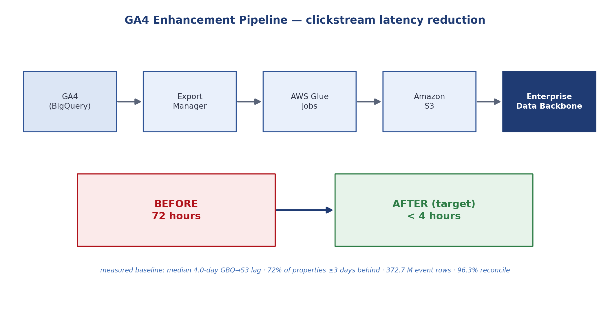
Figure 5.1 GA4 Enhancement Pipeline — the data flow from BigQuery to the Enterprise Data Backbone, and the target reduction in end-to-end latency.
Metric | Measured value
Median lag (BigQuery → S3) | 4.0 days (mean 3.7; worst property 57 days)
Properties ≥ 3 days behind | 126 of 174 (72%)
Total event rows processed | 372.7 million
Data volume | ≈ 505 GB (BigQuery) vs ≈ 1,771 GB (S3, after JSON expansion)
Eventual reconciliation | 96.3% of property-days
Target latency | under 4 hours (an 18× improvement)
Table 5.1 GA4 pipeline — measured baseline metrics over a 161-day window.
The root causes of the delay were traced to a design that waits for BigQuery tables to fully stabilise before exporting, batch state management that only exports settled tables, sequential daily runs in a narrow window, and the absence of any incremental or streaming approach. The proposed enhancement exports available data incrementally from intraday tables, raises the export frequency to every few hours, and reconciles late-arriving data afterwards. At the close of the internship the baseline metrics and discrepancy report were complete and running on a daily cadence, and the enhancement itself was designed and ready, pending repository security-scanning and pull-request-automation compliance before it can be promoted; production rollout is planned for a later quarter.

5.2 Agentic DLT Config Generator — Autonomous API Ingestion
Ingesting data from a REST API into the data platform is done with dlt (Data Load Tool), but writing a dlt configuration by hand is laborious: it requires researching the API’s documentation to find endpoints, understanding each endpoint’s pagination, identifying primary keys, configuring authentication, and debugging runtime errors. This routinely takes hours per API and demands deep knowledge of both the API and the dlt configuration format.
To remove this effort, an autonomous agent was built using Claude on AWS Bedrock with the Strands Agents framework. Given only an API URL and credentials, the agent runs a four-phase workflow: it discovers every endpoint the API exposes using four independent mechanisms; it validates each endpoint with live HTTP requests, inferring schema, pagination type, and primary keys from the real responses; it reports the results for the user to select from; and it generates a complete, runnable dlt pipeline, executing it and self-healing — reading the error, fixing the generated code, and retrying up to three times — until it works. The workflow is shown in Figure 5.2.
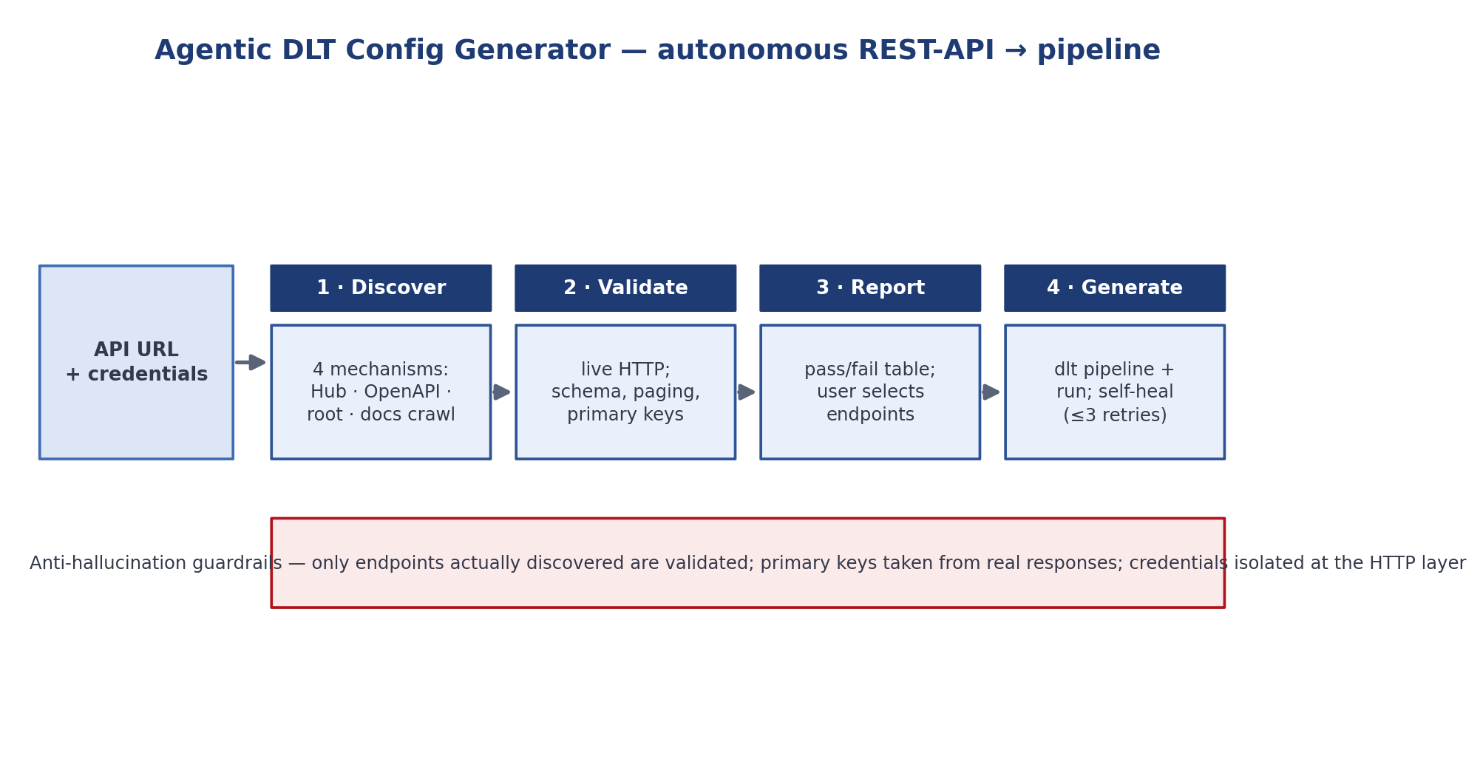
Figure 5.2 Agentic DLT Config Generator — the four-phase autonomous workflow, with anti-hallucination guardrails.
A distinctive feature of the agent is its set of anti-hallucination guardrails. It may only validate endpoints that were actually returned by one of its discovery mechanisms, discovery and validation are exhaustive rather than sampled, primary keys are taken only from real response data, and credentials are injected at the HTTP layer so they are never exposed in model prompts. The generated pipelines are destination-agnostic, working with any dlt destination such as Postgres, BigQuery, Snowflake, or S3. During the internship the generator was built end-to-end — local execution, pagination and authentication support, and integration with the internal GenAI gateway — turning what had been hours of manual work per API into minutes.

5.3 EDB Reusable-Components Dashboard — Lineage and Usage
The Enterprise Data platform is built from a set of reusable components, but there was limited visibility into how each one is actually used — which projects depend on it and who consumes its output. The objective of this contribution was to make that usage and lineage visible. A discovery engine was built that parses the production configuration of each reusable component from its repository, normalises the several different configuration formats into a single relational model in SQLite, links components to their use-cases, projects, consumers, and inter-component dependencies, and identifies gaps where information is missing. It produces an interactive lineage graph, an executive overview dashboard, and a gap report. The architecture is shown in Figure 5.3.
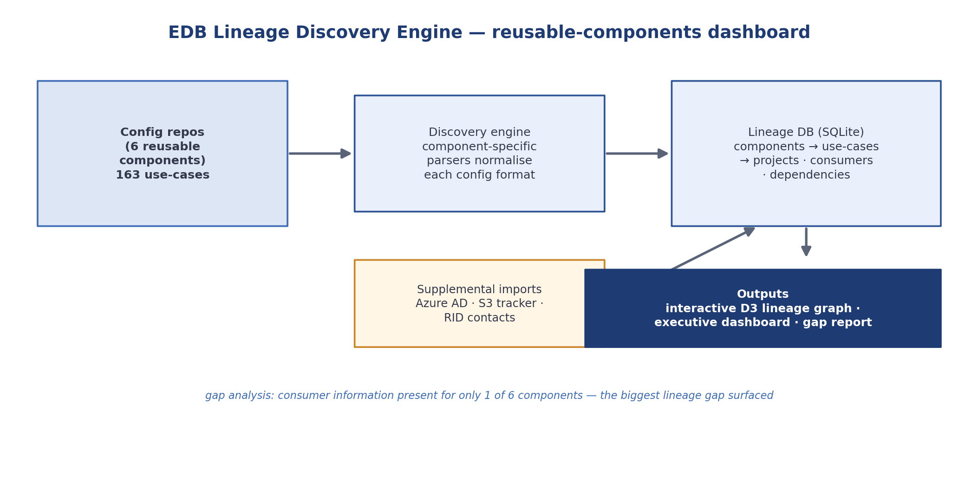
Figure 5.3 EDB Lineage Discovery Engine — configuration discovery, normalisation into a relational model, and interactive dashboard outputs.
Because configuration files tell only part of the story, the engine also enriches its model from supplementary sources of consumer information. Table 5.2 shows the discovery coverage across the components. The exercise surfaced a clear finding: consumer information is the single biggest lineage gap, present for only one of the six components, which pinpoints exactly where enrichment effort should be focused. Change-request attribution was implemented across all components, a lineage tracker and a development-timeline view were added from platform metadata, and the dashboard was demonstrated to the leadership and iterated on their feedback.
Reusable component | Use-cases | Consumer info
Veeva Raw → Refine | 56 | Missing
File Consumption (DAG) | 35 | Missing
Veeva Source → Raw | 34 | Missing
API Ingestion | 22 | Missing
Web Direct Download | 10 | Missing
FastAPI Consumption | 6 | Present
Table 5.2 EDB reusable-components — discovery coverage (163 use-cases across six components).

5.4 Conclusions
The three additional contributions reinforce the theme of the main project. The GA4 work replaced anecdote with a data-backed baseline and a concrete latency-reduction design; the DLT agent automated an entire class of manual pipeline engineering with strong safeguards against hallucination; and the reusable-components dashboard turned an opaque platform into an observable one. In each case, manual effort was reduced and the enterprise data platform was made faster, more automated, or more transparent.
CHAPTER 6

CONCLUSION AND FUTURE SCOPE

6.1 Summary
This report presented the design, implementation, evaluation, and deployment of an enterprise-scale, template-free system for parsing pharmaceutical research PDFs into standardised JSON. The system pairs a reliable OCR baseline with a Visual Language Model that infers and populates a per-page schema, validates every page against the OCR reference, and automatically repairs low-quality pages before merging and refining the result. It was evaluated quantitatively and by domain experts, deployed through development and QA environments, and complemented by three further contributions to the enterprise data platform.

6.2 Conclusions
The work shows that combining OCR ground truth with layout-aware VLM extraction and an explicit, measurable validation step yields a reliable, scalable, and auditable document-processing pipeline. On nineteen representative documents the pipeline achieved approximately eighty-five percent average recall, and domain-expert review reported approximately ninety-five percent accuracy while highlighting the value of per-page quality scoring. The apparent precision gap was shown to be an artefact of comparing structured output against an unstructured reference. Above all, the pipeline changes the nature of the reviewer’s task: instead of reading every line, reviewers now examine only the values the system flags.

6.3 Future Scope
Several directions follow naturally from the evaluation. Because document format is the primary driver of quality, format-aware routing would send scanned and landscape documents down specialised paths, improving OCR accuracy and table reconstruction where it is most needed. Adopting a fixed, standardised output schema across all document types would eliminate schema drift, and identifier-format validation and locale-aware numeric normalisation would further harden character-level accuracy. Standing up a full CI/CD pipeline for the repository and identifying a consuming team would move the parser from QA toward production use. Finally, the structured data produced by the pipeline could seed the exploration of knowledge distillation, training a smaller domain-specific model for cheaper inference at scale.

6.4 Contribution Summary
All of the work described in this report was carried out individually by the author, with guidance and code review from senior members of the Enterprise Data – Data Delivery team. The author was responsible for the design, implementation, validation, and deployment of the PDF parsing pipeline, and for the three additional contributions described in Chapter 5.
REFERENCES
The following are documentation sources referenced during the project. Peer-reviewed literature for the OCR and Visual Language Model discussion in Chapter 2 is to be finalised by the author.
[1] Amazon Web Services, Amazon Textract Developer Guide. https://docs.aws.amazon.com/textract/
[2] Amazon Web Services, AWS Lambda Developer Guide. https://docs.aws.amazon.com/lambda/
[3] Amazon Web Services, AWS Glue Developer Guide. https://docs.aws.amazon.com/glue/
[4] Amazon Web Services, AWS Serverless Application Model (SAM) Developer Guide. https://docs.aws.amazon.com/serverless-application-model/
[5] Anthropic, Claude Models — Documentation. https://docs.anthropic.com/
[6] dltHub, dlt — Data Load Tool Documentation. https://dlthub.com/docs
[7] DS4SD, Docling — Document Processing Library. https://github.com/DS4SD/docling
[8] GitHub, GitHub Actions Documentation. https://docs.github.com/actions
[9] Apache Software Foundation, Apache Spark Documentation. https://spark.apache.org/docs/latest/
[10] SQLite Consortium, SQLite Documentation. https://www.sqlite.org/docs.html
[11] Mike Bostock, D3: Data-Driven Documents. https://d3js.org/
ANNEXURE A
CODE LISTING
Representative structure of the extraction pipeline’s core library (module responsibilities). Full source is maintained in the project repository.
pipeline.py — orchestrates single-PDF processing end-to-end
textract_processor.py — Textract OCR wrapper + continuation detection
schema_generator.py — VLM-driven per-page JSON schema generation
extraction.py — Pass 1 data extraction into the schema
reextraction.py — Pass 2 tiered self-healing re-extraction
completeness.py — recall and Jaccard scoring
deep_merger.py — multi-page merge into a unified document
flagging.py — five data-quality checks
refinement.py — typed numerics, ISO dates, result parsing
ANNEXURE B
ADDITIONAL DATA
Additional supporting data and extended result tables may be included here.
PLAGIARISM REPORT
The similarity-check statistics page (content plagiarism < 15%, AI < 20%) is to be inserted here, with the e-signatures of the student and the internal guide, per the submission guidelines.
PROJECT DETAILS
Student Details
Student Name | Vansh Amit Jogani
Register Number | 220953126
Email Address | vanshjogani04@gmail.com
Project Details
Project Title | Enterprise-Scale Intelligent PDF Parsing and Structured Data Extraction System for Pharmaceutical Research Documents using AWS
Project Duration | 16 January 2026 – 15 July 2026
Date of Reporting | 16 January 2026
Organization Details
Organization Name | Eli Lilly and Company
Address | Hyderabad, Telangana, India
Team | Enterprise Data – Data Delivery
Supervisor / External Guide
Name | Neha Agrawal
Designation | Manager – Data Delivery, Enterprise Data
Internal Guide
Name | Ms. Chithra K
Designation | Assistant Professor, School of Computer Engineering, MIT Manipal
PROJECT / INTERNSHIP OFFER LETTER
The internship offer letter issued by Eli Lilly and Company is to be inserted here.
[ Placeholder — offer letter to be appended. ]

