

SYMBIOSIS CENTRE FOR INFORMATION TECHNOLOGY (SCIT), PUNE
(A constituent of the Symbiosis International University, Pune)

AI SEO Product Description Generator

Submitted By:

NAME | PRN NUMBER
Vansh Kodarlikar | 26030242063
Submitted to: Yogesh Murumkar

Date of Submission: 04-10-2026

Table of Contents
Sr. No. | Topic | Page No.
1 | Introduction and Project Objective | 2
2 | Dataset and Scope | 2
3 | Solution Workflow and Working Build | 2
4 | Prompt Design and Iteration | 3
5 | Correctness and Verification | 3
6 | Readability and Keyword Use | 4
7 | Business Insight and Recommendation | 4
8 | Limitations and Responsible-AI Notes | 4
9 | Personal Reflection and Conclusion | 4

1. Introduction and Project Objective
Online catalogues need hundreds of product descriptions that are consistent, search-friendly and, above all, factually correct. This project builds an AI-assisted workflow that converts structured product attributes into (i) a description of about 60 words, (ii) exactly five feature bullets and (iii) an SEO meta title of at most 60 characters. Every generated claim is then checked against the source attribute sheet, and readability and keyword use are scored.

2. Dataset and Scope
The workbook supplies 150 synthetic products (fields: product_id, product_name, category, price_inr, key_attributes, target_customer) across five categories. A balanced sample of 50 products (10 per category) was selected and stored in the Selected_Products sheet. The data is fictional but treated as real business data; no personal or confidential data was used with any AI tool, and the optional Gold Labels sheet, if present, is reserved for final accuracy measurement only.

3. Solution Workflow and Working Build
The workflow has seven steps: select source attributes → apply the master prompt with strict no-invention rules → generate description, bullets and title → validate length, bullet count, title length and attribute matches → human fact-check every claim → score readability and keywords → log every prompt iteration in the AI Use Log.
The working build is a Streamlit prototype with product selection or manual input, a Demo mode (no API key) and an optional Gemini API mode that uses the same master prompt, generated-content display, a validation panel and CSV export (Figures 1 and 2).
Live build link: https://ai-description-spark.lovable.app
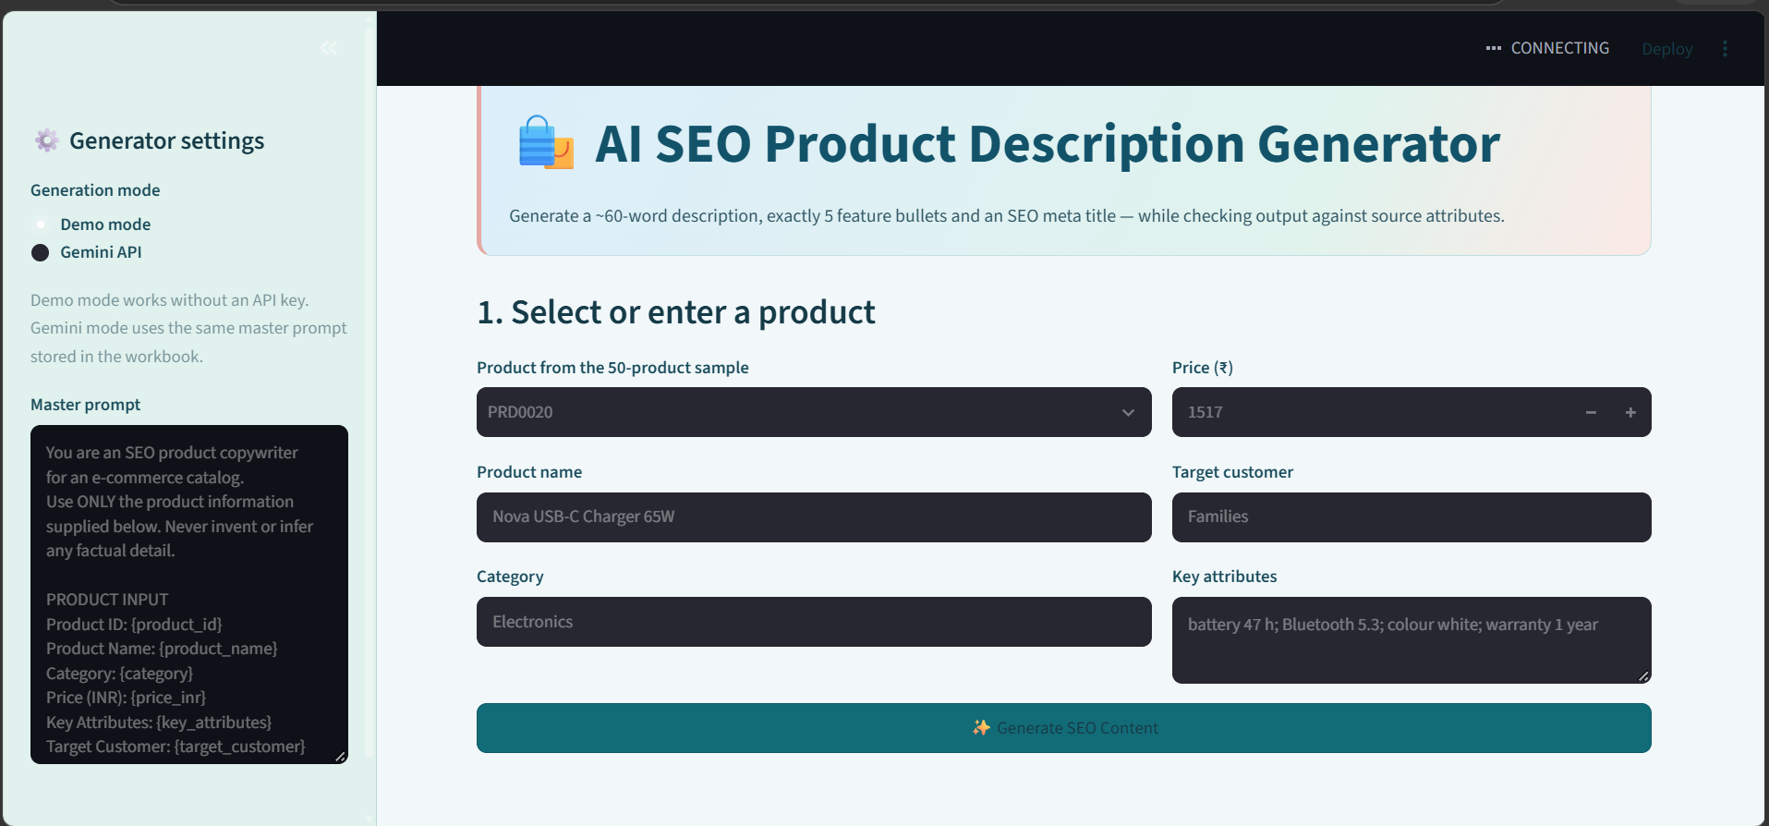
Figure 1: Main generator screen – product inputs, generation mode and master prompt
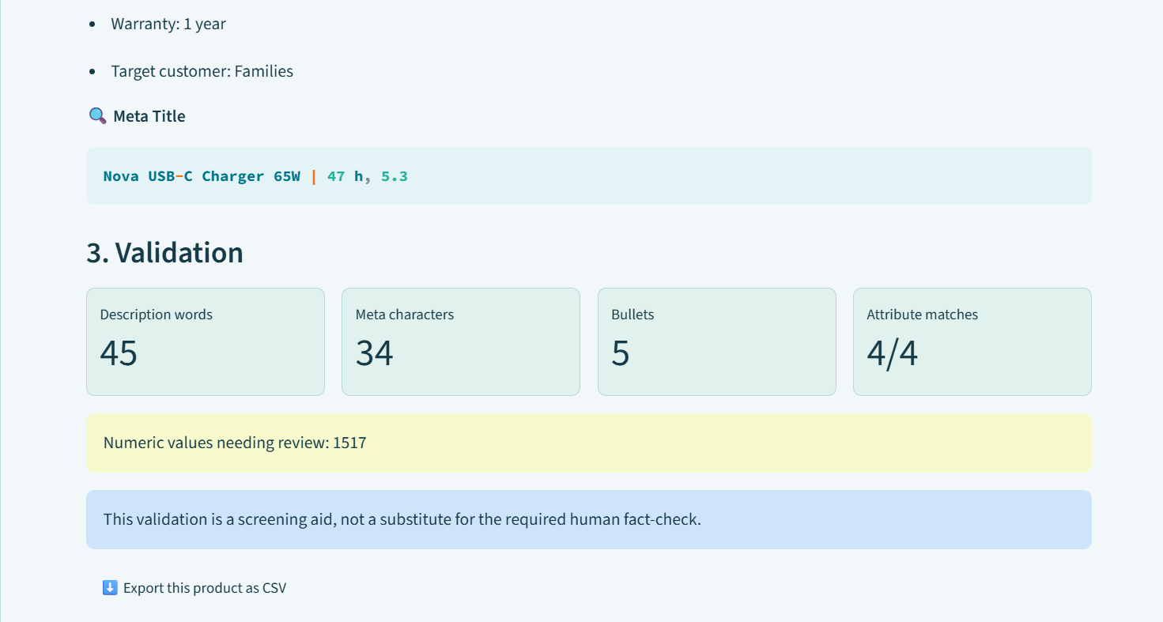
Figure 2: Validation panel – word count, meta-title length, bullet count, attribute matches and human fact-check notice

4. Prompt Design and Iteration
The master prompt (Prompt_Template sheet) fixes the role, restricts the model to the supplied fields, forbids invented specifications or unsupported medical, safety or superiority claims, requires numbers and units to be preserved exactly, prescribes the output format (DESCRIPTION / KEY FEATURES / META TITLE / FACT CHECK) and asks for a claim-to-attribute mapping. Prompt improvement is planned in four rounds, each motivated by a defect actually measured in the draft outputs (Section 5):
Round | Focus | Defect motivating the change (measured) | Evidence in log
Initial | Basic generation + output structure | Baseline for comparison | Prompt + output
Iteration 1 | Remove unsupported / inferred claims | Boilerplate and unverifiable phrasing; source-name conflicts (13 of 50) | Rejected + revised prompt
Iteration 2 | ~60-word description; exactly 5 bullets | Mean 42.9 words (0/50 in 54–66); only 21/50 with 5 bullets | Before / after
Iteration 3 | Preserve numbers, units, source wording | Awkward units (e.g. “warranty 1 years”, “Skin: type dry”) | Before / after

Status: the AI Use Log contains the required 15-entry structure (one worked example plus 14 planned entries). The planned entries must be replaced with real prompts, outputs, keep/reject decisions and screenshot or chat-link evidence after the live LLM run; at least three improvement rounds must appear with reasons.

5. Correctness and Verification
Verification has three layers: (a) automatic checks (word count, title length, bullet count, attribute presence), (b) a Fact_Check sheet that maps each claim to an exact source attribute – 171 claim-to-source mappings across the 50 products – and (c) manual review of every claim, with unsupported claims recorded and fixed. I first measured the current draft/template outputs in SEO_Output as a baseline:
Check (50 products) | Target | Baseline result | Pass rate
Description length | ~60 words | Mean 42.9 (range 40–48) | 0 / 50 (54–66 words)
Feature bullets | Exactly 5 | 21 with 5; 29 with 4 | 21 / 50 (42%)
Meta title length | ≤ 60 chars | Mean 37.2 (max 51) | 50 / 50 (100%)
Product name in description / title | Present | Present in both | 50 / 50 (100%)
All source attributes in description | All used | Third attribute dropped in 17 | 33 / 50 (66%)

Errors found. (1) The 29 Beauty, Home & Kitchen and Grocery rows contain only four bullet items and the meta title is shifted into the bullet_5 column, so the sheet’s own count columns are misaligned – a real formatting error caught by re-parsing the rows. (2) All drafts are about 17 words short of target. (3) 13 of 50 products (26%) carry source-data conflicts that an LLM could “correct” or repeat: Steel Water Bottles listed as aluminium or food-grade plastic (3), Organic Jaggery 1kg listed as 500 g (2), Dry Fruits Mix 500g listed as 1 kg (1), Beard Trimmers with skin-type and ingredient fields (3), and a Power Bank and three USB-C Chargers listed with battery hours and Bluetooth versions (4). The prompt’s “use only supplied data” rule means the output will repeat these values, so they are flagged for human review rather than silently changed.
Final metrics to enter after the live run: fact accuracy = supported claims ÷ total claims; unsupported-claim count and the fixes applied; and, if available, a comparison with the Gold Labels sheet. The current workbook correctly labels the batch “Draft/template mode”, so no final accuracy is claimed here.

6. Readability and Keyword Use
Readability is scored with Flesch Reading Ease and keyword use by presence of the product name and supplied attributes. On the template drafts, mean Flesch Reading Ease is 41.1 (range 31.5–52.6; Home & Kitchen lowest at 36.0), which is “difficult” and reflects the repetitive boilerplate and long product names, so a customer-friendly target of 60 or above is set for the LLM outputs. Product-name use is 50/50 in both description and title, and attribute coverage is 33/50 (full) with no keyword stuffing. These figures serve as the baseline; the final average and distribution will be reported after the 50 LLM outputs are generated.

7. Business Insight and Recommendation
For the e-commerce content manager: use the generator as a controlled first-draft assistant, not an unsupervised publisher. The measured baseline supports three specific actions:
- Add a data-quality gate before generation. 13 of 50 sampled records (26%) contain internally conflicting attributes; at catalogue scale this would be roughly 39 of 150 records. Fix or flag them at source first.
- Keep automated validators and a mandatory human gate. Automatic checks caught the 4-bullet and short-description defects in 58% and 100% of rows respectively; only human review can confirm that every number and unit matches the source, which is the main risk of AI drafting.
- Pilot by category. Start with Electronics and Fashion, whose attribute sets are consistent and already yield five bullets, then extend to Beauty, Grocery and Home & Kitchen after the prompt is tuned. Track four KPIs: fact accuracy (target 100% after review), description within 54–66 words (target ≥ 90%), five bullets (100%), and Flesch ≥ 60.

8. Limitations and Responsible-AI Notes
- Results depend on prompt quality; the model may rephrase, infer or mistranscribe a number even when the source is correct.
- The dataset is synthetic and contains conflicting attributes; Flesch scores are approximate and the 54–66-word band is my own operational reading of “approximately 60”.
- Only free tools were used; no real personal or confidential data was pasted into public AI tools; every number is verified against the source sheet; AI-generated content is disclosed. This report and the draft outputs were prepared with AI assistance and checked by the author against the workbook.

9. Personal Reflection and Conclusion
The most useful lesson was that checking the output was harder than generating it. Measuring the draft outputs showed defects I would not have spotted by reading a few rows: shifted columns, short descriptions and conflicting source data. It convinced me that validators and a human review gate matter more than polished wording. Next time I would clean the source data first and test the prompt on one product per category before the full batch.
In conclusion, the workflow is a sound controlled drafting aid: the build runs, the prompt enforces no-invention rules, and the verification framework exposes real problems. Final accuracy, readability and keyword results should be added once the live LLM run is complete.

