ScholarEase – Report (Module B)
Team – Data Traffickers

1. Introduction
ScholarEase is a database-based system that helps academic institutions manage scholarships and stipends more easily.
The system keeps all information in one place including student records, scholarship details, eligibility rules, applications, verification steps, payments, and required documents.
This report includes the UML Class Diagram, the ER Diagram, an explanation of how the UML was converted to ER, the reasons for each relationship, and all constraints used in the system, as required for Module B.
2. Table Descriptions
Table Name | Table Description
Member | Stores user accounts for both admins and students.
Student | Stores student-specific data including roll number and category.
Admin | Stores admin staff responsible for verification.
Category | Represents caste/category classification.
Scholarship | Holds scholarship information.
EligibilityCriteria | Defines CPI, income, and category-based rules.
Application | Tracks all scholarship applications.
Verification | Stores admin decision and remarks.
Document | Stores document uploads linked to applications.
Payment | Tracks scholarship disbursements.
FundAllocation | Tracks fund allocated to scholarships.
CPIRecord | Stores semester-wise CPI for students.
IncomeCertificate | Stores annual income information uploaded by students.

3. UML Class Diagram
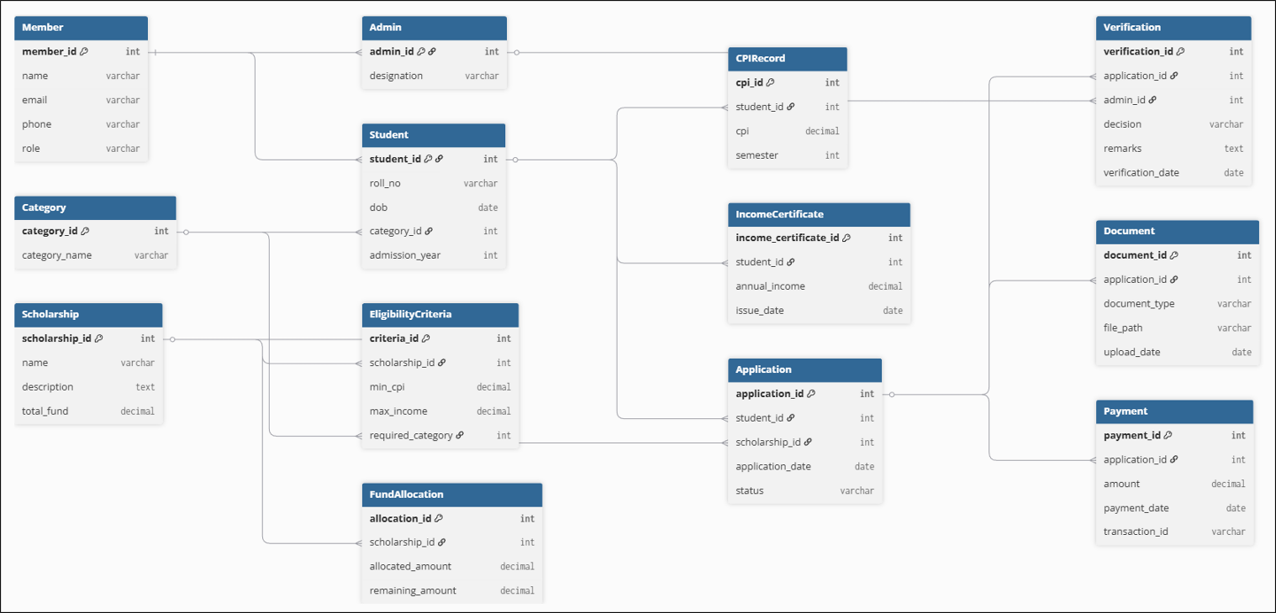

- Primary Keys (PK)
- Foreign Keys (FK)

Multiplicities
1. Member → Student | 1..1 → 0..1  One Member can be linked to zero or one Student (only students have student profiles).
2. Member → Admin | 1..1 → 0..1  One Member can be linked to zero or one Admin (only admins have admin profiles).
3. Category → Student | 1 → * (1..*)  One Category has many Students.  One Student belongs to exactly one Category.
4. Student → CPIRecord | 1 → * (1..*)  One Student has many CPI records.  Each CPIRecord belongs to exactly one Student.
5. Student → IncomeCertificate | 1 → * (1..*)  One Student can upload many income certificates.  Each certificate belongs to exactly one Student.
6. Scholarship → EligibilityCriteria | 1 → * (1..*)  One Scholarship may have multiple eligibility rules.  Each rule belongs to exactly one Scholarship.
7. Scholarship → FundAllocation | 1 → 1  One Scholarship has exactly one FundAllocation entry.
8. Student → Application | 1 → * (1..*)  One Student can submit many Applications.  Each Application belongs to exactly one Student.
9. Scholarship → Application | 1 → * (1..*)  One Scholarship can receive many Applications.  Each Application applies to exactly one Scholarship.
10. Application → Document | 1 → * (1..*)  One Application can have many Documents.  Each Document belongs to exactly one Application.
11. Application → Verification | 1 → 1  One Application has exactly one Verification entry.  One Verification belongs to one Application.
12. Admin → Verification | 1 → * (1..*)  One Admin can verify many Applications.  Each Verification is performed by exactly one Admin.
13. Application → Payment | 1 → * (1..*)  One Application can have many Payments (e.g., installments).  Each Payment is attached to exactly one Application.

4. ER Diagram Creation
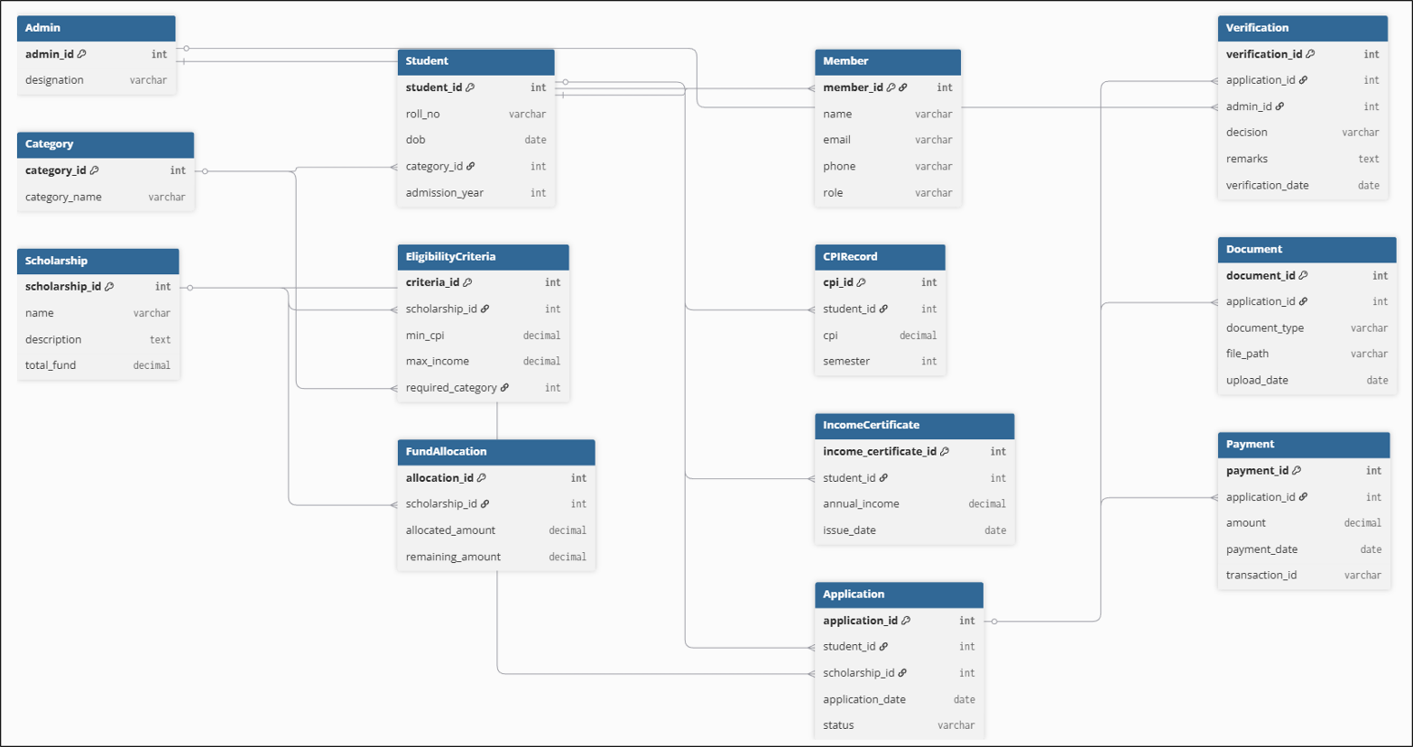
The ER diagram converts UML classes into database tables.
It shows:

- Primary Keys (PK)
- Foreign Keys (FK)
- 1-to-many relationships
- Table attributes
- Structural layout for actual SQL implementation

5. How ER is Derived from UML
Class → Entity
Each UML Class became an ER entity
Associations → Relationships
If UML shows:
Student 1 ---- * Application
ER shows:
- PK: student_id in Student
- FK: student_id in Application
That FK enforces the 1-to-many relationship.
Multiplicity → Cardinality
UML multiplicity tells us how many objects can be linked together in a relationship.
- 1..1 → one
Means exactly one item must be present.
- 1.. → one-to-many*
Means one item on the left can be connected to many items on the right.
- *** → many-to-many**
Means many items on both sides can connect with each other.
In our project, none of the relationships needed many-to-many.
So when converting UML → ER diagram, every relationship became 1-to-many (1:N).
Examples:
- Scholarship → EligibilityCriteria = 1:N
One scholarship can have many eligibility rules.
- Student → CPIRecord = 1:N
One student has many CPI entries (one per semester).
- Application → Payment = 1:N
One application can receive many payments.

6. Relationship Justification
Table Name | Table Description
Student – Category (N:1) | A student belongs to one category (General/OBC/SC/ST), but a category has many students.
Student – Application (1:N) | A student can submit multiple scholarship applications.
Scholarship – EligibilityCriteria (1:N) | A scholarship may have multiple eligibility rules.
Scholarship – FundAllocation (1:1 or 1:N) | One scholarship has one allocation entry (in our design).
Application – Verification (1:1) | Each application is verified once by an admin.
Application – Payment (1:N) | Multiple payments can be linked to a single application (installments, corrections).
Application – Document (1:N) | An application can have many required documents.
Student – CPIRecord (1:N) | Each semester, a student has a new CPI entry.
Student – IncomeCertificate (1:N) | A student can upload multiple income certificates over time.

6. Additional constraints
Primary Keys
Every table has a unique PK:

- student_id
- application_id
- scholarship_id
- criteria_id
- verification_id
- etc.

Foreign Keys

- application.student_id → Student
- eligibilitycriteria.scholarship_id → Scholarship
- verification.admin_id → Admin
- payment.application_id → Application

NOT NULL Constraints
All essential columns (name, date, status, etc.) are NOT NULL.
UNIQUE Constraints

- email (Member)
- roll_no (Student)
- transaction_id (Payment)
- category_name (Category)

CHECK Constraints

- CPI must be between 0 and 10
- Income must be non-negative

Referential Integrity
ON DELETE and ON UPDATE rules maintain database consistency.
Example:
Application → Student
FOREIGN KEY (student_id) REFERENCES Student(student_id) ON DELETE CASCADE
Meaning If a student is deleted then all their applications are deleted automatically.

8. Team Member Contributions
Name | Roll No. | Contribution
Vansh Kumar | 23110351 | Entire Project
Aditya Jain | 23110016
Satchit Velankar | 23110291
Yash Yeole | 23110367

9. Conclusion
This report presents the complete conceptual design of the ScholarEase system.
The UML and ER diagrams clearly show the main tables, their relationships, and all required constraints.
The design fully follows the Module A and Module B requirements and provides a strong foundation for building the ScholarEase database.

