PROJECT REPORT · PHASE 1

Heart Disease Risk Modelling
A comparison of six machine-learning classifiers (Bayesian network, Naive Bayes, Logistic Regression, SVM, Random Forest and Gradient Boosting) on the UCI Cleveland heart disease data, using leakage-safe nested cross-validation

Team: Hardik, Ayush, Akshith, Vansh, Kabir
Roll numbers: 2401010176, 2401010121, 2401010230, 2401010494, 2401010205
Supervisor: Mr. Shobhit Jhori
Institution: Newton School Of Technology, Rishihood University
Date: 26 October 2026

Abstract
We compare six classifiers for angiographically defined heart disease on the Cleveland subset of the UCI Heart Disease data (303 patients, 139 with disease): a domain-informed Bayesian network, Naive Bayes, Logistic Regression, a support vector machine (SVM), a Random Forest and Gradient Boosting. All preprocessing is fitted inside training folds, hyper-parameters are tuned by nested cross-validation, and every model is scored on the same 25 outer folds (5-fold stratified cross-validation repeated 5 times).
All six models discriminate well: pooled out-of-fold ROC AUC ranges from 0.890 (Gradient Boosting) to 0.910 (Bayesian network), and accuracy from 81.8% to 84.9% (SVM). In paired patient-level bootstrap comparisons, five of the six models cannot be told apart; every difference whose 95% interval excludes zero involves Gradient Boosting, which is slightly behind. The three most important predictors are the same for every model examined (number of vessels coloured by fluoroscopy, thallium scan result and chest pain type). With one centre, 303 patients and no external validation, these are internal estimates for an academic comparison and do not demonstrate clinical validity. The project also delivers tested, reproducible code and an interactive Streamlit web application.
Keywords: heart disease, Bayesian network, Naive Bayes, logistic regression, support vector machine, random forest, gradient boosting, nested cross-validation.
Contents
Abstract 2
1. Introduction and research motivation 4
1.1 Research question 4
1.2 Objectives 4
2. Related work and literature review 4
3. Dataset description and exploratory analysis 5
3.1 Source and schema 5
3.2 Data quality 5
3.3 Exploratory findings 5
4. Feature engineering and preprocessing 6
5. Theoretical methodology 7
6. Bayesian network and Naive Bayes 7
6.1 Bayesian network 7
6.2 Naive Bayes 8
7. Linear, kernel and ensemble models 8
8. Experimental design and evaluation metrics 9
8.1 Data splits 9
8.2 Metrics 9
9. Results and comparative analysis 9
9.1 Overall comparison 9
9.2 Are the differences real? 10
9.3 Errors at the 0.5 threshold 11
9.4 Selected hyper-parameters 11
10. Interpretation and feature importance 12
10.1 Permutation feature importance 12
10.2 Probability quality 12
11. Software and web application 13
12. Limitations and ethical considerations 13
13. Conclusion and future work 14
References 14
Appendix A. Team contributions 15
Appendix B. How to reproduce 15

1. Introduction and research motivation
Coronary artery disease is a leading cause of death, and deciding who needs invasive testing is a classic clinical-prediction problem. Given routine findings and exercise-test results, a model should rank patients correctly (diseased patients above healthy ones) and give trustworthy probabilities [1]. Machine-learning models of very different kinds can be trained for this task, and a natural question for a student project is whether the choice of model matters.

1.1 Research question
On the Cleveland data, under one identical and leakage-safe evaluation, how well do six classical machine-learning models predict heart disease, and do they differ meaningfully?

1.2 Objectives
- Load, verify and explore the dataset, documenting its quality and biases.
- Build leakage-safe preprocessing pipelines suited to each family of model.
- Implement a probabilistic graphical model (Bayesian network) and its simplest special case (Naive Bayes).
- Implement linear and kernel models (Logistic Regression, SVM) and tree ensembles (Random Forest, Gradient Boosting).
- Tune every model by nested cross-validation and compare all six on the same folds and metrics, with uncertainty.
- Explain which features the models rely on, and package the work as tested software with a web interface.

2. Related work and literature review
Dataset. The Cleveland, Hungarian, Swiss and Long Beach VA databases come from the international evaluation of a coronary-disease probability algorithm by Detrano et al. [2] and are distributed by the UCI repository [3]. Only the Cleveland file is used here.
Probabilistic graphical models. Pearl [4] and Koller and Friedman [5] give the theory of Bayesian networks and exact inference. Heckerman et al. [6] show how domain knowledge and data can be combined, which motivates fixing the structure from domain knowledge and learning only the probability tables. Domingos and Pazzani [7] explain why Naive Bayes classifies well even when its independence assumption is false.
Linear, kernel and ensemble models. Logistic regression is the standard model for binary clinical outcomes [8]. Support vector machines find a maximum-margin boundary, optionally in a kernel feature space [9], and Platt scaling converts their scores into probabilities [10]. Random forests average many decorrelated trees [11], and gradient boosting adds small trees sequentially to reduce the remaining error [12]. On tabular data, tree ensembles and simple models are strong baselines [13].
Evaluation. Using the same cross-validation for both tuning and reporting is optimistic; nested cross-validation avoids this [14], [15]. Information leaking from test data into preprocessing or model selection is a common cause of irreproducible results [16]. ROC analysis [17], the Brier score [18] and the bootstrap [19] are used here. We did not survey the many published accuracy figures for this dataset, because their protocols differ and are often under-reported.

3. Dataset description and exploratory analysis

3.1 Source and schema
We use processed.cleveland.data from the UCI Heart Disease archive (licence CC BY 4.0). The archive itself warns that the unprocessed cleveland.data is corrupted. The file has no header; columns are assigned in the documented order (Table 1).
Table 1. Predictors and their types (13 predictors plus the target).
Type | Features | Meaning
Continuous | age, trestbps, chol, thalach, oldpeak | age; resting blood pressure; serum cholesterol; maximum heart rate; exercise ST depression
Binary | sex, fbs, exang | sex; fasting blood sugar > 120 mg/dl; exercise-induced angina
Ordinal | ca, slope | vessels coloured by fluoroscopy (0-3); slope of peak-exercise ST segment
Nominal | cp, restecg, thal | chest pain type; resting ECG; thallium perfusion result
Target | num -> target | angiographic diagnosis 0-4; target = 1 if num is 1-4

3.2 Data quality
A verification script lists the archive, extracts the file and checks it before anything else runs. The file has 303 rows and 14 columns, no duplicate rows and no value outside the documented domains. Missing values occur only in ca (4) and thal (2), affecting 6 rows. The diagnosis num has counts 164 / 55 / 36 / 35 / 13 for levels 0-4, giving 164 negative and 139 positive patients (45.9% positive): the classes are close to balanced.
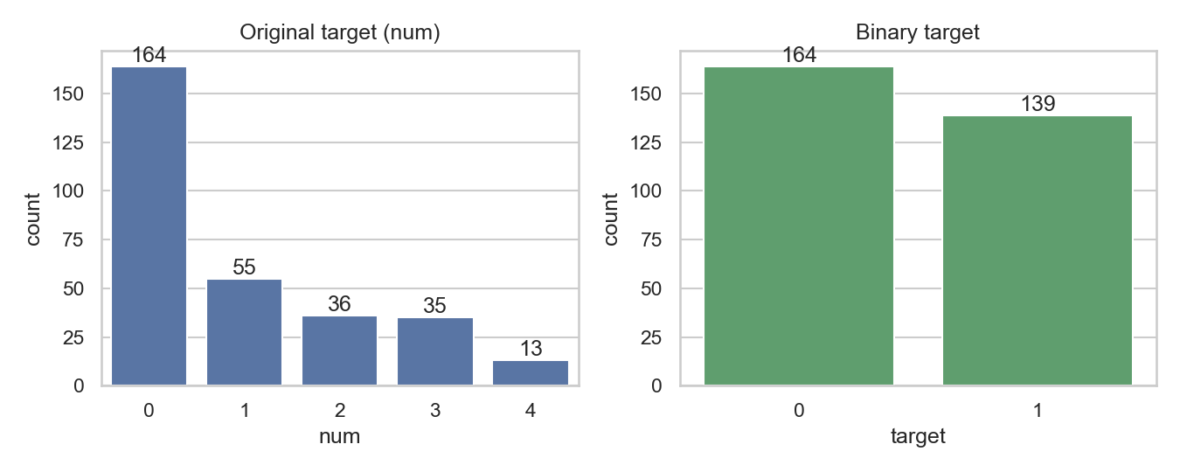
Figure 1. Distribution of the original diagnosis level and of the binary target.

3.3 Exploratory findings
These findings are descriptive; no significance is claimed and correlation does not imply causation.
- Only one predictor pair has |Spearman| >= 0.5: oldpeak and slope (0.595). No feature duplicates another.
- Several category levels are sparse (restecg = 1: 4 rows; thal = 6: 18; ca = 3: 20; cp = 1: 23).
- Asymptomatic chest pain (cp = 4) has the highest disease rate (0.729). This reflects who was referred for angiography rather than a protective effect of chest pain.
- ca, thal, oldpeak, slope, exang and thalach come from exercise testing, fluoroscopy and perfusion imaging, so the setting is a diagnostic work-up, not first-contact screening.
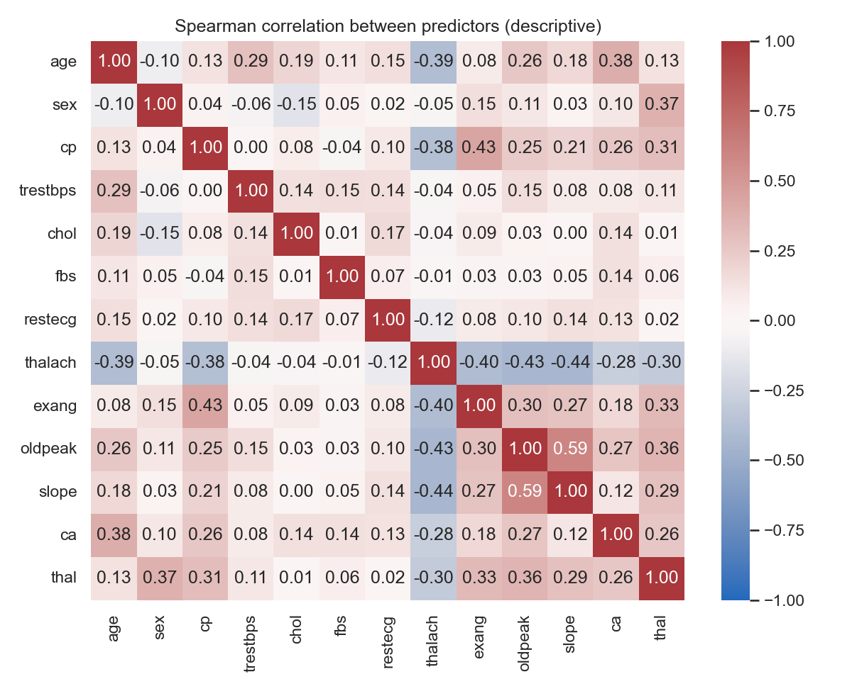
Figure 2. Spearman correlations between predictors and the target (descriptive).

4. Feature engineering and preprocessing
Both pipelines begin with a guard that raises an error if num or target is ever passed in as a predictor. Every data-dependent quantity (imputation values, scaling statistics, categories, bin edges) is learned in fit on the training fold only, and the evaluation clones and refits the whole pipeline in every inner and outer fold. This prevents information from held-out patients leaking into training.
Table 2. The two preprocessing pipelines.
 | Numeric pipeline (LR, SVM, RF, GB) | Discrete pipeline (Bayesian network, Naive Bayes)
Missing values | median (continuous), most frequent (others) | training mode
Continuous | standardised (mean 0, SD 1) | cut into training-fold tertiles (3 bins)
Ordinal | standardised | integer codes
Nominal | one-hot encoded (unseen category -> all zeros) | integer codes from the training categories
Output | 20 numeric columns | 13 integer columns

Why two pipelines. Logistic Regression and the SVM are sensitive to the scale of their inputs (the L2 penalty and the RBF distance both depend on it), so features are standardised; nominal codes such as chest-pain type carry no order and are one-hot encoded. The Bayesian network and Naive Bayes estimate conditional probability tables, which need a finite number of states, so continuous features are discretised. Tree ensembles do not need scaling but share the numeric pipeline to keep the comparison simple.

5. Theoretical methodology
All six models output a probability P(disease | x) for a patient with findings x; a patient is classified as diseased when this probability is at least 0.5.
- Bayesian network: the joint distribution factorises over a directed acyclic graph as P(x1, ..., xn) = Π P(xi | parents(xi)). The posterior of the target given all findings is computed exactly by variable elimination.
- Naive Bayes: a Bayesian network in which the class is the only parent of every predictor, so P(disease | x) ∝ P(disease) Π P(xi | disease).
- Logistic Regression: P(disease | x) = σ(w·x + b), where σ is the logistic (sigmoid) function. Weights minimise the log loss plus an L2 penalty ||w||² / (2C).
- SVM: finds the boundary with the widest margin; the RBF kernel K(x, x') = exp(-γ||x - x'||²) allows a curved boundary. C trades margin width against training errors. Platt scaling fits a sigmoid to the SVM scores to obtain probabilities.
- Random Forest: averages the votes of many decision trees, each grown on a bootstrap sample with a random subset of features at each split (bagging reduces variance).
- Gradient Boosting: adds shallow trees one at a time, each fitted to the gradient of the loss of the current ensemble, scaled by a learning rate (boosting reduces bias).

6. Bayesian network and Naive Bayes

6.1 Bayesian network
The network has 14 nodes (13 predictors plus target) and 16 directed edges fixed before any evaluation, following the convention risk factors -> disease -> findings (Figure 3). Only the conditional probability tables are estimated, from the training fold, with a Dirichlet prior whose pseudo-count is tuned. Inference uses pgmpy [20].
- Domain edges: age, sex and chol point to target; target points to cp, exang, restecg, thal, ca, thalach, oldpeak and slope; age -> thalach.
- Weak edges: age -> trestbps and age -> fbs.
- Modelling edges: cp -> exang and oldpeak -> slope, added to relax the Naive Bayes independence assumption. The second was suggested by the exploratory analysis.
The structure is an assumption, not learned from data and not a causal claim. target has three parents (18 parent configurations, about 13 training rows each), which is why the network was kept sparse. A missing value or a state outside the training range raises an error rather than being silently ignored.
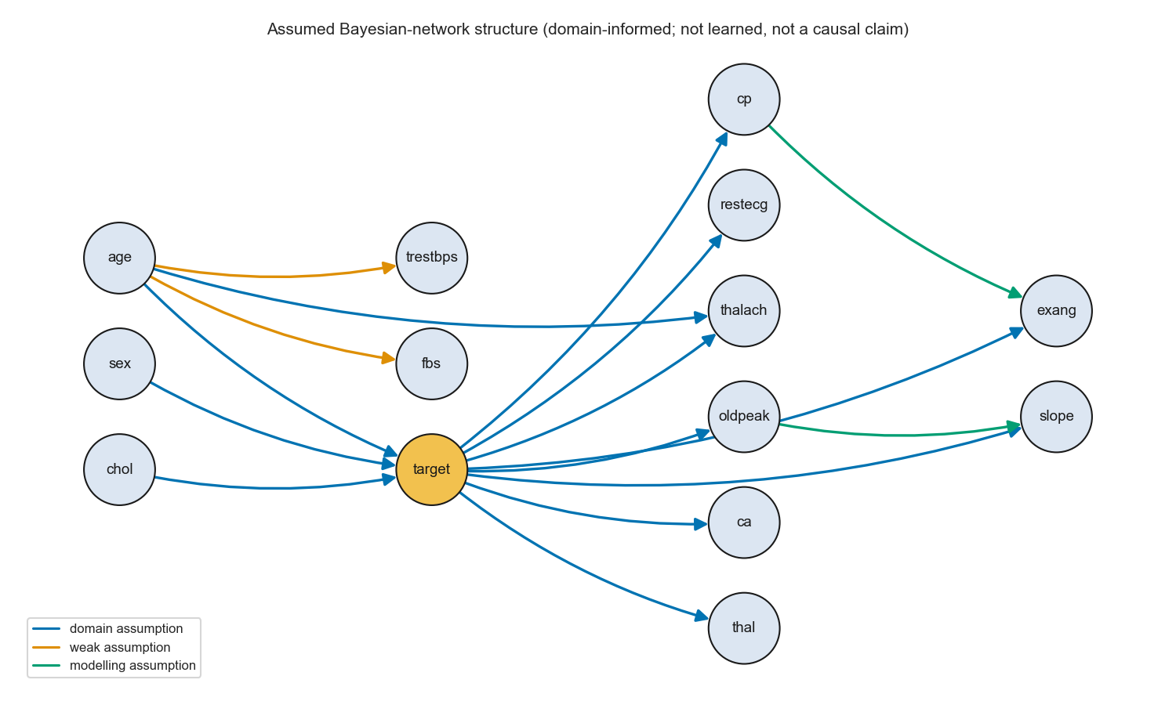
Figure 3. Assumed Bayesian network structure. Blue: domain assumption; orange: weak assumption; green: modelling assumption.

6.2 Naive Bayes
CategoricalNB from scikit-learn [21] on the same discrete inputs, with Laplace smoothing α tuned. Because it uses exactly the same inputs as the Bayesian network, comparing the two isolates the effect of the extra edges.

7. Linear, kernel and ensemble models
All four use the numeric pipeline and scikit-learn implementations, with the project seed fixed for reproducibility.
Table 3. Linear, kernel and ensemble models.
Model | Implementation | Tuned hyper-parameters (grid)
Logistic Regression | LogisticRegression, L2 penalty, lbfgs solver | C: 0.01, 0.1, 1, 10
SVM | SVC, RBF kernel, probability=True (Platt scaling) | C: 0.1, 1, 10; gamma: scale, 0.01
Random Forest | RandomForestClassifier | n_estimators: 200, 500; max_depth: 3, 5, None
Gradient Boosting | GradientBoostingClassifier | learning_rate: 0.05, 0.1; n_estimators: 100, 200; max_depth: 2, 3

8. Experimental design and evaluation metrics

8.1 Data splits
- Outer loop: 5-fold stratified cross-validation repeated 5 times = 25 outer folds of about 60 held-out patients each, identical for every model (seed 42). Stratification keeps about 46% disease in every fold.
- Inner loop (nested tuning): inside each outer training fold, a 5-fold stratified cross-validation tries every setting in the grid and keeps the one with the lowest inner out-of-fold log loss; that setting is refitted on the whole outer training fold. The held-out labels are used only to score the final predictions.
- Integrity checks on every run: each patient is predicted exactly once per repeat, probabilities are valid, and folds are identical across models.

8.2 Metrics
Table 4. Evaluation metrics (threshold 0.5 for the label-based ones).
Metric | Definition | Meaning
Accuracy | (TP + TN) / N | share of patients classified correctly
Sensitivity (recall) | TP / (TP + FN) | share of diseased patients detected
Specificity | TN / (TN + FP) | share of healthy patients correctly cleared
Precision | TP / (TP + FP) | share of positive calls that are correct
F1 | 2 · precision · recall / (precision + recall) | balance of precision and recall
ROC AUC | area under the ROC curve | probability that a random diseased patient scores above a random healthy one
Brier score | mean of (p - y)² | accuracy of the probabilities (lower is better)

Uncertainty. We report the mean ± SD over the 25 folds and, for the pooled out-of-fold predictions, 95% percentile intervals from a 2000-sample patient-level bootstrap [19]. Because every model is scored on the same patients, the bootstrap is paired: differences between two models are resampled together.

9. Results and comparative analysis
All numbers come from results/metrics/. Nothing was tuned against outer-fold results.

9.1 Overall comparison
Table 5. Fold-level mean ± SD over 25 outer folds (threshold 0.5).
Model | Accuracy | ROC AUC | Sensitivity | Specificity | F1 | Brier
Bayesian network | 0.829 ± 0.050 | 0.912 ± 0.036 | 0.793 ± 0.077 | 0.861 ± 0.068 | 0.810 ± 0.057 | 0.121 ± 0.027
Naive Bayes | 0.828 ± 0.049 | 0.907 ± 0.034 | 0.794 ± 0.088 | 0.857 ± 0.067 | 0.808 ± 0.058 | 0.129 ± 0.028
Logistic Regression | 0.847 ± 0.045 | 0.911 ± 0.036 | 0.780 ± 0.072 | 0.905 ± 0.057 | 0.823 ± 0.054 | 0.120 ± 0.023
SVM | 0.849 ± 0.046 | 0.910 ± 0.037 | 0.790 ± 0.078 | 0.899 ± 0.056 | 0.826 ± 0.056 | 0.119 ± 0.026
Random Forest | 0.834 ± 0.048 | 0.906 ± 0.037 | 0.778 ± 0.080 | 0.882 ± 0.053 | 0.810 ± 0.059 | 0.126 ± 0.020
Gradient Boosting | 0.818 ± 0.044 | 0.895 ± 0.047 | 0.772 ± 0.074 | 0.857 ± 0.056 | 0.795 ± 0.052 | 0.131 ± 0.029

Table 6. Pooled out-of-fold estimates with patient-level bootstrap 95% intervals.
Model | Accuracy [95% CI] | ROC AUC [95% CI] | Brier [95% CI]
Bayesian network | 0.830 [0.785, 0.869] | 0.910 [0.876, 0.940] | 0.121 [0.096, 0.148]
Naive Bayes | 0.828 [0.785, 0.867] | 0.905 [0.870, 0.935] | 0.129 [0.102, 0.159]
Logistic Regression | 0.848 [0.809, 0.885] | 0.904 [0.869, 0.936] | 0.120 [0.097, 0.143]
SVM | 0.849 [0.809, 0.886] | 0.907 [0.873, 0.939] | 0.119 [0.096, 0.142]
Random Forest | 0.834 [0.793, 0.872] | 0.903 [0.868, 0.934] | 0.126 [0.107, 0.147]
Gradient Boosting | 0.818 [0.778, 0.857] | 0.890 [0.853, 0.923] | 0.131 [0.109, 0.155]

The highest pooled ROC AUC is the Bayesian network (0.910) and the highest accuracy is the SVM (84.9%), closely followed by Logistic Regression. Gradient Boosting is lowest on both (0.890, 81.8%). Logistic Regression and the SVM have the highest specificity (about 0.90) and the best Brier scores; all models have similar sensitivity (0.77-0.79).
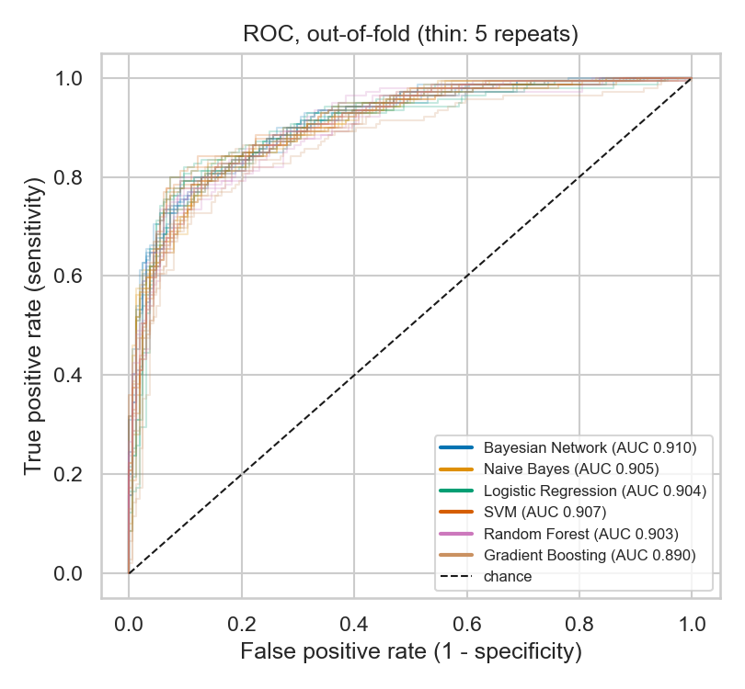
Figure 4. Out-of-fold ROC curves of the six models (thin lines: the 5 repeats).

9.2 Are the differences real?
Of the 15 model pairs, 12 have a ROC AUC difference whose 95% interval includes zero, and 12 have an accuracy difference whose interval includes zero. Every difference that excludes zero involves Gradient Boosting (Table 7); the other five models cannot be told apart. Because 30 intervals are examined, one or two could exclude zero by chance, so this is modest evidence that Gradient Boosting is slightly behind, not proof.
Table 7. Paired differences whose 95% bootstrap interval excludes zero (all others include zero).
Comparison | Metric | Difference | 95% interval
Bayesian Network - Gradient Boosting | ROC AUC | +0.020 | [+0.003, +0.036]
Logistic Regression - Gradient Boosting | accuracy | +0.029 | [+0.005, +0.052]
SVM - Gradient Boosting | accuracy | +0.030 | [+0.007, +0.053]
SVM - Gradient Boosting | ROC AUC | +0.017 | [+0.001, +0.032]
Random Forest - Gradient Boosting | accuracy | +0.016 | [+0.001, +0.031]
Random Forest - Gradient Boosting | ROC AUC | +0.013 | [+0.003, +0.023]

9.3 Errors at the 0.5 threshold
Per repeat, each model misses about 29-32 of the 139 diseased patients (false negatives). Logistic Regression and the SVM raise the fewest false alarms (15.6 and 16.6 per repeat). In a screening setting, missing one in five diseased patients would be a serious weakness.
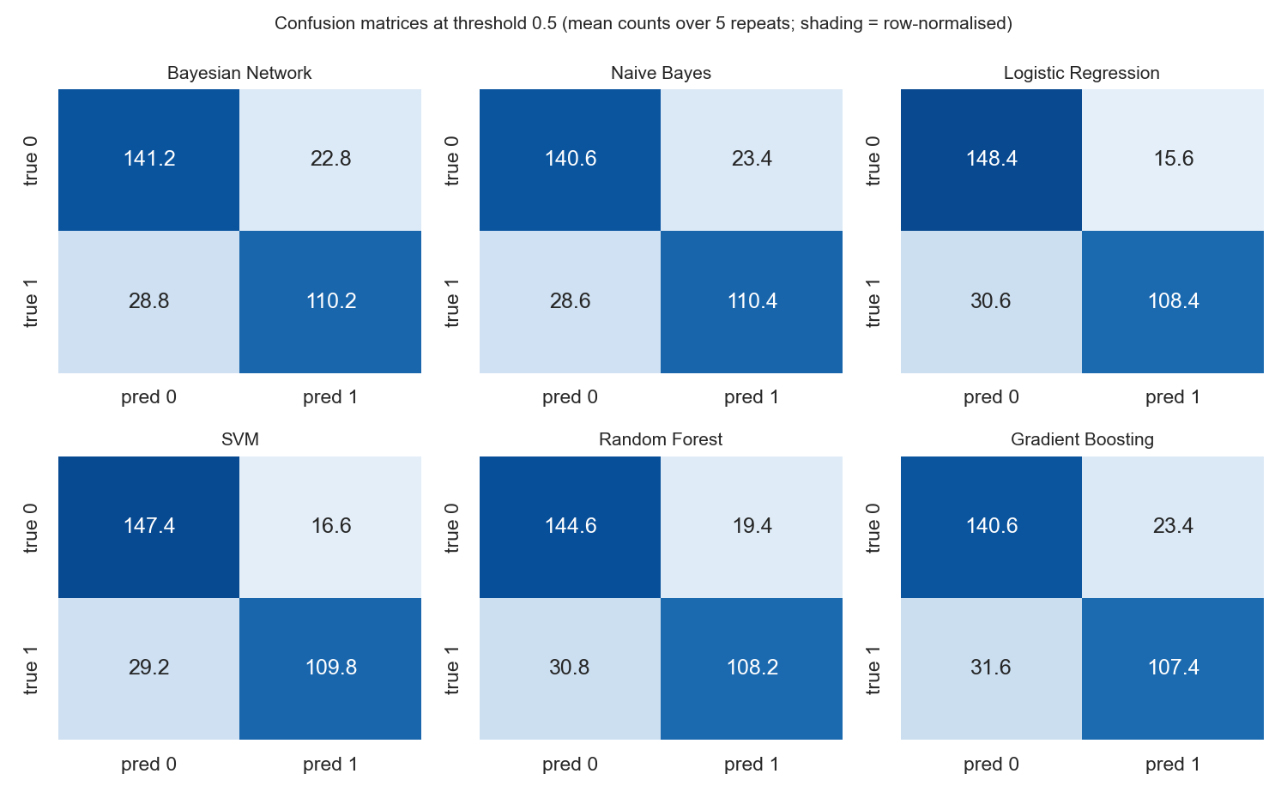
Figure 5. Mean confusion counts per repeat at threshold 0.5.

9.4 Selected hyper-parameters
Table 8. Hyper-parameters chosen most often by the inner cross-validation.
Model | Setting chosen most often | Folds
Bayesian network | pseudo_count = 10 | 25 / 25
Naive Bayes | alpha = 10 | 25 / 25
Logistic Regression | C = 1 | 14 / 25
SVM | C = 1, gamma = 0.01 | 23 / 25
Random Forest | n_estimators = 200, max_depth = 5 | 8 / 25
Gradient Boosting | learning_rate = 0.05, n_estimators = 100, max_depth = 2 | 20 / 25

The Bayesian network and Naive Bayes chose the largest smoothing value (10) in all 25 folds. Their probabilities are over-confident (see Section 10.2), and stronger smoothing pulls them towards less extreme values, which lowers the log loss used for tuning. The grid had already been widened from {0.5, 1, 2} before this run because an earlier run also chose its top value; we did not widen it again after seeing these results, to avoid tuning on the test results, and report it as a limitation.

10. Interpretation and feature importance

10.1 Permutation feature importance
For Logistic Regression, Random Forest and Gradient Boosting we measured permutation importance: on the held-out patients of each repeat-0 outer fold, one predictor is shuffled (30 times) and the drop in ROC AUC is recorded. A large drop means the model relies on that predictor. Each model was refitted with the hyper-parameters selected in that fold, and the refits reproduced the saved predictions exactly.
Table 9. Top six features by mean ROC AUC drop when shuffled.
Rank | Logistic Regression | Random Forest | Gradient Boosting
1 | ca (0.056) | thal (0.054) | ca (0.059)
2 | thal (0.030) | ca (0.042) | thal (0.046)
3 | cp (0.027) | cp (0.033) | cp (0.040)
4 | thalach (0.012) | sex (0.008) | sex (0.017)
5 | sex (0.011) | age (0.007) | age (0.012)
6 | oldpeak (0.007) | oldpeak (0.006) | oldpeak (0.011)

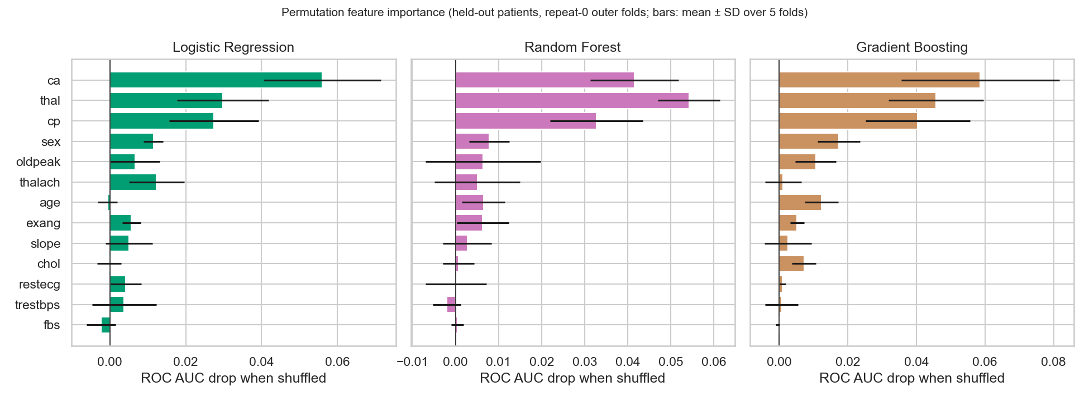
Figure 6. Permutation feature importance (mean ± SD over the five repeat-0 folds).
All three models agree that ca (vessels coloured by fluoroscopy), thal (thallium scan) and cp (chest pain type) carry most of the signal. Importance describes these fitted models on this sample, not causes in patients [22]; correlated predictors share credit, so a low rank (for example for age) does not mean a variable is irrelevant. The three leading features come from specialist tests, which again shows that these are not screening models.

10.2 Probability quality
Naive Bayes and the Bayesian network give the most extreme probabilities (28% and 25% of their predictions are at least 0.9, against 14% for the Random Forest). This is expected: when predictors are correlated, multiplying their probabilities counts the same evidence more than once. Their Brier scores (0.129 and 0.121) are close to the others, so the effect on overall probability accuracy is small, but individual extreme values should not be taken at face value.

11. Software and web application
Table 10. Repository layout. Every source file also has a Jupyter notebook copy.
Folder | Contents
src/data/ | loading and target mapping, archive verification, exploratory analysis
src/features/ | leakage-safe preprocessing pipelines
src/models/ | Bayesian network, Naive Bayes, the six model pipelines
src/evaluation/ | shared folds, nested cross-validation, metrics, the training-and-comparison script, feature importance
src/webapp/, app/ | Streamlit web application and its logic
tests/ | automated unit, integration and web-interface tests
results/ | metrics (CSV/JSON) and figures

python -m src.evaluation.run_evaluation trains and evaluates all six models on the same folds and writes every table and figure. The five-page Streamlit app (Overview, Data explorer, Model results, Risk estimator, Methods and limitations) shows the saved results and lets a user try all six models on a hypothetical patient. Every page carries a not-a-medical-device disclaimer; inputs are validated, nothing entered is stored and usage telemetry is off.
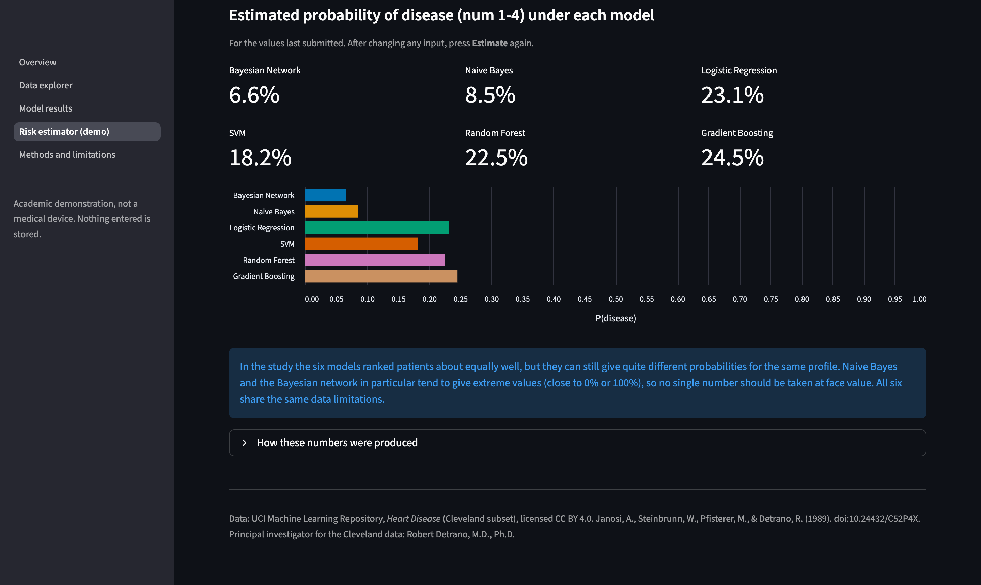
Figure 7. Risk estimator page: probability of disease under each of the six models.
Verification (26 October 2026, macOS, Python 3.9.6): all automated tests pass; all five web pages open without errors; refitting the models reproduces the saved predictions exactly. One project seed (42) drives every random step, and exact package versions are pinned in requirements-lock.txt.

12. Limitations and ethical considerations
- Small, single-centre data: 303 patients from one centre and period, with internal validation only.
- Referral and selection bias: all patients were already being assessed for coronary disease, so the 45.9% prevalence is not a population rate.
- Specialist predictors: the strongest predictors come from exercise testing, fluoroscopy and imaging, so the models do not apply to first-contact screening.
- Simplified target: the five severity levels were collapsed into yes / no.
- Missing data: six rows are filled with the training mode, ignoring imputation uncertainty.
- Tuning grid: Bayesian-network and Naive Bayes smoothing chose the largest grid value in every fold.
- Assumed structure: the Bayesian network is not learned and not causal.
- Fairness: 206 men versus 97 women limits subgroup conclusions; no fairness analysis was done.
- Responsible use: the app and report repeatedly state that this is not a medical device; no personal data is collected or stored. Full reporting guidance for clinical prediction models (TRIPOD [23]) was not followed.

13. Conclusion and future work
Under an identical, leakage-safe nested cross-validation on 303 Cleveland patients, six classical machine-learning models all predict angiographic heart disease well (ROC AUC 0.890-0.910, accuracy 81.8%-84.9%). Five of them cannot be told apart, and Gradient Boosting is slightly behind. Simple, interpretable models (Logistic Regression, the Bayesian network) do as well as the ensembles on this small tabular dataset. These are internal, exploratory estimates for an academic comparison; no clinical usefulness is claimed.
Future work:
- Phase 2: add a neural network and compare it on exactly the same folds.
- External validation on the Hungarian, Swiss and VA files of the same archive.
- Learning the Bayesian-network structure from data and comparing it with the expert structure.
- Multiple imputation of missing values, and subgroup and fairness analysis.

References
[1] E. W. Steyerberg et al., "Assessing the performance of prediction models: A framework for traditional and novel measures," Epidemiology, 2010. doi:10.1097/EDE.0b013e3181c30fb2
[2] R. Detrano et al., "International application of a new probability algorithm for the diagnosis of coronary artery disease," Amer. J. Cardiol., 1989. doi:10.1016/0002-9149(89)90524-9
[3] A. Janosi, W. Steinbrunn, M. Pfisterer and R. Detrano, "Heart Disease" [Dataset], UCI Machine Learning Repository, 1989. doi:10.24432/C52P4X
[4] J. Pearl, Probabilistic Reasoning in Intelligent Systems: Networks of Plausible Inference. Morgan Kaufmann, 1988.
[5] D. Koller and N. Friedman, Probabilistic Graphical Models: Principles and Techniques. MIT Press, 2009.
[6] D. Heckerman, D. Geiger and D. M. Chickering, "Learning Bayesian networks: The combination of knowledge and statistical data," Mach. Learn., 1995. doi:10.1007/BF00994016
[7] P. Domingos and M. Pazzani, "On the optimality of the simple Bayesian classifier under zero-one loss," Mach. Learn., 1997. doi:10.1023/A:1007413511361
[8] D. W. Hosmer, S. Lemeshow and R. X. Sturdivant, Applied Logistic Regression, 3rd ed. Wiley, 2013.
[9] C. Cortes and V. Vapnik, "Support-vector networks," Mach. Learn., 1995. doi:10.1007/BF00994018
[10] J. Platt, "Probabilistic outputs for support vector machines and comparisons to regularized likelihood methods," in Advances in Large Margin Classifiers. MIT Press, 1999.
[11] L. Breiman, "Random forests," Mach. Learn., 2001. doi:10.1023/A:1010933404324
[12] J. H. Friedman, "Greedy function approximation: A gradient boosting machine," Ann. Statist., 2001. doi:10.1214/aos/1013203451
[13] L. Grinsztajn, E. Oyallon and G. Varoquaux, "Why do tree-based models still outperform deep learning on tabular data?" NeurIPS Datasets and Benchmarks, 2022.
[14] S. Varma and R. Simon, "Bias in error estimation when using cross-validation for model selection," BMC Bioinformatics, 2006. doi:10.1186/1471-2105-7-91
[15] G. C. Cawley and N. L. C. Talbot, "On over-fitting in model selection and subsequent selection bias in performance evaluation," J. Mach. Learn. Res., 2010.
[16] S. Kapoor and A. Narayanan, "Leakage and the reproducibility crisis in machine-learning-based science," Patterns, 2023. doi:10.1016/j.patter.2023.100804
[17] T. Fawcett, "An introduction to ROC analysis," Pattern Recognit. Lett., 2006. doi:10.1016/j.patrec.2005.10.010
[18] G. W. Brier, "Verification of forecasts expressed in terms of probability," Mon. Weather Rev., 1950.
[19] B. Efron and R. J. Tibshirani, An Introduction to the Bootstrap. Chapman & Hall, 1993.
[20] A. Ankan and A. Panda, "pgmpy: Probabilistic graphical models using Python," Proc. SciPy, 2015. doi:10.25080/Majora-7b98e3ed-001
[21] F. Pedregosa et al., "Scikit-learn: Machine learning in Python," J. Mach. Learn. Res., 2011.
[22] C. Rudin, "Stop explaining black box machine learning models for high stakes decisions and use interpretable models instead," Nat. Mach. Intell., 2019. doi:10.1038/s42256-019-0048-x
[23] G. S. Collins, J. B. Reitsma, D. G. Altman and K. G. M. Moons, "Transparent reporting of a multivariable prediction model for individual prognosis or diagnosis (TRIPOD)," Ann. Intern. Med., 2015. doi:10.7326/M14-0697

Appendix A. Team contributions
Table 11. Team members and roles.
Member | Phase 1 work | Explains in the viva
Ayush | Data loading, verification, EDA and notebook, preprocessing / feature engineering | Dataset quality and EDA, feature engineering
Vansh | Bayesian network (structure, conditional probability tables, inference), data splits, metrics, Methods page | Theoretical rigour (probabilistic graphical models)
Hardik | Logistic Regression and SVM (new), model pipelines, the script that trains and compares all models | Model application (linear and kernel models)
Akshith | Random Forest and Gradient Boosting (new), hyper-parameter tuning (nested CV), feature importance | Model application (ensembles), tuning
Kabir | Naive Bayes, the web app (adapted to the ML models only) | Model application, demo

Appendix B. How to reproduce
From the project root, with the dataset archive at data/raw/heart+disease.zip:
python3 -m venv .venv && source .venv/bin/activate
pip install -r requirements-lock.txt
python -m src.data.verify
python -m src.data.eda
python -m src.evaluation.run_evaluation # about 10 minutes
python -m src.evaluation.interpret
python -m pytest -q
streamlit run app/streamlit_app.py

