
Heart Health
Vansh Rattan, COSE, vrattan_be23@thapar.edu
Aryan Sood, COSE, asood2_be23@thapar.edu

- Introduction:

- Technical background of project
Heart disease has become one of the biggest health problems today, and early detection can save many lives. Our project HeartHealth focuses on solving this problem by using Machine Learning to predict the risk of heart disease based on medical data.
The system works by studying past patient health records, learning important patterns, and then using those patterns to analyze new data. First, the data goes through cleaning and preprocessing to remove errors and missing values. After that, different classification models are trained so the system can understand which factors indicate higher risk. The best performing model is selected by testing accuracy and other evaluation methods.
Finally, the trained model is connected to a simple and interactive interface where users can enter their medical details and receive instant results. The goal of this project is to use AI in a practical way so that heart risk detection becomes faster, smarter, and more accessible.

- Technical Concepts used

- Uses Supervised Machine Learning
- Performs Binary Classification → stroke / no stroke
- Dataset is prepared by:
- Removing missing or incorrect values
- Converting data into model-readable format
- Selecting important medical features
- Train/Test split used to check real performance
- Multiple ML models tested, best one selected after comparison
Models Used:
- Logistic Regression
- Random Forest
- Decision Tree
- K-Nearest Neighbors (Final selected model)

Model Evaluation:
- Accuracy Score
- Confusion Matrix
- Precision & Recall
- F1-Score
- AUC Score (~0.98)
Libraries / Tools:
- pandas
- NumPy
- scikit-learn
- Flask/Streamlit (for web UI)
System Output:
- User enters medical details
- Data is processed by saved preprocessor
- Model predicts stroke risk
- Result + probability shown instantly in UI

- Motivation
- Stroke is one of the leading causes of death worldwide
- Many patients are diagnosed too late due to lack of early screening
- A fast and smart AI-based screening system can help detect risks early
- Useful to raise awareness and assist doctors with quick pre-checks
- Goal is to make stroke risk prediction easy, quick, and accessible through a web app.

- Problem Statement
Stroke has become a major health concern, and most patients are not able to get early screening due to limited awareness and lack of easily accessible tools. Medical data often contains missing values and imbalance, which makes risk prediction a difficult task.
The problem is to build a system that can take patient health information, process it correctly, and predict stroke risk accurately, while also making the results available instantly through an easy-to-use web application for quick screening, without replacing professional medical diagnosis.

- Area of application
The HeartHealth stroke risk prediction system can be applied in multiple real-world areas. It is useful in hospitals and clinics to support doctors in quick preliminary screening, helping them identify high-risk patients at an early stage. It can also be used in personal health screening web applications, where individuals can check their stroke risk by entering basic medical information.
Additionally, the system is relevant for medical research and data analysis, providing insights into important stroke-related factors. It can be applied in insurance companies for health risk assessment, and in awareness platforms that promote early stroke screening and prevention.
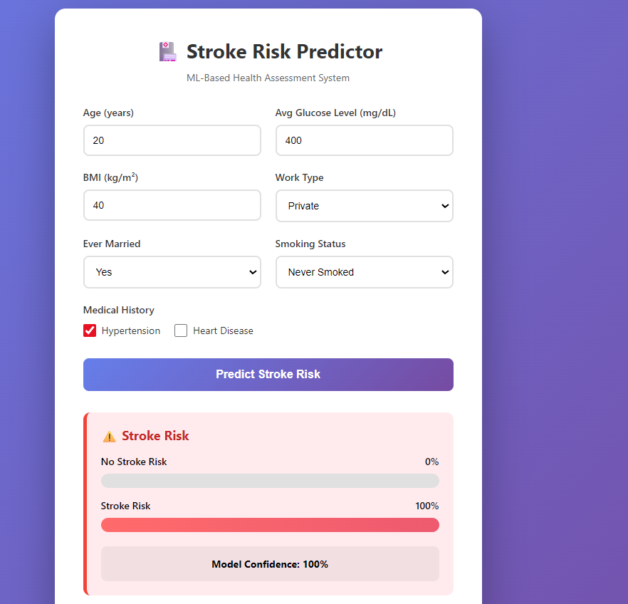

- Dataset and input format

Source: Kaggle Stroke Prediction Dataset
Size: 5,110 rows → cleaned to ~4,851 rows
Format: CSV
Target column: stroke (1 = risk, 0 = no risk)
Features: age, hypertension, heart disease, glucose, BMI, smoking, etc.
Categories converted using One-Hot Encoding
Prediction input from UI/API is in JSON
Example fields to expect in JSON input:
{
"age": 65,
"hypertension": 1,
"heart_disease": 0,
"ever_married": "Yes",
"work_type": "Private",
"avg_glucose_level": 150.2,
"bmi": 28.5,
"smoking_status": "formerly smoked"
}

- Objective
- Main Objective
To develop a machine-learning model that can predict stroke risk accurately from patient health data and make the prediction available through a simple web application for quick screening.
- Sub Objective
- Clean and preprocess the stroke dataset
- Handle missing BMI values and remove/cap outliers
- Convert categorical data using One-Hot Encoding
- Train and compare multiple ML classification models
- Select the best model (KNN) based on accuracy and AUC
- Deploy model using Flask/Streamlit with JSON input API

- Methodology
- Steps
- Load the Kaggle stroke dataset (CSV)
- Remove unnecessary columns and clean missing values
- Handle BMI outliers using standard deviation method
- Transform numeric data using scaling and skew correction
- Convert categorical data using One-Hot Encoding
- Train multiple ML classification models
- Tune top models using Randomized Search
- Select best model → KNN
- Save model and preprocessor as .joblib
- Deploy system using Flask/Streamlit with JSON prediction API

- Deliverable of each steps or phase
Phase | Deliverable
Data Cleaning | Final clean dataset (no unused/missing columns)
Outlier Handling | BMI values corrected dataset
Preprocessing | Scaled + encoded model-ready data pipeline
Resampling | Balanced dataset with improved recall
Model Training | Trained ML models + accuracy scores
Hyperparameter Tuning | Best parameters found for top models
Model Selection | Final KNN model chosen
Model Saving | best_model_knn.joblib and preprocessor.joblib
Deployment | Working web app + /api/predict endpoint

- Working Model
- Technical Diagram
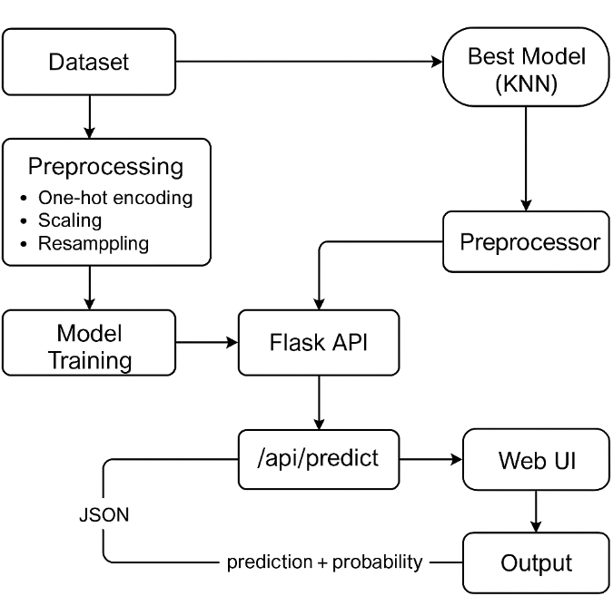
- Working Module
Input Collection: Web UI form takes patient details
Data Processing:
- Missing numeric values filled using Median Imputation
- Skewed features corrected using PowerTransformer
- Numeric values scaled using StandardScaler
- Categorical data converted using One-Hot Encoding
Model Training: Multiple classifiers trained & compared
Best Model: K-Nearest Neighbors (KNN) selected after evaluation

Saved Components:
- Trained model → best_model_knn.joblib
- Preprocessing pipeline → preprocessor.joblib
Prediction Flow:
- JSON input sent to Flask API (/api/predict)
- API processes data through saved pipeline → model predicts risk → returns probabilities
- UI shows result instantly using risk probability bars
Purpose: Quick stroke screening, not a final medical diagnosis

- Attained Deliverable
The project was completed successfully as a functional machine-learning stroke prediction and screening system, deployed with a working web interface and API support.
The main deliverables achieved are:
- Cleaned stroke dataset in CSV format
- Complete preprocessing pipeline implemented and saved
- Training and comparison of multiple classification models
- Final model selected: K-Nearest Neighbors (KNN)
- Saved artifacts for deployment:
  - best_model_knn.joblib
  - preprocessor.joblib
- Working Flask API endpoint /api/predict
- Responsive web UI displaying instant stroke risk and probability bars
After deployment, the system accepts patient input in JSON format, processes it through the saved pipeline, and returns prediction results instantly. The project fulfills the objective of providing fast and reliable stroke risk screening, while clearly stating that it does not replace medical diagnosis and requires clinical confirmation.

- Results:
- Outcome Graphs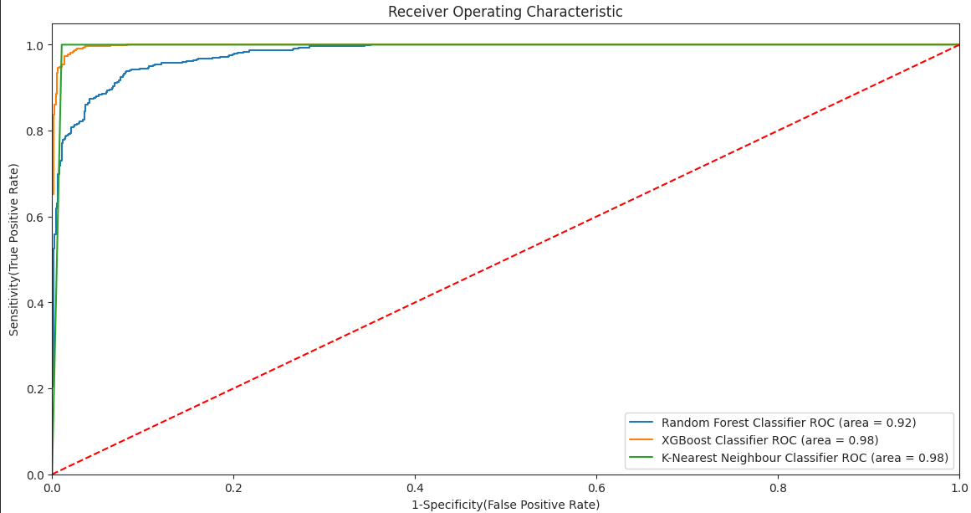
Fig. 5.1 – ROC Curve Comparison for Stroke Risk Prediction Models

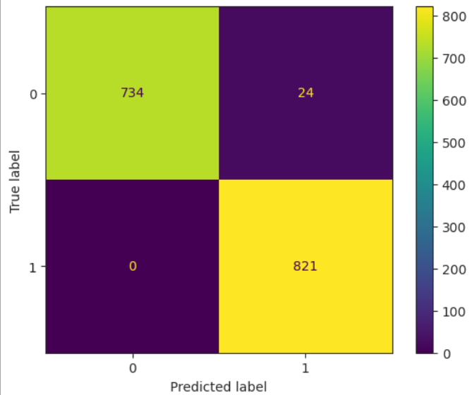

Fig. 5.2 – Confusion Matrix for KNN-Based Stroke Risk Classification

Model Name | Accuracy
Random Forest | 0.982901
XGBoost Classifier | 0.973401
K-Neighbors Classifier | 0.972134
Decision Tree | 0.940469
Gradient Boosting | 0.908803
Logistic Regression | 0.858771
AdaBoost Classifier | 0.844839

- Comparative Studies
- Several machine-learning classifiers were implemented and tested.
- The models were compared mainly on test accuracy and AUC score.
- After evaluation and tuning, K-Nearest Neighbors (KNN) performed the most consistently and was selected as the final model.
- The final model achieved ~98.5%–98.7% accuracy with an AUC close to 0.98.
The comparative study allowed us to understand which model adapts best to balanced and preprocessed medical data. KNN showed the most stable results after resampling and produced high accuracy without major performance fluctuation.
Although the results are strong on the given dataset, external validation will be done in the future to confirm real-world reliability.

- Conclusion
- Justification of Objectives
- The project successfully predicts stroke risk using ML
- Dataset cleaning, preprocessing, and balancing were completed effectively
- KNN model was correctly trained, tuned, and saved
- A working web interface and Flask API were deployed
- System provides instant prediction with risk probability
The objectives are justified as the final system works smoothly from data input to prediction and delivers highly accurate results for quick stroke screening. The web app makes risk detection faster and easily accessible while keeping it clear that it is not a medical diagnosis tool.

- Future Scope
- Expand the system by training on larger and diverse medical datasets to improve reliability across populations
- Integrate explainable AI techniques to clearly highlight risk-driving parameters and support medical decision-making
- Upgrade deployment to a scalable and optimized production environment using efficient backend servers
- Package the application into a containerized setup to ensure the same performance on any system
- Strengthen platform safety by implementing secure API access and input protection layers
- Going forward, the system aims to evolve into a more data-rich and transparent screening platform. By including more real-world stroke records and deeper AI-based reasoning, the predictions will become more adaptable, interpretable, and trustworthy for practical healthcare screening solutions.

- Reference
1. Stroke Prediction Dataset (Kaggle): https://www.kaggle.com/datasets/fedesoriano/stroke- References
prediction-dataset
2. Scikit-Learn – Machine Learning Library
https://scikit-learn.org/stable/
3. Flask – Python Backend Microframework
https://flask.palletsprojects.com/

Submitted by: Submitted to:
Vansh Rattan Dr. Nitin Arora
102316118 Assistant Prof.
Aryan Sood Dept. of CSE
102316123 TIET, Patiala

