**Project Description**

The objective of this project is to classify sonar data to identify whether the sonar signal reflects off a rock or a mine. The dataset used is the Sonar dataset, where each observation consists of features that describe the signal, and the target variable indicates whether the signal is from a rock (labelled as 'R') or a mine (labelled as 'M').

**Steps to Execute the Project**

**Step 1: Import Dependencies**

The first step is to import the necessary libraries.

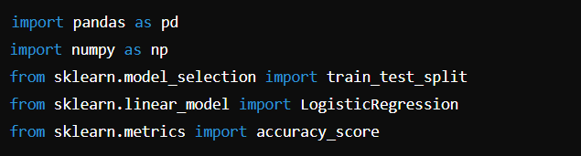

* **pandas**: For data manipulation and analysis.
* **NumPy**: For numerical operations.
* **sklearn.model_selection**: To split the dataset into training and testing sets.
* **sklearn.linear_model**: To implement the logistic regression model.
* **sklearn.metrics**: To evaluate the model’s performance.

**Step 2: Data Collection and Processing**

Load the dataset into a Pandas Data Frame.

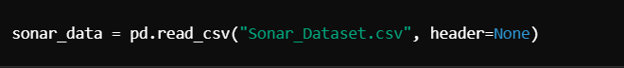

* **Data Loading**: The dataset is read from a CSV file. The header=None option indicates that there are no header rows in the dataset.

**Step 3: Separate Features and Labels**

Separate the features (X) and the labels (Y).

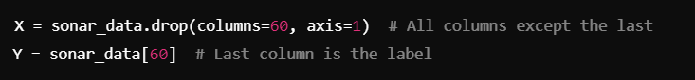

* X: Contains all columns except the last, which are the features.
* Y: Contains the last column, which is the target variable (rock or mine).

**Step 4: Split the Data**

Split the dataset into training and testing sets.



* **train_test_split**: Divides the dataset into training (90%) and testing (10%) subsets.
* **stratify=Y**: Ensures that both classes (rock and mine) are represented in both training and testing sets.

**Step 5: Model Selection**

Select the logistic regression model for classification.



* **Logistic Regression**: This is the chosen model for binary classification tasks.

**Step 6: Train the Model**

Fit the model using the training data.



* **fit**: Trains the model on the training dataset.

**Step 7: Evaluate the Model**

Evaluate the model's performance on both training and testing datasets.

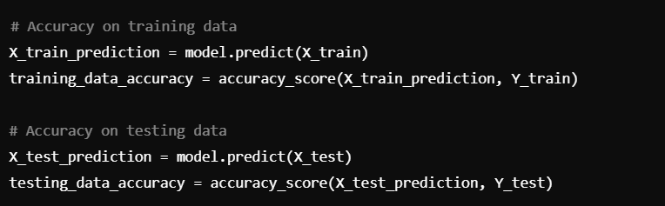

* **predict**: Generates predictions on the provided dataset.
* **accuracy_score**: Calculates the accuracy of the model predictions.

**Step 8: User Input for Predictions**

Allow the user to input their own data for prediction.

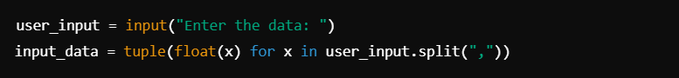

* The user is prompted to enter the features as a comma-separated string, which is converted to a tuple of floats.

**Step 9: Prepare Input Data for Prediction**

Convert the user input into a format suitable for prediction.

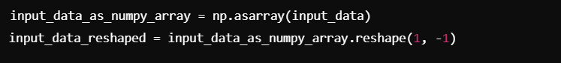

* **reshape**: Prepares the input data as a 2D array with a single sample.

**Step 10: Make Predictions**

Use the trained model to predict whether the input corresponds to a rock or a mine.



**Step 11: Output the Prediction**

Display the prediction result to the user.

* The prediction is checked and printed to inform the user of the result.

**Conclusion**

This project demonstrates the basic workflow of a machine learning classification task using logistic regression. It covers data loading, preprocessing, model training, evaluation, and making predictions based on user input. This foundation can be further expanded with feature engineering, hyperparameter tuning, or exploring more complex models.