DATA SCIENCE TOOLBOX: PYTHON PROGRAMMING

PROJECT REPORT
(Project Semester January-April 2025)

Quantitative and Visual Exploration of Crime Statistics

Submitted by

VANSH SINGLA
Registration No.: 12306679
Programme and Section: - B. TECH CSE & K23GD
Course Code: INT 375

Under the Guidance of

Baljinder Kaur (UID:28968)
(Assistant Professor)

Discipline of CSE/IT

Lovely School of COMPUTER SCIENCE AND ENGINEERING

Lovely Professional University, Phagwara

CERTIFICATE

This is to certify that Vansh Singla bearing Registration no. 12306679 has completed the INT 375 project titled, “Quantitative and Visual Exploration of Crime Statistics under my guidance and supervision. To the best of my knowledge, the present work is the result of his/her original development, effort and study.

Baljinder Kaur (UID:28968)
(Assistant Professor)
School of Computer SCIENCE AND ENGINEERING
Lovely Professional University
Phagwara, Punjab.

Date: 12/04/2024

DECLARATION

I, Vansh Singla, a student of BTech under CSE Discipline at Lovely Professional University, Punjab, hereby declare that all the information furnished in this project report is genuine and based on my intensive work.

Date: 12-04-2025 Signature: Vansh Singla
Registration No. 12306679

ACKNOWLEDGEMENT

I would like to express my heartfelt gratitude to my guide, Baljinder Kaur ma’am, for her invaluable guidance, support, and encouragement throughout the completion of this project. Her expertise and constructive feedback have significantly contributed to the success of this work.
I would also like to extend my sincere thanks to Lovely Professional University for providing me with the opportunity to work on this project under the subject DATA SCIENCE TOOLBOX: PYTHON PROGRAMMING (Subject Code: INT 375). The resources and skills imparted during this course laid a strong foundation for my research.
This project, titled “Analysing, Crime Statistics” has been a valuable learning experience. I am also grateful to my peers, family, and the Chicago Police Department for publishing the dataset that made this analysis possible. and everyone else who supported and encouraged me throughout this journey.
Thank you all for your continuous support and motivation.

Name: Vansh Singla
Section: K23GD
Roll No.: 23
Reg. No.: 12306679
Date: 12-04-2025

TABLE OF CONTENTS
- Introduction
- Source of Dataset
- EDA Process
- Analysis on Dataset
  - Introduction
  - General Description
  - Specific Requirements, Functions and Formulas
  - Analysis Results
  - Visualizations
- Conclusion
- Future Scope
- References

1. INTRODUCTION
In the modern era, data analysis has become an essential part of decision-making in almost every field. Crime data analysis can be of immense help to city planners, law enforcement agencies, and researchers who aim to understand crime patterns, reduce criminal activities, and enhance public safety.
This project is a beginner-level data science analysis focusing on crime data from Chicago between 2001 to the present. The aim is to analyze crime trends, most frequent offenses, and apply basic statistical techniques using Python programming and popular data science libraries such as Pandas, NumPy, Matplotlib, Seaborn, and Scipy.
The project covers essential data science skills like data cleaning, data visualization, exploratory data analysis (EDA), and statistical hypothesis testing. The skills applied are aligned with the topics covered in the Data Science Minor curriculum.

2. SOURCE OF DATASET
The dataset used for this project is titled "Crimes - 2001 to Present" and is publicly available on data.gov.
It has been maintained by the City of Chicago and includes details of reported crimes since 2001. The dataset is rich in information, including the type of crime, location, arrest status, date and time, and more. It consists of millions of records and provides a realistic platform to apply data analysis techniques.
Some of the columns include:
- ID: Unique identifier for each reported crime
- Date: The date and time of the crime
- Primary Type: The main category of the crime
- Location Description: Description of where the crime occurred
- Arrest: Whether an arrest was made
- Domestic: Whether it was a domestic incident
- Year, Month, Hour: Derived from the Date field

3. EDA PROCESS
The Exploratory Data Analysis (EDA) process is the first and most crucial step in understanding the dataset. It involves summarizing the main characteristics of the data and often visualizing them to find patterns, spot anomalies, and test assumptions.
Steps followed:
- Loading and inspecting the dataset using pandas.read_csv().
- Cleaning the data:
  - Converting the 'Date' column to datetime format.
  - Removing rows with missing values in important columns.
- Feature extraction:
  - Creating new columns like 'Year', 'Month', and 'Hour' from the 'Date' column.
- Identifying outliers and inconsistencies.
- Visual exploration of data distributions and patterns.

4. ANALYSIS ON DATASET
Introduction
The dataset contains a wide range of crime records from the city of Chicago. Through this analysis, we aim to derive useful insights like the most common types of crimes, when they usually happen, and how their frequency has changed over time.
General Description
This analysis was done using Python programming. The analysis includes cleaning, transforming, and visualizing the dataset. Libraries like pandas and numpy were used for manipulation, and matplotlib and seaborn were used for plotting. For statistics, scipy.stats was used.
Specific Requirements, Functions and Formulas
- read_csv() - Load CSV file
- dropna() - Remove missing values
- value_counts() - Count occurrences
- datetime.dt.year/month/hour - Extract time information
- plot(), barplot(), countplot(), heatmap(), boxplot() - For plotting
- ttest_1samp() - One-sample t-test
- chisquare() - Chi-squared test
Analysis Results
- Top Crime Types: The most common crimes are THEFT, BATTERY, and CRIMINAL DAMAGE.
- Yearly Trend: The number of crimes peaked in the early 2000s and then fluctuated.
- Hourly Pattern: Crime is most frequent in the late evening hours.
- Location Description: Many crimes occurred on streets, in apartments, and at schools.
- Arrests: A relatively low percentage of crimes resulted in arrests.
Visualizations
- Bar Plot: Top 10 crime types
- Line Graph: Crime trends over the years
- Count Plot: Crimes by hour of the day
- Heatmap: Correlation between Year, Month, Hour
- Box Plot: Outlier detection in crime hour distribution
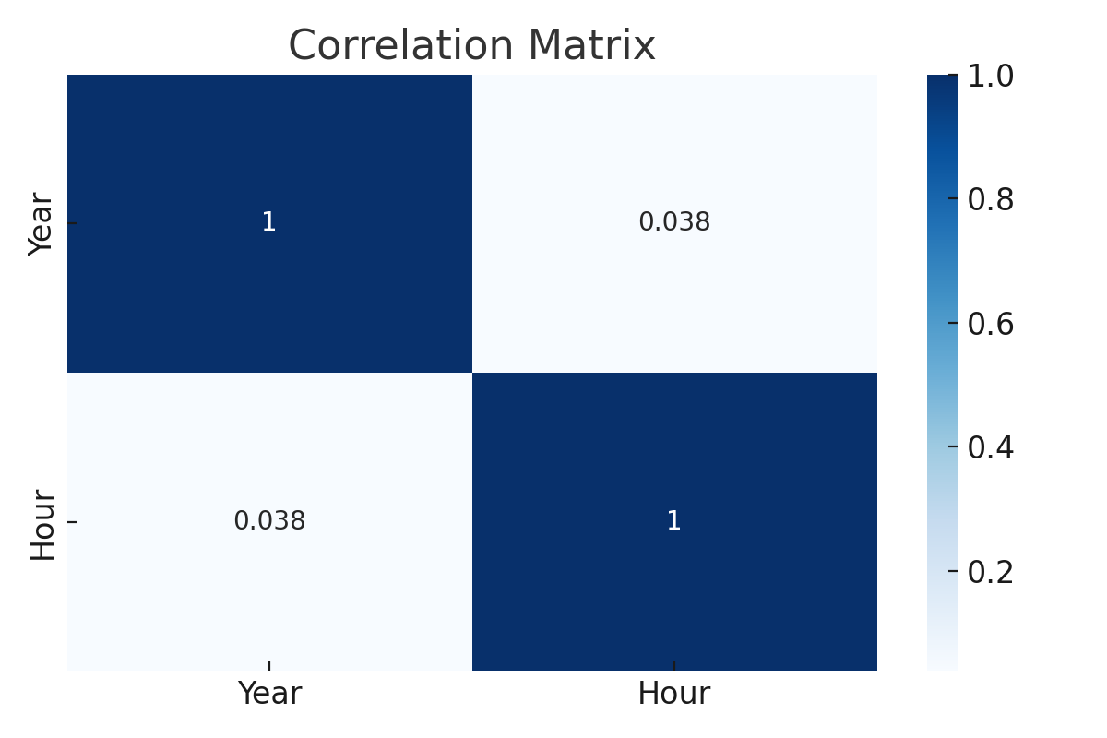
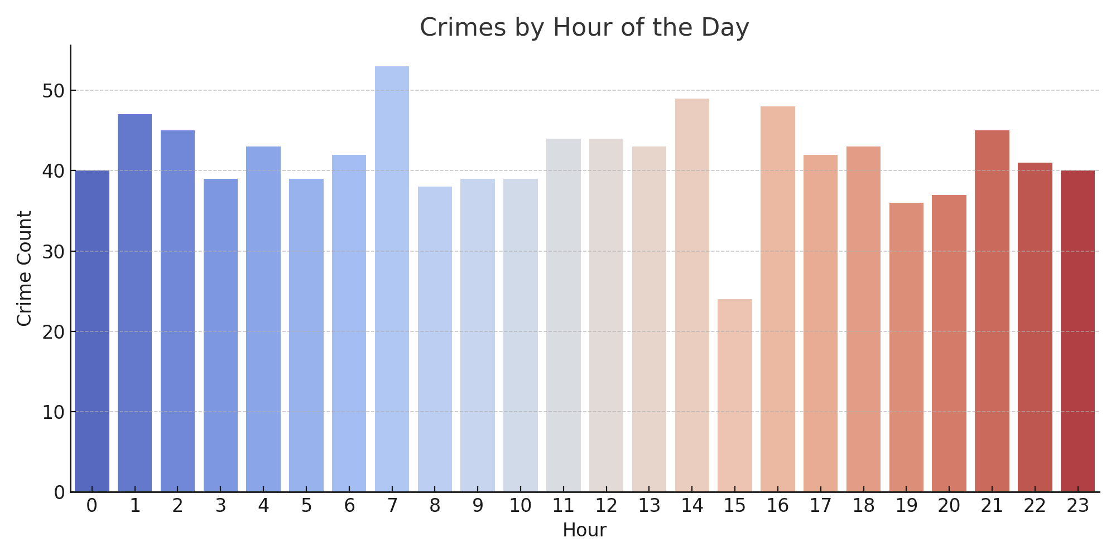

5. CONCLUSION
From this project, we gained insights into the frequency and nature of crimes in Chicago. We learned how to process real-world datasets, extract meaningful features, and visualize data to uncover patterns.
We identified that crimes are more common in specific time slots, and some crime types are more dominant. These findings could potentially help law enforcement agencies in optimizing patrol timings and identifying hotspots. The statistical analysis provided further confidence in interpreting trends.
This project has laid a strong foundation in basic data science practices. It provided hands-on experience in using Python, Pandas, NumPy, Matplotlib, Seaborn, and Scipy.

6. FUTURE SCOPE
- Geospatial Analysis: Using libraries like folium or geopandas to visualize crime locations on maps.
- Time Series Forecasting: Use models like ARIMA or LSTM to predict future crime trends.
- Clustering: Identify crime hotspots using clustering algorithms like KMeans.
- Machine Learning Models: Classify crime types or predict arrest chances.
- Real-time Dashboards: Integrate the results into dashboards using Streamlit or Dash.

7. REFERENCES
[1] City of Chicago Crime Dataset - https://catalog.data.gov/dataset/crimes-2001-to-present [2] Scipy Documentation - https://docs.scipy.org/ [3] Matplotlib Documentation - https://matplotlib.org/ [4] Seaborn Documentation - https://seaborn.pydata.org/ [5] Pandas Documentation - https://pandas.pydata.org/ [6] NumPy Documentation - https://numpy.org/doc/ [7] Python Official Website - https://www.python.org
8. Social MEDIA
- LinkedIn:- https://www.linkedin.com/posts/vaibhavmittal55552_datascience-python-crimeanalysis-activity-7316727545612193792-NL_Q/?utm_source=share&utm_medium=member_android&rcm=ACoAAEdZbWkBdY0KiiI7pdi66uAt9YHURufhQa8
- Github:- https://github.com/VaibhavMittal-web/Statistical-and-Visual-Insights-into-Two-Decades-of-Crime-in-Chicago

