Sustainable Supply Chain Perfomance Dashboard Using PowerBi – Week 1

Steps:-

* First, downloaded the powerbi software from Microsoft store.
* Then downloaded the csv file provided by the sir in group
* Then, as Chaintanya sir taught, loaded the file into power bi and transformed it in order to make change
* Then as per the instructions provided and learned in the lecture ,duplicated the original table provided and starting removing the columns which were irrelevant to the given table
* Then, after all tables were created, choose close and apply option to make changes.
* Made word file and attach the screenshots of the tables created.
* And finally saved the file and uploaded it to my github account
* And as per instructions provided, uploaded week-1 task to LMS portal.

Inventory Table:

1. Product type

2. SKU

3. Availability

4. Number of products sold

5. Customer demographics

6. Stock levels

7. Lead times

8. Order quantities

9. Lead time

10. Revenue generated

Output:-

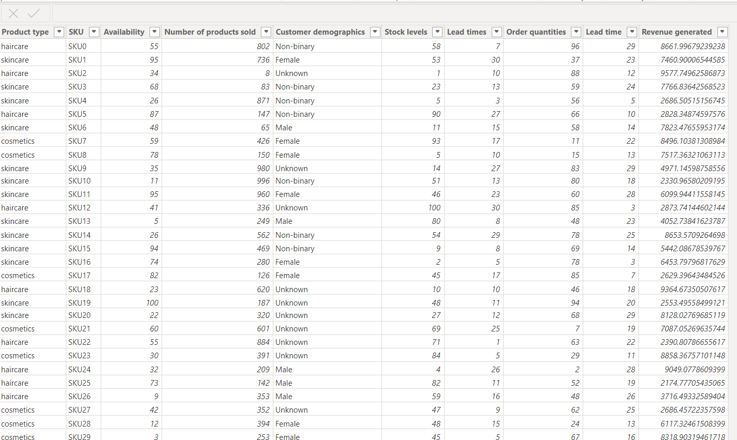

Manufacturing table

1. Product type

2. SKU

3. Production volumes

4. Manutacturing lead time

5. Manufacturing costs

6. Inspection results

7. ⁠ defect rates

Output:-

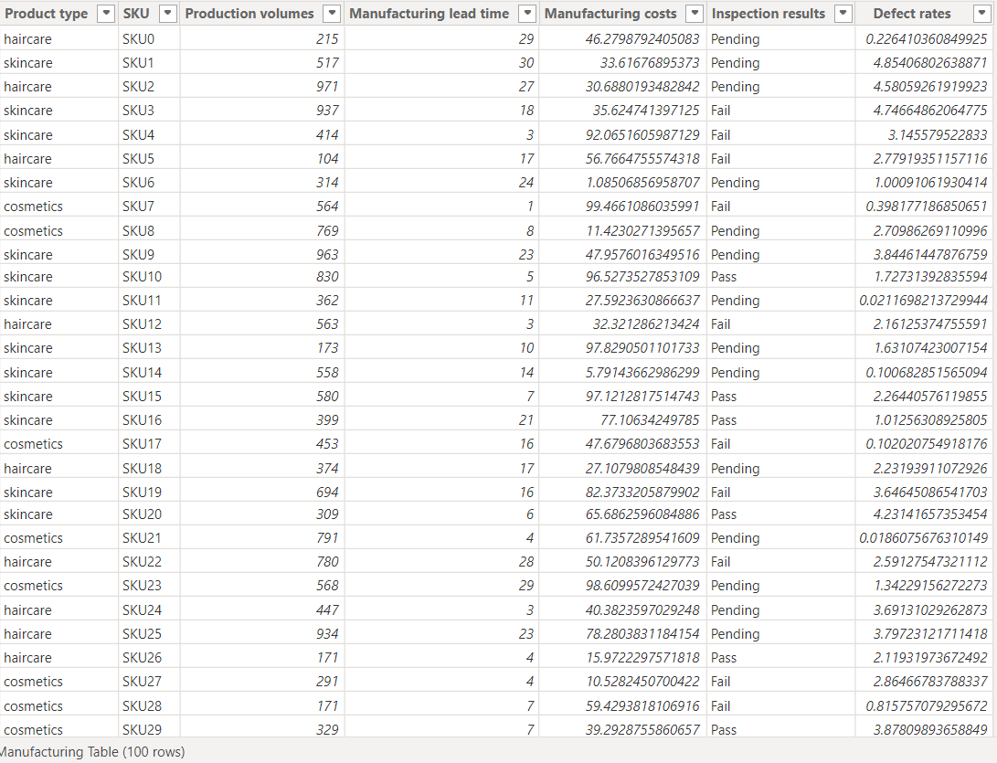

Supplier Table

1. Supplier name

2. Location

3. Lead time

4. transportation modes

5. Routes

Output:-

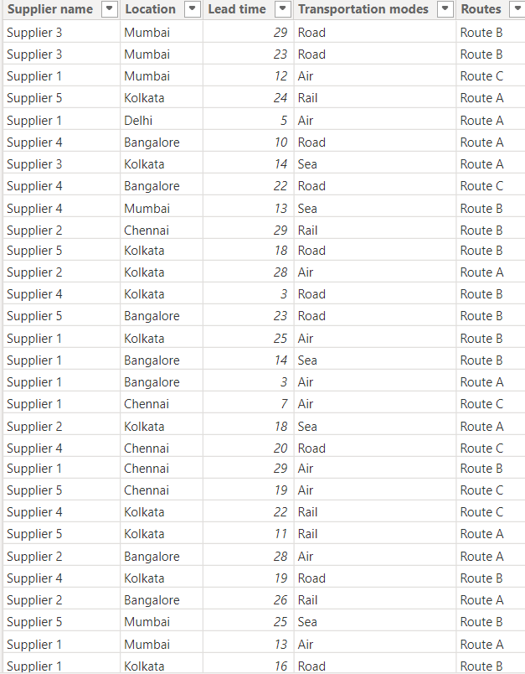

Supply chain table

1. Product type

2. SKU

3. Price

4. Availability

5. Number of products sold

6. Revenue generated

7. Customer demographics

8. Stock levels

9. Lead times

10. Order quantities

11. Shipping times

12. Shipping carriers

13. Shipping costs

14. Supplier name

15. Location

16. Lead time

17. Transportation modes

18. Routes

Output:-

