Lab Expeiment -22 Docker image vulnerability scanning using trivy(windows)

Objective

By the end of this lab, you will be able to:

- Install and configure Trivy on Windows
- Scan Docker images for vulnerabilities
- Interpret scan reports and take remediation actions

Prerequisites

- Windows 10/11 (with Docker Desktop installed and running)
- Internet access (Trivy downloads vulnerability databases)
- Basic familiarity with Docker CLI commands

Step 1: Verify Docker Setup

Before using Trivy, make sure Docker is working correctly.

docker --version

docker run hello-world

Expected Output:

Docker runs successfully and displays the “Hello from Docker!” message.

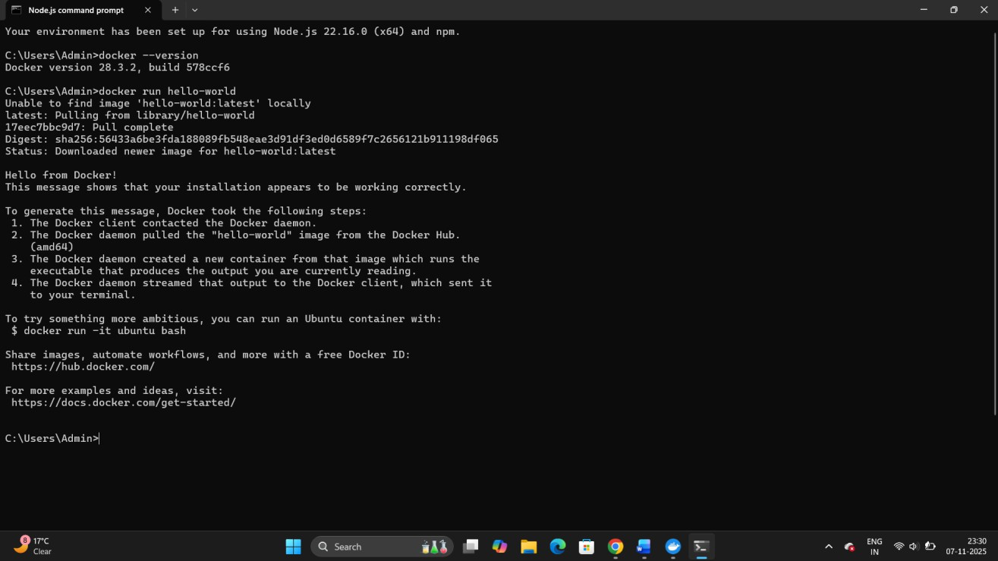

Step 2: Install Trivy on Windows

Manual Installation

- Go to the official GitHub releases page: https://github.com/aquasecurity/trivy/releases
- Download the Windows ZIP file (trivy_x.x.x_windows_amd64.zip)

- Extract it (e.g., to C:\trivy)

- Add that folder to your System PATH environment variable

Verify Installation

Open PowerShell and run:

trivy --version

Expected Output: Trivy version and build information.

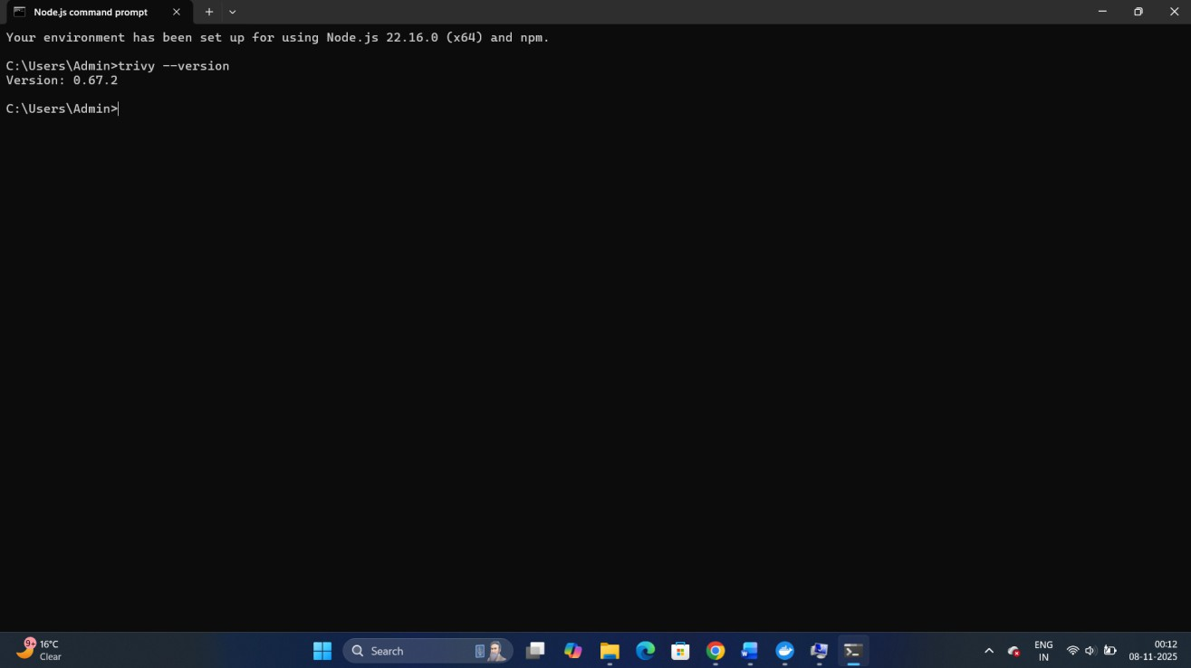

Step 3: Pull a Docker Image

Let’s pull an image that we’ll scan:

docker pull nginx:latest

Check it’s downloaded:

docker images

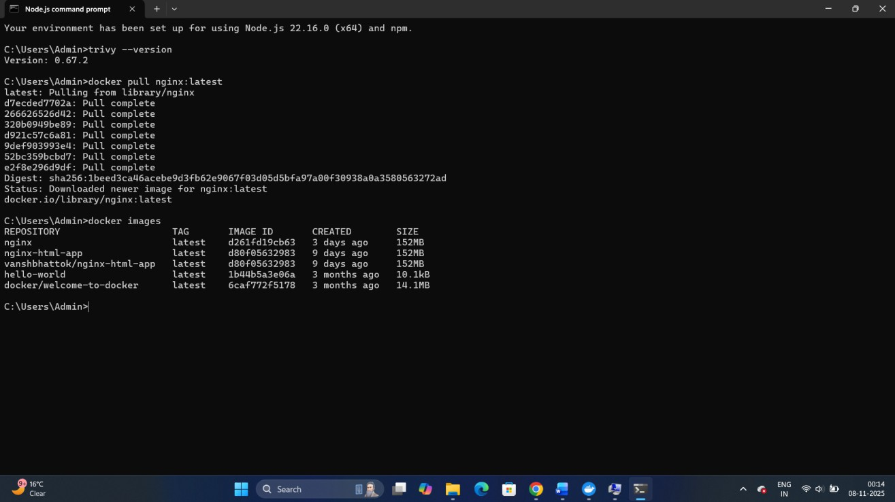

Step 4: Scan Docker Image with Trivy

Now, run a vulnerability scan on the image:

trivy image nginx:latest

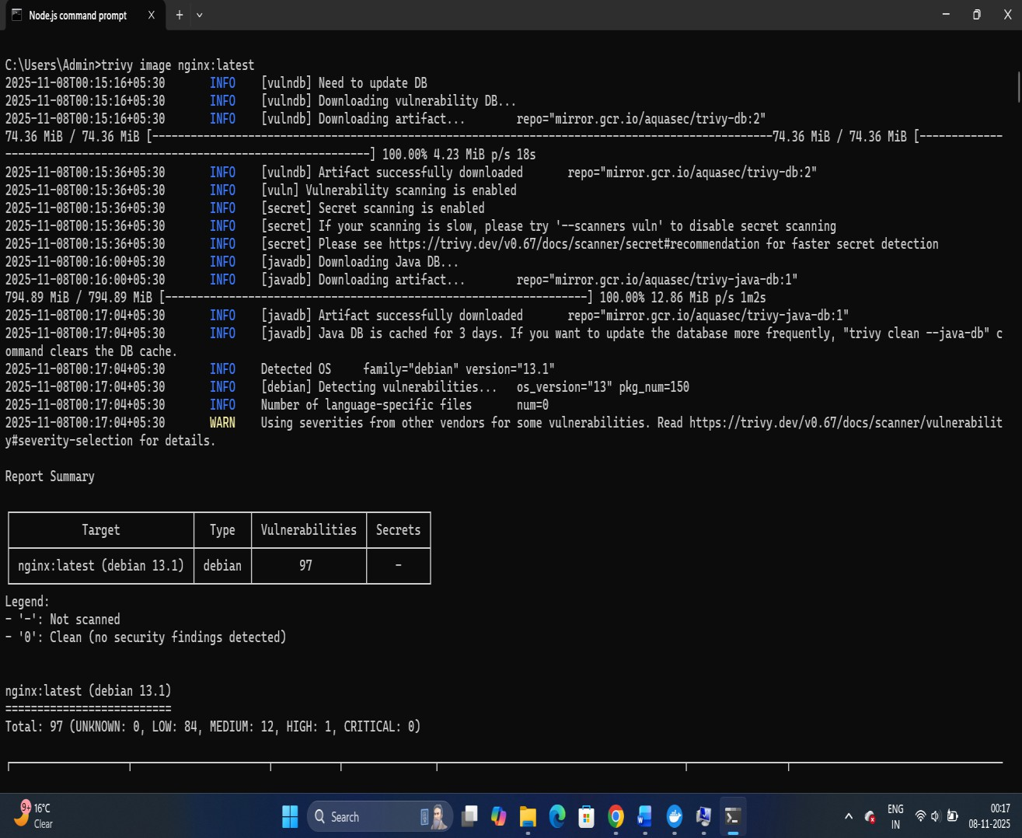

Explanation:

Trivy will:

- Fetch the latest vulnerability database

- Analyze all OS packages and libraries inside the image
- Display severity levels (LOW, MEDIUM, HIGH, CRITICAL)

Sample Output

nginx:latest (debian 12.2)

==================================

Total: 12 (LOW: 2, MEDIUM: 4, HIGH: 5, CRITICAL: 1)

│ PACKAGE │ VULNERABILITY ID
┌──────────────┬────────────────────────────┬────────┬

──────────────────┬──────────────┐
├──────────────┼────────────────────────────┼────────┼

──────────────────┼──────────────┤
│ SEVERITY │ INSTALLED VERSION │ FIXED VERSION
│
└──────────────┴────────────────────────────┴────────┴

──────────────────┴──────────────┘
│ 1.2.12 │
│ MEDIUM │ 1.2.11-5
│ CVE-2022-37434
│ zlib
│ 3.0.9-2 │
│ HIGH │ 3.0.9-1
│ openssl │ CVE-2023-0464
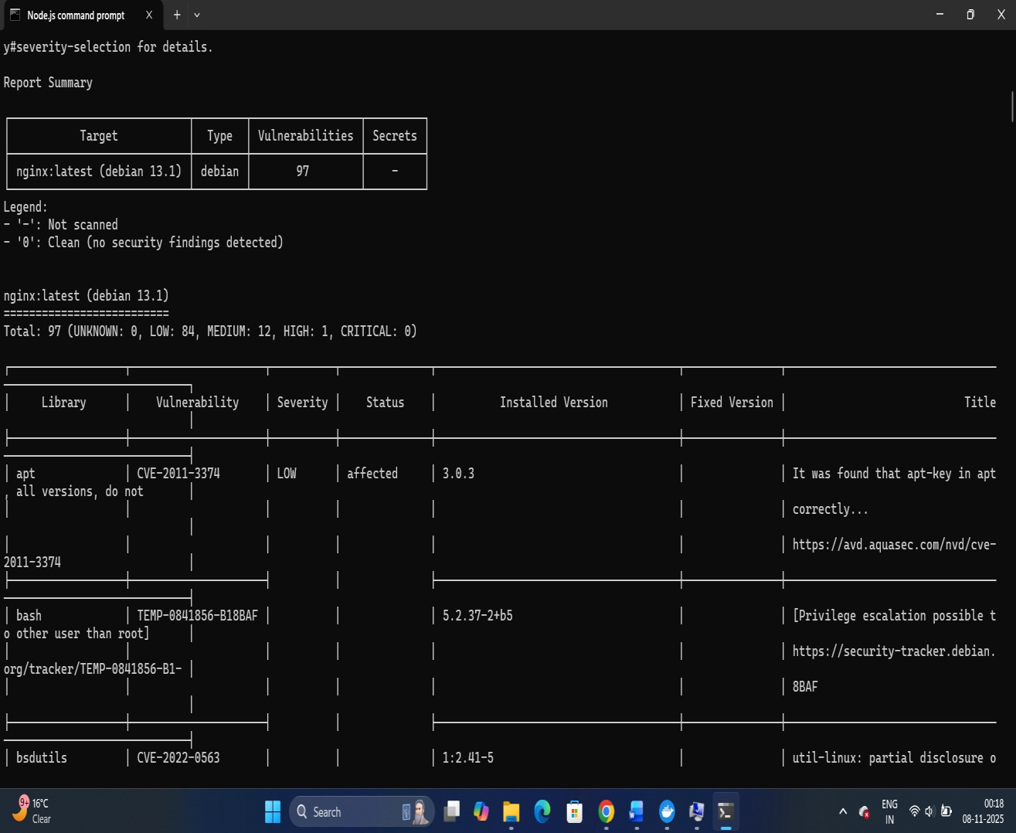

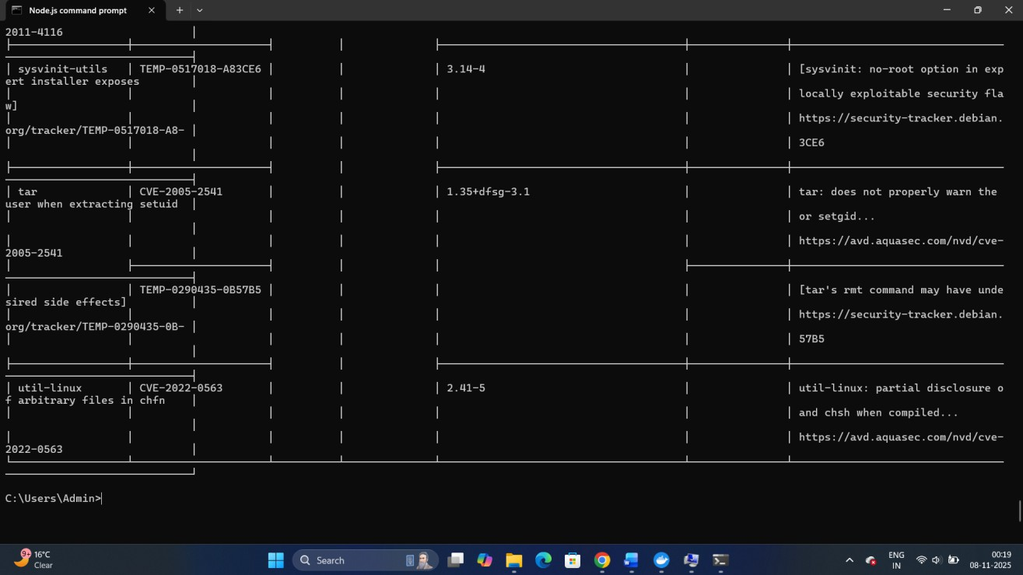

Step 5: Save Report to a File

You can export the results in different formats.

Save as a text file:

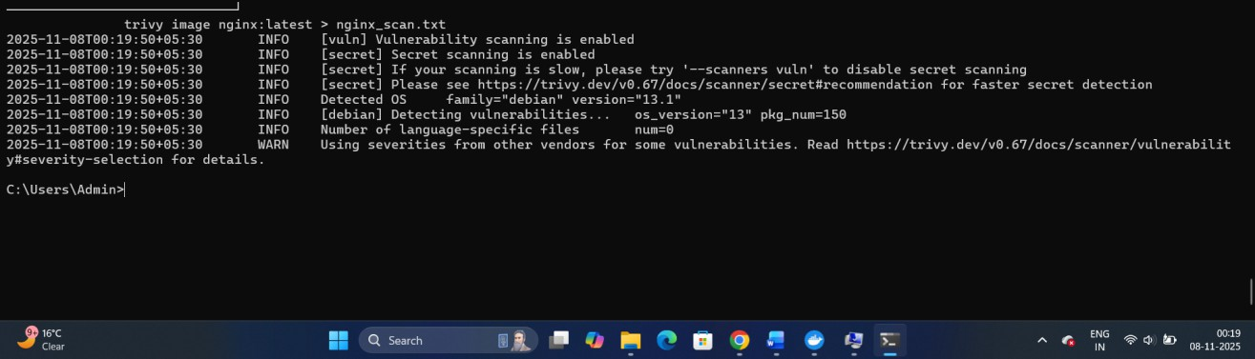
trivy image nginx:latest > nginx_scan.txt

Save as a JSON report:

trivy image --format json -o nginx_scan.json nginx:latest

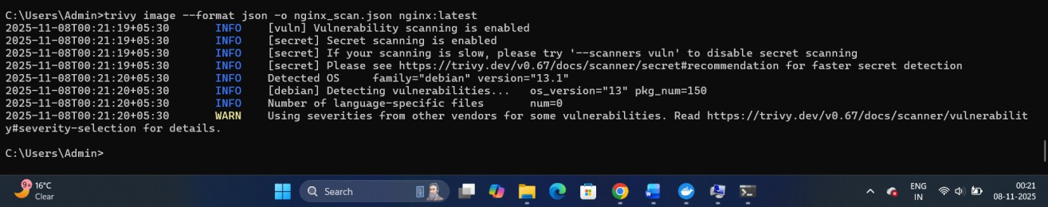
Tip: JSON format is useful for automation or CI/CD integration.

Step 6: Scan a Local Image

If you’ve built your own Docker image:

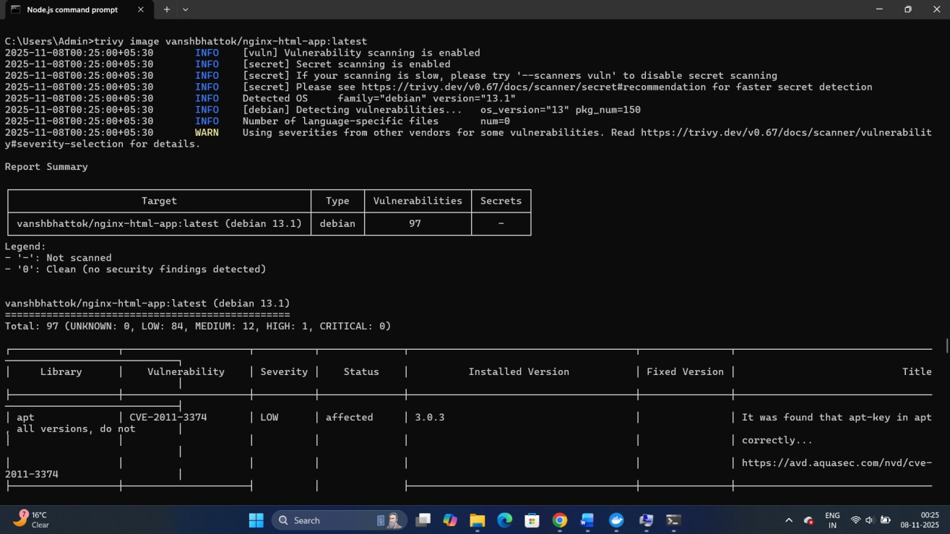
docker build -t myapp:1.0 .

trivy image myapp:1.0

Step 7: Update Vulnerability Database

Keep Trivy’s database up-to-date:

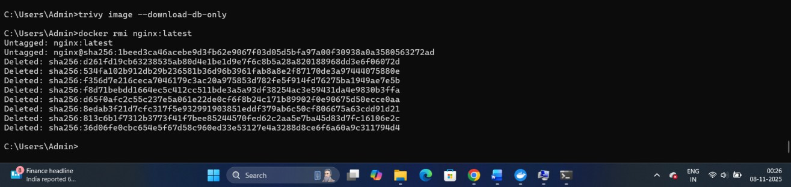
trivy image --download-db-only

Step 8: Clean Up

Remove images (optional):

docker rmi nginx:latest

