**Data Base Management System**

**Name :-** vansh pipaliya

**Roll no :-** 23BCE258

**Practical 4**

**1. Create the constraints as specified for all the tables.**

**a) Create table client (used to store client information) having following attributes:**

|  |  |  |  |  |
| --- | --- | --- | --- | --- |
| **Column Name** | **Data Type** | **Size** | **Default** | **Attributes** |
| clientno | varchar2 | 6 |  | Primary key at column level/first letter must start with ‘C’ (at column level) |
| name | varchar2 | 20 |  | Not Null |
| city | varchar2 | 15 |  |  |
| pincode | number | 8 |  |  |
| state | varchar2 | 15 |  |  |
| baldue | number | 10, 5 |  |  |

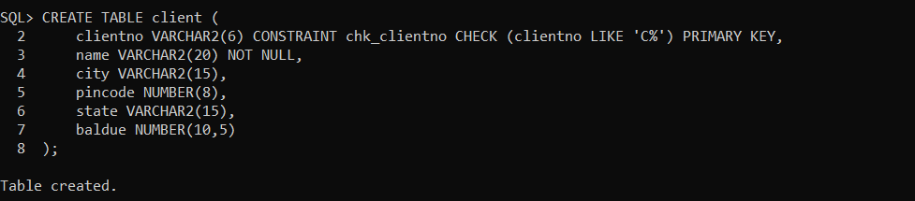

**1. b) Create table product (used to store product information) having following attributes:**

|  |  |  |  |  |
| --- | --- | --- | --- | --- |
| **Column Name** | **Data Type** | **Size** | **Default** | **Attributes** |
| productno | varchar2 | 6 |  | Primary key at table level/first letter must start with ‘P’ (at table level) |
| description | varchar2 | 15 |  | Not Null |
| profitpercent | number | 4, 2 |  | Not Null |
| unitmeasure | varchar2 | 10 |  | Not Null |
| qtyonhand | number | 8 |  | Not Null |
| reorderlvl | number | 8 |  | Not Null |
| sellprice | number | 8, 2 |  | Not Null, Cannot be 0 |
| costprice | number | 8, 2 |  | Not Null, Cannot be 0 |
|  |  |  |  |  |

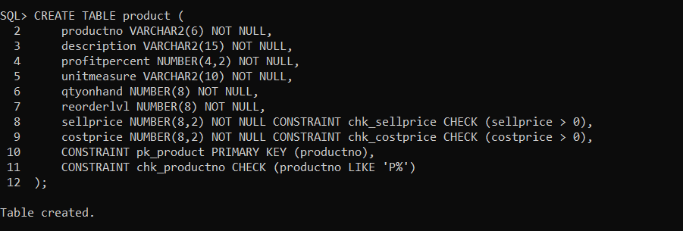

**1. c) Create table salesman (used to store salesman information working for the company) having following attributes:**

|  |  |  |  |  |
| --- | --- | --- | --- | --- |
| **Column Name** | **Data Type** | **Size** | **Default** | **Attributes** |
| salesmanno | varchar2 | 6 |  | Primary key at table level /first letter must start with ‘S’ |
| salesmanname | varchar2 | 20 |  | Not Null |
| address1 | varchar2 | 30 |  | Not Null |
| address2 | varchar2 | 30 |  |  |
| city | varchar2 | 20 |  |  |
| pincode | number | 8 |  |  |
| state | varchar2 | 20 |  |  |
| salamt | number | 8, 2 |  | Not Null, Cannot be 0 |
| tgttoget | number | 6, 2 |  | Not Null, Cannot be 0 |
| ytdsales | number | 6, 2 |  | Not Null |
| remarks | varchar2 | 60 |  |  |

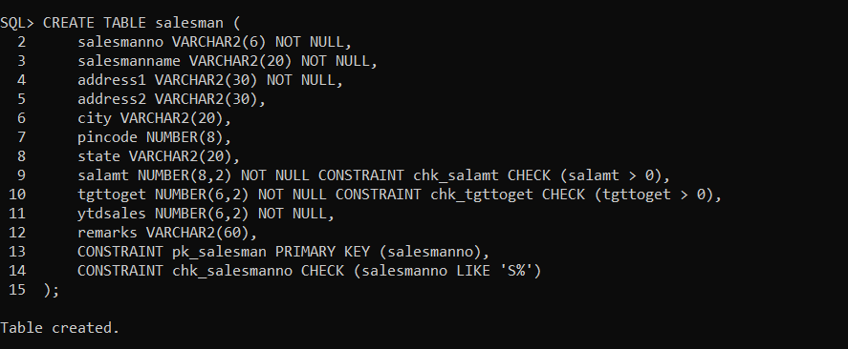

**1. d)** **Create table sales_order (used to store client’s orders) having following attributes:**

|  |  |  |  |  |
| --- | --- | --- | --- | --- |
| **Column Name** | **Data Type** | **Size** | **Default** | **Attributes** |
| orderno | varchar2 | 6 |  | Primary key/first letter must start with ‘O’ |
| clientno | varchar2 | 6 |  | Foreign key (at column level) references clientno of client table. |
| orderdate | date |  |  | Not Null |
| salesmanno | varchar2 | 6 |  | Foreign key (at column level) references salesmanno of salesman table. |
| delaytype | char | 1 | F | Delivery : part (P) / full (F) |
| billyn | char | 1 |  |  |
| delaydate | date |  |  | Cannot be less than orderdate (at table level) |
| orderstatus | varchar2 | 10 |  | Values(‘In Process’,’Fulfilled’,’BackOrder’,’Cancelled’) (at column level) |

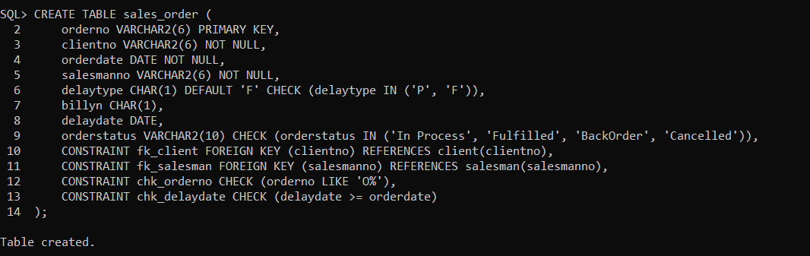

**1. e)** **Create table sales_order_details (used to store client’s orders with details of each product ordered ) having following attributes:**

|  |  |  |  |  |
| --- | --- | --- | --- | --- |
| **Column Name** | **Data Type** | **Size** | **Default** | **Attributes** |
| orderno | varchar2 | 6 |  | Foreign key references (at table level) orderno of sales_order table |
| productno | varchar2 | 6 |  | Foreign key (at table level) references productno of product table |
| qtyordered | number | 8 |  |  |
| productrate | number | 10, 2 |  |  |

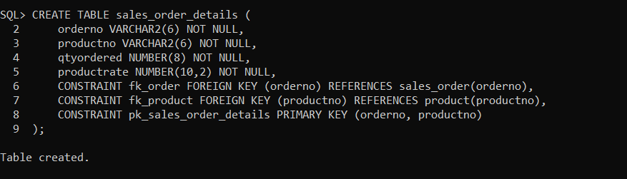

**2.** Alter table salesman, add constraint Not Null on remarks column and observe the behavior. Mention your remarks.

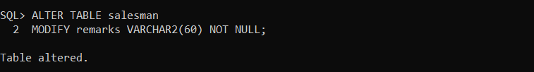

**3.** Insert data in all the tables as per Practical – 2 and check if any constraint is getting violated.

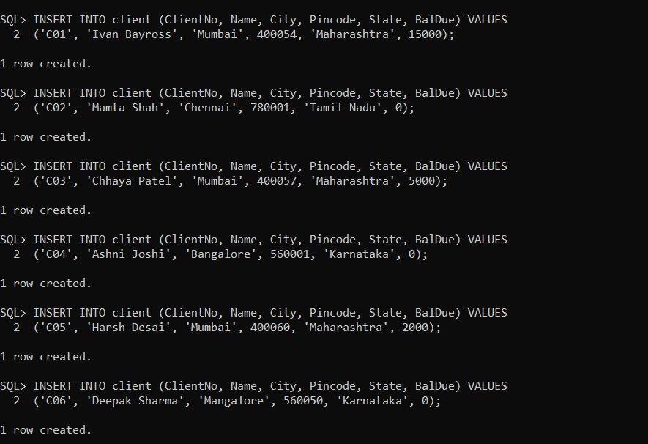

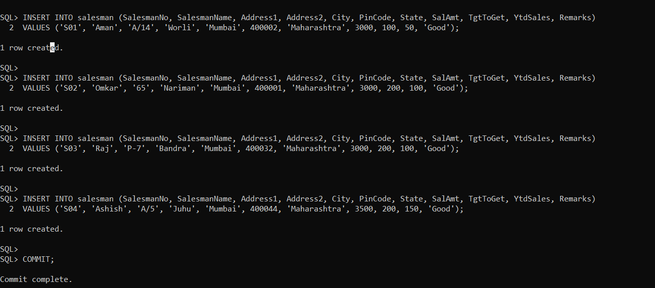

Possible violations for product:

* + productno does not start with 'P'.
  + sellprice or costprice is 0 or NULL.
  + Not Null constraints on profitpercent, description, etc., are violated.

Possible violations for sales order details:

* orderno does not exist in sales_order.
* productno does not exist in product.
* qtyordered or productrate has invalid values.

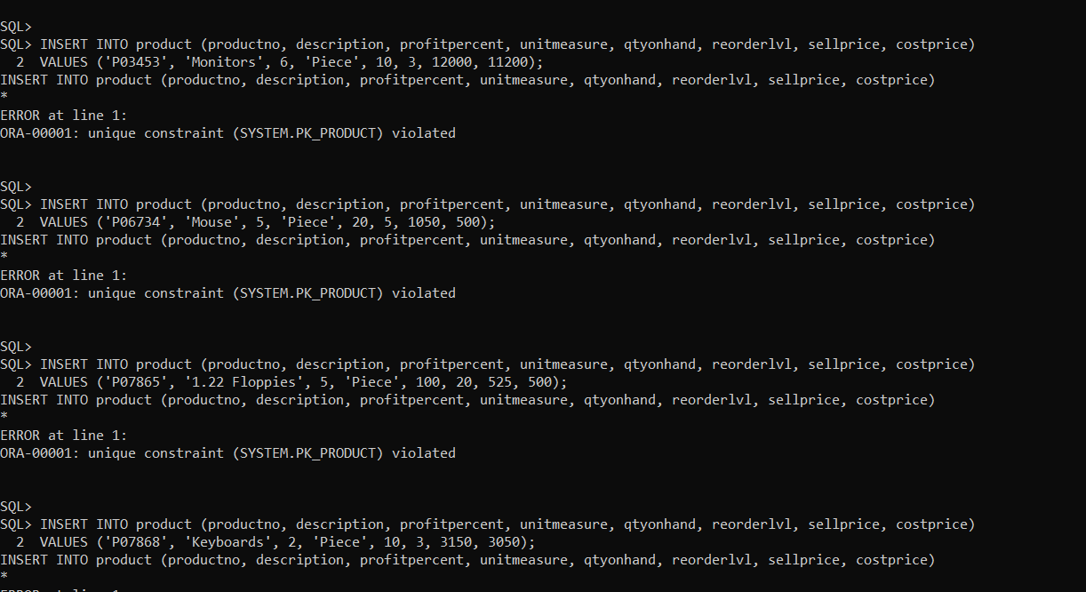

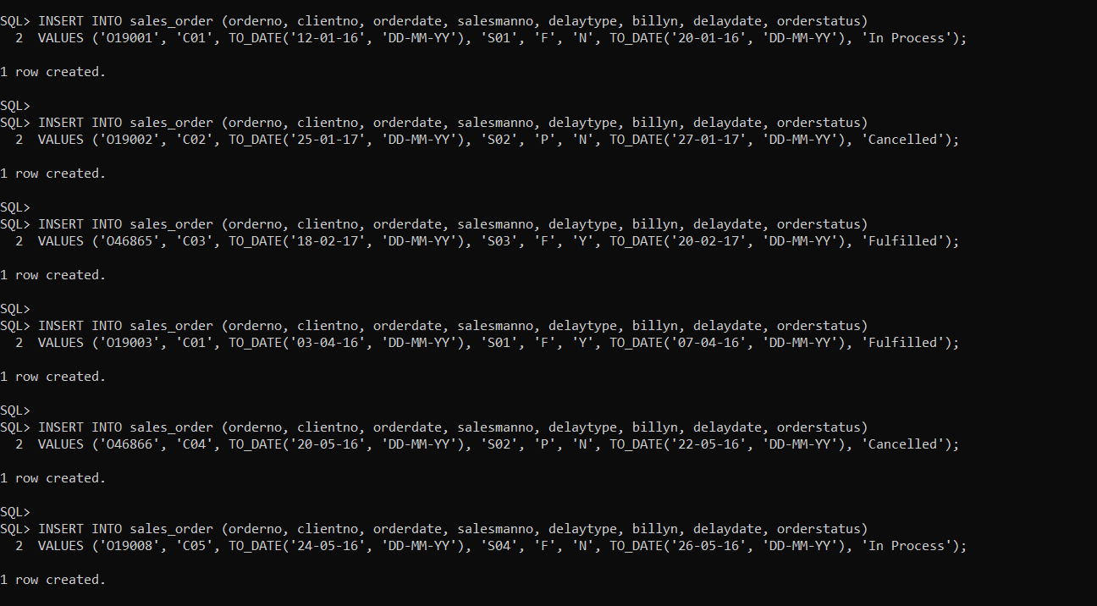

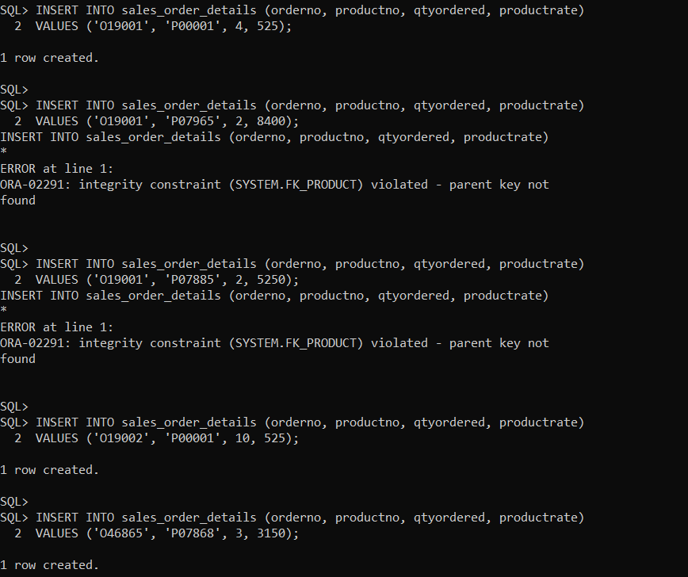

CONDITIONS ARE VIOLATED IN PRODUCT AND SALES_ORDER_DETAILS.

# did Insert for error remove

**4.** Delete data of salesman ‘S01’ from salesman table and observe the error. Rewrite the query for alteration of table, so that on deletion of ‘S01’ from salesman, corresponding values associated should also get deleted.

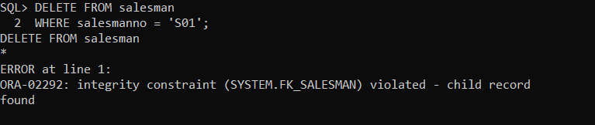

Error:

* The sales_order table references salesmanno as a foreign key.
* If S01 is referenced in sales_order, deletion is not allowed.

Solution:

allow cascade deletion

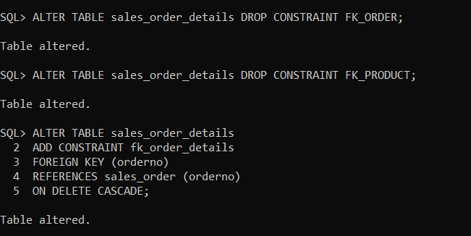

**5.** Delete data of order ‘O19001’ from sales_order table and observe the error. Rewrite the query for alteration of table, so that if you remove ‘O19001’ from sales_order, corresponding values associated should be set to NULL.

Error:

* sales_order_details references orderno as a foreign key.
* If O19001 exists in sales_order_details, deletion is not allowed.

Solution:  
drop constraint,add constrint in fk_salesman,delete cascade

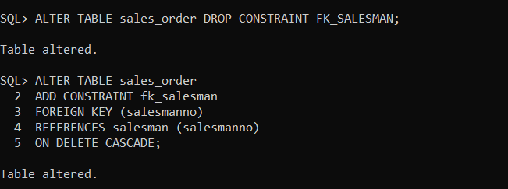

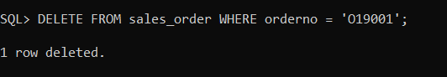

**6.** Drop primary key constraint on ‘orderno’ from sales_order table. Observe the error. Write the drop query, so that associated constraints with ‘orderno’ also gets dropped. Check whether the constraints have dropped from user_constraints table.

Error:

* The orderno column is a foreign key in sales_order_details.
* Dropping the primary key without handling foreign keys causes an error.

Solution:

Subquery constraint p in sales order

