Game Design Document

Fill up the following document

1. Write the title of your project.

Survival hero race

1. What is the goal of the game?

To get all the checkpoints and try to win the game by ecaping dangerous tasks.

1. Write a brief story of your game.

Choose your chareacter and start the game.

You will receive several checkpoints after completing various tasks.

You will have to try and win the race.

1. Which are the playing characters of this game?

* Playing characters are the ones who respond to the user based on the input from the user.
* Cars, monkeys, dinos, wizards, etc., are the playing characters in the game.

|  |  |  |
| --- | --- | --- |
| Number | Character Name | What can this character do? |
| 1 | Main character(any name) | Run, walk, travel and fight |
| 2 | Main character 2(any name) | Run, walk, travel and fight |
| 3 | Main character 3(any name) | Run, walk, travel and fight |
| 4 | Main character 4(any name) | Run, walk, travel and fight |
| 5 |  |  |
| 6 |  |  |
| 7 |  |  |
| 8 |  |  |

1. Which are the Non-Playing Characters of this game?

* Non-Playing characters are the ones that don't have an action or behavior when the user interacts with the game.
* Hurdles, stones, bananas, coins, etc., are non-playing characters in the game.

|  |  |  |
| --- | --- | --- |
| Number | Character Name | What can this character do? |
| 1 | Ramps | Racing area |
| 2 | Racing tracks | Whre racing is being done |
| 3 | Flyovers | Racing area |
| 4 | Sign boards | Used for indicating direction |
| 5 |  |  |
| 6 |  |  |
| 7 |  |  |
| 8 |  |  |

Draw your imagination of this game. What does this game look like?

* Draw the game either on your computer or on paper.
* Add images of the game scenes to show each of the playing and non-playing characters at least once.

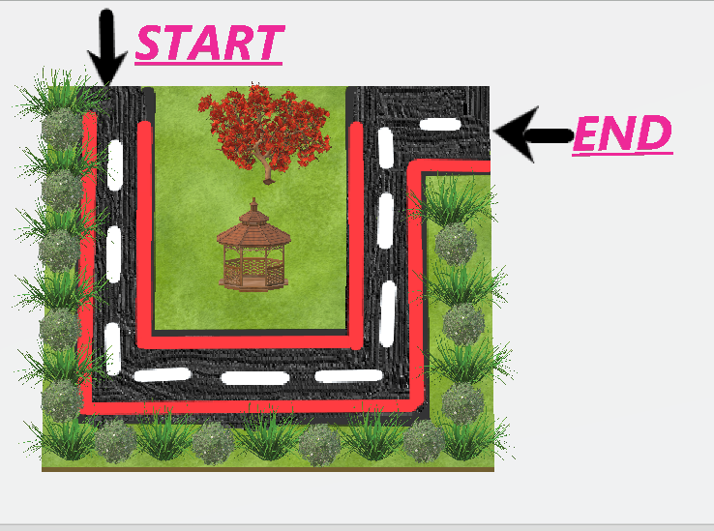

How do you plan to make your game engaging?

There would be different tasks and engaging survival activities that would

Keep the player in the game.