
Dayananda Sagar Academy of Technology & Management
(Autonomous Institute under VTU)
Affiliated to VTU Approved by AICTE
Accredited by NAAC with A+ Grade 6 Programs Accredited by NBA (CSE, ISE, ECE, EEE, MECH, CV)

Project Report On
“MOVIE SEARCH ”
WEB PROGRAMMING (BIS307)”
Of

Bachelor of Engineering
In

Information Science and Engineering
Submitted By
SHREYA SINGH (1DT23IS144)
SNEHIL PANT (1DT23IS152)
SPARSH MAHAJAN (1DT23IS155)
VANSHIKA SHUKLA (1DT23IS178)

Under the guidance of Mrs. Gagana B R Assistant Professor
Department of Information Science and Engineering


Department of Information Science and Engineering

(Accredited by NBA 2022-2025)
2024 – 2025

DAYANANDA SAGAR ACADEMY OF TECHNOLOGY AND MANAGEMENT
(Affiliated to Visvesvaraya Technological University, Belagavi and Approved by AICTE, New Delhi) (Accrediated by NAAC with A+ Grade)
Udayapura, Kanakapura Main Road, Opp. Art of Living, Bengaluru-560082
(Accredited 3 years by NBA, New Delhi)

Department of Information Science and Engineering

CERTIFICATE

This is to certify that the mini project report entitled “MOVIE SEARCH” is a bonafide work carried out by SPARSH MAHAJAN(1DT23IS155), SHREYA SINGH(1DT23IS144), VANSHIKA SHUKLA(1DT23IS178) and SNEHIL PANT(1DT23IS152) in the partial fulfillment of the requirement for the award of degree in Bachelor of Engineering in Information Science and Engineering in DAYANAND SAGAR CADEMY OF TECHNOLOGY AND MANAGEMENT for Visvesvaraya Technological University, Belagavi, for the year 2024-2025. It is certified that all corrections/suggestions indicated for the internal assessment have been incorporated in the report. This report has been approved as it satisfies the academic requirements in respect of project work prescribed for Bachelor of Engineering Degree.

Signature of Guide |  | Signature of HOD
Mrs. Gagana B R,  Assistant Professor  Dept. of, ISE, DSATM |  | Dr. Nandini Prasad K S  Dean-Foreign Affairs & HOD Dept. of ISE, DSATM

EXTERNAL VIVA
Name of the Examiners Signature with Date

1………………………….. …………………………

2………………………….. …………………………

DAYANANDA SAGAR ACADEMY OF TECHNOLOGY AND MANAGEMENT
(Affiliated to Visvesvaraya Technological University, Belagavi and Approved by AICTE, New Delhi) (Accrediated by NAAC with A+ Grade)
Udayapura, Kanakapura Main Road, Opp. Art of Living, Bengaluru-560082
(Accredited 3 years by NBA, New Delhi)

Department of Information Science and Engineering

VISION OF THE INSTITUTE

To strive at creating the institution a centre of highest calibre of learning, so as to create an overall intellectual atmosphere with each deriving strength from the other to be the best of engineers, scientists with management & design skills.

MISSION OF THE INSTITUTE

• To serve its region, state, the nation and globally by preparing students to make meaningful contributions in an increasingly complex global society challenge.
• To encourage reflection on and evaluation of emerging needs and priorities with state of art infrastructure at institutions.
• To support research and services establishing enhancements in technical, economic, human and cultural development.
• To establish an interdisciplinary centre of excellence, supporting/ promoting student's implementation.
• To increase the number of Doctorate holders to promote research culture on campus.
• To establish IIPC, IPR, EDC, innovation cells with functional MOU’s supporting student's quality growth.

DAYANANDA SAGAR ACADEMY OF TECHNOLOGY AND MANAGEMENT
(Affiliated to Visvesvaraya Technological University, Belagavi and Approved by AICTE, New Delhi) (Accrediated by NAAC with A+ Grade)
Udayapura, Kanakapura Main Road, Opp. Art of Living, Bengaluru-560082
(Accredited 3 years by NBA, New Delhi)

Department of Information Science and Engineering

VISION OF THE DEPARTMENT

Impart a magnificent learning atmosphere establishing innovative practices among the students aiming to strengthen their software application knowledge and technical skills.

MISSION OF THE DEPARTMENT

M1: To deliver quality technical training on software application domain.
M2: To nurture teamwork in order to transform individuals was responsible leader and entrepreneur for future trends.
M3: To inculcate research practices in teaching thus ensuring research blend among students.
M4: To ensure more doctorates in the department, aiming at professional strength.
M5: To inculcate the core information science engineering practices with hardware blend by providing advanced laboratories.
M6: To establish innovative labs, start-ups and patent culture.

ACKNOWLEDGEMENT

We would like to take this opportunity to express our sincere thanks and gratitude to all those who have been kind enough to guide when needed which has led to the successful completion of the project.
We would like to express our special thanks and gratitude to Management of Dayananda Sagar Academy of Technology and Management for providing all the required facility.
We would like to convey our immense gratitude to Dr. Ravishankar M, Principal, Dayananda Sagar Academy of Technology and Management and Dr. Nandini Prasad K S, Dean-Foreign Affairs & HOD, Department of Information Science and Engineering, Dayananda Sagar Academy of Technology and Management, Bangalore, for their continuous support and encouragement which enabled us to come up with this project and also thank them for providing the right ambience for carrying out the same.
We would like to express our profound gratitude to our Project Guide Mrs. Gagana B R, Associate professor, Department of Information Science and Engineering, Dayananda Sagar Academy of Technology and Management, Bengaluru for their guidance and suggestions for successful completion of our project.
We would like to thank our parents and friends who helped us in finalizing this project within the stipulated time frame.
Sparsh Mahajan 1DT23IS155
Shreya Singh 1DT23IS144
Vanshika Shukla 1DT23IS178
Snehil Pant 1DT23IS152

ABSTRACT

The Movie Search Website is a user-friendly web application developed to address the challenges faced by users in discovering and exploring movies efficiently. With the vast amount of digital content available today, finding accurate and relevant movie information can be a daunting task. This platform bridges the gap by providing a centralized solution where users can search for movies, view detailed information, and explore personalized recommendations based on their interests.
Powered by the TMDb API, the website fetches real-time data about movies, including titles, genres, release dates, cast, and plot summaries. The integration of a recommendation system enhances user engagement by suggesting similar movies based on search results, creating a seamless and enriched movie discovery experience. The use of modern web technologies such as HTML5, CSS3, and JavaScript ensures a responsive and visually appealing user interface. Dynamic content rendering allows users to interact with the website without requiring frequent page reloads, thereby offering a smooth and interactive browsing experience.
This project emphasizes robust functionality, incorporating essential features like error handling for invalid search queries or API failures, and a responsive design that adapts flawlessly across devices. The development process involved meticulous planning, design, and testing to ensure high standards of usability and performance.
The Movie Search Website not only fulfills its primary objective of delivering a reliable and interactive movie search platform but also lays the groundwork for future enhancements. Proposed features such as advanced filtering options, user authentication, and watchlist functionality could further elevate the platform’s utility. This project serves as a testament to the effective integration of technical knowledge and user-centric design principles.
Through this development, the project demonstrates how technology can be leveraged to address common user challenges creatively and efficiently. It stands as a valuable tool for movie enthusiasts, offering a comprehensive solution for exploring the world of cinema while setting the stage for continued innovation and improvement in web application development.

TABLE OF CONTENTS

Chapter | Description | Page No.
1 | INTRODUCTION | 1
2 | SOFTWARE REQUIREMENTS | 2
3 | FEATURES AND ARCHITECTURE | 3-5
4 | CODE SNIPPETS | 6-12
5 | SNAPSHOT | 13
6 | CHALANGES FACED | 14
7 | CONCLUSION | 15
8 | REFRENCES | 16

TABLE OF FIGURES

Serial No. | Description | Page No.
1 | TMDb | 5
2 | CODE SNIPPET | 6-12
3 | SNAPSHOT | 13

CHAPTER-1

INTRODUCTION

The Movie Search Website is a comprehensive web application designed to allow users to search for movies and receive detailed information and recommendations. With the rise in digital streaming and the abundance of available content, users often struggle to find accurate and organized movie information in one place. This project aims to address that gap by integrating an intuitive search interface with an external movie database API to deliver a seamless user experience.

Purpose of the Project
- To create a user-friendly platform for searching and exploring movies efficiently.
- To integrate a recommendation system for personalized user suggestions.

Scope of the Website
- Provide robust search functionality for movies using an external API.
- Display detailed information about movies, such as title, release year, genre, and plot summary.
- Suggest similar movies based on search results to enhance user engagement.

Objectives
- Build a responsive and accessible website compatible with various devices.
- Ensure smooth interaction with the API to fetch and display movie data accurately.
- Deliver an enhanced user experience through interactive design and personalized recommendations.

CHAPTER-2

SOFTWARE REQUIREMENTS

Frontend Technologies
- HTML5: For structuring the web pages and providing semantic meaning to the content.
- CSS3: For styling, animations, and responsive design to ensure compatibility across devices.
- JavaScript (ES6): For adding interactivity, handling events, and integrating API functionality.

APIs and Libraries
- TMDb API: A reliable external API used to fetch movie data, including titles, descriptions, and recommendations.
- Fetch API: A native JavaScript feature for making asynchronous HTTP requests.

Tools and Platforms
- VS Code: Code editor used for efficient development.
- GitHub: For version control, collaboration, and code management.
- Ngrok: A hosting platform used for deploying the locally hosted website.

CHAPTER-3
FEATURES AND ARCHITECTURE

- Search Functionality: Users can search for movies by entering keywords in the search bar. The system retrieves and displays results, including essential movie details.
- Responsive Design: The website adapts seamlessly to various screen sizes, ensuring usability on desktops, tablets, and smartphones.
- Error Handling: The system displays appropriate messages for invalid searches, API failures, or network issues, ensuring a smooth user experience.
- Dynamic Content Rendering: All content is dynamically loaded using JavaScript, ensuring the user sees updated and relevant information without needing to refresh the page.
Overview of the System: The Movie Search Website consists of the following core components:
- Frontend: The interface where users interact and view movie data.
- API Integration: A bridge between the website and the TMDb API for fetching real-time movie information.

Workflow Diagram
- User inputs a search query in the search bar.
- The query is sent to the TMDb API through an HTTP request.
- The API returns movie data in JSON format.
- JavaScript processes and displays the results dynamically on the website.
- If applicable, recommendations are fetched and displayed based on the selected movie.

TMDb DATABASE

The TMDb (The Movie Database) is a popular and comprehensive online database for movies, TV shows, and other forms of entertainment content. Established in 2008, TMDb is widely recognized for its extensive repository of data, which includes detailed information about movies, TV series, cast members, crew members, reviews, trailers, and more. It is supported and maintained by a passionate community of contributors, making it one of the most reliable and up-to-date sources of entertainment data.
TMDb provides a robust API (Application Programming Interface) that allows developers to access its vast collection of data programmatically. This API is widely used in applications, websites, and services for integrating movie-related information and building features like movie search, recommendations, trending lists, and more.

Features of TMDb
- Comprehensive Database: TMDb offers a vast library of movies and TV shows, including details about genres, release dates, ratings, runtime, reviews, and more.
- High-Quality Content: The database includes high-resolution posters, backdrops, and trailers, enriching the visual appeal of applications that use it.
- Community-Driven Data: TMDb relies on its global community of users to contribute, edit, and update content, ensuring accuracy and timeliness.
- Multilingual Support: TMDb supports multiple languages, allowing developers to fetch content in different languages for a global audience.
- Powerful Search and Discovery: TMDb enables advanced search capabilities, trending lists, and personalized recommendations based on user preferences.

- Free Tier: TMDb offers a free tier for developers, making it an accessible choice for smaller projects and start-ups.
- Community Contributions: The user-driven model ensures that the database is continually updated with the latest releases and corrections.
- Rich Media Content: The inclusion of trailers, posters, and backdrops enhances the appeal of applications that integrate TMDb data.

TMDb in the Movie Search Website
In the Movie Search Website project, TMDb is used to fetch real-time data about movies. The API enables functionalities such as searching for movies by title, retrieving detailed information about a specific movie, and recommending similar movies based on user queries. This integration ensures that the website provides accurate and up-to-date information, offering users a reliable and engaging movie discovery experience.


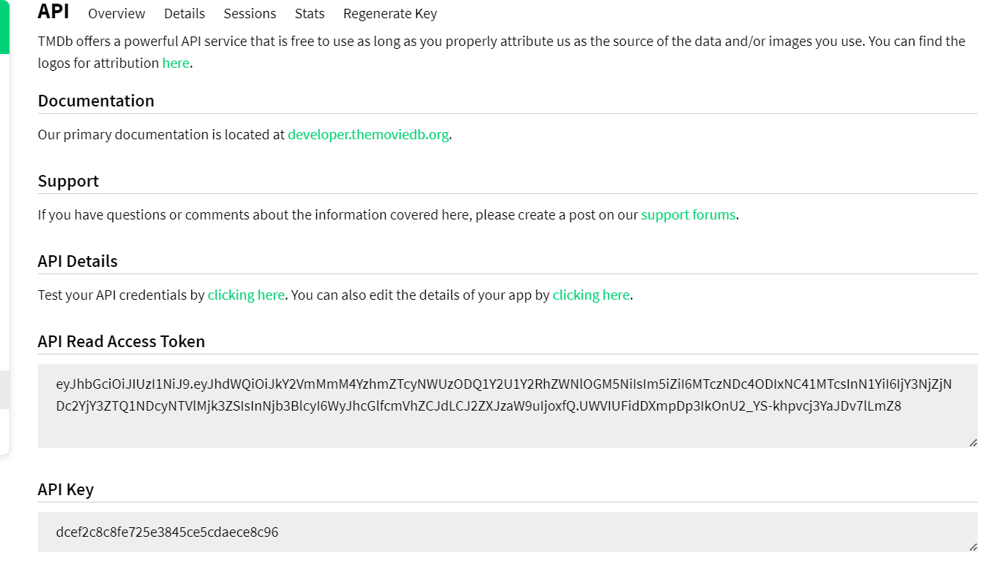
FIG-1 TMDb

CHAPTER-4

CODE SNIPPETS

- HTML5:
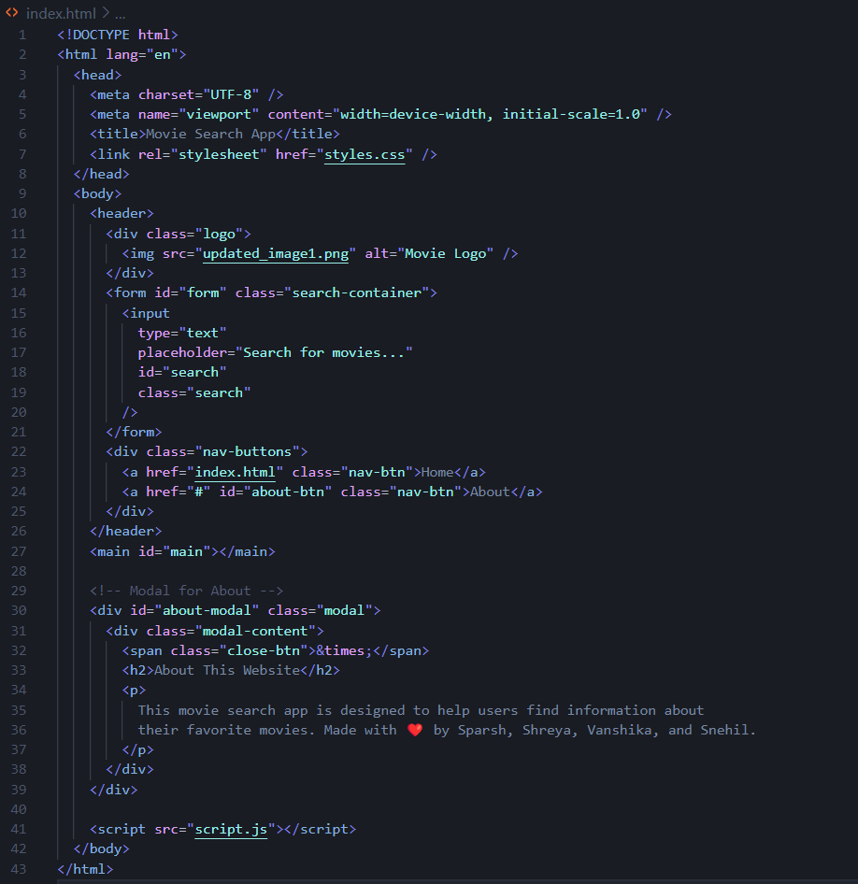
FIG-2 CODE SNIPPET

- CSS:
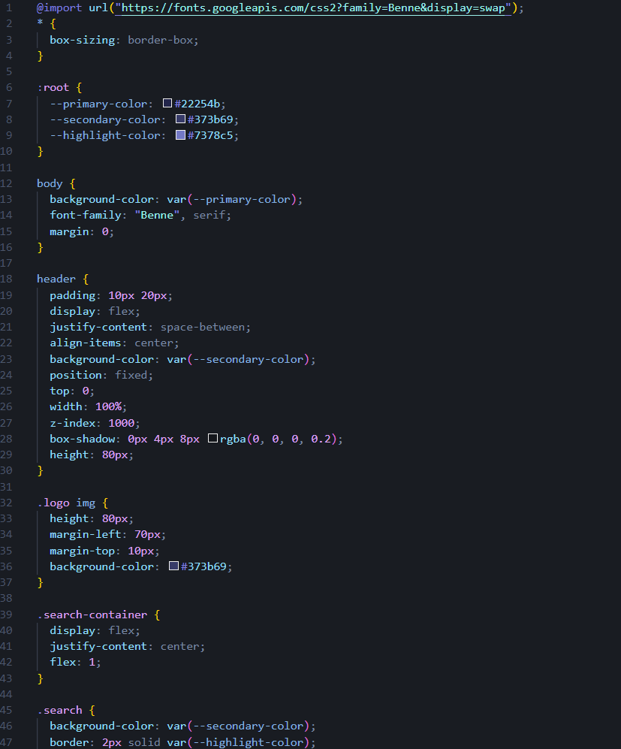
FIG-3 CODE SNIPPET

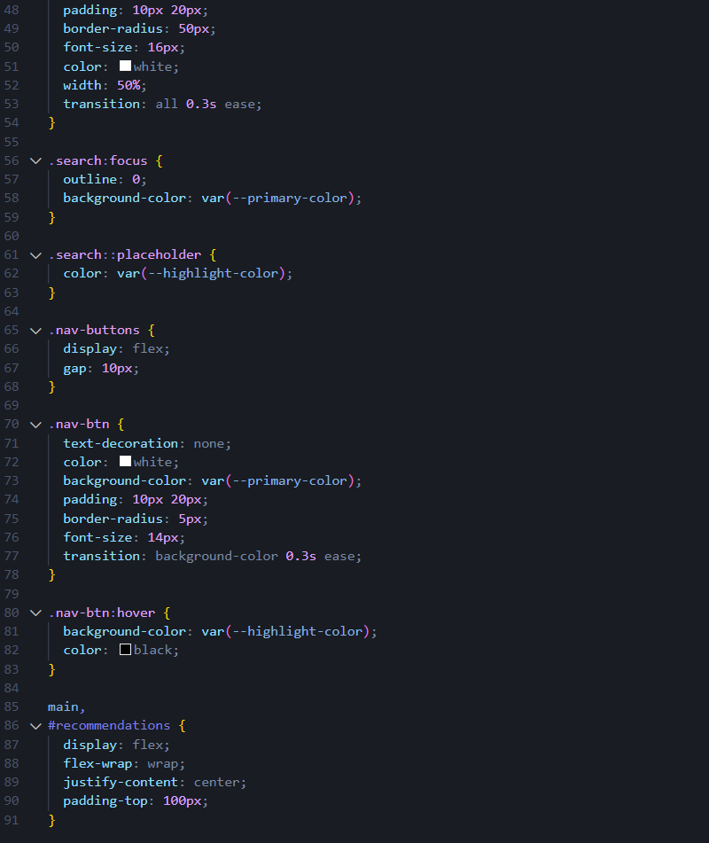
FIG-4 CODE SNIPPET
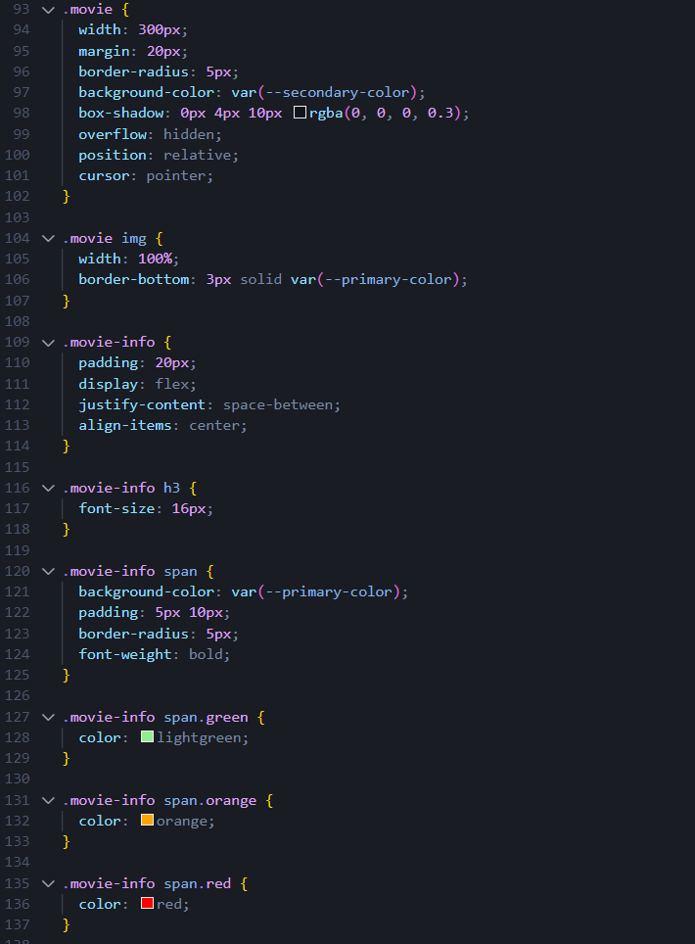
FIG-5 CODE SNIPPET

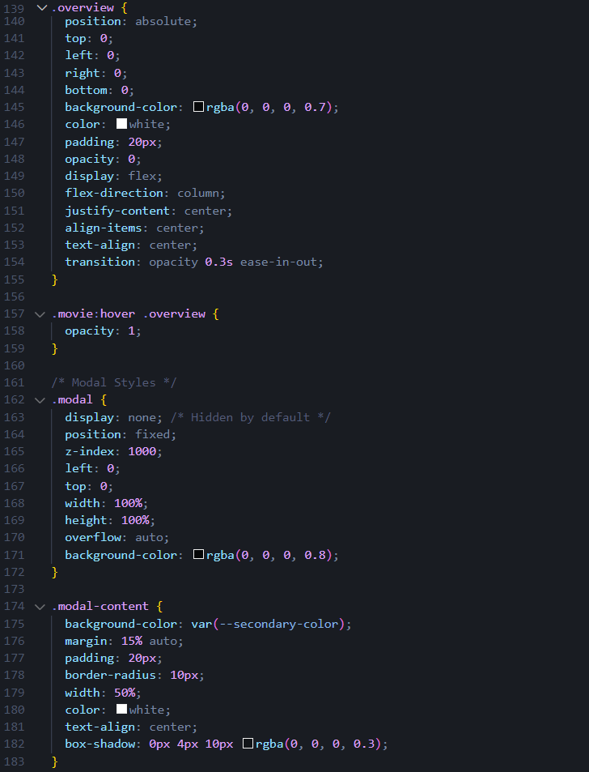
FIG-6 CODE SNIPPET
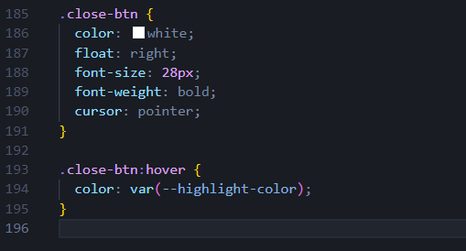
FIG-7 CODE SNIPPET

- JAVASCRIPT:
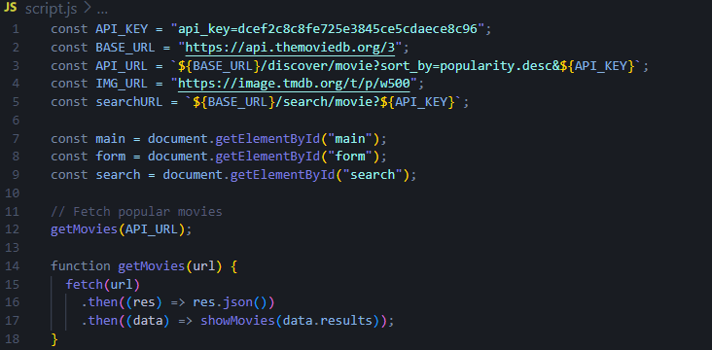
FIG-8 CODE SNIPPET
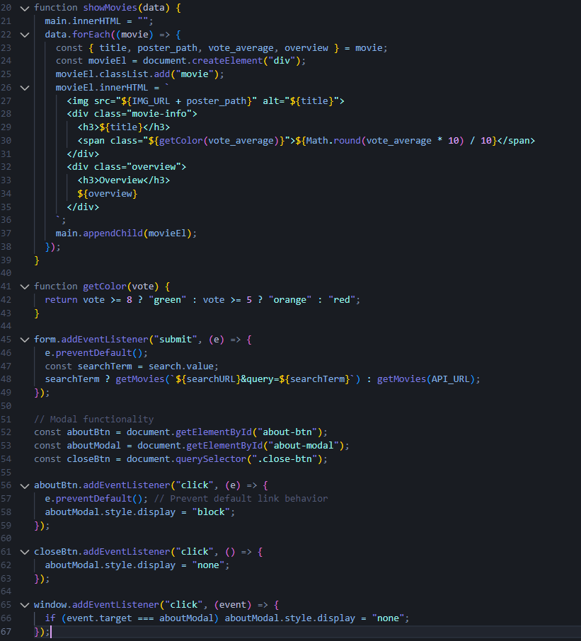
FIG-9 CODE SNIPPET

CHAPTER-5

SNAPSHOT

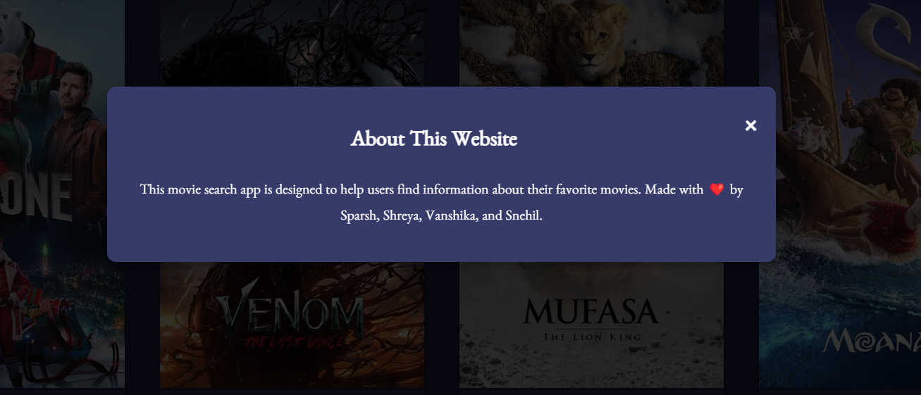
FIG-10 SNAPSHOT

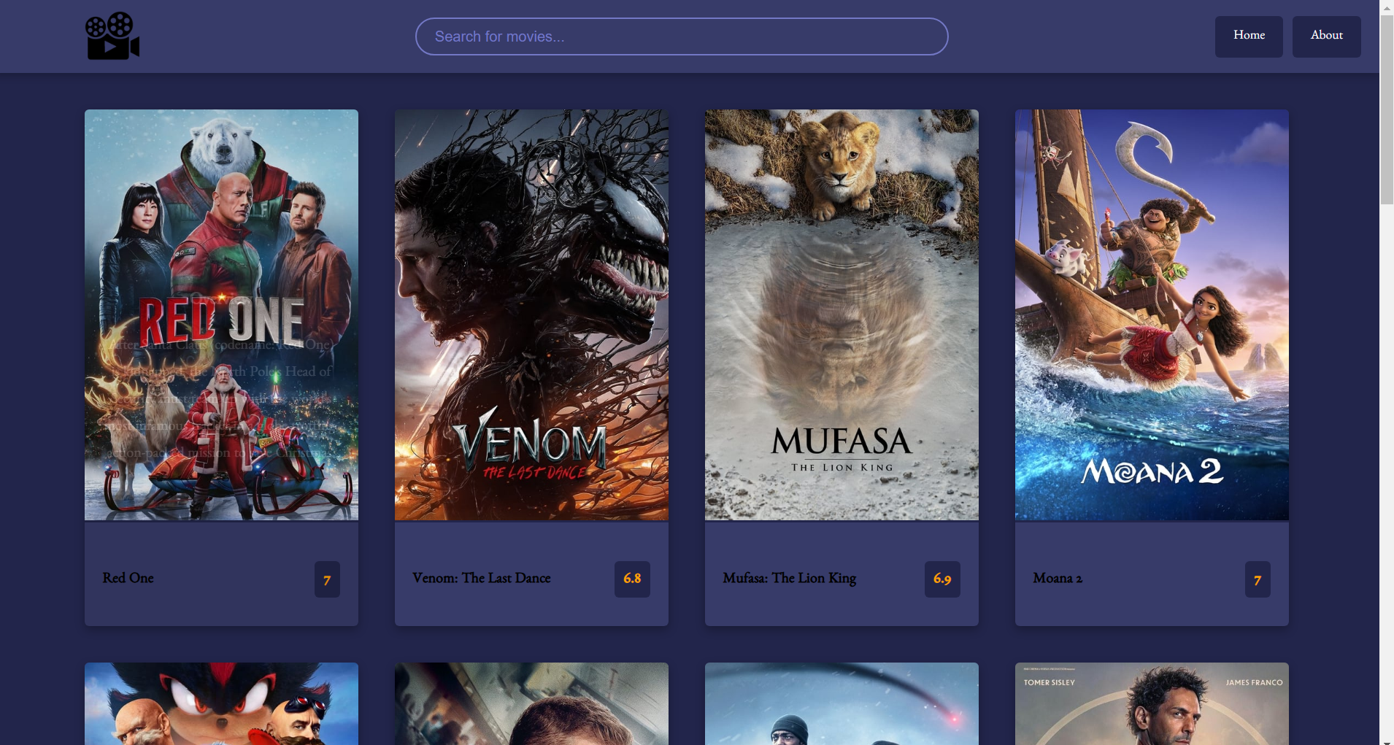
FIG-11 SNAPSHOT

CHAPTER-6

CHALLENGES FACED

API Limitations
- The free tier of the TMDb API restricts the number of requests per day, necessitating efficient query management.
Error Handling
- Designing a user-friendly way to handle and display errors, such as invalid queries or API failures, required careful implementation.
Responsive Design
- Achieving an optimal layout for multiple screen sizes took extensive testing and refinement of CSS media queries.
Dynamic Content Management
- Rendering large volumes of data dynamically posed challenges in maintaining fast load times and smooth interactions.

CHAPTER-7

CONCLUSION

The Movie Search Website represents a significant step toward creating a user-friendly, functional, and visually appealing platform for movie enthusiasts. Through this project, we successfully implemented robust search functionality, seamless API integration, and a recommendation system that caters to diverse user preferences.
The development process involved meticulous planning, design, and testing, ensuring that the platform meets modern web standards and offers a smooth user experience. Moreover, the project has immense potential for future enhancements. Adding features like user authentication, advanced filters, and personalized watchlists can further elevate the platform's value.
Challenges faced during the development, such as API limitations and responsive design hurdles, provided opportunities for learning and improving technical problem-solving skills.

- FUTURE SCOPE:
- User Authentication: Enable users to create accounts and save favourite movies, providing a personalized experience.
- Advanced Search Filters: Add options to filter by genre, release year, or user ratings.
- Movie Watchlist: Allow users to create and manage a watchlist of their favourite or planned-to-watch movies.
- Performance Optimization: Implement caching mechanisms to store frequently accessed data and improve response times.
- Enhanced Visual Design: Introduce animations, themes, and dark mode to elevate the user interface.
- API Movie Recommendations: Whenever user types starting letters of the movie name the API automatically recommends the names of different movies that the user might want to discover.

CHAPTER-8

REFRENCES

- MDN Web Docs

- Netlify Documentation

- TMDb API Documentation

- Perplexity GPT

- GitHub

