## DEVELOPMENT OF FACE MASK DETECTION TECHNIQUE USING MACHINE LEARNING

Project report submitted

in partial fulfillment of requirement for the degree

of

**Bachelor of Technology**

in

**Computer Science and Engineering**

**Name of the student(s) Name of the Supervisor**

**Ravi Mishra(1851110077) Mr. Sanjiv Agrawal**

**Vanshika Agrawal(1851110114) (Assistant Professor)**



#### Department of Computer Science and Engineering

**GL BAJAJ GROUP OF INSTITUTIONS, MATHURA**

Approved by AICTE, CoA & Affiliated to Dr APJ AKTU, Lucknow

NH#2, Mathura-Delhi Road, PO-Akbarpur, Mathura-281406 (UP)

Session: 2021-2022

**INDEX**

**Contents Page No.**

Certificate i

Declaration ii

Acknowledgement iii

Abstract iv

List of Figures & Tables v

Chapter 1.

Introduction 1-3

* 1. Objective & Scope of the Project
     1. Objective 4
     2. Scope 5

Chapter 2.

Literature Review 6

2.1 Dataset 7-9

Chapter 3

Design of Project Model

3.1 Packages Used

3.1.1 Computer Vision 10-11

3.1.2 OpenCV 12-13

3.1.3 Tensor Flow 14-15

3.1.4 Keras 16-17

3.1.5 Jupyter Notebook 18-19

Chapter 4.

Proposed Methodology 20

4.1 Data Processing 21

4.2 Training of Model 22-24

4.3 Implementing Face Mask Detector 25-26

4.4 Hardware and Software Used

4.4.1 Hardware Used 27

4.4.2 Software Used 27

Chapter 5.

Results & Conclusion

5.1 Result 28-32

5.2 Conclusion 33

5.3 Future Works 34

Appendix 35-37

References 38

**CERTIFICATE**

This is to certify that:

Mr Ravi Mishra S/o RajMurti Mishra Enrollment No. 0181CS060 Roll No. 1851110077 and Miss. Vanshika Agrawal D/o Naresh Agrawal Enrollment No. 0181CS020 Roll No. 1851110114 has worked on **“Development of Face Mask Detection Technique using Machine Learning”**. This project is part of a partial fulfillment of requirement for the degree of Bachelor in Technology in Computer Science Engineering.

To the best of my knowledge and belief, this is the original work and has not been submitted for any other degree elsewhere.

Date :24/04/2022

Place: Mathura **Signature**

##### (Mr.Sanjiv Agrawal)

CSE Department,Asst. Prof

##### Signature

**(Dr. Ramakant Baghel)**

CSE Department, HoD

### DECLARATION

I hereby certify that the work which is being presented in B. Tech. Project Report entitled **“Development of Face Mask Detection Technique using Machine Learning”**, as partial fulfillment of the requirement for the degree of Bachelor of Technology in Computer Science and Engineering, submitted to the Department of Computer Science and Engineering of GL BAJAJ Group of Institutions, NH#2- Mathura-Delhi Road, PO-Akbarpur, Mathura-281001 (UP), is an authentic record of my own work carried out during a period from September 2021 to April 2022 under the supervision of Mr. Sanjiv Agrawal, in the CSE Department.

The matter presented in this project report in full or part, has not been submitted by me for the award of any other degree elsewhere and is free from plagiarism.

Name of Candidate:

Ravi Mishra(1851110077) Vanshika Agrawal(1851110114)

### ACKNOWLEDGEMENTS

I would like to express my greatest appreciation to the all individuals who have helped and supported me throughout the project. I am thankful to my HoD and all Faculty members for his ongoing support during the project, from initial advice, and encouragement, which led to the final report of this project. I would also like to thank Mr. Sanjiv Agrawal who was always there for us.

I wish to thank my parents as well for their undivided support and interest who inspired me and encouraged me to go my own way, without whom I would be unable to complete my project.

At the end, I want to thank my friends and classmates who displayed appreciation to my work and motivated me to continue my work.

**Abstract**

COVID- 19 is one of the most dangerous contagion which caused epidemic in mortal life, not only in terms of direct casualties but also regarding socio-profitable impact. The outbreak snappily spread around the world. The 1- time anniversary of the global nimbus contagion epidemic get passed away in 2021, but still no way to tell how long the epidemic will continue. After assaying report by WHO of covid- 19, to minimize the rate of covid- 19 transmission, our public government advised citizens to wear face masks. A model using deep literacy and MobileNetV2 for face mask discovery is presented. This system was trained and checked on the real time dataset. There are images in the Medical Masks Dataset, including 1918 images of people wearing no mask and 1915 images of people wearing masks. We espoused OpenCV to descry faces in real time from a live sluice captured with our webcam. With the aid of computer vision and deep literacy, we hope to classify whether or not the person in the videotape sluice is wearing a face mask. If the camera captures a face without mask an Dispatch announcement will be transferred out to the director and system alarm will ring.

Keywords Corona contagion, Tensor inflow, Mask sensor,

Opencv, Alarmsystem

**List of figures**

|  |  |
| --- | --- |
| **Figure 1** | Depicts images of human wearing a mask |
| **Figure 2** | Depicts images of human not wearing a mask |
| **Figure 3** | Decision flow chart of the proposed approach |
| **Figure 4** | Snippet of face mask detector training code |
| **Figure 5** | Snippet of data preprocessing code |
| **Figure 6** | Snippet of Face mask detector Testing code |
| **Figure 7** | Accuracy Plot |
| **Figure 8** | Analyzing the result without face mask |
| **Figure 9** | Analyzing the result with face mask |
| **Figure 10** | Analyzing the results of test photograph with a probability of 100% when more than two faces are present. |

**Chapter 1**

**Introduction**

COVID- 19, a epidemic complaint caused by Severe Acute Respiratory Syndrome Coronavirus 2, is presently affecting the entire world( SARS- CoV- 2)( 1) According to the world health association, COVID- 19 is primarily transmitted from person to person by respiratory driblets. There's micrometer small covid- 19 patches which always thrown out of our mouth while speaking singing, coughing, etc. We observed indeed after vaccination has started in India also too nimbus contagion cases are adding. According to the World Health Organization's Corona contagion situation check, over 124 million people are infected with the complaint in 213 countries, killing over2.73 million people worldwide as of March 23, 2021. India is now ranked third in the world for the number of cases of infected Corona contagion. It has reported that it has11.5 million infected people and 160 thousand killed people

Observing the global extremity, a new need for face mask identification has surfaced. It's one of the technologies able of detecting and checking the identity of an individual wearing a mask.( 4) This report presents a accurate face mask discovery system using Deep Literacy. It can specify whether a person on real time videotape captured by webcam is wearing face mask or not. It can also descry people who aren't wearing a face mask by sounding an alarm or transferring an dispatch warning to police, authority, or an bystander. This system allows them to see who is not wearing a mask on their faces.

**Why is it important to wear facemask?**

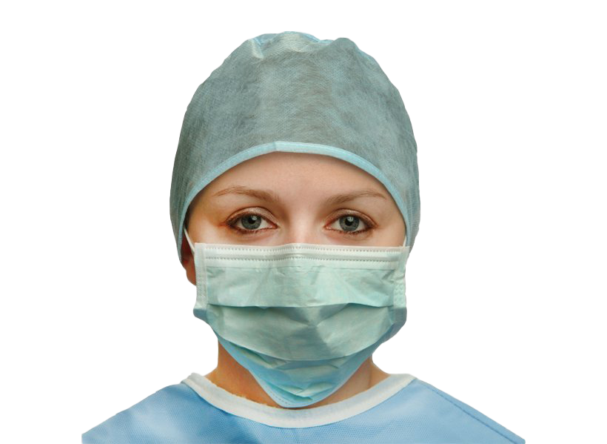

When we go back to the basics, the primary part of face masks is to help the transmission of SARS- CoV- 2 via respiratory droplets, which can easily enter through the mouth and nose to infect new hosts.

This protection is handed thanks to the complete barricade between your nasal and oral depressions with the outside world.

Still, if you wear the mask in a droopy manner that does n’t cover your mouth and nose properly, your trouble of catching the contagion will increase.

The significance of properly wearing face masks, asking people to

• Put the mask over the nose and mouth, also secure it under the chin

• Try to fit it snugly against the sides of the face

One major benefit of wearing face masks is to cover the people around you, especially if you have been exposed to someone carrying the contagion or work in a crowded place(e.g., grocery stores, caffs, fields).

Because of this trouble/ benefit analysis, multitudinous governments around the world released emergency laws that mandate the public to wear masks in an attempt to stop the further spread of COVID- 19.

# 1.1 Objective and Scope of the Project

* + 1. **Objective**

To develop face mask detection technique using python .

* + - * To identify whether the person on video stream is wearing a face mask or not with the help of computer vision.
      * To implement this system at Cement Industries, Chemical Plants, Hospitals where chance of spread of disease .
      * To Implement alarm system and Email Notification system to notify administrator.

# My aim is to classify whether the person on videotape sluice is wearing a face mask or not with the help of computer vision and deep literacy. If the camera captures a face without mask an Dispatch announcement will be transferred out to the director and system alarm will ring.

# 1.1.2 Scope

# A mask acts as a guard to keep the respiratory driblets from getting into the hands of others. When worn over the nose and mouth, studies show that masks minimize the spray of driblets.( 2) Numerous developed and developing countries around the world have made wearing a mask obligatory while leaving the house or going to public places. Face masks are also used in a variety of diligence. Every position, similar as pharmaceutical companies, cement shops, chemical shops, hospitals, while drawing, construction areas, defiled and defiled areas, and so on, was confined by the government. Staff must wear a face mask to cover themselves from poisonous substances at work( coughing, gasping, briefness of breath, casket miserliness, or trouble breathing, for illustration)

# Chapter-2

**Literature Review**

According to( 7) Mortal faces are delicate to model because there are so multitudinous factors that may alter, analogous as facial expression, lighting conditions, exposure and partial occlusions like tones, scarves, and masks. Face discovery can be fulfilled in two ways. 1. Image- predicated approach2. Point- predicated approach. Author in( 2) applied image predicated approach for face discovery and performed this task on dataset which contains mask and no- mask images. According to author( 5) MobileNetV2 expands on MobileNetV1's generalities byusingdepth-wise separable complication as a structure block. V2, on the other hand, adds two fresh architectural features 1. Thruway connections between the backups and direct backups between the layers. MobileNetV2 has used at the place of complication neural network( 5). The authors were suitable to produce a VGG- 16 model for facemask discovery that is both precise and fast. They also observed physical distancing between peoples( 3). Deep knowledge algorithms try to take advantage of the uncertain structure in the input distribution to find good representations, constantly at multiple situations, with advanced- position learned features described in terms of lower- position point.

# 2.1 Dataset

The dataset has been taken from Kaggle and few open source image libraries and Google images. There are 3833 photographs in this dataset, divided into two categories:

* With mask photographs : **1915**
* Without mask photographs: **1918**

With mask folder contains all the images of people mask wearing on their faces . Without mask folder contains all the images of people no mask on their faces .

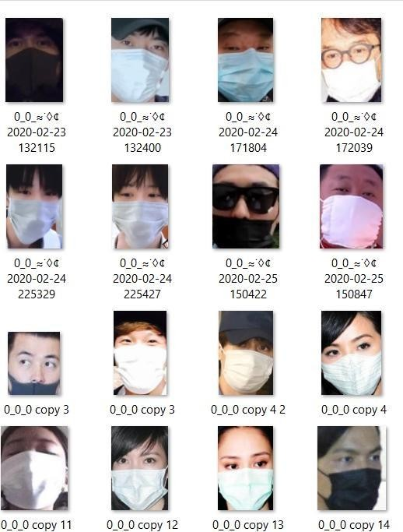

**Figure: 1** Depicts images of human wearing a mask

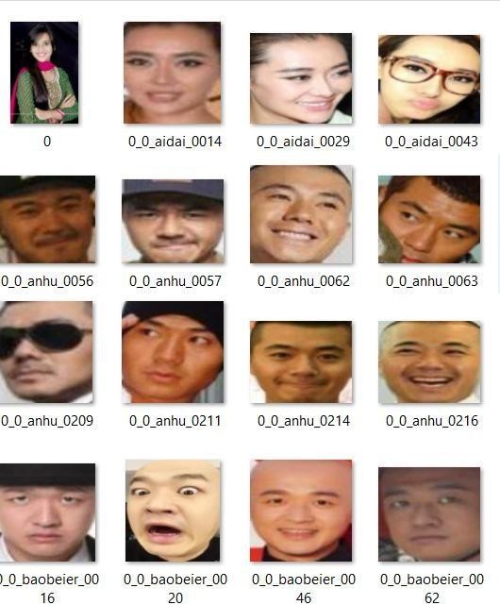

#### **Figure: 2** Depicts images of human not wearing a mask

**Chapter 3**

**Design of Project Model**

**3.1 Packages used**

#### 3.1.1 Computer Vision

**Computer vision** is an interdisciplinary research discipline that studies how computers can learn to interpret artificial images or videos at a high level. From an engineering standpoint, it aims to simplify functions that the human visual system can do. It is a field that include processing analyzing and understanding image in general high dimensional data from the real world in order to produce numerical and symbolic information or It is a scientific and computer technology that allows it to extract information from images.

3.1.1.1 Applications of Computer Vision

Computer vision is being used in more areas than you might expect. From detecting early signs of cancer to enabling automatic checkouts in retail places, computer vision has made its way into our lives. Here are some more computer vision applications:

1. Face recognition

Snapchat, Instagram, Facebook and many other social media apps use face-detection algorithms to recognize you in pictures and apply filters on your face.

1. Image retrieval

Google Images help you find relevant images when you upload an image. There are different algorithms that analyze the content in the image uploaded and return results based on the best-matched content.

1. Biometrics

Fingerprint and iris recognition are some common methods in biometric identification that uses computer vision.

1. Smart cars

Smart cars use computer vision to detect traffic signs and lights and other visual features when the cars go on auto mode.



#### 3.1.2 OpenCV

**OpenCV** (Open Source Computer Vision Library) is an open source computer vision and machine learning software library. OpenCV was created to provide a shared infrastructure for computer vision applications and to speed up the incorporation of machine perception into consumer products. Since OpenCV is a BSD-licensed software, it is simple for companies to use and change the code. It supports Windows, Linux, Android, and Mac OS and has C++, Python, Java, and MATLAB interfaces.

**3.1.2.1 Application of Open CV**

With the help of Open CV in python, its possible to process images, videos easily and can extract useful information out of that, as there are lots of functions available. Some of the common applications are,

1. Image Processing

Images can be read, write, show, and processed with the OpenCV, like can generate a new image from that either by changing its shape, colour, or extract something useful from the given one and write into a new image.

1. Fcae Detection

Either from the live streaming using web camera or from the locally stored videos/images utilizing Haar- Cascade Classifiers.

1. Object Detection

Open CV along with the YOLO, an object detection algorithm can be used to detect objects from the image, videos either moving or stationary objects.

1. Face Recoginition

It followed by face detection from the videos using open cv by drawing bounding boxes i.e. rectangle and then model training using [ML algorithms](https://www.analyticssteps.com/blogs/top-10-machine-learning-algorithms) to recognize faces.

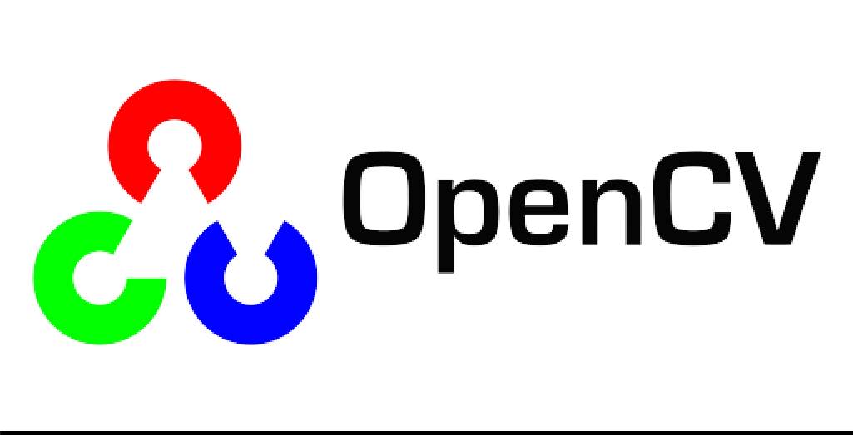

#### 3.1.3 Tensorflow

**TensorFlow** is a free and open-source software library for dataflow and differentiable programming across a range of tasks. It is a symbolic math library, and is also used for machine learning applications such as neural networks . Tensor Flow is capable of running on many CPUs and GPUs (with optional CUDA and SYCL extensions for general-purpose computing on graphics processing units). It enables developers to build machine learning software by using a variety of technologies, libraries, and community resources.

3.1.3.1 Application of TensorFlow

#### 1.Image Recognition

#### It’s one of the most popular Uses of TensorFlow. It is used by Mobile companies, social media, and other telecom houses. Image recognition consists of pixel and pattern matching to identify the image and its parts.

#### 2. Voice Recognition

TensorFlow has significant use in voice recognition systems like Telecom, Mobile companies, security systems, search engines, etc. It uses the voice recognition systems for giving commands, performing operations and giving inputs without using keyboards, mouse.

It is done using Automatic speech recognition which is trained using TensorFlow. These systems convert the human voice into text or computer understandable code by digitizing it.

#### 3.Video Detection

#### With increased technology, companies and businesses look forward to more secure and optimized systems. Hence, the motion detection is used widely at airport security checks, gaming controls, and movement detection.

#### 4 . Text-based applications

The text messages, reactions, comments, tweets, stock results etc are a means of data. This processing of data is done using TensorFlow for the analysis purpose and reaching the expected sales.

We do it using different techniques like sentiment analysis, a bag of words and many more. This can help to find out the risk associated with any organization by decoding the words used in texts.

#### 



#### 3.1.4 Keras

**Keras** is an API designed for human beings, not machines. Keras follows:

best practices for reducing cognitive load: it offers consistent & simple APIs, it minimizes the number of user actions required for common use cases, and it provides clear & actionable error messages. It also has extensive documentation and developer guides. Keras includes various implementations of widely used neural-network building blocks such as layers, objectives, activation functions, optimizers, and a host of tools to make dealing with image and text data simpler.

3.1.4.1 Application of Keras

Keras applications module is used to provide pre-trained model for deep neural networks. Keras models are used for prediction, feature extraction and fine tuning. This chapter explains about Keras applications in detail.

Keras productize the deep models on smartphones. Deep models require a lot of computation power to run, but with the help of Keras, we can make deep models a product that can be executed on smartphones.

Keras is used in the distributed training of deep learning models. Distributed training means that we can split our deep learning model into different parts and train it on systems all across the globe. This makes training of a deep learning model extremely fast. Along with saving time, we are also saving on the computational power of a system as it is not only our system that has to run such a heavy program. By distributing it across various systems, all the resources required to train a deep learning model go down significantly.

### Pre-trained models

Trained model consists of two parts model Architecture and model Weights. Model weights are large file so we have to download and extract the feature from ImageNet database. Some of the popular pre-trained models are listed below,

* ResNet
* VGG16
* MobileNet
* InceptionResNetV2
* InceptionV3



#### 

#### 3.1.5 Jupyter notebook

The **Jupyter Notebook** is a server-client application that allows editing and running notebook documents via a web browser . The Jupyter Notebook app can be executed on a local desktop requiring no internet access or can be installed on a remote server and accessed through the internet.

3.1.5.1 Applications of Jupyter Notebook

1. **Exploratory Data Analysis**

 Jupyter allows users to view the results of the code in-line without the dependency of other parts of the code. In the notebook, every cell of the code can be potentially checked at any time to draw an output.

1. **Language Independent**

Because of its representation in JSON format, Jupyter Notebook is platform-independent as well as language-independent.

1. **Data Visualisation**

 As a component, the shared notebook Jupyter supports visualisations and includes rendering some of the data sets like graphics and charts, which are generated from codes with the help of modules like Matplotlib, Plotly, or Bokeh.

1. **Live Interactions With Code**

Jupyter Notebook uses “ipywidgets” packages, which provide standard user interfaces for exploring code and data interactivity.

1. **Documenting code samples**

Jupyter makes it easy for users to explain their codes line-by-line with feedback attached all along the way.



# Chapter 4

# Proposed Methodology

The project Face mask detection has been achieved by adopting Deep Learning technique and MobileNetV2 Architecture. We have designed our project into three phases:

* 1. Data Preprocessing
     1. Training face mask detector
     2. Implementing face mask detector.

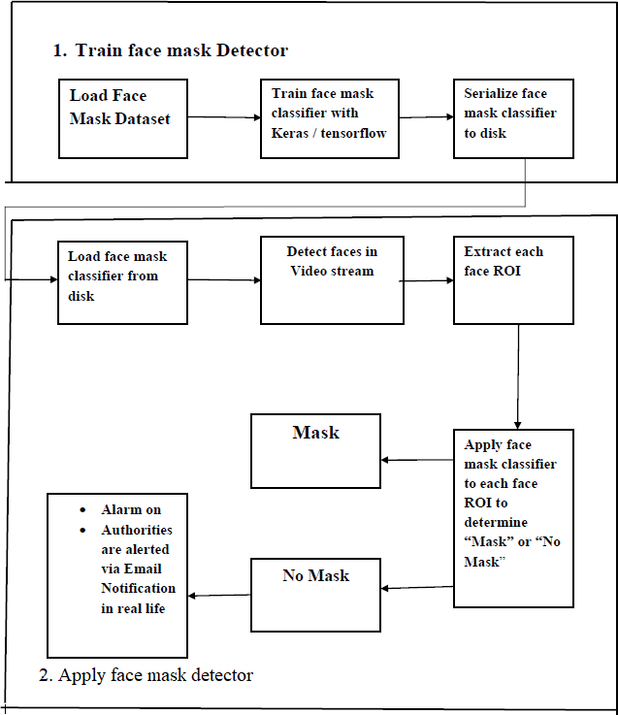

**Figure 3**: Decision flow chart of the proposed approach

First, we used a suitable algorithm to train the mask and non-mask images. After the model has been conditioned, pass on to the loading mask detector, which can detect and identify each face.

* 1. **Data Preprocessing**

Data preprocessing is a system for converting sick data into a clean dataset. Data preprocessing entails converting data from available format to another format that's further stoner-friendly, desirable, and meaningful.

In the data preprocessing part, we converted all the images from the flyers “ with mask ” and “ without mask ” into arrays so that with those array we created deep literacy model.

1. Deviating over the image path( With mask and without mask brochure).

2. Resizing the input images slightly to( 224 x 224).

3. All the photos in dataset is imaged as “ with mask ” and “ without mask ”.

Initialized data and markers, markers are in alphabetical order so by using marker binarizer to covert the data to numeric figures().

4. Converting all images into array by usingimg_to_array function. Thisimg_to_array function comes underkeras.preprocessing.image module.

5. Subjoining thepre-processed input image. Eventually Converting them into NumPy array.

6. Unyoking the training and testing data.

## 4.2 Training of Model

Erecting the Model using MobileNetV2 Architecture

After the input image is reused as an array we shoot the data into the MobilenetV2 and than we do maximum pooling on the same data and also flatten it to produce completely connected subcaste which gives the affair.

MobilenetV2 is faster than Complication Neural Network. MobilenetV2 also uses lower parameter. The weights of each subcaste in the model are predefined grounded on the Image Net dataset. The padding, strides, kernel height, input channels, and affair channels are all represented by weights. MobileNetV2 was named as the algorithm for creating a device- deployable model. On top of the MobileNetV2 model, a customized completely connected subcaste with four successional layers was created. The layers are 1. Average Pooling subcaste with weights 2. Linear subcaste with ReLu activation function 3. Powerhouse Subcaste 4. The final subcaste softmax function gives the result of two chances each bone represents the bracket of “ Mask ” or “ No Mask ”. Image data creator creates numerous images with the help of single image by changing parcels of that image which latterly used for subcaste training, we use Adam optimizer to optimize the result. The image data generated ahead is flown to train the being training data. Latterly we prognosticate the affair by assessing the network using Numpy array.

I ’ve specified three hyperactive parameter constants which include my original literacy rate to 1e- 4, number of training ages to 20, and batch size to 32, These data are taken at similar lower rate to get better delicacy.

We optimized MobileNetV2 on with mask/ No mask dataset and attained a classifier that's 99 accurate.

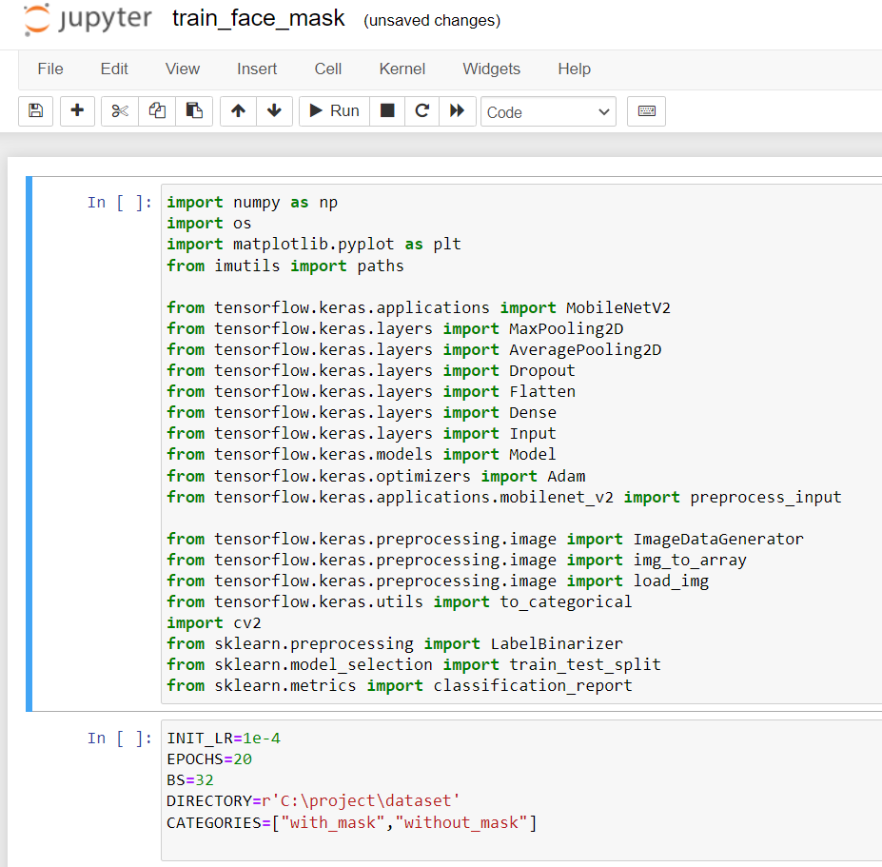

**Fig 4 :** Snippet of face mask detector training code

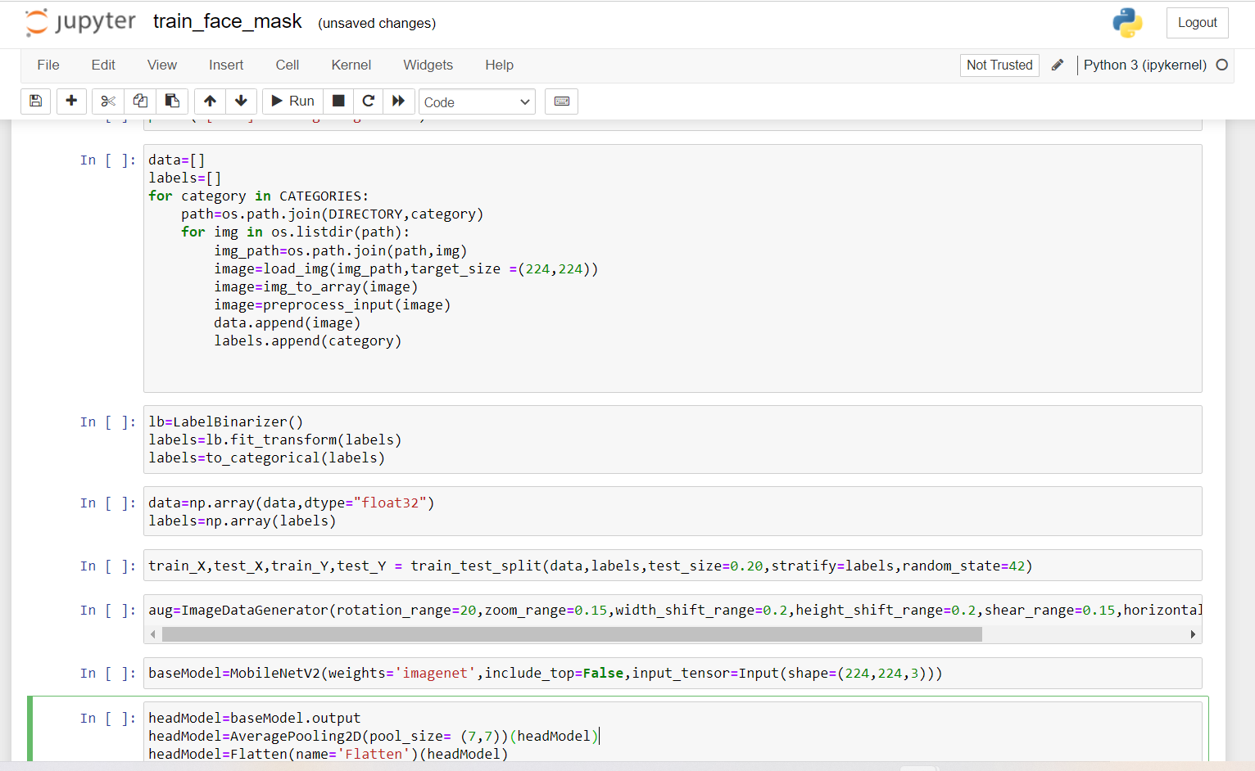

Figure 5: Snippet of data preprocessing code

## 4.3 Implementing face mask detector

1. Cargo face mask trained model and caffe model to descry faces in videotape

2. To identify the fcee/ faces using openCv by collecting real time data through webcam.

3. Now the real time data( frame/ sec) we collected from the webcam to classify it using trained model to prognosticate the affair of the given real time input.

4.As a affair we get frame in which if a person wearing mask it shows “ Mask ” with a cube of green color on his/ her face and if a person isn't wearing Mask it shows “ No Mask ” with a cube of red color on his/ her face particularly.

5. If in case a particular person isn't wearing mask so system automatically generates Dispatch to notify director and also rings alarm system to help neglectfulness of not wearing mask.

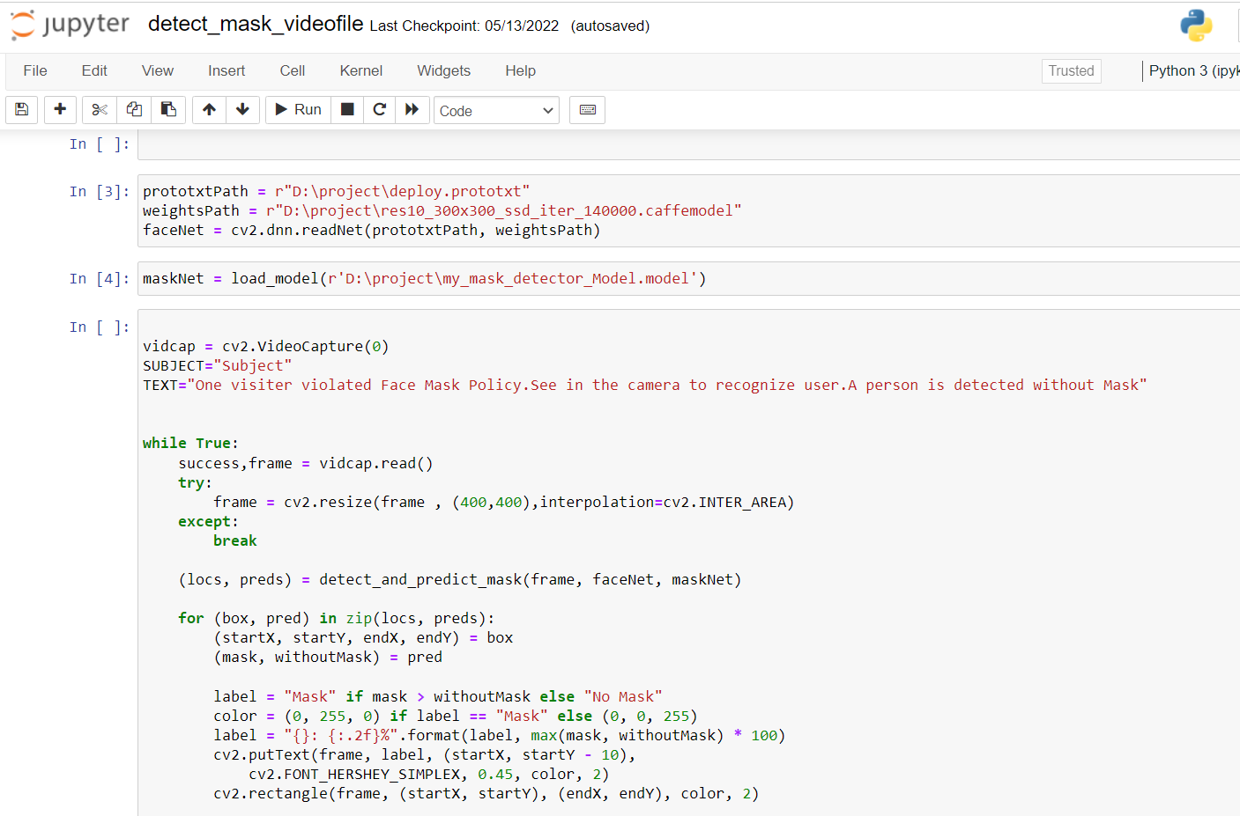

**Figure 6**: Snippet of Face mask detector Testing code

## 

## 4.4 Hardware and Software Used

* + 1. **Hardware Used**
* i5 9th or 10th Generation
* RAM minimum 8GB
* 64-bit Operating System
  + 1. **Software Used**
* Open CV
* Tensor Flow
* Keras
* Jupyter Notebook

**Chapter 5**

**Result and Conclusion**

* 1. **Result**

After successfully training, enforcing and testing the law following affair was attained. The delicacy and replication angles were colluded. Figure4 depicts the training loss and delicacy plot. The system attains 99 delicacy( shown in fig 7). Screenshots of the labors have been displayed ahead. Figure 10 depicts that when a person I s wearing facemask the system indicates that particular person is wearing the facemask. Figure 11 depicts that when a person isn't wearing facemask the system indicates that particular person isn't wearing the facemask and tells that person to kindly wear the facemask. Successfully enforced alarm system in case of particular person not wearing mask so system automatically generates Dispatch to notify director and also rings alarm system to help neglectfulness of not wearing mask.

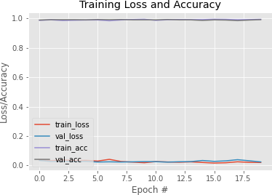

**Figure 7** : epochs # vs accuracy and loss

corresponding to dataset

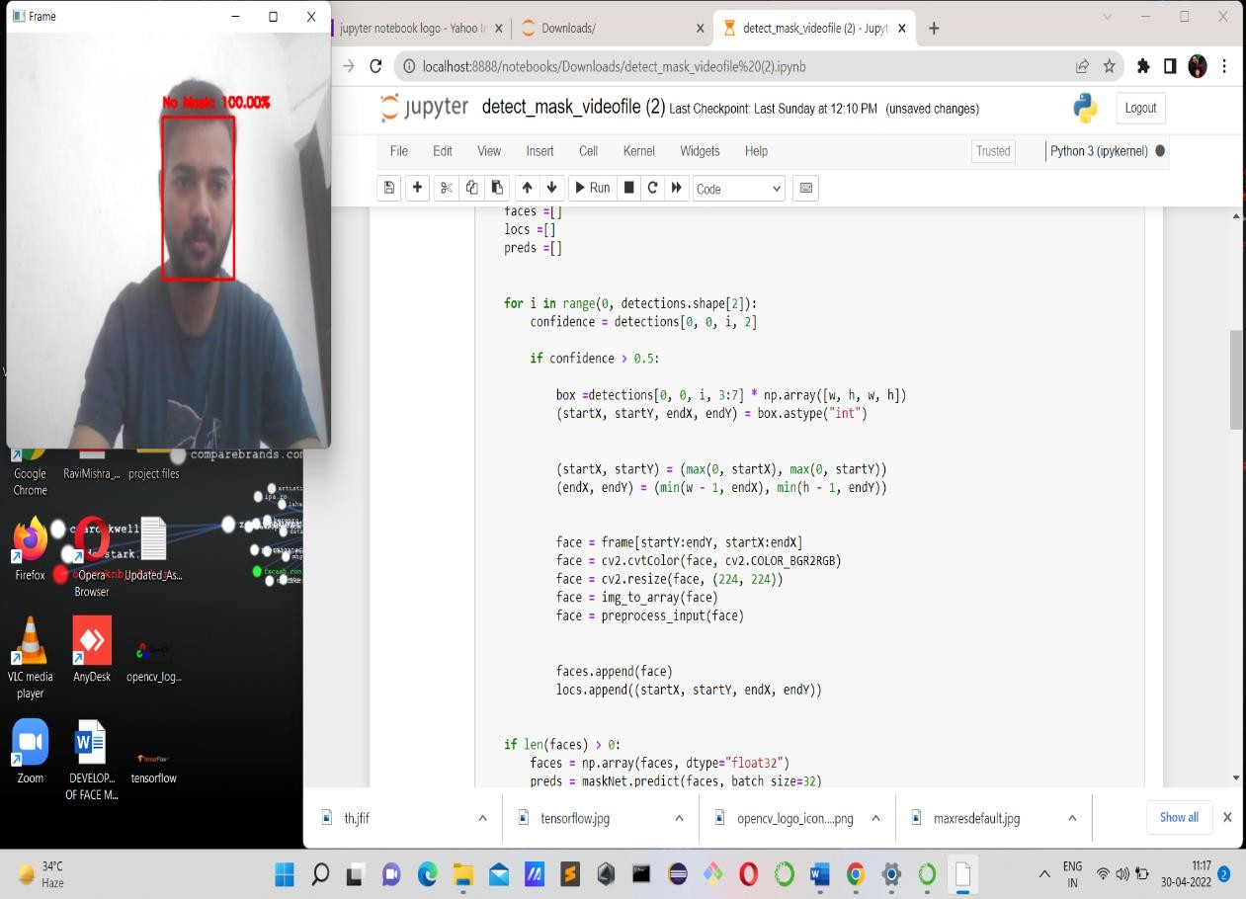

**Figure 8:** Analyzing the results of test photograph with a probability of 100% revealed that Mask was not worn

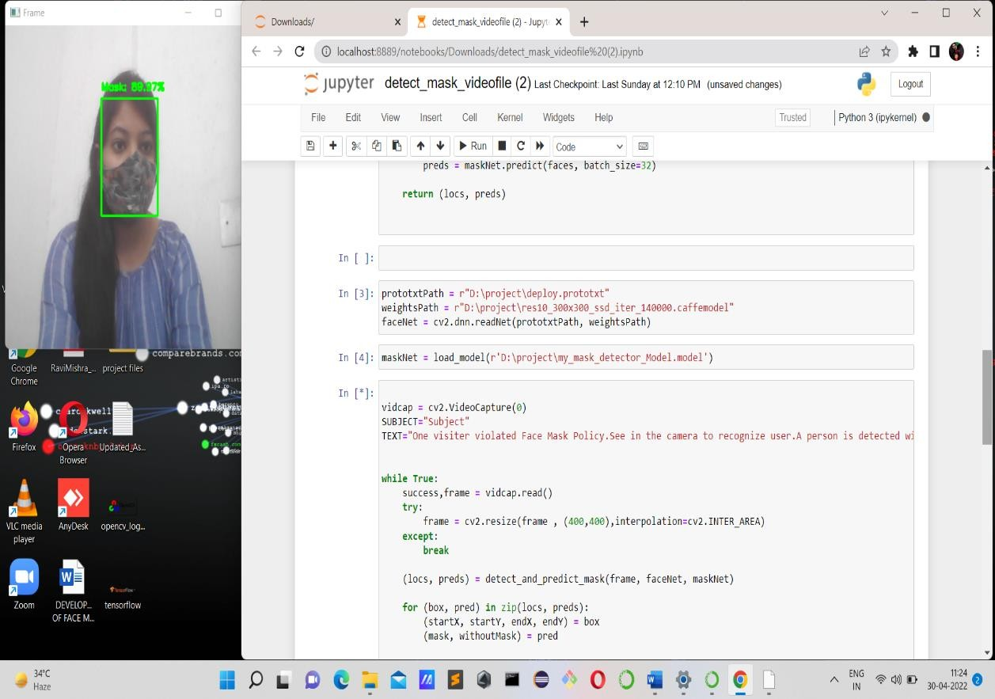

**Figure 9:** Analyzing the results of test photograph with a probability of 90% revealed that Mask was worn

## 

## Figure 10: Analyzing the results of test photograph with a probability of 100% when more than two faces are present.

## 5.2 Conclusion

This report represents a deep literacy model to descry if a person is wearing a face mask or not. We espoused OpenCV, keras, tensor inflow, and mobilenetV2 to specify whether people were wearing face masks or not. The model is tested with photos and real time videotape s treams. The delicacy rate of detecting a person with a mask is 99. This model was erected using MobileNetV2 armature. Successfully erected alarm system to warn a person who did n’t wear mask and enforced Dispatch announcement system to notify reputed authorities.

This system can help spread of covid- 19. This frame may be used as an illustration of edge analytics. This system could be enforced at Cement Diligence, Chemical Shops, Hospitals where chance of spread of complaint, and at field to descry trippers without masks.

**5.3 Future Works**

In future I allowed to add up some extension to this design

1. To count the number of objects who are not wearing mask and notify them using dispatch to the bystander

2. To increase the delicacy and quality so that the current model can work with high description camera which is established there on the business signals and near to the road to observe business.

**APPENDIX**

**Plagiarism Check**

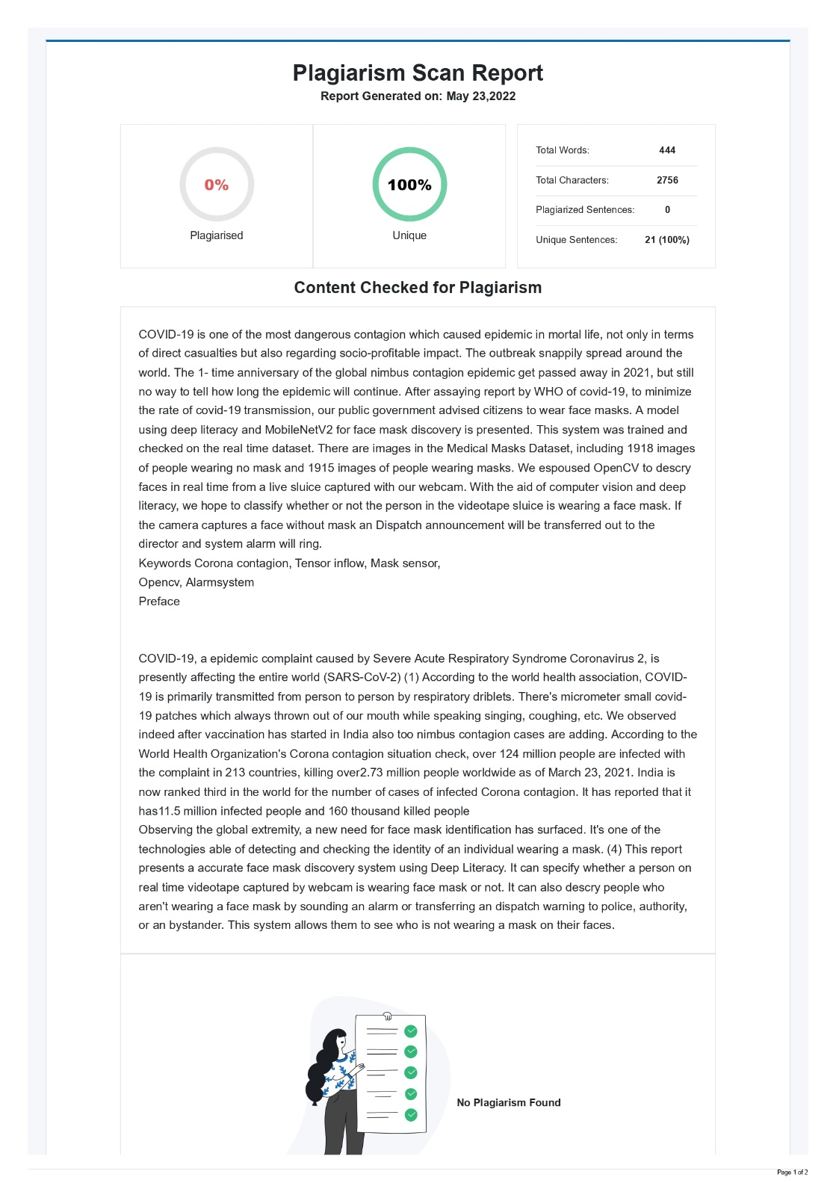

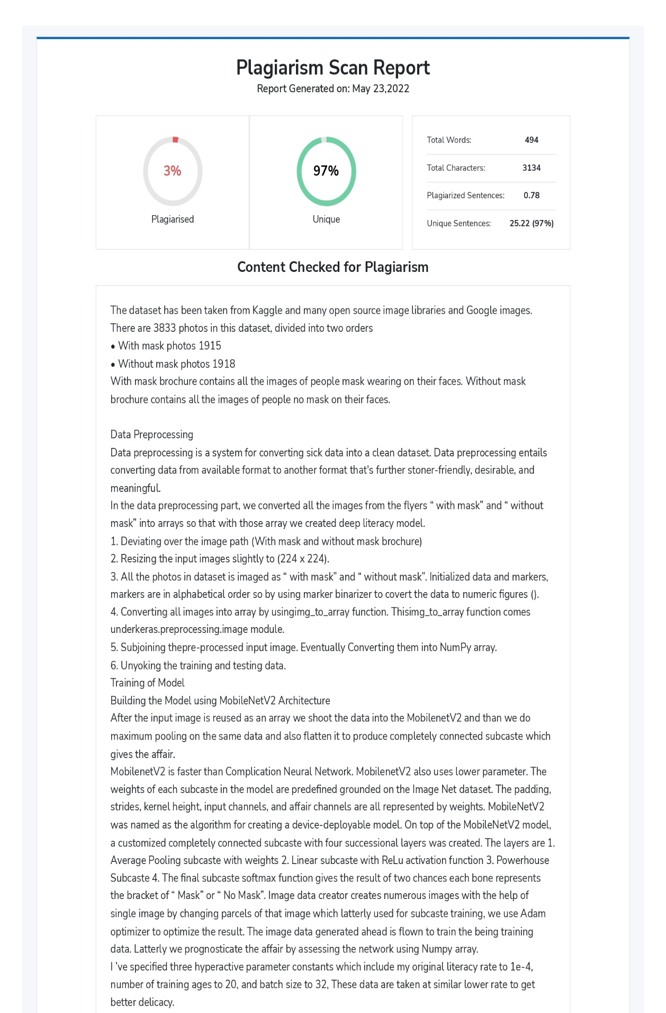

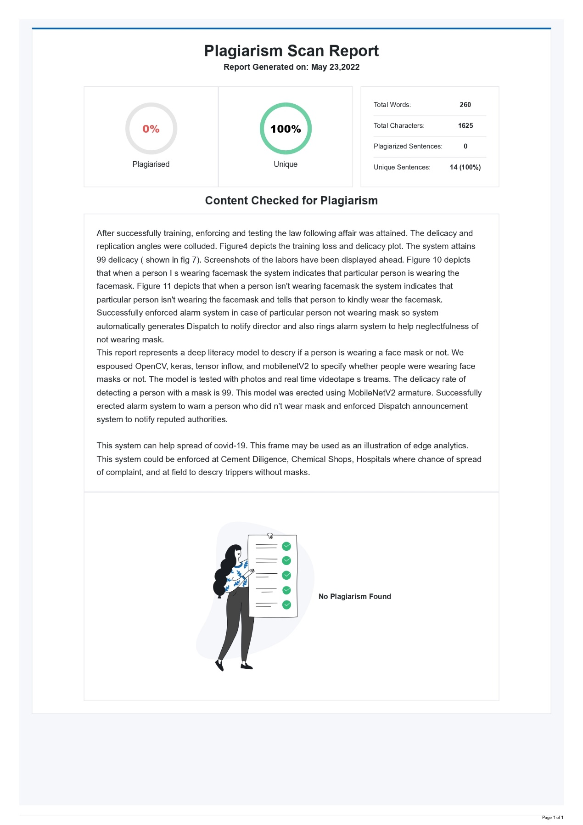

**References**

[1] M. S. Oberste ,P. A. Rota, S. S. Monroe, W. A. Nix, R. Campagnoli, S. Penaranda, B. Bankamp, J. P. Icenogle,K. Maher, M.-h. Chenet al., “Characterization of a novel coronavirus associated with severe acute respiratorysyndrome,”science, vol. 300 , no. 5624, pp. 1394–1399, 2003

[2] Arjya Das, Mohammad Wasif Ansari, Rohini Basak, “Covid-19 Face Mask Detection Using Tensorflow, Keras and OpenCV”,2020

[3] Sammy V. Militante, Nanette V. Dionisio ,“Deep Learning Implementation of Facemask and Physical Distancing Detection with Alarm Systems” , 2020

[4] Bosheng Qin, Dongxiao Li, “Identifying Facemask- Wearing Condition Using Image Super –Resolution with Classification Network to prevent COVID -19”, sensors, 2020,20,5236

[5] Vinitha.V1, Velantina.V2, “ COVID-19 FACEMASK DETECTION WITH DEEP

LEARNING AND COMPUTER VISION”, Vol . 07, 2020.

[6] Kinjal Goswami , A.M Sowjanya, “ DETECTION FACE MASK THROUGH MACHINE Learning” , Vol.02

,2020.

[7] Karim Hammoudi, Adnane Cabani, Halim Benhabiles and Mahmoud Melkemi, “Validating the Correct Wearing of Protection Mask by Taking a Selfie: Design of a Mobile Application “ CheckYourMask” to Limit the Spread of COVID-19”, 2020.

[8] Madhura Inamdar Ninad Mehandale, “Real-time face mask identification using FaceMasknet deep Learning network”