|  |
| --- |
|  |
| **.NET TECHNOLOGY** |
| **Lab Manual** |

|  |
| --- |
| **Vanshika Chavda** |

Contents

Introduction to C# 1

GTUPrograms 7

Overloading 13

Reflection API 18

Perform File Handling. 21

Windows Form Application 25

ASP.NET Validation Control 28

Introduction to Master Pages. 31

Introduction to Web Service 36

**Practical 1**

**AIM:**

# Introduction to C#

**using System;**

**using System.Collections.Generic;**

**using System.Linq;**

**using System.Text;**

**namespace Program1**

**{**

**class vector**

**{**

**public int value;**

**}**

**class Program1**

**{**

**static int i = 25;**

**public enum TimeOfDay**

**{**

**Morning = 0,**

**Afternoon = 1,**

**Evening = 2**

**}**

**static void Main(string[] args)**

**{**

**Console.WriteLine("This is first program");**

**//Scope of variables**

**int i=5;**

**Console.WriteLine("Scope of the variable {0}",i);**

**for (i = 0; i < 2; i++)**

**{**

**Console.WriteLine("{0} {1}",i,Program1.i);**

**}**

**for (int k = 0; k < 2; k++)**

**{**

**Console.WriteLine("{0}",k);**

**}**

**//Constant**

**const int valueConst=25;**

**Console.WriteLine("{0}",valueConst);**

**//valueConst = 15;**

**const int valueConst2 = 15;**

**Console.WriteLine("{0}", valueConst2);**

**//valueConst = valueConst2;**

**Console.WriteLine("{0}",valueConst);**

**//Value Type DataTypes**

**Console.WriteLine("Value Type");**

**int val1, val2;**

**val1 = 50;**

**Console.WriteLine("val1= {0}",val1);**

**val2 = val1;**

**Console.WriteLine("val1= {0} val2= {1}", val1,val2);**

**//Reference Type**

**Console.WriteLine("Reference Type");**

**vector x, y;**

**x = new vector();**

**x.value = 15;**

**y = x;**

**Console.WriteLine("x = {0} y = {1}", x.value,y.value);**

**y.value = 151;**

**Console.WriteLine("x = {0} y = {1}", x.value, y.value);**

**Console.WriteLine("\n Interger Types");**

**sbyte sb = 22;**

**short s = 22;**

**int i1 = 22;**

**long l = 22L;**

**Console.WriteLine("{0} sbtye\n{1} short\n{2} int\n{3} long\n",sb,s,i1,l);**

**Console.WriteLine("Unsigned Integers");**

**byte b = 21;**

**ushort us = 21;**

**uint ui = 21;**

**ulong ul = 21;**

**Console.WriteLine("{0} btye\n{1} ushort\n{2} uint\n{3} ulong\n", b, us, ui, ul);**

**Console.WriteLine("Floating Point");**

**float f = 11.22334455F;**

**double d = 11.2233445566778899;**

**Console.WriteLine("{0} float\n{1} double", f, d);**

**decimal dec = 111.222333444555666777888999M;**

**Console.WriteLine("Decimal:\n{0}", dec);**

**Console.WriteLine("\nBoolean:");**

**bool valBoolean = true;**

**Console.WriteLine("Status: " + valBoolean);**

**Console.WriteLine("\nCharacter:\nSingle Quote \'");**

**Console.WriteLine("Double Quote \"");**

**Console.WriteLine("Back Slash \\");**

**char charA = 'A';**

**Console.WriteLine(charA);**

**int integerA = 2;**

**Console.WriteLine("Predefined Reference Type");**

**Object o1 = "This is object 1";**

**Object o2 = 34;**

**String strObj = o1 as string;**

**Console.WriteLine(strObj);**

**Console.WriteLine(o1.GetHashCode() + " " + o1.GetType());**

**Console.WriteLine(o2.GetHashCode() + " " + o2.GetType());**

**Console.WriteLine(o1.Equals(o2));**

**string s1, s2;**

**s1 = "String 1";**

**s2 = s1;**

**Console.WriteLine("S1 is: {0} and s2 is {1}", s1, s2);**

**s2 = "New String 1";**

**Console.WriteLine("S1 is: {0} and s2 is {1}", s1, s2);**

**s1 = "c:\\NewFolder\\Hello\\P1.cs";**

**Console.WriteLine(s1);**

**s1 = @"c:\NewFolder\Hello\P1.cs";**

**Console.WriteLine(s1);**

**s1 = @"We can also write**

**like this";**

**Console.WriteLine(s1);**

**Console.WriteLine("Flow control if statement");**

**bool isZero;**

**Console.WriteLine("\nFlow Control: (if)\ni is " + i);**

**if (i == 0)**

**{**

**isZero = true;**

**Console.WriteLine("i is Zero");**

**}**

**else**

**{**

**isZero = false;**

**Console.WriteLine("i is Non - zero");**

**}**

**//else if**

**Console.WriteLine("\nType in a string:");**

**string input;**

**input = Console.ReadLine();**

**if (input == "")**

**{**

**Console.WriteLine("You typed in an empty string");**

**}**

**else if (input.Length < 5)**

**{**

**Console.WriteLine("The string had less than 5 characters");**

**}**

**else if (input.Length < 10)**

**{**

**Console.WriteLine("The string had at least 5 but less than 10 characters");**

**}**

**Console.WriteLine("The string was " + input);**

**Console.WriteLine("\nSwitch:");**

**switch (integerA)**

**{**

**case 1:**

**Console.WriteLine("integerA = 1");**

**break;**

**case 2:**

**Console.WriteLine("integerA = 2");**

**//goto case 3;**

**break;**

**case 3:**

**Console.WriteLine("integerA = 3");**

**break;**

**default:**

**Console.WriteLine("integerA is not 1, 2, or 3");**

**break;**

**}**

**WriteGreeting(TimeOfDay.Morning);**

**Console.WriteLine("Argument is: {0}", args[1]);**

**Console.ReadLine();**

**}**

**static void WriteGreeting(TimeOfDay timeOfDay)**

**{**

**switch (timeOfDay)**

**{**

**case TimeOfDay.Morning:**

**Console.WriteLine("Good morning!");**

**break;**

**case TimeOfDay.Afternoon:**

**Console.WriteLine("Good afternoon!");**

**break;**

**case TimeOfDay.Evening:**

**Console.WriteLine("Good evening!");**

**break;**

**default:**

**Console.WriteLine("Hello!");**

**break;**

**}**

**}**

**}**

**}**

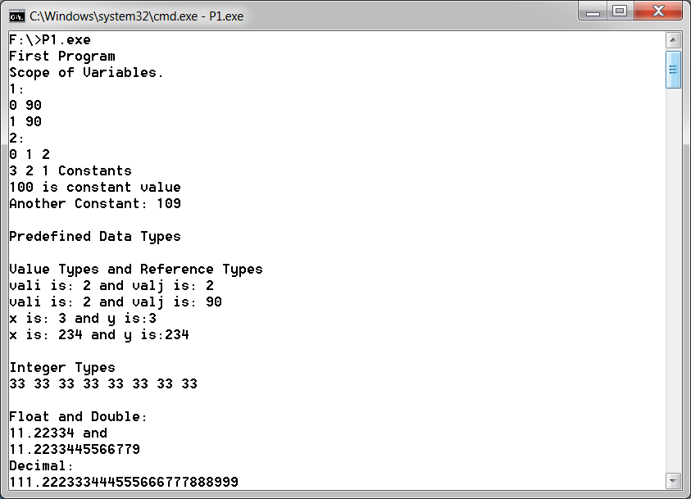

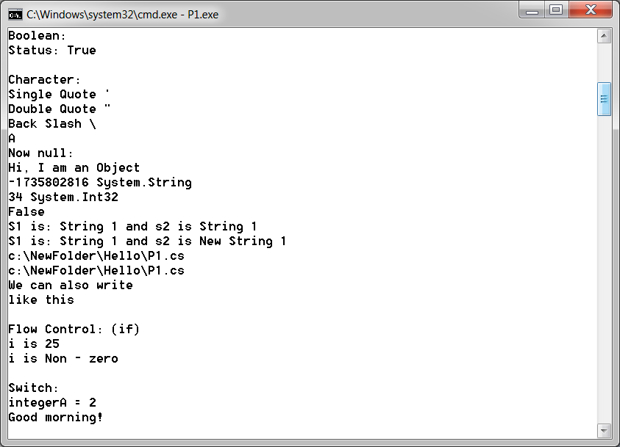

**Practical 2**

**AIM:**

# GTUPrograms

**Program 1:**

**AIM: Write console based program in code behind language VB or C# to print following pattern.**

**@ @ @ @ @**

**@ @ @ @**

**@ @ @**

**@ @**

**@**

**using System;**

**using System.Collections.Generic;**

**using System.Linq;**

**using System.Text;**

**namespace Pattern1**

**{**

**class Program**

**{**

**static void Main(string[] args)**

**{**

**for (int i = 5; i > 0; i--)**

**{**

**for (int j = 0; j <i; j++)**

**{**

**Console.Write("@");**

**}**

**Console.WriteLine();**

**}**

**Console.ReadKey();**

**}**

**}**

**}**

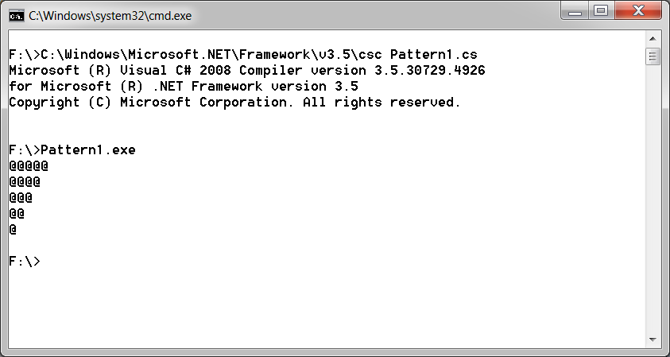

**Program 2**

**AIM: Write console based program in code behind language VB or C# to print following pattern.**

**1**

**1 2**

**1 2 3**

**1 2 3 4**

**using System;**

**using System.Collections.Generic;**

**using System.Linq;**

**using System.Text;**

**namespace Pattern2**

**{**

**class Program**

**{**

**static void Main(string[] args)**

**{**

**String s = Console.ReadLine();**

**int value = int.Parse(s);**

**for (int i = 1; i <= value; i++)**

**{**

**for (int j = 1; j <=i; j++)**

**{**

**Console.Write("{0} ",j);**

**}**

**Console.WriteLine();**

**}**

**Console.ReadKey();**

**}**

**}**

**}**

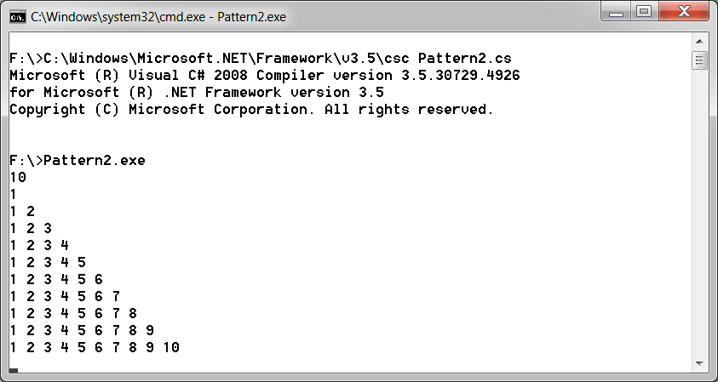

**Program 3**

**AIM: Write C# code to prompt a user to input his/her name and country name and then the output will be shown as an example below:**

**Hello Ram from country India**

**using System;**

**using System.Collections.Generic;**

**using System.Linq;**

**using System.Text;**

**namespace PrintNameCountry**

**{**

**class Program**

**{**

**static void Main(string[] args)**

**{**

**Console.WriteLine("Enter name");**

**String name = Console.ReadLine();**

**Console.WriteLine("Enter Country");**

**String country = Console.ReadLine();**

**Console.WriteLine("Hello {0} from country {1}", name, country);**

**Console.ReadKey();**

**}**

**}**

**}**

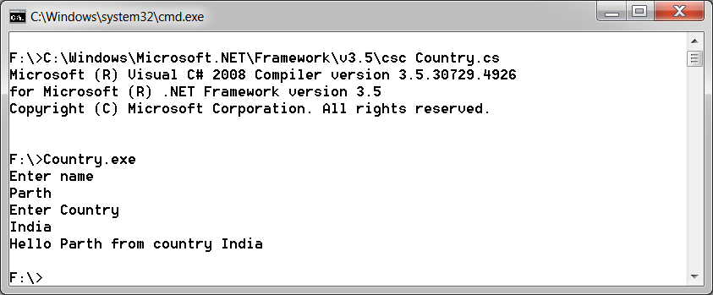

**Program 4**

**AIM: Create C# console application to define Car class and derive Maruti and Mahindra from it to demonstrate inheritance.**

**using System;**

**using System.Collections.Generic;**

**using System.Linq;**

**using System.Text;**

**namespace Inheritance**

**{**

**class Car**

**{**

**protected String name, fuel,id;**

**}**

**class Maruti: Car**

**{**

**internal Maruti(String name, String fuel, String id)**

**{**

**this.name = name;**

**this.fuel = fuel;**

**this.id = id;**

**Console.WriteLine("{0} {1} {2}",this.name, this.fuel, this.id);**

**}**

**}**

**class Mahindra : Car**

**{**

**internal Mahindra(String name, String fuel, String id)**

**{**

**this.name = name;**

**this.fuel = fuel;**

**this.id = id;**

**Console.WriteLine("{0} {1} {2}",this.name, this.fuel, this.id);**

**}**

**}**

**class Program**

**{**

**static void Main(string[] args)**

**{**

**Maruti obj1= new Maruti("abc","petrol","123");**

**Mahindra obj2 =new Mahindra("pqr","disel","456");**

**Console.ReadKey();**

**}**

**}**

**}**

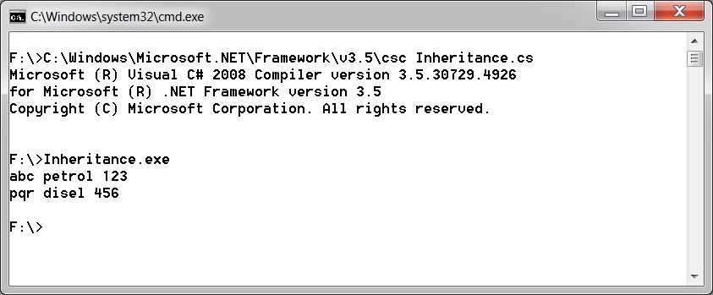

**Practical 3**

**AIM:**

# Overloading

**1.Write a c# program to add two integers, two vectors and two metric using method overloading.**

**using System;**

**using System.Collections.Generic;**

**using System.Linq;**

**using System.Text;**

**namespace MethodOverloading**

**{**

**class Vector**

**{**

**internal int x, y, z;**

**internal Vector(int x, int y, int z)**

**{**

**this.x = x;**

**this.y = y;**

**this.z = z;**

**}**

**internal Vector() { }**

**}**

**class Matrix**

**{**

**internal int [,] m = new int[2,2];**

**internal Matrix(){}**

**}**

**class Program**

**{**

**static void add(int a, int b)**

**{**

**int temp = a + b;**

**Console.WriteLine(temp);**

**}**

**static void add(Vector a, Vector b)**

**{**

**Vector temp = new Vector();**

**temp.x = a.x + b.x;**

**temp.y = a.y + b.y;**

**temp.z = a.z + b.z;**

**Console.WriteLine("{0}x {1}y {2}z", temp.x, temp.y, temp.z);**

**}**

**static void add(Matrix a, Matrix b)**

**{**

**Matrix temp = new Matrix();**

**for (int i = 0; i < 2; i++)**

**{**

**for (int j = 0; j < 2; j++)**

**{**

**temp.m[i, j]=a.m[i,j]+b.m[i,j];**

**Console.Write(temp.m[i, j]+"\t");**

**}**

**Console.Write("\n");**

**Console.WriteLine();**

**}**

**}**

**static void Main(string[] args)**

**{**

**Console.WriteLine("Enter Vector");**

**Vector a = new Vector(int.Parse(Console.ReadLine()), int.Parse(Console.ReadLine()), int.Parse(Console.ReadLine()));**

**Vector b = new Vector(int.Parse(Console.ReadLine()), int.Parse(Console.ReadLine()), int.Parse(Console.ReadLine()));**

**add(a, b);**

**Console.WriteLine("Enter integer");**

**int x = int.Parse(Console.ReadLine());**

**int y = int.Parse(Console.ReadLine());**

**add(x, y);**

**Console.WriteLine("Sum of Matrix is\n");**

**Matrix m1 = new Matrix();**

**Matrix m2 = new Matrix();**

**m1.m[0, 0] = 2;**

**m1.m[0, 1] = 2;**

**m1.m[1, 0] = 2;**

**m1.m[1, 1] = 2;**

**m2.m[0, 0] = 3;**

**m2.m[0, 1] = 3;**

**m2.m[1, 0] = 3;**

**m2.m[1, 1] = 3;**

**add(m1, m2);**

**Console.ReadKey();**

**}**

**}**

**}**

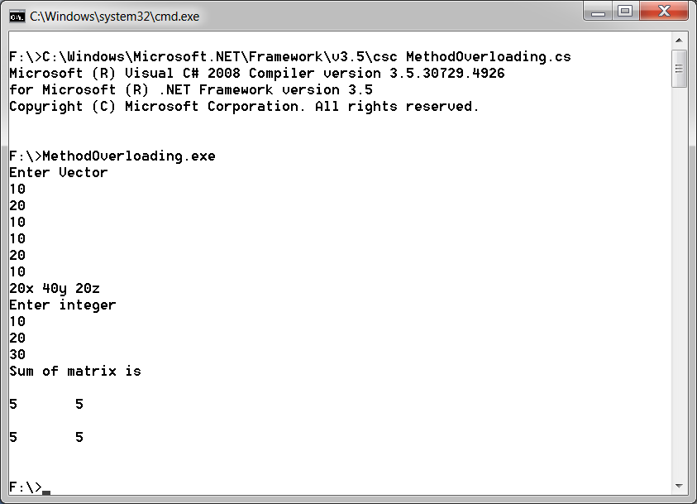

**2. Write a c# program that create student object. Overload constror to create new instant with following details.**

**1. Name**

**2. Name, Enrollment**

**3. Name, Enrollment, Branch**

**using System;**

**using System.Collections.Generic;**

**using System.Linq;**

**using System.Text;**

**namespace ConstructorOverloading**

**{**

**class Student**

**{**

**String name,enroll_no,branch;**

**public Student(String name)**

**{**

**this.name = name;**

**}**

**public Student(String name, String enroll_no)**

**{**

**this.name = name;**

**this.enroll_no = enroll_no;**

**}**

**public Student(String name, String enroll_no, String branch)**

**{**

**this.name = name;**

**this.enroll_no = enroll_no;**

**this.branch = branch;**

**}**

**internal String getName()**

**{**

**return this.name;**

**}**

**internal String getEnroll()**

**{**

**return this.enroll_no;**

**}**

**internal String getBranch()**

**{**

**return this.branch;**

**}**

**}**

**class Program**

**{**

**static void Main(string[] args)**

**{**

**Student s1 = new Student("abc");**

**Console.WriteLine(s1.getName());**

**Student s2 = new Student("pqr", "16047010459");**

**Console.WriteLine(s2.getName());**

**Console.WriteLine(s2.getEnroll());**

**Student s3 = new Student("xyz", "1604710236", "computer");**

**Console.WriteLine(s3.getName());**

**Console.WriteLine(s3.getEnroll());**

**Console.WriteLine(s3.getBranch());**

**Console.ReadKey();**

**}**

**}**

**}**

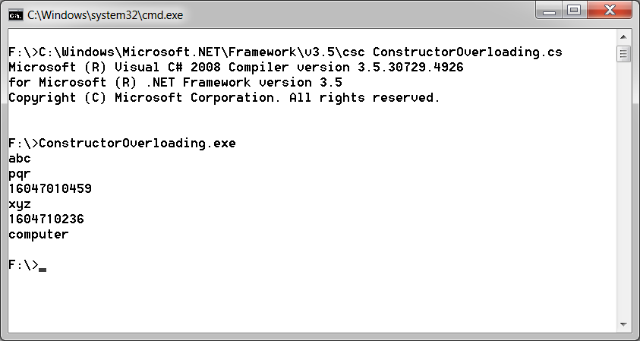

**Practical 4**

**AIM:**

# Reflection API

**1. Create a c# program to find Methods, Properties and Constructors from class of running program.**

**using System;**

**using System.Collections.Generic;**

**using System.Linq;**

**using System.Text;**

**using System.Reflection;**

**namespace Reflection**

**{**

**class Student**

**{**

**String name, enroll_no, branch;**

**public Student(String name)**

**{**

**this.name = name;**

**}**

**public Student(String name, String enroll_no)**

**{**

**this.name = name;**

**this.enroll_no = enroll_no;**

**}**

**public Student(String name, String enroll_no, String branch)**

**{**

**this.name = name;**

**this.enroll_no = enroll_no;**

**this.branch = branch;**

**}**

**public String getName()**

**{**

**return this.name;**

**}**

**public String getEnroll()**

**{**

**return this.enroll_no;**

**}**

**public String getBranch()**

**{**

**return this.branch;**

**}**

**}**

**class Program**

**{**

**static void Main(string[] args)**

**{**

**Type t = Type.GetType("Reflection.Student");**

**ConstructorInfo[] ci = t.GetConstructors();**

**MethodInfo[] mi = t.GetMethods();**

**foreach (ConstructorInfo c in ci)**

**{**

**Console.WriteLine(c.ToString());**

**}**

**foreach (MethodInfo m in mi)**

**{**

**Console.WriteLine(m.ToString());**

**}**

**Console.ReadLine();**

**}**

**}**

**}**

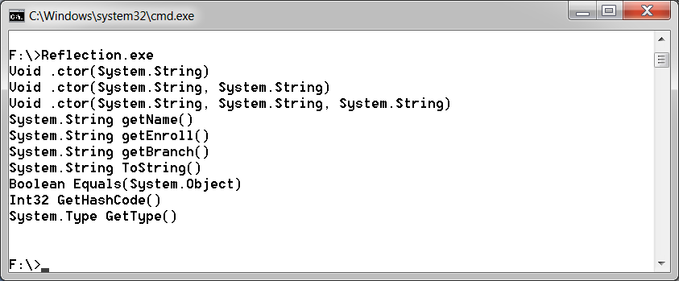

**Practical 5**

**AIM:**

# Perform File Handling.

**1. Write a C# program to copy data from one file to another using StreamReader and StreamWriter class.**

**Program 1**

**using System;**

**using System.Collections.Generic;**

**using System.Linq;**

**using System.Text;**

**using System.IO;**

**namespace CopyFile1**

**{**

**class Program**

**{**

**static void Main(string[] args)**

**{**

**String file1 = @"F:\file1.txt";**

**String file2 = @"F:\file2.txt";**

**using (StreamReader reader = new StreamReader(file1))**

**{**

**using (StreamWriter writer = new StreamWriter(file2))**

**{**

**writer.Write(reader.ReadToEnd());**

**}**

**}**

**}**

**}**

**}**

**FILE1:**

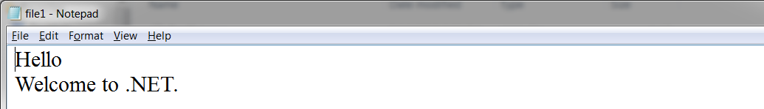

**FILE2:**



**2. Write a C# Program to Read Lines from a File until the End of File is Reached.**

**Program 2**

**using System;**

**using System.Collections.Generic;**

**using System.Linq;**

**using System.Text;**

**using System.IO;**

**namespace CopyFile2**

**{**

**class Program**

**{**

**static void Main(string[] args)**

**{**

**String file1 = @"F:\file1.txt";**

**String file2 = @"F:\file2.txt";**

**String content = null;**

**using (StreamReader reader = new StreamReader(file1))**

**{**

**using (StreamWriter writer = new StreamWriter(file2))**

**{**

**while ((content = reader.ReadLine())!= null)**

**{**

**writer.WriteLine(content);**

**}**

**}**

**}**

**}**

**}**

**}**

**FILE1:**

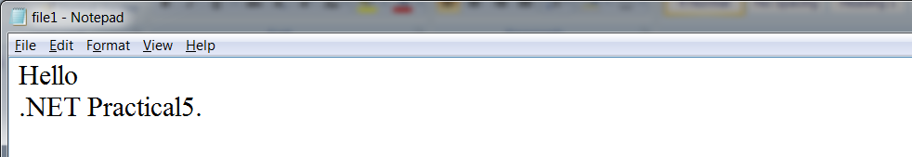

**FILE3:**

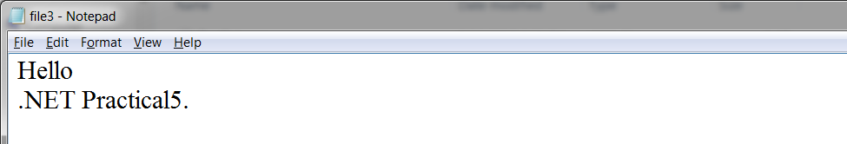

**3. Write a C# Program to List Files in a Directory.**

**Program 3**

**using System;**

**using System.Collections.Generic;**

**using System.Linq;**

**using System.Text;**

**using System.IO;**

**namespace filepractical3**

**{**

**class Program**

**{**

**static void Main(string[] args)**

**{**

**String[] Directories = Directory.GetDirectories(@"F:\DotNET");**

**foreach (string dir in Directories)**

**Console.WriteLine(dir);**

**Console.WriteLine("files are :");**

**String[] files = Directory.GetFiles(@"F:\DotNET");**

**foreach (string file in files)**

**Console.WriteLine(file);**

**Console.ReadKey();**

**}}}**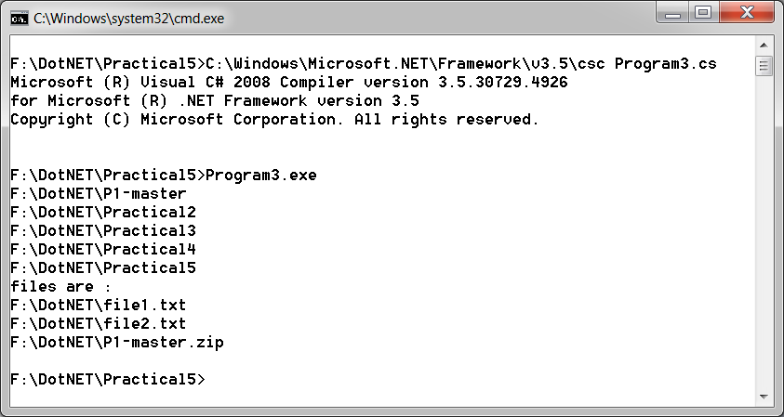

**Practical 6**

**AIM:**

# Windows Form Application

**1.Create Windows Form Application for Student Registration and store student Details in DataBase.**

**using System;**

**using System.Collections.Generic;**

**using System.ComponentModel;**

**using System.Data;**

**using System.Drawing;**

**using System.Linq;**

**using System.Text;**

**using System.Windows.Forms;**

**using System.Data.SqlClient;**

**using System.IO;**

**namespace WindowsForm1**

**{**

**public partial class Form1 : Form**

**{**

**string imgPath; public String gender;**

**public Form1()**

**{**

**InitializeComponent();**

**}**

**private void Form1_Load(object sender, EventArgs e)**

**{**

**}**

**private void button1_Click(object sender, EventArgs e)**

**{**

**String source = @"Data Source=CE3COMP3\sqlexpress;Initial Catalog=DBstudent;Integrated Security=True;Pooling=False";**

**SqlConnection con = new SqlConnection(source);**

**con.Open();**

**String ins = "insert into Tbl1(fname,Middlename,Lname,gender,Date) values('"+fname.Text+"','"+ Middlename.Text+ "','" + Lname.Text + "','" +gender+"','"+ dateTimePicker1.Value.Date +"')";**

**SqlCommand sc = new SqlCommand(ins, con);**

**int i=sc.ExecuteNonQuery();**

**if (i > -1)**

**{**

**MessageBox.Show("Entered into database");**

**}**

**}**

**private void button3_Click(object sender, EventArgs e)**

**{**

**openFileDialog1.Filter = "Png|*.png";**

**if (openFileDialog1.ShowDialog() == DialogResult.OK)**

**{**

**imgPath = @"C:\Users\CRP\Desktop\Images\"+ openFileDialog1.SafeFileName;**

**pictureBox.Image = Image.FromFile(openFileDialog1.FileName);**

**}**

**}**

**private void Male_CheckedChanged(object sender, EventArgs e)**

**{**

**if (Male.Checked)**

**{**

**gender = "Male";**

**}**

**else**

**{**

**gender = "Female";**

**}**

**}**

**}**

**}**

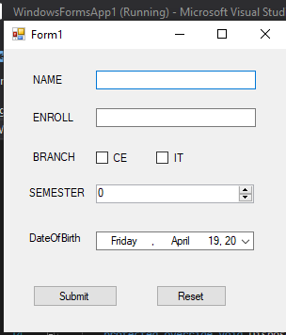

**Practical 7**

**AIM:**

# ASP.NET Validation Control

**RequiredFieldValidator**

**CompareValidator**

**RegularExpressionValidator**

**CustomValidator**

**RangeValidator**

**ValidationSummary**

**Top of Form**

**<%@ Page Language="C#" AutoEventWireup="true" CodeBehind="WebForm1.aspx.cs" Inherits="ASPWebApplication1.WebForm1" %>**

**<!DOCTYPE html PUBLIC "-//W3C//DTD XHTML 1.0 Transitional//EN" "http://www.w3.org/TR/xhtml1/DTD/xhtml1-transitional.dtd">**

**<html xmlns="http://www.w3.org/1999/xhtml">**

**<head runat="server">**

**<title></title>**

**</head>**

**<body>**

**<form id="form1" runat="server">**

**<div>**

**</div>**

**name**

**<asp:TextBox ID="Txtname" runat="server"></asp:TextBox>**

**<asp:RequiredFieldValidator ID="RequiredFieldValidator1" runat="server"**

**ControlToValidate="Txtname" ErrorMessage="name is required" ForeColor="Red"**

**ToolTip="Please enter name">*</asp:RequiredFieldValidator>**

**<br />**

**&nbsp;**

**<br />**

**email<asp:TextBox ID="Txtemail" runat="server"**

**ontextchanged="TextBox1_TextChanged"></asp:TextBox>**

**<asp:RegularExpressionValidator ID="RegularExpressionValidator1" runat="server"**

**ControlToValidate="Txtemail" ErrorMessage="not valid email address"**

**ForeColor="Red" ToolTip="enter valid email"**

**ValidationExpression="\w+([-+.']\w+)**[**\*@\w+([-.]\w+)*\.\w+([-**](mailto:*@\w+(%5b-.%5d\w+)*\.\w+(%5b-)**.]\w+)*">*</asp:RegularExpressionValidator>**

**<br />**

**<br />**

**phone no<asp:TextBox ID="Txtphone" runat="server"**

**ontextchanged="Txtphone_TextChanged"></asp:TextBox>**

**<asp:RegularExpressionValidator ID="RegularExpressionValidator2" runat="server" ControlToValidate="Txtphone" ErrorMessage="not valid phone no" ForeColor="Red" ToolTip="enter 10 digit mobile no" ValidationExpression="[0-9]{10}">*</asp:RegularExpressionValidator>**

**<br />**

**<br />**

**password<asp:TextBox ID="Txtpassword" runat="server"></asp:TextBox>**

**<br />**

**<br />**

**confirm password<asp:TextBox ID="Txtcpasswoed" runat="server"></asp:TextBox>**

**<asp:CompareValidator ID="CompareValidator1" runat="server"**

**ControlToCompare="Txtpassword" ControlToValidate="Txtcpasswoed"**

**ErrorMessage="confirm password not same as passord"**

**ToolTip="not same as password" Type="Integer"></asp:CompareValidator>**

**<br />**

**<br />**

**sem<asp:TextBox ID="Txtsem" runat="server"></asp:TextBox>**

**<asp:RangeValidator ID="RangeValidator1" runat="server"**

**ControlToValidate="Txtsem" ErrorMessage="not valid semester" MaximumValue="8"**

**MinimumValue="1"></asp:RangeValidator>**

**<br />**

**<asp:Button ID="Button1" runat="server" onclick="Button1_Click" Text="submit"/>**

**<br />**

**<asp:ValidationSummary ID="ValidationSummary1" runat="server" />**

**</form>**

**</body>**

**</html>**

**OUTPUT:**

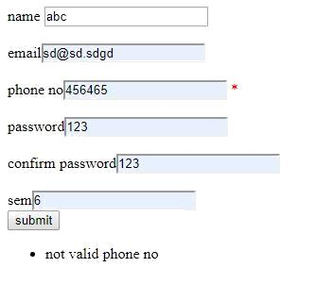

**Practical 8**

**AIM:**

# Introduction to Master Pages.

**Site1.Master**

**<%@ Master Language="C#" AutoEventWireup="true" CodeBehind="Site1.master.cs" Inherits="ASPApplication2.Site1" %>**

**<!DOCTYPE html PUBLIC "-//W3C//DTD XHTML 1.0 Transitional//EN" "http://www.w3.org/TR/xhtml1/DTD/xhtml1-transitional.dtd">**

**<html xmlns="http://www.w3.org/1999/xhtml">**

**<head runat="server">**

**<title></title>**

**<asp:ContentPlaceHolder ID="head" runat="server">**

**</asp:ContentPlaceHolder>**

**</head>**

**<body>**

**<form id="form1" runat="server">**

**<table>**

**<tr> <td>**

**<asp:Label ID="lblheader" runat="server" Text="header"></asp:Label></td></tr>**

**<tr>**

**<td>**

**<asp:Button ID="Buttonsearch" runat="server" Text="Button" />**

**<asp:ContentPlaceHolder ID="ContentPlaceHolder1" runat="server">**

**</asp:ContentPlaceHolder>**

**</td>**

**</tr>**

**<tr><td>footer</td></tr>**

**</table>**

**</form>**

**</body>**

**</html>**

**Site1.Master.cs**

**using System;**

**using System.Collections.Generic;**

**using System.Linq;**

**using System.Web;**

**using System.Web.UI;**

**using System.Web.UI.WebControls;**

**namespace ASPApplication2**

**{**

**public partial class Site1 : System.Web.UI.MasterPage**

**{**

**protected void Page_Load(object sender, EventArgs e)**

**{**

**}**

**public Label LblHeader**

**{**

**get { return lblheader; }**

**}**

**public Button buttonsearch**

**{**

**get { return Buttonsearch; }**

**}**

**}**

**}**

**WebForm1.aspx**

**<%@ Page Title="" Language="C#" MasterPageFile="~/Site1.Master" AutoEventWireup="true" CodeBehind="WebForm1.aspx.cs" Inherits="ASPApplication2.WebForm1" %>**

**<asp:Content ID="Content1" ContentPlaceHolderID="head" runat="server">**

**</asp:Content>**

**<asp:Content ID="Content2" ContentPlaceHolderID="ContentPlaceHolder1" runat="server">**

**<asp:TextBox ID="txtHeader" runat="server"></asp:TextBox>**

**<asp:Button ID="btn1" runat="server" Text="button"**

**onclick="Button1_Click" />**

**</asp:Content>**

**WebForm1.aspx.cs**

**using System;**

**using System.Collections.Generic;**

**using System.Linq;**

**using System.Web;**

**using System.Web.UI;**

**using System.Web.UI.WebControls;**

**namespace ASPApplication2**

**{**

**public partial class WebForm1 : System.Web.UI.Page**

**{**

**protected void Page_Load(object sender, EventArgs e)**

**{**

**}**

**protected void Button1_Click(object sender, EventArgs e)**

**{**

**((Site1)Master).LblHeader.Text = txtHeader.Text;**

**}**

**}**

**}**

**OUTPUT:**

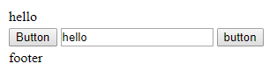

**WebForm2.aspx**

**<%@ Page Title="" Language="C#" MasterPageFile="~/Site1.Master" AutoEventWireup="true" CodeBehind="WebForm2.aspx.cs" Inherits="ASPApplication2.WebForm2" %>**

**<asp:Content ID="Content1" ContentPlaceHolderID="head" runat="server">**

**</asp:Content>**

**<asp:Content ID="Content2" ContentPlaceHolderID="ContentPlaceHolder1" runat="server">**

**<asp:GridView ID="getdetails" runat="server">**

**</asp:GridView>**

**</asp:Content>**

**WebForm2.aspx.cs**

**using System;**

**using System.Collections.Generic;**

**using System.Linq;**

**using System.Web;**

**using System.Web.UI;**

**using System.Web.UI.WebControls;**

**using System.Data.SqlClient;**

**namespace ASPApplication2**

**{**

**public partial class WebForm2 : System.Web.UI.Page**

**{**

**protected void Page_Init(object sender, EventArgs e)**

**{**

**((Site1)Master).buttonsearch.Click+=new EventHandler(buttonsearch_Click);**

**}**

**void buttonsearch_Click(object sender, EventArgs e)**

**{**

**getData();**

**}**

**protected void Page_Load(object sender, EventArgs e)**

**{**

**}**

**void getData()**

**{**

**string source = @"Data Source=CE3COMP3\sqlexpress;Initial Catalog=DBstudent;Integrated Security=True;Pooling=False";**

**string select = "select * from Tbl1";**

**SqlConnection conn = new SqlConnection(source);**

**SqlCommand cmd = new SqlCommand(select,conn);**

**conn.Open();**

**SqlDataReader reader = cmd.ExecuteReader();**

**getdetails.DataSource = reader;**

**getdetails.DataBind();**

**conn.Close();**

**}**

**}**

**}**

**OUTPUT:**

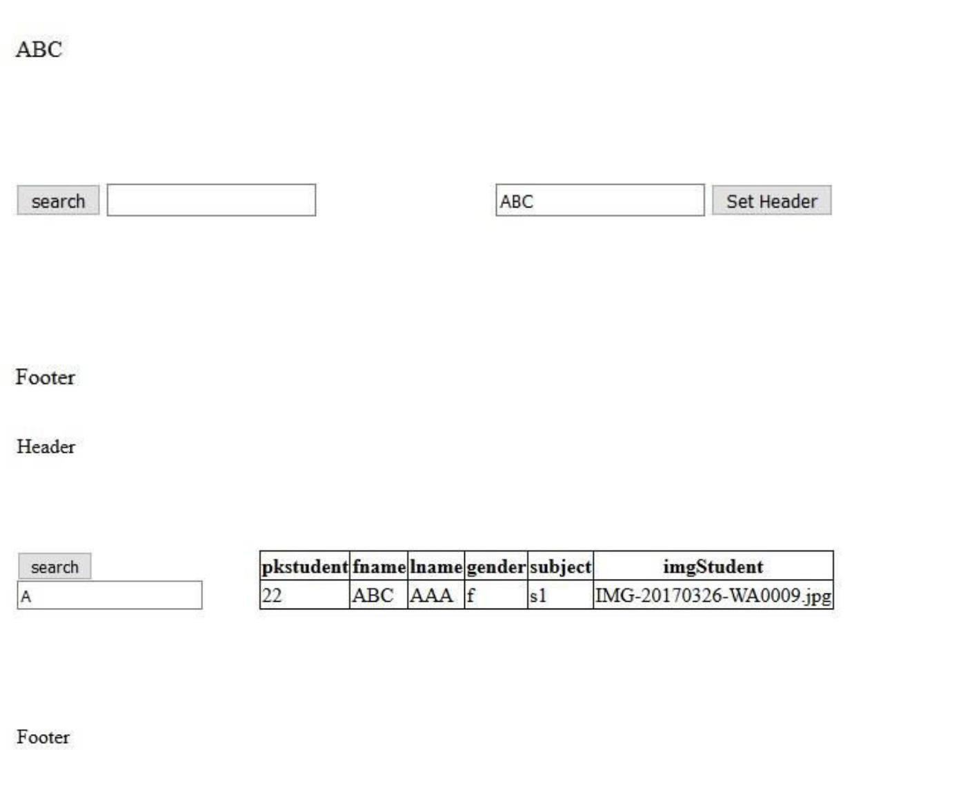

**PRACTICAL 9**

**AIM:**

# Introduction to Web Service

**Webfrom1.aspx.cs:**

|  |  |  |
| --- | --- | --- |
| **using System;** | | |
|  | | |
| **using System.Collections.Generic;** | | | |
|  | | | |
| **using System.Linq;** | |
|  | |
| **using System.Web;** |
|  |

|  |
| --- |
| **using System.Web.UI;** |
|  |

|  |
| --- |
| **using System.Web.UI.WebControls;** |
|  |

|  |
| --- |
|  |
|  |

|  |
| --- |
| **namespace radhika** |
|  |

|  |
| --- |
| **{** |
|  |

|  |
| --- |
| **public partial class WebForm1 : System.Web.UI.Page** |
|  |

|  |
| --- |
| **{** |
|  |

|  |
| --- |
| **webservice.WebService1 cal = new webservice.WebService1();** |
|  |

|  |
| --- |
| **protected void Page_Load(object sender, EventArgs e)** |
|  |

|  |
| --- |
| **{** |
|  |

|  |
| --- |
|  |
|  |

|  |
| --- |
| **}** |
|  |

|  |
| --- |
|  |
|  |

|  |
| --- |
|  |
|  |

|  |
| --- |
|  |
|  |

|  |
| --- |
| **protected void btnadd_Click(object sender, EventArgs e)** |
|  |

|  |
| --- |
| **{** |
|  |

|  |
| --- |
| **lblresult.Text = cal.Add(Convert.ToInt16(txt1.Text), Convert.ToInt16(txt2.Text)).ToString();** |
|  |

|  |
| --- |
| **}** |
|  |

|  |
| --- |
|  |
|  |

|  |
| --- |
|  |
|  |

|  |
| --- |
|  |
|  |

|  |
| --- |
| **protected void btnsub_Click1(object sender, EventArgs e)** |
|  |

|  |
| --- |
| **{** |
|  |

|  |
| --- |
| **lblresult.Text = cal.Sub(Convert.ToInt16(txt1.Text), Convert.ToInt16(txt2.Text)).ToString();** |
|  |

|  |
| --- |
| **}** |
|  |

|  |
| --- |
|  |
|  |

|  |
| --- |
| **protected void btnmul_Click1(object sender, EventArgs e)** |
|  |

|  |
| --- |
| **{** |
|  |

|  |
| --- |
| **lblresult.Text = cal.Mul(Convert.ToInt16(txt1.Text), Convert.ToInt16(txt2.Text)).ToString();** |
|  |

|  |
| --- |
| **}** |
|  |

|  |
| --- |
|  |
|  |

|  |
| --- |
| **protected void btndiv_Click1(object sender, EventArgs e)** |
|  |

|  |
| --- |
| **{** |
|  |

|  |
| --- |
| **lblresult.Text = cal.Div(Convert.ToInt16(txt1.Text), Convert.ToInt16(txt2.Text)).ToString();** |
|  |

|  |
| --- |
| **}** |
|  |

|  |
| --- |
| **}** |
|  |

**}**

***Webform1.designer.aspx.cs:***

|  |
| --- |
| **namespace viral{** |
|  |

|  |
| --- |
|  |
|  |

|  |
| --- |
|  |
|  |

|  |
| --- |
| **public partial class WebForm1 {** |
|  |

|  |
| --- |
|  |
|  |

|  |
| --- |
| **/// <summary>** |
|  |

|  |
| --- |
| **/// form1 control.** |
|  |

|  |
| --- |
| **/// </summary>** |
|  |

|  |
| --- |
| **/// <remarks>** |
|  |

|  |
| --- |
| **/// Auto-generated field.** |
|  |

|  |
| --- |
| **/// To modify move field declaration from designer file to code-behind file.** |
|  |

|  |
| --- |
| **/// </remarks>** |
|  |

|  |
| --- |
| **protected global::System.Web.UI.HtmlControls.HtmlForm form1;** |
|  |

|  |
| --- |
|  |
|  |

|  |
| --- |
| **/// <summary>** |
|  |

|  |
| --- |
| **/// txt1 control.** |
|  |

|  |
| --- |
| **/// </summary>** |
|  |

|  |
| --- |
| **/// <remarks>** |
|  |

|  |
| --- |
| **/// Auto-generated field.** |
|  |

|  |
| --- |
| **/// To modify move field declaration from designer file to code-behind file.** |
|  |

|  |
| --- |
| **/// </remarks>** |
|  |

|  |
| --- |
| **protected global::System.Web.UI.WebControls.TextBox txt1;** |
|  |

|  |
| --- |
|  |
|  |

|  |
| --- |
| **/// <summary>** |
|  |

|  |
| --- |
| **/// RegularExpressionValidator1 control.** |
|  |

|  |
| --- |
| **/// </summary>** |
|  |

|  |
| --- |
| **/// <remarks>** |
|  |

|  |
| --- |
| **/// Auto-generated field.** |
|  |

|  |
| --- |
| **/// To modify move field declaration from designer file to code-behind file.** |
|  |

|  |
| --- |
| **/// </remarks>** |
|  |

|  |
| --- |
| **protected global::System.Web.UI.WebControls.RegularExpressionValidator RegularExpressionValidator1;** |
|  |

|  |
| --- |
|  |
|  |

|  |
| --- |
| **/// <summary>** |
|  |

|  |
| --- |
| **/// RequiredFieldValidator1 control.** |
|  |

|  |
| --- |
| **/// </summary>** |
|  |

|  |
| --- |
| **/// <remarks>** |
|  |

|  |
| --- |
| **/// Auto-generated field.** |
|  |

|  |
| --- |
| **/// To modify move field declaration from designer file to code-behind file.** |
|  |

|  |
| --- |
| **/// </remarks>** |
|  |

|  |
| --- |
| **protected global::System.Web.UI.WebControls.RequiredFieldValidator RequiredFieldValidator1;** |
|  |

|  |
| --- |
|  |
|  |

|  |
| --- |
| **/// <summary>** |
|  |

|  |
| --- |
| **/// txt2 control.** |
|  |

|  |
| --- |
| **/// </summary>** |
|  |

|  |
| --- |
| **/// <remarks>** |
|  |

|  |
| --- |
| **/// Auto-generated field.** |
|  |

|  |
| --- |
| **/// To modify move field declaration from designer file to code-behind file.** |
|  |

|  |
| --- |
| **/// </remarks>** |
|  |

|  |
| --- |
| **protected global::System.Web.UI.WebControls.TextBox txt2;** |
|  |

|  |
| --- |
|  |
|  |

|  |
| --- |
| **/// <summary>** |
|  |

|  |
| --- |
| **/// RequiredFieldValidator2 control.** |
|  |

|  |
| --- |
| **/// </summary>** |
|  |

|  |
| --- |
| **/// <remarks>** |
|  |

|  |
| --- |
| **/// Auto-generated field.** |
|  |

|  |
| --- |
| **/// To modify move field declaration from designer file to code-behind file.** |
|  |

|  |
| --- |
| **/// </remarks>** |
|  |

|  |
| --- |
| **protected global::System.Web.UI.WebControls.RequiredFieldValidator RequiredFieldValidator2;** |
|  |

|  |
| --- |
|  |
|  |

|  |
| --- |
| **/// <summary>** |
|  |

|  |
| --- |
| **/// RegularExpressionValidator2 control.** |
|  |

|  |
| --- |
| **/// </summary>** |
|  |

|  |
| --- |
| **/// <remarks>** |
|  |

|  |
| --- |
| **/// Auto-generated field.** |
|  |

|  |
| --- |
| **/// To modify move field declaration from designer file to code-behind file.** |
|  |

|  |
| --- |
| **/// </remarks>** |
|  |

|  |
| --- |
| **protected global::System.Web.UI.WebControls.RegularExpressionValidator RegularExpressionValidator2;** |
|  |

|  |
| --- |
|  |
|  |

|  |
| --- |
| **/// <summary>** |
|  |

|  |
| --- |
| **/// btnadd control.** |
|  |

|  |
| --- |
| **/// </summary>** |
|  |

|  |
| --- |
| **/// <remarks>** |
|  |

|  |
| --- |
| **/// Auto-generated field.** |
|  |

|  |
| --- |
| **/// To modify move field declaration from designer file to code-behind file.** |
|  |

|  |
| --- |
| **/// </remarks>** |
|  |

|  |
| --- |
| **protected global::System.Web.UI.WebControls.Button btnadd;** |
|  |

|  |
| --- |
|  |
|  |

|  |
| --- |
| **/// <summary>** |
|  |

|  |
| --- |
| **/// btnsub control.** |
|  |

|  |
| --- |
| **/// </summary>** |
|  |

|  |
| --- |
| **/// <remarks>** |
|  |

|  |
| --- |
| **/// Auto-generated field.** |
|  |

|  |
| --- |
| **/// To modify move field declaration from designer file to code-behind file.** |
|  |

|  |
| --- |
| **/// </remarks>** |
|  |

|  |
| --- |
| **protected global::System.Web.UI.WebControls.Button btnsub;** |
|  |

|  |
| --- |
|  |
|  |

|  |
| --- |
| **/// <summary>** |
|  |

|  |
| --- |
| **/// btnmul control.** |
|  |

|  |
| --- |
| **/// </summary>** |
|  |

|  |
| --- |
| **/// <remarks>** |
|  |

|  |
| --- |
| **/// Auto-generated field.** |
|  |

|  |
| --- |
| **/// To modify move field declaration from designer file to code-behind file.** |
|  |

|  |
| --- |
| **/// </remarks>** |
|  |

|  |
| --- |
| **protected global::System.Web.UI.WebControls.Button btnmul;** |
|  |

|  |
| --- |
|  |
|  |

|  |
| --- |
| **/// <summary>** |
|  |

|  |
| --- |
| **/// btndiv control.** |
|  |

|  |
| --- |
| **/// </summary>** |
|  |

|  |
| --- |
| **/// <remarks>** |
|  |

|  |
| --- |
| **/// Auto-generated field.** |
|  |

|  |
| --- |
| **/// To modify move field declaration from designer file to code-behind file.** |
|  |

|  |
| --- |
| **/// </remarks>** |
|  |

|  |
| --- |
| **protected global::System.Web.UI.WebControls.Button btndiv;** |
|  |

|  |
| --- |
|  |
|  |

|  |
| --- |
| **/// <summary>** |
|  |

|  |
| --- |
| **/// lblresult control.** |
|  |

|  |
| --- |
| **/// </summary>** |
|  |

|  |
| --- |
| **/// <remarks>** |
|  |

|  |
| --- |
| **/// Auto-generated field.** |
|  |

|  |
| --- |
| **/// To modify move field declaration from designer file to code-behind file.** |
|  |

|  |
| --- |
| **/// </remarks>** |
|  |

|  |
| --- |
| **protected global::System.Web.UI.WebControls.Label lblresult;** |
|  |

|  |
| --- |
| **}** |
|  |

**}**

**WEBSERVICE.AMSX.CS:-**

|  |
| --- |
| **using System;** |
|  |

|  |
| --- |
| **using System.Collections.Generic;** |
|  |

|  |
| --- |
| **using System.Linq;** |
|  |

|  |
| --- |
| **using System.Web;** |
|  |

|  |
| --- |
| **using System.Web.Services;** |
|  |

|  |
| --- |
|  |
|  |

|  |
| --- |
| **namespace WebApplication1** |
|  |

|  |
| --- |
| **{** |
|  |

|  |
| --- |
| **/// <summary>** |
|  |

|  |
| --- |
| **/// Summary description for WebService1** |
|  |

|  |
| --- |
| **/// </summary>** |
|  |

|  |
| --- |
| **[WebService(Namespace = "http://tempuri.org/")]** |
|  |

|  |
| --- |
| **[WebServiceBinding(ConformsTo = WsiProfiles.BasicProfile1_1)]** |
|  |

|  |
| --- |
| **[System.ComponentModel.ToolboxItem(false)]** |
|  |

|  |
| --- |
| **// To allow this Web Service to be called from script, using ASP.NET AJAX, uncomment the following line.** |
|  |

|  |
| --- |
| **// [System.Web.Script.Services.ScriptService]** |
|  |

|  |
| --- |
| **public class WebService1 : System.Web.Services.WebService** |
|  |

|  |
| --- |
| **{** |
|  |

|  |
| --- |
|  |
|  |

|  |
| --- |
| **[WebMethod]** |
|  |

|  |
| --- |
| **public string HelloWorld()** |
|  |

|  |
| --- |
| **{** |
|  |

|  |
| --- |
| **return "Hello World";** |
|  |

|  |
| --- |
| **}** |
|  |

|  |
| --- |
| **[WebMethod]** |
|  |

|  |
| --- |
| **public int Add(int a,int b)** |
|  |

|  |
| --- |
| **{** |
|  |

|  |
| --- |
| **return a+b;** |
|  |

|  |
| --- |
| **}** |
|  |

|  |
| --- |
| **[WebMethod]** |
|  |

|  |
| --- |
| **public int Sub(int a, int b)** |
|  |

|  |
| --- |
| **{** |
|  |

|  |
| --- |
| **return a - b;** |
|  |

|  |
| --- |
| **}** |
|  |

|  |
| --- |
| **[WebMethod]** |
|  |

|  |
| --- |
| **public int Mul(int a, int b)** |
|  |

|  |
| --- |
| **{** |
|  |

|  |
| --- |
| **return a * b;** |
|  |

|  |
| --- |
| **}** |
|  |

|  |
| --- |
| **[WebMethod]** |
|  |

|  |
| --- |
| **public int Div(int a, int b)** |
|  |

|  |
| --- |
| **{** |
|  |

|  |
| --- |
| **return a / b;** |
|  |

|  |
| --- |
| **}** |
|  |

|  |
| --- |
|  |
|  |

**}**

**}**

**OUTPUT:**

