Computer Vision - Lab Sheet 3

import cv2
import numpy as np
import matplotlib.pyplot as plt
import pandas as pd

from PIL import Image
from skimage.metrics import structural_similarity as ssim
from IPython.display import display, clear_output
import ipywidgets as widgets

plt.rcParams["figure.figsize"] = (12, 6)

print("OpenCV version:", cv2.__version__)
print("Setup complete.")
Output
OpenCV version: 5.0.0
Setup complete.

Code
plt.rcParams["figure.figsize"] = (12, 6)

def load_image(path):
"""Load an image as RGB."""
image = cv2.imread(path)
if image is None:
raise FileNotFoundError(f"Could not read image: {path}")
return cv2.cvtColor(image, cv2.COLOR_BGR2RGB)

def select_image_for_program():
"""Helper function to select an image via upload or local path."""
image_path = None
try:
from google.colab import files
print("Please upload an image for this program:")
uploaded = files.upload()
image_path = next(iter(uploaded))
except Exception:
image_path = input("Enter image path for this program: ")
return load_image(image_path)

def show_images(images, titles, figsize=(16, 5)):
"""Display multiple RGB/grayscale images side by side."""
plt.figure(figsize=figsize)
for i, (image, title) in enumerate(zip(images, titles), 1):
plt.subplot(1, len(images), i)
if len(image.shape) == 2:
plt.imshow(image, cmap="gray")
else:
plt.imshow(image)
plt.title(title)
plt.axis("off")
plt.tight_layout()
plt.show()

def add_salt_pepper_noise(image, amount=10, seed=42):
"""Add salt-and-pepper noise to an RGB image."""
rng = np.random.default_rng(seed)
noisy = image.copy()

h, w = image.shape[:2]
n = int(h * w * amount / 100)

rows = rng.integers(0, h, n)
cols = rng.integers(0, w, n)

half = n // 2
noisy[rows[:half], cols[:half]] = 255
noisy[rows[half:], cols[half:]] = 0

return noisy

def calculate_psnr(original, filtered):
"""Calculate PSNR in dB."""
original = original.astype(np.float64)
filtered = filtered.astype(np.float64)

mse = np.mean((original - filtered) ** 2)

if mse == 0:
return float("inf")

return 10 * np.log10((255 ** 2) / mse)

def calculate_ssim(original, filtered):
"""Calculate SSIM for RGB images."""
return ssim(
original,
filtered,
channel_axis=2,
data_range=255
)

print("Helper functions loaded.")
Output
Helper functions loaded.

1. Noise Removal: Gaussian, Median and Mean Filters
Code
program1_image = select_image_for_program()

noise_amount = 10
noisy = add_salt_pepper_noise(program1_image, noise_amount)

# Convert RGB -> BGR for OpenCV
noisy_bgr = cv2.cvtColor(noisy, cv2.COLOR_RGB2BGR)

kernel_size = 3

mean_result = cv2.blur(
noisy_bgr,
(kernel_size, kernel_size)
)

gaussian_result = cv2.GaussianBlur(
noisy_bgr,
(kernel_size, kernel_size),
0
)

median_result = cv2.medianBlur(
noisy_bgr,
kernel_size
)

mean_rgb = cv2.cvtColor(mean_result, cv2.COLOR_BGR2RGB)
gaussian_rgb = cv2.cvtColor(gaussian_result, cv2.COLOR_BGR2RGB)
median_rgb = cv2.cvtColor(median_result, cv2.COLOR_BGR2RGB)

show_images(
[program1_image, noisy, mean_rgb, gaussian_rgb, median_rgb],
[
"Original",
"Salt & Pepper Noise",
"Mean Filter",
"Gaussian Filter",
"Median Filter"
],
figsize=(20, 5)
)
Output
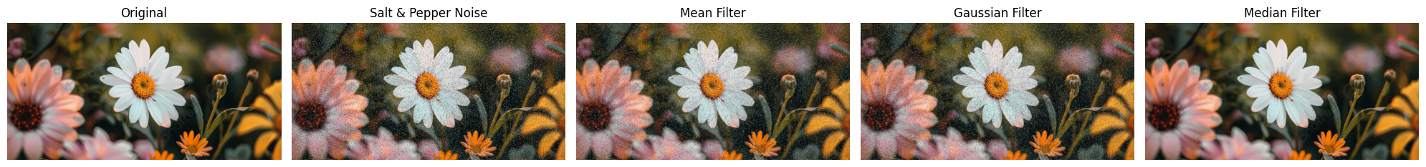

2. Edge Detection Using Sobel and Laplacian
Code
program2_image = select_image_for_program()

gray = cv2.cvtColor(program2_image, cv2.COLOR_RGB2GRAY)

sobel_x = cv2.Sobel(gray, cv2.CV_64F, 1, 0, ksize=3)
sobel_y = cv2.Sobel(gray, cv2.CV_64F, 0, 1, ksize=3)

sobel_magnitude = np.sqrt(sobel_x ** 2 + sobel_y ** 2)
sobel_edges = cv2.normalize(
sobel_magnitude, None, 0, 255, cv2.NORM_MINMAX
).astype(np.uint8)

laplacian = cv2.Laplacian(
gray,
cv2.CV_64F,
ksize=3
)

laplacian_edges = cv2.normalize(
np.abs(laplacian),
None,
0,
255,
cv2.NORM_MINMAX
).astype(np.uint8)

show_images(
[program2_image, gray, sobel_edges, laplacian_edges],
[
"Original",
"Grayscale",
"Sobel Edge Map",
"Laplacian Edge Map"
],
figsize=(16, 5)
)

print("Sobel X kernel:")
print(np.array([[-1, 0, 1],
[-2, 0, 2],
[-1, 0, 1]]))

print("\nLaplacian kernel:")
print(np.array([[0, 1, 0],
[1, -4, 1],
[0, 1, 0]]))
Output
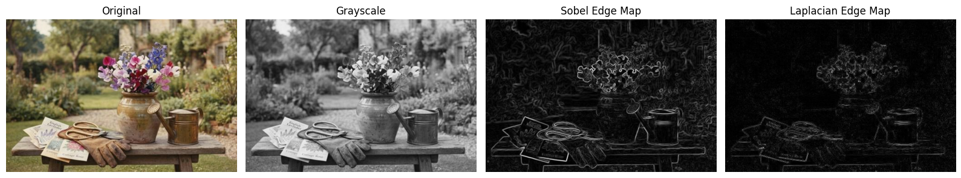
Sobel X kernel:
[[-1 0 1]
[-2 0 2]
[-1 0 1]]

Laplacian kernel:
[[ 0 1 0]
[ 1 -4 1]
[ 0 1 0]]

3. Interactive Low-Pass Blur Tool
Code
program3_image = select_image_for_program()

def interactive_blur(image):
slider = widgets.IntSlider(
value=5,
min=3,
max=31,
step=2,
description="Kernel:",
continuous_update=True
)

output = widgets.Output()

def update(change=None):
with output:
clear_output(wait=True)

k = slider.value
blurred = cv2.blur(
image,
(k, k)
)

show_images(
[image, blurred],
["Original", f"Mean Low-Pass Blur ({k}x{k})"],
figsize=(12, 5)
)

slider.observe(update, names="value")
update()

display(slider, output)

interactive_blur(program3_image)
Output
Interactive widget output (sliders / dropdown controls) — rendered live in the notebook; no static image was saved.

4. Sharpening Using Unsharp Masking
Code
program4_image = select_image_for_program()

def interactive_unsharp(image):
kernel_slider = widgets.IntSlider(
value=5,
min=3,
max=31,
step=2,
description="Kernel:",
continuous_update=True
)

strength_slider = widgets.FloatSlider(
value=1.5,
min=0,
max=5,
step=0.1,
description="Strength:",
continuous_update=True
)

output = widgets.Output()

def update(change=None):
with output:
clear_output(wait=True)

k = kernel_slider.value
strength = strength_slider.value

blurred = cv2.GaussianBlur(
image,
(k, k),
0
)

sharpened = cv2.addWeighted(
image,
1 + strength,
blurred,
-strength,
0
)

sharpened = np.clip(
sharpened,
0,
255
).astype(np.uint8)

show_images(
[image, blurred, sharpened],
[
"Original",
f"Gaussian Blur ({k}x{k})",
f"Unsharp Masking (Strength={strength:.1f})"
],
figsize=(16, 5)
)

kernel_slider.observe(update, names="value")
strength_slider.observe(update, names="value")
update()

display(kernel_slider, strength_slider, output)

interactive_unsharp(program4_image)
Output
Interactive widget output (sliders / dropdown controls) — rendered live in the notebook; no static image was saved.

5. Custom Convolution Kernel Designer
Code
program5_image = select_image_for_program()

def apply_custom_kernel(image, kernel):
image_bgr = cv2.cvtColor(image, cv2.COLOR_RGB2BGR)
result = cv2.filter2D(
image_bgr,
-1,
kernel.astype(np.float32)
)
return cv2.cvtColor(result, cv2.COLOR_BGR2RGB)

preset_kernels = {
"Identity": np.array(
[[0, 0, 0],
[0, 1, 0],
[0, 0, 0]],
dtype=np.float32
),

"Blur": np.ones((3, 3), dtype=np.float32) / 9,

"Sharpen": np.array(
[[0, -1, 0],
[-1, 5, -1],
[0, -1, 0]],
dtype=np.float32
),

"Edge Detection": np.array(
[[-1, -1, -1],
[-1, 8, -1],
[-1, -1, -1]],
dtype=np.float32
),

"Sobel X": np.array(
[[-1, 0, 1],
[-2, 0, 2],
[-1, 0, 1]],
dtype=np.float32
),

"Sobel Y": np.array(
[[-1, -2, -1],
[0, 0, 0],
[1, 2, 1]],
dtype=np.float32
),

"Emboss": np.array(
[[-2, -1, 0],
[-1, 1, 1],
[0, 1, 2]],
dtype=np.float32
)
}

preset_dropdown = widgets.Dropdown(
options=list(preset_kernels.keys()),
description="Preset:"
)

kernel_text = widgets.Textarea(
value=np.array2string(
preset_kernels["Identity"],
separator=" "
),
description="Kernel:",
layout=widgets.Layout(width="500px", height="120px")
)

button = widgets.Button(
description="Apply Kernel",
button_style="primary"
)

output = widgets.Output()

def parse_kernel(text):
rows = []
for line in text.strip().splitlines():
line = line.replace("[", "").replace("]", "")
values = [float(x) for x in line.replace(",", " ").split()]
if values:
rows.append(values)

if not rows:
raise ValueError("Kernel is empty.")

if len(set(len(row) for row in rows)) != 1:
raise ValueError("All kernel rows must have the same length.")

kernel = np.array(rows, dtype=np.float32)

if kernel.shape[0] != kernel.shape[1]:
raise ValueError("Kernel must be square.")

if kernel.shape[0] % 2 == 0:
raise ValueError("Kernel size must be odd.")

return kernel

def update_kernel_text(change):
kernel = preset_kernels[change["new"]]
kernel_text.value = np.array2string(
kernel,
separator=" "
)

def apply_kernel(_):
with output:
clear_output(wait=True)

try:
kernel = parse_kernel(kernel_text.value)
result = apply_custom_kernel(program5_image, kernel)

print("Kernel:")
print(kernel)

show_images(
[program5_image, result],
["Original", "Custom Convolution Result"],
figsize=(12, 5)
)

except Exception as e:
print("Error:", e)

preset_dropdown.observe(
update_kernel_text,
names="value"
)

button.on_click(apply_kernel)

display(
preset_dropdown,
kernel_text,
button,
output
)
Output
Interactive widget output (sliders / dropdown controls) — rendered live in the notebook; no static image was saved.

6. Bilateral Filtering vs Gaussian Blur
Code
program6_image = select_image_for_program()

def interactive_bilateral_comparison(image):
gaussian_k = widgets.IntSlider(
value=9, min=3, max=31, step=2,
description="Gaussian:"
)

gaussian_sigma = widgets.FloatSlider(
value=2.0, min=0.1, max=10, step=0.1,
description="G Sigma:"
)

bilateral_d = widgets.IntSlider(
value=9, min=3, max=15, step=2,
description="Bilateral:"
)

sigma_color = widgets.IntSlider(
value=75, min=1, max=150, step=1,
description="Sigma Color:"
)

sigma_space = widgets.IntSlider(
value=75, min=1, max=150, step=1,
description="Sigma Space:"
)

output = widgets.Output()

def update(change=None):
with output:
clear_output(wait=True)

g = cv2.GaussianBlur(
image,
(gaussian_k.value, gaussian_k.value),
gaussian_sigma.value
)

bgr = cv2.cvtColor(
image,
cv2.COLOR_RGB2BGR
)

b = cv2.bilateralFilter(
bgr,
bilateral_d.value,
sigma_color.value,
sigma_space.value
)

b = cv2.cvtColor(
b,
cv2.COLOR_BGR2RGB
)

show_images(
[image, g, b],
[
"Original",
"Gaussian Blur",
"Bilateral Filter"
],
figsize=(16, 5)
)

for w in [
gaussian_k,
gaussian_sigma,
bilateral_d,
sigma_color,
sigma_space
]:
w.observe(update, names="value")

update()

display(
gaussian_k,
gaussian_sigma,
bilateral_d,
sigma_color,
sigma_space,
output
)

interactive_bilateral_comparison(program6_image)
Output
Interactive widget output (sliders / dropdown controls) — rendered live in the notebook; no static image was saved.

7. Denoising Pipeline for Old/Scanned Photographs
Code
program7_image = select_image_for_program()

def denoising_pipeline(image, median_k=3, gaussian_k=5,
gaussian_sigma=1.0,
bilateral_d=9,
sigma_color=50,
sigma_space=50):

bgr = cv2.cvtColor(
image,
cv2.COLOR_RGB2BGR
)

stage1 = cv2.medianBlur(
bgr,
median_k
)

stage2 = cv2.GaussianBlur(
stage1,
(gaussian_k, gaussian_k),
gaussian_sigma
)

stage3 = cv2.bilateralFilter(
stage2,
bilateral_d,
sigma_color,
sigma_space
)

return [
image,
cv2.cvtColor(stage1, cv2.COLOR_BGR2RGB),
cv2.cvtColor(stage2, cv2.COLOR_BGR2RGB),
cv2.cvtColor(stage3, cv2.COLOR_BGR2RGB)
]

pipeline_images = denoising_pipeline(program7_image)

show_images(
pipeline_images,
[
"Original",
"1. Median Filter",
"2. Gaussian Filter",
"3. Bilateral Filter"
],
figsize=(20, 5)
)
Output
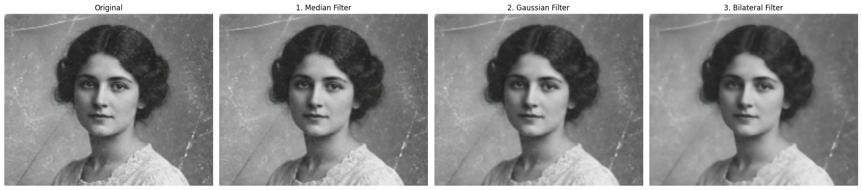

8. Motion-Blur Reduction Using High-Pass Sharpening
Code
program8_image = select_image_for_program()

def high_pass_sharpen(image, kernel_size=5, sigma=1.0, strength=1.5):
blurred = cv2.GaussianBlur(
image,
(kernel_size, kernel_size),
sigma
)

high_pass = image.astype(np.float32) - blurred.astype(np.float32)

sharpened = image.astype(np.float32) + strength * high_pass

sharpened = np.clip(
sharpened,
0,
255
).astype(np.uint8)

high_pass_display = cv2.normalize(
np.abs(high_pass),
None,
0,
255,
cv2.NORM_MINMAX
).astype(np.uint8)

return blurred, high_pass_display, sharpened

def interactive_motion_sharpen(image):
kernel_slider = widgets.IntSlider(
value=5, min=3, max=31, step=2,
description="Kernel:"
)

sigma_slider = widgets.FloatSlider(
value=1.0, min=0.1, max=10, step=0.1,
description="Sigma:"
)

strength_slider = widgets.FloatSlider(
value=1.5, min=0, max=5, step=0.1,
description="Strength:"
)

output = widgets.Output()

def update(change=None):
with output:
clear_output(wait=True)

blurred, high_pass, sharpened = high_pass_sharpen(
image,
kernel_slider.value,
sigma_slider.value,
strength_slider.value
)

show_images(
[image, high_pass, sharpened],
[
"Input",
"High-Pass Detail",
"Sharpened Output"
],
figsize=(16, 5)
)

for w in [
kernel_slider,
sigma_slider,
strength_slider
]:
w.observe(update, names="value")

update()

display(
kernel_slider,
sigma_slider,
strength_slider,
output
)

interactive_motion_sharpen(program8_image)
Output
Interactive widget output (sliders / dropdown controls) — rendered live in the notebook; no static image was saved.

9. Cartoonify Effect Generator
Code
program9_image = select_image_for_program()

def cartoonify(image,
bilateral_d=9,
sigma_color=75,
sigma_space=75,
median_k=5,
threshold1=100,
threshold2=200):

bgr = cv2.cvtColor(
image,
cv2.COLOR_RGB2BGR
)

# Smooth colors while preserving edges
smooth = cv2.bilateralFilter(
bgr,
bilateral_d,
sigma_color,
sigma_space
)

# Prepare grayscale image for edge detection
gray = cv2.cvtColor(
bgr,
cv2.COLOR_BGR2GRAY
)

gray = cv2.medianBlur(
gray,
median_k
)

# Detect edges
edges = cv2.Canny(
gray,
threshold1,
threshold2
)

# Invert edges: edges become black
edges = cv2.bitwise_not(edges)

# Convert mask to 3 channels
edges_color = cv2.cvtColor(
edges,
cv2.COLOR_GRAY2BGR
)

# Combine smooth colors and edge mask
cartoon = cv2.bitwise_and(
smooth,
edges_color
)

return (
cv2.cvtColor(smooth, cv2.COLOR_BGR2RGB),
edges,
cv2.cvtColor(cartoon, cv2.COLOR_BGR2RGB)
)

smooth, cartoon_edges, cartoon_result = cartoonify(program9_image)

show_images(
[
program9_image,
smooth,
cartoon_edges,
cartoon_result
],
[
"Original",
"Smoothed",
"Edges",
"Cartoonified"
],
figsize=(18, 5)
)
Output
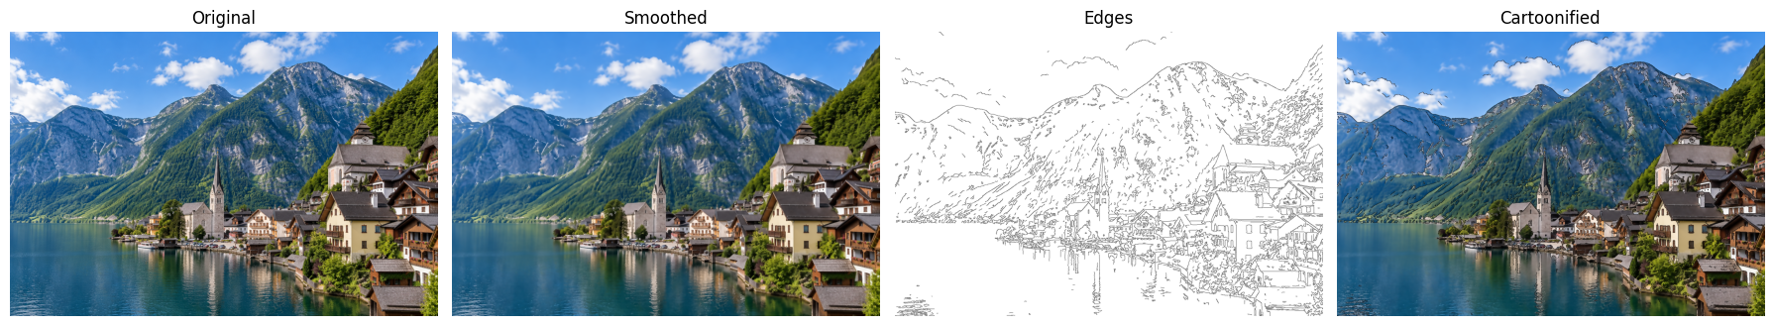

Interactive Cartoonify Controls
Code
program9_image_interactive = select_image_for_program()

def interactive_cartoon(image):
bilateral_d = widgets.IntSlider(
value=9, min=5, max=15, step=2,
description="Diameter:"
)

sigma_color = widgets.IntSlider(
value=75, min=10, max=200, step=5,
description="Sigma Color:"
)

sigma_space = widgets.IntSlider(
value=75, min=10, max=200, step=5,
description="Sigma Space:"
)

threshold1 = widgets.IntSlider(
value=100, min=0, max=255, step=5,
description="Threshold 1:"
)

threshold2 = widgets.IntSlider(
value=200, min=0, max=255, step=5,
description="Threshold 2:"
)

output = widgets.Output()

def update(change=None):
with output:
clear_output(wait=True)

smooth, edges, result = cartoonify(
image,
bilateral_d.value,
sigma_color.value,
sigma_space.value,
5,
threshold1.value,
threshold2.value
)

show_images(
[image, smooth, edges, result],
[
"Original",
"Smoothed",
"Edge Map",
"Cartoonified"
],
figsize=(18, 5)
)

for w in [
bilateral_d,
sigma_color,
sigma_space,
threshold1,
threshold2
]:
w.observe(update, names="value")

update()

display(
bilateral_d,
sigma_color,
sigma_space,
threshold1,
threshold2,
output
)

interactive_cartoon(program9_image_interactive)
Output
Interactive widget output (sliders / dropdown controls) — rendered live in the notebook; no static image was saved.

10. PSNR/SSIM Filtering Comparison Dashboard
Code
program10_image = select_image_for_program()

def comparison_dashboard(
clean_image,
noise_amount=10,
kernel_size=3,
bilateral_d=9,
sigma_color=75,
sigma_space=75
):

# Fixed seed makes the noisy input identical for every filter
noisy = add_salt_pepper_noise(
clean_image,
noise_amount,
seed=42
)

noisy_bgr = cv2.cvtColor(
noisy,
cv2.COLOR_RGB2BGR
)

# Apply filters to the SAME noisy image
mean_result = cv2.blur(
noisy_bgr,
(kernel_size, kernel_size)
)

gaussian_result = cv2.GaussianBlur(
noisy_bgr,
(kernel_size, kernel_size),
0
)

median_result = cv2.medianBlur(
noisy_bgr,
kernel_size
)

bilateral_result = cv2.bilateralFilter(
noisy_bgr,
bilateral_d,
sigma_color,
sigma_space
)

results = {
"Mean Filter": cv2.cvtColor(
mean_result,
cv2.COLOR_BGR2RGB
),
"Gaussian Filter": cv2.cvtColor(
gaussian_result,
cv2.COLOR_BGR2RGB
),
"Median Filter": cv2.cvtColor(
median_result,
cv2.COLOR_BGR2RGB
),
"Bilateral Filter": cv2.cvtColor(
bilateral_result,
cv2.COLOR_BGR2RGB
)
}

# Calculate scores
rows = []

for name, result in results.items():
rows.append({
"Filter": name,
"PSNR (dB)": calculate_psnr(
clean_image,
result
),
"SSIM": calculate_ssim(
clean_image,
result
)
})

scores = pd.DataFrame(rows)

# Display images
show_images(
[
clean_image,
noisy,
results["Mean Filter"],
results["Gaussian Filter"],
results["Median Filter"],
results["Bilateral Filter"]
],
[
"Clean Reference",
f"Noisy ({noise_amount}%)",
"Mean",
"Gaussian",
"Median",
"Bilateral"
],
figsize=(20, 7)
)

# Display scores
scores_display = scores.copy()
scores_display["PSNR (dB)"] = scores_display[
"PSNR (dB)"
].round(2)
scores_display["SSIM"] = scores_display[
"SSIM"
].round(4)

scores_display = scores_display.sort_values(
"PSNR (dB)",
ascending=False
)

display(scores_display)

# Plot comparison
fig, axes = plt.subplots(1, 2, figsize=(12, 4))

axes[0].bar(
scores["Filter"],
scores["PSNR (dB)"]
)
axes[0].set_title("PSNR Comparison")
axes[0].set_ylabel("PSNR (dB)")
axes[0].tick_params(axis="x", rotation=30)

axes[1].bar(
scores["Filter"],
scores["SSIM"]
)
axes[1].set_title("SSIM Comparison")
axes[1].set_ylabel("SSIM")
axes[1].tick_params(axis="x", rotation=30)

plt.tight_layout()
plt.show()

best_psnr = scores.loc[
scores["PSNR (dB)"].idxmax(),
"Filter"
]

best_ssim = scores.loc[
scores["SSIM"].idxmax(),
"Filter"
]

print("Best PSNR:", best_psnr)
print("Best SSIM:", best_ssim)

return scores

comparison_scores = comparison_dashboard(
program10_image,
noise_amount=10,
kernel_size=3,
bilateral_d=9,
sigma_color=75,
sigma_space=75
)
Output
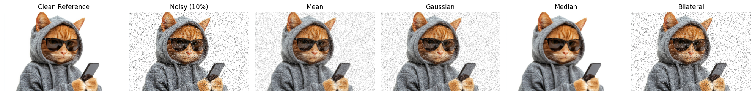
Filter PSNR (dB) SSIM
2 Median Filter 29.13 0.9067
0 Mean Filter 21.51 0.4084
1 Gaussian Filter 21.06 0.4056
3 Bilateral Filter 13.98 0.2161

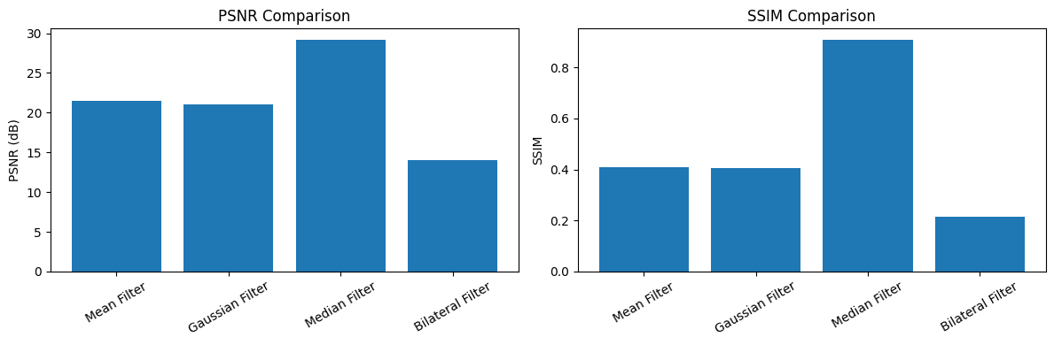
Best PSNR: Median Filter
Best SSIM: Median Filter

