Requirement Analysis

Data Flow Diagrams & User Stories

|  |  |
| --- | --- |
| Date | 10 April 2025 |
| Team ID | SWTID1743172790 |
| Project Name | Social Media Web App |
| Maximum Marks | 4 marks |

**Data Flow Diagrams:**

A Data Flow Diagram (DFD) is a traditional visual representation of the information flows within a system. A neat and clear DFD can depict the right amount of the system requirement graphically. It shows how data enters and leaves the system, what changes the information, and where data is stored.

**Social Media Web App DFDs:**

**Level-0 Description:**

User:  
The end-user who interacts with the social media web application to post content, like/comment, chat, and manage their profile.

Post Content:  
Handles user requests to create, edit, delete, and view posts. Updates and retrieves content from the database for display in user feeds.

User Interaction:  
Manages actions like likes, comments, follows, and unfollows. Updates the interaction records in the database.

Real-Time Chat:  
Processes user messages and delivers them in real-time through socket communication. Manages chat history and active sessions.

User Profile Management:  
Handles user registration, login, logout, and profile updates. Manages personal user data securely.

Content Database:  
Stores user-generated content such as posts, comments, and media.

User Database:  
Stores user credentials, profiles, follower/following lists, and settings.

Media Storage Service:  
External service (e.g., Cloudinary) used to store and retrieve images and videos uploaded by users.

**Level-1 Description and Processes:**

User:

The end-user who interacts with the social media web app by posting content, liking, commenting, following, and managing their profile.

Data Stores:

* User Data: Stores user credentials, profile info, settings, and followers/following relationships.
* Post Data: Stores user-generated content (posts, captions, media links, timestamps).
* Interaction Data: Stores likes, comments, shares, and user engagement records.
* Notification Data: Stores notification messages and their delivery status.

Processes (Level-1):

1. User Interface (UI):  
   Handles all interactions between the user and the app. Displays feeds, posts, notifications, and profile information.
2. User Authentication (Auth):
   * Processes login, signup, logout, and password recovery.
   * Reads from and writes to User Data.
3. Content Manager:
   * Handles creating, editing, deleting, and viewing posts.
   * Interacts with Post Data and Media Storage Service.
4. Interaction Handler:
   * Manages likes, comments, and shares.
   * Updates Interaction Data and can trigger notifications.
5. Profile Manager:
   * Allows users to update profile details and manage follower relationships.
   * Reads from and updates User Data.
6. Feed Generator:
   * Aggregates and displays posts for the user feed based on followers, interactions, and timestamps.
   * Pulls data from Post Data and Interaction Data.

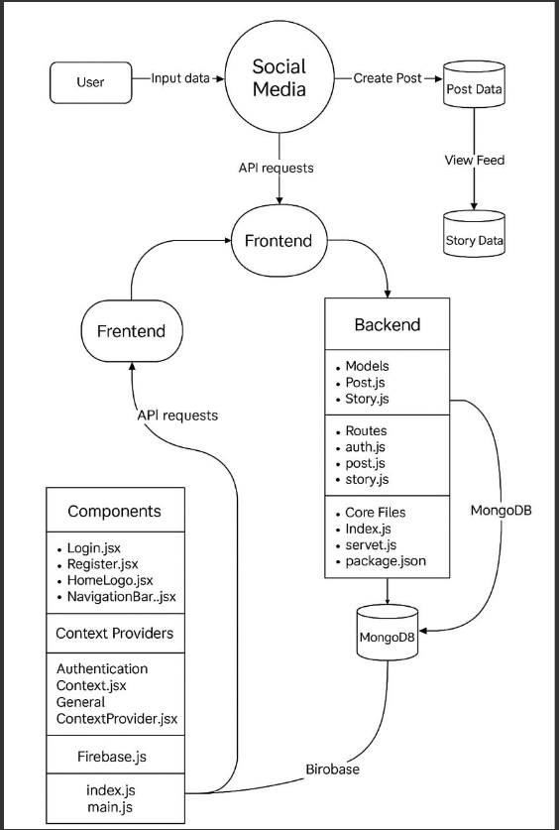

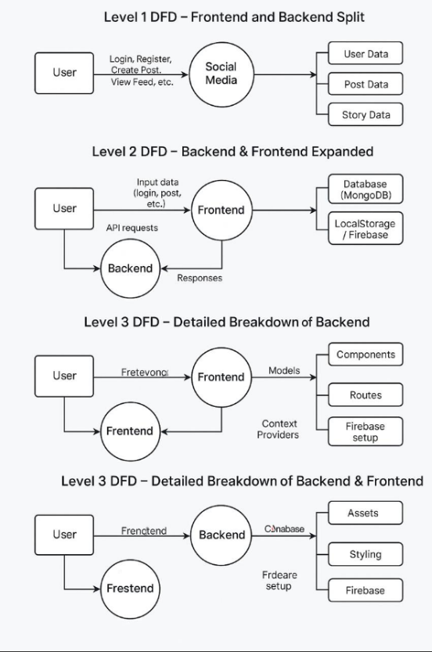

User Stories

Use the below template to list all the user stories for the product.

| User Type | Functional Requirement (Epic) | User Story Number | User Story / Task | Acceptance Criteria | Priority | Release |
| --- | --- | --- | --- | --- | --- | --- |
| Customer (Web user) | Account Management | USM-1 | As a user, I want to create an account to join the platform | I can enter personal details, choose a username/password, and successfully register. | High | Sprint 1 |
| Customer (Web user) | Account Management | USM-2 | As a user, I want to log in to my existing account. | I can log in using my credentials and access my profile and feed. | High | Sprint 1 |
| Customer (Web user) | Account Management | USM-3 | As a user, I want to reset my password if I forget it. | I can request a password reset link and reset it through email. | Medium | Sprint 2 |
| Customer (Web user) | Content Creation | USM-4 | As a user, I want to create and share posts with media and captions. | I can upload media, write a caption, and post it successfully. | High | Sprint 1 |
| Customer (Web user) | Content Interaction | USM-5 | As a user, I want to like and comment on other users' posts. | I can click a like button and add comments that are visible under posts. | High | Sprint 1 |
| Customer (Web user) | Profile Management | USM-6 | As a user, I want to view and edit my profile. | I can update profile picture, bio, and personal information. | Medium | Sprint 2 |
| Customer (Web user) | Search & Discover | USM-7 | As a user, I want to search for users and follow them. | I can search users by name/username and follow/unfollow them | High | Sprint 3 |
| Customer (Web user) | Feed/Timeline | USM-8 | As a user, I want to view a feed of posts from people I follow. | I see a chronological/tailored list of posts from followed users. | High | Sprint 3 |