mysql> **create database** IC;

mysql> **use** IC;

mysql> **create table participated**(driver_id varchar(10),regno varchar(10),report_no int, damage_amt float(10,2));

mysql> **create table person**(driver_id char(10),name varchar(20), address varchar(30));

mysql> **create table CAR**(regno varchar(10), model varchar(30), year int(4));

mysql> **create table ACCIDENT**(ReportNumber int(10),acc_date date, location varchar(20));

mysql> **create table OWNS**(driver_id varchar(10), regno varchar(20));

mysql**> insert into OWNS** **values**("1","UP36E7");

mysql> insert into OWNS values("2","UP16E7");

mysql> insert into OWNS values("3","DL16E7");

mysql> insert into OWNS values("4","DL00E7");

mysql> insert into OWNS values("5","DL10E7");

mysql> **insert into CAR** **values**("Duster", "2",2000);

mysql> insert into CAR values("DC Avanti", "36",2009);

mysql> insert into CAR values("Porsche", "36",2020);

mysql> insert into CAR values("Fortuner", "43",2021);

mysql> insert into CAR values("Creta", "4",2022);

mysql> **insert into PERSON** **values("**1","Vanshika","Rajnagar");

mysql> insert into PERSON values("2","Steve","Rajnagar");

mysql> insert into PERSON values("3","Aditya","Noida");

mysql> insert into PERSON values("4","Prakhar","Wave City");

mysql> insert into PERSON values("5","Vanshii","Wave City");

mysql> **insert into participated values**("1","UP36E7",27,6000);

mysql> insert into participated values("2","UP16E7",17,10000);

mysql> insert into participated values("3","DL16E7",10,11000);

mysql> insert into participated values("4","DL00E7",22,9000);

mysql> insert into participated values("5","DL10E7",40,8500.97);

mysql> alter table **PERSON add PRIMARY KEY** (driver_id);

mysql> alter table **CAR add primary key**(regno);

mysql> alter table **ACCIDENT add primary key**(ReportNumber);

mysql> alter table **OWNS add primary key**(driver_id);

mysql> alter table **PARTICIPATED add primary key**(driver_id);

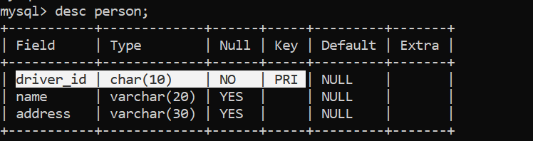

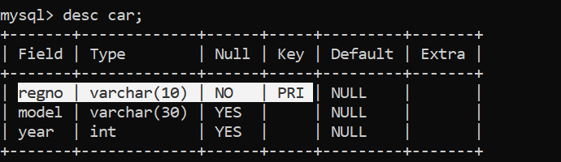

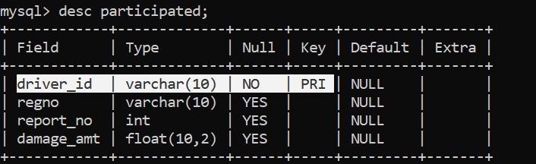

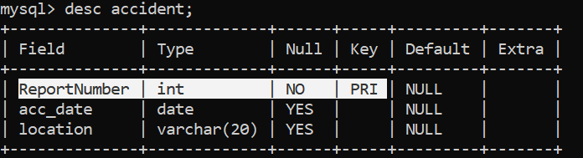

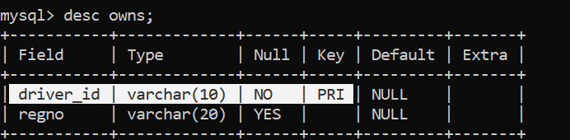

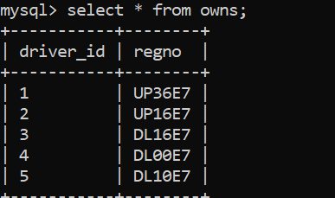(ii)

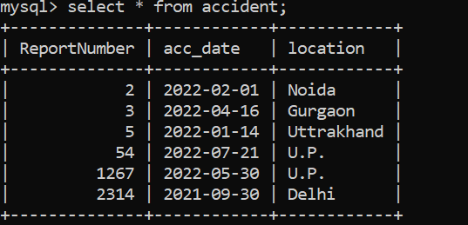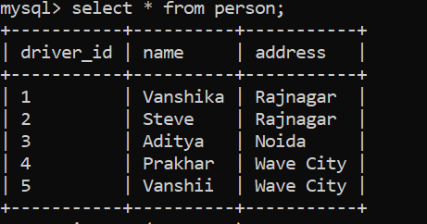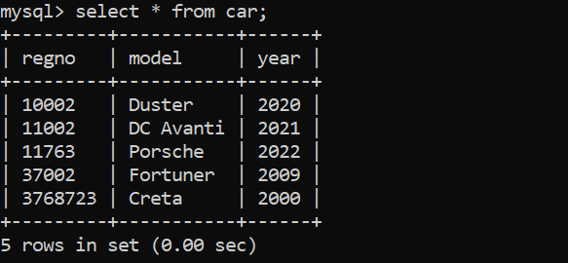

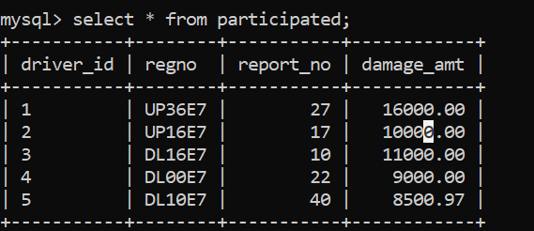

(iii)

