Name: Vanshika Rao
Section: B4
Batch: B2
Roll No.: 28
PRACTICAL VI

Cost Estimation using COCOMO technique:

Code:
import math

print("COCOMO COST ESTIMATION")
print("1. Organic")
print("2. Semi-Detached")
print("3. Embedded")

mode = int(input("Enter mode (1-3): "))
kloc = float(input("Enter project size in KLOC: "))
cost_per_month = float(input("Enter cost per person-month (Rs.): "))

if mode == 1:
a, b, c, d = 2.4, 1.05, 2.5, 0.38
mode_name = "Organic"

elif mode == 2:
a, b, c, d = 3.0, 1.12, 2.5, 0.35
mode_name = "Semi-Detached"

elif mode == 3:
a, b, c, d = 3.6, 1.20, 2.5, 0.32
mode_name = "Embedded"

else:
print("Invalid mode")
exit()

effort = a * math.pow(kloc, b)
development_time = c * math.pow(effort, d)
staff = effort / development_time
total_cost = effort * cost_per_month

print("\n----- COCOMO COST ESTIMATION -----")
print("Mode :", mode_name)
print("Project Size :", kloc, "KLOC")
print("Effort :", round(effort, 2), "Person-Months")
print("Development Time :", round(development_time, 2), "Months")
print("Staff Required :", round(staff, 2), "Persons")
print("Estimated Cost : Rs.", round(total_cost, 2))

Outputs:

- Organic:
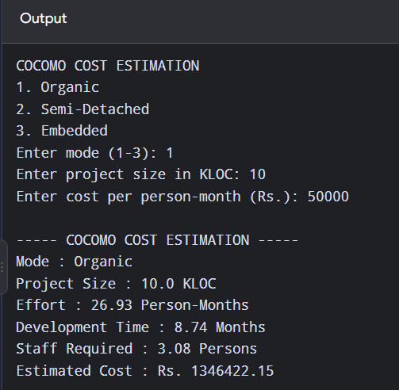

- Semi-detached:
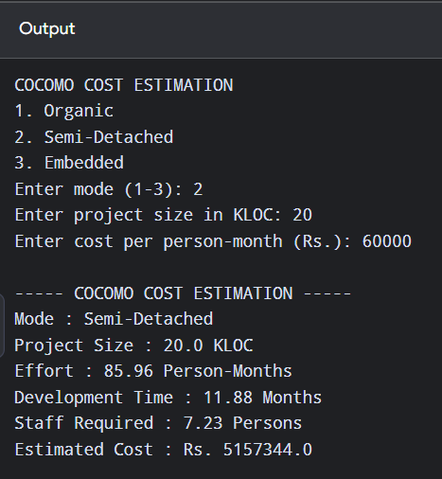

- Embedded:
