Name: Vanshika Rao
Section: B4
Batch: B2
Roll No.: 28
PRACTICAL VII
Excel :
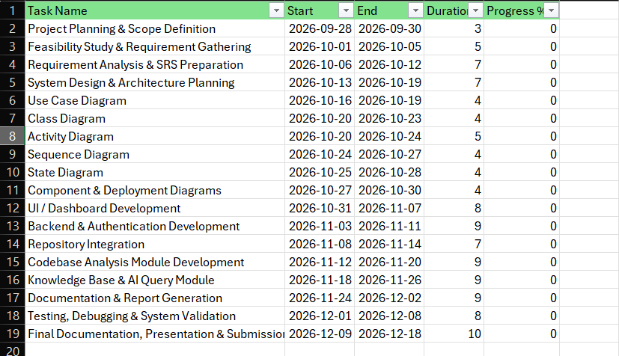

Gantt chart:
