Name: Vanshika Rao
Section: B4
Batch: B2
Roll No.: 28

PRACTICAL II

Functional and Non Functional Requirements

Requirements analysis is a crucial phase in software development where the needs and expectations of users and stakeholders are identified and documented. It ensures the system is built correctly and meets its intended goals.
- Functional Requirements: Define what the system should do (features and operations).
- Non-Functional Requirements: Define how the system should perform (quality, performance, and constraints).

Functional Requirements For Our Project

Title: Autonomous Codebase Onboarding Agent

Functional Requirements

These describe what the system should do.

- Repository Integration
  - Connect to Git repositories (GitHub, GitLab, Bitbucket).
  - Clone or access repositories using secure authentication.

- Codebase Analysis
  - Scan the project structure automatically.
  - Detect programming languages, frameworks, and libraries used.
  - Identify important files such as README, configuration files, and dependency files.

- Dependency Extraction
  - Read package/dependency files (e.g., package.json, requirements.txt, pom.xml).
  - Generate a list of project dependencies and versions.

- Architecture Detection
  - Analyze folder hierarchy and module relationships.
  - Identify design patterns and software architecture (MVC, Microservices, Layered Architecture, etc.).
- Documentation Generation
  - Generate summaries of project modules.
  - Create onboarding documentation for new developers.
  - Explain the purpose of key files and directories.

- Code Explanation
  - Provide natural language explanations for classes, methods, and functions.
  - Answer developer questions about the codebase using AI.

- Dependency Graph Visualization
  - Display relationships between modules, packages, and files.
  - Generate architecture or flow diagrams.

- Search and Query Interface
  - Allow users to search files, functions, classes, and APIs.
  - Support natural language queries like:
    - "Where is user authentication implemented?"
    - "Which module handles database connections?"

- Knowledge Base Creation
  - Store analyzed project information for future queries.
  - Update the knowledge base whenever the repository changes.

- Version Tracking
- Detect repository updates.
- Re-analyze modified files automatically.

- User Authentication
- Secure login for users.
- Role-based access (Developer, Team Lead, Admin).

- Report Generation
- Export onboarding reports in PDF or HTML.
- Include architecture overview, dependencies, and project summary.

----------------------------------------------------------------------------------------------------------------

Non-Functional Requirements

These describe how well the system performs.

1. Performance
- Analyze medium-sized repositories within 2–5 minutes.
- Respond to user queries within 3–5 seconds.

2. Scalability
- Support repositories ranging from small projects to enterprise-scale codebases.
- Handle multiple users simultaneously.

3. Reliability
- Ensure consistent analysis results.
- Recover gracefully from interrupted scans or network failures.

4. Security
- Encrypt repository access tokens and credentials.
- Implement secure authentication and authorization.
- Protect sensitive source code from unauthorized access.
5. Availability
- Maintain high system uptime (e.g., 99.9% availability).
- Support continuous monitoring and recovery.

6. Usability
- Provide an intuitive dashboard.
- Offer clear navigation and easy-to-understand visualizations.
- Support developers with minimal training.

7. Maintainability
- Use a modular architecture for easy updates.
- Allow new language analyzers and AI models to be added with minimal changes.

8. Compatibility
- Support major operating systems (Windows, Linux, macOS).
- Work with popular Git platforms and IDEs.

9. Accuracy
- Correctly identify project components and dependencies.
- Generate reliable AI-based explanations with minimal hallucinations.

10. Extensibility
- Support additional programming languages and frameworks through plugins.
- Allow integration with CI/CD tools and project management platforms.

11. Portability
- Deploy on cloud platforms or on-premises environments.
- Support containerized deployment using Docker.

12. Logging and Monitoring
- Maintain logs of repository analysis and user activities.
- Monitor system performance and detect failures automatically.

Use case diagram on the next page

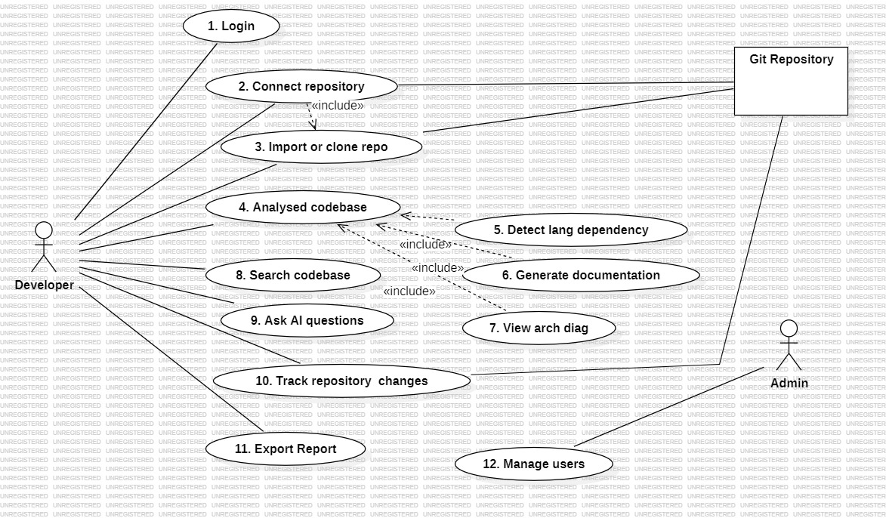

Activity diagram for our problem statement :
