Name: Vanshika Rao
Section: B4
Batch: B2
Roll No.: 28
PRACTICAL V

Component diagram for our project: Autonomous codebase onboarding agent
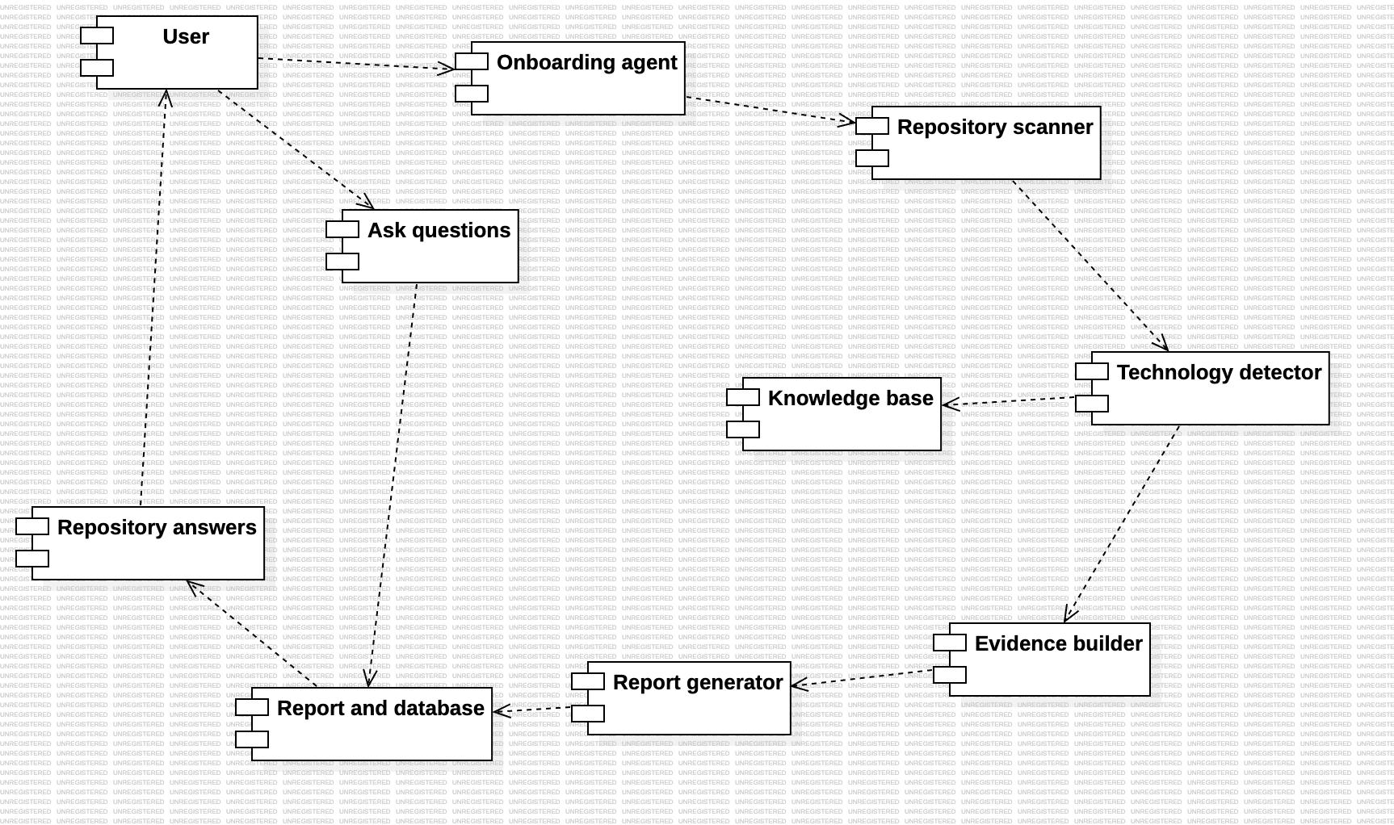

Deployment diagram for our project: Autonomous codebase onboarding agent
