Name: Vanshika Rao
Section: B4
Batch: B2
Roll No.: 28

SOFTWARE REQUIREMENTS SPECIFICATION (SRS)

Project Title:
Autonomous Codebase Onboarding Agent

TABLE OF CONTENTS
- 1. Introduction
- 2. Overall Description
- 3. Functional Requirements
- 4. Non-Functional Requirements
- 5. External Interface Requirements
- 6. System Models / UML Diagrams
- 7. Project Planning
- 8. Cost Estimation using COCOMO
- 9. Risk Management
- 10. Testing
- 11. Constraints and Assumptions
- 12. Future Scope
- 13. Conclusion

1. INTRODUCTION

1.1 Purpose
The purpose of this document is to define the software requirements for the Autonomous Codebase Onboarding Agent. The system automatically analyzes an existing codebase, understands its structure, identifies dependencies, generates documentation, and helps developers understand the project quickly.

1.2 Scope
The system allows developers to connect a Git repository and automatically analyze its source code. It identifies programming languages, dependencies, project structure, and architecture. It also generates documentation, stores codebase information in a knowledge base, answers user queries, and generates onboarding reports.

1.3 Objectives
- Reduce the time required to understand an unfamiliar codebase.
- Automate codebase analysis and dependency identification.
- Generate project documentation automatically.
- Provide architecture and module-level understanding.
- Allow developers to search and ask natural-language questions about the codebase.
- Store analyzed information in a knowledge base for future queries.
- Generate onboarding reports.

1.4 Definitions, Acronyms and Abbreviations
Term | Meaning
ACOA | Autonomous Codebase Onboarding Agent
UI | User Interface
AI | Artificial Intelligence
NLP | Natural Language Processing
API | Application Programming Interface
Git | Version Control System
KB | Knowledge Base
PDF | Portable Document Format
LLM | Large Language Model

1.5 References
- IEEE Software Requirements Specification guidelines
- UML 2.5 specifications

2. OVERALL DESCRIPTION

2.1 Product Perspective
The Autonomous Codebase Onboarding Agent is a web-based application that integrates with Git repositories and AI services. It analyzes source code and stores the extracted information in a knowledge base for future searches and queries.

2.2 Product Functions
- User authentication
- Repository connection and import
- Automatic codebase analysis
- Programming language detection
- Dependency detection
- Code structure analysis
- Documentation generation
- Architecture analysis
- Knowledge base creation
- Natural language codebase search
- AI-based code explanation
- Report generation and export

2.3 User Classes
User Class | Description
Developer | Uses the system to understand an existing codebase, search for information, and view generated documentation.
Project Maintainer | Manages repositories and reviews generated documentation and reports.
Administrator | Manages users, system settings, and integrations.

2.4 Operating Environment
The system operates as a web application and can be accessed through modern web browsers. The backend can run on Windows or Linux servers and requires Internet connectivity for Git and AI services.

3. FUNCTIONAL REQUIREMENTS
ID | Requirement
FR1 – User Authentication | The system shall allow users to securely log in and log out.
FR2 – Repository Connection | The system shall allow users to connect a Git repository using its URL and required authentication credentials.
FR3 – Repository Import | The system shall clone or import the selected repository for analysis.
FR4 – Codebase Analysis | The system shall analyze the source code, project structure, and modules.
FR5 – Language and Dependency Detection | The system shall identify programming languages, frameworks, libraries, and dependencies used in the project.
FR6 – Documentation Generation | The system shall automatically generate documentation describing important files, modules, classes, and functions.
FR7 – Architecture Analysis | The system shall identify relationships between project components and generate an architecture representation.
FR8 – Knowledge Base | The system shall store analyzed codebase information in a searchable knowledge base.
FR9 – Codebase Search | The system shall allow users to search the codebase using keywords or natural language queries.
FR10 – AI Code Explanation | The system shall provide AI-generated explanations for code and user queries.
FR11 – Change Tracking | The system shall detect changes in the repository and update the stored information when required.
FR12 – Report Generation | The system shall generate onboarding reports and allow users to export them in formats such as PDF or HTML.

4. NON-FUNCTIONAL REQUIREMENTS
ID | Requirement
NFR1 – Performance | The system should provide search and query results within a reasonable response time.
NFR2 – Security | The system shall protect user credentials, repository access tokens, and source code from unauthorized access.
NFR3 – Reliability | The system should handle errors and failures without losing previously stored information.
NFR4 – Scalability | The system should support both small and large codebases and multiple users.
NFR5 – Usability | The system shall provide a simple and user-friendly interface.
NFR6 – Accuracy | The system should provide accurate code analysis, documentation, and AI-generated explanations.
NFR7 – Maintainability | The system should be modular and easy to update or extend.
NFR8 – Availability | The system should remain available during normal operating conditions and recover from failures.

5. EXTERNAL INTERFACE REQUIREMENTS

5.1 User Interface
- Login page
- Dashboard
- Repository connection interface
- Codebase analysis status
- Search interface
- Documentation viewer
- Architecture viewer
- Report generation interface

5.2 Software Interfaces
- GitHub/GitLab/Bitbucket
- AI/LLM APIs
- Database
- File storage
- Web browser

5.3 Communication Interfaces
The system shall use secure communication protocols such as HTTPS for communication between the client, server, Git services, and external APIs.

6. SYSTEM MODELS / UML DIAGRAMS
The revised SRS incorporates the UML work completed in Practicals 2–5. The supplied practical files contain the Activity, Class, Sequence, Component, and Deployment diagrams for the project.
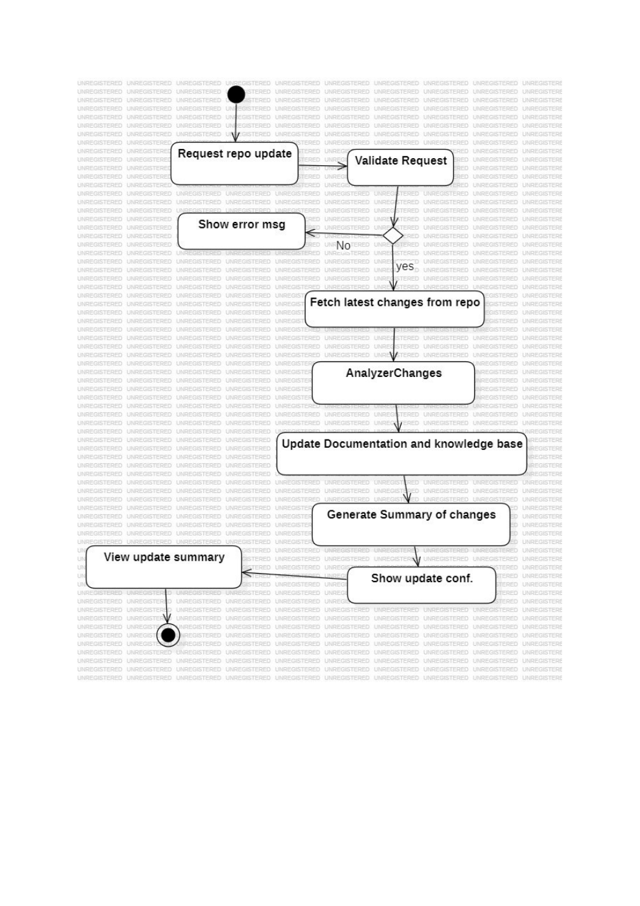
Figure 6.1: Activity Diagram — Practical 2
The activity diagram represents the repository-update workflow, including request validation, fetching latest changes, change analysis, knowledge/documentation update, summary generation, and confirmation.
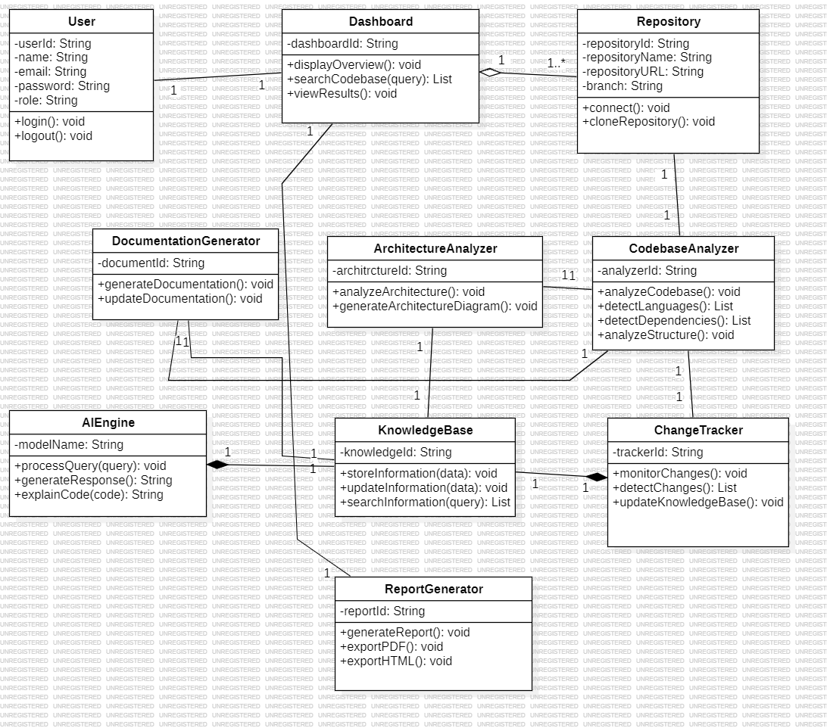
Figure 6.2: Class Diagram — Practical 3
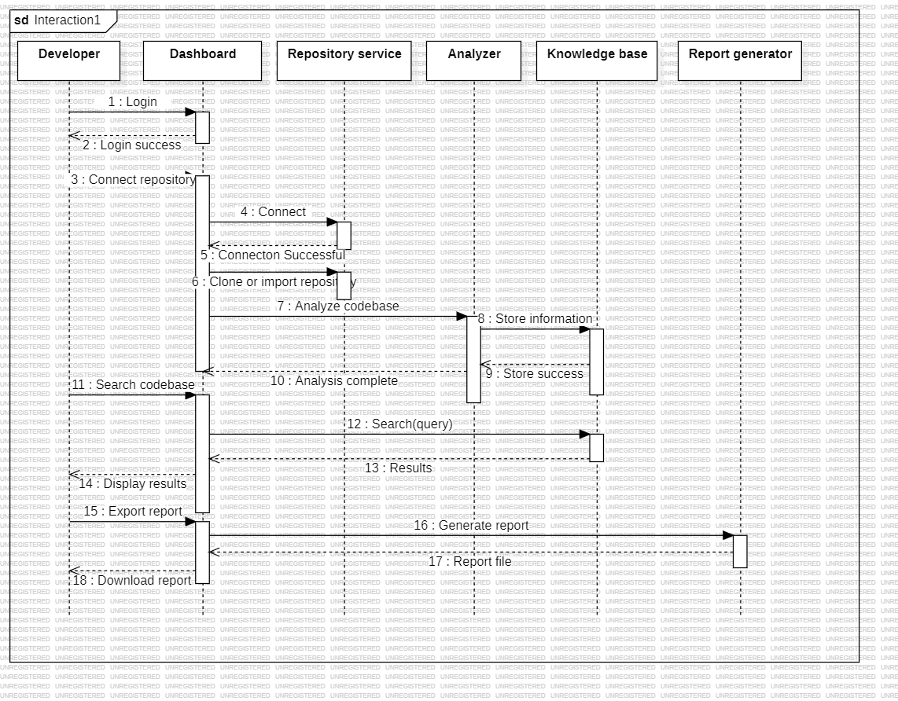
Figure 6.3: Sequence Diagram — Practical 4
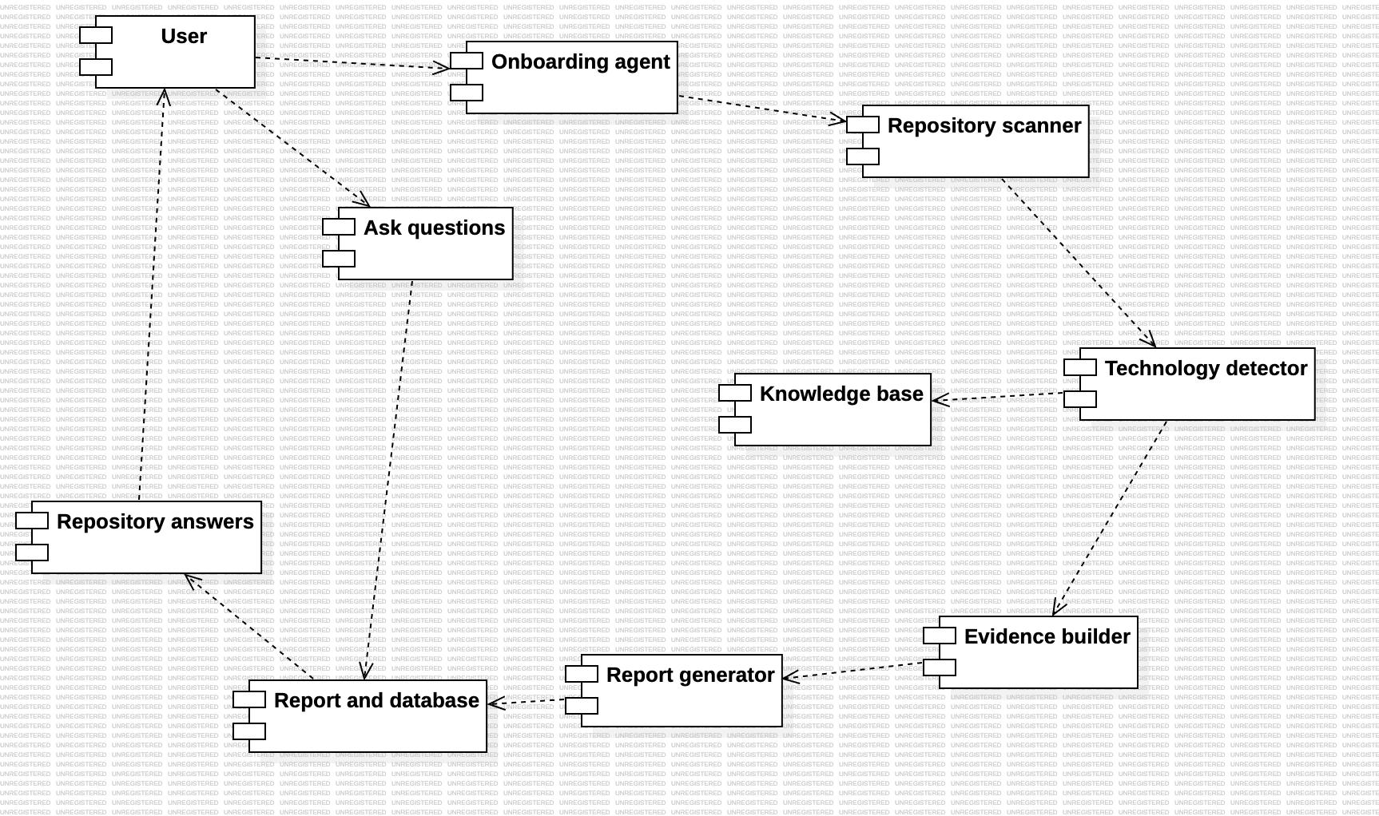
Figure 6.4: Component Diagram — Practical 5
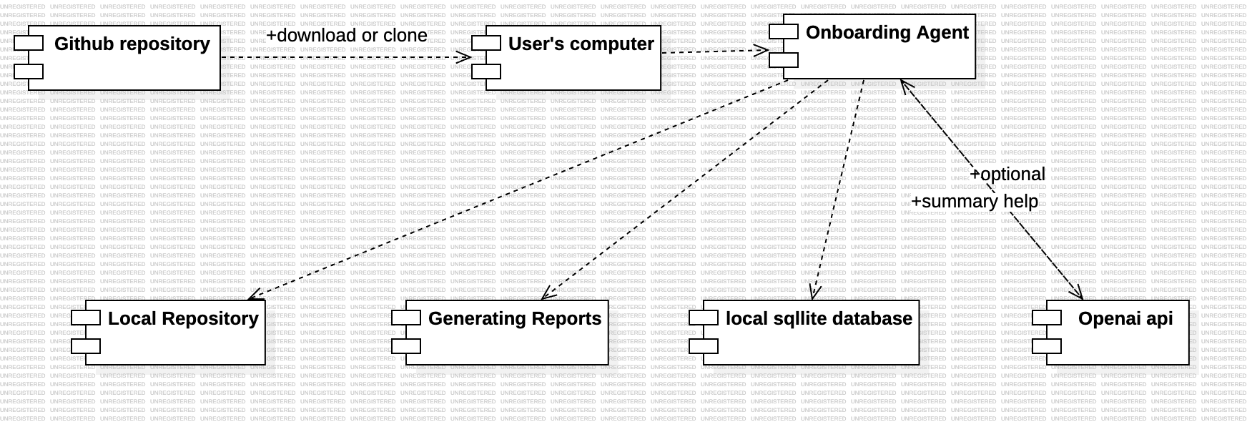
Figure 6.5: Deployment Diagram — Practical 5

6.6 Other UML Models
The earlier SRS listed Use Case and State diagrams among the system models. The practical files supplied for this revision do not contain those two diagram images, so they have not been represented as completed practical figures in this document.

7. PROJECT PLANNING

7.1 Gantt Chart
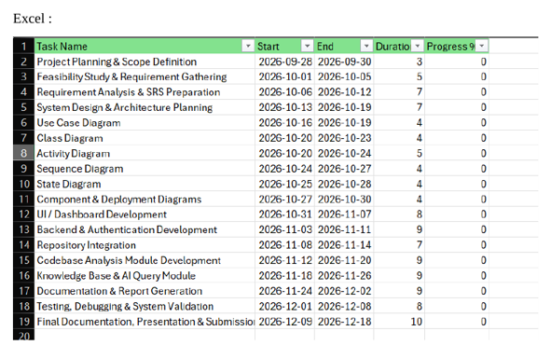
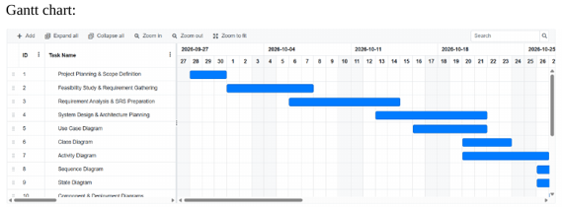

Figure 7.1: Project Gantt Chart — Practical 7
The project schedule was prepared in Excel as part of Practical 7. The chart covers project planning, requirements, design, UML diagrams, development, repository integration, codebase analysis, knowledge base and AI module work, documentation, testing, and final submission.

7.2 Project Schedule
Task | Start | End | Duration (Days)
Project Planning & Scope Definition | 2026-09-28 | 2026-09-30 | 3
Feasibility Study & Requirement Gathering | 2026-10-01 | 2026-10-05 | 5
Requirement Analysis & SRS Preparation | 2026-10-06 | 2026-10-12 | 7
System Design & Architecture Planning | 2026-10-13 | 2026-10-19 | 7
Use Case Diagram | 2026-10-16 | 2026-10-19 | 4
Class Diagram | 2026-10-20 | 2026-10-23 | 4
Activity Diagram | 2026-10-20 | 2026-10-24 | 5
Sequence Diagram | 2026-10-24 | 2026-10-27 | 4
State Diagram | 2026-10-25 | 2026-10-28 | 4
Component & Deployment Diagrams | 2026-10-27 | 2026-10-30 | 4
UI / Dashboard Development | 2026-10-31 | 2026-11-07 | 8
Backend & Authentication Development | 2026-11-03 | 2026-11-11 | 9
Repository Integration | 2026-11-08 | 2026-11-14 | 7
Codebase Analysis Module Development | 2026-11-12 | 2026-11-20 | 9
Knowledge Base & AI Query Module | 2026-11-18 | 2026-11-26 | 9
Documentation & Report Generation | 2026-11-24 | 2026-12-02 | 9
Testing, Debugging & System Validation | 2026-12-01 | 2026-12-08 | 8
Final Documentation, Presentation & Submission | 2026-12-09 | 2026-12-18 | 10

8. COST ESTIMATION USING COCOMO
Cost estimation was performed using the COCOMO technique in Practical 6. The practical implements the Organic, Semi-Detached, and Embedded modes and calculates effort, development time, staff required, and estimated cost.

8.1 COCOMO Equations
- Effort = a × (KLOC)^b
- Development Time = c × (Effort)^d
- Staff Required = Effort / Development Time
- Estimated Cost = Effort × Cost per Person-Month

8.2 Organic Mode
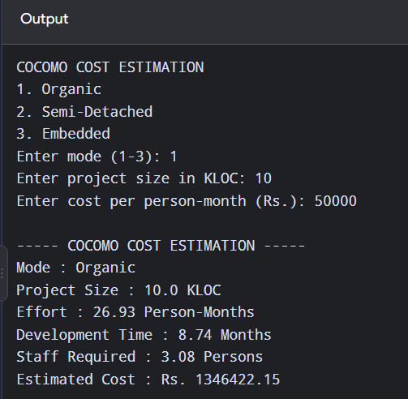
Figure 8.1: COCOMO Organic Mode Output — Practical 6
Parameter | Value
Project Size | 10.0 KLOC
Cost per Person-Month | Rs. 50,000
Effort | 26.93 Person-Months
Development Time | 8.74 Months
Staff Required | 3.08 Persons
Estimated Cost | Rs. 1,346,422.15

8.3 Semi-Detached Mode
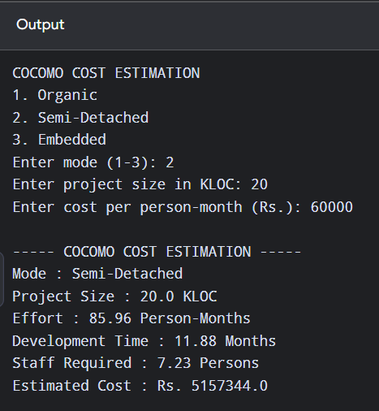
Figure 8.2: COCOMO Semi-Detached Mode Output — Practical 6
Parameter | Value
Project Size | 20.0 KLOC
Cost per Person-Month | Rs. 60,000
Effort | 85.96 Person-Months
Development Time | 11.88 Months
Staff Required | 7.23 Persons
Estimated Cost | Rs. 5,157,344.00

8.4 Embedded Mode
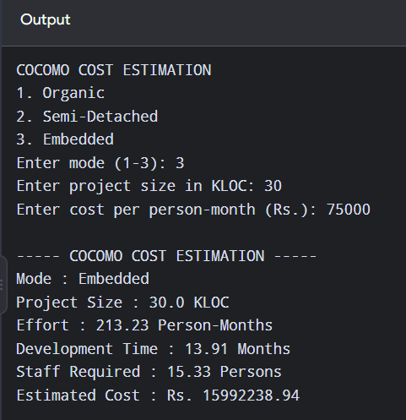
Figure 8.3: COCOMO Embedded Mode Output — Practical 6
Parameter | Value
Project Size | 30.0 KLOC
Cost per Person-Month | Rs. 75,000
Effort | 213.23 Person-Months
Development Time | 13.91 Months
Staff Required | 15.33 Persons
Estimated Cost | Rs. 15,992,238.94

9. RISK MANAGEMENT
Risk | Impact | Mitigation
Large codebase | High processing time | Optimize analysis and processing.
Repository unavailable | Analysis cannot start | Validate repository connection and handle connection errors.
AI service unavailable | AI queries unavailable | Handle API failure gracefully.
Incorrect AI explanation | Possible misunderstanding of code | Validate generated information where required.
Security issue | Possible data exposure | Use secure authentication and communication.
Storage limitations | Insufficient storage | Manage stored project information and resources.

10. TESTING
The following test cases provide a basic validation plan for the major functions described in the SRS.
Test Case | Input / Action | Expected Result
TC01 | Enter valid login details | User successfully logs in.
TC02 | Connect a valid Git repository | Repository is connected.
TC03 | Start codebase analysis | System analyzes the project.
TC04 | Search for a class/function | Relevant result is displayed.
TC05 | Ask AI about code | An explanation is generated.
TC06 | Generate documentation | Documentation is created.
TC07 | Generate report | Report is generated.
TC08 | Connect an invalid repository | An error message is displayed.

11. CONSTRAINTS AND ASSUMPTIONS

11.1 Constraints
- The system requires Internet connectivity for external Git and AI services.
- Repository access requires valid authentication credentials.
- AI functionality depends on the availability of the selected AI service.
- Large repositories may require additional processing time and storage.

11.2 Assumptions
- Users have valid repository access.
- The repository contains readable source code.
- Users have a modern web browser.
- Required external services are available.

11.3 Dependencies
- Git repository provider
- AI/LLM service
- Database or knowledge base
- Server and network infrastructure

12. FUTURE SCOPE
- Support for additional Git providers.
- Improved AI-based code understanding.
- More detailed architecture visualization.
- Automated onboarding tutorials.
- Advanced code dependency graphs.
- Improved change tracking.
- Additional report formats.

13. CONCLUSION
The Autonomous Codebase Onboarding Agent is designed to reduce the time required for developers to understand an unfamiliar codebase. By combining automated code analysis, documentation generation, knowledge storage, architecture representation, and AI-based querying, the system provides an efficient and centralized onboarding solution. This revised SRS consolidates the requirements from Practical 1 with the UML, cost-estimation, and project-planning work c

