A

SEMINAR REPORT

ON

**“SMART GLOVE FOR SPECIAL PEOPLE COMMUNICATION AND HEALTH MONITORING”**

By

Madhvi Sonone (PRN No 72026936K)

Pranali Yeole (PRN No 71910997D)

Vanshika Sable (PRN No 72026982C)

Under the Guidance of

Prof. S.V.Shelke

**DEPARTMENT OF ELECTRONICS AND TELECOMMUNICATION ENGINEERING**

# BHARATI VIDYAPEETH’S COLLEGE OF ENGINEERING FOR WOMEN,Pune-43

**Savitribai Phule Pune University , Pune**

# YEAR 2022-23



**CERTIFICATE**

This is to certify that the BE Seminar report of

**“SMART GLOVE FOR SPECIAL PEOPLE COMMUNICATION AND HEALTH MONITORING”**

By ,

Madhvi Sonone (PRN No 72026936K)

Pranali Yeole (PRN No 71910997D)

Vanshika Sable (PRN No 72026982C)

Of BE (Electronics & Telecommunication) is a bonafide work carried out by them under the guidance of **Prof.S.V.Shelke** and it is approved for the partial fulfillment of the requirement of Savitribai Phule Pune University for the avoíd of **bachelor’s** degree of **engineering** in **Electronics & Telecommunication** of Savitíibai Phule Pune University at Bhrarati Vidyapeeth’s College of Engineering for Women Dhankawadi , Pune- 43

|  |  |  |
| --- | --- | --- |
| **Prof.S.V.Shelke** | **Prof.Dr.S.A.Dhole** | **Prof.Dr.S.R.Patil** |
| **Guide** | **Project Co-orídinator** | **Principal,H.O.D E&TC** |

**Place: Pune**

**Date:**

# Abstract

Smart Hand Gloves enable all humans to be equal with each other. A dumb person can’tcommunicate, these smart gloves make it possible for users to transform hand gestures into written text and prerecorded voices, that help alleviate the communication barrier. The smart gloves also aid a person in understanding what a specially-abled person is actually trying to say so that one can reply accordingly. This particular Smart Glove also possesses an additional functionality of Home Appliance automation using which a specially-abled person can regulate and manage household appliances. The fundamental goal of this assembly is to create a dependable, easy to implement and use, lightweight smart hand glove that will reduce the boundaries between the communication all human beings.

Another goal of our venture is to build a wireless heart beat monitoring framework utilizing GSM Technology, which could conceivably be a fundamental piece of individual healthcare apparatuses. As its name infers this is a system, having characteristic of sending SMS to both the doctor & patients relative in event of an emergency, henceforth the system can be utilized at clinics, hospitals and in addition at home.

# INDEX

|  |  |  |
| --- | --- | --- |
| **Sr.**  **No.** | **Chapter** | **Page no.** |
| **1** | Introduction | **1** |
| **2** | Literature Survey | **2** |
| **3** | Problem Statement | **4** |
| **4** | Objective | **5** |
| **5** | Methodology | **6** |
| **6** | Specifications of the System | **7** |
| **7** | Block diagram of the System and its explanation | **8** |
| **8** | Flowchart | **14** |
| **9** | Algorithm | **15** |
| **10** | Hardware Design | **16** |
| **11** | Software Design | **16** |
| **12** | Simulation | **17** |
| **13** | Summary | **19** |
| **14** | Reference | **20** |

# ACKNOWLEDGEMENTS

Gratitude takes three forms –“A feeling from heart, an expression in words and a giving in return”.We

take this opportunity to express our heart-feelings.

First and foremost, we wish to express our profound gratitude to our respected Principal Prof. Dr.S.R. Patil, for providing all the facilities in the college. We would like to express our sincere thanks to Prof. Dr.S.R.Patil , Head of the department of Electronics and Telecommunication Engineering for his continuous support and encouragement.

We feel deeply indebted to our esteemed guide Asst. Prof .S.V Shelke for her guidance, right from the conception and visualization to the very presentation of the project. She has been our guiding light throughout.

We are greatly indebted to our faculties, both teaching and supporting staff, Department of Electronics and Telecommunication Engineering, who took great interest in our project work. They motivated and guided us throughout the accomplishment of this goal. We express our profound thanks for their meticulous guidance.

Finally, we would like to express our heartfelt thanks to our beloved parents for their blessings, our friends for their help and wishes for the successful completion of this project work.

# List of tables

|  |  |  |
| --- | --- | --- |
| **Table no.** | **Description** | **Page no.** |
| 6.1 | Arduino specifications | 8 |

**List of figures:**

|  |  |  |
| --- | --- | --- |
| **Fig no.** | **Description** | **Page no.** |
| 1 | Block Diagram of system | 8 |
| 2 | Images of components | 11 |
| 3 | Flow chart of system | 14 |
| 4 | Circuit Diagram | 15 |
| 5 | PCB Layout | 17 |
| 6 | Simulation | 26 |

# List of Abbreviations:

# LCD : Liquid Crystal display

# ICU : Intensive Care Unit

# GSM : Global System for Mobile Communication

# PSU: Public Sector Undertaking

# ROM: Read Only Memory

# RPM: Remote patient Monitoring

# INTRODUCTION

# In our daily lives, we meet numerous especially abled people, a number of them in part, and several are completely disabled. People with partial disabilities like deaf, dumb and paralysis manage life with many difficulties. Here, conversation per- forms a substantial role as communication can make someone feel much better and can also help them be in place of an independent person. Flex Sensors play a major role in this particular undertaking. The flex sensors are actually outfitted on the glove along all fingers including the thumb. The flex receptors supply output in the form of distinct voltage variants which varies with various levels of bend angles. This particular output from the flex sensor is actually provided to a digital converter which transforms analog signals into discrete digital values through the routes of micro controllers. It alerts and performs the conversion of analog signal to a digital signal. Through this phase, the Gesture is actually diagnosed, and the appropriate output gets displayed on an LCD screen. Along with this display, a voice is played in the background with the help of a speaker module. Using the flex sensor, household appliances like lights, bells and fans can also be managed using this glove. The light weight and portability of this particular undertaking is actually the primary advantage of this smart glove. Consequently, with the guidance of this particular prototype, the communication barrier experienced by these specially abled people is reduced, hence making them independent and at par with other human beings.

# Consistent observing of the human's body parameters for example, temperature, heartbeat rate, voltage and so forth is a troublesome task. Likewise in intensive care units it is important to screen constantly the patient's health parameters and keep their record. There is plausibility of human mistakes .There are a few shortcomings in existing framework. As of now there are number of health checking systems accessible for the ICU patients which can be utilized just when the patient is on bed .This has wiring complexities .Such systems create troublesome where the distance amongst System and PC is more. The accessible systems are colossal in size. General monitoring of a patient isn't possible once he/she is released from hospitals .These systems can't be utilized at singular level .Consequently to remove human mistakes and to diminish excessive burden of constantly checking patient's health from doctors head, we are proposing health checking framework utilizing GSM. The goal of health monitoring system is to have quantitative evaluation of essential Physiological factors of patients amid critical conditions .This system is utilized for estimating consistently automatically the values of the patient's vital physiological parameters, for example, body temperature and pulse rate.

**LITERATURE REVIEW**

**1. Smart Glove: Gesture Vocalizer for Deaf and Dumb [1]**

In [1], the system comprises a Glove, flex receptors, and an accelerometer. These sensors are motion sensitive and give values that are different for various degrees of bends. This particular program even offers a speech synthesizer module that transforms motion of fingers into real-time speech output, along with a display that has written text for the corresponding gesture. Sign language is the standard way for communication between specially-abled and ordinary individuals. With that said, usually, they find trouble in talking with other people as a lot of people don’t actually understand sign language. The above results in a continuous language barrier, to reduce this barrier. The content and speech output is actually in English. Thus, this device offers an effective means of communication for both ordinary and deaf-dumb folks. All of these voices are customizable, and every end-user could have their own set of messages which enable them to communicate.

**2. Design of Smart Gloves.[2]**

Being deaf and dumb is considered to be a perceptual disability. To eradicate this barrier of

communication in [2], the gadget makes use of flex sensors, a micro controller and a PSU.The software component of this prototype uses embedded C written in Keil Micro vision. This converts the degree of bends into measurable values which further correspond to recognized hand movement sign languages. This glove presents the corresponding alphabet for each sign language movement, thus reducing the communication barrier between the deaf/dumb and normal people.

**3. Review Paper On Evolution Of Smart Glove.[3]**

Each day interaction with the general public poses a tremendous struggle for all with hearing loss and hearing disability. For this purpose, an immediate sign language recognition system was developed using the machine learning algorithm of Random Forest Classifier, as well as in order to convert the sign alphabets and words that are common into sound and text. A glove circuit has been created with flex sensors, a 3 axis accelerometer, along with a gyroscope to record the gestures or perhaps sign data. The finger bend information is received from flex sensors on every finger as the accelerometer, as well as a gyroscope, offers the trajectories of the hand movement. The information from the receptors is then transferred from the skilled model to understand the Gesture. The main purpose of Smart Glove would be to present ease of sharing simple concepts, reduce communication gap and much easier cooperation for the hard of listening to individuals.

**4. Real Time Sign Language Translation Using Color Segmentation and Neural Network[4]**

In [4], the unit makes use of Machine Learning Algorithms of Random Forest and k-nearest neighbors to draw out as well as display the output in accordance with the various bend perspectives of the flex receptors. It provides an automatic sign language translator that transforms Malaysian Sign language to English. This was one of the very first papers to recognize gestures along with lexical finger movements. It made use of the

gestures to determine dynamic and static finger movements using the K nearest neighbour machine learning algorithm. The glove circuit consists of flex sensors that create several bend angles. These values are actually passed through the machine learning versions of Random K and Forest’s nearest neighbors to display the corresponding output. The main goal of the smart glove is usually to recognize hand gestures besides the signal languages.

Astounding result was achieved by Adarsh Ghimire, the system is based on a desktop application using a machine learning algorithm. The process flow is, data acquisition from the flex sensors embedded on each finger along with accelerometer and gyroscope from each hand followed by the processing of collected data in the Arduino mega processor. The data is then used as an input to the machine learning algorithm to predict the output of the gesture made by the user to an output screen and the speaker respectively. The accuracy of the machine learning model is 75 – 80 %, with a capacity of storing 350 datasets for each alphabet. The accuracy and precision of this system are far better than the other proposed ones. Although a drawback from the correlation plot was a confusion of the system to understand certain alphabets due to the almost similar finger bending making the results ambiguous sometimes.

**Existing Systems**

These kinds of methods have been implemented before in a traditional way that is by the law of

conventional sign language that was taught to every specially-abled people who cannot speak or hear. These sign languages were used to process into computer language to process every letter of a sentence. These conventional sign languages were used to convert these letters and from a word or sentence and used for communication but the problem was, for some letter conversion was very ambiguous and due to which some letters were wrongly interpreted as another.

Due to this problem, communication was falsely conveyed to each other. Letters which caused

ambiguity problems where ‘i’ and ‘j’, ‘t’ and ‘u’ were converted to the same output or ‘W’ and ‘6’ / ‘F’ and ‘9’ were interpreted as the same . Also, letters ‘X’, ‘Y’, ‘Z’ cannot be interpreted at all. Toovercome this ambiguity problem our model does not convert letters but some input of flex sensors have predefined sentences as output rather than letter conversion.

Home automation will allow a person to control devices like fans and switches to turn on or off from one place itself with the help of just a glove and give a command. Changing the method from Conversion of ASL letters to Conversion of an input to a predefined output like ‘I need water’, ‘I need Food’, ‘I need Medicines’ etc can remove the ambiguity of traditional methods.

**PROBLEM STATEMENT**

* To design dependable ,easy to use smart hand glove that will reduce the boundaries between the communication of all human beings.

**OBJECTIVES**

* To design, implement and test a device for remotely monitoring hand and fingers movements. The system uses Smart Glove and a multitude of E-textile sensors to measure the range of motion (ROM) of fingers, and a microcontroller.
* Developing monitoring systems is to reduce health care costs by reducing physician office visits, hospitalizations, and diagnostic testing procedure. The GSM technology helps the server to update the patient data on website.
* To develop a cost effective system which can give voice to voiceless person with the help of Smart Gloves.
* To interfacing health sensors like – Body temp, Pulse etc.

**METHODOLOGY**

The work of this project start from movement of hand gloves where the flex sensors are attached, and the value of sensor changes when its experiences the bending. The flex sensor is another type of potentiometer are attach to the fingers when we bend the figure the value of the sensor get changes. The changing value of the sensor is depend upon the resistance and applied angle of the bending when we bend the sensor at some particular angle we can see the value of the resistance is increase and accordingly the output get reduced. On the other way we can say that it’s like a inversely proportional when the resistance of the sensor is increase at that instant the value of output decrease and accordingly we can make project by getting the advantage of this process.

Heart beat sensor is designed to give digital output of heat beat when a finger is placed inside it. This digital output can be connected to Arduino directly to measure the Beats per Minute (BPM) rate. It works on the principle of light modulation by blood flow through finger each pulse.

The most widely measured physical parameter is body temperature; it can be calculated by putting the sensor in contact with human body. The sensor used in this project is an LM35 temperature sensor. LM35 is a precision IC temperature sensor with its output proportional to the temperature (in ℃). The LM35 sensor has more features that attracted us to choose it, such as Calibrated directly in Celsius (Centigrade), Linear + 10-mV/°C scale factor; it measures temperatures from -55°C to +150°C range, the accuracy ±0.5°C.

The implementation of this unit commences with the action of the gloves fitted with flex sensors.

The flex sensor outputs an analogue signal, which is distinct for various degrees of bends. The flex sensor used in this undertaking is a potentiometer which, when connected across the length of the fingers gives discrete values corresponding to different sensor adjustments. The change of value sent by the sensor depends upon the degree of the bend and the resistance caused by it. The bend of the flex sensor sends a certain value of the resistance caused by the movement of the flex sensor. As the resistance goes up the value sent by the flex sensor gets decreased. Additionally, we are able to decide and infer that the resistance of the sensor is inversely proportional to sensor values.

# SPECIFICATIONS OF THE SYSTEM

**Software Requirements:**

1) Avr Studio (Programming c)

2) Express PCB (Circuit &layout design)

**Hardware Requirements:**

1. Microcontroller (AT mega 328)
2. GSM model
3. Pulse Sensor
4. Buzzer
5. Relay
6. Regulator
7. Lcd 16*2

# BLOCK DIAGRAM

**LCD 16X2 Display**

**AVR Microcontroller**

**(ATmega328)**

**GSM**

**Power Supply**

**ADXL335**

**Serial Data**

**Voice Module**

**Relay Driver**

**Light**

**Fan**

**Flex Sensor**

**Power Supply**

**Thingspeak.com**

**ESP 32**

**Body temp Sensor**

**Pulse sensor**

**Explaination :**

**Microcontroller AT Mega 328**

# 

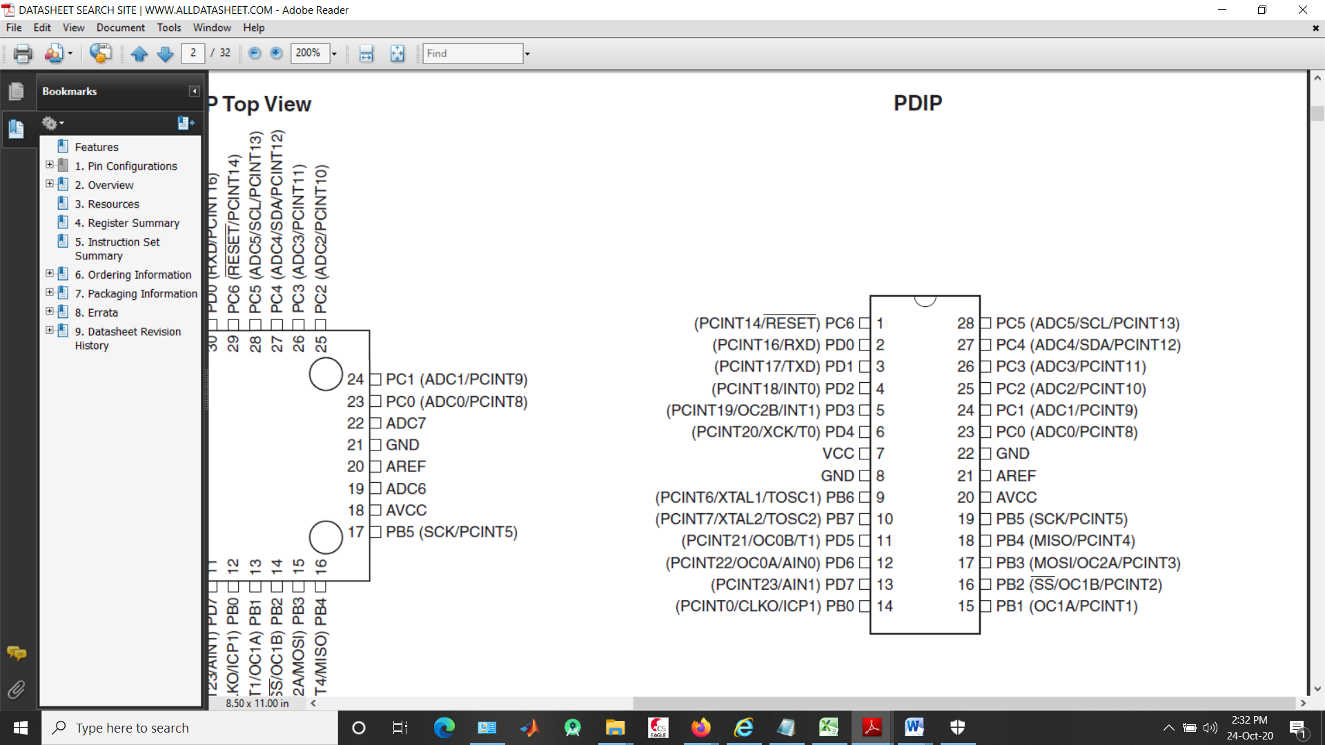

# Pin diagram

**LCD**

Commonly referred to as Liquid Crystal Display. LCD is connected to the Arduino Board with some pins which are : Register Select: It controls the part where the output is displayed on the LCD. Write and Read Pin: It enables us to activate either the writing mode or the reading mode Enable Pin: It writes the data into the registers. Data Pin: No of bits you are going to write in the register. (low/high):

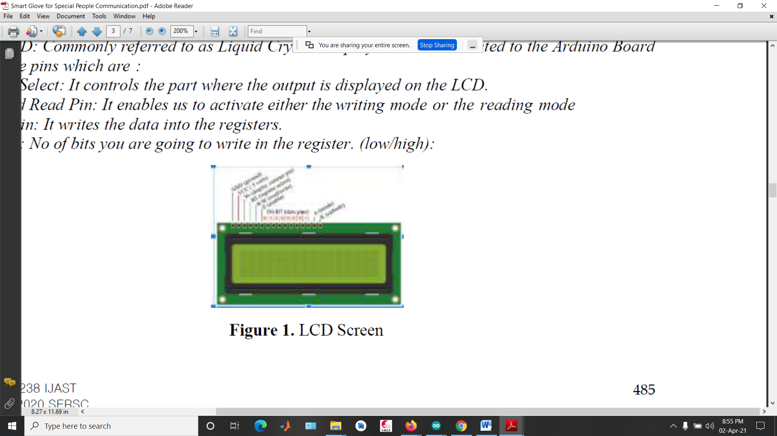

**LM35 sensor**

The **LM35** series are precision integrated-circuit temperature devices with an output voltage linearly- proportional to the Centigrade temperature. ... The low-output impedance, linear output, and precise inherent calibration of the **LM35** device makes interfacing to readout or control circuitry especially easy.

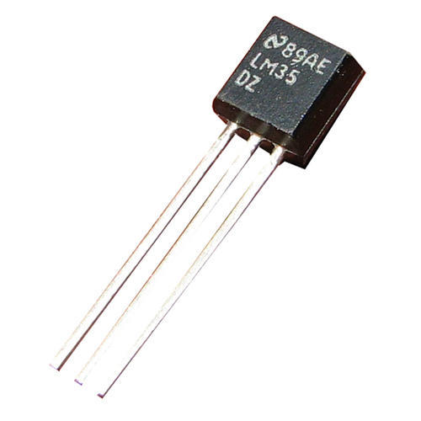

**BUZZER:**

Buzzer sends a 1KHz sound signal controller Board and delay (1000) is maintained i.e. buzzer keeps on sending signal for a sec after every delay time.

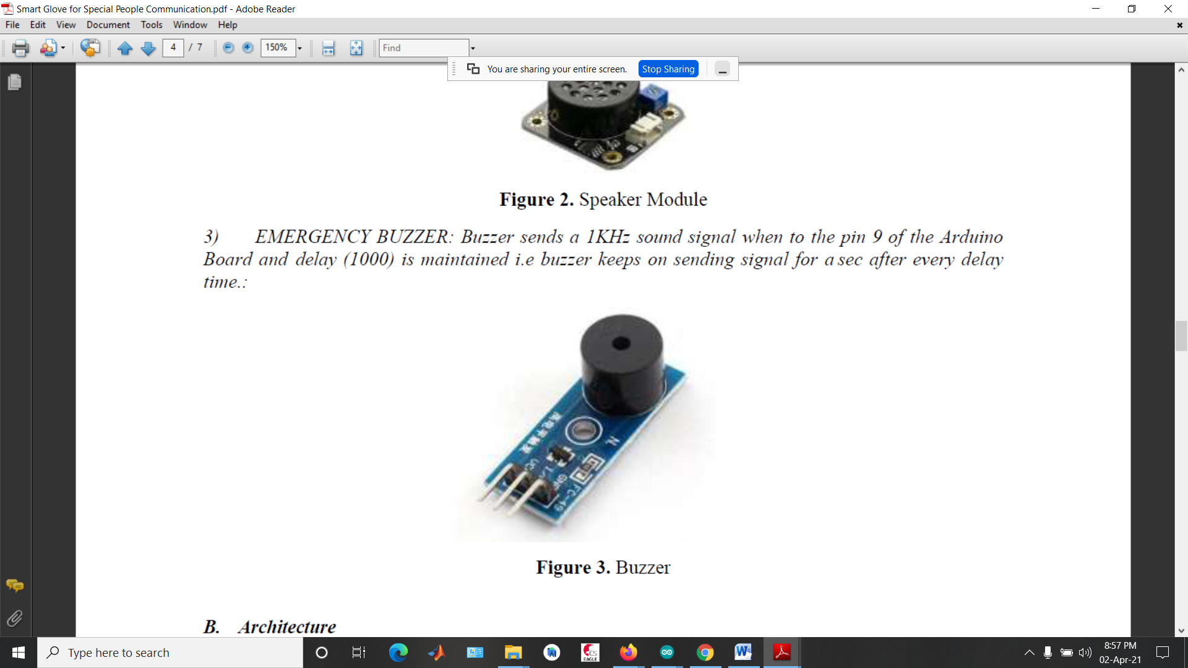

**GSM module:**

A GSM modem is a specific one kind of modulator-demodulator in which a SIM card is acknowledged and we can operate over a subscription to the mobile operator. GSM module is utilized for the information to a GSM required framework. In numerous nations, it is utilized as architecture for mobile communication. GSM module comprises of a GSM modem and we have RS-232, USB alongside a power supply circuit for PC. GSM modem imparts over the mobile network when associated with a PC. GSM modems are additionally used to send and receive SMS messages. A GSM can be effectively interfaced with the microcontroller system and uses serial communication for data exchange.



**Heart Rate Sensor:**

It is an electronic device that is used to measure the heart rate i.e. speed of the heartbeat. The principle involved in the working of the Heartbeat Sensor is Photoplethysmography. The changes in the density of blood in an organ are measured by the changes in the intensity of the light passing through that organ. Usually, the source of light in a heartbeat sensor is most probably an IR LED and the detector would be a Photo Diode, an LDR (Light Dependent Resistor), or a Photo Transistor.



# FLOW CHART

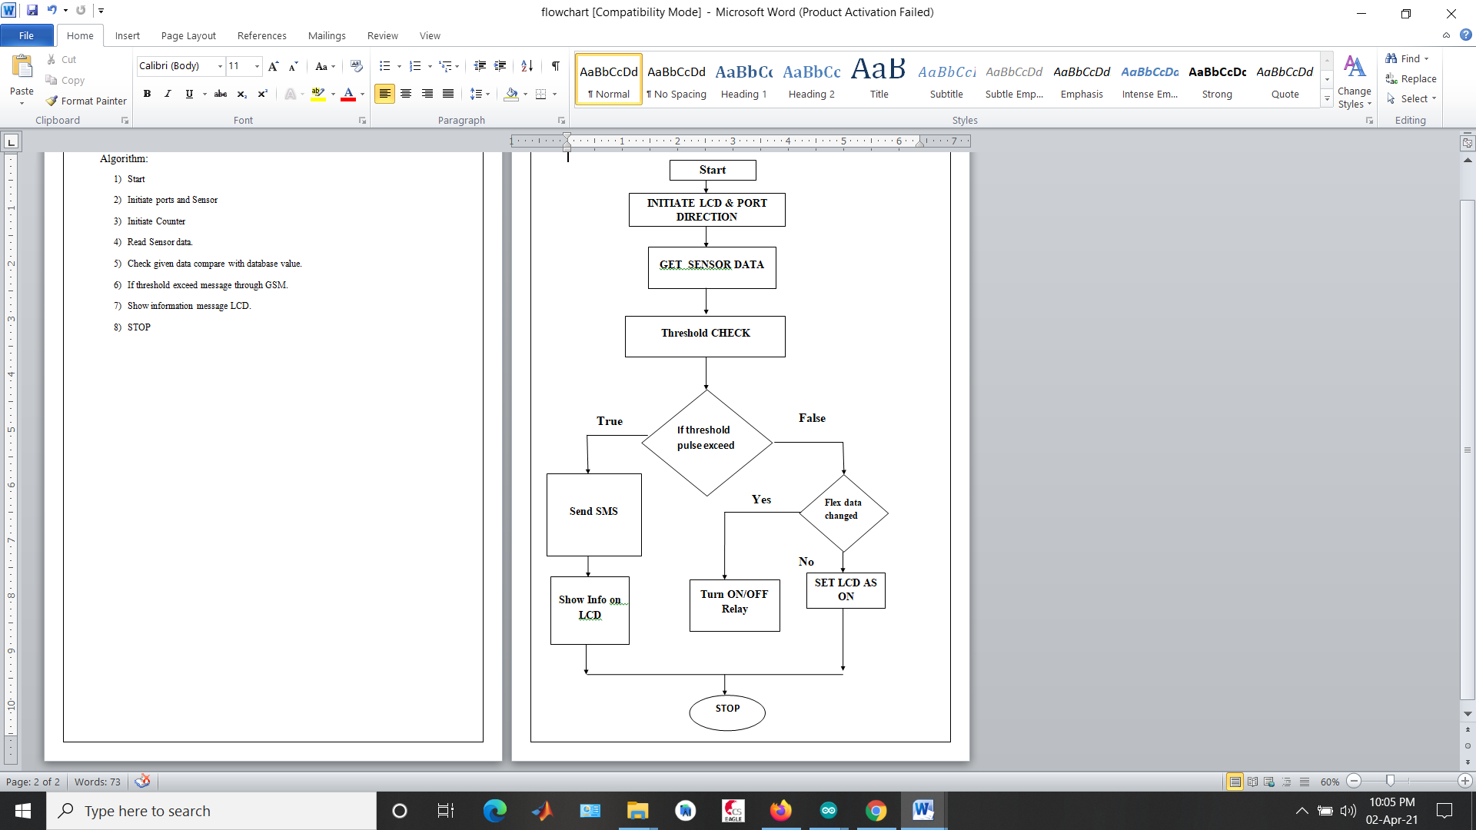

# SOFTWARE DESIGN

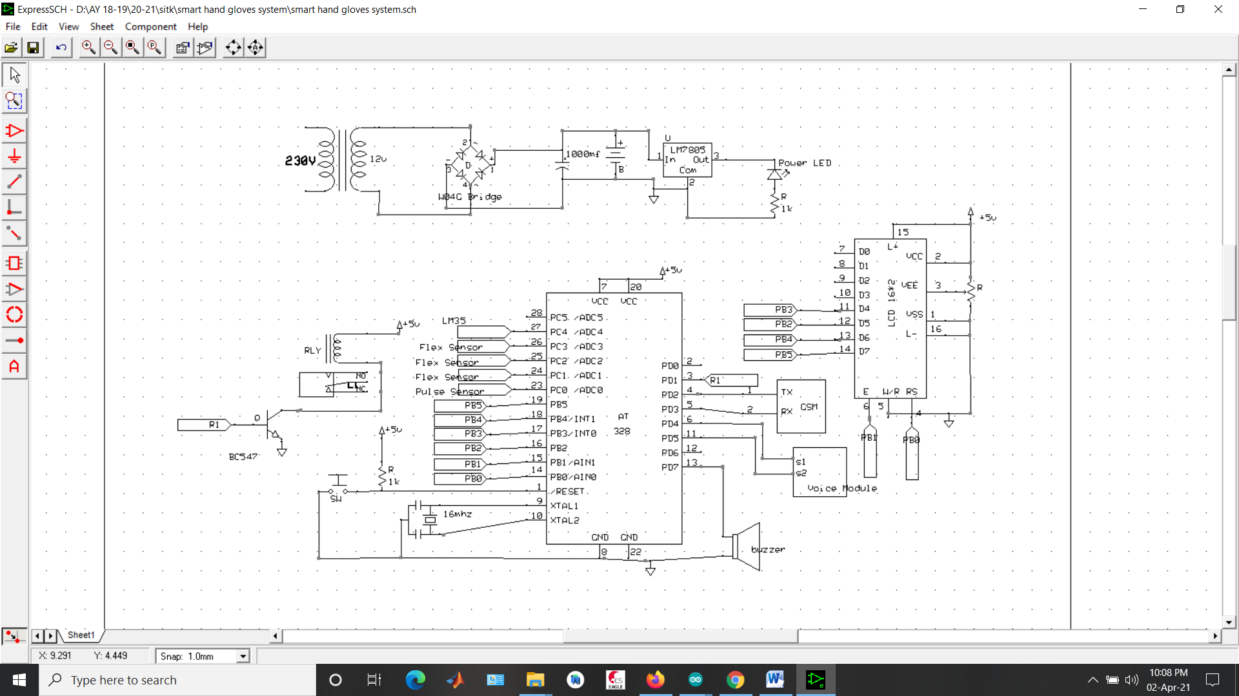

# HARDWARE DESIGN

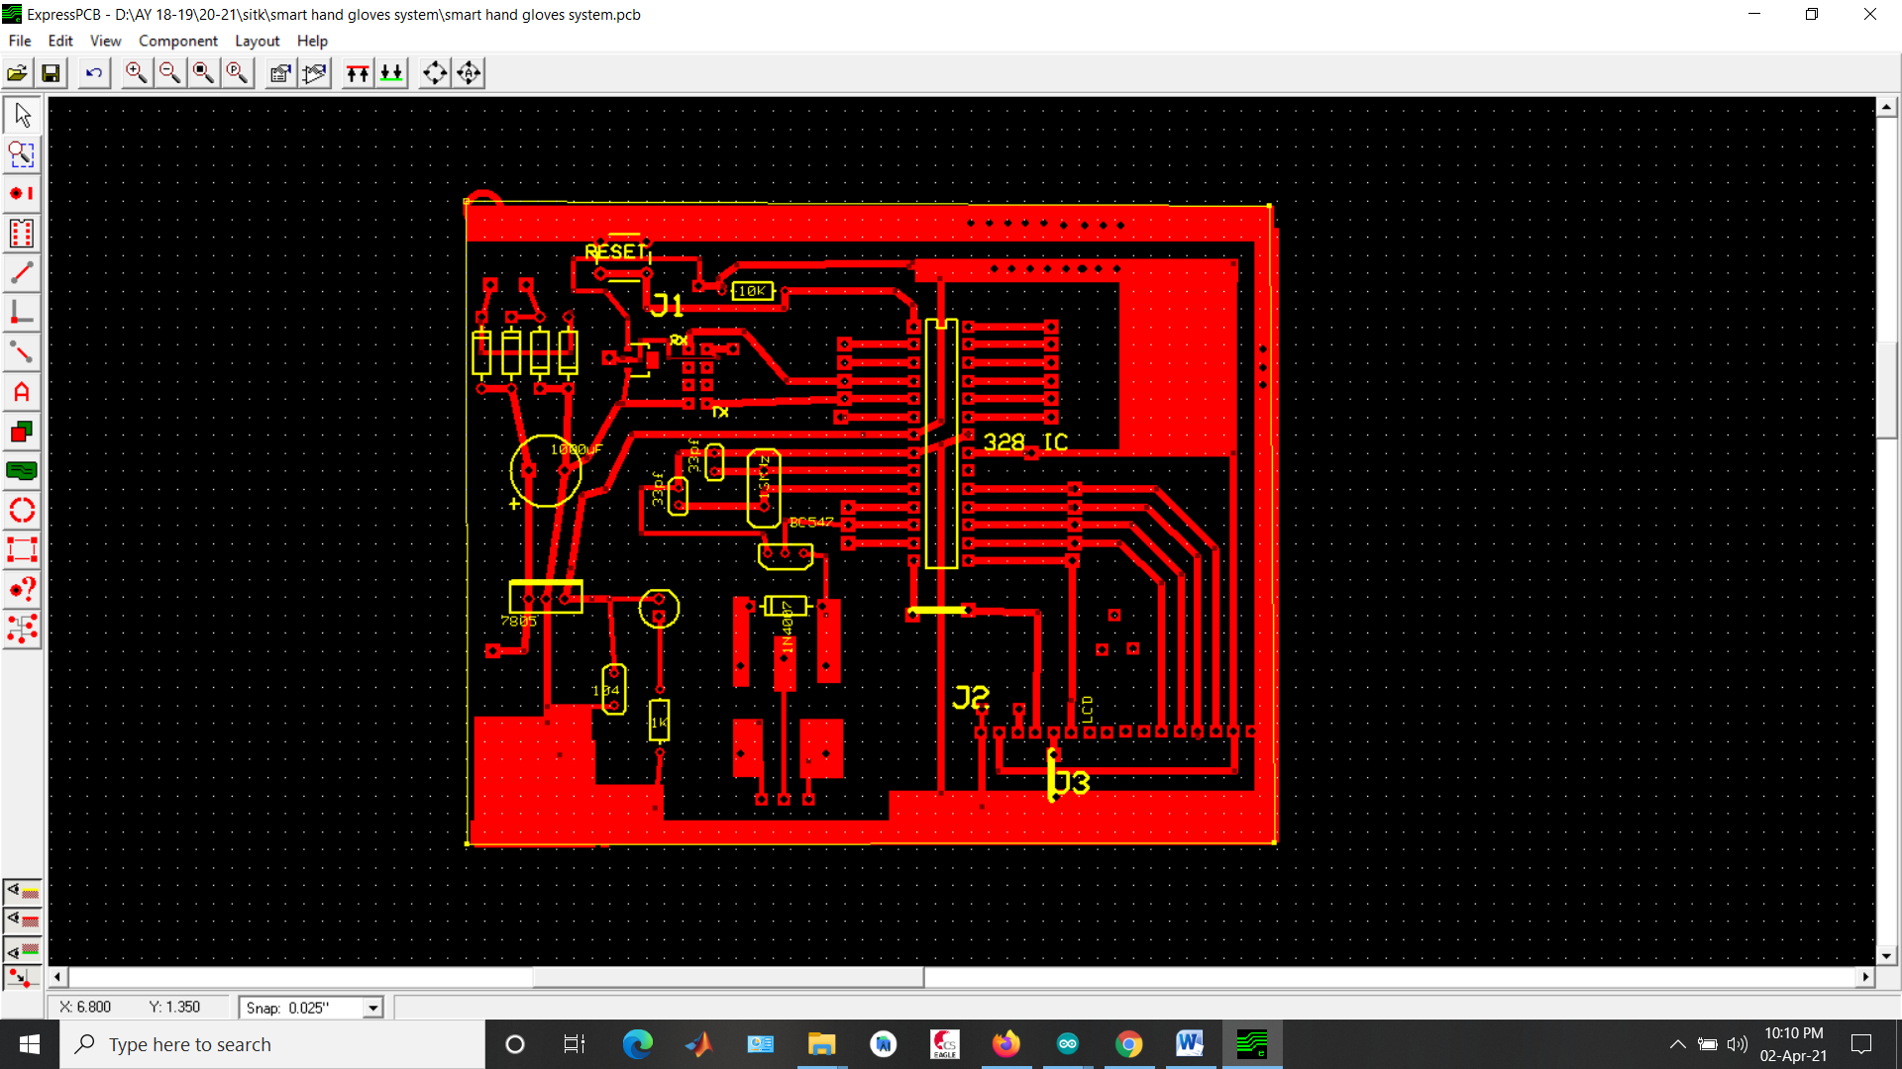

# SIMULATION

# 

# ADVANTAGES

1. Remote patient monitoring (RPM) for clinicians —  Ease of access to patient data, the ability to deliver higher-quality care to more patients with a lower risk of burnout — and for healthcare providers — lower costs and higher efficiency.
2. By helping patients mimic normal **hand** movement, NeoMano delivers obvious physical and psychological **benefits**, and increases confidence.
3. Cost effective system.

# APPLICATIONS

1. Hospitals to provide patient information remotely
2. Home care system.
3. Robotics for control by gesture.

# 

# 

# SUMMARY

The Smart Hand Gloves will provide a far more effective, dependable, and light-weight assembly to the end user than the already existing systems. This can play a huge task in creating meaning in the daily lives of Disabled People. During this particular task, we faced a variety of challenges like the price, weight, and portability of the unit. The Smart Hand Glove not only enables the abolishment of the communication barrier between the specially abled people and other individuals but also makes them independent by providing home automation functionalities. By using different angled bends, users can easily manage all electrical appliances. Also this project provide is to diminish the hospitalization & assistance cost. Health checking application is essentially proposed to give alerts to medical health checking staff for the patients when required.

# 

# REFERENCES

1. K. V. Fale, Pratik Chaudhari, Akshay Phalke, Pradeep Jadhav. ”Smart Glove: Gesture

Vocalizer for Deaf and Dumb People.” International Journal of Innovative Research in Computer

and Communication Engineering, Vol. 4, Issue 4, April 2016.

2. Ms. Pallavi Verma, Mrs. Shimi S. L., D r. S. Chatterji, Mrs. Shimi S. L.” Design of Smart

Gloves.” International Journal of Engineering Research Technology (IJERT), ISSN: 2278-

0181.Vol. 3 Issue 11, November-2014

3. Harmeet Kaur, Amit Saxena, Abhishek Tandon, Ke- shavMehrotra, Khushboo Kashyap. ”A

Review Paper On Evo- lution Of Smart Glove.” International Journal of Scientific Research

andManagement Studies (IJSRMS), ISSN: 2349- 3771, Volume 3, Issue 3, pg: 124-128.

4. Rini Akmeliawati, Melanie Po-Leen Ooi and Ye Chow Kuang, “Real Time Sign Language

Translation Using Colour Segmentation and Neural Network”, IEEE on Instrumentation and

Measurement Technology Conference Proceeding, War- saw, Poland 2012.

5. A Zigbee based home automation system Khushwinder Gill, ShuangHua Yang, Fang Yao, and

Xin Lu. IEEE Trans- actions on Consumer Electronics, Vol. 55, No. 2, MAY 2009.

6. VishwatejaMudiam Reddy, NareshVinay, Tappan Pokharna and Shashank Shiva Kumar Jha,

Internet of Things Enabled Smart Switch, Thirteenth International Conference on Wireless and

Optical Communications Networks (WOCN), Hyderabad, (2016).

7. AnbarasiRajamohan, Hemavathy R.., Dhanalakshmi M., “Deaf-Mute Communication

Interpreter” International Journal of Scientific Engineering and Technology, Vol.2 Issue 5, 1

May 2013, pp.336-341.

8. Richard M. Goff, Janis P. Terpenny, Mitzi R. Vernon, William R. Green, and Clive R. Vorster

, “Work in Progress – Interdisciplinary Design of Assistive Technology for the Third World”

35th ASEE/IEEE Frontiers in Education Conference, Indianapolis, IN, October 19 – 22,

2005, pp.F2H-7-F2H-8.

9. Control of home devices based on hand gestures’. Pomboza- Junez Gonzalo Holgado-Terriza

Juan A. 2015 IEEE 5th International Conference on Consumer Electronics Berlin (ICCEBerlin).

10. S.R.Aarthi Avanthiga and V.Balaji, “A Design Pro-totypic Sarcastic Gadget Technology for

Perceptual Dis-abilities” International Journal of Recent Technology andEngineering

(IJRTE), Vol.2, Issue 6, January 2014, pp.81-85

11. [Mohammad Ali Mazidi and Janice Gillispie, The 8051 Microcontroller and Embedded Systems, (2), 5-17 (2007).

12.Matthew Kane, Amy kesluk, Edward Teaw etal., “A Wireless Health Monitoring System,” in Proc .IEEE, 2005.

13. Adarsh Ghimire, Smart Gloves, https://www.researchgate.net/publication/330497137_Smart_Glove.