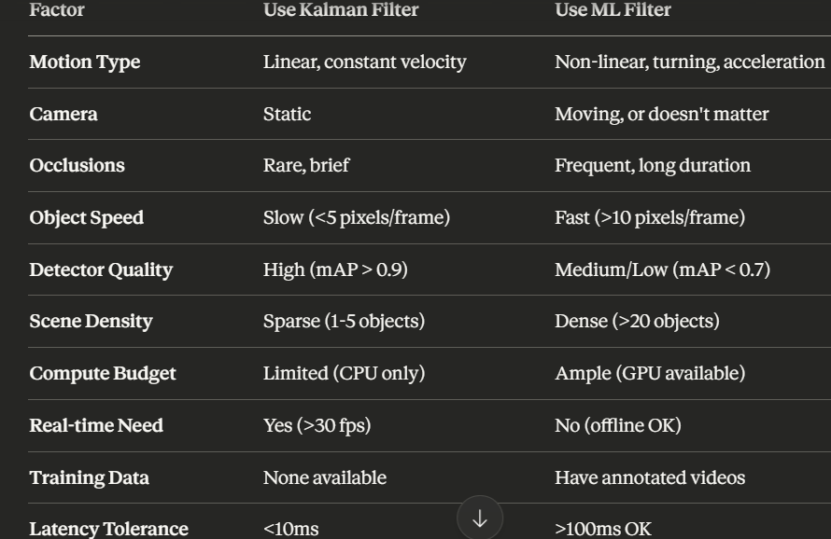

def choose_filter(video_characteristics):
if camera_static and motion_linear and low_occlusion:
return KalmanFilter() # Fast, good enough

elif high_accuracy_needed and gpu_available:
return NODEFilter() # Best accuracy, most robust

elif need_balance:
return RNN_CNP() # 10× faster than NODE, nearly as good

else:
# Adaptive approach
motion_complexity = analyze_motion()
if motion_complexity > threshold:
switch_to_ML_filter()
```

---

## **📈 ROI ANALYSIS (Implicit from Paper)**

**When ML cost is justified:**

Calculate: `accuracy_gain × importance - (compute_cost × duration)`

**Example 1: Highway surveillance (24/7)**
- Accuracy gain: 0.5%
- Compute cost: 153× higher (NODEFilter)
- **Verdict:** Not worth it, use KF

**Example 2: Sports broadcast analysis (2 hours)**
- Accuracy gain: 5%
- Offline processing: Time doesn't matter
- **Verdict:** Definitely use ML

**Example 3: Autonomous vehicle**
- Accuracy gain: 3%
- Safety critical: Infinite importance
- **Verdict:** Use ML despite cost

---

## **🎓 KEY TAKEAWAY FROM PAPER**

The paper doesn't just say "ML is better" - it provides **specific quantified guidance**:

### **Motion Linearity Test:**
```
If average_direction_change_per_second < 15°:
→ Kalman Filter sufficient (MOT17/MOT20 scenario)

If average_direction_change_per_second > 30°:
→ ML essential (DanceTrack/SportsMOT scenario)
```

### **Occlusion Frequency Test:**
```
If occlusion_rate < 20%:
→ Kalman Filter acceptable

If occlusion_rate > 50%:
→ ML provides significant advantage
```

### **Performance Impact:**
```
Linear motion: ML gain = 0.5-1% (not worth 100× slower)
Non-linear motion: ML gain = 3-8% (worth the cost)
High occlusion: ML gain = 5-10% (essential)

