**NAME : VANSH KOLTE ROLL_NO : 62**

**BATCH : C4 SUB : MD**

**PRACTICAL_5**

**AIM :**

**LED interfacing programs**

**i) Toggling all LEDs**

CODE :

ORG 0000H

CLR C

MOV A, #0FFH

START:

MOV P1, A

CPL A

SJMP START

DELAY:

MOV R2, #25H

HERE1:

MOV R3, #25H

HERE:

DJNZ R3, HERE

DJNZ R2, HERE1

RET

END

**ON :**

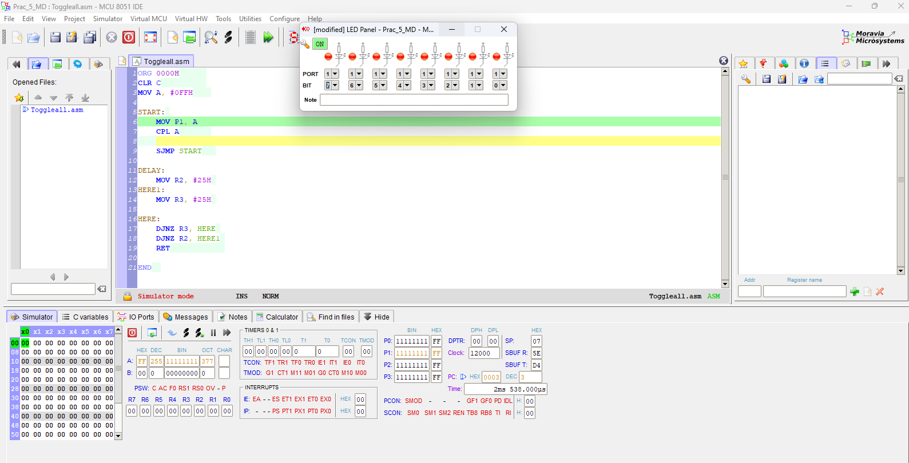

**OFF :**

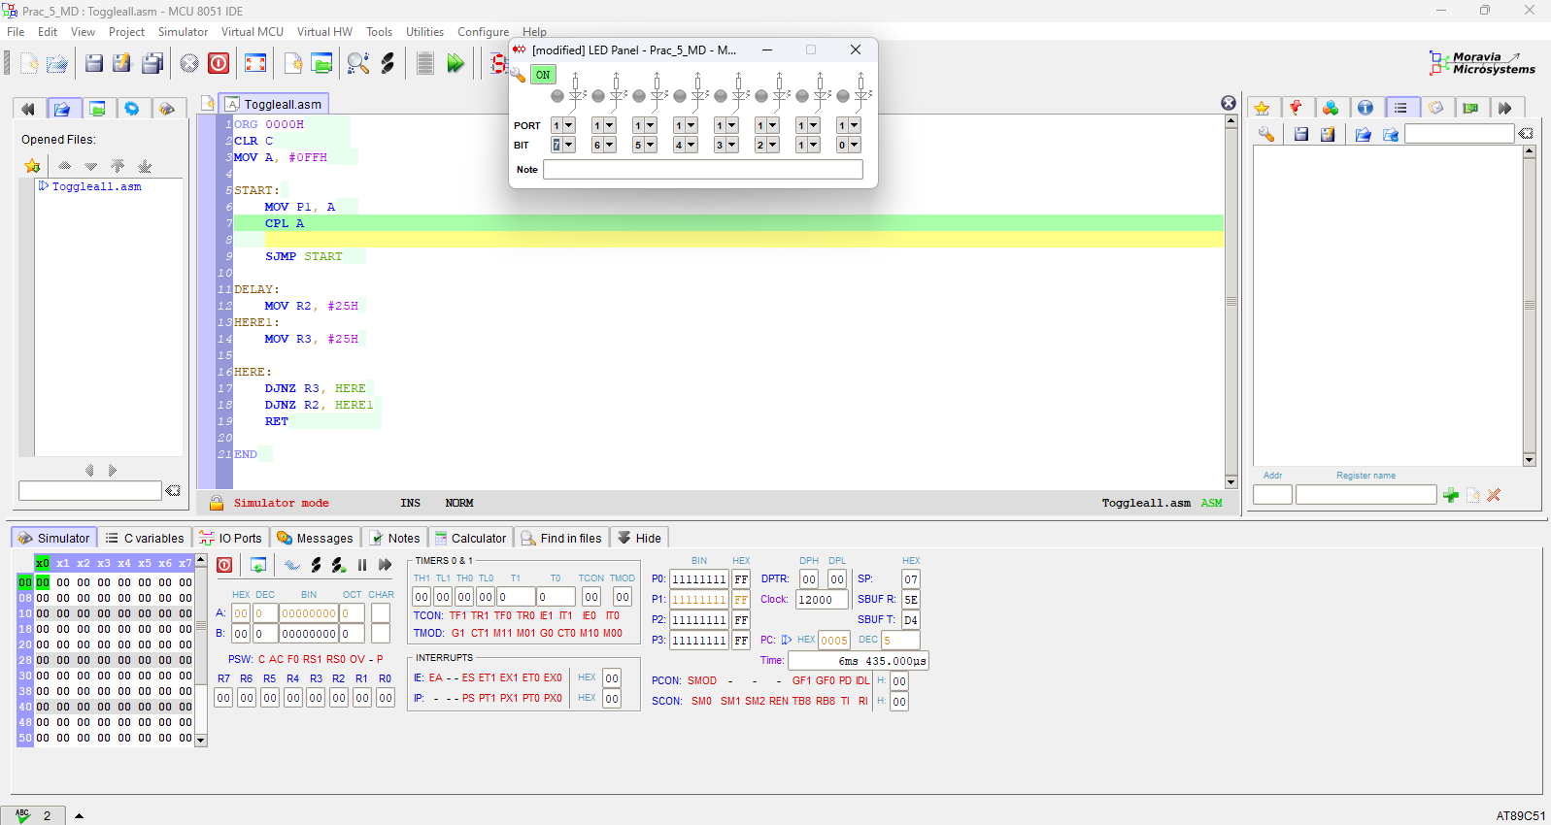

**ii) Toggling alternate LEDs :**

**CODE :**

ORG 0000H

CLR C

MOV A, #0AAH

START:

MOV P1, A

CPL A

SJMP START

DELAY:

MOV R2, #25H

HERE1:

MOV R3, #25H

HERE:

DJNZ R3, HERE

DJNZ R2, HERE1

RET

END

**ALTERNATE ODD :**

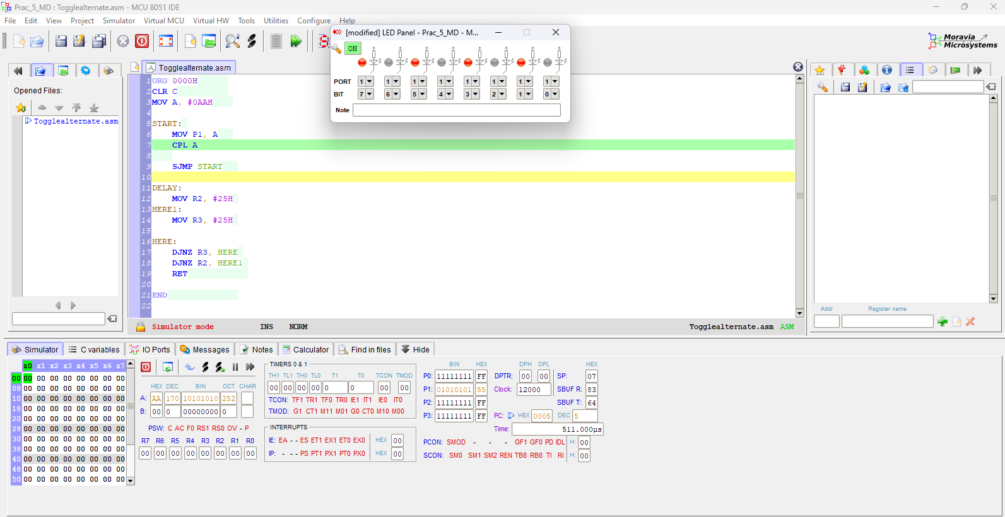

**ALTERNATE EVEN :**

