**WEEK-3**

**Task-1**

**Aim:** Writeaprogramthat uses the osmodule to displaythe current user'susername**,** homedirectory, and operatingsystem platform.

Create afunction that utilizes the osmodule to display the total system memory**,** free memory**,** and the percentage of free memory available.

**Code:**

const os = require('os');

const http = require('http');

const port  = 3000;

const totalMem = os.totalmem().toFixed(2)

const freeMem = os.freemem().toFixed(2)

const server = http.createServer((req, res) => {

    if(req.url === '/osinfo'){

        res.writeHead(200, {

            'Content-Type': 'application/json'

        });

        res.write(`Username : ` + os.userInfo().username + `\n`)

        res.write(`Home directory : ` +os.homedir()+ `\n`)

        res.write(`PlatForm : ` +os.platform()+ `\n`)

        res.write(`Total Memory : ` +totalMem+ `\n`)

        res.write(`Free Memory : ` +freeMem + `\n`)

        res.write(`Percentage : ` +((freeMem / totalMem )*100 ).toFixed(2) + `%`)

        res.end()

}else{

    res.writeHead(404, { 'Content-Type': 'application/json' });

    res.write('404 Not Found');

    res.end()

}

});

server.listen(port, () => {

  console.log(`Server running at http://localhost:${port}/`);

});

**Output:**

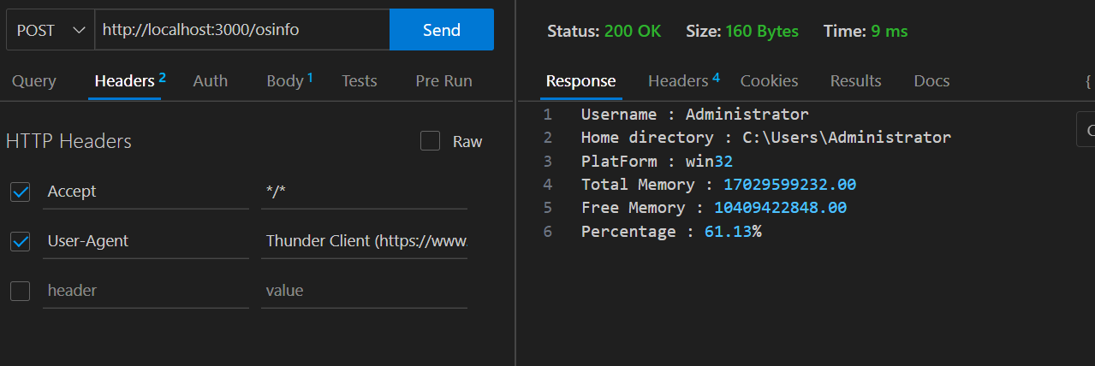

**Task-2**

**Aim: Experiment with chalk ,uppercase and external modules**

**Code:**

const chalk = require('chalk');

function print(){

    console.log(chalk.bold.inverse.blue(('Hello world!').toUpperCase()));

}

**Output:**

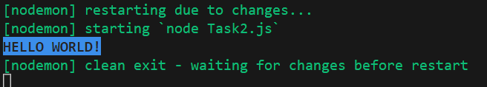

**Task-3**

**Aim: Your own custom module and import/export.**

**Code:**

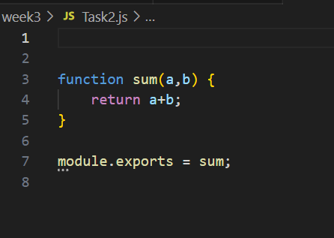

const chalk = require('chalk');

const sum = require('./Task2.js')

console.log(chalk.bold.inverse.red(`sum = `+sum(10,20)))

**Output:**

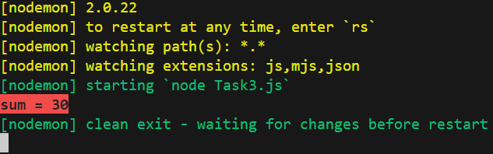

**Conclusion:**

From this practical I learnt many new concepts like chalk, External module and utilise it’s functionality.