A PROJECT REPORT

on

“Interactive Credit Approval Prediction and Explainability”

EXPLAINABLE CREDIT SCORING

ABSTRACT

The project builds an interactive, explainable credit-approval prediction model which uses a predictive model based on a Random Forest and uses post-hoc Explainable AI (SHAP and LIME). Incorporating applicant demographic and financial characteristics, including age, employment years, annual income, education and marital status, the pipeline engages in some precautionary preprocessing, feature engineering and model selection to generate a probability of approval as opposed to a hard binary only. A Streamlit user interface allows users and loan officers to use intuitive "what-if" inputs (vary income, length of employment, etc.), see global feature scores and local explanations of specific decisions, and enhance insight and transparency into automated credit decisions.

The experimental analysis of the given dataset demonstrates that it has strong predictive ability (testing accuracy ≈ 0.90, mean cross-validation accuracy ≈ 0.93, ROC-AUC ≈ 0.74) but the integrated SHAP and LIME visualisation reveal which features raise or lower the likelihood of approval of both population and individual applicants. The prototype shows how explainability can be incorporated into lending processes to make them more accountable and trusted by users; future applications will involve fairness audits, provide more credit history to data, deploying it in production, and how to make explainability at scale in real time.

Keywords: Credit scoring, Explainable AI, Random Forest, LIME, Streamlit, ML classifier, Transperancy
EXPLAINABLE CREDIT SCORING

Chapter 1

Introduction

The fast growth of digital financial services has brought more credit evaluation requirements which are automated. Conventional credit scoring systems usually offer binary accept / reject responses with minimal or no data on the rationale behind a choice. This obscurity decreases the confidence of the user and it becomes hard to enhance the credit worthiness of the applicant.

The project creates a clear machine learning pipeline of credit approval prediction, using a high performance model (Random Forest) with post hoc explanatory tools (SHAP to provide general explanations and LIME to provide local explanations). The web-based user interface will give the applicants the opportunity to view what they might want (what if) and see which attributes most affect the decisions.

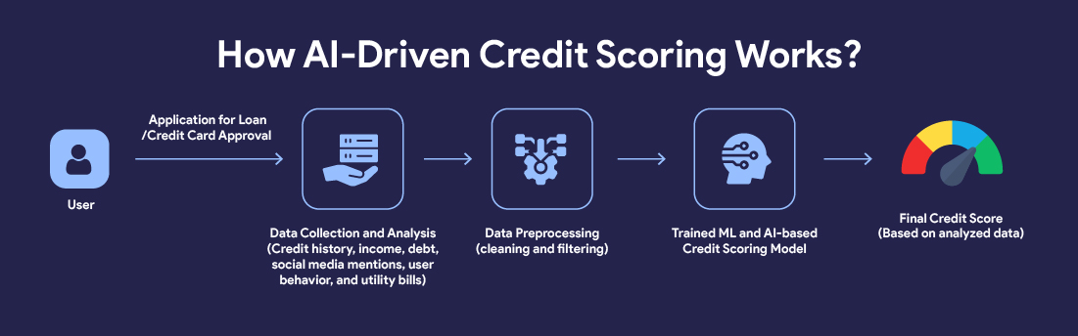

Figure 1.1: Process of ML based Credit Score

Vansika Jhawar 1

EXPLAINABLE CREDIT SCORING

Chapter 2

Basic Concepts/ Literature Review

Credit risk analysis is an important element of the contemporary financial systems, the purpose of which is to determine the possibility of default debtor on a loan. Historically, statistical models, like logistic regression, have been employed to that end, but with the accessibility of large-scale structured data and the development of the art of computation, machine learning (ML) methods have become a more common tool. ML allows automated learning and recognition of features and better predictive efficiency, which can support more objective and data-driven credit decisions.

2.1. Credit Scoring & Machine Learning
There is an extensive tradition of credit risk modeling by machine learning models (logistic regression, tree-based ensembles, gradient boosting) based on learning complex patterns related to structured data.

2.2. Random Forests
This is a collection of decision trees, which averages together the trees in order to minimize variance; they are also resistant to outliers and can be used with mixed features.

2.3. Explainable AI (XAI)
Global SHAP shows overall feature impact. LIME explains why an individual prediction was made. It helps identify rejection reasons for specific applicants.

2.4. Interactive What-If Analysis
The ability to modify the input features and immediately view projected probabilities lets the applicants and credit officers observe what can be done to modify the results.

Vansika Jhawar 2

EXPLAINABLE CREDIT SCORING
Chapter 3

Problem Statement / Requirement Specifications
Conventional credit scoring mechanisms usually adopt rigid statistical frameworks that do not reflect the complicated financial and behavioral tendencies, resulting in wrong or obscure choices. Credit risk modeling may now be approached using data-driven methods with the increased adoption of machine learning to improve prediction accuracy. But the majority of ML models are black boxes, with the applicants or credit officers having limited visibility.
In this project, the goal is to create a credit Scoring System based on Explainable Machine Learning which predicts the probability of loan default and offers insights which are interpretable utilizing SHAP and LIME. An interactive What-If analysis tool is also built in to the system whereby one can change feature values and see the resulting change in results.

3.1 Project Planning
Steps followed:
- Gathering of requirements and study of dataset.
- Preprocessing and feature selection Data.
- Model training and assessment.
- Explainability (SHAP, LIME) integration.
- Creation of interactive UI.
- Testing, validation and documentation.

3.2 Project Analysis
Some of the requirements were analyzed in terms of feasibility, ambiguity and ethical considerations. The problems of risks of data imbalance and overfitting were overcome using cross-validation and feature engineering. Accuracy and transparency, which are necessary in the model, adhere to the fairness and accountability principles.

3.3 System Design
3.3.1 Design Constraints
Software: Python 3.11, Scikit-learn, XGBoost, SHAP, LIME, Streamlit/Flask
Hardware: Intel i5 or higher, 8 GB RAM, Windows/Linux environment.
3.3.2 System Architecture OR Block Diagram
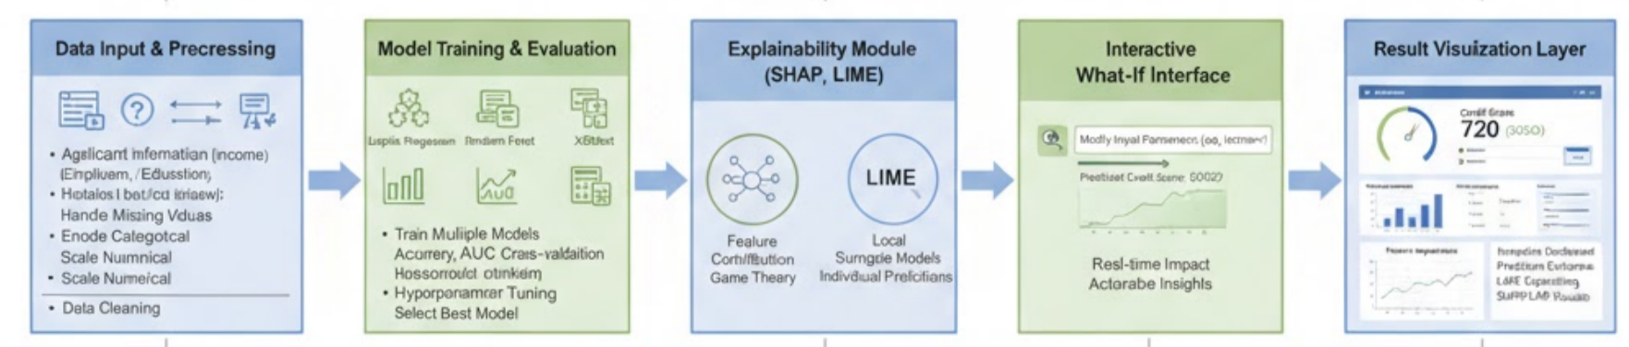

Vansika Jhawar 3

EXPLAINABLE CREDIT SCORING

Chapter 4

Implementation

4.1 Methodology OR Proposal

4.1.1. Dataset and Preprocessing
- The dataset contained demographic, work and finances features where target variable is Credit Card Approval (Approved/Rejected).
- Cleaning tasks: standardized column names, deleted duplicates and redundant fields, missing values.
- Outlier treatment: IQR approach of handling continuous variables like income and age.
- Feature engineering: Turned birthday count into Age, counted EmployedYears based on the number of days worked, grouped age, and label-encoded categorical features.
- Chi-square, Z-test and RFE were used to select features to end up with final feature set.

4.1.2. Modeling Approach
Baselines: Logistic Regression, Decision tree, KNN, SVM, Gradient Boosting.
Primary model:Random Forest Classifier selected based on the best performance overall and consistent behaviour.
Hyperparameter tuning: grid search / randomised search of nestimators, maxdepth, minsamples split etc.

4.1.3. Evaluation Metrics
Models are evaluated using Accuracy, Cross-Validation Accuracy, ROC?,AUC?, Precision, Recall and Confusion Matrix.

4.1.4. Explainability AI
SHAP was applied to the global feature importance and summary plots to provide everything that increases or decreases the probability of approval in general.
LIME plotted local explanations of the feature contributions to a single prediction. They were incorporated into Streamlit as the explanation visuals to the users.

4.1.5 Deployment
Streamlit application has interactive input modules (sliders, dropdowns) to input profile values, calculate prediction and probability, display a gauge to reflect confidence, display SHAP world plots, and display LIME definition of the specified input.

4.2 Testing OR Verification Plan
Model | Testing Accuracy before Hypertuning | Testing Accuracy after Hypertuning | Mean Cross-Validation Accuracy | AUC
Logistic Regression | 0.87 | 0.87 | 0.91 | 0.61
Decision Tree | 0.84 | 0.85 | 0.88 | 0.71
Random Forest | 0.91 | 0.90 | 0.93 | 0.74
Support Vector Machine | 0.87 | 0.87 | 0.91 | 0.71
K-Nearest Neighbour | 0.88 | 0.90 | 0.89 | 0.70
Gradient Boosting | 0.90 | 0.89 | 0.92 | 0.74
Each model was evaluated using standard performance metrics.

4.3 Result Analysis OR Screenshots
The evaluation metrics of Random Forest Classifier is as follows :
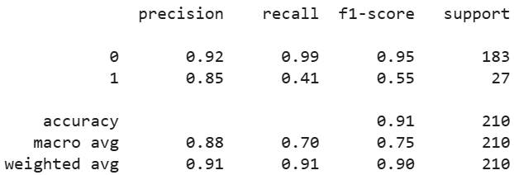

4.4 Quality Assurance
As we can see from the evaluation metrics of the model, it achieves accuracy of 91%. This ensures quality. Futhermore we are adding XAI methonds on this which futher helps us inprove quality of performance.

Vansika Jhawar 4

EXPLAINABLE CREDIT SCORING

Chapter 5

Standards Adopted

5.1 Design Standards
- Architectural Modularity: The system is based on a modular pipeline Data Ingestion Preprocessing Model Training Explainability Visualization/UI Each stage is a testable and independent component of the system.
- Documentation and Diagrams: UML and block diagrams were to be the representation of component interactions and data flow.
- Data Handling: Reproducibility was done using standardized column names, uniformity of data types and imputation.
- Security & Privacy: Model artifacts were handled with security, input validation was done and data was anonymized.
- Documentation: Design decisions and assumptions are documented in inline comments and READM files and a data dictionary document.

5.2 Coding Standards
- Language & Style: It was written in python 3.x and it was written in line with the PEP8 guidelines with meaningful names to its variables and also it contains docstrings.
- Modularity Modularity Modularity functions and classes are single-responsible and easier to test and reuse.
- Dependency Management: Version controlling of all libraries is done by using a requirements.txt file.
- Version Control: Source management has been done using Git with descriptive commits and experimenting using a branch.
- Error Handling & Logging: Python logging and validation checks help to make the process of training and the UI robust.
- Reproducibility: Since there is random seeding and metadata monitoring, it facilitates reproducibility of experiments.

5.3 Testing Standards
- Unit and Integration Testing: Core modules were tested in isolation and end to end with held out datasets to test end to end.
- Model Evaluation A stratified cross-validation was used to assure balanced testing. Measures such as Accuracy, Precision, Recall, F1-score and ROC-AUC were used.
- Acceptance Criteria: The Random Forest model was accepted in terms of [?]90% accuracy and ROC-AUC [?]0.70 with the same result across folds.
- Test Documentation: Test cases were done on input validation, UI boundary checks and SHAP/LIME functionality.
- Compliance: The software testing was conducted in accordance with the standard principles of IEEE/ISO of software verification and validation.

Vansika Jhawar 5

EXPLAINABLE CREDIT SCORING

Chapter 6

Conclusion and Future Scope

6.1 Conclusion

The credit scoring system developed is a successful harmonisation of machine learning and explainable AI to offer an effective and transparent, data-based and reliable system of credit risk evaluation. The system can provide high predictive accuracy by using the most sophisticated models, including Logistic Regression, Random Forest, and XGBoost, and interpretability tools, including SHAP and LIME, to guarantee the applicability of the results to the interpretation of the decisions. The interactive what-if interface and visualization layer are added, which contributes to the improved engagement and trust of the users and makes the system applicable to the practical use of finances and compliance with the regulations.

6.2 Future Scope

The enhancements to be introduced in the future may be the integration of real-time data in the system, deep learning models, and automated bias detection to enhance fairness and flexibility. Predictive power may also be enhanced by adding NLP-based credit behaviour prediction on unstructured data, e.g. transaction history or customer comments. Besides, by implementing the model as a web-based or cloud-based API, it would be possible to integrate it with banking systems easily and make it scalable and available to large financial institutions.

Vansika Jhawar 6
EXPLAINABLE CREDIT SCORING

References

[1 ] D. J. Hand and W. E. Henley, “Statistical classification methods in consumer credit scoring: A review,” Journal of the Royal Statistical Society: Series A (Statistics in Society), vol. 160, no. 3, pp. 523–541, 1997.

[2] J. Lessmann, B. Baesens, H.-V. Seow, and L. C. Thomas, “Benchmarking state-of-the-art classification algorithms for credit scoring: An update of research,” European Journal of Operational Research, vol. 247, no. 1, pp. 124–136, 2015.

[3] P. Domingos, “A few useful things to know about machine learning,” Communications of the ACM, vol. 55, no. 10, pp. 78–87, 2012.

[4] A. Belle and R. Papantonis, “Principles and practice of explainable machine learning,” Frontiers in Big Data, vol. 4, pp. 1–10, 2021.

[5] A. Mujo, S. Nikolla, E. Hoxha and E. Pelivani, “Explainable AI in Credit Scoring: Improving Transparency in Loan Decisions,” Journal of Information Systems Engineering & Management, vol. 10, no. 27s, 2025.

[6] S. Kakkar, “Explainable AI Models for Credit Risk Scoring in Banking: Balancing Accuracy and Regulatory Transparency,” International Journal of Financial Data Science (IJFDS), vol. 3, no. 2, pp. 1–6, 2025.

[7] M. Talha Mohsin and N. Bin Nasim, “Explaining the Unexplainable: A Systematic Review of Explainable AI in Finance,” ArXiv Preprint, Mar. 2025.

[8] “Explainable AI in Finance — CFA Institute Research and Policy Center,” CFA Institutue, 2025.

