SMNLS: Practical Report, Silvan de Boer

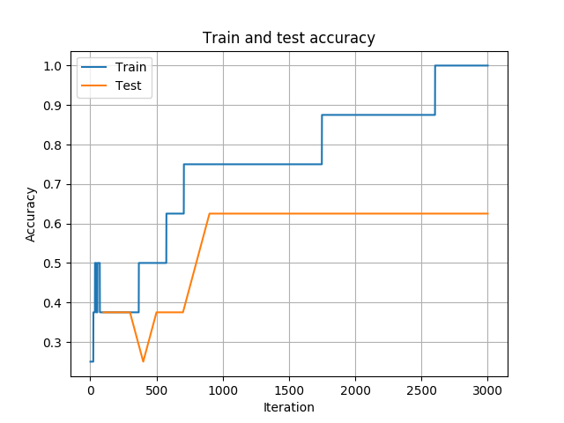
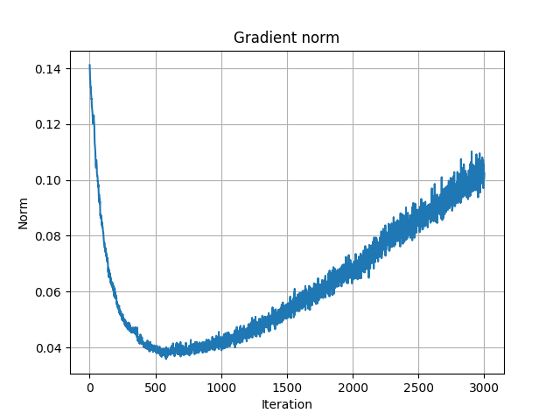
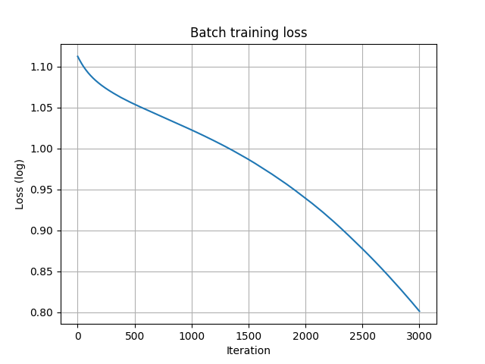

Fig1: Overfitting the Baseline model with a data set of 8 sentence pairs.

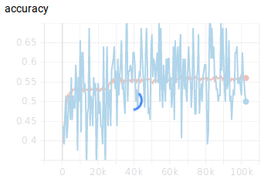
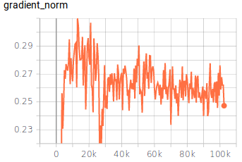
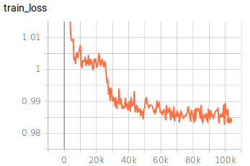

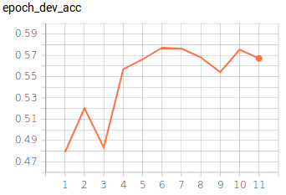
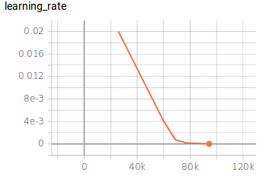

Fig2: Baseline trained until stopped (because dev accuracy decreased five epochs)

The baseline model achieved these accuracies:
- Macro accuracy: 0.4437
- Micro accuracy: 0.4513

