**TRƯỜNG ĐẠI HỌC SƯ PHẠM KỸ THUẬT TP. HỒ CHÍ MINH**

**KHOA CƠ KHÍ CHẾ TẠO MÁY**

**BỘ MÔN CƠ ĐIỆN TỬ**



**HOMEWORK AI: WEEK 14**

**GVHD:** TS. Nguyễn Trường Thịnh

**SVTH:** Phạm Phúc Chương

**MSSV:** 19146311

TP.Hồ Chí Minh, tháng năm 2022

**Mục Lục**

**1.** **Phân loại trái cây** 3

**2.** **CNN_Nhận dạng 11 loại tiền Việt Nam** 6

**3.** **Dự đoán món ăn Việt Nam** 9

**4.** **Training CNN MNIST** 12

**5.** **Training FASION_MNIST** 15

**6.** **Training Cifar-100** 18

1. **Phân loại trái cây**

**Code:**

**#import thu vien**

from keras.models import Sequential

from keras.layers import Dense, Activation, Dropout, Conv2D, MaxPooling2D, Flatten

from tensorflow.keras.optimizers import Adam

from sklearn.preprocessing import StandardScaler

from keras.utils import np_utils

from sklearn.utils import shuffle

import cv2

import matplotlib.pyplot as plt

import numpy as np

import pickle

import tensorflow as tf

#dung file data up san tren google

from google.colab import drive

drive.mount('/content/drive')

#Ham ve do thi

def plot_history(history_fine):

  f1 = history_fine.history['acc']

  val_f1 = history_fine.history['val_acc']

  loss = history_fine.history['loss']

  val_loss = history_fine.history['val_loss']

  plt.figure(figsize=(8, 8))

  plt.subplot(2, 1, 1)

  plt.plot(f1, label='Acc')

  plt.plot(val_f1, label='Validation Acc')

  plt.legend(loc='lower right')

  plt.title('Accuracy')

  plt.subplot(2, 1, 2)

  plt.plot(loss, label='Loss')

  plt.plot(val_loss, label='Validation Loss')

  plt.legend(loc='upper right')

  plt.title('Loss')

  plt.xlabel('epoch')

  plt.show()

# Load Data

with open('/content/drive/MyDrive/Colab Notebooks/Data/data_fruit.pickle', 'rb') as f:

    (x_train, y_train) = pickle.load(f)

# Reshape Data

x_pre_1 = x_train[1]

x_pre_2 = x_train[13]

x_pre_3 = x_train[26]

x_pre_4 = x_train[38]

x_pre_5 = x_train[56]

 Preprocessing Data

x_train = x_train.astype('float32')

x_train /= 255

# Encoding Y

y_train = np_utils.to_categorical(y_train, 10)

# Shuffe Data

x_train, y_train = shuffle(x_train, y_train)

# Tao model

model = Sequential()

model.add(Conv2D(32, (3,3), activation='relu',kernel_initializer='he_uniform', padding ='same', input_shape = (150,150,3)))

model.add(Conv2D(32, (3,3), activation='relu',kernel_initializer='he_uniform', padding ='same'))

model.add(MaxPooling2D(2,2))

model.add(Conv2D(64, (3,3), activation='relu',kernel_initializer='he_uniform', padding ='same'))

model.add(Conv2D(64, (3,3), activation='relu',kernel_initializer='he_uniform', padding ='same'))

model.add(MaxPooling2D(2,2))

model.add(Conv2D(128, (3,3), activation='relu',kernel_initializer='he_uniform', padding ='same'))

model.add(Conv2D(128, (3,3), activation='relu',kernel_initializer='he_uniform', padding ='same'))

model.add(MaxPooling2D(2,2))

model.add(Flatten())

model.add(Dense(128, activation='relu', kernel_initializer='he_uniform'))

model.add(Dense(10, activation='softmax'))

model.summary()

# Training

opt = Adam(lr = 0.001)

model.compile(optimizer = opt, loss = 'categorical_crossentropy', metrics = ['acc'])

his = model.fit(x_train, y_train, epochs = 100, batch_size = 64, validation_split = 0.2)

#Bieu do ket qua training

plot_history(his)

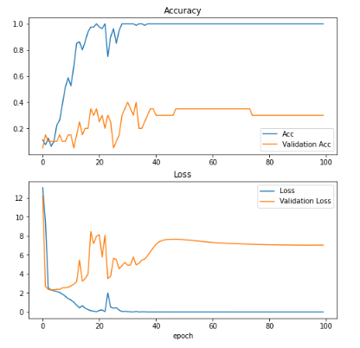

Hình 1 Kết quả training

# add label cho model

label = ['Cam','Dao','Dua hau','Du du','Khe','Le','Oi','Man','Sapoche','Xoai']

# Xet lai

plt.title("Model dự đoán:  " + label[np.argmax(model.predict(x_pre_1.reshape(1,150,150,3)))])

plt.imshow(cv2.cvtColor(x_pre_1, cv2.COLOR_BGR2RGB), cmap=plt.get_cmap('gray'))

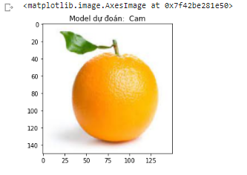

Hình 2 Kết quả test model trên quả cam

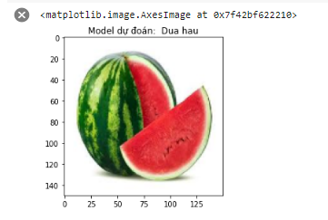

Hình 3 Kết quả test model trên dưa hấu

1. **CNN_Nhận dạng 11 loại tiền Việt Nam**

**#Import lib**

from keras.models import Sequential

from keras.layers import Dense, Activation, Dropout, Conv2D, MaxPooling2D, Flatten

from tensorflow.keras.optimizers import Adam

from sklearn.preprocessing import StandardScaler

from keras.utils import np_utils

from sklearn.utils import shuffle

import cv2

import matplotlib.pyplot as plt

import numpy as np

import pickle

import tensorflow as tf

#chuan bi ham ve bieu do

def plot_history(history_fine):

  f1 = history_fine.history['acc']

  val_f1 = history_fine.history['val_acc']

  loss = history_fine.history['loss']

  val_loss = history_fine.history['val_loss']

  plt.figure(figsize=(8, 8))

  plt.subplot(2, 1, 1)

  plt.plot(f1, label='Acc')

  plt.plot(val_f1, label='Validation Acc')

  plt.legend(loc='lower right')

  plt.title('Accuracy')

  plt.subplot(2, 1, 2)

  plt.plot(loss, label='Loss')

  plt.plot(val_loss, label='Validation Loss')

  plt.legend(loc='upper right')

  plt.title('Loss')

  plt.xlabel('epoch')

  plt.show()

#add data in drive

from google.colab import drive

drive.mount('/content/drive')

# Load Data

with open('/content/drive/MyDrive/Colab Notebooks/Data/data_MoneyVN.pickle', 'rb') as f:

    (x_train, y_train) = pickle.load(f)

# Reshape Data

x_pre_1 = x_train[1]

x_pre_2 = x_train[12]

x_pre_3 = x_train[25]

x_pre_4 = x_train[38]

x_pre_5 = x_train[56]

x_pre_6 = x_train[86]

# Preprocessing Data

x_train = x_train.astype('float32')

x_train /= 255

# Encoding Y

y_train = np_utils.to_categorical(y_train, 11)

# Shuffe Data

x_train, y_train = shuffle(x_train, y_train)

#tao model CNN

model = Sequential()

model.add(Conv2D(32, (3,3), activation='relu',kernel_initializer='he_uniform', padding ='same', input_shape = (150,150,3)))

model.add(Conv2D(32, (3,3), activation='relu',kernel_initializer='he_uniform', padding ='same'))

model.add(MaxPooling2D(2,2))

model.add(Conv2D(64, (3,3), activation='relu',kernel_initializer='he_uniform', padding ='same'))

model.add(Conv2D(64, (3,3), activation='relu',kernel_initializer='he_uniform', padding ='same'))

model.add(MaxPooling2D(2,2))

model.add(Conv2D(128, (3,3), activation='relu',kernel_initializer='he_uniform', padding ='same'))

model.add(Conv2D(128, (3,3), activation='relu',kernel_initializer='he_uniform', padding ='same'))

model.add(MaxPooling2D(2,2))

model.add(Flatten())

model.add(Dense(128, activation='relu', kernel_initializer='he_uniform'))

model.add(Dense(11, activation='softmax'))

model.summary()

#Training

opt = Adam(lr = 0.001)

model.compile(optimizer = opt, loss = 'categorical_crossentropy', metrics = ['acc'])

his = model.fit(x_train, y_train, epochs = 30, batch_size = 64, validation_split = 0.2)

#ve bieu do xem ket qua training

plot_history(his)

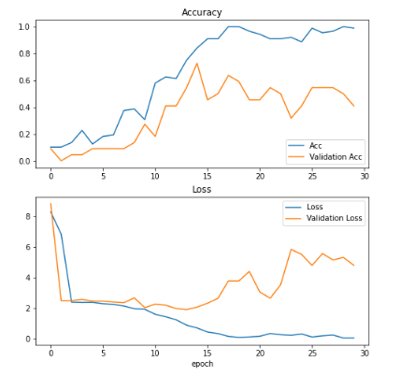

Hình 4 Kết quả training

# Add label

label = ['200đ','500đ','1000đ','2000đ','5000đ','10000đ','20000đ','50000đ','100000đ','200000đ','500000']

# model du doan

plt.title("Model dự đoán:  " + label[np.argmax(model.predict(x_pre_1.reshape(1,150,150,3)))])

plt.imshow(cv2.cvtColor(x_pre_1, cv2.COLOR_BGR2RGB), cmap=plt.get_cmap('gray'))

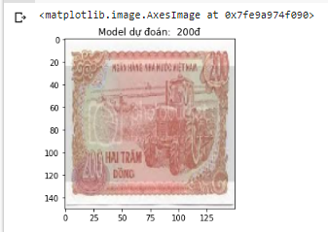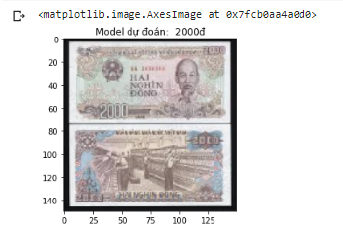

Hình 5 Kết quả model dự đoán

1. **Dự đoán món ăn Việt Nam**

**#Add lib**

from keras.models import Sequential

from keras.layers import Dense, Activation, Dropout, Conv2D, MaxPooling2D, Flatten

from tensorflow.keras.optimizers import Adam

from sklearn.preprocessing import StandardScaler

from keras.utils import np_utils

from sklearn.utils import shuffle

import cv2

import matplotlib.pyplot as plt

import numpy as np

import pickle

import tensorflow as tf

from google.colab import drive

drive.mount('/content/drive')

#chuan bi ham ve bieu do

def plot_history(history_fine):

  f1 = history_fine.history['acc']

  val_f1 = history_fine.history['val_acc']

  loss = history_fine.history['loss']

  val_loss = history_fine.history['val_loss']

  plt.figure(figsize=(8, 8))

  plt.subplot(2, 1, 1)

  plt.plot(f1, label='Acc')

  plt.plot(val_f1, label='Validation Acc')

  plt.legend(loc='lower right')

  plt.title('Accuracy')

  plt.subplot(2, 1, 2)

  plt.plot(loss, label='Loss')

  plt.plot(val_loss, label='Validation Loss')

  plt.legend(loc='upper right')

  plt.title('Loss')

  plt.xlabel('epoch')

  plt.show()

# Load Data

with open('/content/drive/MyDrive/Colab Notebooks/Data/data_food.pickle', 'rb') as f:

    (x_train, y_train) = pickle.load(f)

# Reshape Data

x_pre_1 = x_train[48]

x_pre_2 = x_train[22]

x_pre_3 = x_train[64]

x_pre_4 = x_train[75]

x_pre_5 = x_train[92]

# Preprocessing Data

x_train = x_train.astype('float32')

x_train /= 255

# Encoding Y

y_train = np_utils.to_categorical(y_train, 10)

# Shuffe Data

x_train, y_train = shuffle(x_train, y_train)

#chuan bi model

model = Sequential()

model.add(Conv2D(32, (3,3), activation='relu',kernel_initializer='he_uniform', padding ='same', input_shape = (150,150,3)))

model.add(Conv2D(32, (3,3), activation='relu',kernel_initializer='he_uniform', padding ='same'))

model.add(MaxPooling2D(2,2))

model.add(Conv2D(64, (3,3), activation='relu',kernel_initializer='he_uniform', padding ='same'))

model.add(Conv2D(64, (3,3), activation='relu',kernel_initializer='he_uniform', padding ='same'))

model.add(MaxPooling2D(2,2))

model.add(Conv2D(128, (3,3), activation='relu',kernel_initializer='he_uniform', padding ='same'))

model.add(Conv2D(128, (3,3), activation='relu',kernel_initializer='he_uniform', padding ='same'))

model.add(MaxPooling2D(2,2))

model.add(Flatten())

model.add(Dense(128, activation='relu', kernel_initializer='he_uniform'))

model.add(Dense(10, activation='softmax'))

model.summary()

#training

opt = Adam(lr = 0.001)

model.compile(optimizer = opt, loss = 'categorical_crossentropy', metrics = ['acc'])

his = model.fit(x_train, y_train, epochs = 50, batch_size = 64, validation_split = 0.2)

#Draw bieu do

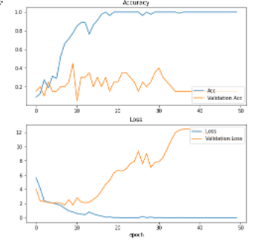

Hình 6 Biểu đồ training 10 món ăn

#add label

label = ['Banh_chung','Banh_day','Banh Mi','Bun dau mam tom','Che_buoi','com_tam','nem_ran','Pho','Thit kho hot vit','Vit lon']

# test model

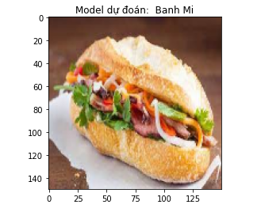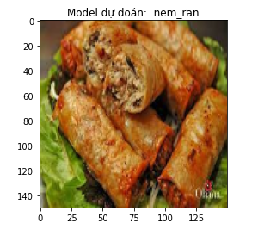

Hình 7 Kết quả training model

1. **Training CNN MNIST**

#add lib

from keras.models import Sequential, load_model

from keras.layers import Flatten,Dense

from tensorflow.keras.optimizers import Adam,SGD

from keras.callbacks import EarlyStopping

from keras.utils import np_utils

from keras.datasets import fashion_mnist

import matplotlib.pyplot as plt

import numpy as np

import tensorflow as tf

from keras.layers.convolutional import Conv2D

from keras.layers.pooling import MaxPooling2D

#chuan bi ham ve bieu do

def plot_history(history_fine):

  f1 = history_fine.history['acc']

  val_f1 = history_fine.history['val_acc']

  loss = history_fine.history['loss']

  val_loss = history_fine.history['val_loss']

  plt.figure(figsize=(8, 8))

  plt.subplot(2, 1, 1)

  plt.plot(f1, label='Acc')

  plt.plot(val_f1, label='Validation Acc')

  plt.legend(loc='lower right')

  plt.title('Accuracy')

  plt.subplot(2, 1, 2)

  plt.plot(loss, label='Loss')

  plt.plot(val_loss, label='Validation Loss')

  plt.legend(loc='upper right')

  plt.title('Loss')

  plt.xlabel('epoch')

  plt.show()

# Load Data

(x_train,y_train),(x_test, y_test) = fashion_mnist.load_data()

for i in range(9):

  plt.subplot(330+i+1)

  plt.imshow(x_test[i])

print(x_train.shape, y_train.shape)

x_train = x_train.reshape(60000,28,28,1)

x_test = x_test.reshape(10000,28,28,1)

x_train = x_train.astype('float32')

x_test = x_test.astype('float32')

x_train /=255

x_test /=255

y_train = np_utils.to_categorical(y_train)

y_test = np_utils.to_categorical(y_test)

y_train.shape

#tao model

model = Sequential()

model.add(Conv2D(32, (3,3), activation='relu',kernel_initializer='he_uniform', padding ='same', input_shape = (28,28,1)))

model.add(Conv2D(32, (3,3), activation='relu',kernel_initializer='he_uniform', padding ='same'))

model.add(MaxPooling2D(2,2))

model.add(Conv2D(64, (3,3), activation='relu',kernel_initializer='he_uniform', padding ='same'))

model.add(Conv2D(64, (3,3), activation='relu',kernel_initializer='he_uniform', padding ='same'))

model.add(MaxPooling2D(2,2))

model.add(Conv2D(128, (3,3), activation='relu',kernel_initializer='he_uniform', padding ='same'))

model.add(Conv2D(128, (3,3), activation='relu',kernel_initializer='he_uniform', padding ='same'))

model.add(MaxPooling2D(2,2))

model.add(Flatten())

model.add(Dense(128, activation='relu', kernel_initializer='he_uniform'))

model.add(Dense(10, activation='softmax'))

model.summary()

#training

opt = Adam(lr = 0.001)

model.compile(optimizer = opt, loss = 'categorical_crossentropy', metrics = ['acc'])

his = model.fit(x_train, y_train, epochs = 50, batch_size = 64, validation_split = 0.2)

#ket qua training

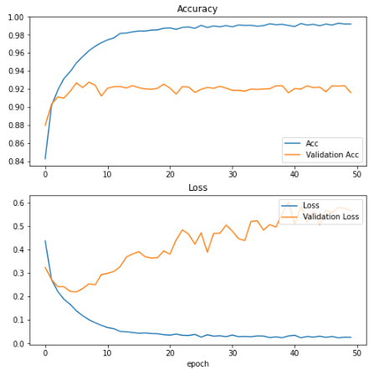

Hình 8 Ket qua training model

#save model

model.save('CNN_fashion_mnist.h5')

# chuan bi data test

x_test_2 = x_test.reshape(10000, 28,28)

# label

label = ['T-shirt/top','Trouser','Pullover','Dress','Coat','Sandal','Shirt','Sneaker','Bag','Ankle boot']

# ket qua

b = int(input('Mẫu muốn nhận dạng:'))

plt.imshow(x_test_2[b])

label[np.argmax(model.predict(x_test_2)[b])]

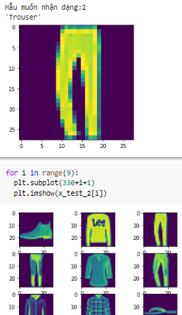

Hình 9 Kết quả nhận diện

1. **Training FASION_MNIST**

#import thư viện

from keras.models import Sequential, load_model

from keras.layers import Flatten,Dense

from tensorflow.keras.optimizers import Adam,SGD

from keras.callbacks import EarlyStopping

from keras.utils import np_utils

from keras.datasets import mnist

import matplotlib.pyplot as plt

import numpy as np

import tensorflow as tf

from keras.layers.convolutional import Conv2D

from keras.layers.pooling import MaxPooling2D

# chuan bi ham ve bieu do

def plot_history(history_fine):

  f1 = history_fine.history['acc']

  val_f1 = history_fine.history['val_acc']

  loss = history_fine.history['loss']

  val_loss = history_fine.history['val_loss']

  plt.figure(figsize=(8, 8))

  plt.subplot(2, 1, 1)

  plt.plot(f1, label='Acc')

  plt.plot(val_f1, label='Validation Acc')

  plt.legend(loc='lower right')

  plt.title('Accuracy')

  plt.subplot(2, 1, 2)

  plt.plot(loss, label='Loss')

  plt.plot(val_loss, label='Validation Loss')

  plt.legend(loc='upper right')

  plt.title('Loss')

  plt.xlabel('epoch')

  plt.show()

# Load Data

(x_train,y_train),(x_test, y_test) = mnist.load_data()

for i in range(9):

  plt.subplot(330+i+1)

  plt.imshow(x_test[i])

print(x_train.shape, y_train.shape)

x_train = x_train.reshape(60000,28,28,1)

x_test = x_test.reshape(10000,28,28,1)

x_train = x_train.astype('float32')

x_test = x_test.astype('float32')

x_train /=255

x_test /=255

y_train = np_utils.to_categorical(y_train)

y_test = np_utils.to_categorical(y_test)

y_train.shape

#chuan bi model

model = Sequential()

model.add(Conv2D(32, (3,3), activation='relu',kernel_initializer='he_uniform', padding ='same', input_shape = (28,28,1)))

model.add(Conv2D(32, (3,3), activation='relu',kernel_initializer='he_uniform', padding ='same'))

model.add(MaxPooling2D(2,2))

model.add(Conv2D(64, (3,3), activation='relu',kernel_initializer='he_uniform', padding ='same'))

model.add(Conv2D(64, (3,3), activation='relu',kernel_initializer='he_uniform', padding ='same'))

model.add(MaxPooling2D(2,2))

model.add(Conv2D(128, (3,3), activation='relu',kernel_initializer='he_uniform', padding ='same'))

model.add(Conv2D(128, (3,3), activation='relu',kernel_initializer='he_uniform', padding ='same'))

model.add(MaxPooling2D(2,2))

model.add(Flatten())

model.add(Dense(128, activation='relu', kernel_initializer='he_uniform'))

model.add(Dense(10, activation='softmax'))

model.summary()

#training

opt = Adam(lr = 0.001)

model.compile(optimizer = opt, loss = 'categorical_crossentropy', metrics = ['acc'])

his = model.fit(x_train, y_train, epochs = 50, batch_size = 64, validation_split = 0.2)

#ve bieu do

plot_history(his)

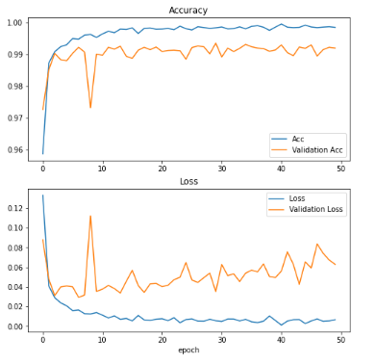

Hình 10 Kết quả training model

# test

a = int(input('Random phan tu muon test:'))

print('Model nhan dang ra= ')

print(np.argmax(model.predict(x_test),axis=1)[a])

#ket qua  
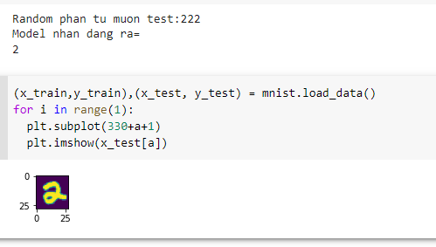

Hình 11 Kết quả test model

1. **Training Cifar-100**

# add lib  
from keras.models import Sequential, load_model

from keras.layers import Flatten,Dense

from tensorflow.keras.optimizers import Adam,SGD

from keras.callbacks import EarlyStopping

from keras.utils import np_utils

from keras.datasets import  cifar100

import matplotlib.pyplot as plt

import numpy as np

import tensorflow as tf

from keras.layers.convolutional import Conv2D

from keras.layers.pooling import MaxPooling2D

#chuan bi ham ve bieu do

def plot_history(history_fine):

  f1 = history_fine.history['acc']

  val_f1 = history_fine.history['val_acc']

  loss = history_fine.history['loss']

  val_loss = history_fine.history['val_loss']

  plt.figure(figsize=(8, 8))

  plt.subplot(2, 1, 1)

  plt.plot(f1, label='Acc')

  plt.plot(val_f1, label='Validation Acc')

  plt.legend(loc='lower right')

  plt.title('Accuracy')

  plt.subplot(2, 1, 2)

  plt.plot(loss, label='Loss')

  plt.plot(val_loss, label='Validation Loss')

  plt.legend(loc='upper right')

  plt.title('Loss')

  plt.xlabel('epoch')

  plt.show()

# Load Data

(x_train,y_train),(x_test, y_test) = cifar100.load_data()

for i in range(9):

  plt.subplot(330+i+1)

  plt.imshow(x_test[i])

print(x_train.shape, y_train.shape)

x_train = x_train.astype('float32')

x_test = x_test.astype('float32')

x_train /=255

x_test /=255

y_train = np_utils.to_categorical(y_train,100)

y_test = np_utils.to_categorical(y_test,100)

#chuan bi model

model = Sequential()

model.add(Conv2D(32,(3,3),activation = 'relu',kernel_initializer='he_uniform',padding ='same',input_shape = (32,32,3)))

model.add(Conv2D(32,(3,3),activation = 'relu',kernel_initializer='he_uniform',padding ='same'))

model.add(MaxPooling2D(2,2))

model.add(Conv2D(64,(3,3),activation = 'relu',kernel_initializer='he_uniform',padding ='same'))

model.add(Conv2D(64,(3,3),activation = 'relu',kernel_initializer='he_uniform',padding ='same'))

model.add(MaxPooling2D(2,2))

model.add(Conv2D(128,(3,3),activation = 'relu',kernel_initializer='he_uniform',padding ='same'))

model.add(Conv2D(128,(3,3),activation = 'relu',kernel_initializer='he_uniform',padding ='same'))

model.add(MaxPooling2D(2,2))

model.add(Flatten())

model.add(Dense(512, activation ='relu',kernel_initializer='he_uniform'))

model.add(Dense(100,activation ='softmax'))

model.summary()

#training

opt = SGD(lr = 0.001)

model.compile(optimizer = opt, loss ='categorical_crossentropy', metrics = ['acc'])

his = model.fit(x_train, y_train, batch_size = 64, epochs = 100, validation_data = (x_test,y_test))

#bieu do model training duoc

plot_history(his)

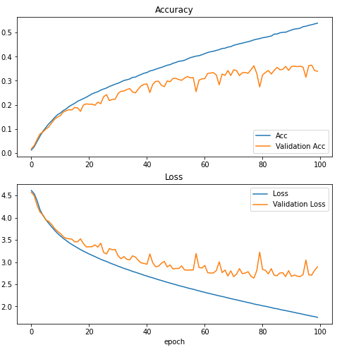

Hình 12 Kết quả training model

#lưu model

model.save('CNN_cifar100.h5')

# creat label<99>

dict = {0: 'apple',1: 'aquarium_fish',2: 'baby',3: 'bear',4: 'beaver',5: 'bed',6: 'bee',7: 'beetle',8: 'bicycle',9: 'bottle',10:'bowl',11: 'boy',12: 'bridge',13: 'bus',14: 'butterfly',15: 'camel',16: 'can',17: 'castle',18: 'caterpillar',19: 'cattle',20: 'chair',21: 'chimpanzee',22: 'clock',23: 'cloud',24: 'cockroach',25:'couch',26: 'cra',27: 'crocodile',28:'cup',29: 'dinosaur',30: 'dolphin',31: 'elephant',32: 'flatfish',33: 'forest',34: 'fox',35: 'girl',36: 'hamster',37: 'house',38: 'kangaroo',39: 'keyboard',40: 'lamp',41: 'lawn_mower',42: 'leopard',43: 'lion',44: 'lizard',45: 'lobster',46: 'man',47: 'maple_tree',48: 'motorcycle',49: 'mountain',50: 'mouse',51: 'mushroom',52: 'oak_tree',53: 'orange',54: 'orchid',55: 'otter',56: 'palm_tree',57: 'pear',58: 'pickup_truck',59: 'pine_tree',60: 'plain',61: 'plate',62: 'poppy',63: 'porcupine',64: 'possum',65: 'rabbit',66: 'raccoon',

67: 'ray',68: 'road',69: 'rocket',70: 'rose',71: 'sea',72: 'seal',3: 'shark',74: 'shrew',75: 'skunk',76: 'skyscraper',77: 'snail',

78: 'snake',79: 'spider',80: 'squirrel',81: 'streetcar',82: 'sunflower',

83: 'sweet_pepper',84: 'table',85: 'tank',86: 'telephone',87: 'television',88: 'tiger',89: 'tractor',90: 'train',91: 'trout',92: 'tulip',93: 'turtle',94: 'wardrobe',95: 'whale',96: 'willow_tree',97: 'wolf',98: 'woman',99: 'worm'}

# Test

img = tf.keras.utils.load_img("testmt.jpg", target_size = (32,32))

plt.imshow(img)

plt.show()

img = tf.keras.utils.img_to_array(img)

img = img.reshape(1,32,32,3)

img = img.astype('float32')

img /=255

print(dict[np.argmax(model.predict(img),axis = 1)[0]])

#import ảnh ngoài

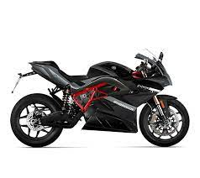

Hình 13 Anh motor dung de test

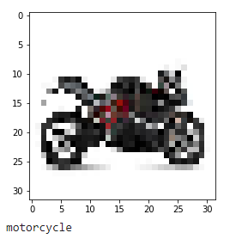

Hình 14 Ket qua training