KPR INSTITUTE OF ENGINEERING AND TECHNOLOGY
(Autonomous Institution, Affiliated to Anna University, Chennai)
Coimbatore – 641 407
DEPARTMENT OF COMPUTER SCIENCE AND ENGINEERING
U21CS501 – WEB TECHNOLOGY
ASSIGNMENT II
STUDENT ADMISSION PORTAL: REGISTRATION FORM, PHP STUDENT RECORD MANAGEMENT AND SERVLET PROFILE VIEWER

Submitted by
Detail | Information
Student Name | Jayavanthanaa T
Roll Number | 24CS082
Department | Computer Science and Engineering
Course Code & Title | U21CS501 – Web Technology
Assignment | Assignment II
Academic Year | 2026–2027
Maximum Marks | 40

Signature of the StudentSignature of the Course Faculty

TABLE OF CONTENTS
S.No. | Title
1 | Assignment Objectives and General Project Structure
2 | Project Folder Structure
3 | Question 1 – HTML, CSS and JavaScript Registration Form
4 | Question 2 – PHP and MySQL Student Management with File Upload
5 | Question 3 – Servlet, JDBC and JSP Student Profile Portal
6 | Overall Testing Summary
7 | Submission Checklist
8 | Brief Conclusion
9 | GitHub Repository

List of Figures
Figure | Caption
1.1 | Registration form (desktop view)
1.2 | Validation error messages
1.3 | Password strength meter
1.4 | Responsive mobile view
2.1 | Student records table
2.2 | Add student form with file upload
2.3 | Upload validation error
2.4 | Student details page with uploaded files
2.5 | Edit student form
2.6 | Record after deletion
2.7 | student_files metadata (MySQL query result)
3.1 | Login page
3.2 | Redirect / invalid login message
3.3 | Student profiles rendered by JSP
3.4 | Image and document streamed by FileServlet

1. ASSIGNMENT OBJECTIVES AND GENERAL PROJECT STRUCTURE

1.1 Introduction
A college admission office collects personal details and supporting documents from hundreds of applicants every year. Handling this on paper is slow and error-prone, while a web portal lets applicants register online and lets staff search, correct and verify the records from one central database.
This assignment builds a small Student Admission Portal in three parts. Question 1 is the browser-side registration form written in HTML5, CSS3 and JavaScript. Question 2 is a PHP admin panel that stores student records and their uploaded images and documents in MySQL. Question 3 is a Java Servlet and JSP portal that reads the same database over JDBC, streams the stored files to the browser and allows access only to logged-in users. All three parts share one MySQL database named admission_portal.

1.2 Objectives
- Design a responsive student registration form with HTML5 and CSS3.
- Validate required fields, e-mail format, password strength and uploaded files in JavaScript before submission.
- Create a relational schema with primary, unique and foreign keys for students and their file metadata.
- Implement Add, Edit, Delete and View operations in PHP using prepared statements.
- Handle file uploads safely: size limit, type check and no overwriting of existing files.
- Store file path, type and upload date in MySQL and show the files on the student details page.
- Use JDBC from a Servlet to load students and file paths, and stream the files back to the browser.
- Protect the Servlet portal with HTTP sessions so that only logged-in users can open it.

1.3 Architecture
The system follows a three-tier design. The browser is the presentation tier. The PHP application (served by Apache in XAMPP) and the Java web application (served by Apache Tomcat) form the application tier. MySQL and the uploads folder form the data tier. The files uploaded through PHP are saved once on disk and recorded once in MySQL, and the Servlet module reads exactly the same data.
Tier | Component | Technology | Responsibility
Presentation | Web browser | HTML5, CSS3, JavaScript | Forms, tables, client-side validation
Application (Q2) | Apache + PHP | PHP 8, mysqli | CRUD, server validation, file upload
Application (Q3) | Apache Tomcat 9 | Servlet, JSP, JDBC | Login, session, profile pages, file streaming
Data | MySQL server | MySQL 8 / MariaDB | students, student_files, admin_users
Storage | File system | uploads/images, uploads/documents | Actual image and PDF files

1.4 Software Requirements
Category | Requirement
Operating system | Windows 10 / 11
Web server, PHP and database | XAMPP 8.x (Apache, PHP 8, MySQL/MariaDB)
Java | JDK 11 or above
Servlet container | Apache Tomcat 9.0 (javax.servlet 4.0)
JDBC driver | MySQL Connector/J 8.x
Editor / IDE | VS Code, Eclipse IDE for Enterprise Java
Browser | Google Chrome or Microsoft Edge

2. PROJECT FOLDER STRUCTURE
Each question has its own folder so it can be run and evaluated independently. The SQL script is kept in a separate folder.
StudentAdmissionPortal/
|-- README.md
|-- Frontend/ (Question 1)
| |-- index.html registration form
| |-- style.css layout, colours, responsive rules
| `-- script.js client-side validation
|-- PHP/ (Question 2)
| |-- db.php connection + upload helper functions
| |-- header.php, footer.php common page layout
| |-- add_student.php Create
| |-- view_students.php Read (list)
| |-- student_details.php Read (one student + files)
| |-- edit_student.php Update
| |-- delete_student.php Delete
| `-- uploads/
| |-- .htaccess blocks script execution
| |-- images/ jpg, png files
| `-- documents/ pdf files
|-- Servlet/ (Question 3)
| |-- src/com/portal/
| | |-- DBUtil.java, Student.java, StudentFile.java, StudentDAO.java
| | |-- LoginServlet.java, LogoutServlet.java, AuthFilter.java
| | `-- StudentListServlet.java, FileServlet.java
| `-- WebContent/
| |-- login.jsp, style.css
| `-- WEB-INF/
| |-- web.xml
| |-- lib/mysql-connector-j-8.x.jar
| `-- views/students.jsp
`-- Database/
`-- admission_portal.sql schema + default admin account

The PHP pages reuse Frontend/style.css, and the Servlet project carries a copy of it, so all three modules look alike. The JSP page sits inside WEB-INF/views, which the browser cannot open directly; it is reachable only through StudentListServlet.

3. QUESTION 1 – HTML, CSS AND JAVASCRIPT REGISTRATION FORM

3.1 Scenario and Task Mapping
The admission portal needs a well-designed registration page with proper validation and styling. The table below maps each task of the question to its implementation.
Task | Implementation
1. HTML form (name, roll number, email, course, file upload) | index.html – text, email, password, drop-down and two file inputs inside one multipart/form-data form.
2. CSS: layout, colours, responsive design, styled inputs, buttons, errors | style.css – card layout, colour variables, focus styles, .invalid and .error classes, media queries at 768 px and 480 px.
3. JavaScript: required fields, email format, password strength | script.js – regular-expression rules, live strength meter, file type and size checks, submit handler.

3.2 HTML Structure
Every field sits in a div.field that holds a label, the control and an empty small.error element. The error element has the id err-<field>, so one JavaScript function can write the message for any field. The novalidate attribute switches off the browser's own pop-ups so the custom messages are shown instead, and enctype="multipart/form-data" is required for the file inputs to send file content. The accept attribute narrows the file chooser, but it can be bypassed, so file type and size are checked again in JavaScript and later on the server.

3.3 CSS Styling and Responsive Design
Colours are declared once as CSS variables (--brand, --error, --border) and reused everywhere. The form is a white card with rounded corners and a soft shadow, centred with margin: auto and limited to 640 px. Focused fields get a blue outline, invalid fields get a red border and a pale red background through the .invalid class that JavaScript adds. Responsiveness comes from the viewport meta tag and two media queries: at 768 px the card padding shrinks, and at 480 px the buttons become full-width and wide tables scroll sideways.

3.4 JavaScript Validation
The rules are stored at the top of script.js as regular expressions. Each field has its own validator that returns true or false and writes the message through setError(). Validators run when a field loses focus and again for all fields on submit; if any returns false, event.preventDefault() stops the submission and focus moves to the first invalid field.
Field | Rule applied
Full name | Required; 3–60 letters, spaces or dots
Roll number | Required; two digits + 2–4 letters + three digits (e.g. 24CS082)
Email | Required; must match name@domain.tld
Password | Required; at least 8 characters with uppercase, lowercase, digit and symbol
Course | A course must be selected
Profile photo | Optional; JPG/PNG only, maximum 2 MB
ID proof / certificate | Optional; PDF/JPG/PNG only, maximum 2 MB
The password strength is a score from 0 to 4 (length, mixed case, digit, symbol). The same score drives the coloured bar below the password field, so the user sees feedback while typing. A password is accepted only when all four conditions are met.

3.5 Source Code with Comments
Listing 1.1 – index.html
<!DOCTYPE html>
<html lang="en">
<head>
<meta charset="UTF-8">
<!-- makes the page scale properly on phones -->
<meta name="viewport" content="width=device-width, initial-scale=1.0">
<title>Student Registration</title>
<link rel="stylesheet" href="style.css">
</head>
<body>
<header class="top-bar">Student Admission Portal</header>

<main class="card">
<h1>Student Registration</h1>
<!-- novalidate: we show our own messages; multipart: needed for file upload -->
<form id="regForm" action="../PHP/add_student.php" method="post"
enctype="multipart/form-data" novalidate>

<div class="field">
<label for="name">Full Name *</label>
<input type="text" id="name" name="name" placeholder="e.g. Jayavanthanaa T">
<small class="error" id="err-name"></small>
</div>

<div class="field">
<label for="roll">Roll Number *</label>
<input type="text" id="roll" name="roll_number" placeholder="e.g. 24CS082">
<small class="error" id="err-roll"></small>
</div>

<div class="field">
<label for="email">Email *</label>
<input type="email" id="email" name="email" placeholder="you@example.com">
<small class="error" id="err-email"></small>
</div>

<div class="field">
<label for="password">Password *</label>
<input type="password" id="password" name="password">
<!-- live strength indicator filled by script.js -->
<div class="meter"><span id="meterBar"></span></div>
<small id="meterText" class="hint">Minimum 8 characters with upper, lower, digit and symbol</small>
<small class="error" id="err-password"></small>
</div>

<div class="field">
<label for="course">Course *</label>
<select id="course" name="course">
<option value="">-- Select course --</option>
<option>B.E. Computer Science and Engineering</option>
<option>B.E. Electronics and Communication</option>
<option>B.E. Mechanical Engineering</option>
<option>B.Tech Information Technology</option>
</select>
<small class="error" id="err-course"></small>
</div>

<div class="field">
<label for="photo">Profile Photo (JPG/PNG, max 2 MB)</label>
<input type="file" id="photo" name="photo" accept=".jpg,.jpeg,.png">
<small class="error" id="err-photo"></small>
</div>

<div class="field">
<label for="document">ID Proof / Certificate (PDF/JPG/PNG, max 2 MB)</label>
<input type="file" id="document" name="document" accept=".pdf,.jpg,.jpeg,.png">
<small class="error" id="err-document"></small>
</div>

<div class="actions">
<button type="submit" class="btn primary">Register</button>
<button type="reset" class="btn">Reset</button>
</div>
</form>
</main>

<script src="script.js"></script>
</body>
</html>

Listing 1.2 – style.css
/* ---------- Colour tokens ---------- */
:root {
--brand: #1f4e79;
--brand-dark: #163a5a;
--bg: #eef2f7;
--border: #c9d3df;
--error: #c62828;
--ok: #2e7d32;
}

* { box-sizing: border-box; }

body {
margin: 0;
font-family: "Segoe UI", Arial, sans-serif;
background: var(--bg);
color: #222;
}

.top-bar {
background: var(--brand);
color: #fff;
padding: 14px 24px;
font-size: 18px;
font-weight: 600;
}

/* ---------- Card layout (centred, max 640px) ---------- */
.card {
max-width: 640px;
margin: 28px auto;
background: #fff;
border: 1px solid var(--border);
border-radius: 8px;
padding: 24px 30px;
box-shadow: 0 2px 8px rgba(0, 0, 0, .08);
}
.wide { max-width: 1000px; }
h1 { margin-top: 0; color: var(--brand); font-size: 22px; }

/* ---------- Form fields ---------- */
.field { margin-bottom: 16px; }
label { display: block; margin-bottom: 5px; font-weight: 600; font-size: 14px; }

input[type=text], input[type=email], input[type=password],
input[type=file], select {
width: 100%;
padding: 9px 11px;
border: 1px solid var(--border);
border-radius: 5px;
font-size: 14px;
}
input:focus, select:focus { outline: none; border-color: var(--brand); box-shadow: 0 0 0 2px rgba(31,78,121,.15); }

/* Class added by JavaScript to an invalid field */
.invalid { border-color: var(--error) !important; background: #fff6f6; }
.error { display: block; color: var(--error); font-size: 12.5px; margin-top: 4px; min-height: 1em; }
.hint { display: block; color: #666; font-size: 12px; margin-top: 4px; }

/* ---------- Password strength meter ---------- */
.meter { height: 6px; background: #e3e8ee; border-radius: 3px; margin-top: 6px; overflow: hidden; }
.meter span { display: block; height: 100%; width: 0; transition: width .25s, background .25s; }

/* ---------- Buttons ---------- */
.actions { display: flex; gap: 10px; margin-top: 8px; }
.btn {
padding: 10px 20px; border: 1px solid var(--border); border-radius: 5px;
background: #f4f6f9; cursor: pointer; font-size: 14px; text-decoration: none; color: #222;
}
.btn.primary { background: var(--brand); border-color: var(--brand); color: #fff; }
.btn.primary:hover { background: var(--brand-dark); }
.btn.danger { background: var(--error); border-color: var(--error); color: #fff; }

/* ---------- Messages and tables (used by PHP pages) ---------- */
.msg { padding: 10px 14px; border-radius: 5px; margin-bottom: 14px; font-size: 14px; }
.msg.ok { background: #e8f5e9; color: var(--ok); border: 1px solid #a5d6a7; }
.msg.err { background: #fdecea; color: var(--error); border: 1px solid #f5b5b0; }

table.data { width: 100%; border-collapse: collapse; font-size: 14px; }
table.data th { background: var(--brand); color: #fff; text-align: left; padding: 9px; }
table.data td { border-bottom: 1px solid var(--border); padding: 8px 9px; vertical-align: middle; }
.thumb { width: 44px; height: 44px; object-fit: cover; border-radius: 50%; border: 1px solid var(--border); }
.profile-img { width: 140px; height: 140px; object-fit: cover; border-radius: 8px; border: 1px solid var(--border); }

/* ---------- Responsive design ---------- */
@media (max-width: 768px) {
.card { margin: 14px; padding: 18px; }
}
@media (max-width: 480px) {
.actions { flex-direction: column; }
.btn { width: 100%; text-align: center; }
table.data { display: block; overflow-x: auto; } /* scroll wide tables */
}

Listing 1.3 – script.js
// ---------- Validation rules (regular expressions) ----------
const RULES = {
name: /^[A-Za-z][A-Za-z .]{2,59}$/, // letters, spaces, dots
roll: /^[0-9]{2}[A-Za-z]{2,4}[0-9]{3}$/, // e.g. 24CS082
email: /^[^\s@]+@[^\s@]+\.[A-Za-z]{2,}$/ // basic e-mail shape
};
const MAX_BYTES = 2 * 1024 * 1024; // 2 MB upload limit

// ---------- Small helpers ----------
const $ = (id) => document.getElementById(id);

function setError(field, message) {
$("err-" + field).textContent = message;
$(field).classList.toggle("invalid", message !== "");
return message === ""; // true when valid
}

// Returns a score from 0 to 4 for a password
function passwordScore(p) {
let s = 0;
if (p.length >= 8) s++;
if (/[a-z]/.test(p) && /[A-Z]/.test(p)) s++;
if (/[0-9]/.test(p)) s++;
if (/[^A-Za-z0-9]/.test(p)) s++;
return s;
}

// Checks one optional file input for type and size
function checkFile(id, allowed) {
const input = $(id);
if (input.files.length === 0) return setError(id, ""); // upload is optional
const file = input.files[0];
const ext = file.name.split(".").pop().toLowerCase();
if (!allowed.includes(ext))
return setError(id, "Allowed types: " + allowed.join(", ").toUpperCase());
if (file.size > MAX_BYTES)
return setError(id, "File is larger than 2 MB.");
return setError(id, "");
}

// ---------- Individual field validators ----------
function vName() {
const v = $("name").value.trim();
if (v === "") return setError("name", "Name is required.");
return setError("name", RULES.name.test(v) ? "" : "Use 3-60 letters, spaces or dots only.");
}
function vRoll() {
const v = $("roll").value.trim();
if (v === "") return setError("roll", "Roll number is required.");
return setError("roll", RULES.roll.test(v) ? "" : "Format: 2 digits + branch + 3 digits (24CS082).");
}
function vEmail() {
const v = $("email").value.trim();
if (v === "") return setError("email", "Email is required.");
return setError("email", RULES.email.test(v) ? "" : "Enter a valid email address.");
}
function vPassword() {
const v = $("password").value;
if (v === "") return setError("password", "Password is required.");
return setError("password", passwordScore(v) === 4 ? "" :
"Need 8+ characters with upper, lower, digit and symbol.");
}
function vCourse() {
return setError("course", $("course").value === "" ? "Please choose a course." : "");
}

// ---------- Live password strength meter ----------
$("password").addEventListener("input", () => {
const score = passwordScore($("password").value);
const colours = ["#c62828", "#ef6c00", "#f9a825", "#7cb342", "#2e7d32"];
const labels = ["Very weak", "Weak", "Fair", "Good", "Strong"];
$("meterBar").style.width = (score * 25) + "%";
$("meterBar").style.background = colours[score];
$("meterText").textContent = labels[score];
});

// Validate each field when the user leaves it
$("name").addEventListener("blur", vName);
$("roll").addEventListener("blur", vRoll);
$("email").addEventListener("blur", vEmail);
$("course").addEventListener("change", vCourse);
$("photo").addEventListener("change", () => checkFile("photo", ["jpg", "jpeg", "png"]));
$("document").addEventListener("change", () => checkFile("document", ["pdf", "jpg", "jpeg", "png"]));

// ---------- Final check on submit ----------
$("regForm").addEventListener("submit", (event) => {
// run every validator (no short-circuit, so all messages show together)
const results = [
vName(), vRoll(), vEmail(), vPassword(), vCourse(),
checkFile("photo", ["jpg", "jpeg", "png"]),
checkFile("document", ["pdf", "jpg", "jpeg", "png"])
];
if (results.includes(false)) {
event.preventDefault(); // stop submission
document.querySelector(".invalid").focus(); // jump to first error
}
});

// Reset button also clears messages and the meter
$("regForm").addEventListener("reset", () => {
document.querySelectorAll(".error").forEach(e => e.textContent = "");
document.querySelectorAll(".invalid").forEach(e => e.classList.remove("invalid"));
$("meterBar").style.width = "0";
$("meterText").textContent = "Minimum 8 characters with upper, lower, digit and symbol";
});

3.6 Testing
Table 3.1 – Test cases for Question 1
TC | Test case | Expected result | Observed | Status
TC1.1 | Submit with all fields empty | Required messages shown for name, roll, email, password, course | Messages shown: "Name is required."; "Roll number is required."; "Email is required."; "Password is required."; "Please choose a course." | PASS
TC1.2 | Name entered as "J1" | Name format error | "Use 3-60 letters, spaces or dots only." | PASS
TC1.3 | Roll number "CS24082" | Roll number format error | "Format: 2 digits + branch + 3 digits (24CS082)." | PASS
TC1.4 | Email "name@gmail" | Invalid email message | "Enter a valid email address." | PASS
TC1.5 | Password "abc12345" | Password strength error; meter shows Weak/Fair | "Need 8+ characters with upper, lower, digit and symbol."; meter shows Fair | PASS
TC1.6 | Password "Vanth@2026" | Accepted; meter shows Strong | Accepted; meter shows Strong | PASS
TC1.7 | Photo of type .gif | File type error | "Allowed types: JPG, JPEG, PNG" | PASS
TC1.8 | Photo larger than 2 MB | File size error | "File is larger than 2 MB." (2.9 MB file) | PASS
TC1.9 | Press Reset after errors | All messages and the meter are cleared | All messages cleared; meter reset | PASS
TC1.10 | Submit with all valid data | Form is submitted to ../PHP/add_student.php | Posted to add_student.php; redirected to view_students.php with "Student registered successfully." | PASS
TC1.11 | Open page at 375 px width | Single-column layout with full-width buttons | Single column, page width 375 px, Register button 309 px wide | PASS

3.7 Output Screenshots
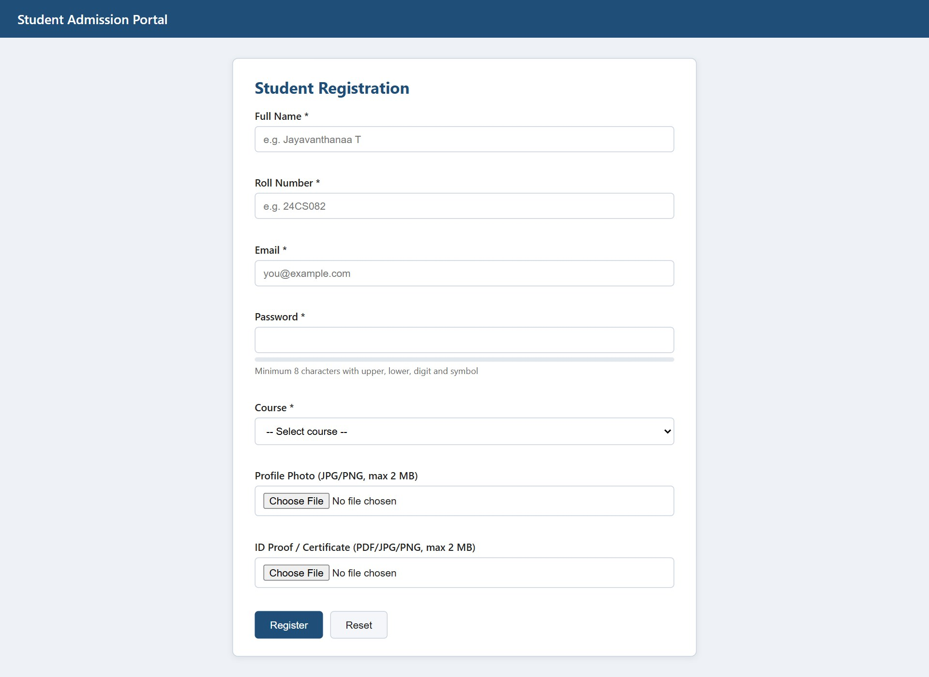
Figure 1.1 – Registration form (desktop view)
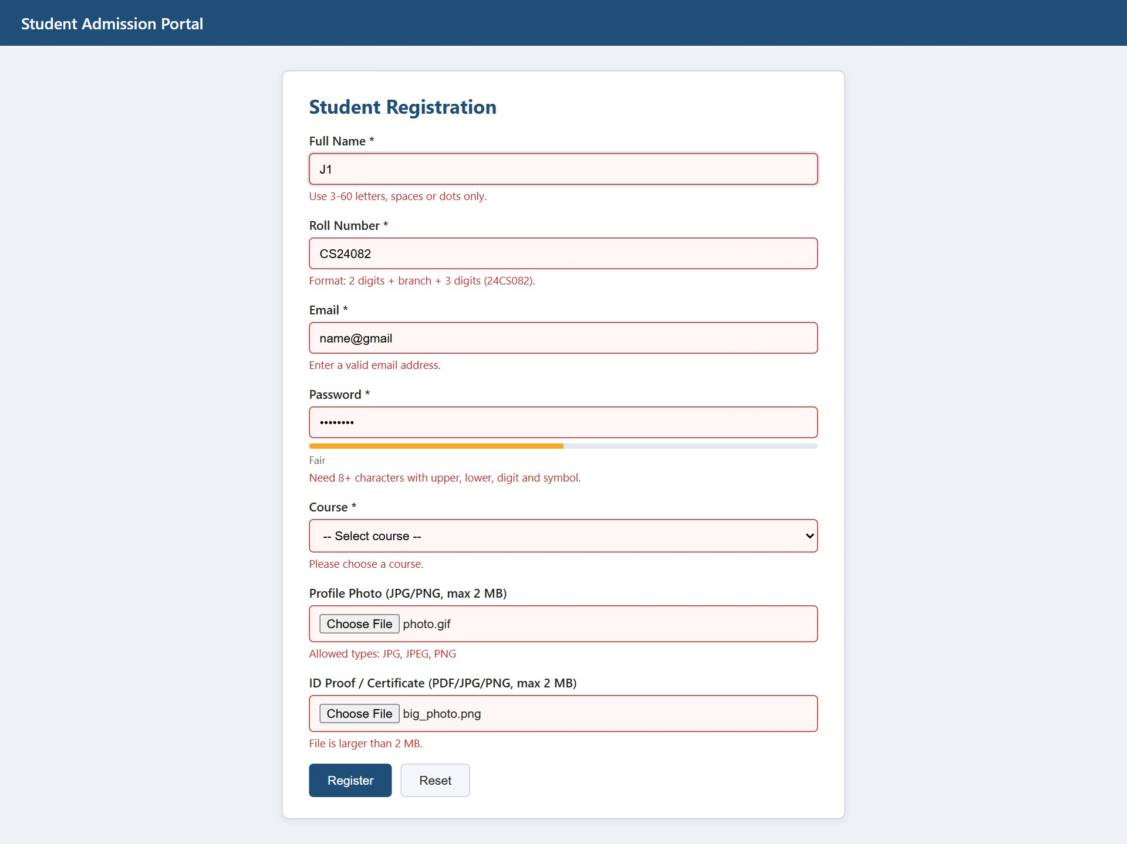
Figure 1.2 – Validation error messages
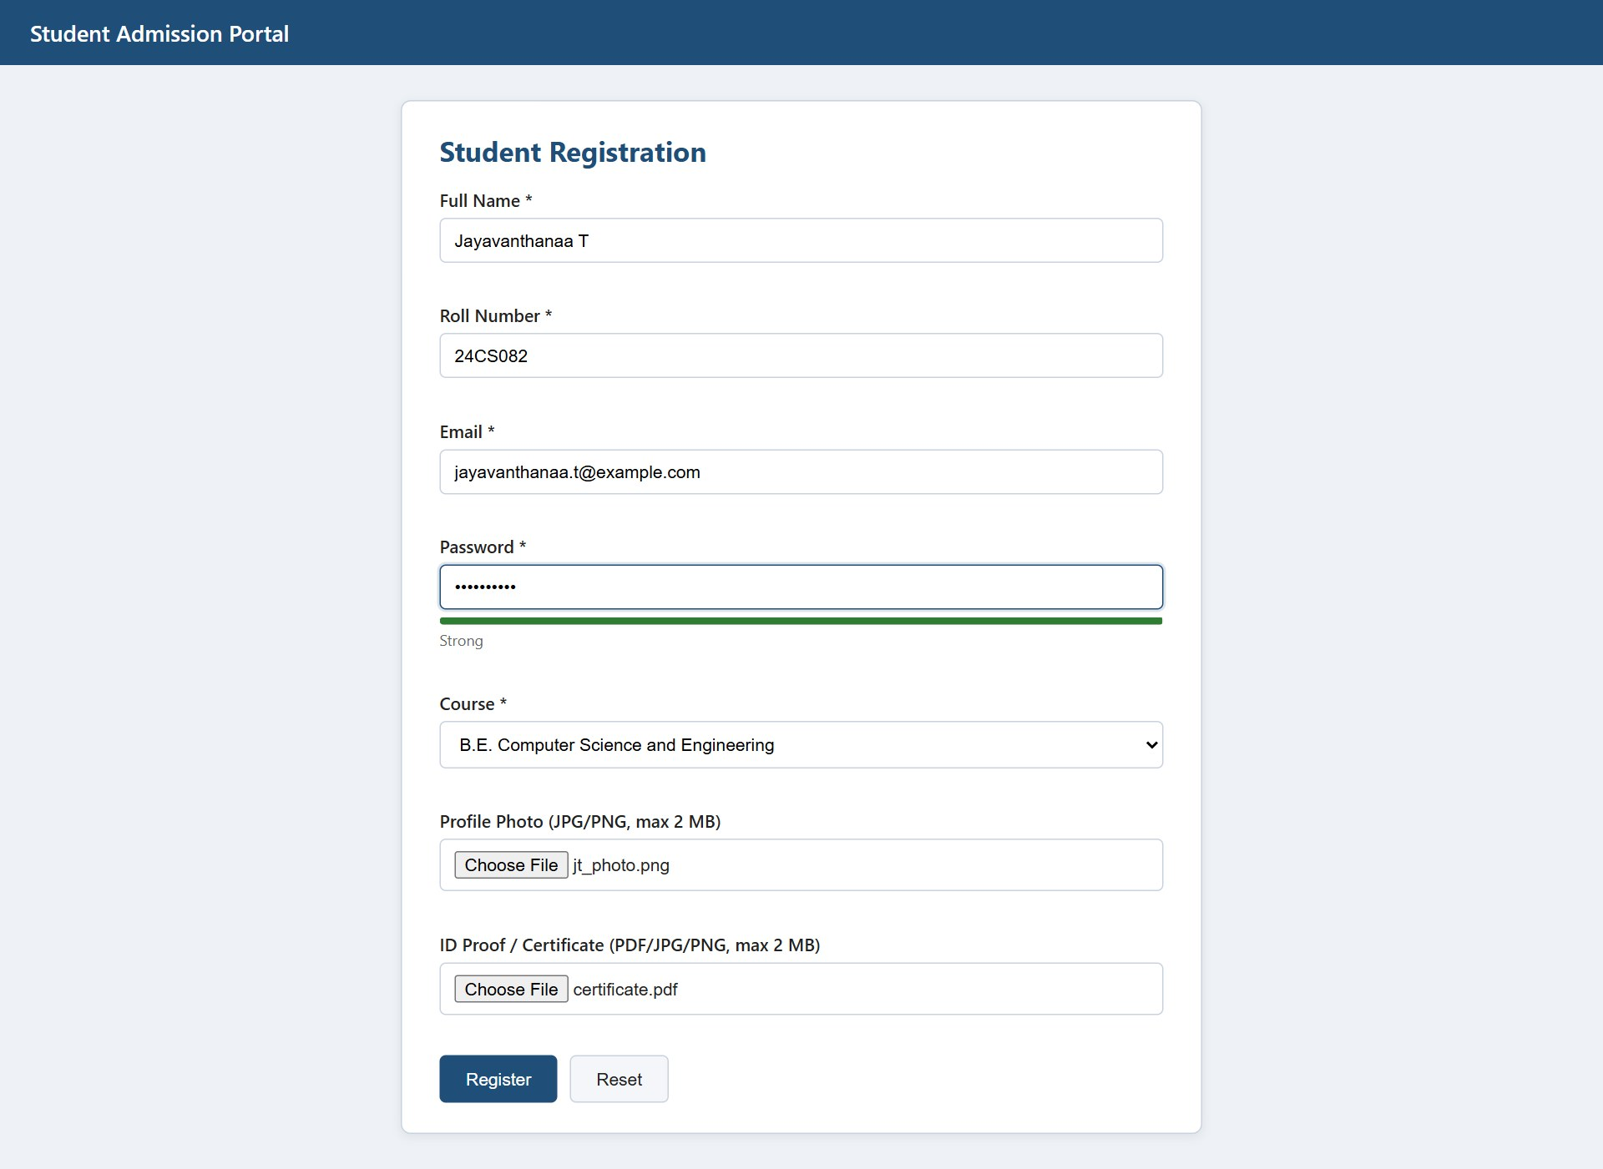
Figure 1.3 – Password strength meter
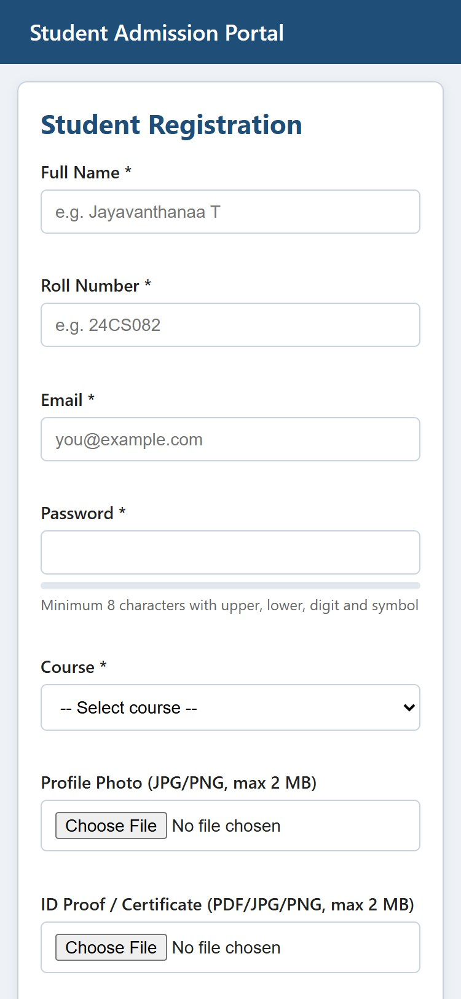
Figure 1.4 – Responsive mobile view

4. QUESTION 2 – PHP AND MYSQL STUDENT MANAGEMENT WITH FILE UPLOAD

4.1 Scenario and Task Mapping
The admin panel must manage student records together with their profile images and documents. The table maps the five tasks of the question to the files that implement them.
Task | Implementation
1. CRUD for student details | add_student.php (Create), view_students.php and student_details.php (Read), edit_student.php (Update), delete_student.php (Delete)
2. File upload for images and documents | check_upload() and save_upload() in db.php; photo goes to uploads/images/, PDFs to uploads/documents/
3. Metadata in MySQL | student_files table (path, type, size, upload date) filled by save_metadata(), linked by student_id
4. Display uploaded files | student_details.php lists every file with thumbnail or PDF link; view_students.php shows each photo
5. Validation and error handling | Size, extension and real MIME check; unique file names; transactions; duplicate check; try/catch

4.2 Database Design
Two tables are used by this module. students stores the personal details; roll_number and email carry UNIQUE constraints so the database itself rejects duplicates. The password is never stored in plain text; the column holds a bcrypt hash from password_hash(). student_files stores one row per uploaded file and points to its owner through a foreign key defined with ON DELETE CASCADE, so deleting a student also removes the related metadata rows. The table admin_users is used only by Question 3.
Table 4.1 – Structure of the students table
Column | Type | Constraint | Description
student_id | INT | PRIMARY KEY, AUTO_INCREMENT | Unique student id
name | VARCHAR(100) | NOT NULL | Full name
roll_number | VARCHAR(15) | NOT NULL, UNIQUE | e.g. 24CS082
email | VARCHAR(100) | NOT NULL, UNIQUE | Email address
password_hash | VARCHAR(255) | NOT NULL | bcrypt hash
course | VARCHAR(60) | NOT NULL | Selected course
created_at | TIMESTAMP | DEFAULT CURRENT_TIMESTAMP | Registration time
Table 4.2 – Structure of the student_files table
Column | Type | Constraint | Description
file_id | INT | PRIMARY KEY, AUTO_INCREMENT | Unique file id
student_id | INT | FOREIGN KEY, ON DELETE CASCADE | Owner of the file
category | ENUM | 'photo','document' | Kind of upload
original_name | VARCHAR(255) | NOT NULL | Name chosen by the user
file_path | VARCHAR(255) | NOT NULL | Path relative to uploads/
file_type | VARCHAR(10) | NOT NULL | jpg, png or pdf
file_size | INT | NOT NULL | Size in bytes
upload_date | TIMESTAMP | DEFAULT CURRENT_TIMESTAMP | Upload time
Listing 2.1 – admission_portal.sql (DB schema script)
-- Database script for the Student Admission Portal (24CS082)
CREATE DATABASE IF NOT EXISTS admission_portal
CHARACTER SET utf8mb4 COLLATE utf8mb4_general_ci;
USE admission_portal;

-- Main table: one row per registered student
CREATE TABLE IF NOT EXISTS students (
student_id INT AUTO_INCREMENT PRIMARY KEY,
name VARCHAR(100) NOT NULL,
roll_number VARCHAR(15) NOT NULL UNIQUE, -- prevents duplicate roll numbers
email VARCHAR(100) NOT NULL UNIQUE,
password_hash VARCHAR(255) NOT NULL, -- bcrypt hash, never plain text
course VARCHAR(60) NOT NULL,
created_at TIMESTAMP DEFAULT CURRENT_TIMESTAMP
) ENGINE = InnoDB;

-- Metadata of every uploaded file, linked to a student
CREATE TABLE IF NOT EXISTS student_files (
file_id INT AUTO_INCREMENT PRIMARY KEY,
student_id INT NOT NULL,
category ENUM('photo','document') NOT NULL,
original_name VARCHAR(255) NOT NULL,
file_path VARCHAR(255) NOT NULL, -- relative to the uploads folder
file_type VARCHAR(10) NOT NULL, -- jpg, png, pdf
file_size INT NOT NULL, -- bytes
upload_date TIMESTAMP DEFAULT CURRENT_TIMESTAMP,
FOREIGN KEY (student_id) REFERENCES students(student_id)
ON DELETE CASCADE -- files rows go with the student
) ENGINE = InnoDB;

-- Login accounts used by the Servlet portal (Question 3)
CREATE TABLE IF NOT EXISTS admin_users (
admin_id INT AUTO_INCREMENT PRIMARY KEY,
username VARCHAR(50) NOT NULL UNIQUE,
password_hash CHAR(64) NOT NULL -- SHA-256 hex digest
) ENGINE = InnoDB;

INSERT IGNORE INTO admin_users (username, password_hash)
VALUES ('admin', SHA2('Admin@123', 256));

4.3 Connection and Helper Functions (db.php)
Every page includes db.php. It starts the session (used for one-time flash messages), opens the connection and calls mysqli_report() so that SQL errors become exceptions that can be caught. It also defines the helpers: e() escapes output to prevent cross-site scripting, check_upload() validates a file, save_upload() stores it, save_metadata() records it in MySQL, remove_file() deletes it, and validate_student() applies the same field rules that JavaScript uses.

4.4 CRUD Operations

4.4.1 Create – add_student.php
The page shows the form and handles its own submission. It trims the input, validates the text fields and both files, and checks for an existing roll number or e-mail. If anything fails, the messages are listed and the typed values are kept in the form. If all checks pass, the student row and the file rows are written inside a database transaction. When any statement throws, rollback() undoes the database changes and the files already copied are removed, so the database and the folder never disagree. All SQL uses prepared statements with bound parameters, which prevents SQL injection.

4.4.2 Read – view_students.php and student_details.php
view_students.php joins students with the photo row of student_files using a LEFT JOIN, so students without a photo are still listed. student_details.php reads one student by id and lists all rows of student_files for that student, showing a thumbnail for images and an Open link for PDFs together with type, size and upload date.

4.4.3 Update – edit_student.php
The edit form is pre-filled from the database. Duplicate checking excludes the student being edited. If a new photo or document is uploaded, the old file row of that category is replaced and the old file is deleted from disk only after the transaction has been committed successfully.

4.4.4 Delete – delete_student.php
Deletion works only through a POST request, so a record cannot be removed by opening a link, and a JavaScript confirmation is shown first. The script reads the file paths, deletes the student row (the cascade removes the metadata rows) and then deletes the physical files.

4.5 File Upload Handling and Safety
- Size: files larger than 2 MB are rejected (MAX_BYTES).
- Type: only JPG, PNG and PDF extensions are accepted, and the real MIME type read by finfo must match the extension, so a renamed .exe is refused.
- No overwriting: every file is saved under a unique name generated by uniqid(); the loop repeats if that name already exists.
- Isolation: uploads/.htaccess disables script execution and directory listing in the upload folder.
- Metadata: path, type, size and upload date are saved in student_files and linked to the student by student_id.

4.6 Source Code with Comments
Listing 2.2 – db.php
<?php
// db.php - connection, upload settings and helper functions (included by every page)
session_start(); // used for flash messages

const DB_HOST = 'localhost';
const DB_USER = 'root';
const DB_PASS = '';
const DB_NAME = 'admission_portal';

const UPLOAD_ROOT = __DIR__ . '/uploads/'; // physical folder
const MAX_BYTES = 2 * 1024 * 1024; // 2 MB limit

// Throw exceptions for SQL errors so they can be caught with try/catch
mysqli_report(MYSQLI_REPORT_ERROR | MYSQLI_REPORT_STRICT);
try {
$conn = new mysqli(DB_HOST, DB_USER, DB_PASS, DB_NAME);
$conn->set_charset('utf8mb4');
} catch (mysqli_sql_exception $ex) {
die('Database connection failed. Please start MySQL and import the SQL script.');
}

// Escape output to stop cross-site scripting
function e($text) { return htmlspecialchars((string)$text, ENT_QUOTES, 'UTF-8'); }

// Store a one-time message and read it back on the next page
function flash($type, $text) { $_SESSION['flash'] = [$type, $text]; }
function show_flash() {
if (!empty($_SESSION['flash'])) {
[$type, $text] = $_SESSION['flash'];
echo '<div class="msg ' . ($type === 'ok' ? 'ok' : 'err') . '">' . e($text) . '</div>';
unset($_SESSION['flash']);
}
}

/**
* Validate one uploaded file.
* Returns an error string, or '' when the file is acceptable (or not supplied).
*/
function check_upload($field, $allowedExt, $label) {
if (!isset($_FILES[$field]) || $_FILES[$field]['error'] === UPLOAD_ERR_NO_FILE) {
return ''; // optional field left empty
}
$f = $_FILES[$field];
if ($f['error'] !== UPLOAD_ERR_OK) return "$label could not be uploaded.";
if ($f['size'] > MAX_BYTES) return "$label must be 2 MB or smaller.";

$ext = strtolower(pathinfo($f['name'], PATHINFO_EXTENSION));
if (!in_array($ext, $allowedExt, true)) return "$label: only " . strtoupper(implode(', ', $allowedExt)) . ' allowed.';

// Look at the real file content, not just the extension
$mime = (new finfo(FILEINFO_MIME_TYPE))->file($f['tmp_name']);
$okMime = ['jpg' => 'image/jpeg', 'jpeg' => 'image/jpeg', 'png' => 'image/png', 'pdf' => 'application/pdf'];
if ($mime !== $okMime[$ext]) return "$label: content does not match the file extension.";
return '';
}

/**
* Move a validated upload into uploads/images or uploads/documents.
* A unique name (uniqid) guarantees an existing file is never overwritten.
* Returns [relativePath, type, size, originalName].
*/
function save_upload($field) {
$f = $_FILES[$field];
$ext = strtolower(pathinfo($f['name'], PATHINFO_EXTENSION));
$sub = ($ext === 'pdf') ? 'documents/' : 'images/';
do {
$name = uniqid('f_', true) . '.' . $ext; // e.g. f_65a1b2c3d4e5f6.12345678.jpg
} while (file_exists(UPLOAD_ROOT . $sub . $name));
move_uploaded_file($f['tmp_name'], UPLOAD_ROOT . $sub . $name);
return [$sub . $name, $ext, $f['size'], $f['name']];
}

// Insert one row of file metadata linked to a student
function save_metadata($conn, $studentId, $category, $info) {
[$path, $type, $size, $orig] = $info;
$st = $conn->prepare('INSERT INTO student_files
(student_id, category, original_name, file_path, file_type, file_size)
VALUES (?, ?, ?, ?, ?, ?)');
$st->bind_param('issssi', $studentId, $category, $orig, $path, $type, $size);
$st->execute();
}

// Delete a stored file from disk (ignores missing files)
function remove_file($relativePath) {
$full = UPLOAD_ROOT . $relativePath;
if (is_file($full)) unlink($full);
}

// Shared server-side validation for the text fields
function validate_student($d, $needPassword) {
$err = [];
if (!preg_match('/^[A-Za-z][A-Za-z .]{2,59}$/', $d['name'])) $err[] = 'Enter a valid name.';
if (!preg_match('/^[0-9]{2}[A-Za-z]{2,4}[0-9]{3}$/', $d['roll_number'])) $err[] = 'Roll number format is invalid.';
if (!filter_var($d['email'], FILTER_VALIDATE_EMAIL)) $err[] = 'Enter a valid email.';
if ($d['course'] === '') $err[] = 'Select a course.';
if ($needPassword && !preg_match('/^(?=.*[a-z])(?=.*[A-Z])(?=.*\d)(?=.*[^A-Za-z0-9]).{8,}$/', $d['password']))
$err[] = 'Password needs 8+ characters with upper, lower, digit and symbol.';
return $err;
}

Listing 2.3 – header.php
<?php /* header.php - common top bar, navigation and flash message */ ?>
<!DOCTYPE html>
<html lang="en"><head>
<meta charset="UTF-8">
<meta name="viewport" content="width=device-width, initial-scale=1.0">
<title>Admin Panel</title>
<link rel="stylesheet" href="../Frontend/style.css">
</head><body>
<header class="top-bar">
Admin Panel &nbsp;|&nbsp;
<a href="view_students.php" style="color:#fff">Students</a> &nbsp;
<a href="add_student.php" style="color:#fff">Add Student</a>
</header>
<main class="card wide">
<?php show_flash(); ?>

Listing 2.4 – add_student.php
<?php
// add_student.php - CREATE: shows the form and inserts the record + files
require 'db.php';
$errors = [];
$old = ['name' => '', 'roll_number' => '', 'email' => '', 'course' => ''];

if ($_SERVER['REQUEST_METHOD'] === 'POST') {
// 1. Read and trim the input
$d = [
'name' => trim($_POST['name'] ?? ''),
'roll_number' => strtoupper(trim($_POST['roll_number'] ?? '')),
'email' => trim($_POST['email'] ?? ''),
'course' => trim($_POST['course'] ?? ''),
'password' => $_POST['password'] ?? '',
];
$old = $d;

// 2. Validate text fields and both files
$errors = validate_student($d, true);
foreach ([check_upload('photo', ['jpg', 'jpeg', 'png'], 'Photo'),
check_upload('document', ['pdf', 'jpg', 'jpeg', 'png'], 'Document')] as $msg) {
if ($msg !== '') $errors[] = $msg;
}

// 3. Reject duplicate roll number or email
if (!$errors) {
$st = $conn->prepare('SELECT student_id FROM students WHERE roll_number = ? OR email = ?');
$st->bind_param('ss', $d['roll_number'], $d['email']);
$st->execute();
if ($st->get_result()->num_rows > 0) $errors[] = 'Roll number or email is already registered.';
}

// 4. Save everything inside one transaction
if (!$errors) {
$saved = []; // files written so far
$conn->begin_transaction();
try {
$hash = password_hash($d['password'], PASSWORD_DEFAULT);
$st = $conn->prepare('INSERT INTO students (name, roll_number, email, password_hash, course)
VALUES (?, ?, ?, ?, ?)');
$st->bind_param('sssss', $d['name'], $d['roll_number'], $d['email'], $hash, $d['course']);
$st->execute();
$id = $conn->insert_id;

foreach (['photo' => 'photo', 'document' => 'document'] as $field => $cat) {
if (isset($_FILES[$field]) && $_FILES[$field]['error'] === UPLOAD_ERR_OK) {
$info = save_upload($field);
$saved[] = $info[0];
save_metadata($conn, $id, $cat, $info); // path, type, date in MySQL
}
}
$conn->commit();
flash('ok', 'Student registered successfully.');
header('Location: view_students.php');
exit;
} catch (mysqli_sql_exception $ex) {
$conn->rollback(); // undo DB changes
foreach ($saved as $p) remove_file($p); // undo file changes
$errors[] = 'Could not save the record. Please try again.';
}
}
}
include 'header.php';
?>
<h1>Add Student</h1>
<?php foreach ($errors as $m): ?><div class="msg err"><?= e($m) ?></div><?php endforeach; ?>

<form method="post" enctype="multipart/form-data">
<div class="field"><label>Full Name</label>
<input type="text" name="name" value="<?= e($old['name']) ?>" required></div>
<div class="field"><label>Roll Number</label>
<input type="text" name="roll_number" value="<?= e($old['roll_number']) ?>" required></div>
<div class="field"><label>Email</label>
<input type="email" name="email" value="<?= e($old['email']) ?>" required></div>
<div class="field"><label>Password</label>
<input type="password" name="password" required></div>
<div class="field"><label>Course</label>
<input type="text" name="course" value="<?= e($old['course']) ?>" required></div>
<div class="field"><label>Profile Photo (JPG/PNG)</label>
<input type="file" name="photo" accept=".jpg,.jpeg,.png"></div>
<div class="field"><label>ID Proof / Certificate (PDF/JPG/PNG)</label>
<input type="file" name="document" accept=".pdf,.jpg,.jpeg,.png"></div>
<button class="btn primary" type="submit">Save Student</button>
</form>
<?php include 'footer.php'; ?>

Listing 2.5 – view_students.php
<?php
// view_students.php - READ: list of all students with a small photo
require 'db.php';
include 'header.php';

// LEFT JOIN so students without a photo are still listed
$sql = "SELECT s.student_id, s.name, s.roll_number, s.email, s.course, f.file_path
FROM students s
LEFT JOIN student_files f ON f.student_id = s.student_id AND f.category = 'photo'
ORDER BY s.student_id DESC";
$rows = $conn->query($sql);
?>
<h1>Student Records</h1>
<table class="data">
<tr><th>Photo</th><th>Name</th><th>Roll No.</th><th>Course</th><th>Actions</th></tr>
<?php if ($rows->num_rows === 0): ?>
<tr><td colspan="5">No students registered yet.</td></tr>
<?php endif; ?>
<?php while ($r = $rows->fetch_assoc()): ?>
<tr>
<td><?php if ($r['file_path']): ?>
<img class="thumb" src="uploads/<?= e($r['file_path']) ?>" alt="photo">
<?php else: ?>&mdash;<?php endif; ?></td>
<td><?= e($r['name']) ?></td>
<td><?= e($r['roll_number']) ?></td>
<td><?= e($r['course']) ?></td>
<td>
<a href="student_details.php?id=<?= (int)$r['student_id'] ?>">View</a> |
<a href="edit_student.php?id=<?= (int)$r['student_id'] ?>">Edit</a> |
<!-- POST form so a record cannot be deleted by just opening a link -->
<form method="post" action="delete_student.php" style="display:inline"
onsubmit="return confirm('Delete this student and all files?')">
<input type="hidden" name="id" value="<?= (int)$r['student_id'] ?>">
<button class="btn danger" style="padding:3px 10px">Delete</button>
</form>
</td>
</tr>
<?php endwhile; ?>
</table>
<?php include 'footer.php'; ?>

Listing 2.6 – student_details.php
<?php
// student_details.php - READ one student and display the uploaded files
require 'db.php';
$id = (int)($_GET['id'] ?? 0);

$st = $conn->prepare('SELECT * FROM students WHERE student_id = ?');
$st->bind_param('i', $id);
$st->execute();
$s = $st->get_result()->fetch_assoc();
if (!$s) { flash('err', 'Student not found.'); header('Location: view_students.php'); exit; }

$fs = $conn->prepare('SELECT * FROM student_files WHERE student_id = ? ORDER BY upload_date');
$fs->bind_param('i', $id);
$fs->execute();
$files = $fs->get_result();
include 'header.php';
?>
<h1><?= e($s['name']) ?></h1>
<p><b>Roll No:</b> <?= e($s['roll_number']) ?> &nbsp;
<b>Email:</b> <?= e($s['email']) ?> &nbsp;
<b>Course:</b> <?= e($s['course']) ?></p>

<h3>Uploaded Files</h3>
<table class="data">
<tr><th>Preview</th><th>Name</th><th>Type</th><th>Size</th><th>Uploaded</th></tr>
<?php while ($f = $files->fetch_assoc()): ?>
<tr>
<td><?php if ($f['file_type'] === 'pdf'): ?>
<a href="uploads/<?= e($f['file_path']) ?>" target="_blank">Open PDF</a>
<?php else: ?>
<a href="uploads/<?= e($f['file_path']) ?>" target="_blank">
<img class="thumb" src="uploads/<?= e($f['file_path']) ?>" alt=""></a>
<?php endif; ?></td>
<td><?= e($f['original_name']) ?> (<?= e($f['category']) ?>)</td>
<td><?= strtoupper(e($f['file_type'])) ?></td>
<td><?= round($f['file_size'] / 1024) ?> KB</td>
<td><?= e($f['upload_date']) ?></td>
</tr>
<?php endwhile; ?>
</table>
<p><a class="btn" href="view_students.php">&larr; Back</a></p>
<?php include 'footer.php'; ?>

Listing 2.7 – edit_student.php
<?php
// edit_student.php - UPDATE student details and optionally add/replace files
require 'db.php';
$id = (int)($_GET['id'] ?? $_POST['id'] ?? 0);
$errors = [];

$st = $conn->prepare('SELECT * FROM students WHERE student_id = ?');
$st->bind_param('i', $id);
$st->execute();
$s = $st->get_result()->fetch_assoc();
if (!$s) { flash('err', 'Student not found.'); header('Location: view_students.php'); exit; }

if ($_SERVER['REQUEST_METHOD'] === 'POST') {
$d = [
'name' => trim($_POST['name'] ?? ''),
'roll_number' => strtoupper(trim($_POST['roll_number'] ?? '')),
'email' => trim($_POST['email'] ?? ''),
'course' => trim($_POST['course'] ?? ''),
'password' => '',
];
$errors = validate_student($d, false); // password not changed here
foreach ([check_upload('photo', ['jpg', 'jpeg', 'png'], 'Photo'),
check_upload('document', ['pdf', 'jpg', 'jpeg', 'png'], 'Document')] as $msg) {
if ($msg !== '') $errors[] = $msg;
}
if (!$errors) { // duplicate check excluding self
$c = $conn->prepare('SELECT student_id FROM students
WHERE (roll_number = ? OR email = ?) AND student_id <> ?');
$c->bind_param('ssi', $d['roll_number'], $d['email'], $id);
$c->execute();
if ($c->get_result()->num_rows > 0) $errors[] = 'Roll number or email belongs to another student.';
}
if (!$errors) {
$oldFiles = []; // replaced files to delete later
$newFiles = [];
$conn->begin_transaction();
try {
$u = $conn->prepare('UPDATE students SET name=?, roll_number=?, email=?, course=?
WHERE student_id=?');
$u->bind_param('ssssi', $d['name'], $d['roll_number'], $d['email'], $d['course'], $id);
$u->execute();

foreach (['photo' => 'photo', 'document' => 'document'] as $field => $cat) {
if (isset($_FILES[$field]) && $_FILES[$field]['error'] === UPLOAD_ERR_OK) {
// collect the old file of this category, then remove its row
$q = $conn->prepare('SELECT file_path FROM student_files WHERE student_id=? AND category=?');
$q->bind_param('is', $id, $cat);
$q->execute();
foreach ($q->get_result() as $row) $oldFiles[] = $row['file_path'];
$del = $conn->prepare('DELETE FROM student_files WHERE student_id=? AND category=?');
$del->bind_param('is', $id, $cat);
$del->execute();

$info = save_upload($field);
$newFiles[] = $info[0];
save_metadata($conn, $id, $cat, $info);
}
}
$conn->commit();
foreach ($oldFiles as $p) remove_file($p); // only after a successful commit
flash('ok', 'Student updated successfully.');
header('Location: view_students.php');
exit;
} catch (mysqli_sql_exception $ex) {
$conn->rollback();
foreach ($newFiles as $p) remove_file($p);
$errors[] = 'Update failed. Please try again.';
}
}
$s = array_merge($s, $d); // keep typed values on error
}
include 'header.php';
?>
<h1>Edit Student</h1>
<?php foreach ($errors as $m): ?><div class="msg err"><?= e($m) ?></div><?php endforeach; ?>
<form method="post" enctype="multipart/form-data">
<input type="hidden" name="id" value="<?= $id ?>">
<div class="field"><label>Full Name</label><input type="text" name="name" value="<?= e($s['name']) ?>"></div>
<div class="field"><label>Roll Number</label><input type="text" name="roll_number" value="<?= e($s['roll_number']) ?>"></div>
<div class="field"><label>Email</label><input type="email" name="email" value="<?= e($s['email']) ?>"></div>
<div class="field"><label>Course</label><input type="text" name="course" value="<?= e($s['course']) ?>"></div>
<div class="field"><label>New Photo (optional)</label><input type="file" name="photo" accept=".jpg,.jpeg,.png"></div>
<div class="field"><label>New Document (optional)</label><input type="file" name="document" accept=".pdf,.jpg,.jpeg,.png"></div>
<button class="btn primary" type="submit">Update</button>
<a class="btn" href="view_students.php">Cancel</a>
</form>
<?php include 'footer.php'; ?>

Listing 2.8 – delete_student.php
<?php
// delete_student.php - DELETE a student, the file rows (cascade) and the files on disk
require 'db.php';

if ($_SERVER['REQUEST_METHOD'] !== 'POST') { // refuse direct URL access
flash('err', 'Invalid request.');
header('Location: view_students.php');
exit;
}
$id = (int)($_POST['id'] ?? 0);

// 1. Remember the file paths before the rows disappear
$q = $conn->prepare('SELECT file_path FROM student_files WHERE student_id = ?');
$q->bind_param('i', $id);
$q->execute();
$paths = array_column($q->get_result()->fetch_all(MYSQLI_ASSOC), 'file_path');

// 2. Delete the student; ON DELETE CASCADE removes student_files rows
$d = $conn->prepare('DELETE FROM students WHERE student_id = ?');
$d->bind_param('i', $id);
$d->execute();

// 3. Remove the physical files
foreach ($paths as $p) remove_file($p);

flash('ok', $d->affected_rows ? 'Student deleted.' : 'Student not found.');
header('Location: view_students.php');

Listing 2.9 – uploads/.htaccess
# Never execute scripts from the upload folder and hide the file listing
Options -Indexes
php_flag engine off
<FilesMatch "\.(php|phtml|php5|phar)$">
Require all denied
</FilesMatch>

4.7 Testing
Table 4.3 – Test cases for Question 2
TC | Test case | Expected result | Observed | Status
TC2.1 | Add a student with valid data, photo and PDF | Student saved; two rows in student_files | "Student registered successfully."; 2 rows in student_files | PASS
TC2.2 | Add a student with an existing roll number | Duplicate message; nothing saved | "Roll number or email is already registered."; student count unchanged (4) | PASS
TC2.3 | Disable JavaScript and submit invalid data | Server lists all validation errors | 5 server messages: Enter a valid name.; Roll number format is invalid.; Enter a valid email.; Select a course.; Password needs 8+ characters with upper, lower, digit and symbol. | PASS
TC2.4 | Upload a file larger than 2 MB | Size error shown | "Photo must be 2 MB or smaller." | PASS
TC2.5 | Upload a .txt file renamed to .jpg | Content-mismatch error | "Photo: content does not match the file extension." | PASS
TC2.6 | Upload two files with the same original name | Both stored under different names | documents/f_6ac9181ef10ab5.22740969.pdf and documents/f_6ac91820c105a4.20647264.pdf | PASS
TC2.7 | Open View Students | All students listed with photo thumbnails | 4 students listed, 3 photo thumbnails (Sanjay M has no photo) | PASS
TC2.8 | Open a student's details page | Personal data and all uploaded files displayed | Name, roll no., e-mail, course and 2 files (photo, certificate.pdf) shown | PASS
TC2.9 | Edit name and upload a new photo | Record updated; old photo deleted from disk | "Student updated successfully."; photo images/f_6ac91820c00d05.22177505.jpg replaced by images/f_6ac91826a911a4.31760641.png, old file deleted | PASS
TC2.10 | Delete a student | Student row, file rows and files removed | Confirm dialog shown; "Student deleted."; 1 student row, 2 file rows and 2 files removed | PASS
TC2.11 | Open delete_student.php directly in the URL | "Invalid request" message; nothing deleted | "Invalid request."; nothing deleted | PASS
TC2.12 | Stop MySQL and open a page | Friendly connection error message | "Database connection failed. Please start MySQL and import the SQL script." | PASS

4.8 Output Screenshots
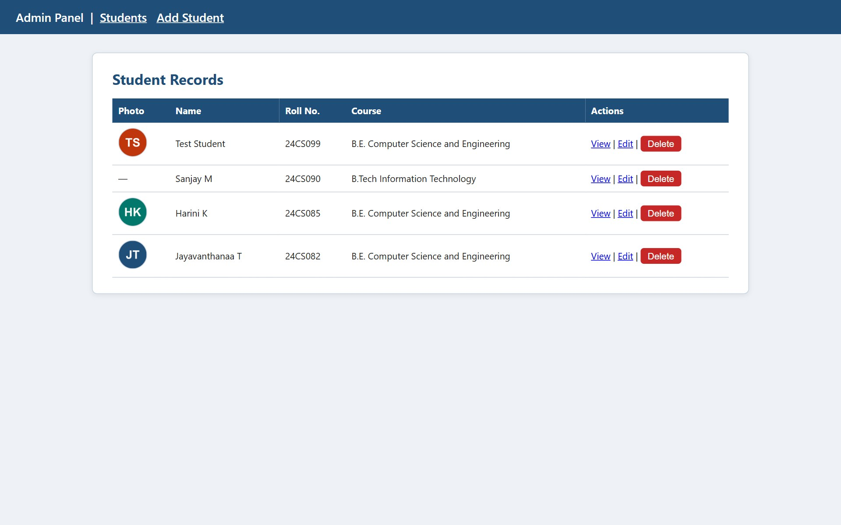
Figure 2.1 – Student records table
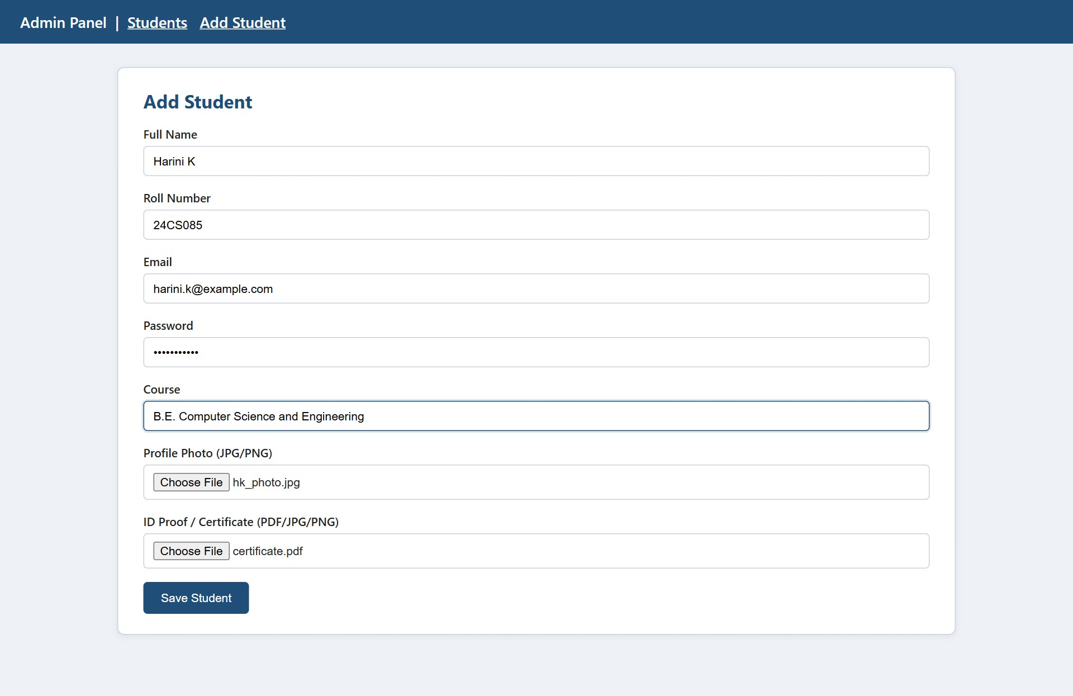
Figure 2.2 – Add student form with file upload
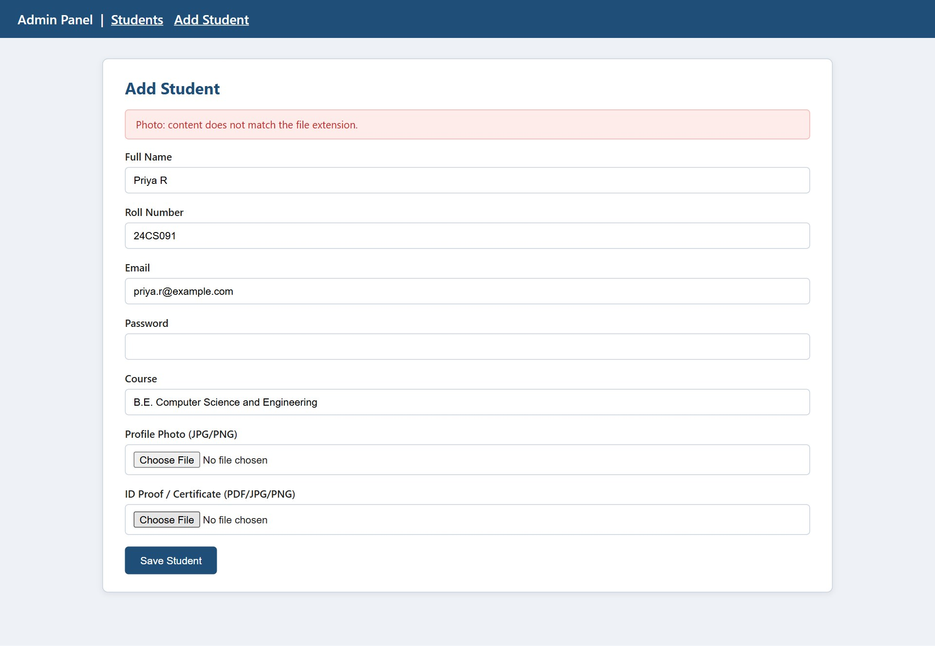
Figure 2.3 – Upload validation error
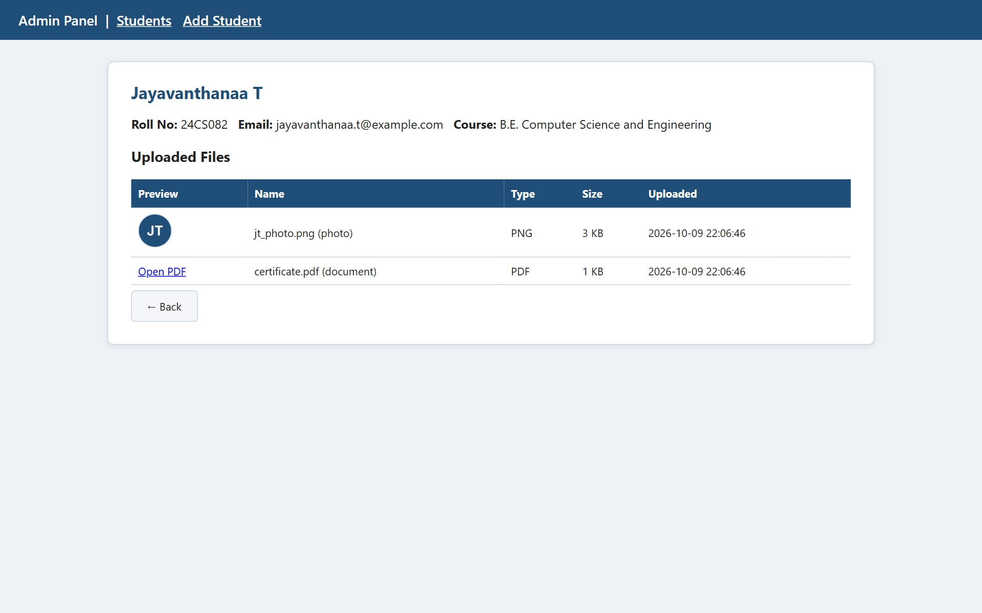
Figure 2.4 – Student details page with uploaded files
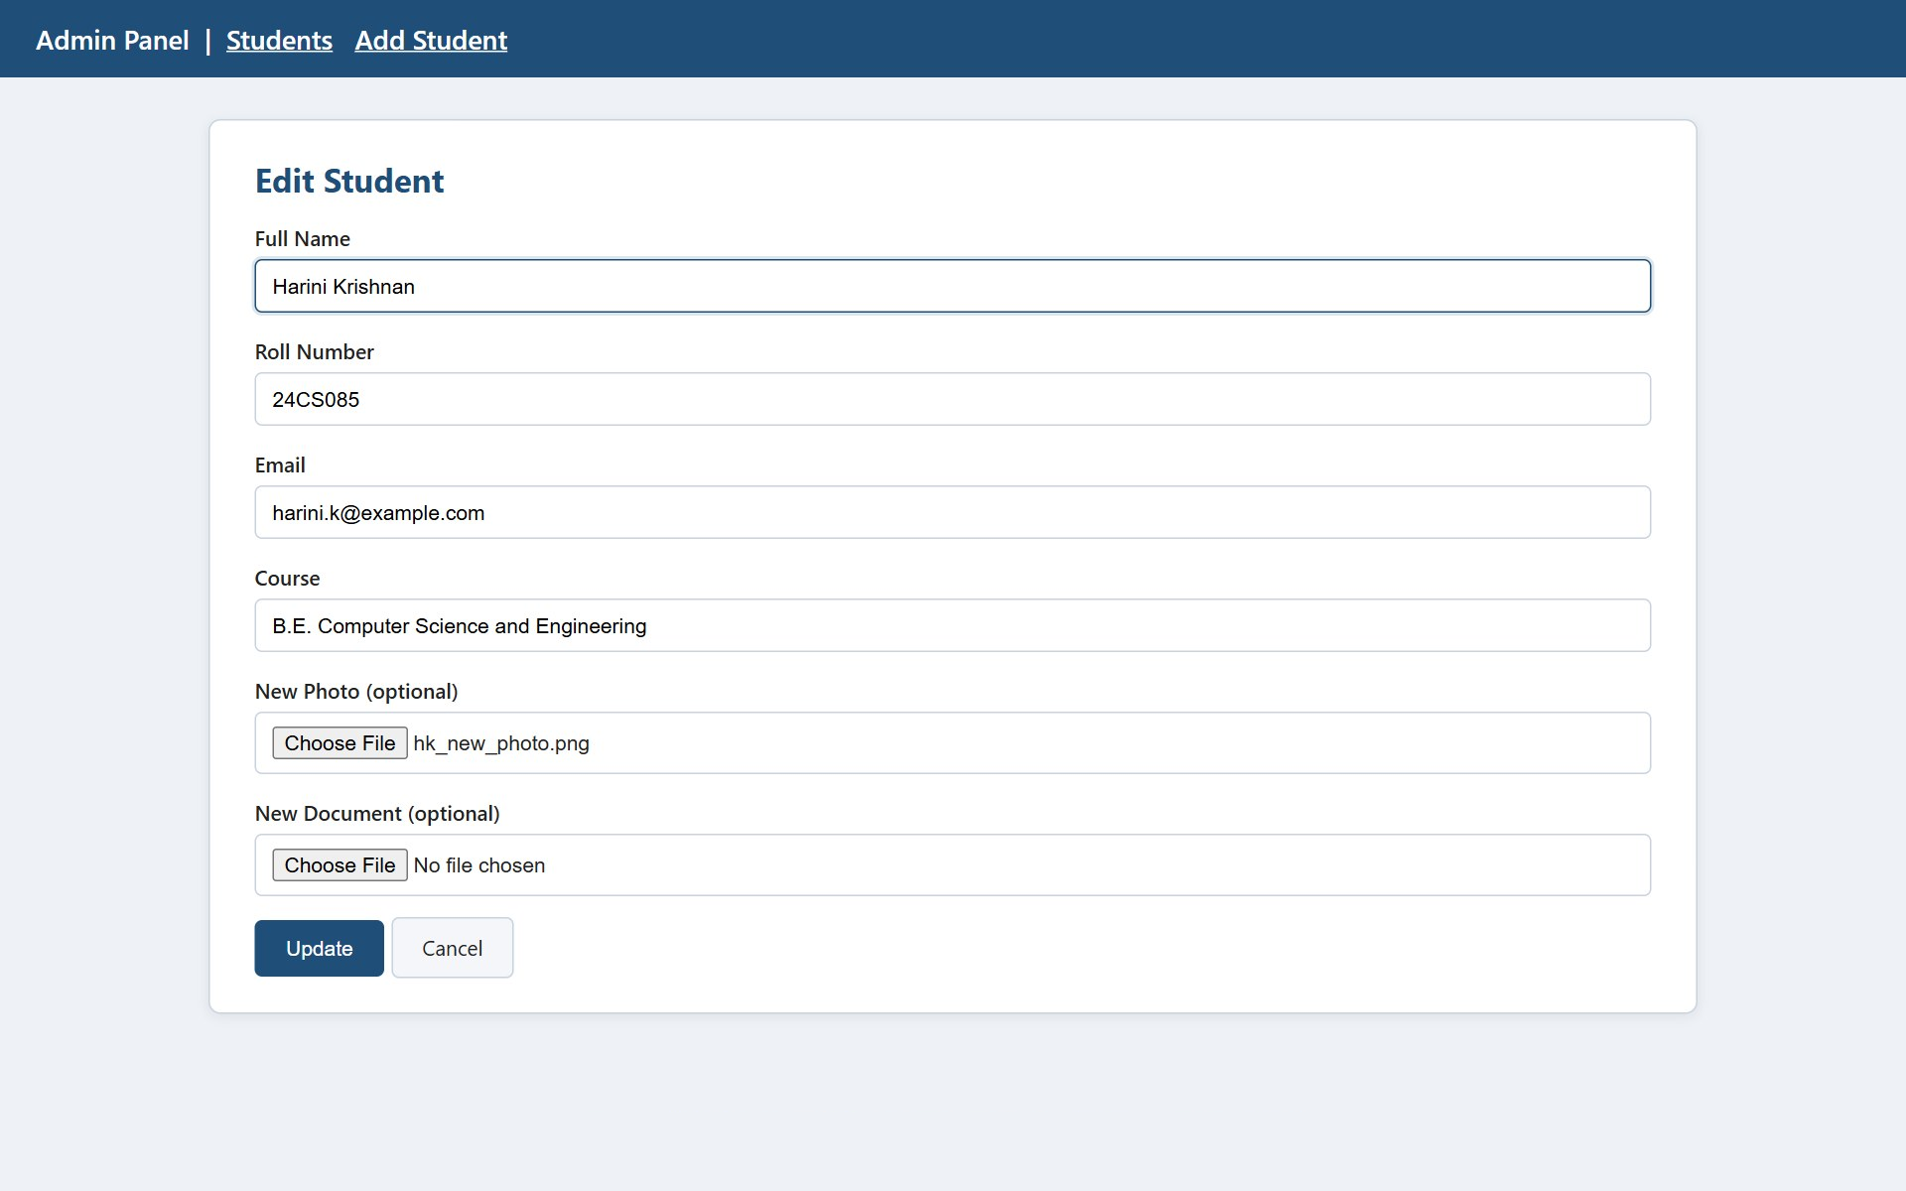
Figure 2.5 – Edit student form
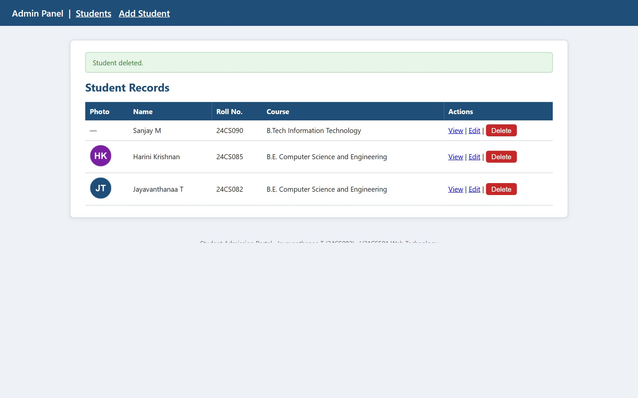
Figure 2.6 – Record after deletion
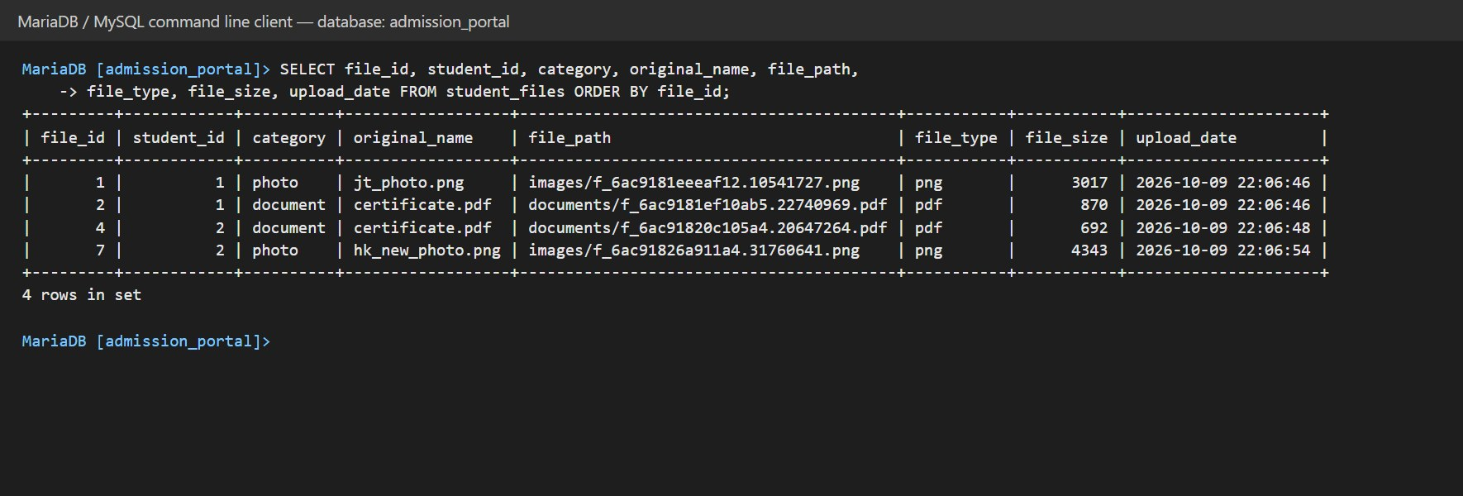
Figure 2.7 – student_files metadata (MySQL query result)

5. QUESTION 3 – SERVLET, JDBC AND JSP STUDENT PROFILE PORTAL

5.1 Scenario and Task Mapping
The front-end portal lets users view student profiles together with their uploaded images and documents. The table maps the five tasks to the implementation.
Task | Implementation
1. JDBC connection, fetch details and file paths | DBUtil opens the connection; StudentDAO.findAllWithFiles() reads students and student_files with PreparedStatement/ResultSet.
2. Retrieve and stream files from the storage folder | FileServlet maps /file?id=N to a path stored in MySQL and copies the file to the response in 4 KB blocks.
3. Dynamic HTML/JSP page with <img> pointing to the Servlet | students.jsp uses <img src="file?id=..."> for each photo.
4. Looping and conditional logic | Nested for loops over students and their files; if checks for empty list, missing photo and files without upload.
5. Session handling | LoginServlet creates the session; AuthFilter guards /students and /file; LogoutServlet invalidates the session.

5.2 Request–Response Flow
- The browser opens login.jsp and submits the username and password to /login.
- LoginServlet hashes the password with SHA-256 and StudentDAO compares it with admin_users using a PreparedStatement.
- On success the servlet creates a session, stores the attribute user and redirects to /students; on failure it forwards back to the login page with an error message.
- AuthFilter intercepts /students, finds the user attribute in the session and lets the request pass.
- StudentListServlet loads the students and their files and forwards the list to students.jsp.
- For each photo, the browser sends a second request to /file?id=N; AuthFilter checks the session again and FileServlet streams the file.
- /logout invalidates the session, after which the protected URLs redirect to the login page.
Table 5.1 – Servlets, filter and URL mappings
Class | URL | Role
LoginServlet | /login | Validates credentials, creates the session
LogoutServlet | /logout | Invalidates the session
AuthFilter | /students, /file | Allows only logged-in users
StudentListServlet | /students | Fetches data and forwards to students.jsp
FileServlet | /file | Streams an image or document from disk

5.3 JDBC and Layers
The code is split into small layers: Student and StudentFile are plain model classes, StudentDAO contains every SQL statement, the servlets handle requests, and the JSP only displays data. Every query uses PreparedStatement and try-with-resources, which closes connections, statements and result sets automatically. The MySQL driver (mysql-connector-j-8.x.jar) is placed in WEB-INF/lib.

5.4 Streaming Files
The browser never sends a file path. It sends only a numeric id; FileServlet finds the real relative path in student_files, resolves it against the uploadDir configured in web.xml, and refuses to continue if the resulting path is outside that folder. It then sets the content type, content length and a Content-Disposition: inline header and copies the bytes to the output stream. Because the response is a normal image, an ordinary <img> tag can display it, and PDFs open in the browser tab.

5.5 Session Handling
A session is created only after a successful login. The session id is changed with changeSessionId() to prevent session fixation, and the session expires after 15 minutes of inactivity. AuthFilter calls getSession(false), which returns the existing session without creating a new one, and redirects to the login page when the user attribute is missing. The filter also sends Cache-Control: no-store, so the Back button cannot show protected pages after logout.

5.6 Source Code with Comments
Listing 3.1 – DBUtil.java
package com.portal;

import java.sql.Connection;
import java.sql.DriverManager;
import java.sql.SQLException;

/** Creates JDBC connections to the admission_portal database. */
public class DBUtil {
private static final String URL =
"jdbc:mysql://localhost:3306/admission_portal?useSSL=false&serverTimezone=UTC";
private static final String USER = "root";
private static final String PASS = "";

static {
try {
Class.forName("com.mysql.cj.jdbc.Driver"); // load the MySQL driver once
} catch (ClassNotFoundException e) {
throw new ExceptionInInitializerError(e);
}
}

public static Connection getConnection() throws SQLException {
return DriverManager.getConnection(URL, USER, PASS);
}
}

Listing 3.2 – Student.java
package com.portal;

import java.util.ArrayList;
import java.util.List;

/** A student together with the list of his or her uploaded files. */
public class Student {
private int id;
private String name, rollNumber, email, course;
private List<StudentFile> files = new ArrayList<>();

public Student(int id, String name, String rollNumber, String email, String course) {
this.id = id; this.name = name; this.rollNumber = rollNumber;
this.email = email; this.course = course;
}
public int getId() { return id; }
public String getName() { return name; }
public String getRollNumber() { return rollNumber; }
public String getEmail() { return email; }
public String getCourse() { return course; }
public List<StudentFile> getFiles() { return files; }

/** Returns the profile photo or null when the student has none. */
public StudentFile getPhoto() {
for (StudentFile f : files) if ("photo".equals(f.getCategory())) return f;
return null;
}
}

Listing 3.3 – StudentFile.java
package com.portal;

/** One uploaded file (row of student_files). */
public class StudentFile {
private int fileId;
private String category, originalName, filePath, fileType, uploadDate;
private int fileSize;

public StudentFile(int fileId, String category, String originalName, String filePath,
String fileType, int fileSize, String uploadDate) {
this.fileId = fileId; this.category = category; this.originalName = originalName;
this.filePath = filePath; this.fileType = fileType;
this.fileSize = fileSize; this.uploadDate = uploadDate;
}
public int getFileId() { return fileId; }
public String getCategory() { return category; }
public String getOriginalName() { return originalName; }
public String getFilePath() { return filePath; }
public String getFileType() { return fileType; }
public int getFileSize() { return fileSize; }
public String getUploadDate() { return uploadDate; }
public boolean isImage() { return !"pdf".equals(fileType); }
}

Listing 3.4 – StudentDAO.java
package com.portal;

import java.security.MessageDigest;
import java.sql.*;
import java.util.*;

/** All database access of the portal (JDBC with PreparedStatement). */
public class StudentDAO {

/** Checks username and password against admin_users. */
public boolean validateLogin(String username, String password) throws Exception {
String sql = "SELECT 1 FROM admin_users WHERE username = ? AND password_hash = ?";
try (Connection con = DBUtil.getConnection();
PreparedStatement ps = con.prepareStatement(sql)) {
ps.setString(1, username);
ps.setString(2, sha256(password));
try (ResultSet rs = ps.executeQuery()) {
return rs.next(); // true when a row matches
}
}
}

/** Loads every student and attaches the associated file records. */
public List<Student> findAllWithFiles() throws SQLException {
Map<Integer, Student> map = new LinkedHashMap<>();
try (Connection con = DBUtil.getConnection()) {
// 1. students
try (Statement st = con.createStatement();
ResultSet rs = st.executeQuery(
"SELECT student_id, name, roll_number, email, course " +
"FROM students ORDER BY name")) {
while (rs.next()) {
map.put(rs.getInt(1), new Student(rs.getInt(1), rs.getString(2),
rs.getString(3), rs.getString(4), rs.getString(5)));
}
}
// 2. file metadata of all students
try (Statement st = con.createStatement();
ResultSet rs = st.executeQuery(
"SELECT file_id, student_id, category, original_name, file_path, " +
"file_type, file_size, upload_date FROM student_files ORDER BY file_id")) {
while (rs.next()) {
Student s = map.get(rs.getInt("student_id"));
if (s != null) s.getFiles().add(new StudentFile(
rs.getInt("file_id"), rs.getString("category"),
rs.getString("original_name"), rs.getString("file_path"),
rs.getString("file_type"), rs.getInt("file_size"),
rs.getString("upload_date")));
}
}
}
return new ArrayList<>(map.values());
}

/** Finds one file record by id (null when it does not exist). */
public StudentFile findFile(int fileId) throws SQLException {
String sql = "SELECT file_id, category, original_name, file_path, file_type, " +
"file_size, upload_date FROM student_files WHERE file_id = ?";
try (Connection con = DBUtil.getConnection();
PreparedStatement ps = con.prepareStatement(sql)) {
ps.setInt(1, fileId);
try (ResultSet rs = ps.executeQuery()) {
if (!rs.next()) return null;
return new StudentFile(rs.getInt(1), rs.getString(2), rs.getString(3),
rs.getString(4), rs.getString(5), rs.getInt(6), rs.getString(7));
}
}
}

/** SHA-256 hex digest, same as MySQL SHA2(text, 256). */
private String sha256(String text) throws Exception {
byte[] d = MessageDigest.getInstance("SHA-256").digest(text.getBytes("UTF-8"));
StringBuilder sb = new StringBuilder();
for (byte b : d) sb.append(String.format("%02x", b));
return sb.toString();
}
}

Listing 3.5 – LoginServlet.java
package com.portal;

import java.io.IOException;
import javax.servlet.ServletException;
import javax.servlet.annotation.WebServlet;
import javax.servlet.http.*;

/** Handles the login form and creates the session. */
@WebServlet("/login")
public class LoginServlet extends HttpServlet {

@Override
protected void doPost(HttpServletRequest req, HttpServletResponse resp)
throws ServletException, IOException {
String user = req.getParameter("username");
String pass = req.getParameter("password");
try {
if (user != null && pass != null && new StudentDAO().validateLogin(user.trim(), pass)) {
req.changeSessionId(); // stops session fixation
HttpSession session = req.getSession(true); // create the session
session.setAttribute("user", user.trim()); // marks the user as logged in
session.setMaxInactiveInterval(15 * 60); // 15 minutes
resp.sendRedirect(req.getContextPath() + "/students");
} else {
req.setAttribute("error", "Invalid username or password.");
req.getRequestDispatcher("/login.jsp").forward(req, resp);
}
} catch (Exception e) {
throw new ServletException(e);
}
}

@Override
protected void doGet(HttpServletRequest req, HttpServletResponse resp)
throws ServletException, IOException {
req.getRequestDispatcher("/login.jsp").forward(req, resp);
}
}

Listing 3.6 – LogoutServlet.java
package com.portal;

import java.io.IOException;
import javax.servlet.annotation.WebServlet;
import javax.servlet.http.*;

/** Destroys the session and returns to the login page. */
@WebServlet("/logout")
public class LogoutServlet extends HttpServlet {
@Override
protected void doGet(HttpServletRequest req, HttpServletResponse resp) throws IOException {
HttpSession session = req.getSession(false); // do not create a new one
if (session != null) session.invalidate();
resp.sendRedirect(req.getContextPath() + "/login.jsp");
}
}

Listing 3.7 – AuthFilter.java
package com.portal;

import java.io.IOException;
import javax.servlet.*;
import javax.servlet.annotation.WebFilter;
import javax.servlet.http.*;

/** Blocks every protected URL unless the user has logged in. */
@WebFilter(urlPatterns = {"/students", "/file"})
public class AuthFilter implements Filter {

@Override
public void doFilter(ServletRequest request, ServletResponse response, FilterChain chain)
throws IOException, ServletException {
HttpServletRequest req = (HttpServletRequest) request;
HttpServletResponse resp = (HttpServletResponse) response;

HttpSession session = req.getSession(false); // existing session only
boolean loggedIn = session != null && session.getAttribute("user") != null;

if (loggedIn) {
// do not let the browser cache protected pages after logout
resp.setHeader("Cache-Control", "no-store");
chain.doFilter(request, response); // allow the request
} else {
resp.sendRedirect(req.getContextPath() + "/login.jsp");
}
}
}

Listing 3.8 – StudentListServlet.java
package com.portal;

import java.io.IOException;
import java.util.List;
import javax.servlet.ServletException;
import javax.servlet.annotation.WebServlet;
import javax.servlet.http.*;

/** Loads students from MySQL and forwards them to the JSP view. */
@WebServlet("/students")
public class StudentListServlet extends HttpServlet {
@Override
protected void doGet(HttpServletRequest req, HttpServletResponse resp)
throws ServletException, IOException {
try {
List<Student> students = new StudentDAO().findAllWithFiles();
req.setAttribute("students", students); // data for the JSP
req.getRequestDispatcher("/WEB-INF/views/students.jsp").forward(req, resp);
} catch (Exception e) {
throw new ServletException(e);
}
}
}

Listing 3.9 – FileServlet.java
package com.portal;

import java.io.*;
import java.nio.file.*;
import javax.servlet.ServletException;
import javax.servlet.annotation.WebServlet;
import javax.servlet.http.*;

/**
* Streams a stored image or document to the browser.
* The client sends only a file id (/file?id=7); the real path comes from MySQL,
* so the user can never request an arbitrary file on the server.
*/
@WebServlet("/file")
public class FileServlet extends HttpServlet {

@Override
protected void doGet(HttpServletRequest req, HttpServletResponse resp)
throws ServletException, IOException {
int id;
try {
id = Integer.parseInt(req.getParameter("id"));
} catch (NumberFormatException e) {
resp.sendError(HttpServletResponse.SC_BAD_REQUEST);
return;
}

try {
StudentFile meta = new StudentDAO().findFile(id);
if (meta == null) { resp.sendError(HttpServletResponse.SC_NOT_FOUND); return; }

// uploadDir is configured in web.xml (the PHP uploads folder)
Path base = Paths.get(getServletContext().getInitParameter("uploadDir")).normalize();
Path file = base.resolve(meta.getFilePath()).normalize();
if (!file.startsWith(base) || !Files.isRegularFile(file)) {
resp.sendError(HttpServletResponse.SC_NOT_FOUND);
return;
}

// Tell the browser what is coming
String mime = getServletContext().getMimeType(file.getFileName().toString());
resp.setContentType(mime != null ? mime : "application/octet-stream");
resp.setContentLengthLong(Files.size(file));
resp.setHeader("Content-Disposition",
"inline; filename=\"" + meta.getOriginalName().replace("\"", "") + "\"");

// Copy the file to the response in 4 KB blocks
try (InputStream in = Files.newInputStream(file);
OutputStream out = resp.getOutputStream()) {
byte[] buf = new byte[4096];
int n;
while ((n = in.read(buf)) != -1) out.write(buf, 0, n);
}
} catch (java.sql.SQLException e) {
throw new ServletException(e);
}
}
}

Listing 3.10 – WEB-INF/web.xml
<?xml version="1.0" encoding="UTF-8"?>
<web-app xmlns="http://xmlns.jcp.org/xml/ns/javaee" version="4.0">
<display-name>StudentPortal</display-name>

<!-- Folder in which the PHP module stores the uploaded files -->
<context-param>
<param-name>uploadDir</param-name>
<param-value>C:/xampp/htdocs/StudentAdmissionPortal/PHP/uploads</param-value>
</context-param>

<session-config>
<session-timeout>15</session-timeout>
</session-config>

<welcome-file-list>
<welcome-file>login.jsp</welcome-file>
</welcome-file-list>
</web-app>

Listing 3.11 – login.jsp
<%@ page contentType="text/html;charset=UTF-8" %>
<!DOCTYPE html>
<html lang="en">
<head>
<meta charset="UTF-8">
<meta name="viewport" content="width=device-width, initial-scale=1.0">
<title>Portal Login</title>
<link rel="stylesheet" href="style.css">
</head>
<body>
<header class="top-bar">Student Admission Portal</header>
<main class="card" style="max-width:380px">
<h1>Login</h1>
<% String error = (String) request.getAttribute("error"); %>
<% if (error != null) { %>
<div class="msg err"><%= error %></div>
<% } %>
<form method="post" action="login">
<div class="field"><label>Username</label>
<input type="text" name="username" required></div>
<div class="field"><label>Password</label>
<input type="password" name="password" required></div>
<button class="btn primary" type="submit">Sign in</button>
</form>
</main>
</body>
</html>

Listing 3.12 – WEB-INF/views/students.jsp
<%@ page contentType="text/html;charset=UTF-8" import="java.util.*,com.portal.*" %>
<%
// Data placed in the request by StudentListServlet
List<Student> students = (List<Student>) request.getAttribute("students");
%>
<!DOCTYPE html>
<html lang="en">
<head>
<meta charset="UTF-8">
<meta name="viewport" content="width=device-width, initial-scale=1.0">
<title>Student Profiles</title>
<link rel="stylesheet" href="style.css">
</head>
<body>
<header class="top-bar">
Student Profiles &nbsp;|&nbsp; Logged in as <%= session.getAttribute("user") %>
&nbsp; <a href="logout" style="color:#fff">Logout</a>
</header>

<main class="card wide">
<h1>Registered Students (<%= students.size() %>)</h1>

<% if (students.isEmpty()) { %>
<p>No students found.</p>
<% } %>

<% for (Student s : students) { // loop over every student %>
<section style="display:flex;gap:18px;border-bottom:1px solid #c9d3df;padding:14px 0;flex-wrap:wrap">
<% StudentFile photo = s.getPhoto(); %>
<% if (photo != null) { %>
<!-- the image is served by FileServlet, not by a direct path -->
<img class="profile-img" src="file?id=<%= photo.getFileId() %>" alt="Photo of <%= s.getName() %>">
<% } else { %>
<div class="profile-img" style="background:#eef2f7;text-align:center;line-height:140px">No photo</div>
<% } %>

<div>
<h3 style="margin:0"><%= s.getName() %></h3>
<p style="margin:4px 0"><%= s.getRollNumber() %> &middot; <%= s.getCourse() %></p>
<p style="margin:4px 0"><%= s.getEmail() %></p>

<b>Files:</b>
<% if (s.getFiles().isEmpty()) { %>
<i>none uploaded</i>
<% } else { %>
<ul>
<% for (StudentFile f : s.getFiles()) { // loop over this student's files %>
<li>
<a href="file?id=<%= f.getFileId() %>" target="_blank">
<%= f.getOriginalName() %></a>
(<%= f.getCategory() %>, <%= f.getFileType().toUpperCase() %>,
<%= f.getFileSize() / 1024 %> KB)
</li>
<% } %>
</ul>
<% } %>
</div>
</section>
<% } %>
</main>
</body>
</html>

5.7 Testing
Table 5.2 – Test cases for Question 3
TC | Test case | Expected result | Observed | Status
TC3.1 | Open /students without logging in | Redirected to login.jsp | Redirected to /StudentPortal/login.jsp | PASS
TC3.2 | Open /file?id=1 without logging in | Redirected to login.jsp | Redirected to /StudentPortal/login.jsp | PASS
TC3.3 | Login with a wrong password | "Invalid username or password." shown | "Invalid username or password." shown | PASS
TC3.4 | Login as admin / Admin@123 | Redirected to the student list | Redirected to /StudentPortal/students | PASS
TC3.5 | View the list with several students | Each student is shown with photo and file list | 3 students shown; 2 photos streamed via /file; file lists shown | PASS
TC3.6 | Student without a photo | "No photo" placeholder shown | "No photo" placeholder shown for Sanjay M | PASS
TC3.7 | Click a PDF in the file list | PDF streams and opens in the browser | HTTP 200, Content-Type application/pdf, inline; filename="certificate.pdf" | PASS
TC3.8 | Open /file?id=99999 | 404 response | HTTP 404 | PASS
TC3.9 | Open /file?id=abc | 400 response | HTTP 400 | PASS
TC3.10 | Logout, then press Back | Protected page is not shown; login page appears | After Back: /StudentPortal/login.jsp (login page shown) | PASS

5.8 Output Screenshots
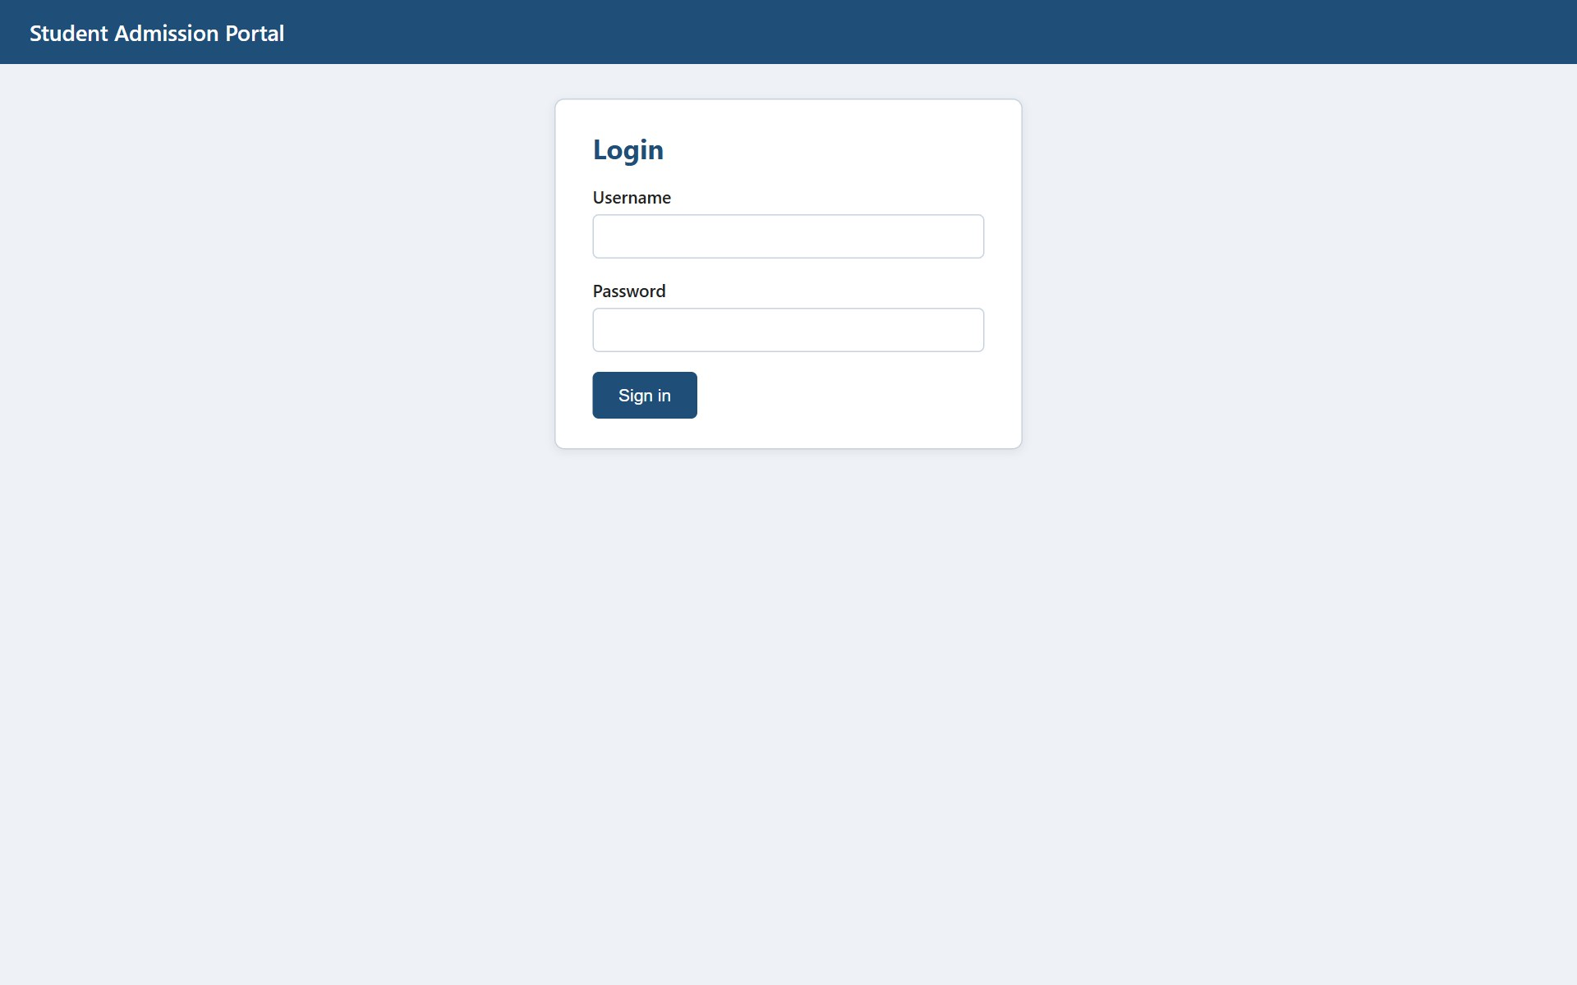
Figure 3.1 – Login page
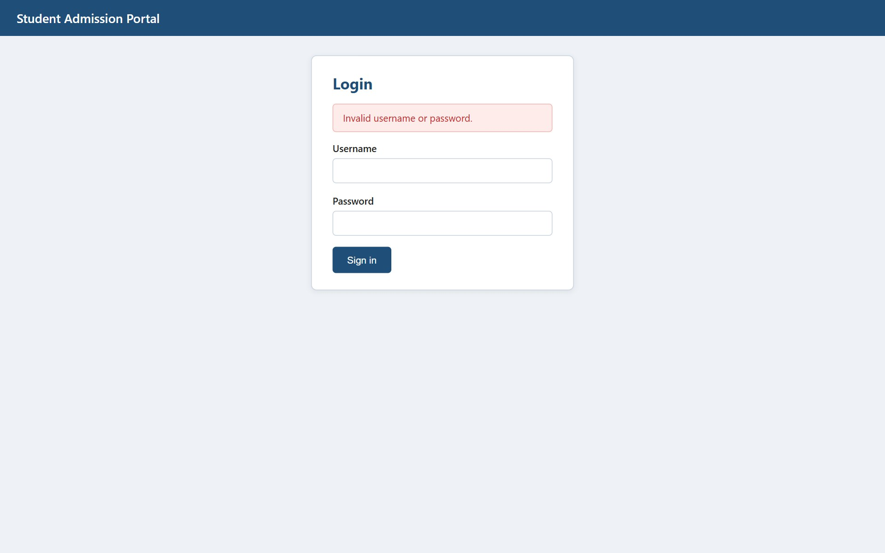
Figure 3.2 – Redirect / invalid login message

Figure 3.3 – Student profiles rendered by JSP
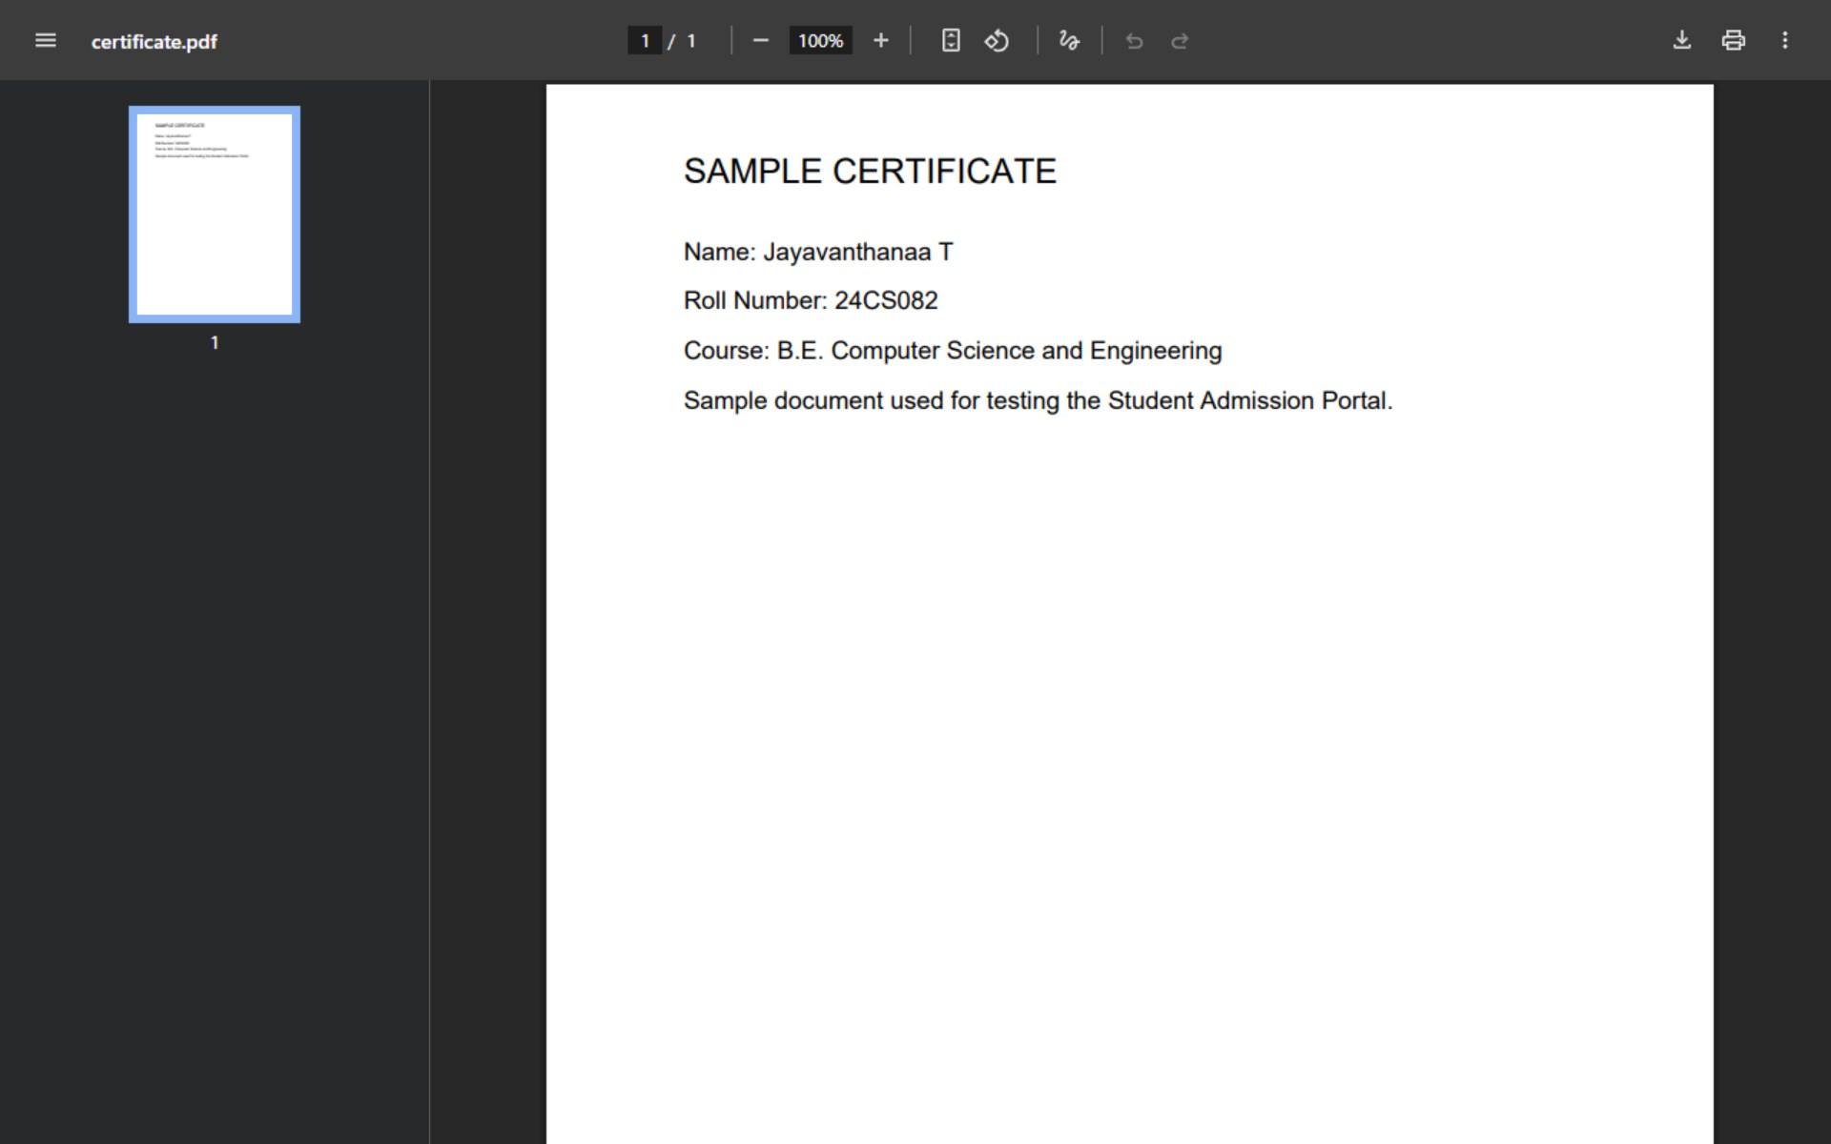
Figure 3.4 – Image and document streamed by FileServlet

6. OVERALL TESTING SUMMARY
The three modules were designed to be tested one after another. Question 1 is opened directly from Frontend/index.html; Question 2 is run from http://localhost/StudentAdmissionPortal/PHP/; Question 3 is deployed to Tomcat and opened at http://localhost:8080/StudentPortal/. Register a few students through Question 2, and then log in to Question 3 to see the same students, photos and documents.
Question | Technology | Key checks | Result
Q1 | HTML, CSS, JavaScript | Required fields, e-mail, password strength, file checks, responsive layout | 11/11 PASS
Q2 | PHP, MySQL | CRUD, duplicate prevention, upload validation, metadata, safe delete | 12/12 PASS
Q3 | Servlet, JDBC, JSP | Login, session guard, dynamic list, file streaming | 10/10 PASS

6.1 How to Run
- Start Apache and MySQL in XAMPP and import Database/admission_portal.sql in phpMyAdmin.
- Copy the project folder to C:\xampp\htdocs\StudentAdmissionPortal.
- Open http://localhost/StudentAdmissionPortal/Frontend/index.html for Question 1 and http://localhost/StudentAdmissionPortal/PHP/view_students.php for Question 2.
- Import the Servlet folder into Eclipse as a Dynamic Web Project, add mysql-connector-j-8.x.jar to WEB-INF/lib, set uploadDir in web.xml to the PHP uploads folder and run on Tomcat 9.
- Log in with admin / Admin@123.

7. SUBMISSION CHECKLIST
Requirement | Where it is provided
PHP files, Servlet WEB-INF files, .html, .css, .js files | Sections 3.5, 4.6 and 5.6 and the GitHub repository
DB schema script | Listing 2.1 and Database/admission_portal.sql
Screenshots of output in the browser | Sections 3.7, 4.8 and 5.8
Explanation of code with inline comments | Every listing carries inline comments; each question has an explanation section
Brief conclusion (3–5 lines) | Section 8
GitHub repository link | Section 9

8. BRIEF CONCLUSION
The Student Admission Portal was built in three layers: a validated and responsive registration form, a PHP and MySQL module that manages student records and uploaded files safely, and a Servlet and JSP portal that streams the same files to logged-in users only. The work covered client-side validation, prepared statements, transactions, secure file handling, JDBC and session-based access control. Together these show how different server technologies can share one database to form a complete web application.

9. GITHUB REPOSITORY
The complete source code, database script and this report are available in the repository below.
Item | Details
GitHub Repository Link | https://github.com/Vanthanaa/Web-technology-assignment2.git
Repository Name | StudentAdmissionPortal
Maintained by | Jayavanthanaa T (24CS082)

