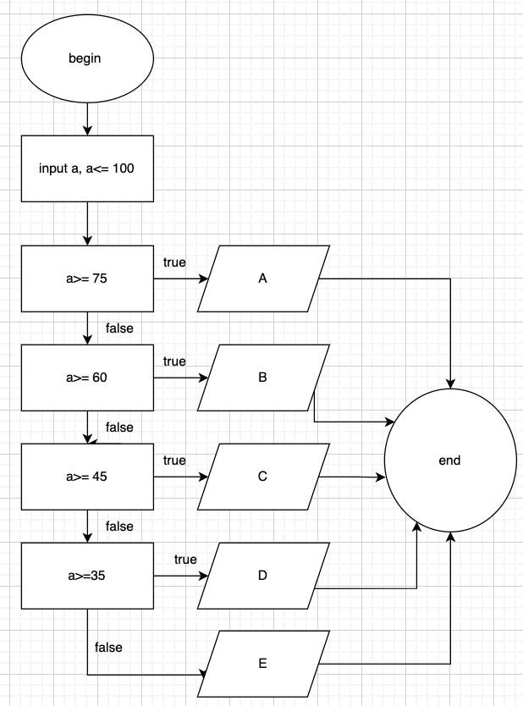Begin

Input a (a<100)

If a >= 75

Display ‘loai A’

Else if a>= 60

Display ‘loai b’

Else if a>=45

Display ‘loai c’

Else if a>= 35

Display ‘loai d’

Else

Display ‘loai e’

End if

End