**EMAIL ADDRESS:**

**CP#:**

No. of Processed Workers = 0 in Principal, 0 in Landbased Accreditation System (5)

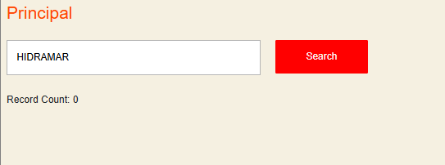

MWO/POLO/PE/PCG Validation (6)

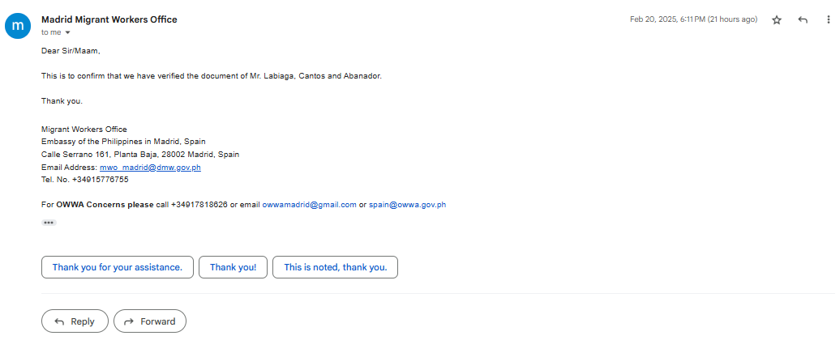

1. DHPSW-ROIVA-YYYY-MMDD-MonthTotal-YearTotal
2. Currency based on contract converted to USD
3. Check one only
4. Encode some documents based on experience and highest education
   1. Attached screenshot