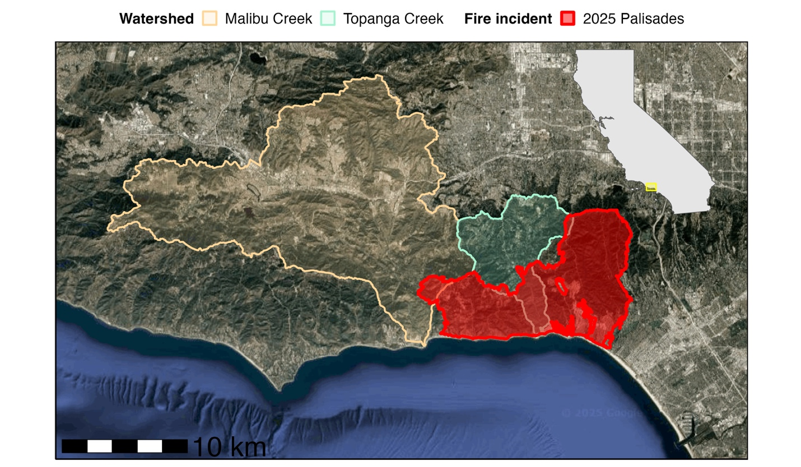

Malibu Bluffs

Big Rock

The Vantuna Research Group (VRG) has conducted habitat and biodiversity surveys at two sites adjacent to the footprint of the January 2025 Palisades Fire: Malibu Bluffs (near the outflow of Malibu Creek) and Big Rock (directly adjacent to fire footprint). The VRG surveys two depth zones (~5m and ~10m) at Malibu Bluffs and one depth zone (~5m) at Big Rock.

Table 1. Site, depth and percent cover across four relief categories for rocky reef habitats in Malibu, based on dive survey data.

|  |  |  |  |  |  |
| --- | --- | --- | --- | --- | --- |
| **Site** | **Depth** | **Flat**  **(0-0.1m)** | **Mild**  **(0.1-1m)** | **Moderate**  **(1-2m)** | **High**  **(>2m)** |
| Malibu Bluffs | ~5m | 34% | 56% | 10% | 0% |
|  | ~10m | 13% | 87% | 0% | 0% |
| Big Rock | ~5m | 16% | 77% | 6% | 0% |

Table 2. Site, depth and percent cover across four substrate size categories for rocky reef habitats in Malibu, based on dive survey data.

|  |  |  |  |  |  |
| --- | --- | --- | --- | --- | --- |
| **Site** | **Depth** | **Sand** | **Cobble** | **Boulder** | **Bedrock** |
| Malibu Bluffs | ~5m | 45% | 0% | 0% | 55% |
|  | ~10m | 23% | 0% | 16% | 61% |
| Big Rock | ~5m | 21% | 0% | 5% | 74% |

Big Rock

Malibu Bluffs

Table 3. Summary of average fish, macroinvertebrates, and kelp densities on Malibu reefs surveyed by the Vantuna Research Group.

|  |  |  |  |  |  |
| --- | --- | --- | --- | --- | --- |
| **Site** | **Depth** | **Average fish density (count/100 m2)** | **Average fish density (kg/100 m2)** | **Average macro-invertebrate density (count/100 m2)** | **Average total kelp density (count/100 m2)** |
| Malibu Bluffs | ~5m | 25.8 | 2.3 | 25.0 | 5.8 |
|  | ~10m | 10.8 | 2.2 | 172.5 | 46.7 |
| Big Rock | ~5m | 20.8 | 2.2 | 380.8 | 5.0 |

In 2023, 9 taxa of fish were observed on Malibu reefs near the footprint of the Palisades Fire.

Table 4. Fish taxa observed at each site and depth surveyed by the Vantuna Research Group at Malibu reefs in 2023, with raw abundances and densities (individuals per 100 m² and kg per 100 m² in italics) listed in descending order (by count) within each site-depth combination.

|  |  |  |  |  |
| --- | --- | --- | --- | --- |
| **Site** | **Depth** | **Taxa** | **Count from 4 30 m3 transects** | **Estimated density**  **count/100 m2**  ***kg/100 m2*** |
| Malibu Bluffs | ~5m | Senorita  *Oxyjulis californica* | 43 | 17.9  *1.65* |
|  | ~5m | kelp bass  *Paralabrax clathratus* | 16 | 6.7  *2.03* |
|  | ~5m | rock wrasse  *Halichoeres semicinctus* | 2 | 0.8  *0.57* |
|  | ~5m | white seaperch  *Phanerodon furcatus* | 1 | 0.4  *0.10* |
|  | ~10m | kelp bass  *Paralabrax clathratus* | 20 | 8.3  *0.21* |
|  | ~10m | rock wrasse  *Halichoeres semicinctus* | 4 | 1.7  *0.01* |
|  | ~10m | Senorita  *Oxyjulis californica* | 1 | 0.4  *0.24* |
|  | ~10m | barred sand bass  *Paralabrax nebulifer* | 1 | 0.4  *0.3* |
| Big Rock | ~5m | white seaperch  *Phanerodon furcatus* | 14 | 5.8  *0.02* |
|  | ~5m | black perch  *Embiotoca jacksoni* | 11 | 4.6  *0.35* |
|  | ~5m | rock wrasse  *Halichoeres semicinctus* | 8 | 3.3  *0.03* |
|  | ~5m | kelp bass  *Paralabrax clathratus* | 6 | 2.5  *0.05* |
|  | ~5m | Garibaldi damselfish  *Hypsypops rubicundus* | 4 | 1.7  *0.10* |
|  | ~5m | California sheephead  *Semicossyphus pulcher* | 3 | 1.3  *0.40* |
|  | ~5m | Blacksmith  *Chromis punctipinnis* | 2 | 0.8  *0.61* |
|  | ~5m | Senorita  *Oxyjulis californica* | 1 | 0.4  *0.01* |
|  | ~5m | barred sand bass  *Paralabrax nebulifer* | 1 | 0.4  *0.02* |

|  |  |  |  |  |
| --- | --- | --- | --- | --- |
| **Site** | **Depth** | **Taxa** | **Count from 2 60 m2 transects** | **Estimated density**  **count/100 m2** |
| Malibu Bluffs | ~5m | chain bladder kelp *Stephanocystis sp.* | 5 | 4.2 |
|  | ~5m | giant kelp  *Macrocystis pyrifera* | 1(5 stipes) | 0.8 |
|  | ~5m | stalked kelp  *Pterygophora californica* | 1 | 0.8 |
|  | ~10m | stalked kelp  *Pterygophora californica* | 30 | 25 |
|  | ~10m | chain bladder kelp *Stephanocystis sp.* | 13 | 10.8 |
|  | ~10m | giant kelp  *Macrocystis pyrifera* | 11(18 stipes) | 9.2 |
|  | ~10m | southern sea palm  *Eisenia arborea* | 1 | 0.8 |
|  | ~10m | golden kombu  *Laminaria farlowii* | 1 | 0.8 |
| Big Rock | ~5m | chain bladder kelp *Stephanocystis sp.* | 5 | 4.2 |
|  | ~5m | stalked kelp  *Pterygophora californica* | 1 | 0.8 |

In 2023, 5 taxa of kelp (macroalgae) were observed on Malibu reefs near the footprint of the Palisades Fire.

Table 5. Kelp (macroalgae) species observed at each site and depth surveyed by the Vantuna Research Group at Malibu reefs in 2023, with raw abundances and densities (individuals per 100 m²) listed in descending order within each site-depth combination.

In 2023, 13 taxa of macroinvertebrates were observed on Malibu reefs near the footprint of the Palisades Fire.

Table 6. Macroinvertebrate taxa observed at each site and depth surveyed by the Vantuna Research Group at Malibu reefs in 2023, with raw abundances and densities (individuals per 100 m²) listed in descending order within each site-depth combination.

|  |  |  |  |  |
| --- | --- | --- | --- | --- |
| **Site** | **Depth** | **Taxa** | **Count from 2 60 m2 transects** | **Estimated density**  **count/100 m2** |
| Malibu Bluffs | ~5m | golden gorgonian  *Muricea californica* | 10 | 8.3 |
|  |  | stalked tunicate  *Styela montereyensis* | 8 | 6.7 |
|  |  | starburst anenome  *Anthopleura sola* | 6 | 5 |
|  |  | Spanish shawl nudibranch  *Flabellina iodinea* | 2 | 1.7 |
|  |  | wavy turban snail  *Megastraea undosa* | 2 | 1.7 |
|  |  | burrowing anemone  *Anthopleura artemisia* | 1 | 0.8 |
|  |  | spiny sand star  *Astropecten armatus* | 1 | 0.8 |
|  | ~10m | stalked tunicate  *Styela montereyensis* | 164 | 136.7 |
|  |  | wavy turban snail  *Megastraea undosa* | 26 | 21.7 |
|  |  | golden gorgonian  *Muricea californica* | 15 | 12.5 |
|  |  | California two-spot octopus  *Octopus bimaculoides* | 1 | 0.8 |
|  |  | California spiny lobster  *Panulirus interruptus* | 1 | 0.8 |
| Big Rock | Inner | golden gorgonian  *Muricea californica* | 354 | 295 |
|  |  | brown gorgonian  *Muricea fruticosa* | 69 | 57.5 |
|  |  | wavy turban snail  *Megastraea undosa* | 19 | 15.8 |
|  |  | bat star  *Patiria miniata* | 8 | 6.7 |
|  |  | chestnut cowrie  *Neobernaya spadicea* | 3 | 2.5 |
|  |  | stalked tunicate  *Styela montereyensis* | 2 | 1.7 |
|  |  | starburst anenome  *Anthopleura sola* | 1 | 0.8 |
|  |  | red urchin  *Mesocentrotus franciscanus* | 1 | 0.8 |