|  |
| --- |
| Difference Between NAAC & NBA Accreditation - Haq Se EngineerPREC LONIJai Shriram Engineering College (@JSREC09) / Twitter**JAI SHRIRAM ENGINEERING COLLEGE**  **TIRUPPUR – 638 660**  Approved by AICTE, New Delhi & Affiliated to Anna University, Chennai  Recognized by UGC & Accredited by NAACandNBA (CSE and ECE) |

**DEPARTMENT OF**

**ELECTRONICS AND COMMUNICATION ENGINEERING**

**IBM - Naan Mudhalvan**

**Internet of Things**

**Group 3**

**Phase 4 - Project Submission**

**NAME : VARSHINI.M**

**NM ID : au711221106043**

**YEAR : III ECE**

**TEMPERATURE MONITORING**

Temperature and humidity are vital data points in today’s industrial world. Monitoring environmental data for server rooms, commercial freezers, and production lines is necessary to keep things running smoothly. There are lots of solutions out there ranging from basic to complex and it can seem overwhelming on what your business needs and where to start.

We’ll walk through how to build and use a Raspberry Pi temperature sensor with different temperature sensors. This is a good place to start since these solutions are inexpensive, easy to do, and gives you a foundation to build off of for other environmental monitoring.

**Raspberry Pi**

A Raspberry Pi is an inexpensive single board computer that will allow you to connect to a temperature sensor and stream the data to a data visualization software. Raspberry Pi’s started out as a learning tool and have evolved to an industrial workplace tool. The ease of use and ability to code with Python, the fastest growing programming language, has made them a go to solution.

You’ll want a Raspberry Pi that has WiFi built in, which are any model 3, 4, and zero W/WH. Between those you can choose based on pricing and features. The Zero W/WH is the cheapest but if you need more functionality you can choose between the 3 and 4. You can only buy one Zero W/WH at a time due to limitations by the Raspberry Pi Foundation. Whatever Pi you choose, make sure to purchase a charger since that is how you’ll power the Pi and an SD card with Raspbian to make installation of the operating system as easy as possible.

There are other single board computer that can work as well, but that’s for another time and another article.

**Sensors**

There are four sensors we recommend using because they are inexpensive, easy to connect, and give accurate readings; DSB18B20, DHT22, BME280, and Raspberry Pi Sense HAT.

**DHT22** — This temperature and humidity sensor has temperature accuracy of +/- 0.5 C and a humidity range from 0 to 100 percent. It is simple to wire up to the Raspberry Pi and doesn’t require any pull up resistors.

**DSB18B20** — This temperature sensor has a digital output, which works well with the Raspberry Pi. It has three wires and requires a breadboard and resistor for the connection.

**BME280** — This sensor measures temperature, humidity, and barometric pressure. It can be used in both SPI and I2C.

**Sense HAT** — This is an add on board for Raspberry Pi that has LEDs, sensors, and a tiny joystick. It connects directly on to the GPIO on the Raspberry Pi but using a ribbon cable gives you more accurate temperature readings.

**Raspberry Pi Setup**

If this is the first time setting up your Raspberry Pi you’ll need to install the raspbian operating system and connect your pi to wifi. This will require a monitor and keyboard to connect to the Pi. Once you have it up and running and connected to the WiFI, your Pi is ready to go.

**DHT22 Temperature and Humidity Sensor**

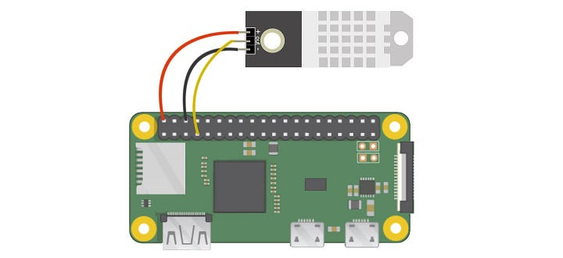

The DHT22 will have three pins — 5V, Gnd, and data. There should be a pin label for power on the DHT22 (e.g. ‘+’ or ‘5V’). Connect this to pin 2 (the top right pin, 5V) of the Pi. The Gnd pin will be labeled ‘-’ or ‘Gnd’ or something equivalent. Connect this to pin 6 Gnd (two pins below the 5V pin) on the Pi. The remaining pin on the DHT22 is the data pin and will be labeled ‘out’ or ‘s’ or ‘data’. Connect this to one of the GPIO pins on the Pi such as GPIO4 (pin 7). Once this is wired, power on your Pi.

**CODING**

import os

import glob

import time

from ISStreamer.Streamer import Streamer

streamer=Streamer(bucket_name="TemperatureStream", bucket_key="piot_temp_stream031815", access_key="PUT_YOUR_ACCESS_KEY_HERE")

os.system('modprobe w1-gpio')

os.system('modprobe w1-therm')

base_dir = '/sys/bus/w1/devices/'

device_folder = glob.glob(base_dir + '28*')[0]

device_file = device_folder + '/w1_slave'

def read_temp_raw():

f = open(device_file, 'r')

lines = f.readlines()

f.close()

return lines

def read_temp():

lines = read_temp_raw()

while lines[0].strip()[-3:] != 'YES':

time.sleep(0.2)

lines = read_temp_raw()

equals_pos = lines[1].find('t=')

if equals_pos != -1:

temp_string = lines[1][equals_pos+2:]

temp_c = float(temp_string) / 1000.0

return temp_c

while True:

temp_c = read_temp()

temp_f = temp_c * 9.0 / 5.0 + 32.0

streamer.log("temperature (C)", temp_c)

streamer.log("temperature (F)", temp_f)

time.sleep(.5)

# BME280 Solution

* BME280 Pressure, Temperature, & Humidity Sensor

This sensor comes with pins that you’ll need to solder on the sensor. I recommend using a breadboard with the pins long side down into the breadboard to make soldering easier. Once you’ve completed this we need to wire the sensor to the Pi.