**Soda Vending Machine**

Spring MVC framework is a well-designed framework that is used to develop SodaVendingMachine web application using MVC design pattern.

1. **Architecture Design:**

Spring Web MVC framework provides Model view controller design pattern. There are mainly 3 layers developed in this application.

* **Presentation Layer:** View is responsible for rendering the rendering the model data and it generates the output that the client browser can interpret. Controller class is the entry points of our application. If user submits any request, controller takes the request, identifies the type of request and sends it appropriate service method to generate Model Data. So the output of controller will be Model.

Index.jsp -> view

SodaVendingMachineController -> Controller class

* **Service Layer:** Service layer is to provide logic to operate on the data sent to and from the DAO and the client. Very often these 2 pieces will be bundled together into the same module, and occasionally into the same code, but you’ll still see them as distinct logical entities. This layer Provides separation of concern, security and loose coupling.

The below classes are used in the Service layer.

VendingMachineService -> This is the interface at service level.

VendingMachineServiceImpl -> This is the Implemented class at service level.

* **Data Access Layer:** This is also known as persistence layer or infrastructure. The classes in this layer are responsible for fetching the data from the database and also responsible for all the database related operations.

The below classes are used in the Data access layer.

VendingMachineDAO -> This is the interface at Data access level. VendingMachineDAOImpl -> This is the Implemented class at Data access level.

1. **Architectural diagram:**

The below Spring MVC architecture which is used in this SodaVendingMachine application.

[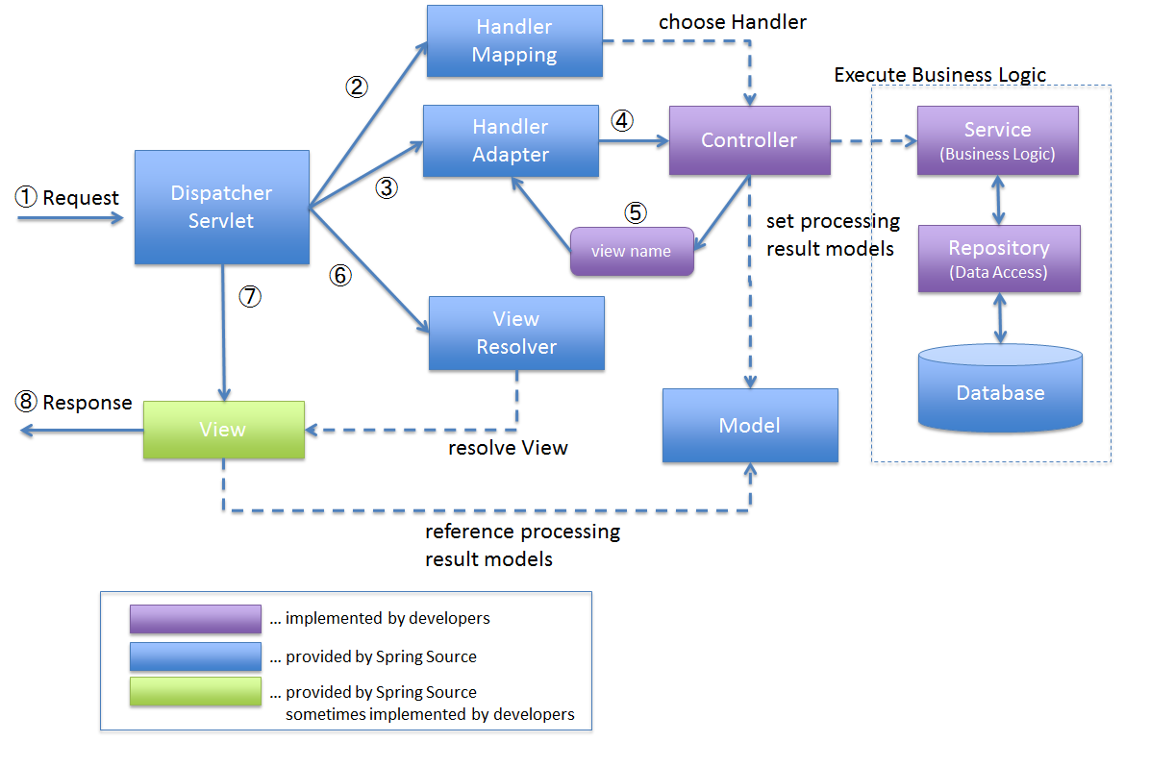](https://terasolunaorg.github.io/guideline/1.0.1.RELEASE/en/_images/RequestLifecycle.png)

1. **Vending Machine System:**

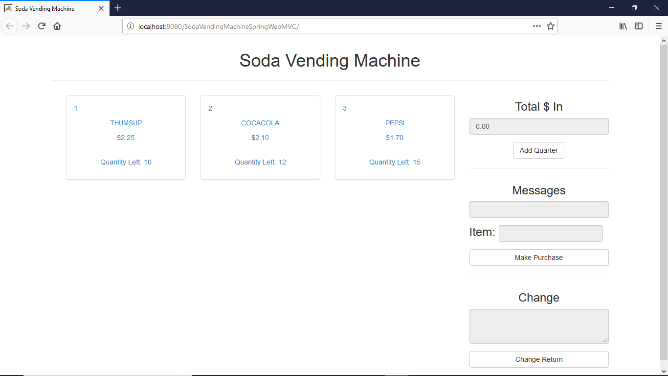

We are displaying list of items in vending machine from backend services and displays on UI with Item name, Cost and Quantity.

**Operating steps:**

1. Click on the item.
2. Enter the amount as quarter (like $0.25) and click on Add Quarter button to get it increase by quarter($0.25)
3. Check the Item number in the Item text box and then click on Make Purchase button.
4. If any change is remain as per the cost of the item and the entered amount, it will be displayed on the Change text box.