HOUSEHOLDS

- Households are productive units responsible for creation and re-creation of societies.
- HH’s are constructed by shifting set of relationships.
- HHs are constructed by shifting set of relationships, within and between HH groups, and even further wider social contexts in which they are embedded
- Activity Areas (CY), Distant milking area, cooking, drying vegetables, powdered soup base from tarhana
- Storing Food

Theory, Inferences, concerning Gordion Economy.

HH organization affects economic fluctuations over 60 yr. period (since 1950’s)
- “One of the main aims of HH analyses is the reconstruction of the social organization of houses and their inhabitants” (Pfalzner in Veenhof, 1996)- Activity area research--
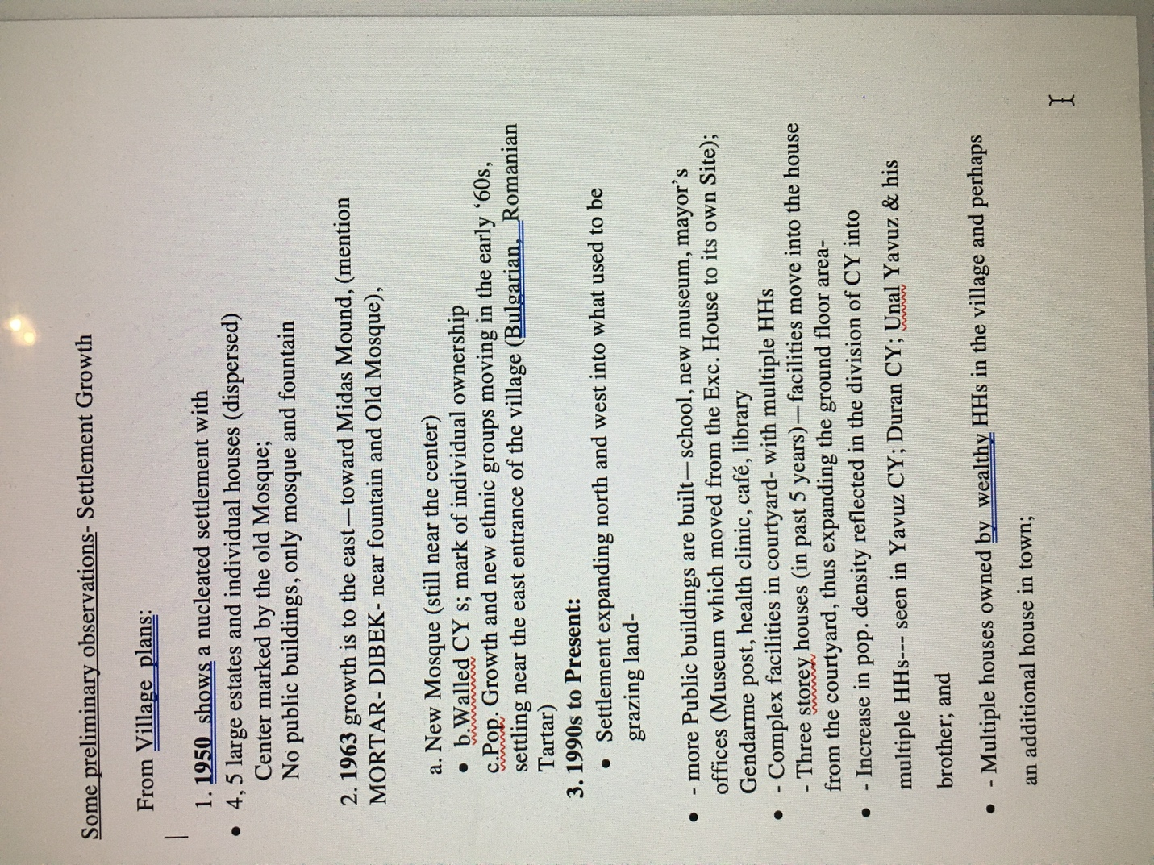
- My ethnograpjic research provides important new diachronic data on the economic variables and land use—s
- it is critical to understand the organization of household (no. of people, age and gender structure, tasks performed…)

- Understanding the organization of multi-family house is critical to understanding the evolution of social complexity in ancient societies.

- Household is a basic socio-economic unit; hence, a variety of approaches to study it are possible: focussing on material and technical aspects, on economic and social implications, approaches which could be both comparative and diachronic….could be dealt with both archaeologial and textual sources…

- High status individuals or families could engage in the production of subsistence surpluses, feasting etc…through the control of resources and large labor forces (for ex. Faruk and Bingül Yavuz; Pembe Kayran & famiy);

- How did multi-family HHs organized their production and consumption?

- How was labor organized for public Works, such as canals, construction of mosque etc.?

- Who was the builder of the house/s? An amateur or an experienced, trained builder from the village or from outside?

- Social environment Determines Health (B. Marsh, p.6)

SEASONALITY, SCHEDULING OF ACTIVITIES.

Agriculture – Sept. 15 Ploughing fields (Father, son, workmen)

Harvest – June-July

Building/Repair – Sept. Father and rest of HH

Plastering house, oven CY – summer (men, women other members)

Sale/exchange of Crops (Male members of HH)

Food Prep. For Winter – (Women, children)

