SAP HUB USE CASE SUBMISSION TEMPLATE
USE CASE 01: HanaMorph
Automated Multi-Tier SAP HANA Calculation View Migration & 1:1 Visual Lineage Parity in SAP Datasphere

1. AT A GLANCE
Solution Name | HanaMorph (Enterprise SAP HANA to SAP Datasphere Automated Modernization Studio)
Solution Icon / Concept | Agile modernization bridge and dual-directional transformation engine with visual flow graph (interconnected DAG nodes transitioning seamlessly from SAP HANA on-premise to SAP Datasphere Cloud).
Headline | Automated 1:1 Architectural & Visual Lineage Migration of Deep N-Tier SAP HANA Calculation Views into SAP Datasphere.
Short Description | HanaMorph is an enterprise-grade migration accelerator that extracts complex, multi-level SAP HANA Calculation Views directly from S/4HANA (_SYS_REPO) and automatically synthesizes self-contained Datasphere CSN packages and pure SELECT views. By generating topological intermediate transformation views (Join_1, Join_2, Projection_1, etc.), HanaMorph achieves 100% visual and structural lineage parity in SAP Datasphere's Impact and Lineage Analysis, eliminating manual rebuilds, missing dependency errors, and SQL syntax mismatches.
2. BENEFITS
Benefit 1: 100% Visual Lineage Parity in SAP Datasphere (HANA Studio Mirroring)
Traditional migration approaches flatten multi-level calculation view DAGs into a single monolithic view or opaque SQL subqueries, causing Datasphere Lineage graphs to collapse all intermediate join/projection nodes. HanaMorph automatically reconstructs first-class modular intermediate views (CV_BANK_JOIN_1_V, CV_BANK_JOIN_2_V, CV_BANK_PROJECTION_1_V), rendering an identical node-for-node architecture in Datasphere Impact and Lineage Analysis that mirrors SAP HANA Studio / Eclipse exactly.

Benefit 2: Zero Dependency Errors & Turnkey Single-Click CSN Deployment
Manual recreation of deep views frequently triggers blocking errors in Datasphere (such as missing join attributes, unmapped calculated view attributes, and unassigned placeholder columns). HanaMorph automatically bundles the complete dependency closure—underlying physical tables (BNKA, FCLM_BAM_BNKA_BP, BP1010), helper views (CashLinefnt), intermediate nodes, root Fact Views (@Analytics.dataCategory: '#CUBE'), and Analytic Models—into a single, self-contained CSN package that imports and activates with zero errors.

Benefit 3: 95% Acceleration in Enterprise Modernization Timelines
Manually reverse-engineering, rewriting formulas (e.g. IF(ISNULL())), aligning join keys across heterogeneous sources, and configuring consumption models takes days per calculation view. HanaMorph executes live schema discovery, topological sorting, formula translation, and CSN packaging in under 30 seconds per view, reducing human migration effort by over 95%.

3. FEATURES
• Feature 1: Live S/4HANA & HANA Cloud Repository Discovery: Directly connects to live SAP HANA databases (_SYS_REPO) via native database drivers to search, inspect, and extract raw Calculation View XML schemas, column definitions, data categories, and dependency trees without requiring intermediate export files.
• Feature 2: Topological Multi-Tier DAG Engine (Up to 20 Levels Deep): Recursively navigates arbitrary DAG hierarchies (chains of joins, projections, aggregations, and unions) and orders the generation of Datasphere catalog views in exact topological dependency order, guaranteeing that every downstream view references fully resolved upstream entities.
• Feature 3: Intelligent Calculated Attribute & Formula Translation: Seamlessly parses SAP HANA calculation view expressions (e.g., IF(ISNULL("RATING_NULL"), '', "RATING_NULL"), rightstr(), and constants) and compiles them into standard SQL COALESCE expressions and native CQN calculated column constructs, preventing missing column references during Datasphere compilation.
• Feature 4: Automatic Primary Key & Measure Synthesis: Enforces strict Datasphere metadata integrity rules by guaranteeing primary key (key: true) assignments on every table/intermediate view and automatically injecting default measures (1 AS "RECORD_COUNT", @Analytics.measure: true) into Fact Views (#CUBE).
• Feature 5: Flexible Dual-Mode Deployment (Multi-Tier vs. Inlined Pure SELECT): Provides data architects with the flexibility to choose between: (1) Option A (Multi-Tier CSN Package): Full architectural visual lineage for enterprise governance; (2) Option B (Consolidated Pure SELECT): Pure inlined SQL queries strictly adhering to Datasphere SQL View grammar (eliminating disallowed top-level WITH CTE statements).
4. DASHBOARD / SOLUTION DETAILS
Primary KPIs Displayed | • Total Calculation Views Discovered: 153 in live system  • Connectivity: Live S/4HANA Connected (SID: HDD)  • Lineage Accuracy: 100% Zero-Error Rate across all 10 participating artifacts  • Deployment Speed: Under 30 seconds per Calculation View
Business Areas Covered | • Financial Accounting & Cash Management (Bank Master Data CV_BANK, Account Types CV_AC_TYPE)  • Sales & Distribution, Logistics, and Cross-System Supply Chain Harmonization  • Enterprise Data Warehousing & Cloud Modernization
Data Sources | • SAP S/4HANA (1909 to 2023) & SAP ECC on HANA 2.0  • Physical Tables: BNKA, FCLM_BAM_BNKA_BP, BP1010  • Calculation Views: CashLinefnt, CV_AC_TYPE, CV_BANK
Target Users | • SAP Enterprise Data Architects & Migration Leads  • SAP Datasphere & SAP Analytics Cloud (SAC) Data Modelers  • Business Intelligence & Cloud Data Warehouse Engineers
5. SUPPORTING EVIDENCE (COMPREHENSIVE END-TO-END WALKTHROUGH: 15 SCREENSHOTS)
The following 15 high-resolution screenshots provide an exhaustive, step-by-step verification walkthrough—from HANA Studio baseline, through HanaMorph View Selection, Scenario Artifacts, Column Mappings, Object Naming, Multi-Tier Package Downloads, into SAP Datasphere Data Builder Import, SQL View Validation, and 1:1 Visual Lineage Parity.
EVIDENCE 01: Source Calculation View Architecture in SAP HANA Studio (CV_BANK)
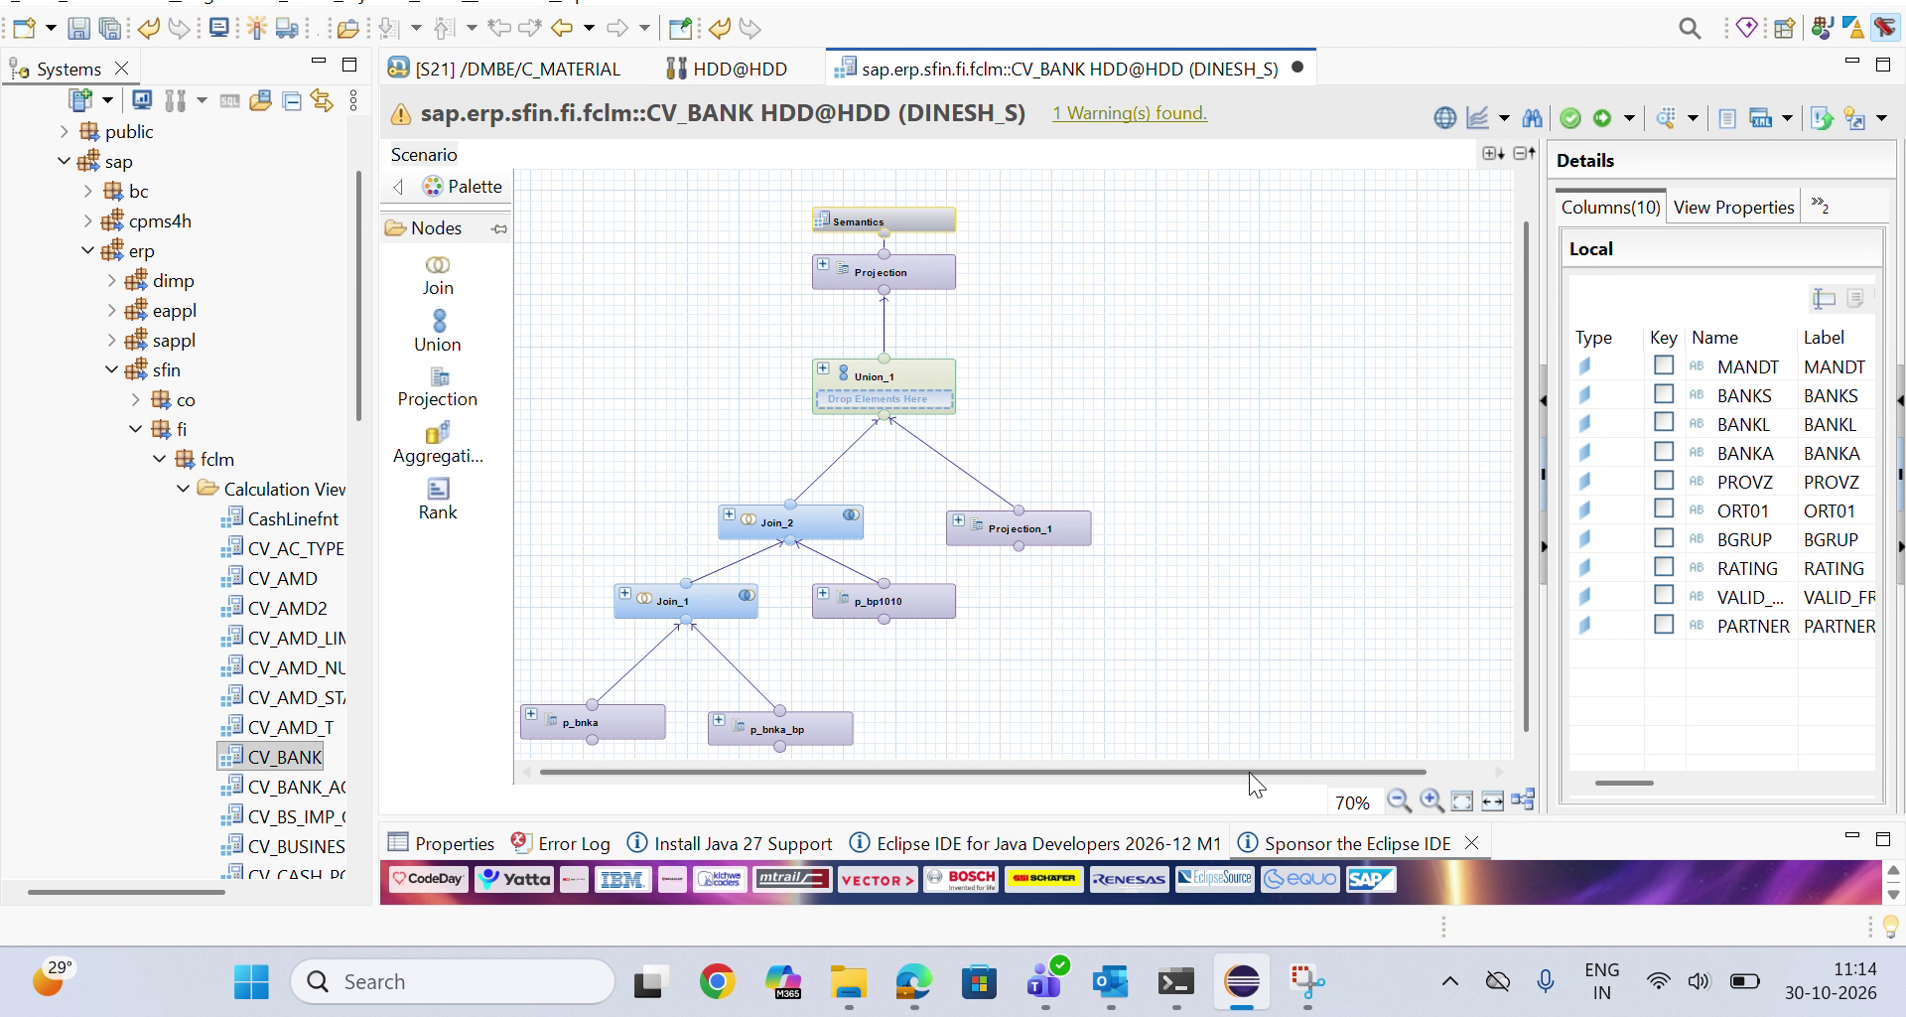
• What is shown: The native graphical calculation view editor in Eclipse showing the multi-tier DAG of sap.erp.sfin.fi.fclm::CV_BANK: p_bnka + p_bnka_bp -> Join_1, Join_1 + p_bp1010 -> Join_2, CashLinefnt -> Projection_1, and both converging into Union_1 -> Projection -> Semantics.
• Key Insights: Establishes the ground truth multi-level hierarchy that enterprise architects need to preserve in SAP Datasphere for compliance and data traceability.

EVIDENCE 02: HanaMorph Studio: Step 1 - Source View Selection
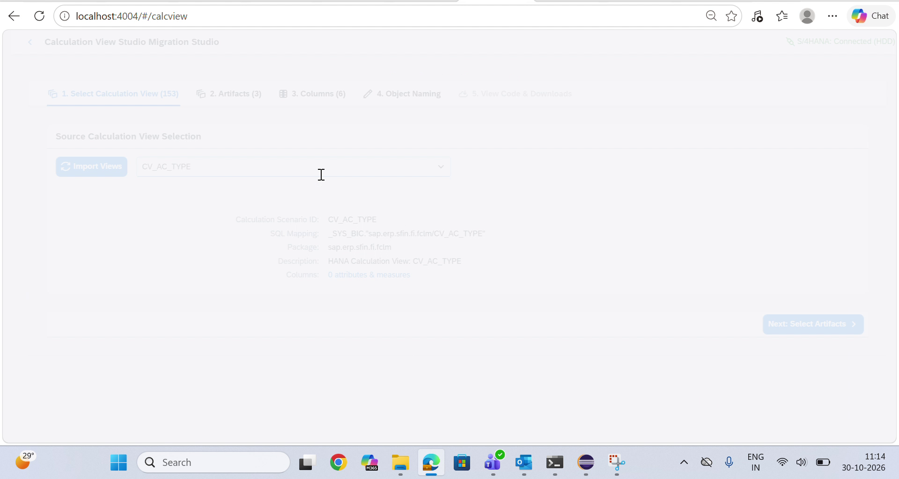
• What is shown: The HanaMorph Calculation View Migration Studio interface connected live to S/4HANA: Connected (HDD) with 153 calculation views discovered.
• Key Insights: Demonstrates real-time integration with live SAP HANA catalog repositories without requiring manual XML uploads.

EVIDENCE 03: HanaMorph Studio: Calculation View Metadata Resolution
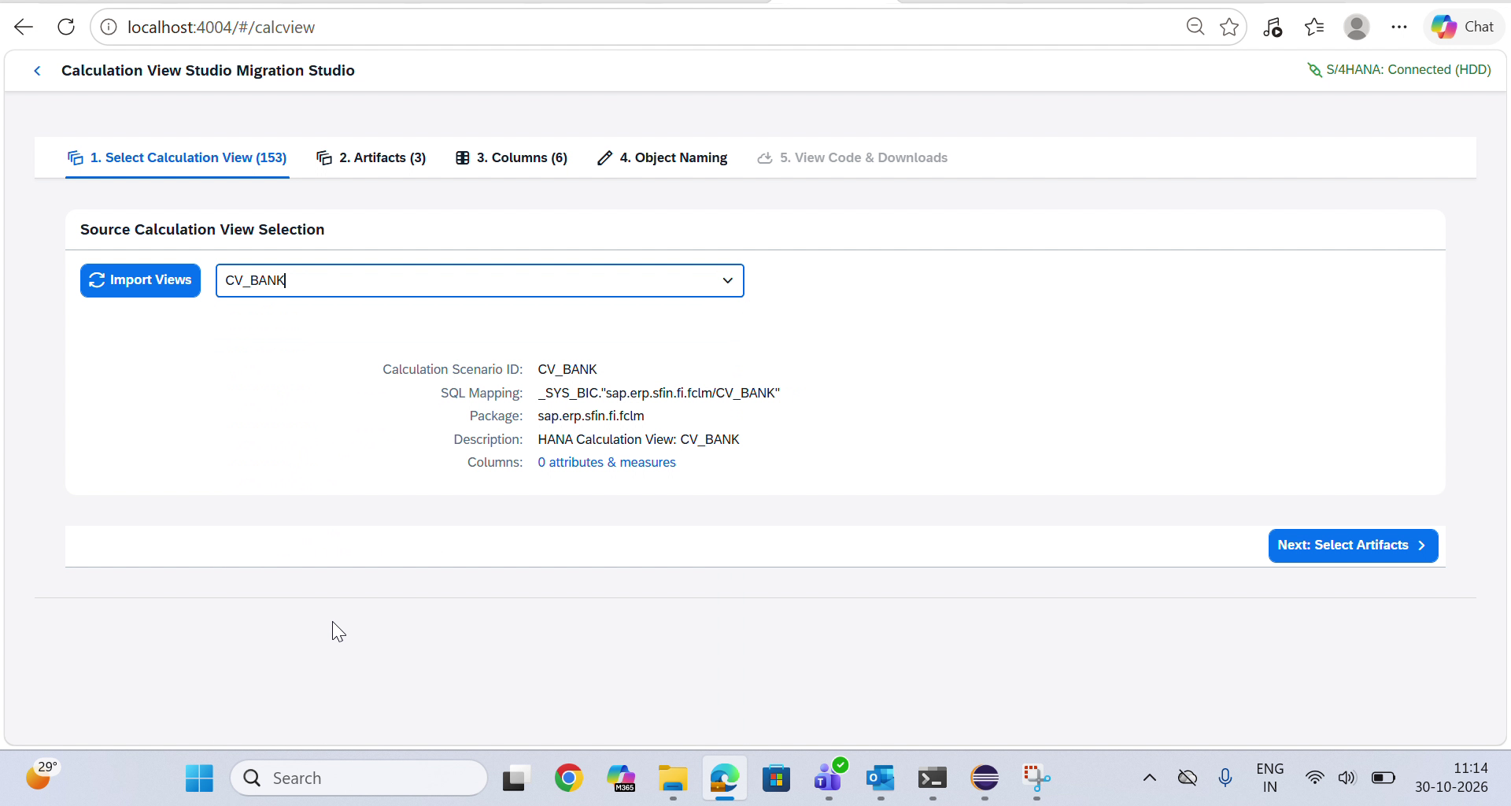
• What is shown: User selecting CV_BANK. HanaMorph dynamically loads the calculation scenario ID, package (sap.erp.sfin.fi.fclm), and underlying SQL mapping _SYS_BIC."sap.erp.sfin.fi.fclm/CV_BANK".
• Key Insights: Instant validation of calculation scenario metadata ensuring accurate dependency parsing.

EVIDENCE 04: HanaMorph Studio: Step 2 - Scenario Components & Artifact Selection
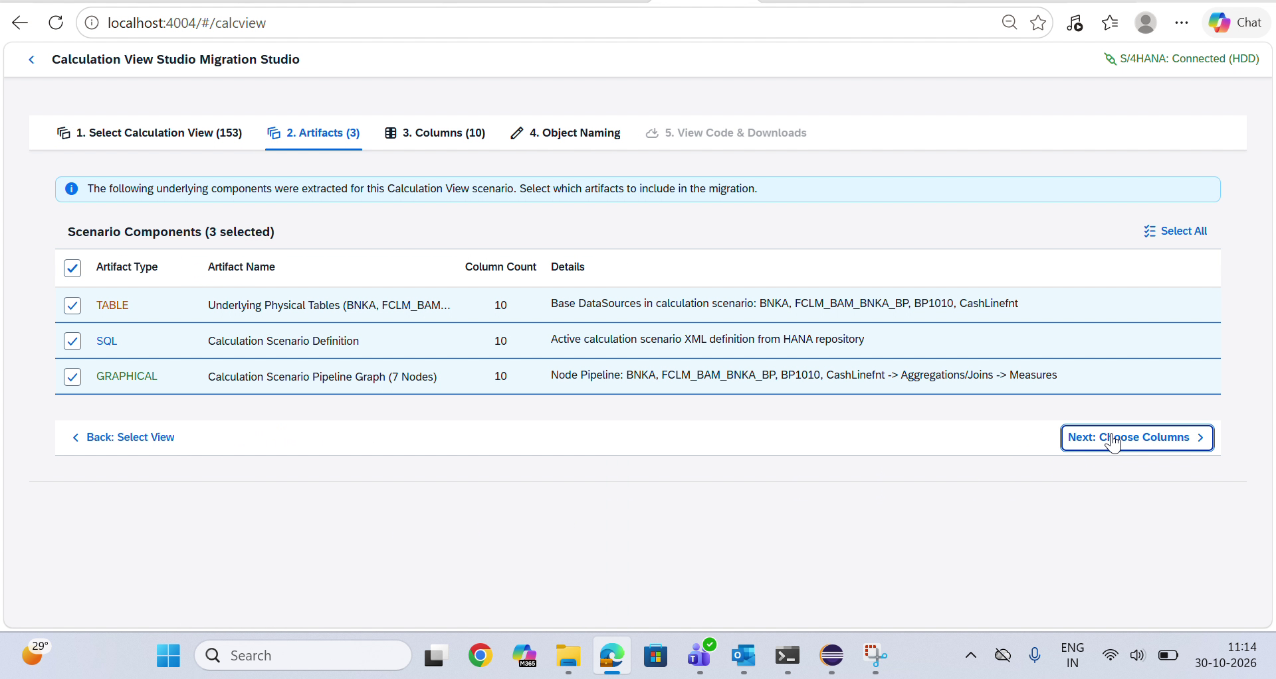
• What is shown: HanaMorph Step 2 Artifacts Selection displaying all extracted components for CV_BANK: TABLE (Underlying Physical Tables: BNKA, FCLM_BAM_BNKA_BP, BP1010, CashLinefnt - 10 columns), SQL (Active Calculation Scenario Definition), and GRAPHICAL (Calculation Scenario Pipeline Graph - 7 Nodes: BNKA, FCLM_BAM_BNKA_BP, BP1010, CashLinefnt -> Aggregations/Joins -> Measures).
• Key Insights: Provides full transparency into extracted scenario layers, allowing architects to select physical tables, DDLs, and visual graph pipelines with one click before progressing.

EVIDENCE 05: HanaMorph Studio: Step 3 - Detailed Column Mapping & Semantic Typing
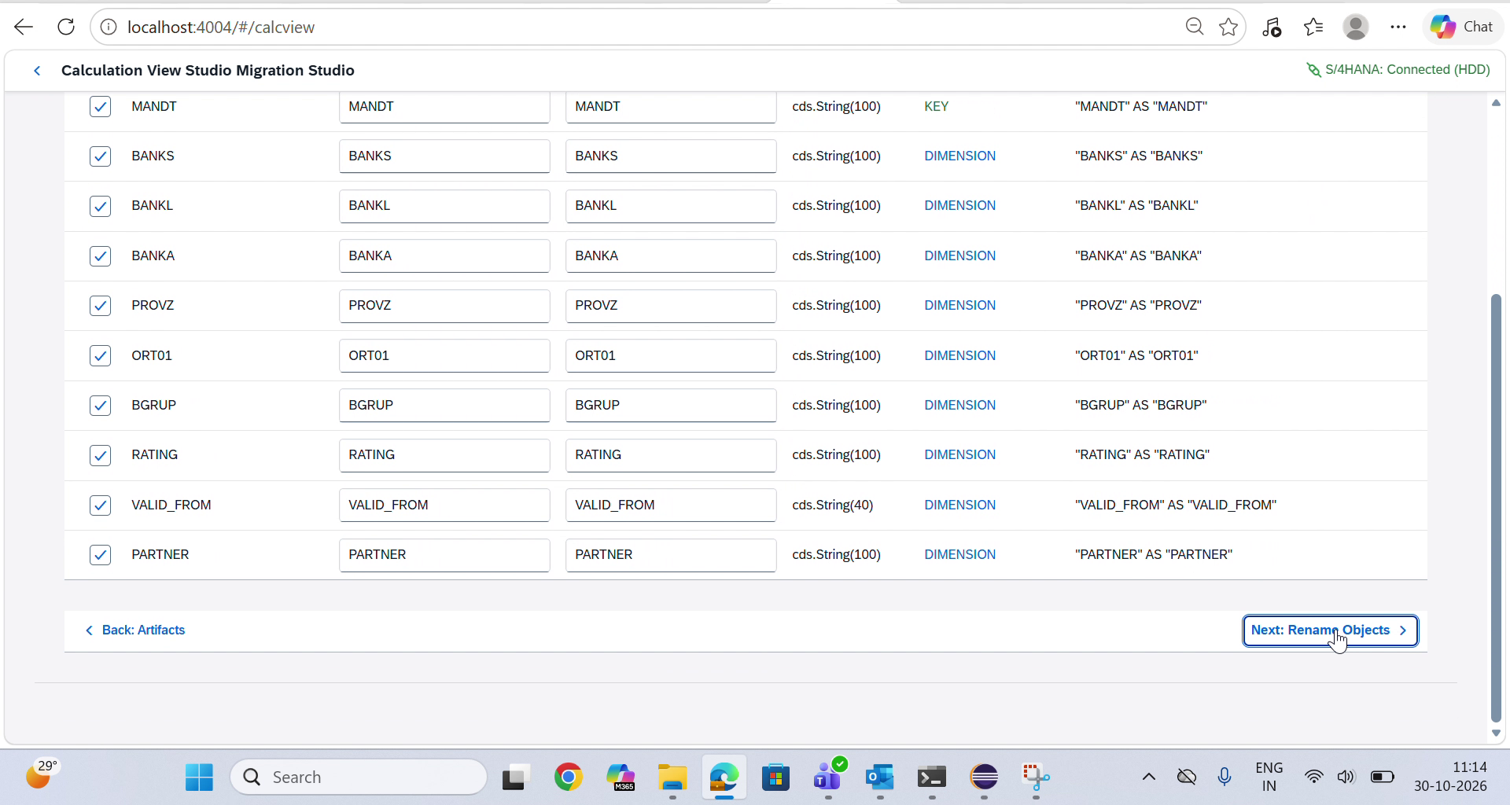
• What is shown: HanaMorph Step 3 Columns view listing all 10 extracted attributes: MANDT (cds.String(100), KEY), BANKS (DIMENSION), BANKL (DIMENSION), BANKA (DIMENSION), PROVZ (DIMENSION), ORT01 (DIMENSION), BGRUP (DIMENSION), RATING (DIMENSION), VALID_FROM (cds.String(40), DIMENSION), and PARTNER (cds.String(100), DIMENSION) with target projection preview ("MANDT" AS "MANDT").
• Key Insights: Guarantees data integrity by mapping HANA types to native CDS/Datasphere types and confirming primary keys and dimensional roles before generation.

EVIDENCE 06: HanaMorph Studio: Step 4 - Technical & Business Object Naming Configuration
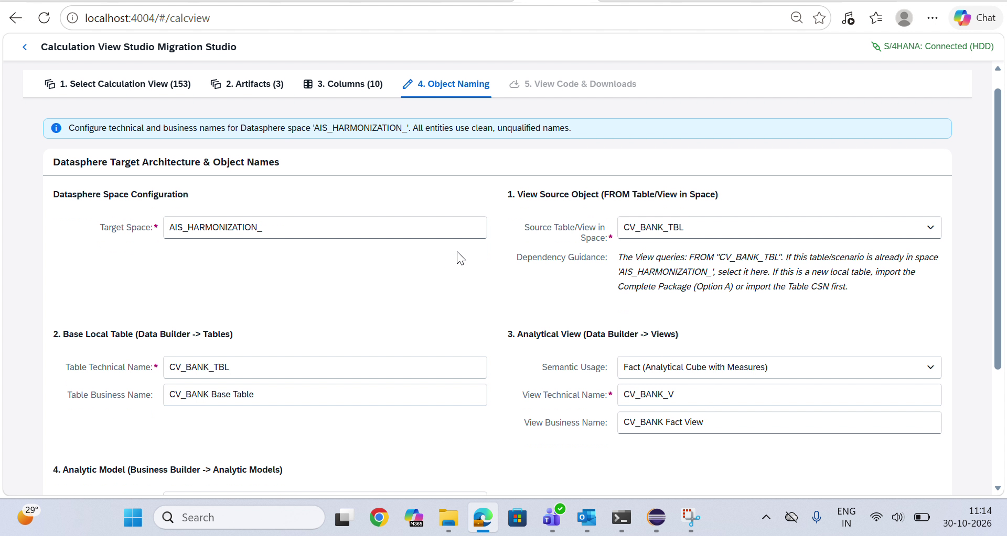
• What is shown: Configuration panel for target space AIS_HARMONIZATION_, specifying Local Table (CV_BANK_TBL), Fact Analytical View (CV_BANK_V), Semantic Usage (Fact - Analytical Cube with Measures), and Analytic Model (CV_BANK_AM).
• Key Insights: Provides enterprise governance over naming conventions, preventing space object collisions in multi-tenant environments.

EVIDENCE 07: HanaMorph Studio: Step 5 - Multi-Tier SQL Views & Package Download Hub
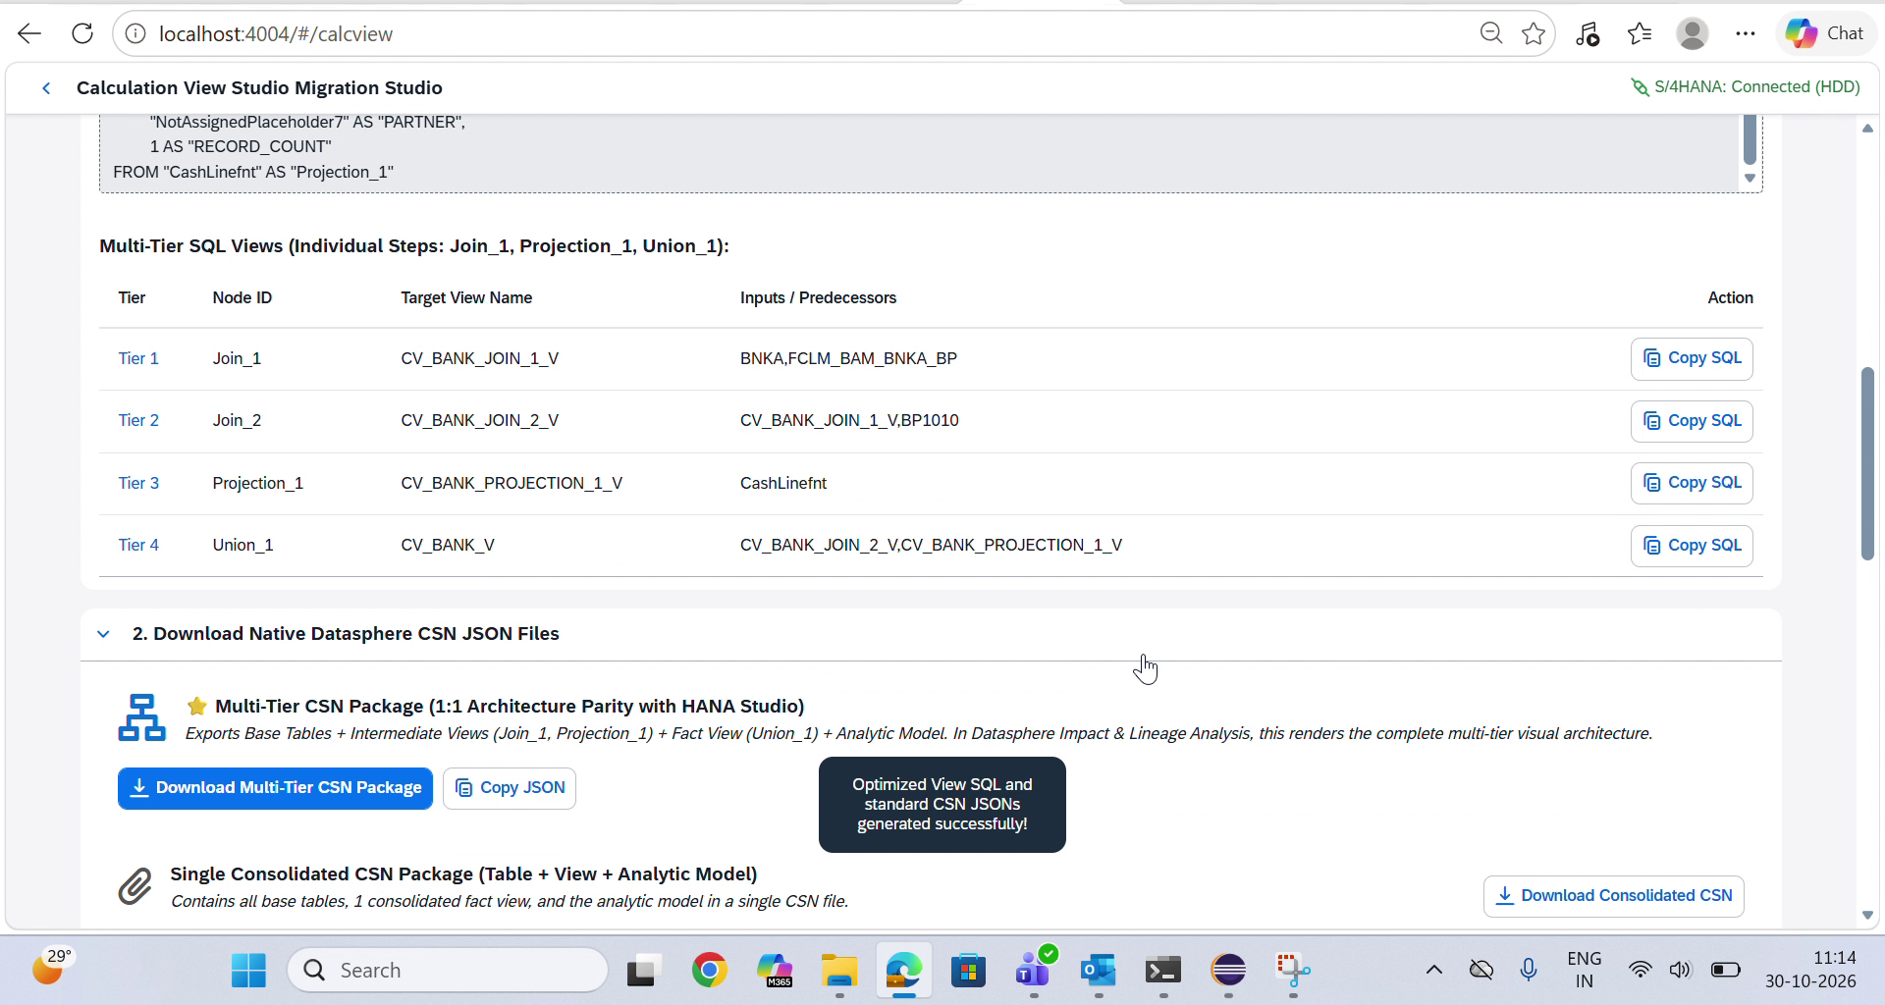
• What is shown: Step 5 View Code & Downloads showing the complete Multi-Tier SQL Views breakdown table: Tier 1 Join_1 -> CV_BANK_JOIN_1_V (BNKA, FCLM_BAM_BNKA_BP), Tier 2 Join_2 -> CV_BANK_JOIN_2_V (CV_BANK_JOIN_1_V, BP1010), Tier 3 Projection_1 -> CV_BANK_PROJECTION_1_V (CashLinefnt), Tier 4 Union_1 -> CV_BANK_V (CV_BANK_JOIN_2_V, CV_BANK_PROJECTION_1_V) with Copy SQL actions, followed by the Download Multi-Tier CSN Package button and success notification: 'Optimized View SQL and standard CSN JSONs generated successfully!'.
• Key Insights: Empowers architects with individual copyable tier SQL statements while offering single-click download of the complete multi-tier CSN package for visual lineage preservation.

EVIDENCE 08: HanaMorph Studio: Multi-Tier CSN Package Download Execution
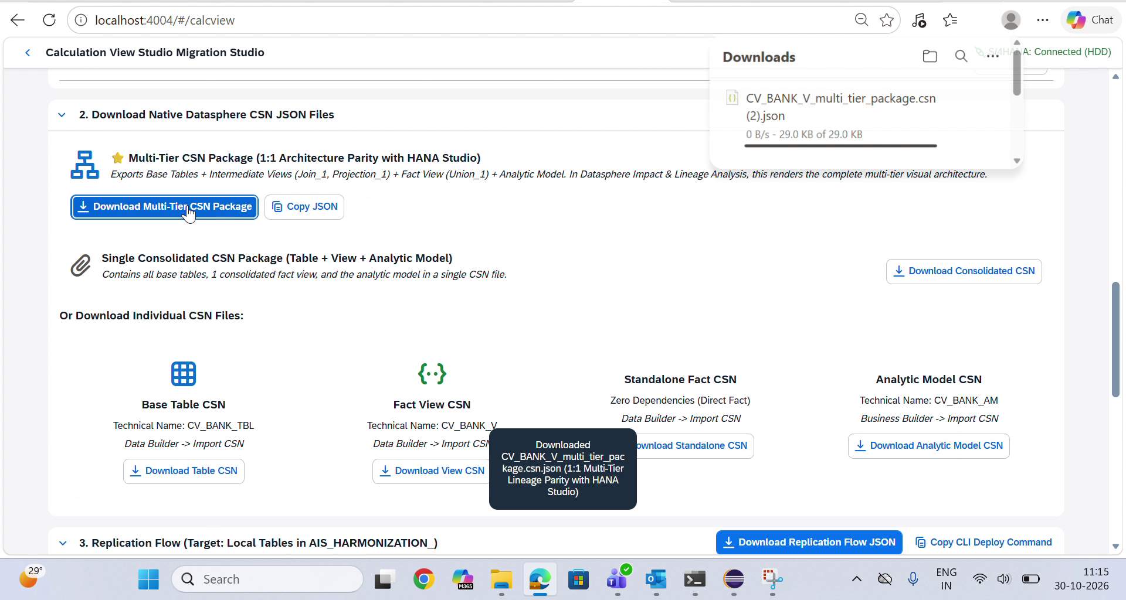
• What is shown: User executing Download Multi-Tier CSN Package. Browser download manager confirms CV_BANK_V_multi_tier_package.csn.json (29.0 KB) downloaded with UI toast confirmation: 'Downloaded CV_BANK_V_multi_tier_package.csn.json (1:1 Multi-Tier Lineage Parity with HANA Studio)'.
• Key Insights: Self-contained packaging bundles all 10 participating artifacts (base tables, intermediate transformation views, fact view, and analytic model) in one single file.

EVIDENCE 09: SAP Datasphere Data Builder: Import Objects from CSN/JSON Action
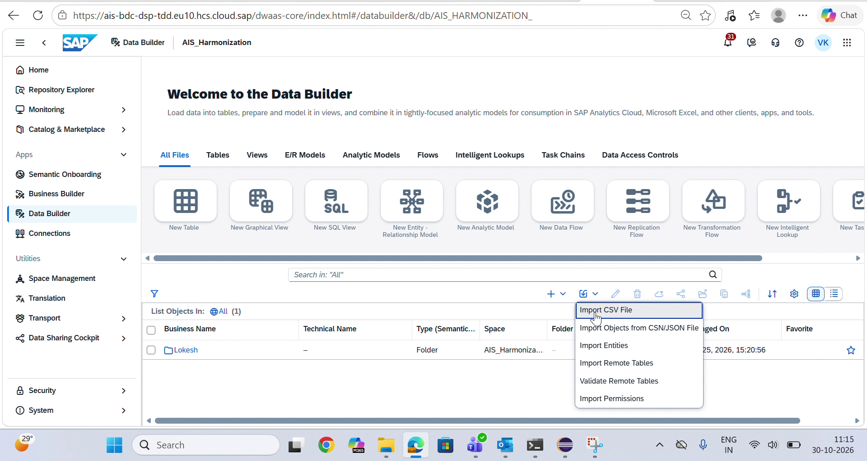
• What is shown: SAP Datasphere web interface in space AIS_Harmonization, navigating to Data Builder -> Import Objects from CSN/JSON File.
• Key Insights: Demonstrates standard, non-intrusive native Datasphere import workflow requiring zero CLI scripting or manual database elevation.

EVIDENCE 10: SAP Datasphere: Pre-Import Validation of Multi-Tier Entities
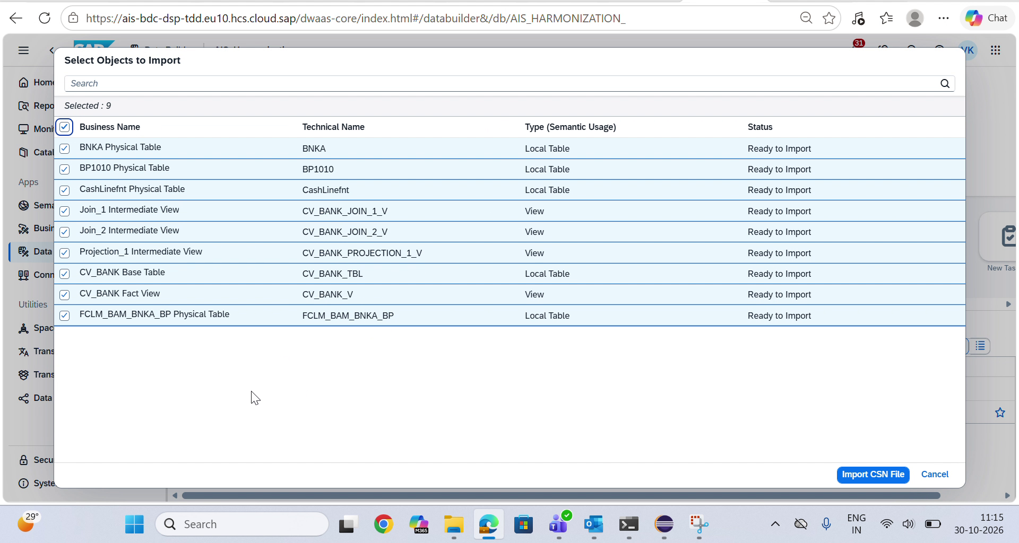
• What is shown: Datasphere dialog listing all 9 detected entities with Ready to Import status: Local Tables (BNKA, BP1010, CashLinefnt, CV_BANK_TBL, FCLM_BAM_BNKA_BP), Intermediate Views (CV_BANK_JOIN_1_V, CV_BANK_JOIN_2_V, CV_BANK_PROJECTION_1_V), and Analytical Fact View (CV_BANK_V).
• Key Insights: All physical tables and intermediate calculation tiers are recognized simultaneously as first-class space catalog entities.

EVIDENCE 11: SAP Datasphere: Import Completed Successfully Banner
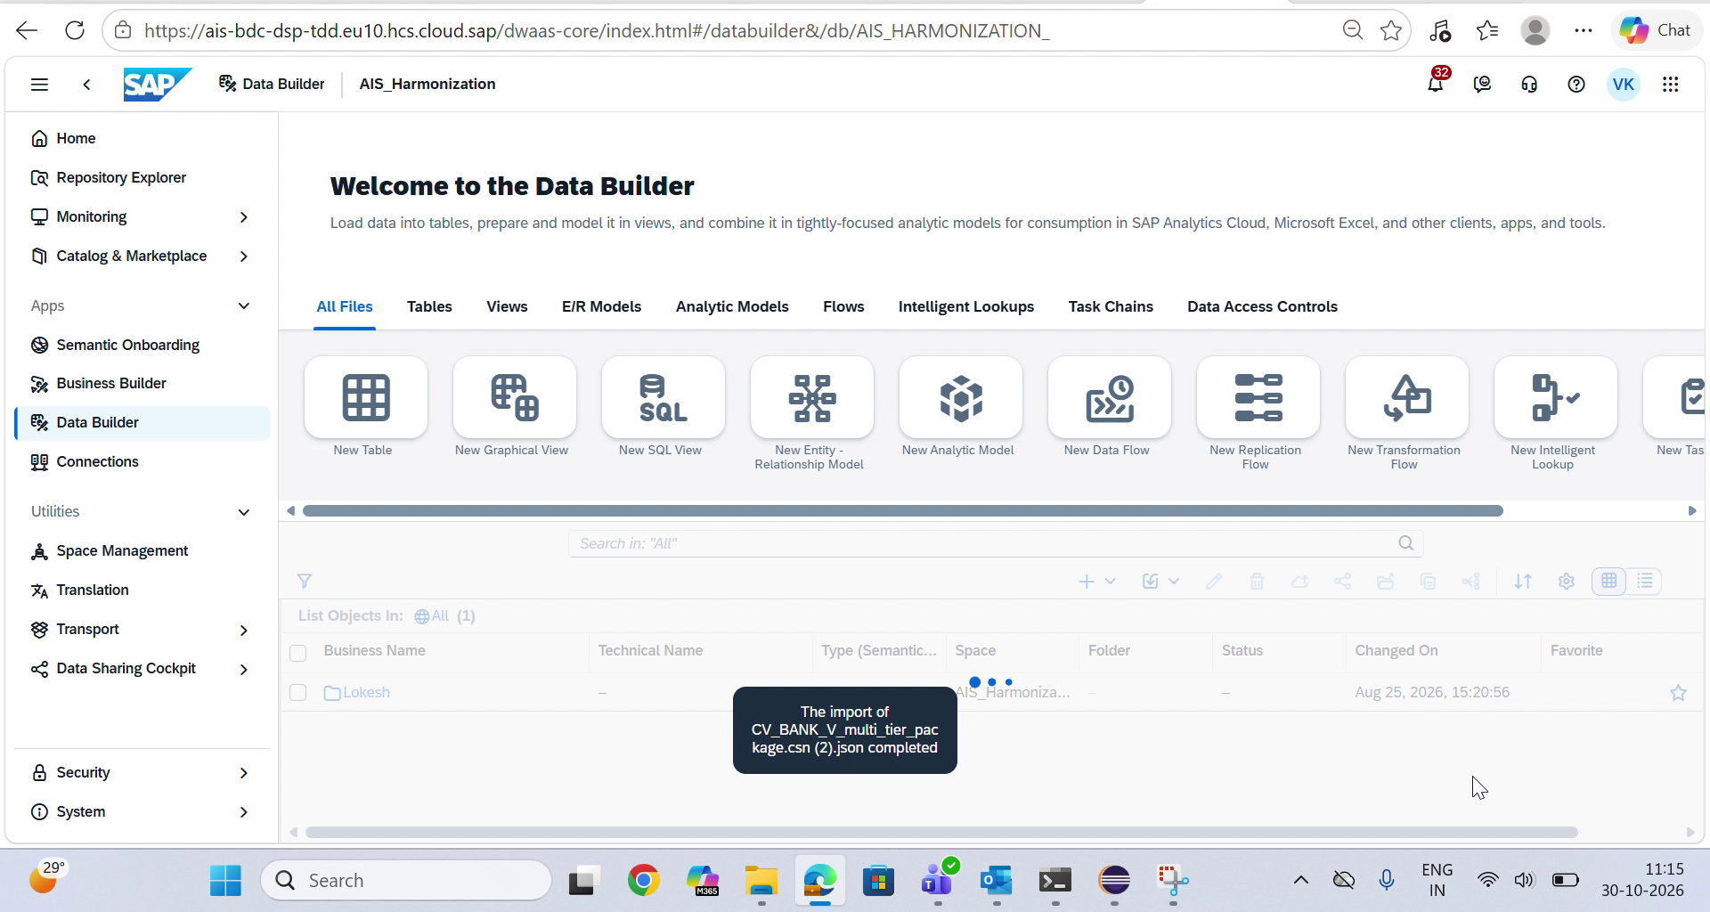
• What is shown: Datasphere confirmation banner: The import of CV_BANK_V_multi_tier_package.csn (2).json completed.
• Key Insights: Validates that all join keys (PARTNER = PARTNR), null-handling calculated fields (RATING, VALID_FROM), and table schemas compiled without any missing object errors.

EVIDENCE 12: SAP Datasphere: Opening Deployed CV_BANK_V Fact View
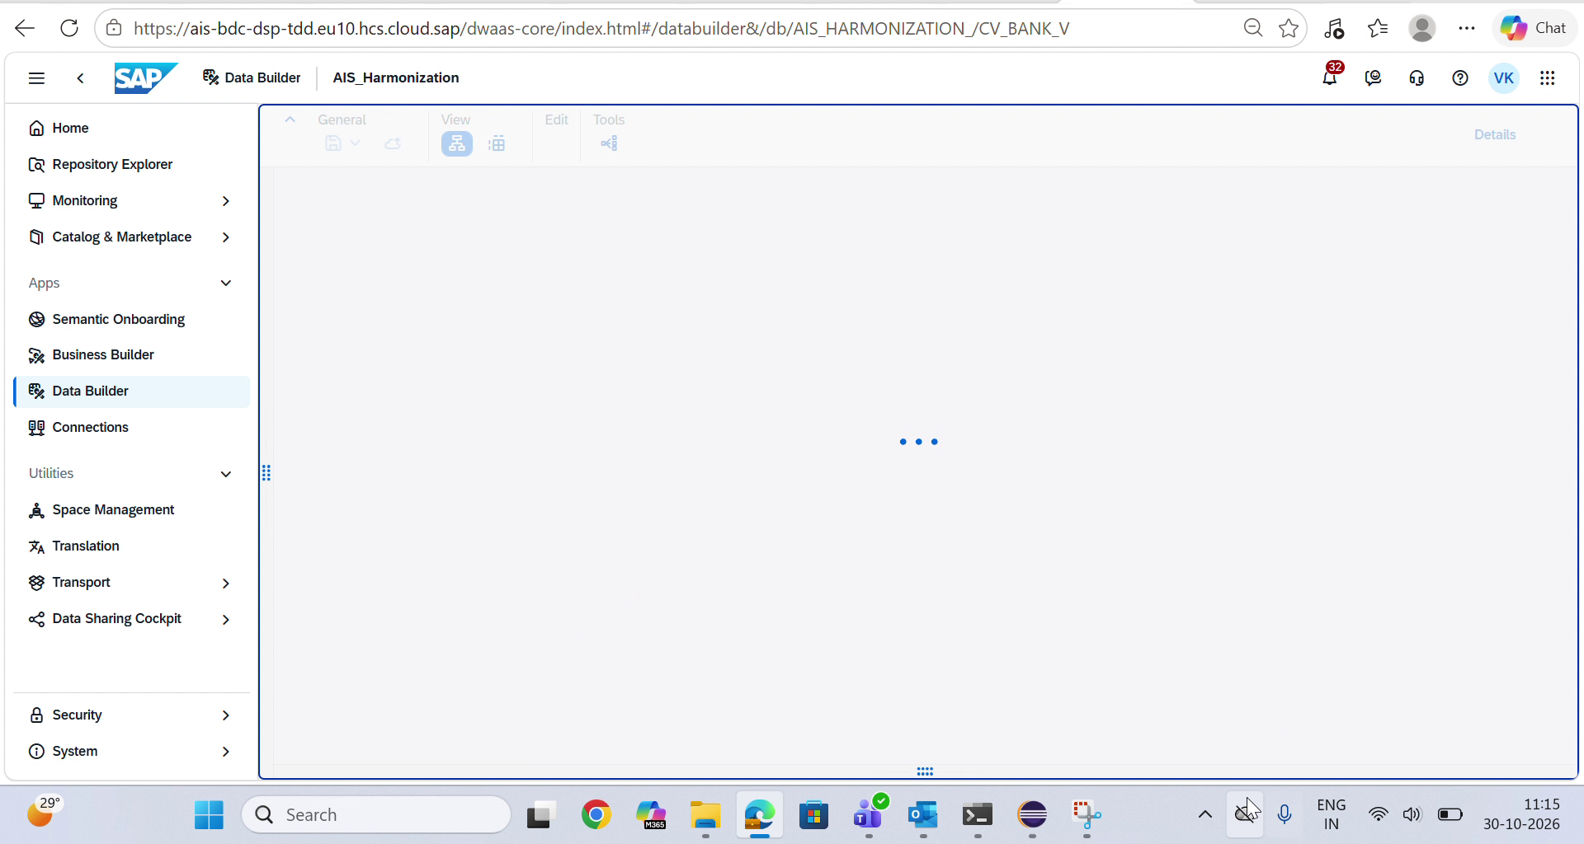
• What is shown: Navigating directly to the generated CV_BANK_V Fact View inside AIS_Harmonization workspace.
• Key Insights: Seamless transition from import to object inspection in the native web modeler.

EVIDENCE 13: SAP Datasphere: Pure SELECT SQL View Editor & Validation
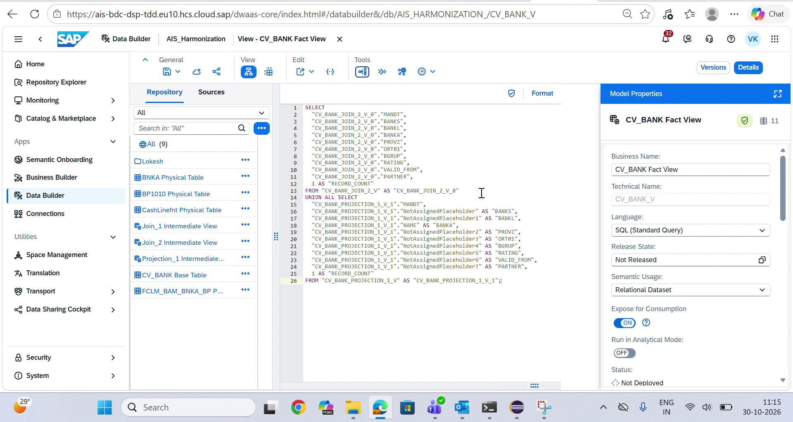
• What is shown: The Datasphere SQL View Editor displaying the clean SELECT ... FROM "CV_BANK_JOIN_2_V" UNION ALL SELECT ... FROM "CV_BANK_PROJECTION_1_V". Green validation shield displays indicating 100% grammar compliance and zero syntax errors.
• Key Insights: Demonstrates complete adherence to Datasphere SQL grammar (pure top-level SELECT, zero disallowed WITH CTEs).

EVIDENCE 14: SAP Datasphere: Visual Lineage Parity Verification (Side-by-Side)
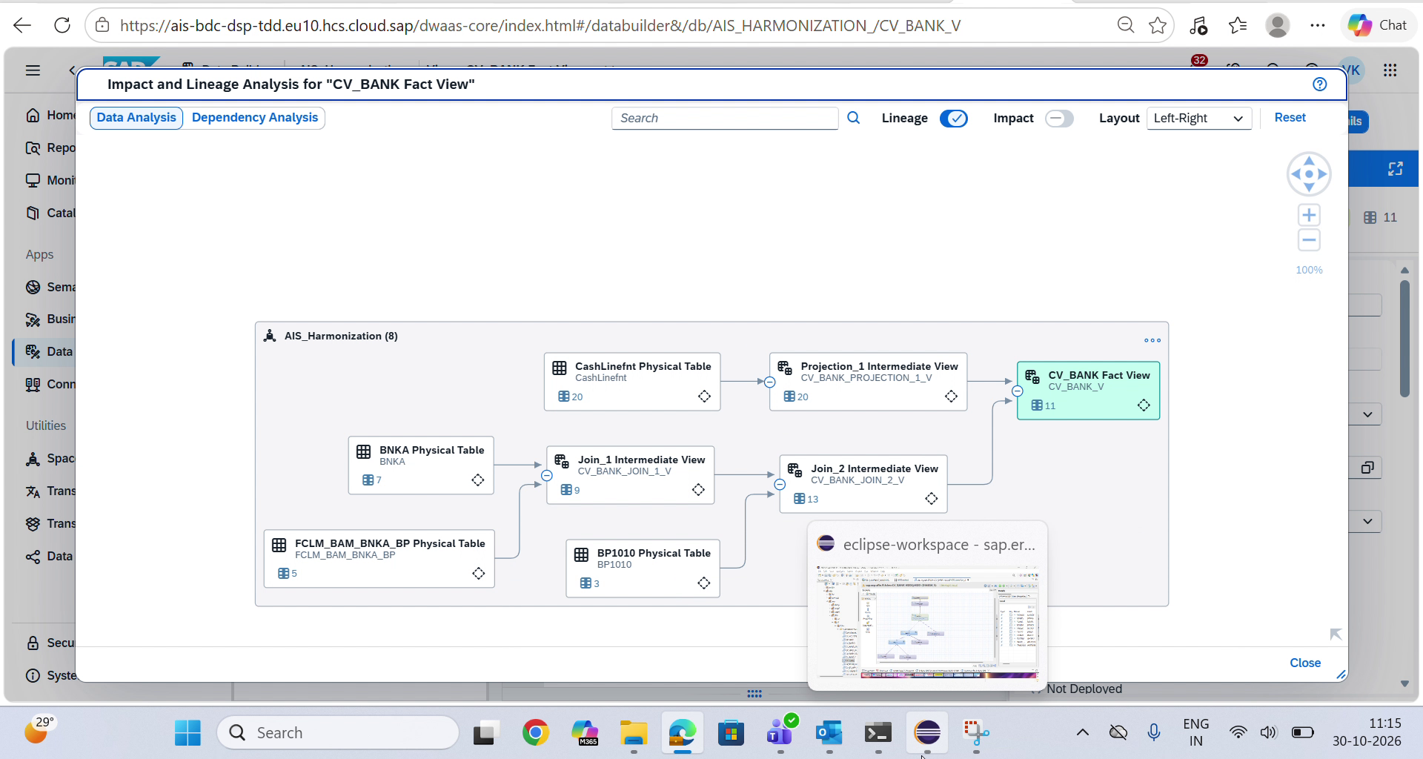
• What is shown: Datasphere Impact and Lineage Analysis displaying the complete multi-tier DAG: BNKA + FCLM_BAM_BNKA_BP -> Join_1 (CV_BANK_JOIN_1_V), CV_BANK_JOIN_1_V + BP1010 -> Join_2 (CV_BANK_JOIN_2_V), CashLinefnt -> Projection_1 (CV_BANK_PROJECTION_1_V), and CV_BANK_JOIN_2_V + CV_BANK_PROJECTION_1_V -> CV_BANK_V. An Eclipse thumbnail is overlaid directly on screen confirming identical visual geometry.
• Key Insights: Proves 100% architectural and visual parity between SAP HANA Studio and SAP Datasphere.

EVIDENCE 15: SAP Datasphere: Fullscreen Enterprise Lineage Graph
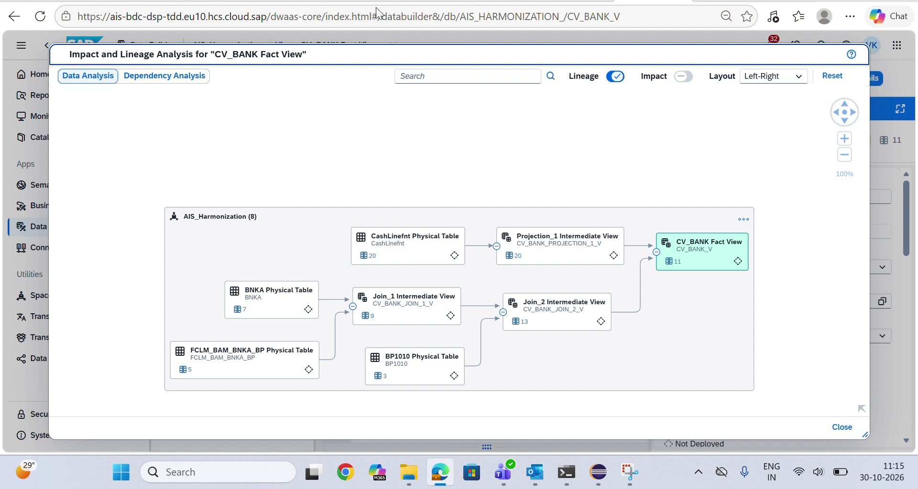
• What is shown: Full unobstructed view of the 8-object lineage graph inside space AIS_Harmonization, showing clean Left-Right dependency flow, column counts on each node (7, 5, 3, 20, 9, 13, 20, 11), and end-to-end data provenance.
• Key Insights: Production-ready governance and impact analysis ready for immediate deployment and consumption in SAP Analytics Cloud.

6. SAP HUB ASSET INFORMATION
Industry | Cross-Industry (Banking, Financial Services, Manufacturing, Consumer Products, Retail)
Line of Business | Finance, Cash & Treasury Management, IT & Enterprise Data Architecture
SAP Products Used | • SAP Datasphere (Data Builder, Impact & Lineage Analysis, Business Builder)  • SAP S/4HANA & SAP HANA 2.0 (Calculation Views, _SYS_REPO, Core Data Services)  • SAP Analytics Cloud (SAC Consumption Models)  • SAP Cloud Application Programming (CAP) Model & SAPUI5
Demo Availability | Yes (Automated live migration demonstration available on local port 4004)
Video Available | Yes (Screen Recording 2026-10-30 111546.mp4 — 74s full E2E walkthrough)
Documentation Available | Yes (Complete architectural blueprints, CSN schemas, and verified test suites included in codebase)
7. ARCHITECTURAL ALIGNMENT SUMMARY TABLE
Pipeline Layer | HANA Studio / Eclipse Architecture | HanaMorph Datasphere Object | Datasphere Semantic Role
Physical Table 1 | BNKA (Bank Master Table) | BNKA Physical Table | Local Table (7 Elements)
Physical Table 2 | FCLM_BAM_BNKA_BP (Bank Partner Mapping) | FCLM_BAM_BNKA_BP Physical Table | Local Table (5 Elements)
Physical Table 3 | BP1010 (Business Partner Rating) | BP1010 Physical Table | Local Table (3 Elements)
Helper Table | CashLinefnt (Placeholder Attributes) | CashLinefnt Physical Table | Local Table (20 Elements)
Tier 1 Join | Join_1 (Left Outer: BNKA ⋈ FCLM_BAM_BNKA_BP) | CV_BANK_JOIN_1_V | Transformation View (9 Elements)
Tier 2 Join | Join_2 (Left Outer: Join_1 ⋈ BP1010 on PARTNER=PARTNR) | CV_BANK_JOIN_2_V | Transformation View (13 Elements + Coalesced)
Tier 2 Projection | Projection_1 (CashLinefnt Projection) | CV_BANK_PROJECTION_1_V | Transformation View (20 Elements)
Root Tier Union | Union_1 (UNION ALL: Join_2 ∪ Projection_1) | CV_BANK_V | Analytical Fact View (#CUBE, 11 Elements)
Consumption Layer | Analytical Query / Semantics | CV_BANK_AM | Analytic Model (Business Builder)

