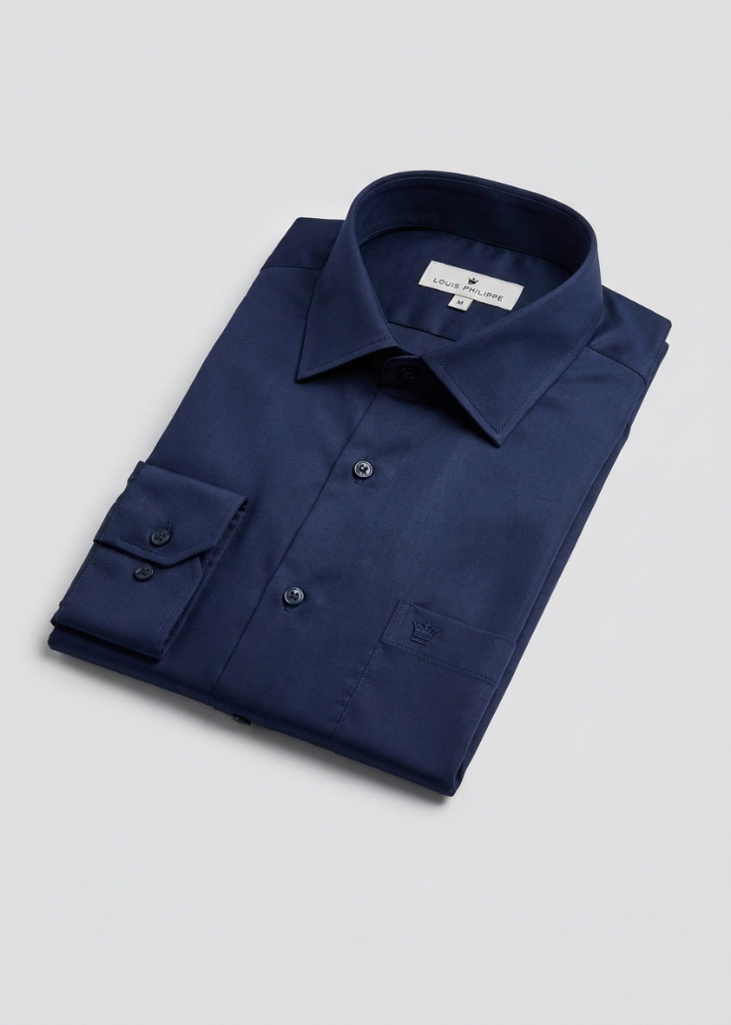
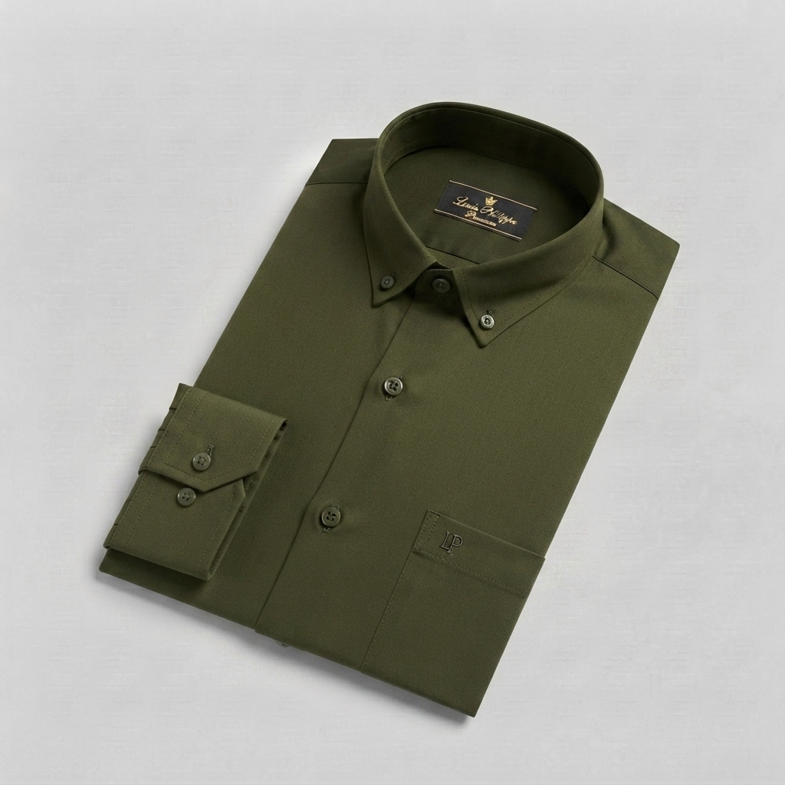
Louis Philippe
Men's Premium Shirt
Olive Green , Blue, Red, white
Premium men's shirt offering a smart and sophisticated casual look.
Size: S, M, L, XL, XXL;
Fit: Slim Fit; Sleeve: Full Sleeve; Fabric: Cotton Blend; Pattern: Solid; Collar: Button-Down

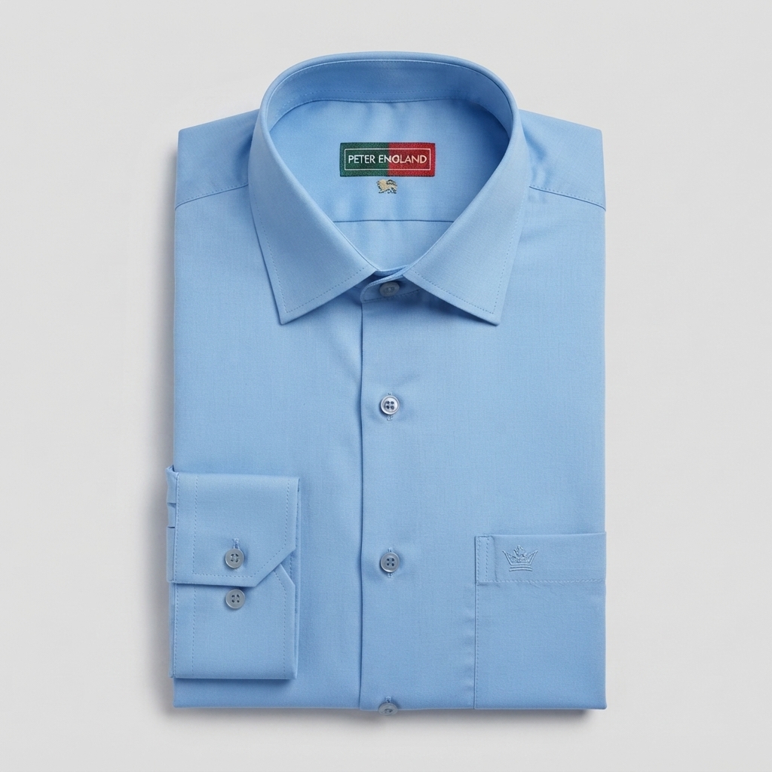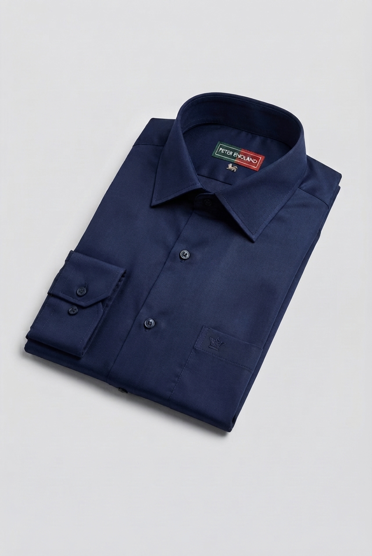
Peter England
Men's Formal Shirt
Navy Blue, black, sky blue
Stylish formal shirt suitable for office and professional wear.
Size: S, M, L, XL, XXL; Fit: Slim Fit; Sleeve: Full Sleeve; Fabric: Cotton Blend; Pattern: Solid; Collar: Spread
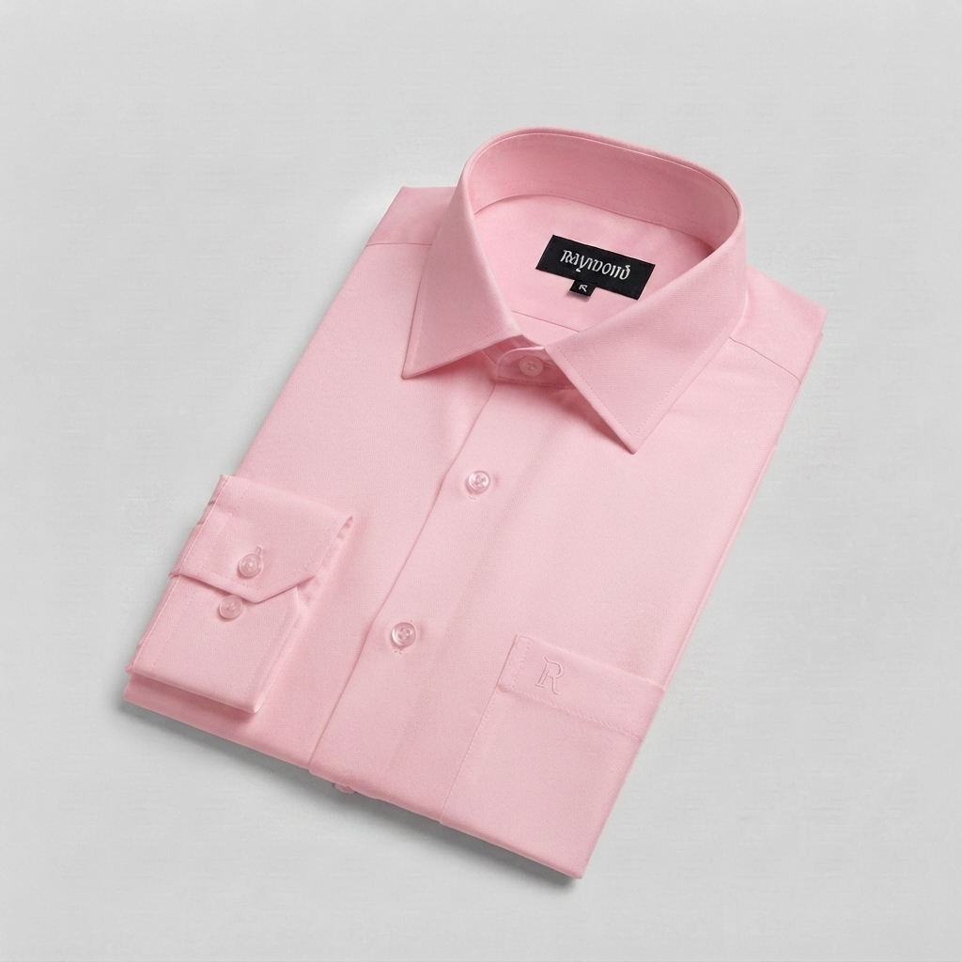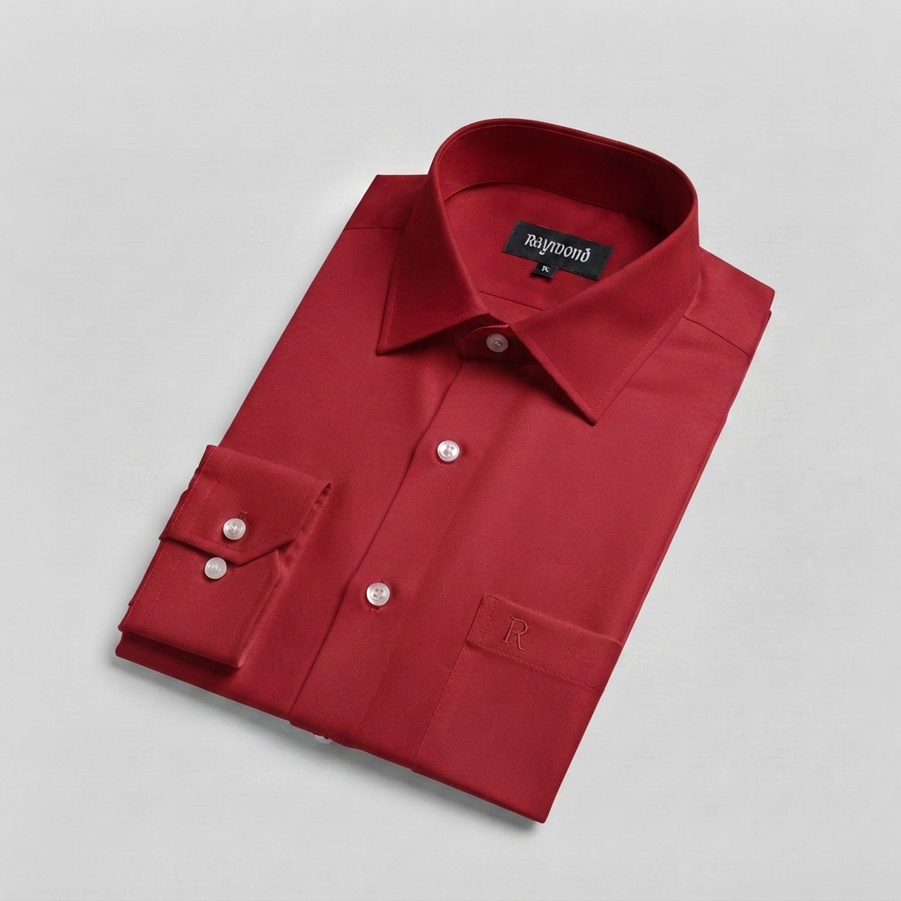
Raymond
Men's Formal Shirt
White, pink, sky blue, red , purple
Premium classic shirt designed for a clean and elegant formal look.
Size: S, M, L, XL, XXL; Fit: Regular Fit; Sleeve: Full Sleeve; Fabric: Cotton; Pattern: Solid; Collar: Spread
give me image
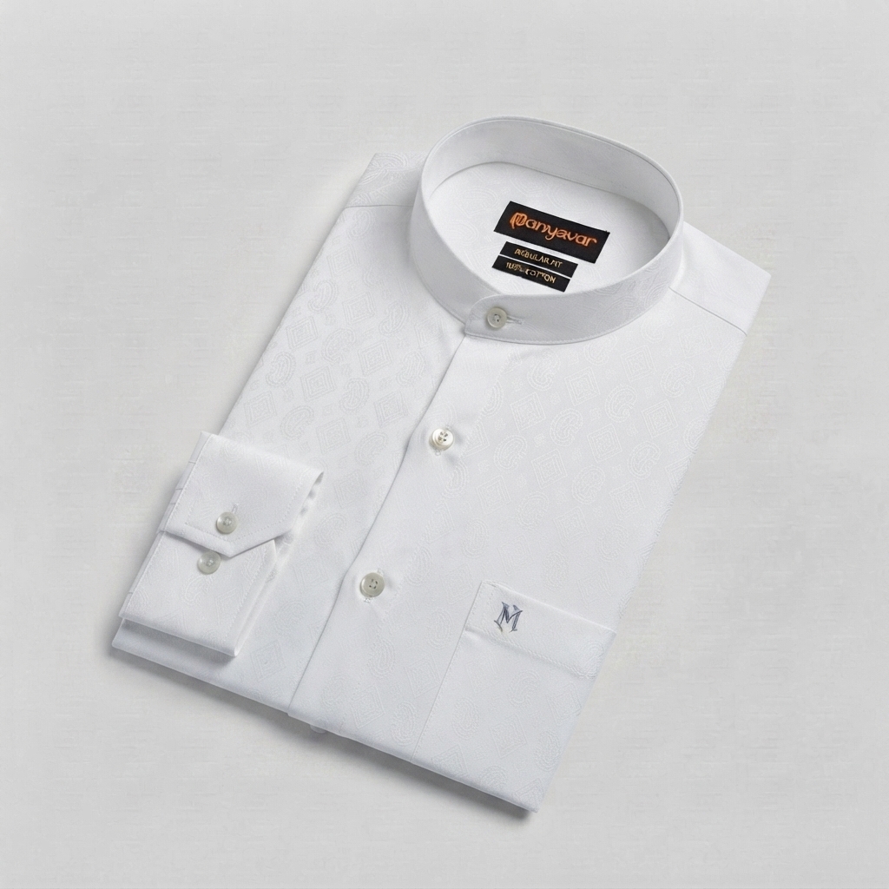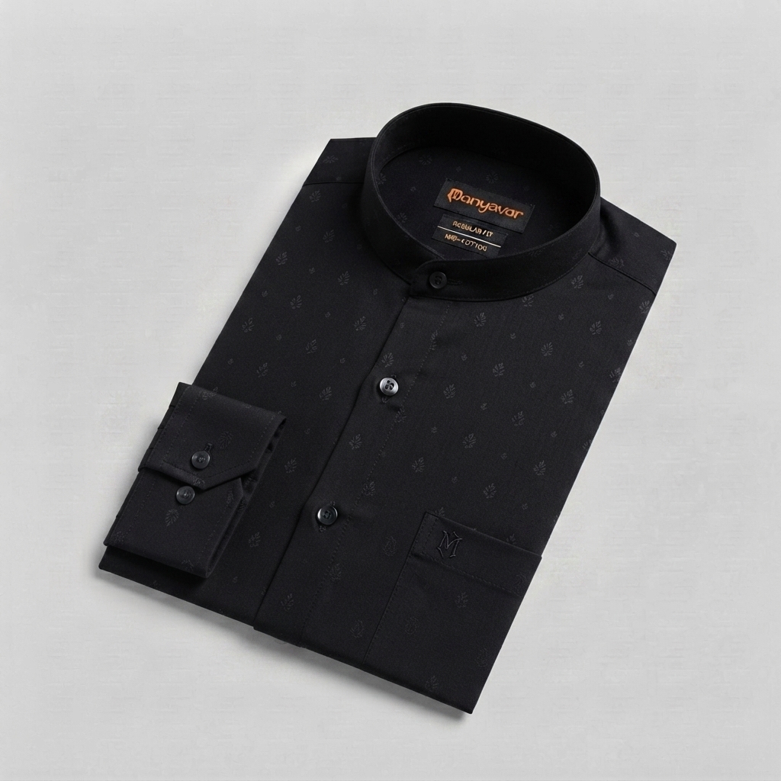
Manyavar
Men's Casual Shirt
white, black, olive green, red, grey, yellow
Comfortable and stylish shirt suitable for casual occasions and outings.
Size: S, M, L, XL, XXL; Fit: Regular Fit; Sleeve: Full Sleeve; Fabric: Cotton; Pattern: Printed; Collar: Mandarin

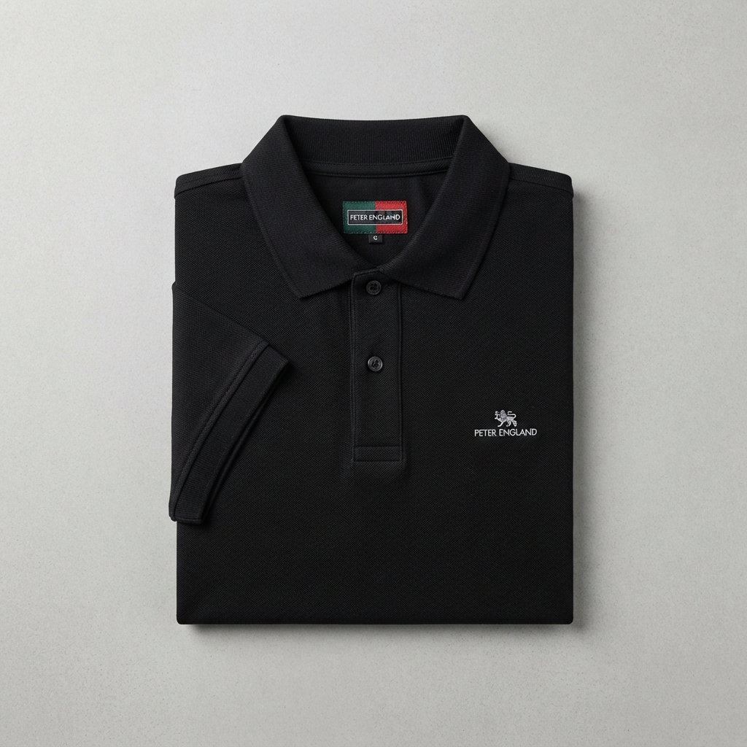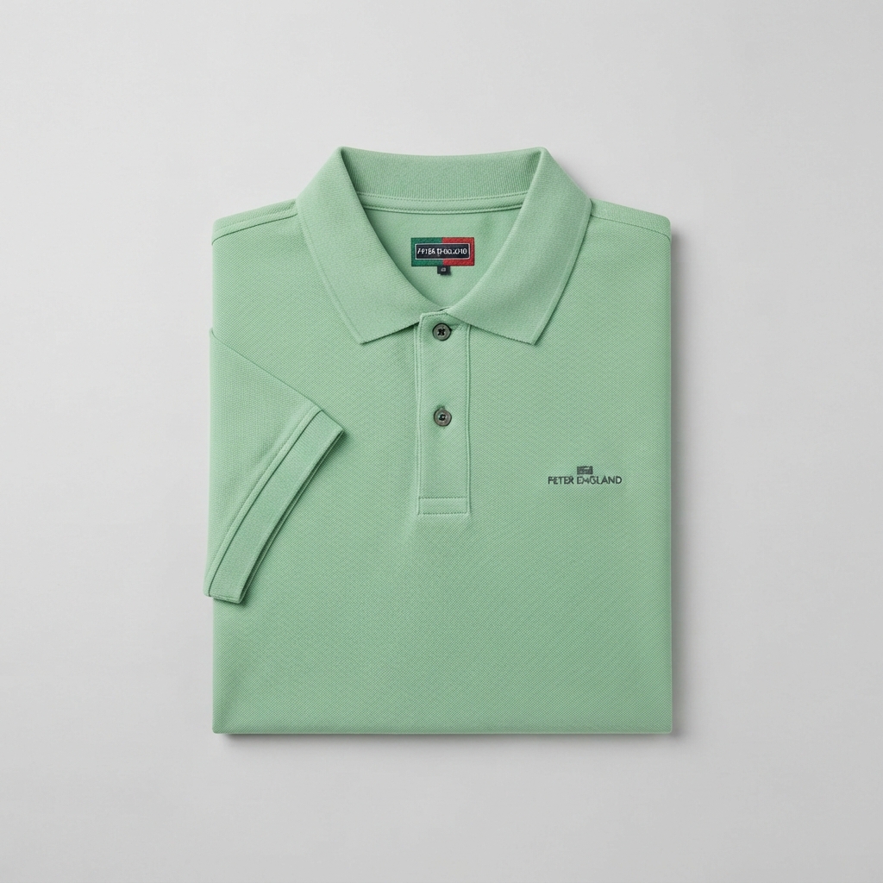
Peter England
Men's Solid Polo T-Shirt
Navy Blue, white , black, marun, pestal green, grey
Classic polo T-shirt suitable for casual and smart-casual wear.
Size: S, M, L, XL, XXL; Fit: Regular Fit; Sleeve: Half Sleeve; Fabric: Cotton; Pattern: Solid; Neck: Polo
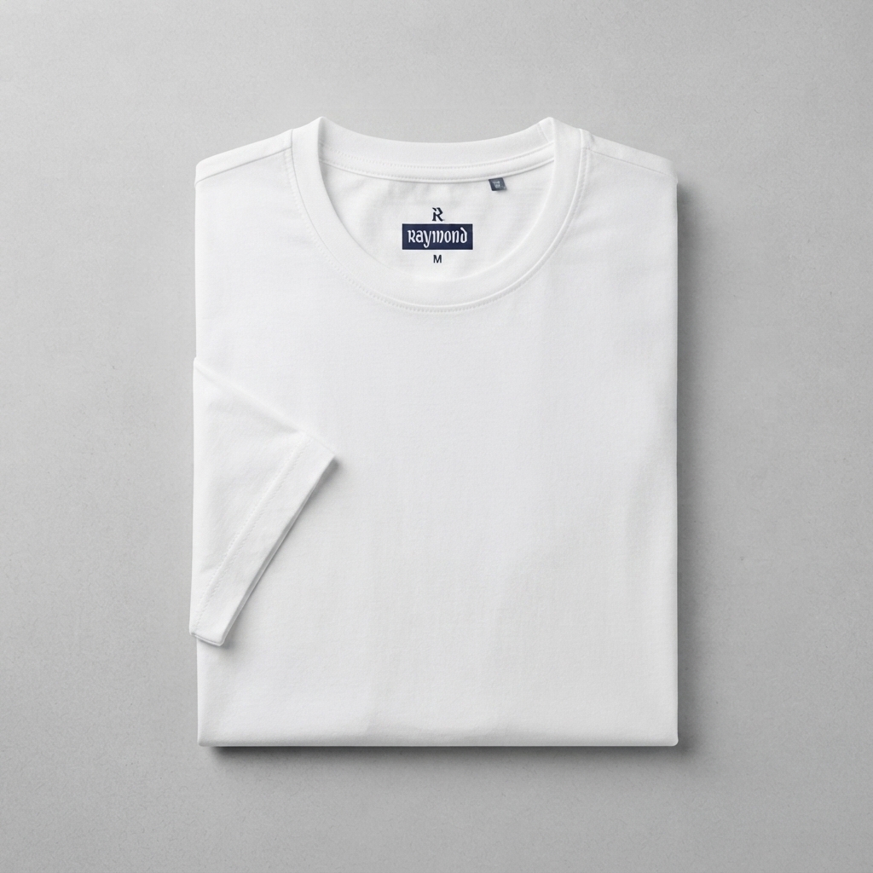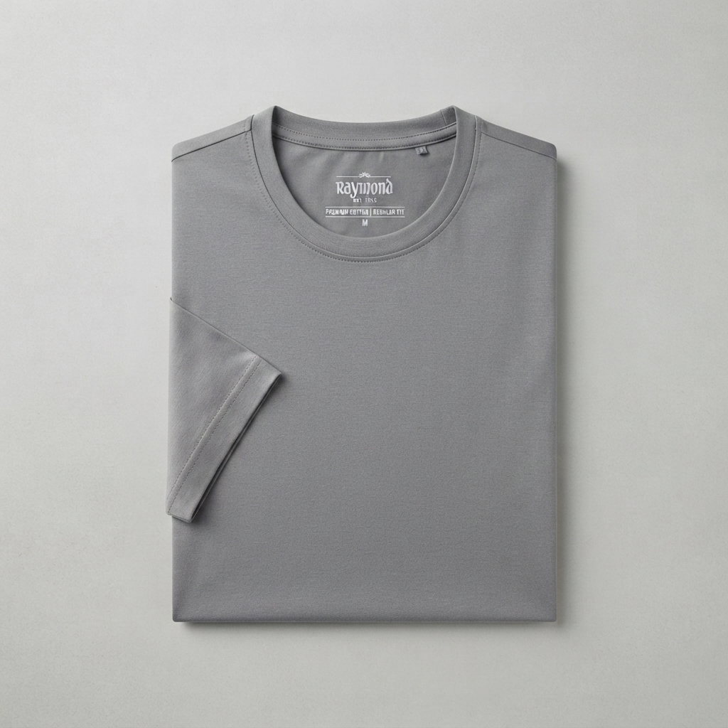
Raymond
Men's Cotton T-Shirt
White lack blue red grey
Comfortable cotton T-shirt with a clean and minimal look for everyday wear.
Size: S, M, L, XL, XXL; Fit: Regular Fit; Sleeve: Half Sleeve; Fabric: Cotton; Pattern: Solid; Neck: Round Neck

