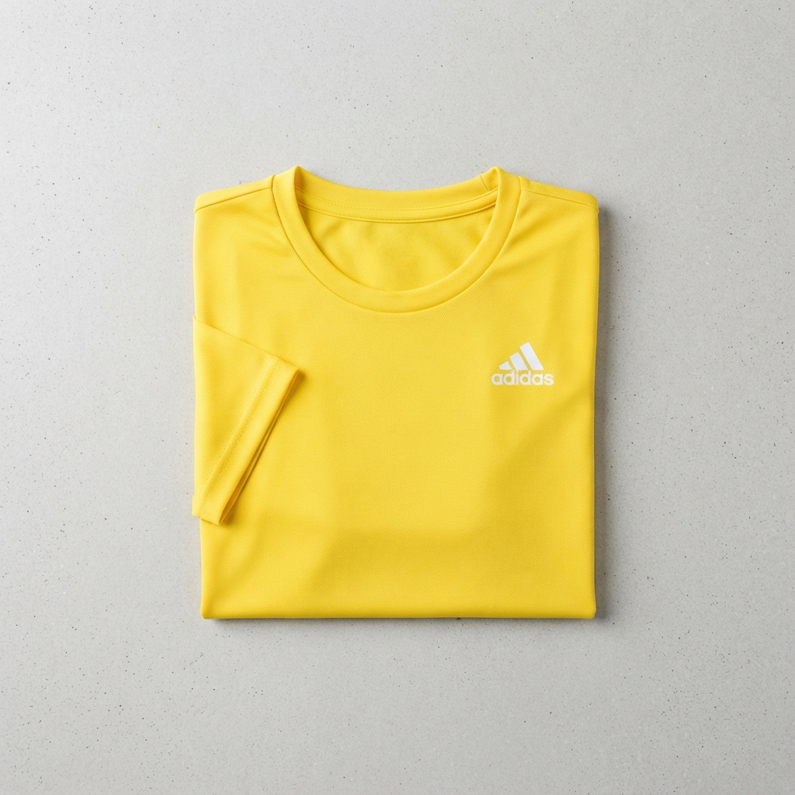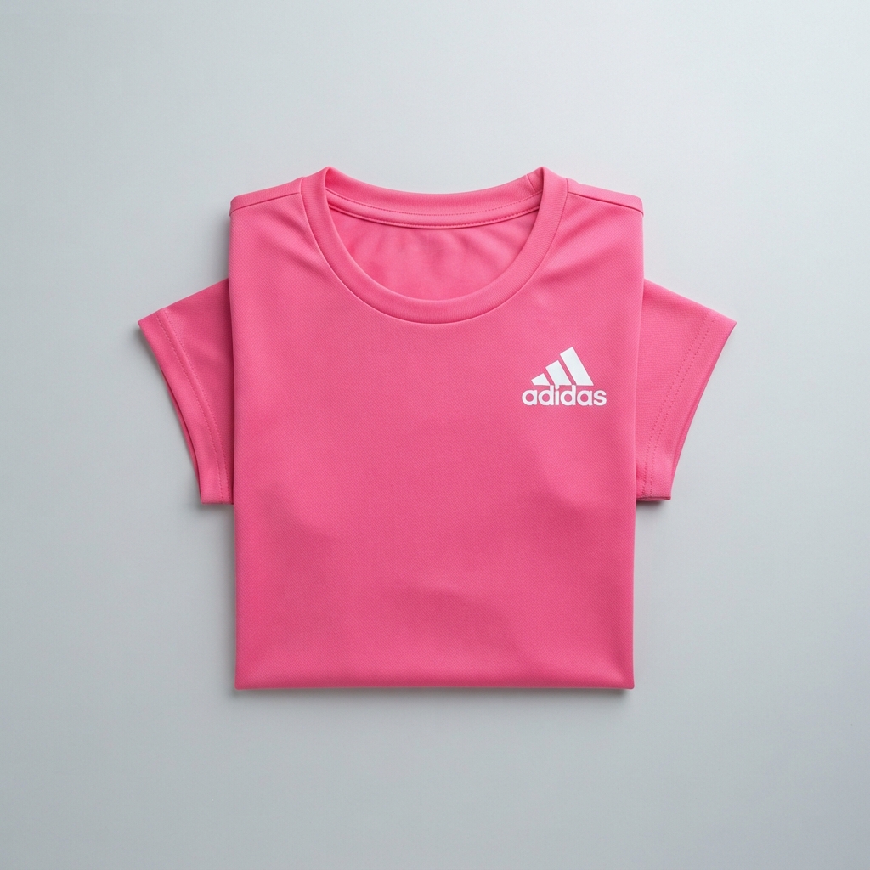
Adidas
Women's Sports T-Shirt
Black pink yellow pestal green grey black
Stylish sports T-shirt designed for workouts, running, and active lifestyles.
Size: S, M, L, XL; Fit: Regular Fit; Sleeve: Half Sleeve; Fabric: Polyester; Pattern: Solid; Neck: Round Neck
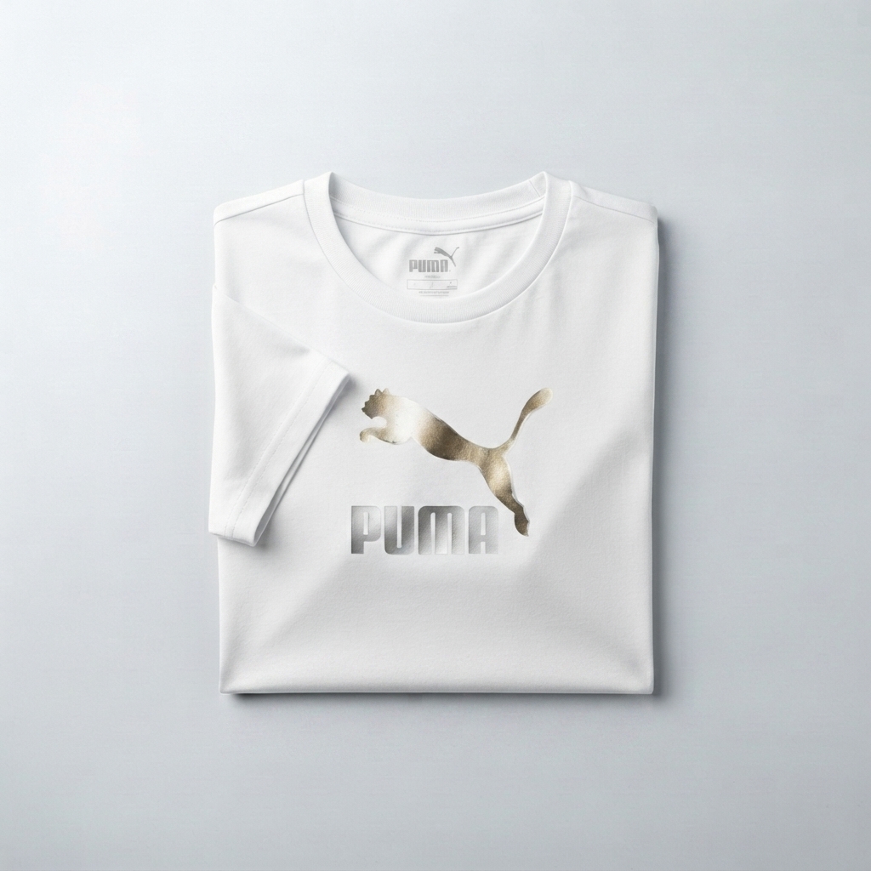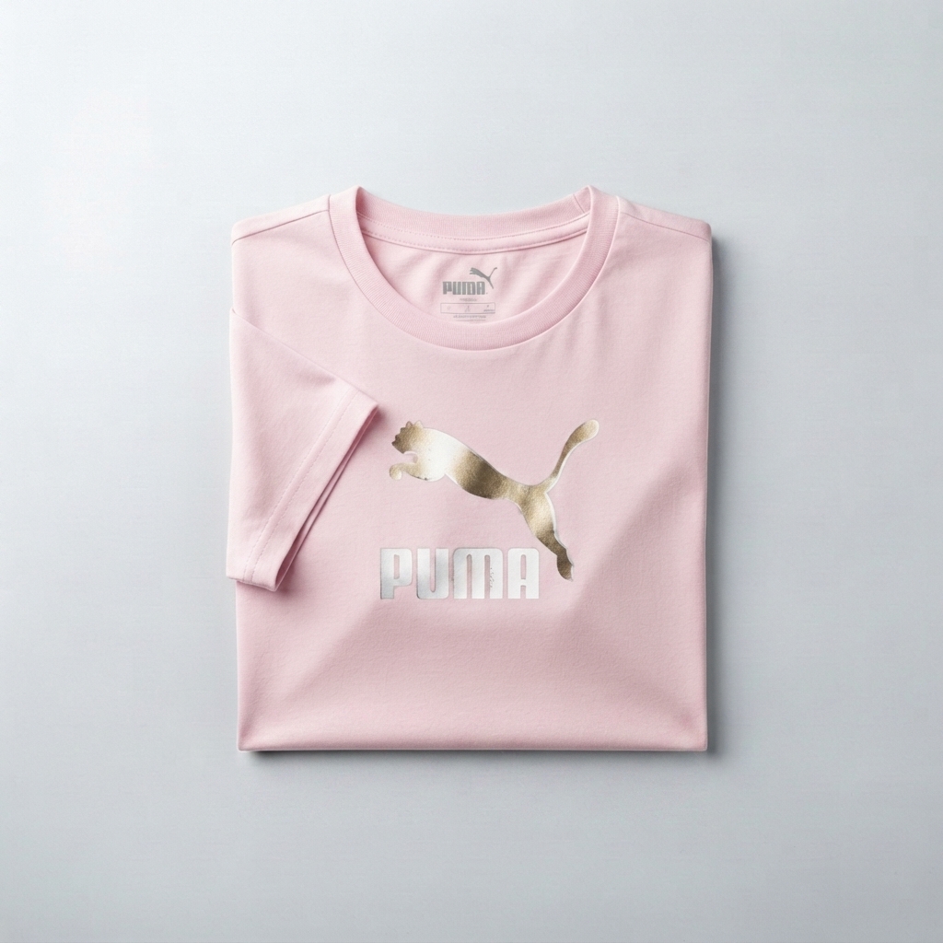
Puma
Women's Casual T-Shirt
Sky Blue Baby Pink Lavender Sky Blue White Black Mustard Yellow Mint Green Peach Maroon Beige Powder Blue Rose Pink
Comfortable and trendy T-shirt perfect for casual outings and everyday wear.
Size: S, M, L, XL; Fit: Regular Fit; Sleeve: Half Sleeve; Fabric: Cotton Blend; Pattern: Graphic Print; Neck: Round Neck

