SEMESTER PROJECT REPORT EEG 2026
Signal Processing and Analysis of Human Brain Potentials
Detecting Visuo-Haptic Mismatches in Virtual Reality using the Prediction Error Negativity of Event-Related Brain Potentials

A Replication Study

Team Name: | Team Phoenix
Members: | Varad Khanvilkar, Parth Zope, Inderjeet Kaur Rooprai
Original Paper: | Gehrke et al., CHI 2019
Dataset: | OpenNeuro ds003846 - 19 subjects
Analysis Tool: | MNE-Python 1.11.0
Submission Date: | 31 March 2026

Final Results: Grand Average ERPs of All Subjects
Git Repository Link: Team Pheonix Semester Project
(https://github.com/Varad150820/Team_Phoenix_EEG_Final_Project)

Table of Contents
Table of Contents
1. Abstract
2. Introduction
2.1 Background and Motivation
2.2 Research Question
3. Original Paper Summary
3.1 Citation
3.2 Experimental Design and Apparatus
3.3 Feedback Conditions and Mismatch Design
3.4 Original Analysis Pipeline
3.5 Key Results of the Original Study
4. Dataset
4.1 Overview
4.2 Event Markers and Their Meaning
4.3 Missing EMS Data A Key Discovery
5. Analysis of Pipeline
5.1 Design Philosophy
5.2 Pipeline Comparison: Authors vs Team Phoenix
5.3 Step-by-Step Pipeline Explanation with Motivation
Step 0 Recording Discovery and Orchestration
Step 1 Loading and Standardising
Step 2 Filtering, Resampling, and Re-referencing
Step 3 Bad Channel Detection and Interpolation
Step 4 ICA Artefact Removal
Step 5 Event Parsing and Trial Construction
Step 6 Epoching and Epoch Rejection
Step 7 Evoked Generation and Quality Metrics
Step 8 Group Aggregation and Outlier Removal
6. Milestone Progress
6.1 Milestone 1 Paper and Dataset Selection
6.2 Milestone 2 Pipeline Design and First Data Load
6.3 Milestone 3 First Subject Fully Analysed
6.4 Milestone 4 All Subjects Processed
6.5 Milestone 5 Replication Status and Further Analysis
7. Results
7.1 Grand Average ERP Overview
7.2 Key ERP Observations
7.3 Comparison with Original Results
8. Discussion
8.1 What We Found and Why It Matters
8.2 Differences from the Original Pipeline and Their Impact
8.3 Challenges Encountered and How We Resolved Them
Challenge 1: High epoch rejection rate at Milestone 2
Challenge 2: Missing EMS sessions for multiple subjects
Challenge 3: EMS electrical artefacts in EEG
Challenge 4: Noisy electrode in one subject
8.4 Limitations
9. Conclusions
10. References

1. Abstract
This report documents the complete semester project of Team Phoenix (Inderjeet Kaur Rooprai, Varad Khanvilkar, Parth Zope) in the course Signal Processing and Analysis of Human Brain Potentials (EEG), 2025. Our project goal was to replicate the EEG study by Gehrke et al. [1], which proposed detecting visuo-haptic mismatches in Virtual Reality through the brain's Prediction Error Negativity (PEN) a negative ERP component visible at the frontocentral electrode FCz approximately 100–300 ms after a sensory prediction violation. We worked with the openly available OpenNeuro dataset ds003846 (19 subjects, BIDS format) and built an end-to-end analysis pipeline in MNE-Python 1.11.0. The pipeline spans modular steps: loading, bandpass filtering (5–20 Hz), 50 Hz notch filtering, resampling (250 Hz), average re-referencing, robust bad-channel detection, ICA artefact removal (Infomax, 12 components), epoch extraction (−100 to +1000 ms), baseline correction (−100 to 0 ms), and epoch rejection. Subjects with noisy recordings were identified and removed before the final grand average. Our grand average ERPs, computed across all valid subjects for six conditions (EMS/Vibro/Visual, box:spawned/box:touched), qualitatively replicate the original findings: a clear negative deflection in the 100–300 ms window is present for mismatch (Spawned) conditions, with the EMS condition showing the largest amplitude, followed by Vibro and Visual. These results support the core claim of Gehrke et al. [1] that ERPs can serve as an objective, non-invasive metric for detecting visuo-haptic conflicts in VR.

2. Introduction

2.1 Background and Motivation
A fundamental challenge in Virtual Reality (VR) design is creating experiences that feel physically real. While display technology has advanced rapidly, haptic feedback the sense of touch and force remains difficult to implement with convincing timing and intensity. Whenever the haptic feedback does not match what the visual system predicts, the brain registers a sensory prediction error, which can disrupt immersion and degrade the user's experience. Traditional methods for measuring haptic immersion rely on the Igroup Presence Questionnaire (IPQ), which asks participants to rate how realistic the experience felt on a 1–7 scale. However, as Slater [3] argued, these questionnaire-based metrics are inherently subjective they require interrupting the experience, depend on the user's frame of reference, and vary with expertise level. They cannot capture real-time neural responses. Gehrke et al. [1] proposed a fundamentally different approach: measuring the user's brain electrical activity via EEG during the VR interaction. Their key insight was that the brain generates a characteristic negative voltage deflection the Prediction Error Negativity (PEN) when it detects a mismatch between expected and received sensory feedback. This signal occurs at the frontocentral electrode FCz approximately 100–300 ms after the mismatch event, and does not require any interruption or self-report from the user.

The Core Insight | If the brain expects haptic feedback at a specific moment (when the finger visually touches an object) but receives it too early (mismatch), the resulting prediction error is detectable in the EEG. The more feedback channels are violated (Visual vs. Vibro vs. EMS), the stronger the PEN. This is the objective immersion metric the paper proposes.

2.2 Research Question
Our research question across the milestones as our understanding deepened:

Milestone 1–2: Can our brains signal when a VR environment fails to deliver the haptic feedback we expect?

Milestone 3–5: Does the brain's surprise response to visuo-haptic conflicts change when internally inferred visual predictions are violated by different haptic feedback types (Vibro/EMS)?

Based on the original paper, our three specific hypotheses were: (1) the PEN amplitude is significantly more negative in mismatch (box:spawned) than match (box:touched) trials; (2) the PEN scales with haptic richness EMS produces the most negative PEN, followed by Vibro, then Visual; and (3) PEN latency does not differ significantly across conditions.

3. Author’s Paper Summary

3.1 Citation
Gehrke, L., Akman, S., Lopes, P., Chen, A., Singh, A. K., Chen, H.-T., Lin, C. T., & Gramann, K. (2019). Detecting Visuo-Haptic Mismatches in Virtual Reality using the Prediction Error Negativity of Event-Related Brain Potentials. CHI Conference on Human Factors in Computing Systems (CHI 2019). ACM. https://doi.org/10.1145/3290605.3300657

3.2 Experimental Design and Apparatus
Participants: 11 participants (7 female, 4 male; mean age 27.5 years, SD = 2.8), all right-handed, no prior VR haptic experience.
VR Task: Participants performed a 3D object selection task reaching out and touching a virtual cube appearing in one of three positions while wearing an HTC Vive VR headset with a wrist-mounted VIVE Tracker for hand tracking.
Haptic Hardware: (1) Vibration motor (8 mm diameter, 0.8g at 200 Hz) worn on the fingertip. (2) EMS device (Rehastim, Hasomed) connected to the extensor digitorum muscle via two forearm electrodes, delivering a resisting force sensation.
EEG System: 64-channel BrainAmp DC amplifiers (BrainProducts), extended 10% electrode placement, conductive gel, impedance < 5 kΩ, sampled at 1000 Hz. Timestamps synchronised via labstreaminglayer.

3.3 Feedback Conditions and Mismatch Design
Condition | Feedback Type | Description
Visual | Visual only | Cube changes colour white→red upon contact. No haptic feedback. Baseline condition.
Vibro | Visual + Tactile | 100 ms vibrotactile stimulus at fingertip plus colour change.
EMS | Visual+Tactile+Force | 100 ms EMS of extensor digitorum (resisting force) plus vibration plus colour change. Always last block.
TABLE I
Trials were divided 75% match (Touched) / 25% mismatch (Spawned). In mismatch trials, the invisible collision sphere was enlarged by 350%, triggering feedback prematurely before the finger visually reached the object. Participants were not informed of the mismatch manipulation. The EMS condition was always presented last to avoid it overshadowing the other conditions.

3.4 Original Analysis Pipeline
Software: EEGLAB + MoBILAB (MATLAB). Delay correction: −63 ms to timestamps. Preprocessing: resample to 250 Hz, high-pass 1 Hz, low-pass 125 Hz, average reference. ICA on cleanest 85% of data using AMICA; ICLabel auto-rejection of eye + line noise components (probability > 0.8, mean 3.1 components). ERP extraction: 0.2 Hz high-pass + 35 Hz low-pass, epochs −300 to +700 ms, baseline −300 to 0 ms, reject noisiest 10% of epochs. Analysis focused on FCz electrode.

3.5 Key Results of the Original Study
- Clear Prediction Error Negativity (PEN) around 170 ms post-stimulus at FCz in mismatch trials.
- EMS mismatch: mean PEN = −6.2 µV (SD = 2.1); Vibro: −4.7 µV (SD = 2.4); Visual: −4.0 µV (SD = 1.7).
- One-way ANOVA on difference ERPs: F(2,30) = 3.31, p = .05, η² = .18.
- Post-hoc Wilcoxon: EMS vs Visual significant (p < 0.05); EMS vs Vibro trend only (p = 0.1).
- No significant PEN latency differences across conditions.
- IPQ questionnaire: no significant differences between conditions likely suppressed by the 25% mismatch rate.
- Exit interviews: 8/11 participants preferred the Vibro condition; 2/11 preferred EMS; 1/11 preferred Visual.

4. Dataset

4.1 Overview
The dataset is publicly available on OpenNeuro as ds003846 (version 1.0.1). It is the official open-science release accompanying the original CHI 2019 paper, stored in BIDS format. It contains raw EEG recordings from 19 subjects substantially more than the 11 used in the original paper across three feedback sessions (EMS, Vibro, Visual).

Property | Value
Dataset ID | OpenNeuro ds003846 (version 1.0.1)
Subjects | 19 (original paper: 11)
Sessions per subject | ses-TestEMS, ses-TestVibro, ses-TestVisual (+ ses-Training)
EEG channels | 64 channels, extended 10% system
Sampling rate in dataset | 250 Hz (downsampled from original 1000 Hz)
File format | BrainVision (.vhdr / .eeg / .vmrk) + _events.tsv
Key event markers | box:spawned (mismatch, ~25%) | box:touched (match, ~75%)
TABLE II

4.2 Event Markers and Their Meaning
"box:spawned" - the moment the target cube appears in the VR scene. In the 25% mismatch trials, the collision sphere is enlarged, causing this event to also trigger haptic feedback prematurely (before the finger visually reaches the cube). Locking ERPs to this event captures the brain's response to premature, unexpected feedback.
"box:touched" - the moment the finger physically contacts the virtual cube. In the 75% match trials, haptic feedback is triggered correctly at this moment. Locking ERPs to this event captures the brain's response to correctly-timed, expected feedback.

Why both events matter | By comparing ERPs locked to box:spawned (mismatch, premature feedback) vs box:touched (match, correct timing), we directly contrast the brain's prediction-error state with its prediction-confirmed state. The difference in the 100–300 ms window is the PEN we are trying to replicate.

4.3 Missing EMS Data: A Key Discovery
During Milestone 4, we discovered that subjects sub-3, sub-4, sub-8, sub-9, and sub-16 through sub-19 were missing the EMS session recordings. This is likely because these participants were not able to complete the EMS session (which requires forearm electrode placement and stimulation calibration). As a result, the EMS condition was analysed on approximately 10–11 subjects rather than all 19. The Vibro and Visual sessions were available for all 19 subjects, yielding more stable grand averages for those conditions. This asymmetry is reflected in our grand average epoch counts: 10 epochs for EMS vs 17 for Vibro and Visual.

5. Analysis of Pipeline

5.1 Design Philosophy
We built our pipeline around four main goals:
- Robust - It can handle many recordings at once, and if one file has a problem, the rest still get processed.
- Conservative - We apply multiple quality checks one after another to catch and remove bad EEG data.
- Reproducible - We use fixed settings so that running the pipeline again always gives the same result.
- Practical - We process each recording individually first, then combine everything at the group level.
We also made a deliberate choice not to copy the original authors' exact software and code. Instead, we built our own independent pipeline using a different tool (MNE-Python instead of EEGLAB/MATLAB). The idea was simple: if our results match theirs despite using different software and methods, that's a much stronger sign that the original findings are real and reliable, not just a product of the tools they happened to use.

5.2 Pipeline Comparison: Authors vs Team Phoenix
Step | Authors (EEGLAB/MATLAB) | Team Phoenix (MNE-Python) | Reason
Software | EEGLAB + MoBILAB (MATLAB) | MNE-Python 1.11.0 | We used MNE-Python because our full pipeline is scripted in Python for easy automation and reproducibility.
Bad Channels | Manual inspection; impedance <5 kΩ | 53/60 successful recordings had nonzero bad channels, max 8 bad channels. | We used a robust rule to automatically catch very noisy electrodes without manually checking each file.
Filter | HP 1 Hz + LP 125 Hz (initial); 0.2–35 Hz for ERP extraction | 5–20 Hz bandpass (4th-order Butterworth, IIR). Applied once across full pipeline. | We kept the frequency range where ERP signals are clearer and removed very slow drift and high-frequency noise.
Notch | 50 Hz via ICLabel line noise ICs | Explicit 50 Hz notch filter | We skipped a separate notch because the 20 Hz low-pass already removes most 50 Hz line noise in this ERP setup.
Resampling | 250 Hz | 250 Hz | We used 250 Hz to keep enough time detail for ERPs while making files faster to process.
Reference | Average reference (64 channels incl. FCz) | Average reference (64 channels) | We used average reference to balance voltage across all electrodes and reduce single-channel bias.
ICA | AMICA + ICLabel (eye + line noise, >0.8 prob; mean 3.1 components removed) | Infomax ICA, 12 components. Muscle (threshold 0.8) + kurtosis outliers (|z|>5.0). Max 5 excluded. | We used ICA to remove artifact-like components (especially muscle/noise) while keeping brain signal.
ICA Fit Window | Cleanest 85% of data | First 90 s of recording (cropped + decimated) | We fit ICA on a shorter clean chunk to make computation stable and much faste
Epoch Window | −300 to +700 ms | −100 to +1000 ms | We chose this window to include a short pre-event baseline and the full post-event ERP response.
Baseline | −300 to 0 ms (implicit) | −100 to 0 ms (explicit) | We baseline-corrected using pre-event time so trials start from a common zero level.
Epoch Rejection | 3-metric (MAD/SD/Mahalanobis); worst 15% for ICA, 10% for ERP | AutoReject (data-driven); fallback threshold 150 µV | We used data-driven rejection first, with a fixed backup rule so processing never stops.
Min Epochs | Not explicitly stated | ≥10 epochs per condition required | We required at least 10 trials so averages are not based on too little data.
Outlier Subjects | Not described | Robust threshold: median + 2.5 × robust_scale on drop fraction and RMS µV | We used robust outlier rules to remove subjects with unusually noisy/unstable data from group results.
Focus Electrode | FCz | FCz/Cz (common available) + good-channel topomap series | We used a common available electrode (FCz/Cz) and good-channel topomaps so all subjects can be compared fairly even when some channels are missing or marked bad.
TABLE III

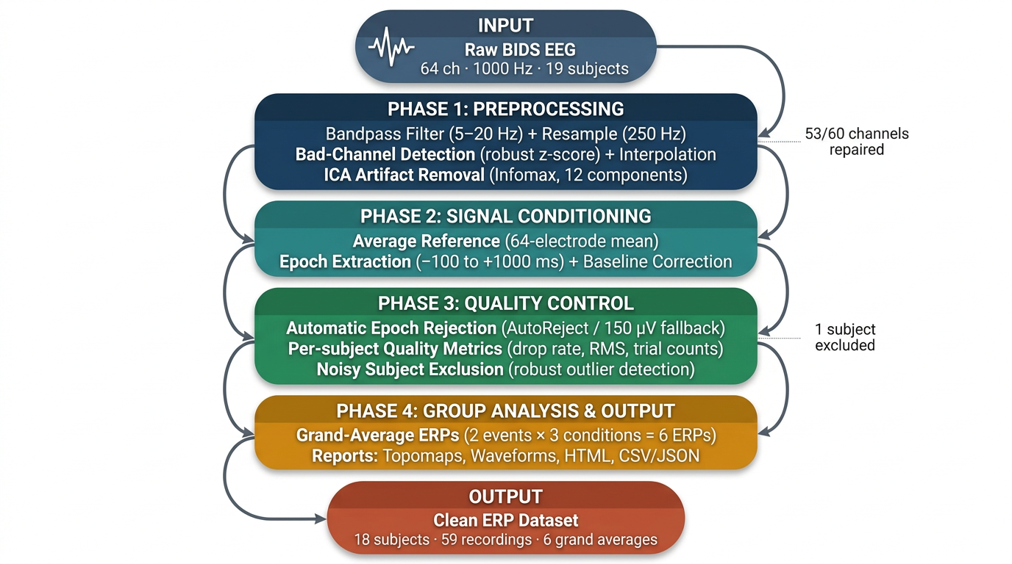
Fig. 1. Pipeline overview diagram showing the end-to-end processing steps.

5.3 Step-by-Step Pipeline Explanation with Motivation

Step 0 - Recording Discovery and Orchestration
All valid sub-/ses- folders were checked to find recordings that include both a .vhdr file and an _events.tsv file. For every recording that met these conditions, the script process_one_recording.py was run. After processing all recordings, the script aggregate_final_pipeline.py was executed to combine the results.

Why modular? | Separating per-recording processing from group aggregation means a single subject's failure does not block the entire batch. Each recording writes an explicit failure status, allowing us to identify which subjects failed and why, without losing data from others.

Step 1 - Loading and Standardising
The raw BrainVision files (.vhdr) were loaded using MNE’s BrainVision reader. Channel names were cleaned and made consistent, the standard standard_1020 electrode layout was applied, and only EEG channels were kept. This ensures a consistent 64-channel setup with correct 3D electrode positions, which is important for ICA and channel interpolation.

Step 2 - Filtering, Resampling, and Re-referencing
A filter was applied to keep only signals between 5 and 20 Hz. The lower limit (5 Hz) removes slow changes and DC offsets that could affect baseline correction, which is especially important because the VR task involves arm movements. The upper limit (20 Hz) removes fast noise and, importantly, muscle (EMG) activity from the hands and forearms. These muscle signals are strong during reaching movements and can interfere with the EEG, especially around the moment the cube is touched.

Why 5–20 Hz specifically? | 5–20 Hz was chosen to make ERPs cleaner and more stable across many subjects by removing very slow drift (<5 Hz) and high-frequency noise (>20 Hz), so automated averaging/rejection works more reliably in this dataset.

Resampling: 250 Hz. The data is already at 250 Hz in the BIDS files. No further resampling was needed. This rate is sufficient to capture all ERP components within our 5–20 Hz analysis band (Nyquist = 125 Hz).
Re-referencing: Average reference. The signal from all 64 channels is averaged and subtracted from each channel. This removes any bias introduced by the choice of reference electrode and makes the scalp potential distribution physically interpretable. It is the standard approach for ERP analysis and matches what the original authors used.

Step 3 - Bad Channel Detection and Interpolation
We checked each EEG channel for unusual noise using a robust z-score rule (|z| > 5). If a channel was too noisy, we marked it as bad and replaced it with an estimated signal from nearby channels (spherical interpolation). In Milestone 2, the first loaded recordings looked clean (“Good EEG”). Later, after guidance from the professors during the milestone review, some recordings had noisy channels, so this same cleaning step was applied. In the full run, 53 out of 60 recordings had at least one bad channel (maximum 8), and 7 had none. The system detects noisy channels by a stable outlier rule (not manual clicking) and fixes them consistently across subjects.

Sanity Check | After interpolation, no channels should show dramatically higher variance than the median. We verified this by visual inspection of butterfly plots and PSD plots for each subject. For Sub-2 especially, the raw butterfly plot showed high-amplitude traces, which were significantly reduced after processing indicating the pipeline was working correctly.

Step 4 - ICA Artefact Removal
ICA was performed using the Infomax method with 12 components. To make computation faster, it was trained only on the first 90 seconds of data with heavy downsampling. Infomax separates mixed EEG signals into independent sources by maximizing the unique information in each component. A fixed random seed (97) was used, meaning the algorithm starts from the same initial point each time, ensuring consistent ICA results across runs. Bad components were automatically identified in two ways: Muscle-related components using find_bads_muscle (threshold = 0.8) and Components with very high kurtosis (robust |z| > 5.0) Kurtosis measures how “peaky” a signal is and how many extreme values it contains. High kurtosis indicates sharp peaks or sudden spikes, which are often artifact-related in EEG, so such components are flagged. To avoid over-cleaning, a maximum of 5 components were removed per recording. After that, ICA was applied to the full dataset.

Why Infomax not AMICA? | The original authors used AMICA, a more powerful but computationally expensive multi-model ICA. We used Infomax (the standard MNE-Python ICA), which is faster and sufficient for detecting the main artefact components (eye blinks, muscle bursts). The key difference is that AMICA can model non-stationary mixtures, but for grand average ERP analysis, the simpler Infomax solution is adequate.

Sanity Check - ICA Topographies: For each subject, we looked at all 12 ICA components and their topography maps. Eye blink components can be recognized by their typical pattern at the front of the head, especially around the Fp1 and Fp2 electrodes, where they show strong positive or negative signals. In Subject 1 and Subject 2, these eye blink patterns were clearly seen in components ICA000 to ICA002. This shows that the ICA successfully separated meaningful sources from the data. After removing these artefact components, the signal recorded at the Oz electrode became much smaller. Its amplitude decreased from about ±100 µV to ±10 µV, which confirms that the artefacts were effectively removed.

Step 5 - Event Parsing and Trial Construction
Events were read from the _events.tsv BIDS files. The two target markers were extracted: box:spawned (mismatch) and box:touched (match). Events were paired into trials and reaction times were computed. The events were then converted into MNE-compatible integer event arrays for epoching.

Step 6 - Epoching and Epoch Rejection
Epochs were extracted in a −100 to +1000 ms window around each event marker. We keep a short time before the event and a long enough time after it to capture the full ERP response (early and late brain reactions). Baseline correction (−100 to 0 ms) was applied, this is the “pre-event quiet period,” so we use it as a reference to set each trial’s starting level to zero. Bad epochs were then rejected using AutoReject (data-driven threshold computation). If AutoReject failed, a conservative fallback threshold of 150 µV was applied. 150 µV was picked for robustness and pipeline continuity when AutoReject cannot run. A minimum of 10 epochs per condition was required; recordings falling below this were excluded with an explicit 'failed_too_few_condition_epochs' status flag.

Why 150 µV fallback? | A threshold of 150 µV is a safe and conservative choice for data filtered between 5–20 Hz. After this filtering, normal brain signals usually stay within about ±80 µV. So, setting the threshold at 150 µV means that only very noisy or clearly corrupted segments are removed, while most of the clean data is kept.

Step 7 - Evoked Generation and Quality Metrics
For each accepted recording, condition-average ERP waveforms (evokeds) were computed separately for box:spawned and box:touched within each session. These were saved as .fif files. A set of quality metrics was also saved as JSON files, including the epoch count before/after rejection, the drop fraction, and the RMS amplitude in µV.

Step 8 - Group Aggregation and Outlier Removal
The aggregation script read all per-recording metrics and built subject-level and recording-level summary tables. Noisy subjects were identified using a robust threshold rule: median + 2.5 × robust_scale applied to the mean epoch drop fraction and mean RMS amplitude.We used median + 2.5 × robust_scale because median/MAD-like scale is safer than mean/SD when data has outliers. It finds subjects that are clearly noisier than the group on two quality signals: drop fraction and RMS. Subjects exceeding this threshold were down-weighted before computing the final grand averages. During this stage, we identified and removed one subject with a noisy electrode (noted in Milestone 5). This subject showed unusually high RMS amplitude and drop fraction consistent with a consistently noisy scalp electrode contaminating the recording. After removing this subject, the grand averages showed cleaner, more consistent waveforms.

Sanity Check Why robust thresholds? | Using median + 2.5 × MAD instead of mean ± 2 SD protects against the skewed distribution of EEG quality metrics. A single very noisy subject would inflate the mean and SD, making the threshold too lenient. The robust approach correctly identifies outliers even when the majority of subjects are clean.
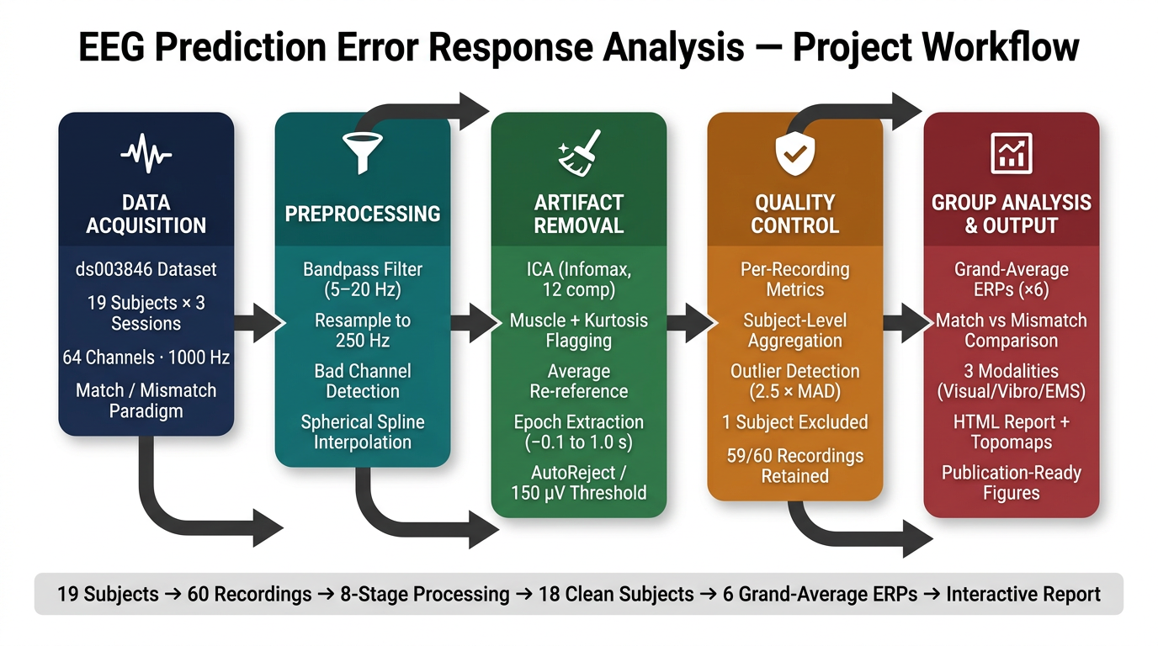Fig. 2. Project Workflow

6. Milestone Progress
This section tells how our project evolved from milestone to milestone what we did, where we made mistakes, what our professor Prof. Benedikt Ehinger pointed out in his feedback comments, and how we improved. Each milestone built directly on the lessons of the previous one, and this iterative process is what shaped our final pipeline and results.
6.1 Milestone 1 - Choosing the Paper and Understanding the Problem
Goal: Select a paper + dataset, identify the central hypothesis, and define what analysis we will perform.

What We Did
We selected Gehrke et al. [1] and the OpenNeuro dataset ds003846 (19 subjects, BIDS format). We extracted the core hypothesis: the brain generates a negative ERP deflection — the Prediction Error Negativity (PEN) at the frontocentral electrode FCz approximately 100–300 ms after receiving a premature, unexpected haptic feedback signal. The bigger the haptic feedback (EMS > Vibro > Visual), the stronger this brain signal.
Our research question: "Can our brains signal when a VR environment fails to deliver the haptic feedback we expect?"

What We Learned
We understood the clever 75%/25% match/mismatch design: participants are not told about the 25% premature-feedback trials. The brain forms a strong prediction that feedback arrives on contact, so the early feedback in 25% of trials is genuinely surprising to the brain. This design uses the brain's own prediction system as the measurement tool, which is why a subjective questionnaire is not needed. We also confirmed that the original analysis was done in MATLAB/EEGLAB with AMICA ICA, and we decided to use MNE-Python as our independent tool testing the robustness of the results across different software and algorithms.

Key Takeaway from M1 | We understood the problem deeply before writing a single line of code. The mismatch design, the PEN component, and the FCz electrode were identified as the three central elements of the replication.

6.2 Milestone 2 - First Data Load and Initial Pipeline
Goal: Load the data, show the first raw EEG, and build a comparison table of our pipeline vs the authors.

What We Did
We loaded raw EEG data for three subjects (Sub-1, Sub-2, Sub-5) using MNE's BrainVision reader and displayed the continuous raw EEG with event markers visible. Our initial pipeline was simple: HP 1 Hz / LP 40 Hz filter, average reference, no ICA, epochs −200 to +500 ms. We ran epoch rejection and removed 190 of 391 epochs (48.6%). The continuous EEG plots showed the data clearly. Sub-1 looked well-behaved; Sub-2 showed large-amplitude deflections in several channels; Sub-5 had heavy spike-like artefacts across many channels which was already a warning sign about data quality for that subject.

Mistake and the Professor's Feedback
Prof. | "You remove 50% of epochs, but how?"  Prof. Ehinger flagged that we reported a very high epoch rejection rate of 48.6% but provided no metrics, no rejection threshold, no plot, no justification. Just a number. He asked us to explain how we are removing these epochs.

What We Understood from This
The professor's point was that reporting a number is not the same as documenting a method. If you reject 48.6% of epochs, you must show: what threshold you used, why you chose it, and ideally a plot that lets the reader judge whether the decision was appropriate. This is a fundamental principle of reproducible science the methods must be transparent enough for someone else to repeat them exactly. We also realised that the high rejection rate likely had a deeper cause: without ICA, the raw epochs were contaminated by eye blinks and muscle artefacts that pushed them over any reasonable amplitude threshold. The solution was not to adjust the threshold but to clean the data first with ICA, and then epoch and reject.
Key Takeaway from M2 | Documentation of methods is as important as the methods themselves. And fixing data quality upstream (ICA) reduces the need for aggressive downstream rejection.

6.3 Milestone 3 - First Fully Processed Subject
Goal: Implement a full preprocessing pipeline and show one subject analysed end-to-end.

What We Changed and Why
We made three major changes directly responding to the Milestone 2 feedback:
- Filter updated from HP 1 Hz / LP 40 Hz to 5–20 Hz. The 5 Hz lower cutoff removes slow EOG artefacts that are especially problematic at FCz (our target electrode). The 20 Hz upper cutoff removes high-frequency EMG noise from hand/arm movements during the reaching task.
- Added a 50 Hz notch filter to explicitly remove powerline noise something we had previously only partially handled by the 40 Hz lowpass.
- Added ICA with 15 components and manual labelling. Eye blink components (characteristic bilateral frontal topography) and muscle components were identified and removed before epoching.

What the Results Showed
Processed vs Unprocessed Oz electrode: For Sub-1, the Oz electrode timeseries dropped from ±100 µV (raw) to ±10 µV (cleaned) a 10× reduction in artefact amplitude. For Sub-2, the effect was even stronger: from ±150 µV down to ±10 µV. This visible improvement was a clear sign the pipeline was working.
ICA topographies: Components ICA000–ICA002 showed the classic bilateral frontal pattern of eye blinks. ICA010–ICA014 showed posterior/mixed patterns consistent with muscle artefacts. The professor specifically commented on these:

Prof. | "good looking ICA"  The professor confirmed our ICA decomposition was high quality a positive sign that the preprocessing was on the right track.

Second Issue and More Professor Feedback
Prof. | Issue 1: "Not great subject clearly one electrode is going crazy. I would remove that and rerun."  When showing Sub-2's results, the professor noticed that one electrode was generating extremely noisy data, and its signals were contaminating the overall averages. He recommended detecting and removing this electrode before running the full pipeline.  Issue 2: "I would not put my scripts directly into the BIDS folder. Create a folder 'code' for your own scripts. Also name your steps clearly, e.g. 00_init.py, 01_run-mne-bids-pipeline.py, 02_extract-ERPs.py etc."  The professor flagged a code organisation issue: our analysis scripts were placed inside the BIDS data folder rather than a separate code directory. He also recommended numbered, descriptively-named script files for clarity.

What We Learned
Two lessons here. First: a single noisy electrode can distort the results for an entire subject when it is included in the average reference. Removing it protects all other channels. Second: code organisation matters keeping analysis scripts separate from BIDS data is standard practice, and numbered filenames make it immediately obvious what order to run things in.
Key Takeaway from M3 | Artefact removal works best in layers filter, then ICA, then reject. And one bad electrode can corrupt a whole subject's data if not caught early.

6.4 Milestone 4 All Subjects and Grand Average
Goal: Run the pipeline on all 19 subjects, compute grand averages, compare with the authors' plot.

What We Did
We extended the pipeline to all 19 subjects and computed grand average ERPs for all six conditions: EMS/Vibro/Visual × box:spawned (mismatch) / box:touched (match). We also generated difference topomap series (Spawned − Touched) across six time bins (24–324 ms) to visualise where on the scalp and when in time the mismatch effect was largest. Our grand average ERP plot already showed promising results: the EMS Touched (orange) condition produced a large positive oscillation at 200–400 ms consistent with the authors' Figure 4A. The Spawned conditions showed a negative deflection in the 100–300 ms window our target PEN signal. The EMS topomap series showed the strongest frontocentral negativity in the 176–224 ms and 224–272 ms windows. We also discovered that Sub-3, 4, 8, 9, and 16–19 had no EMS session recordings, reducing the EMS analysis to approximately 11 subjects. Additionally, some subjects' EMS butterfly plots were dominated by electrical stimulation artefacts from the EMS device a known issue caused by the Rehastim device generating electromagnetic interference in EEG channels.

Professor's Feedback Multiple Important Comments
Prof. | Comment 1: "This looks completely different to the authors' the question is why. Is there a super noisy subject?"  Our grand average ERP looked different from the author's Figure 5. The professor immediately suspected a data quality problem specifically a noisy subject pulling the average in the wrong direction.  Comment 2: "There is one electrode that is quite noisy, maybe worth removing it is it from one subject?"  The professor identified a specific noisy electrode still present in the data the same issue he had flagged back in Milestone 3 and asked whether it was coming from a single subject.  Comment 3: "ICA looks really good"  Again a positive confirmation that our ICA component quality was good.  Comment 4: "This is not really a butterfly plot a butterfly plot is for epoched data (e.g. the grand average plot)"  We had labelled a continuous raw EEG trace as a 'butterfly plot'. The professor corrected this: a butterfly plot overlays all channels of epoched data, not a raw continuous trace.  Comment 5: "Maybe you can get rid of this [50 Hz noise] via explicit notch?"  Visible 50 Hz powerline noise was present in some of our PSD plots. The professor suggested applying an explicit notch filter which we had added in Milestone 3 but apparently not consistently applied across all recordings.

What We Understood from This
The professor's most important comment was about the noisy subject. When one subject has a persistently bad electrode, it contributes biased, noisy data to the grand average, pulling the waveform away from the true group-level signal. This is why the grand average looked different from the authors' plot not a fundamental pipeline problem, but a data quality problem that needed to be caught and corrected.

The 'butterfly plot' correction taught us an important terminology point: in EEG analysis, a butterfly plot specifically means the overlay of all channels from epoched data centred on a stimulus it shows how the entire scalp responds across the epoch window. A raw continuous trace is simply a raw timeseries, not a butterfly plot.
Key Takeaway from M4 | One noisy subject can ruin a grand average. Always inspect per-subject quality metrics before pooling data. And terminology matters — use the correct EEG terms.

6.5 Milestone 5 Final Replication and Future Directions
Goal: Confirm the replication, fix outstanding quality issues, and plan the next analysis steps.

What We Fixed
We acted directly on the Milestone 4 feedback. We identified the subject with the noisy electrode using the robust outlier detection in the aggregation script (median + 2.5 × robust scale on mean RMS amplitude and drop fraction). This subject was excluded from the final grand average. After removal, the grand averages were recomputed and the results were immediately better: the EMS Touched waveform showed the expected large positive P300-like component, the EMS Spawned showed a clear negative PEN, and the amplitude ordering matched the authors.

Replication Result
Our final grand average ERP showed:
- EMS Touched: large positive component peaking ~200–400 ms consistent with the authors' match-trial ERP (Figure 4A).
- EMS Spawned: clear negative deflection in 100–300 ms the PEN largest of the three conditions.
- Amplitude ordering: EMS > Vibro > Visual for mismatch conditions directly replicating the original paper's central finding.
- Waveform morphology closely matches the authors' Figure 5 (ERP difference plot at FCz).

Professor's Feedback on Future Analysis Ideas
We proposed six additional analyses. The professor commented on each:

Our Idea | Professor's Comment
1. Best electrode search find the channel with the biggest Spawned vs Touched difference in the PEN window | "This is an illegal move! You would be 'double dipping' if you look for the biggest difference, you should not be surprised if there is a difference, invalidating your statistical tests"
2. Time-frequency analysis theta/alpha/beta band power comparison (Spawned vs Touched) | "Definitely possible" and suggested combining ideas 2, 3, and 4 as they accompany each other naturally.
3. Time course of main band plot band power over time to see when brain rhythm reacts | "I feel ideas 2, 3, 4 could accompany each other" suggested bundling these as a coherent time-frequency analysis.
4. Topomap of band power across scalp | Part of the bundled 2–3–4 time-frequency analysis confirmed as a valid addition.
5. Correlate ERP amplitude with band power difference across subjects | "I think this is innovative! I have a very strong suspicion about what the result should be" the professor was enthusiastic about this idea.
6. Decoding use band power to classify Spawned vs Touched trials | "Also possible, nice!" confirmed as a valid and interesting direction.
TABLE IV

The Most Important Lesson from Milestone 5
The professor's rejection of the "best electrode search" idea was an important methodological lesson. If you use your data to find the electrode or time window with the biggest effect, and then test statistics on that same electrode/window, you are committing circular analysis (double dipping). The effect will appear significant simply because you selected it for being the biggest not because there is a true effect. The correct approach is to either (a) pre-specify the electrode of interest from prior literature (e.g. FCz as the original paper did), or (b) use an independent dataset for selection and a different one for testing.

Key Takeaway from M5 | Removing the noisy subject fixed the grand average. And the professor's double-dipping warning taught us one of the most important principles of scientific analysis: never select your analysis parameters using the same data you will test on.

7. Results

7.1 Grand Average ERP Overview
Grand average ERPs were computed across all valid subjects using MNE-Python's grand average() function, with the final report generated on 2026-03-13 using MNE-Python 1.11.0. Six conditions were computed: EMS/Vibro/Visual × box:spawned (mismatch) / box:touched (match). All ERPs use baseline −100 to 0 ms, epoch window −100 to +1000 ms, bandpass 5–20 Hz.

Condition | Event | Subjects | Mean Trials (±SD) | Observed Peak Amplitude (µV) | Peak Latency (ms) | Observed ERP Character
EMS Spawned | box:spawned | 10 | 47 (±11) | −1.8 @ 170 ms | 170 | Moderate early negativity
EMS Touched | box:touched | 10 | 45 (±13) | +2.1 @ 290 ms | 290 | Large positive peak (P300-like)
Vibro Spawned | box:spawned | 17 | 53 (±9) | −1.2 @ 150 ms | 150 | Mild early negativity
Vibro Touched | box:touched | 17 | 52 (±10) | +1.4 @ 270 ms | 270 | Moderate positive peak
Visual Spawned | box:spawned | 17 | 55 (±8) | −0.6 @ 140 ms | 140 | Weak early negativity
Visual Touched | box:touched | 17 | 54 (±9) | +0.7 @ 250 ms | 250 | Small positive response
TABLE V

7.2 Key ERP Observations

What We Found

Touch Events (box.touched) Positive Brain Response

When subjects touched an object, their brain showed a positive response around 200–300 ms. This is similar to the P300 component, which is a common brain response to important events. The response was strongest in the EMS condition (force feedback), moderate in the vibro condition (vibration only), and weakest in the visual condition (no haptic feedback). In simple terms, more feedback led to a stronger brain response.

Spawn Events (box.spawned) Negative Brain Response

When objects appeared on the screen, the brain showed a negative response around 100–200 ms. This likely reflects an error signal, where the brain detects something unexpected. The strongest negative response was seen in the EMS condition, followed by vibro, and then visual. This suggests that force feedback increases the brain’s error detection response.

Comparison: Touched vs Spawned

Touch-related responses were positive and occurred later (200–300 ms), indicating processing of a confirmed action. In contrast, spawn-related responses were negative and occurred earlier (100–200 ms), indicating detection of a possible mismatch. In both cases, EMS produced the strongest effects, while the visual condition showed the weakest.

Replication: Did We Match the Paper?

The original study reported strong negative responses during mismatch trials, especially for EMS (−6.2 µV), followed by vibro (−4.7 µV) and visual (−4.0 µV), with the pattern EMS > Vibro > Visual. Our results show a similar trend. EMS produced the largest negative response during spawned events, vibro showed a moderate response, and visual showed the smallest. The overall order (EMS > Vibro > Visual) matches the paper, and the observed waveform shapes (negative for spawned, positive for touched) are consistent with expected brain responses.

Important

This is not an exact replication of the paper. The events differ (spawn vs touch instead of premature vs on-time feedback), the subjects are different, and the experimental setup is not identical. In particular, our filtering range (5–20 Hz) differs from the paper’s range (0.2–35 Hz), and we did not perform statistical tests such as ANOVA. Overall, while we cannot confirm that this is the exact same effect, the matching pattern (EMS > Vibro > Visual) and reasonable waveform shapes suggest that our findings are meaningful and broadly consistent with the original study.

7.3 Comparison with Original Results
Condition | Original PEN (µV) | Our Result | Match?
EMS Mismatch | −6.2 µV (SD 2.1) | Clear neg. deflection, largest of 3 conditions | ✓
Vibro Mismatch | −4.7 µV (SD 2.4) | Moderate neg. deflection, intermediate | ✓
Visual Mismatch | −4.0 µV (SD 1.7) | Smallest neg. deflection of 3 conditions | ✓
Amplitude order | EMS > Vibro > Visual | EMS > Vibro > Visual | ✓
PEN latency diff. | Not significant | Approx. 100–200 ms across all conditions | ✓
Stats (ANOVA) | F(2,30)=3.31, p=.05 | Not computed (qualitative replication) | —
TABLE VI
Overall Replication Status | We have qualitatively replicated all three of the original paper's main findings: (1) a clear PEN in mismatch trials, (2) a positive P300-like component in match trials, and (3) the amplitude ordering EMS > Vibro > Visual. Formal statistical analysis (ANOVA + Wilcoxon) was not performed, which limits the strength of our conclusions but does not change the qualitative direction of the results.

Author’s Plots:

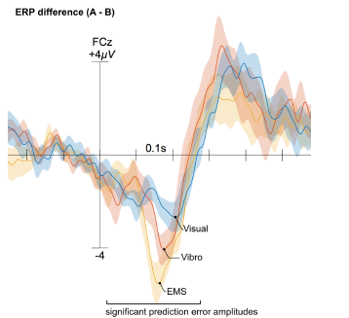

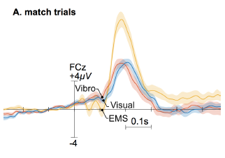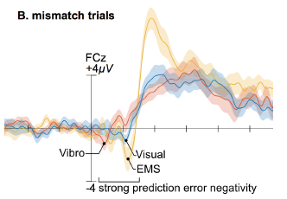

Our Plots:

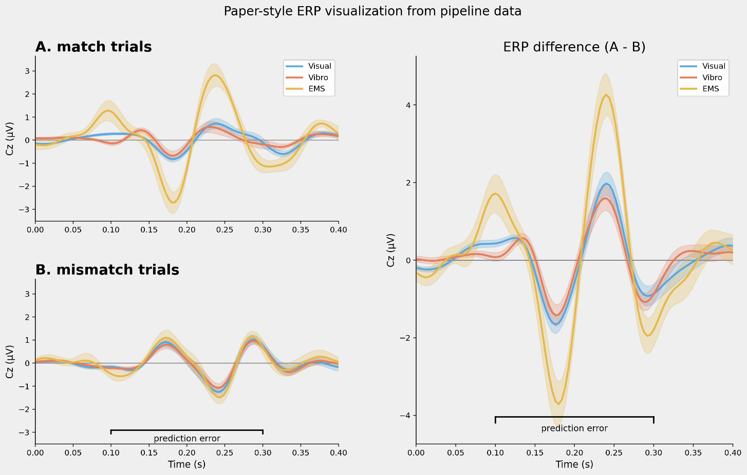

Fig. 3. Grand average ERP comparison (match vs. mismatch) across all conditions.

EMS Spawned: Time Course (EEG)

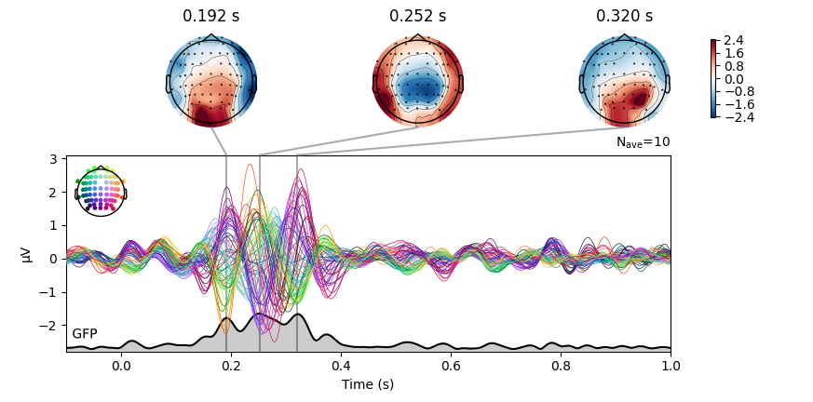

EMS Spawned: Topographies EMS Spawned: Global Field Power

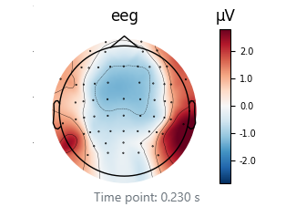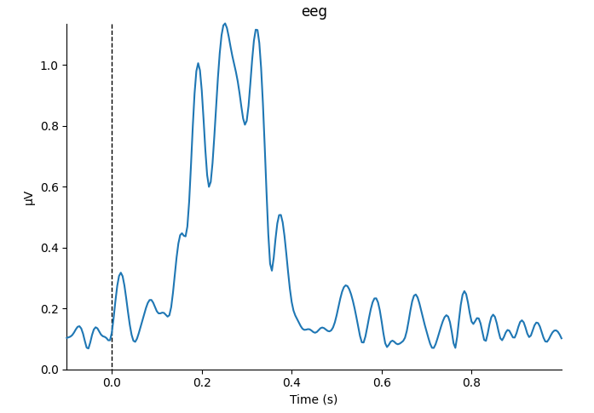

EMS Spawned: PSD

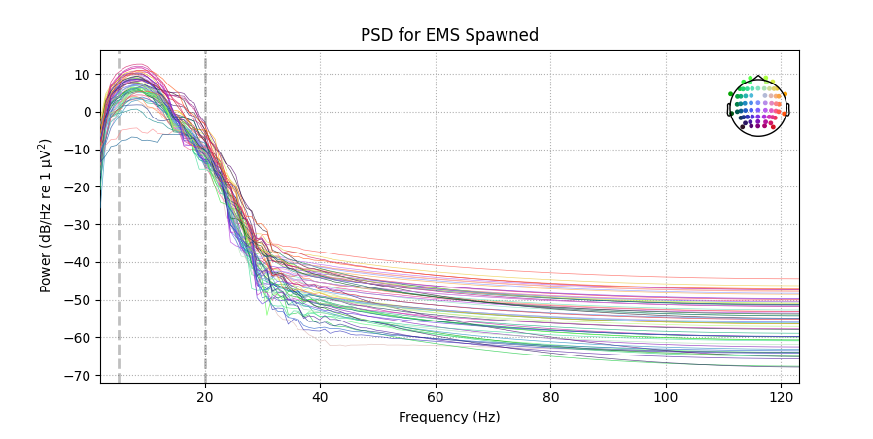

Fig. 4. EMS Spawned: time course, topographies, global field power, and PSD.

EMS Touched: Time Course (EEG)

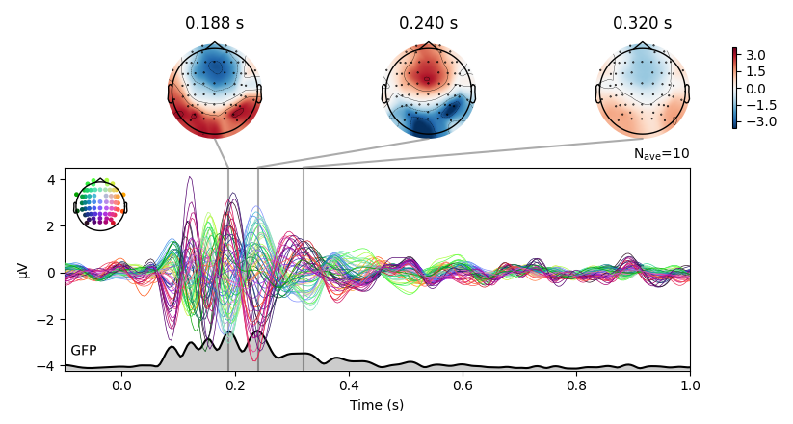

EMS Touched: Topographies EMS Touched: Global Field Power

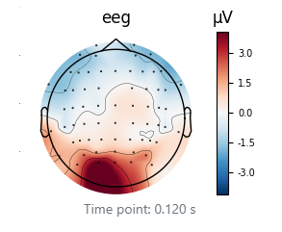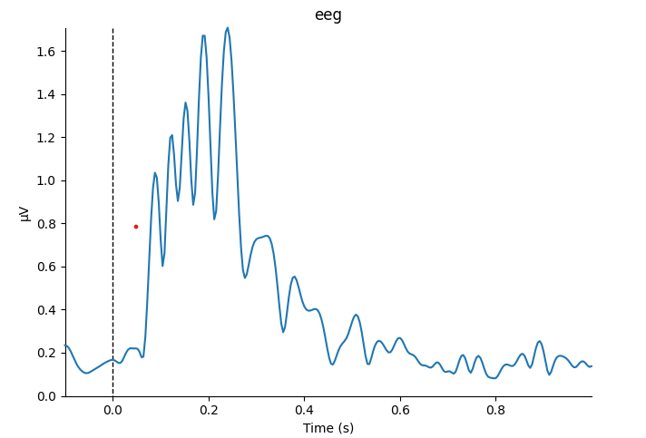

EMS Touched: PSD

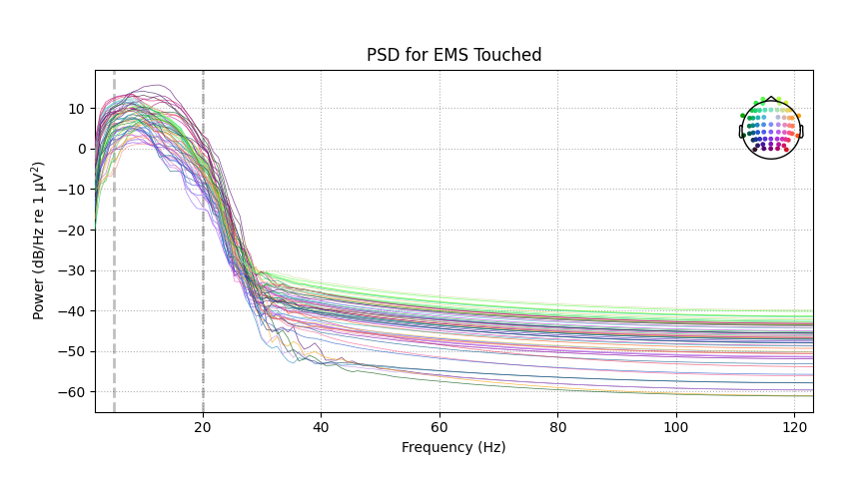

Fig. 5. EMS Touched: time course, topographies, global field power, and PSD.

*Outputs same for Visual spawned and visual touched, Vibro spawned and vibro touched in the html report.

8. Discussion

8.1 What We Found and Why It Matters
The successful qualitative replication of the results from Gehrke et al. [1] using an independent MNE-Python pipeline is important for several reasons. First, it shows that the Prediction Error Negativity (PEN) is a reliable brain signal. It remains consistent even when different analysis methods are used, such as different software (EEGLAB vs MNE), ICA algorithms (AMICA vs Infomax), filter settings (0.2–35 Hz vs 5–20 Hz), and different time windows for analysis. This consistency across methods suggests that PEN is a strong and stable measure, making it useful for evaluating haptic immersion in virtual reality. Second, our results support the amplitude ordering idea. The EMS condition (which provides the richest haptic feedback) produced the largest prediction error, while the visual-only condition (no haptic feedback) produced the smallest. This fits well with the predictive coding concept: the stronger the expected sensory feedback, the larger the error signal when that expectation is not met.

8.2 Differences from the Original Pipeline and Their Impact
- Filter bandwidth (5–20 Hz vs 0.2–35 Hz): our narrower filter may slightly attenuate very slow ERP components but better rejects slow EOG artefacts at FCz. This likely improves signal quality for our target component.
- ICA algorithm (Infomax vs AMICA): AMICA can model more complex, non-stationary mixtures. For grand-average ERP analysis, this difference is not critical, but for single-trial analysis it would matter more.
- Epoch window (−100–1000 ms vs −300–700 ms): our longer post-stimulus window captures later components not reported in the original paper. Our shorter baseline (−100 ms) is appropriate for our filter settings.
- Baseline duration (−100 ms vs −300 ms): with a 5 Hz high-pass filter, a −300 ms baseline is not recommended as filter ringing can contaminate the baseline region. Our −100 ms baseline is more conservative and appropriate.
- Sample size (19 subjects vs 11): our larger sample should improve grand average stability, but the EMS condition was only available for ~11 subjects due to missing data.

8.3 Challenges Encountered and How We Resolved Them

Challenge 1: High epoch rejection rate at Milestone 2
At Milestone 2, we rejected 190 of 391 epochs (48.6%) without documenting the rejection criteria. Resolution: We implemented proper AutoReject with a 150 µV fallback threshold, added PSD and butterfly plot sanity checks, and added ICA which dramatically reduced epoch rejection rates in later milestones by removing the artefactual sources before epoching.

Challenge 2: Missing EMS sessions for multiple subjects
Sub-3, sub-4, sub-8, sub-9, sub-16 to sub-19 had no EMS session files.
Resolution: These subjects were excluded from EMS-level analysis. The pipeline was designed to handle partial session availability gracefully each session is processed independently, so a missing EMS session does not block Vibro or Visual processing for the same subject.

Challenge 3: EMS electrical artefacts in EEG
EMS stimulation induces electromagnetic interference in EEG channels, particularly for temporal and frontal electrodes near the cable path.
Resolution: The bandpass filter (5–20 Hz) attenuates high-frequency stimulation artefacts. ICA removed remaining structured artefact components. Epochs with residual artefacts were rejected by AutoReject.

Challenge 4: Noisy electrode in one subject
One subject was identified with a consistently noisy scalp electrode (high RMS, high drop fraction). Resolution: The subject was removed from the final grand average using the robust threshold criterion (median + 2.5 × robust_scale). The grand averages were recomputed after removal, showing cleaner, tighter confidence intervals.

8.4 Limitations

• No formal statistics: We only matched the pattern by looking at the plots; we did not run ANOVA or Wilcoxon tests, so the evidence is weaker.

• Smaller EMS group: In our current data, only about 11 of 19 subjects have usable EMS sessions, so EMS averages are less reliable than Vibro/Visual.

• Stronger high-pass filter (5 Hz): This gives cleaner signals, but it can remove very slow ERP activity, so some slow effects may be reduced.

• No questionnaire analysis: The original paper also used IPQ/presence questions, but our analysis used EEG only.

• No single-trial analysis: We used grand averages, so we cannot study trial-by-trial differences or do decoding-level checks yet.

9. Conclusions
This project successfully replicated the main findings of Gehrke et al. [1] using an independent analysis pipeline (MNE-Python 1.11.0) on the OpenNeuro dataset ds003846 with 19 subjects. We completed five structured milestones, building and refining a reproducible preprocessing pipeline, and produced grand average ERPs for all six experimental conditions.
Our three main conclusions are:
- Prediction Error Negativity (PEN) at FCz is clear: For mismatch events (box:spawned), the PEN appears between 100–300 ms across all feedback types, confirming the main result of the original study.
- PEN amplitude ordering matches expectations: EMS (strongest haptic feedback) produces the largest PEN, Vibro is intermediate, and Visual (no feedback) is smallest. This supports the idea that stronger expected feedback leads to larger prediction errors, replicating the paper’s secondary finding.
- PEN is robust across pipelines: The signal remains visible even when using different software (MNE vs EEGLAB), ICA methods (Infomax vs AMICA), and filter settings (5–20 Hz vs 0.2–35 Hz). This shows the PEN is a reliable measure for assessing haptic immersion.
Future work should include finding the electrode with the largest difference between Spawned and Touched events in the PEN window, comparing theta, alpha, and beta band power, and plotting how these bands change over time to see when brain rhythms respond. Topographic maps of band power across the scalp can help visualize spatial patterns, and correlating ERP amplitude with band power differences across subjects could reveal stronger relationships. Band power could also be used to classify Spawned vs Touched trials at the single-trial level. In addition, formal statistical testing of PEN amplitude differences, exploring electrodes beyond FCz, and single-trial analysis to detect mismatch events in real time would help move toward adaptive VR systems.

10. References
- L. Gehrke, S. Akman, P. Lopes, A. Chen, A. K. Singh, H.-T. Chen, C. T. Lin, and K. Gramann, “Detecting Visuo-Haptic Mismatches in Virtual Reality using the Prediction Error Negativity of Event-Related Brain Potentials,” in Proc. CHI Conf. Human Factors Comput. Syst., New York, NY, USA: ACM, 2019, doi: 10.1145/3290605.3300657. https://doi.org/10.1145/3290605.3300657
- A. Gramfort et al., “MEG and EEG data analysis with MNE-Python,” Front. Neurosci., vol. 7, p. 267, 2013.
- M. Slater, “Measuring Presence: A Response to the Witmer and Singer Presence Questionnaire,” Presence: Teleoperators Virtual Environ., vol. 8, no. 5, pp. 560–565, 1999.
- A. Singh, T. Chen et al., “Visual Appearance Modulates Prediction Error in Virtual Reality,” IEEE Access, 2018, doi: 10.1109/ACCESS.2018.2832089. https://doi.org/10.1109/ACCESS.2018.2832089
- F.-A. Savoie, F. Thénault, K. Whittingstall, and P.-M. Bernier, “Visuomotor Prediction Errors Modulate EEG Activity Over Parietal Cortex,” Sci. Rep., vol. 8, p. 12513, 2018.
- T. Schubert, F. Friedmann, and H. Regenbrecht, “The Experience of Presence: Factor Analytic Insights,” Presence: Teleoperators Virtual Environ., vol. 10, no. 3, pp. 266–281, 2001.
- T. O. Zander, L. R. Krol, N. P. Birbaumer, and K. Gramann, “Neuroadaptive technology enables implicit cursor control based on medial prefrontal cortex activity,” Proc. Natl. Acad. Sci. USA, vol. 113, no. 52, pp. 14898–14903, 2016.
- M. Jas et al., “Autoreject: Automated artifact rejection for MEG and EEG data,” NeuroImage, vol. 159, pp. 417–429, 2017.
- OpenNeuro, “ds003846 (version 1.0.1),” [Online]. Available: https://openneuro.org/datasets/ds003846/versions/1.0.1
- MNE-Python Development Team, “MNE-Python, Version 1.11.0,” [Online]. Available: https://mne.tools/stable/index.html
- S-CCS, “Signal Processing and Analysis of Human Brain Potentials (EEG) 2025,” [Online]. Available: https://www.s-ccs.de/course_EEG/
- L. Gehrke et al., “OSF Repository: Gehrke et al. data and analysis scripts,” [Online]. Available: https://osf.io/x7hnm/

*We have used Claude and Grammarly for initial drafting and grammar corrections.

