**Steps to install ingress class and load balancer controller to cluster**

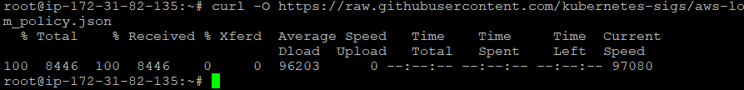



I deleted the existing IAM policy in AWS console with above name  
And executed the above command again, got as belows

{

"Policy": {

"PolicyName": "AWSLoadBalancerControllerIAMPolicy",

"PolicyId": "ANPAXWMA6KSNT2FXNO6BL",

"Arn": "arn:aws:iam::529088271515:policy/AWSLoadBalancerControllerIAMPolicy",

"Path": "/",

"DefaultVersionId": "v1",

"AttachmentCount": 0,

"PermissionsBoundaryUsageCount": 0,

"IsAttachable": true,

"CreateDate": "2024-11-06T14:29:22+00:00",

"UpdateDate": "2024-11-06T14:29:22+00:00"

}

}

**Now executing below:**eksctl create iamserviceaccount \

--cluster=varadeks \

--namespace=kube-system \

--name=aws-load-balancer-controller \

--role-name AmazonEKSLoadBalancerControllerRole \

--attach-policy-arn=arn:aws:iam::529088271515:policy/AWSLoadBalancerControllerIAMPolicy \

--approve

**Got below error  
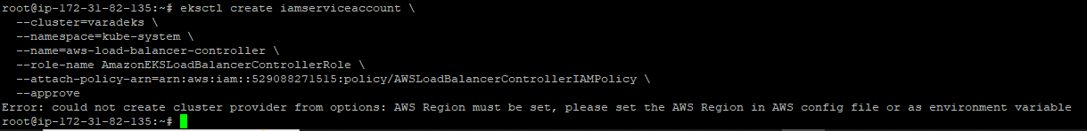**

Error says to add region.  
so we are executing below command:  
“aws configure”  
  
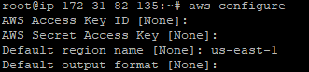

**Again, executing below command and getting error again**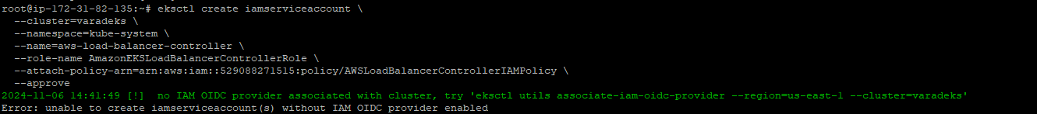

To remove that error we are executing OIDC command:

oidc_id=$(aws eks describe-cluster --name varadeks --query "cluster.identity.oidc.issuer" --output text | cut -d '/' -f 5)  


aws iam list-open-id-connect-providers | grep $oidc_id | cut -d "/" -f4  


we will need OIDC ID  
so we will run below command  
echo $oidc_id  


**Creating loadbalancer trust policy as follows**

cat >load-balancer-role-trust-policy.json <<EOF

{

"Version": "2012-10-17",

"Statement": [

{

"Effect": "Allow",

"Principal": {

"Federated": "arn:aws:iam::529088271515:oidc-provider/oidc.eks.us-east-1.amazonaws.com/id/A391399F03121F534925F9F30E0ADE88"

},

"Action": "sts:AssumeRoleWithWebIdentity",

"Condition": {

"StringEquals": {

"oidc.eks.us-east-1.amazonaws.com/id/A391399F03121F534925F9F30E0ADE88:aud": "sts.amazonaws.com",

"oidc.eks.us-east-1.amazonaws.com/id/A391399F03121F534925F9F30E0ADE88:sub": "system:serviceaccount:kube-system:aws-load-balancer-controller"

}

}

}

]

}

EOF  
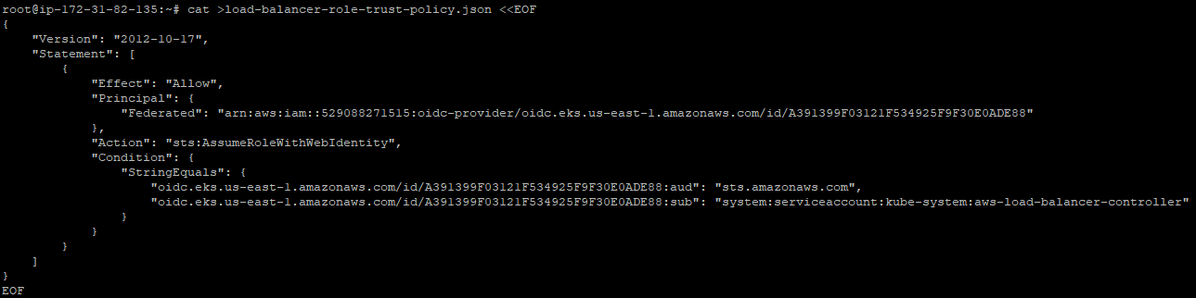

**Creating IAM role**

aws iam create-role \

--role-name AmazonEKSLoadBalancerControllerRole \

--assume-role-policy-document file://"load-balancer-role-trust-policy.json"  
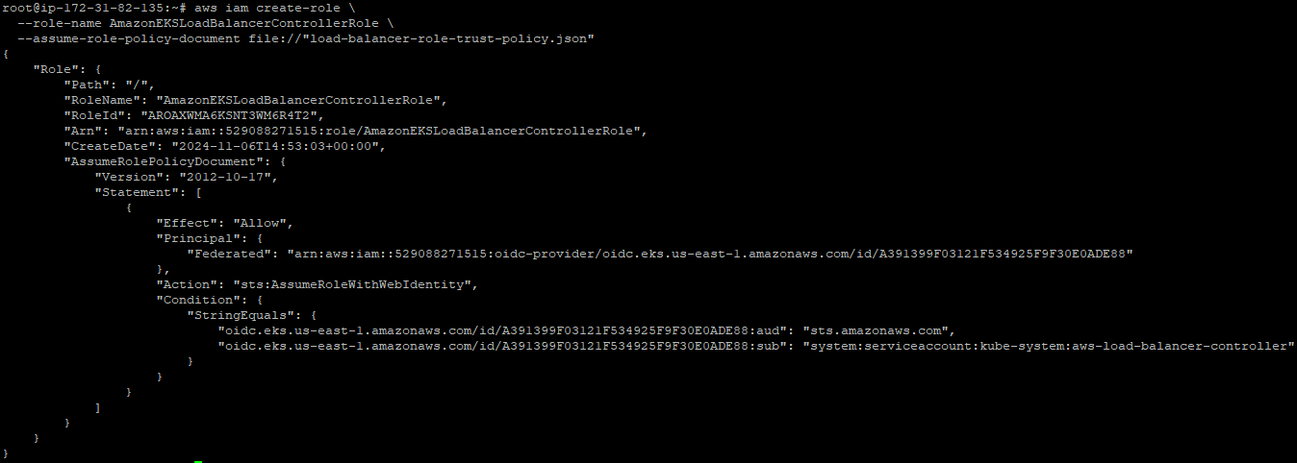

**Attach role policy**

aws iam attach-role-policy \

--policy-arn arn:aws:iam::529088271515:policy/AWSLoadBalancerControllerIAMPolicy \

--role-name AmazonEKSLoadBalancerControllerRole  


**Then Run below**

cat >aws-load-balancer-controller-service-account.yaml <<EOF

apiVersion: v1

kind: ServiceAccount

metadata:

labels:

app.kubernetes.io/component: controller

app.kubernetes.io/name: aws-load-balancer-controller

name: aws-load-balancer-controller

namespace: kube-system

annotations:

eks.amazonaws.com/role-arn: arn:aws:iam::529088271515:role/AmazonEKSLoadBalancerControllerRole

EOF  
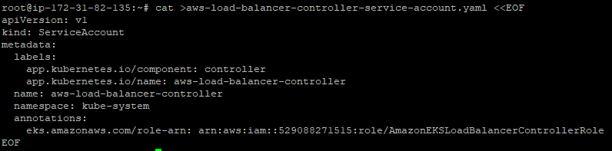

**Then**

kubectl apply -f aws-load-balancer-controller-service-account.yaml

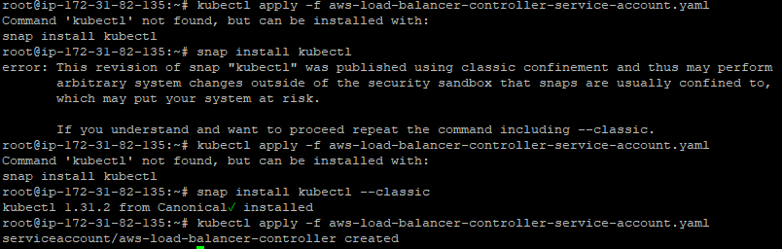

**Install Cert-Manager**kubectl apply \

--validate=false \

-f https://github.com/jetstack/cert-manager/releases/download/v1.13.5/cert-manager.yaml

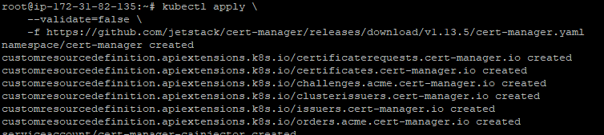

**Install AWS loadbalancer controller**

curl -Lo v2_7_2_full.yaml <https://github.com/kubernetes-sigs/aws-load-balancer-controller/releases/download/v2.7.2/v2_7_2_full.yaml>  


$ sed -i.bak -e '612,620d' ./v2_7_2_full.yaml  


$ sed -i.bak -e 's|your-cluster-name|my-cluster|' ./v2_7_2_full.yaml  


sed -i.bak -e 's|public.ecr.aws/eks/aws-load-balancer-controller|529088271515.dkr.ecr.region-code.amazonaws.com/eks/aws-load-balancer-controller|' ./v2_7_2_full.yaml  


**Apply yaml file**  
kubectl apply -f v2_7_2_full.yaml  
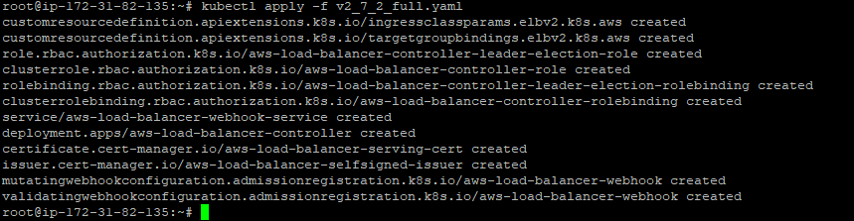

Download ingress class  
curl -Lo v2_7_2_ingclass.yaml <https://github.com/kubernetes-sigs/aws-load-balancer-controller/releases/download/v2.7.2/v2_7_2_ingclass.yaml>  


**Apply manifest to cluster**kubectl apply -f v2_7_2_ingclass.yaml  
  
