NUTAN MAHARASHTRA INSTITUTE OF ENGINEERING & TECHNOLOGY, TALEGAON DABHADE, 410507

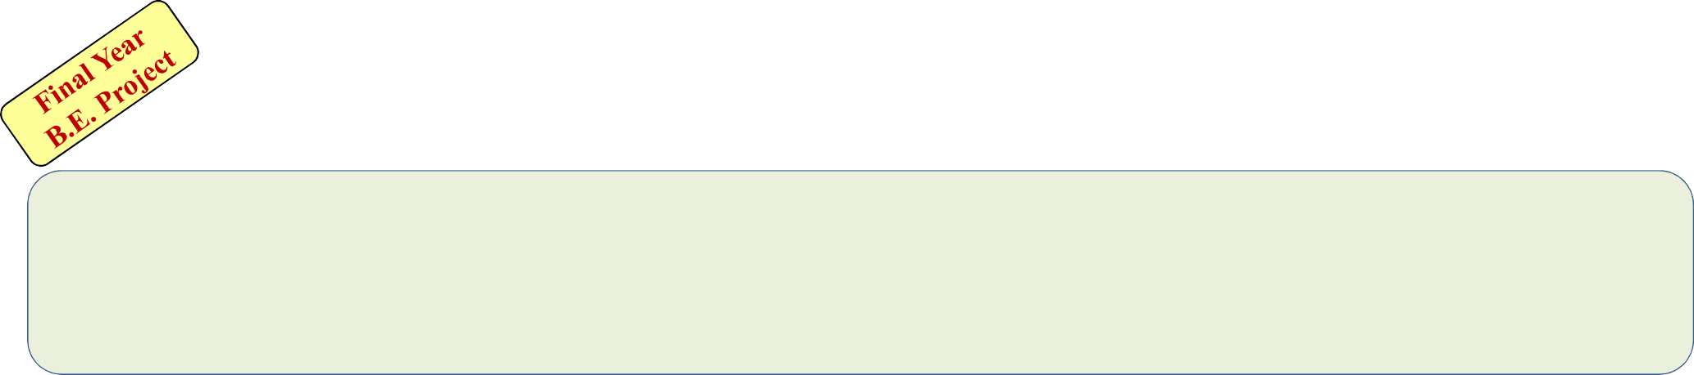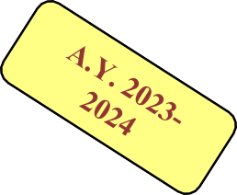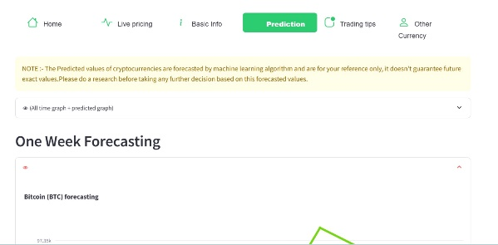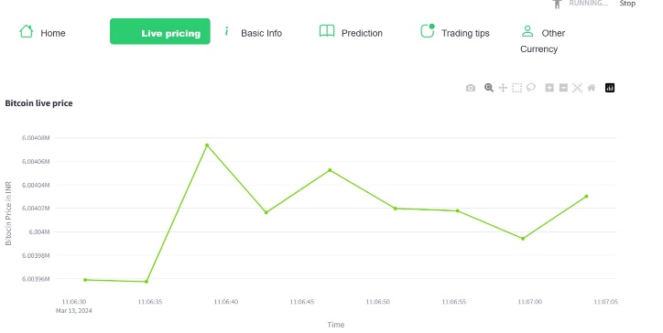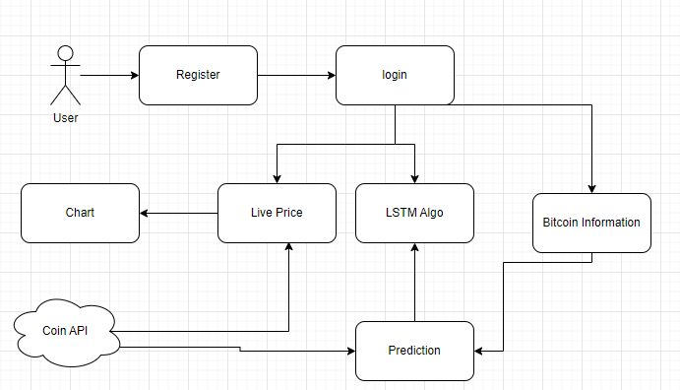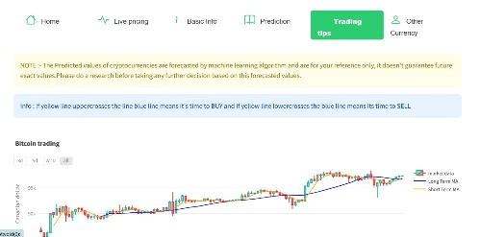

Department Of Computer Engineering

**Project Title: “Healthcare Chatbot on Hospital Management System.”**

**Aim :Creating Healthcare chatbot that serves patients various features.**

**Objectives:** **To Implement linear regression and Long Short-Term Memory (LSTM) models for bitcoin price prediction.**

**To predict prices for Bitcoin using Machine learning techniques for the next day and prepare a strategy to maximize gains for investors.**

**Project Photo Project Application Need:**

To develop a model which can help us to predict the price of the crypto currency used (in this case: Bitcoin), with low error rate and a high precision of accuracy.

**Future Scope:**

* We can create a android app for price prediction
* Bitcoin trading can also added
* News flash

**Results :**

**Conclusion:**

The LSTM model which we are going to implement here, is a basic model that takes into

consideration only all features that affect the Bitcoin price.

We will try to create model which is accurate when predicting the future prices.

However, to increase the efficiency of the model we will take live prices of bitcoin.

|  |  |  |
| --- | --- | --- |
| **Sr.**  **No.** | **Name &Roll No Student** | **Guide Name**  **& Sign** |
| **1** | **Mr. Yashraj Kishor Patel (BEB108)** | **Prof. Sopan Kshirsagar** |
| **2** | **Mrs. Minal Narendra Patil (BEB114)** |
| **3** | **Mr. Pratik Praphullakumar Pawar (BEB115)** |