Model Comparison
Model | Accuracy | MacroF1
Elman | 0.22 | 0.17
LSTM | 0.78 | 0.78
BERT | 0.87 | 0.87
🟩 Green = Best Accuracy, 🟦 Blue = Best Macro F1

Performance Plots
Bar Chart:
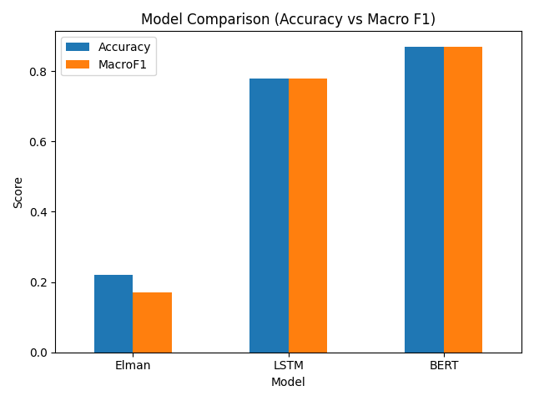
Line Chart:
