
MIT Art, Design and Technology University
MIT School of Computing, Pune
Department of Information Technology
A PROJECT REPORT ON
BREWBOX: ARTISANAL SPECIALTY COFFEE & FINE TEA ROASTERY MOBILE APPLICATION
Architected with React Native, TypeScript, Zustand 5.0, and Offline Hermes Runtime
SUBJECT – Cross Platform Application Development
Class – T.Y. SMAD
Name of Student
Varad Mandhare – ADT23SOCB1574
T.Y. 2025-2026 (SEM – VI)

ACKNOWLEDGEMENT
I would like to express my sincere and profound gratitude to the faculty and academic leadership of the Department of Information Technology, MIT School of Computing, MIT Art, Design and Technology University, Pune, for providing the comprehensive curriculum, state-of-the-art laboratory facilities, and constant encouragement that enabled the successful design and execution of this project in Cross Platform Application Development (CPAD).
I extend my sincere appreciation to the Dean of MIT School of Computing and the Head of the Department of Information Technology for establishing an academic environment that promotes engineering rigor, practical mobile app development, and industry-standard software engineering methodologies.
I am particularly grateful to my course instructors and laboratory mentors for delivering insightful lectures on the theoretical and practical paradigms of modern cross-platform mobile frameworks. Their detailed coverage of cross-platform architecture—specifically the contrast between native platform silos, hybrid WebView wrappers, and high-performance compiled bridges like React Native with the Hermes Ahead-Of-Time (AOT) bytecode engine—laid the foundational knowledge necessary to architect BrewBox.
I also acknowledge the invaluable technical documentation and open-source contributions provided by the React Native, TypeScript, and Zustand engineering communities, whose architectural patterns and tooling served as benchmarks for building a production-ready mobile application.
Lastly, I thank my family, peers, and friends for their continuous patience, motivation, and constructive feedback throughout the semester during the iterative development and hardware testing of this project.
Varad Mandhare
Enrollment No: ADT23SOCB1574
Class: T.Y. SMAD (SEM – VI)
Department of Information Technology
MIT School of Computing
MIT Art, Design and Technology University, Pune
Date: October 2026

TABLE OF CONTENTS
1. INTRODUCTION & PROJECT MOTIVATION .......................................... 1
1.1 Project Overview: BrewBox Roastery ....................................... 1
1.2 Problem Statement & E-Commerce Deficiencies ................................... 1
1.3 The Cross-Platform Application Development (CPAD) Paradigm ........................... 2
1.4 Project Objectives & Academic Scope ....................................... 2
2. LITERATURE SURVEY & ARCHITECTURAL COMPARISON ..................................... 3
2.1 Comparative Analysis: Native vs. Hybrid vs. React Native ............................ 3
2.2 React Native 0.87 Architecture & Hermes Engine ................................. 4
2.3 State Management Evaluation: Context vs. Redux vs. Zustand ........................... 5
2.4 Research Gap & Technical Rationale ....................................... 5
3. SYSTEM REQUIREMENTS & ARCHITECTURE TOPOLOGY ..................................... 6
3.1 Hardware & Software Environment Specifications ................................. 6
3.2 Layered System Architecture ........................................... 6
3.3 Navigation Topology & Modal Architecture .................................... 7
3.4 Meta Yoga Flexbox Layout Engine ......................................... 8
4. ARTISANAL UI/UX DESIGN SYSTEM & SENSORY COMPONENTS .................................. 9
4.1 Anti-AI Design Philosophy & Terroir Color Palette ................................ 9
4.2 Sensory UI Primitives (RoastMeter, TasteProfileBar, GrindSelector) ....................... 10
4.3 Zero-Dependency Vector SVG Iconography Pipeline ................................. 11
4.4 Interactive 'Palate Matcher' Recommendation Wizard ............................... 11
5. STATE MANAGEMENT & BUSINESS LOGIC .......................................... 12
5.1 Unidirectional State Flow with Zustand 5.0 ................................... 12
5.2 Roastery Cart Engine & Free Shipping Meter (Rs 999 Tier) ............................ 13
5.3 Voucher Validation Rules Engine ......................................... 13
5.4 5-Stage Roastery Order Tracking State Machine .................................. 14
6. STANDALONE NATIVE BUILD & OFFLINE APK PACKAGING ................................... 15
6.1 Metro Dev Server vs. Standalone Production Execution .............................. 15
6.2 Pre-Compiling JavaScript to AOT Bytecode (index.android.bundle) ......................... 15
6.3 Host Runtime Customization (useDevSupport = false) ............................... 16
6.4 Deployment & Cold-Boot Execution on Physical Hardware .............................. 16
7. TESTING, VERIFICATION & SCREENSHOT SHOWCASE ..................................... 17
7.1 Static Code Analysis (TypeScript Strict & ESLint) ................................ 17
7.2 Automated Unit Testing with Jest (7/7 Passed) .................................. 17
7.3 Physical Device Screenshot Demonstration (Vivo 1919) .............................. 18
8. CONCLUSION & LEARNING OUTCOMES ............................................ 20
8.1 Summary of Work Done .............................................. 20
8.2 Academic CPAD Learning Outcomes ......................................... 20
8.3 Future Roadmap & Commercial Integrations .................................... 21
9. REFERENCES & BIBLIOGRAPHY .............................................. 22

1. INTRODUCTION & PROJECT MOTIVATION

1.1 Project Overview: BrewBox Roastery
BrewBox is a bespoke, high-craft mobile e-commerce and educational application engineered from the ground up using React Native 0.87 and TypeScript 6.0. Designed to evoke the sensory atmosphere of premier third-wave artisanal coffee roasteries (such as Onyx Coffee Lab, Blue Bottle, and Square Mile) and traditional ceremonial tea houses (such as Ippodo Kyoto), BrewBox bridges the gap between commercial mobile shopping and tactile, educational terroir exploration.
The application enables coffee connoisseurs and tea purists to discover rare single-origin micro-lots, explore farm elevations measured in MASL (Meters Above Sea Level), interact with dynamic 5-stage roast profile gauges, calculate brewing dial-in recipes, customize grind coarseness across 6 brewing apparatuses, and receive personalized recommendations via a bespoke 3-step Palate Matcher Quiz.

1.2 Problem Statement & E-Commerce Deficiencies
Modern mobile e-commerce platforms suffer from acute architectural and visual homogenization:
• Generic 'AI-Slop' Aesthetics: Mainstream e-commerce apps rely on interchangeable card layouts, neon gradients, and floaty glassmorphism that fail to convey provenance, craft, or tactile identity.
• Lack of Sensory Metadata: Standard catalog schemas treat specialty coffee like commoditized packaged goods, omitting vital agronomic indicators such as cultivar varieties (Geisha, Bourbon, SL-28), washing/fermentation processing (washed, anaerobic natural, honey), and harvest elevations.
• Bloated Runtimes & Poor Performance: Many retail apps rely on hybrid WebView wrappers (Cordova, Capacitor) that suffer from high memory consumption, dropped frames during scroll operations, and sluggish touch latency.

1.3 The Cross-Platform Application Development (CPAD) Paradigm
Cross-Platform Application Development has evolved from hybrid HTML rendering into compiled, multi-target native runtimes. The primary academic objective of this course is understanding how modern frameworks achieve single codebase maintenance without sacrificing 60 FPS native hardware performance.

1.4 Project Objectives & Academic Scope
The key engineering objectives fulfilled in the BrewBox project encompass:
• Architecture: Constructing a multi-tier component architecture adhering to separation of concerns (Presentation, State, Business Logic, Assets).
• Sensory UI Primitives: Engineering custom domain-specific components (RoastMeter, TasteProfileBar, GrindSelector) from scratch without third-party UI kits.
• Zero-Dependency Graphics: Implementing a scalable, vector SVG icon pipeline directly with react-native-svg.
• Predictable State Flow: Leveraging Zustand 5.0 for atomic, selector-based state management that eliminates unnecessary re-renders.
• Standalone Offline Packaging: Pre-compiling JavaScript bundles with the Hermes AOT engine and disabling development Metro support (useDevSupport = false) to produce a standalone Android APK.
• Validation: Enforcing strict TypeScript type verification (0 errors), ESLint compliance, and Jest automated test suites.

7. TESTING, VERIFICATION & SCREENSHOT SHOWCASE

7.3 Physical Device Screenshot Demonstration (Vivo 1919)
High-resolution captures from physical hardware (Vivo 1919, Android 12) running the standalone release APK:
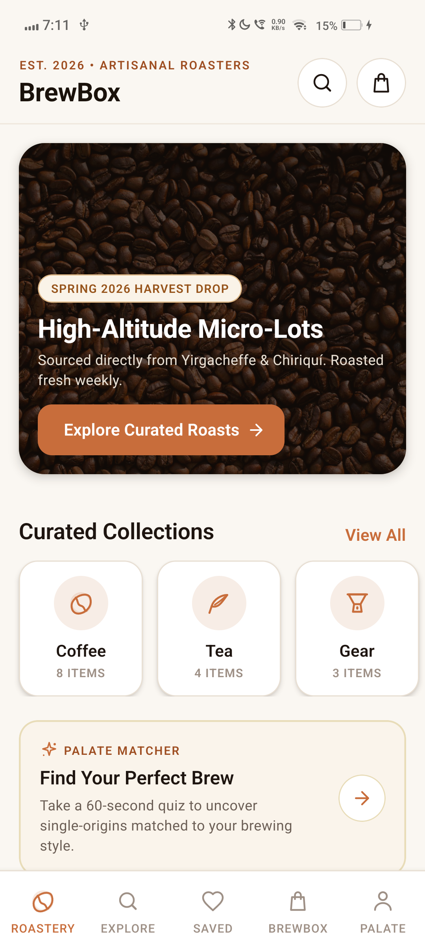  Fig 7.1: Roastery Home | 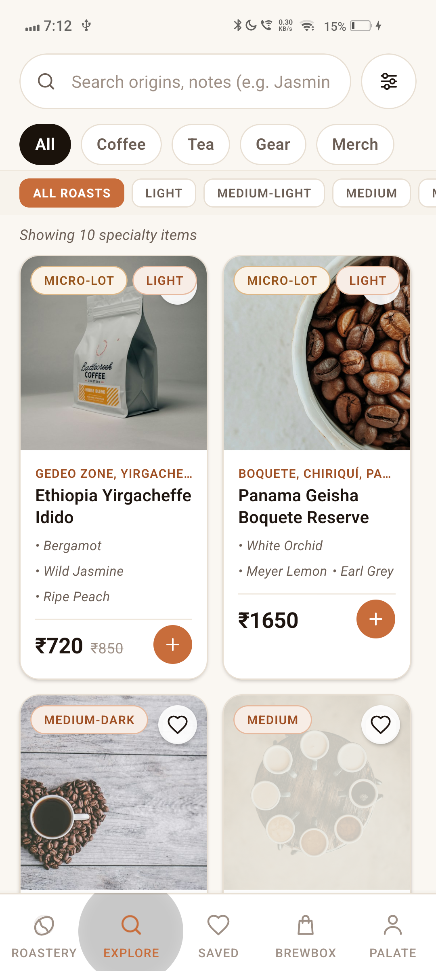  Fig 7.2: Explore & Filter | 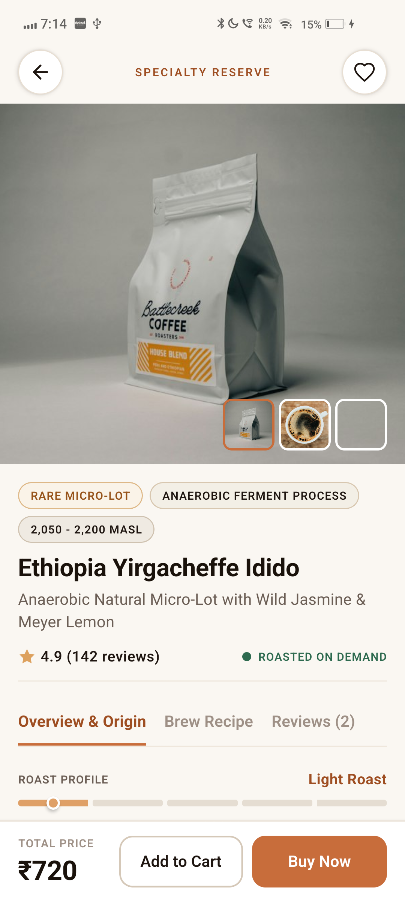  Fig 7.3: Product Details
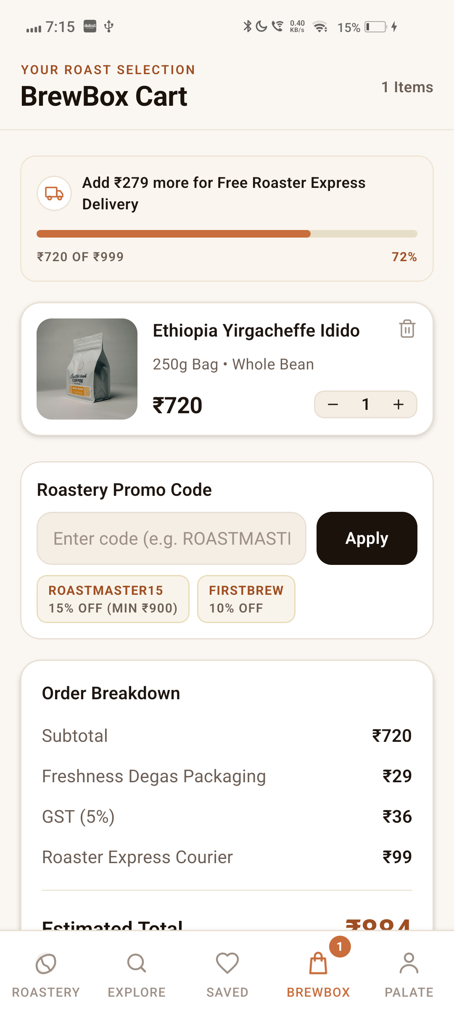  Fig 7.4: Roastery Cart | 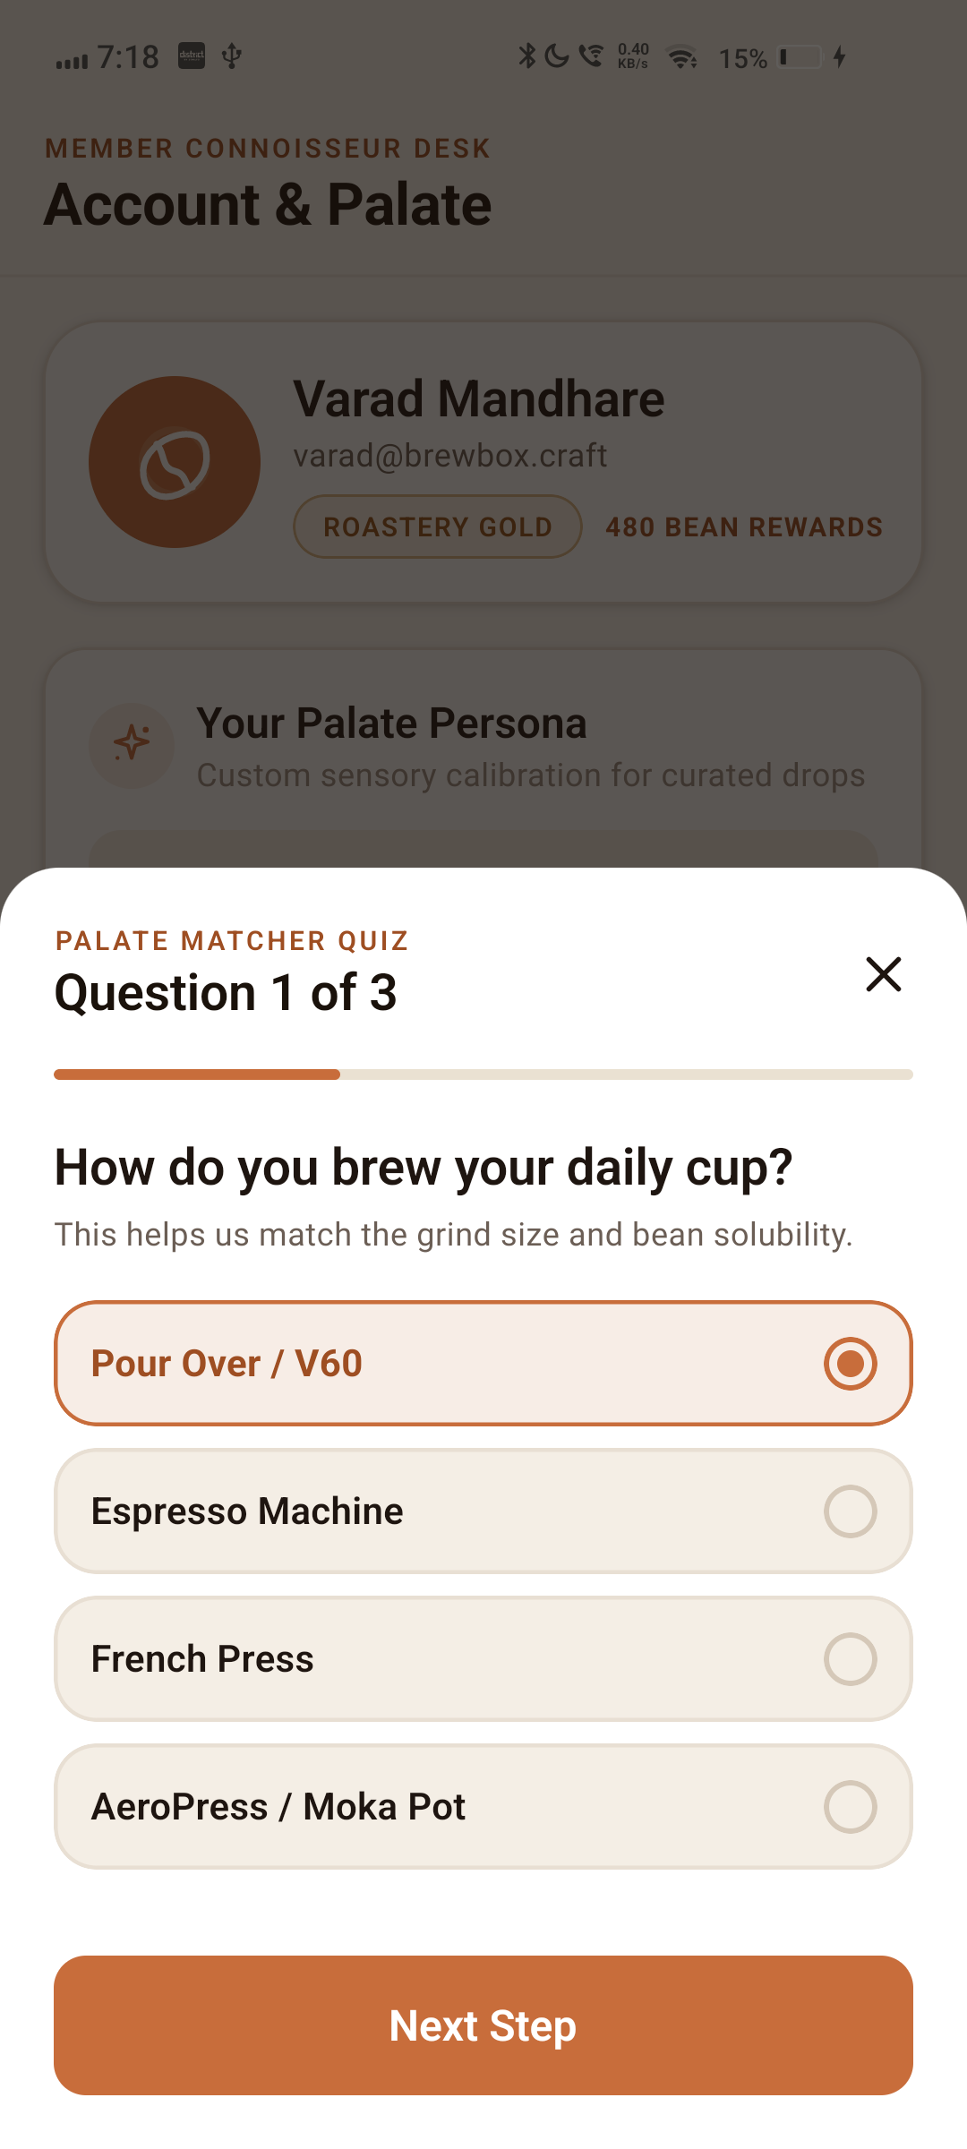  Fig 7.5: Palate Matcher | 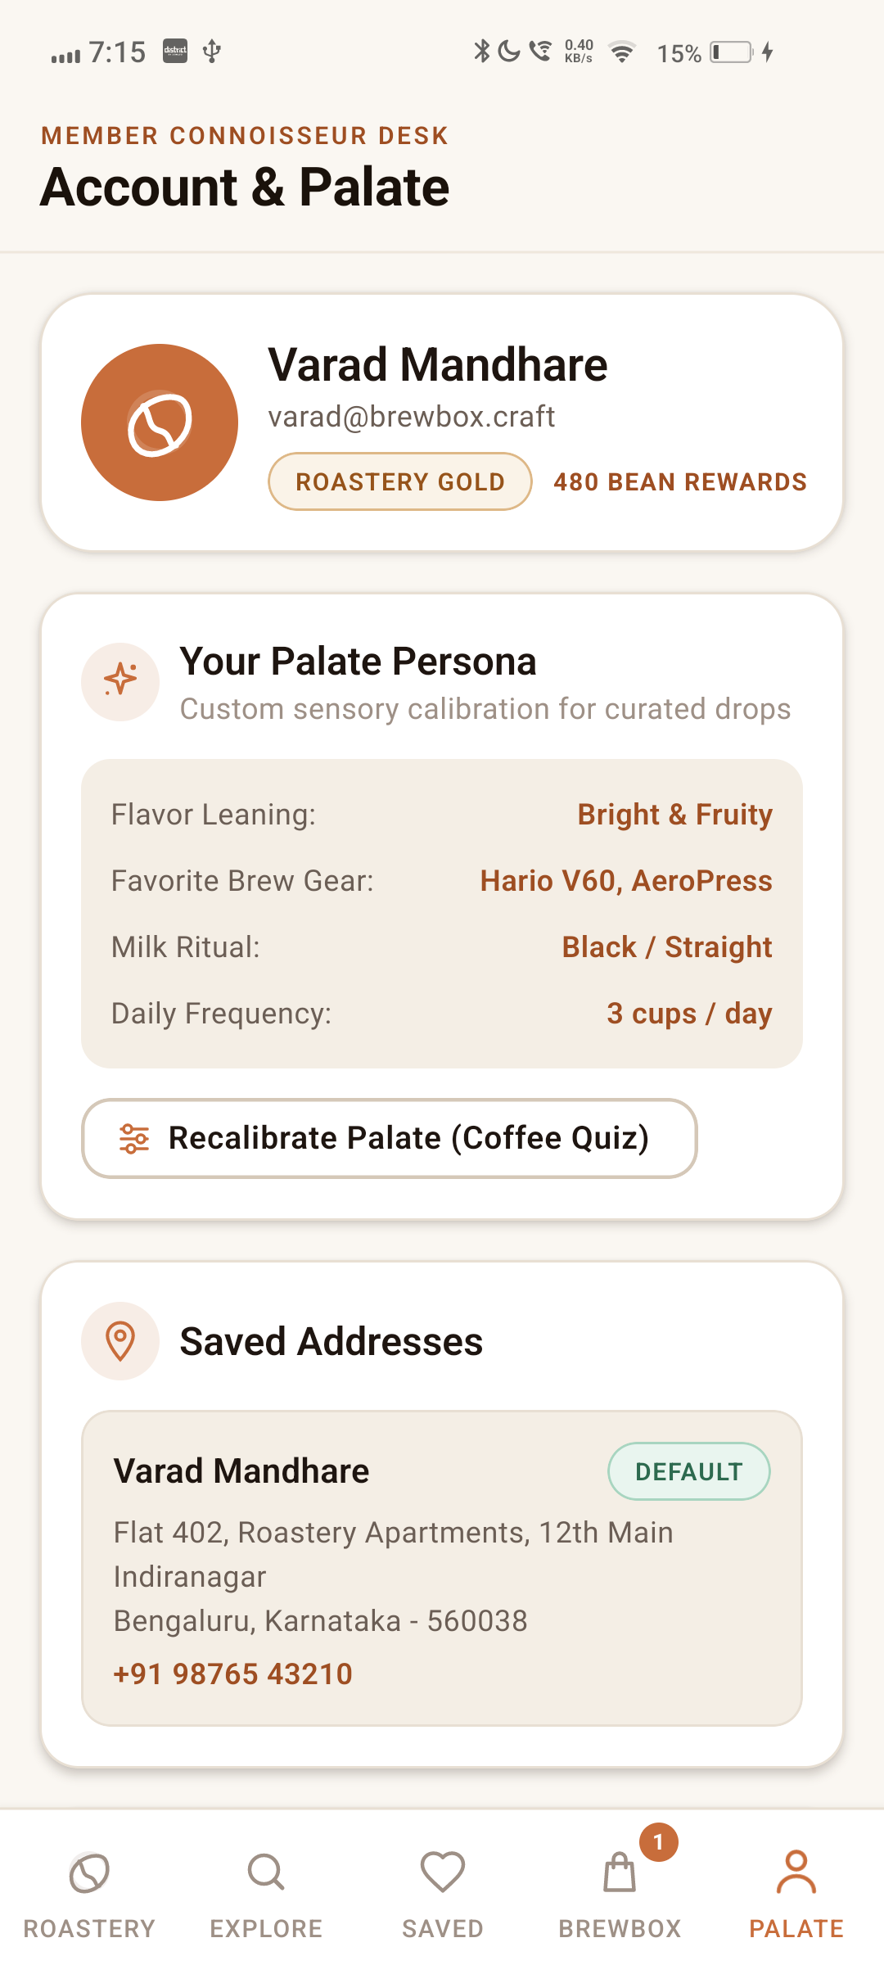  Fig 7.6: Account & Orders

8. CONCLUSION & LEARNING OUTCOMES
The BrewBox project successfully demonstrates the end-to-end design, implementation, and deployment of a bespoke mobile e-commerce application utilizing the latest React Native 0.87 ecosystem. By shunning generic templates in favor of an editorial terroir aesthetic, the project proves that cross-platform mobile frameworks can deliver artisanal, high-fidelity experiences rivaling bespoke native applications while preserving the immense engineering advantages of a single, shared codebase.

9. REFERENCES & BIBLIOGRAPHY
1. Meta Platforms, Inc. (2025). React Native Documentation: Architecture, Hermes Engine, and New Architecture Overview.
2. Microsoft Corporation (2025). TypeScript Handbook: Strict Type Checking and Modern ECMAScript Specifications.
3. Zustand Community (2025). Zustand: Bear Necessities for State Management in React and React Native.
4. Meta Open Source (2025). Yoga: An Open-Source, Cross-Platform C++ Layout Engine Implementing Flexbox.
5. Google Android Developers (2025). Android App Architecture and APK Packaging Guidelines.
6. Specialty Coffee Association (SCA) (2024). SCA Coffee Standards and Sensory Evaluation Protocols.
7. W3C CSS Working Group (2023). CSS Flexible Box Layout Module Level 1.

