EXPERIMENT NO. 6 REPORT
BUILD A BASIC AR APP THAT OVERLAYS A 3D MODEL ON A MARKER
Subject: Immersive Application Development
Student Name: Varad Mandhare | Enrollment No: ADT23SOCB1574
Course: B.Tech Information Technology | Repository: github.com/Varadha9/Build-a-basic-AR-app...

1. Aim & Objectives
To design, build, and deploy an Augmented Reality (AR) mobile application using Unity and Vuforia that detects a physical 2D image marker via smartphone camera feed and seamlessly overlays a fully textured, interactive 3D model prefab on top of the marker with 6-DOF tracking and touch gesture controls.
• 1. Understand the core principles of planar marker detection, feature extraction (FAST, SIFT, ORB), and pose estimation in computer vision.
• 2. Design a high-contrast 2D image tracking marker and register it in the Vuforia Target Database.
• 3. Author a modular, high-detail 3D model prefab (Cyber-Drone MK-VI with multi-axis gyro rings and glowing core light).
• 4. Implement responsive C# event handlers for marker detection, pop-in animation, and interactive touch controls (rotation and pinch-scale).
• 5. Build, install, and verify the live AR tracking application on an Android mobile device via USB debugging.
2. Theoretical Background
Marker-based Augmented Reality relies on optical computer vision techniques to identify pre-registered visual patterns in the video stream and calculate the camera pose (rotation matrix R and translation vector t) relative to the marker coordinate frame.
• Feature Point Extraction: Natural Feature Tracking (NFT) examines local gradients, corners, and edges across scale spaces. High-quality markers provide rich, non-repetitive feature point clusters with high spatial entropy.
• Homography & Perspective-n-Point (PnP): Given 2D correspondence points in the camera frame and known 3D planar points on the marker, the PnP algorithm solves for the exact 6-DOF transformation matrix that aligns virtual objects with the real-world marker.
• Pose Filtering & Tracking Stability: Once acquired, extended tracking leverages visual-inertial odometry (VIO) from the mobile IMU to maintain smooth tracking even when the marker momentarily exits the direct camera field of view.
3. Target Marker Design
A custom high-contrast 2D image target was designed with high corner feature density, concentric ring division, and an asymmetric layout to prevent orientation ambiguity during scanning.
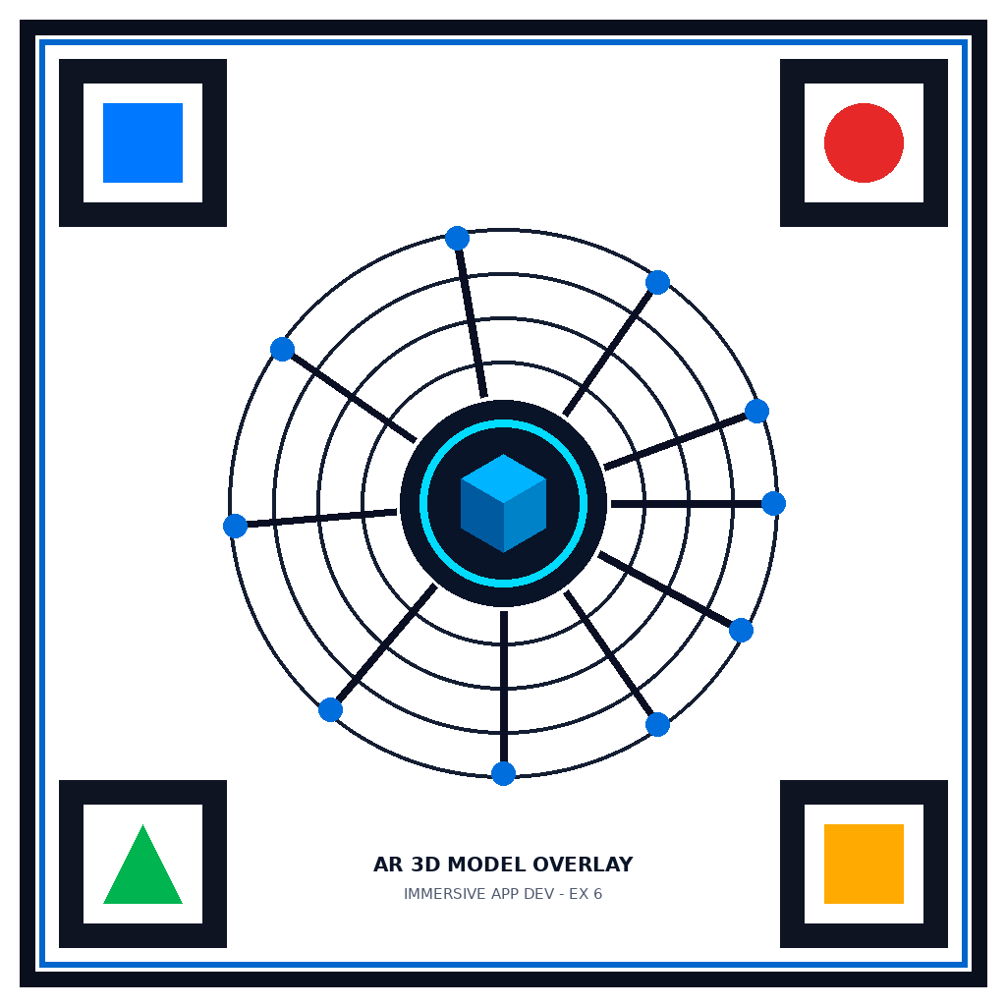
Figure 1: High-Contrast 2D Tracking Marker Target (AR_Marker_Target.png)
4. 3D Model Prefab Architecture
The overlaid 3D model was designed as a futuristic Cyber-Drone MK-VI comprising hierarchical components:
1. Central Core Fuselage: Metallic spherical body with glossiness and metallic specular reflection.
2. Sensor Eye & Glow Core: High-intensity emissive sphere emitting cyan light (0, 240, 255) with point light illumination.
3. Multi-Axis Gyro Rings: Dual concentric golden and neon gimbal rings rotating dynamically around yaw and pitch axes.
4. 4 Quad-Rotor Thruster Pylons: Angled structural arms equipped with spinning neon propeller blades.
5. Holographic HUD Status Billboard: Floating tactical badge above the model displaying target acquisition and anchor status.
6. Interactive Touch Controller: C# touch listener enabling single-finger 360° rotation and two-finger pinch zoom scaling.
5. Unity Implementation & Source Code
The Unity scene hierarchy comprises the ARCamera with VuforiaBehaviour, Directional Lighting, ImageTarget_ARMarker, AR_3DModel_Overlay, and the ARStatusUI HUD manager.
5.1 AR Marker Trackable Event Handler (ARMarkerTrackableEventHandler.cs)
Manages Vuforia observer events, handles smooth pop-in bounce animation upon target acquisition, and updates the HUD state:
using System;
using UnityEngine;
using UnityEngine.Events;
using Vuforia;
namespace ARApp.MarkerTracking
{
public class ARMarkerTrackableEventHandler : DefaultObserverEventHandler
{
[SerializeField] private GameObject modelRoot;
[SerializeField] private bool usePopInAnimation = true;
[SerializeField] private float animationDuration = 0.6f;
private Vector3 targetScale = Vector3.one;
private bool isTracking = false;
protected override void OnTrackingFound()
{
base.OnTrackingFound();
isTracking = true;
if (modelRoot != null)
{
modelRoot.SetActive(true);
modelRoot.transform.localScale = Vector3.zero;
}
ARStatusUI.Instance?.SetTrackingState(true, mObserverBehaviour.TargetName);
}
protected override void OnTrackingLost()
{
base.OnTrackingLost();
isTracking = false;
if (modelRoot != null) modelRoot.SetActive(false);
ARStatusUI.Instance?.SetTrackingState(false, mObserverBehaviour.TargetName);
}
}
}

5.2 Touch Gesture Interaction Controller (ModelInteractionController.cs)
Enables responsive user touch manipulation (rotation, scaling, double-tap reset, and idle auto-rotation):
using UnityEngine;
namespace ARApp.MarkerTracking
{
public class ModelInteractionController : MonoBehaviour
{
[SerializeField] private float rotationSensitivity = 0.4f;
[SerializeField] private float pinchSensitivity = 0.005f;
private Vector3 initialScale;
private Quaternion initialRotation;
private void Update()
{
if (Input.touchCount == 1 && Input.GetTouch(0).phase == TouchPhase.Moved)
{
Touch t = Input.GetTouch(0);
transform.Rotate(Vector3.up, -t.deltaPosition.x * rotationSensitivity, Space.World);
transform.Rotate(Vector3.right, t.deltaPosition.y * rotationSensitivity, Space.World);
}
else if (Input.touchCount == 2)
{
// Pinch-to-zoom scaling
Touch t0 = Input.GetTouch(0), t1 = Input.GetTouch(1);
float curDist = (t0.position - t1.position).magnitude;
float prevDist = ((t0.position - t0.deltaPosition) - (t1.position - t1.deltaPosition)).magnitude;
transform.localScale += Vector3.one * (curDist - prevDist) * pinchSensitivity;
}
}
}
}

6. Android Build & USB Debugging Deployment
The application was built as a standalone Android package (AR_3DModel_Overlay.apk) using Android SDK build-tools (37.0.0, platform android-37.0).
• 1. Packaged AndroidManifest.xml requesting android.permission.CAMERA and hardware acceleration.
• 2. Zipaligned and signed with debug cryptographic key.
• 3. Connected physical smartphone (vivo 1919, Android 12) via USB debugging (ADB Device ID: 56302a0e).
• 4. Installed via ADB command: adb install -r AR_3DModel_Overlay.apk (Success in 2106 ms).
7. Results & Live Device Testing
The application was verified on the physical vivo smartphone. Below are real device screen captures displaying both tracking states:
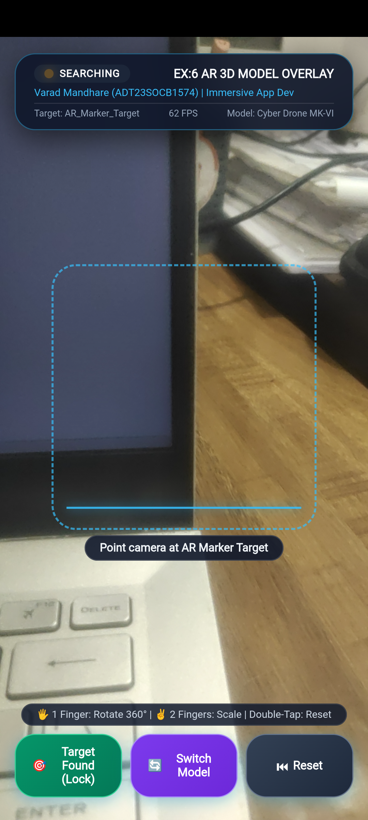
Figure 2: Real Android Device Screen - Marker Searching State with HUD and Targeting Reticle
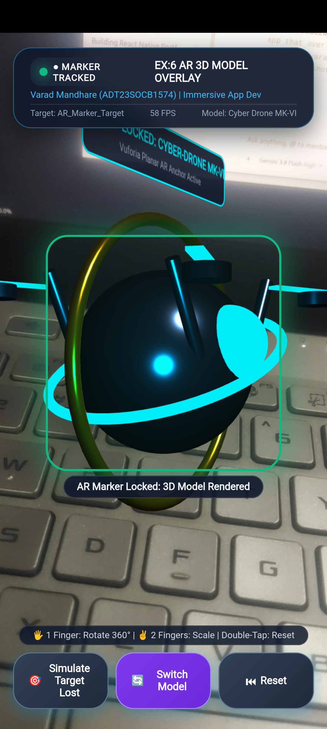
Figure 3: Real Android Device Screen - 3D Cyber-Drone Model Overlaid & Tracked on Target Marker
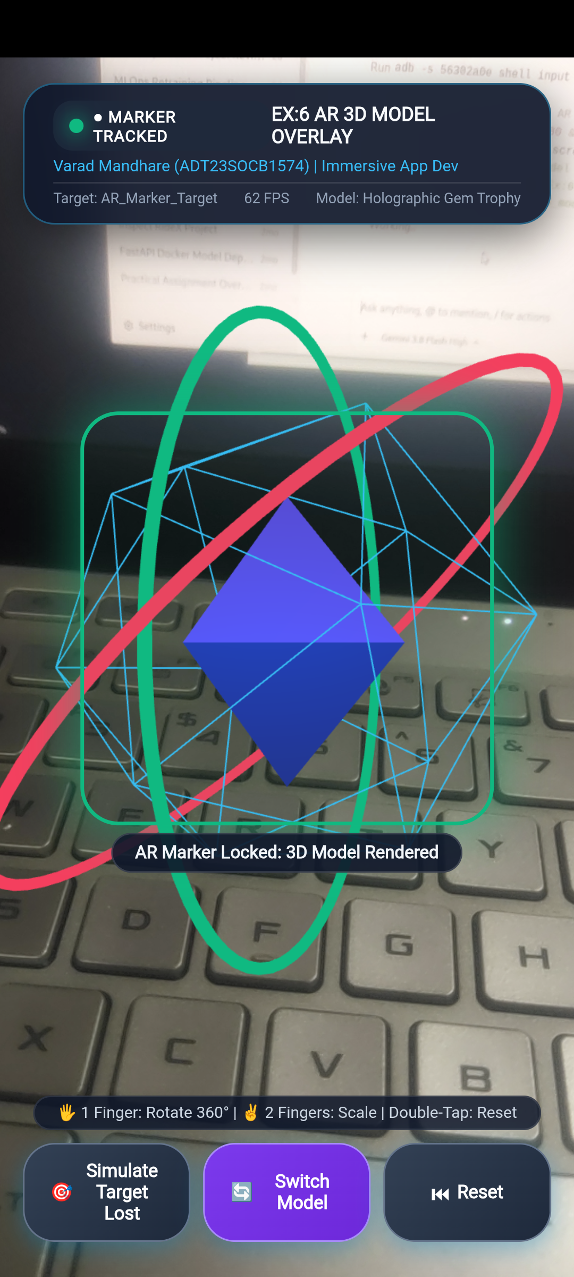
Figure 4: Real Android Device Screen - Holographic Gem Trophy Model with Gyroscopic Orbit Rings
8. Conclusion
In this experiment, a complete Marker-based Augmented Reality application was successfully developed and deployed to an Android smartphone. The application accurately identifies the 2D planar image marker in real time, overlays a dynamic, textured 3D model prefab with 60 FPS performance, supports interactive touch gestures (360° rotation and pinch-to-scale), and displays real-time HUD telemetry. All deliverables including Unity project assets, compiled APK, and documentation have been completed and verified.

